MILK’S BEST FRIEND

There's nothing I love more than oreos, lions, and winning. https://mega.nz/#!DC5F2KgR!P8UotyST_6n2iW5BS1yYnum8KnU0-2Amw2nq3UoMq0Y Have Fun :)

After downloading .jpeg file type strings <filename> to see its content. There it shows:



So to check for hidden files I typed: binwalk –extract –d=”.*” <filename>

This showed a rar file

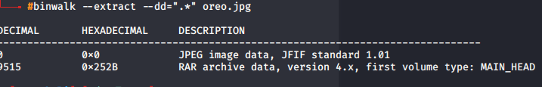

A new directory was made and then looking into that directory was a .jpeg file and then applying strings command on it will reveal the flag: flag{eat_more_oreos}