Basic Injection

See if you can leak the whole database. The flag is in there somwhere… <https://web.ctflearn.com/web4/>

After opening the link you will be forwarded to this webpage.

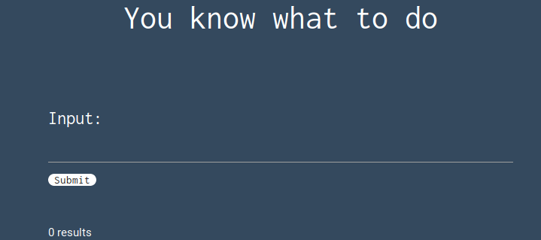

The input space requires some malicious sql code to display the content of whole database.

We will try the basic sql injection code : ‘ or ’’=’ . This works and will give the following output.

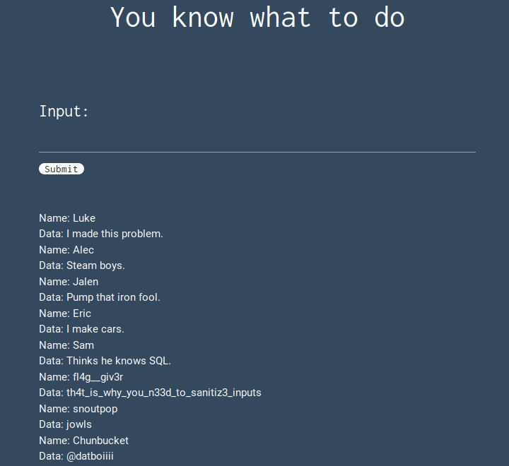

Here you can see the name of the flag as fl4g_giv3r.

This is the required flag.