CALCULATE M3

Here! http://web.ctflearn.com/web7/ I forget how we were doing those calculations, but something tells me it was pretty insecure.

This was an interesting challenge as I have to view some of the hints from google.

If you calculate anything in the web calculator it will reflect the calculation.

After viewing the page source there was a calc.js file which gave the following results:

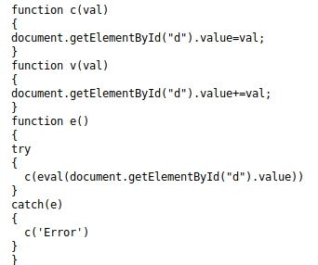

It is clearly understood from the above text that c and v function are assigning values and they are passed in function e as eval(). This gives a hint about os command injection.

So I opened burp suite and intercepted the request and calculated for (6+3) and waited for the browser to show the result as:



After this I typed basic command “ls” in RHS of expression and got the flag:

expression = ; ls



Flag : ctf{watch_0ut_f0r_th3_m0ng00s3}