GIT IS GOOD

The flag used to be there. But then I redacted it. Good Luck. [https://mega.nz/#!3CwDFZpJ!Jjr55hfJQJ5-jspnyrnVtqBkMHGJrd6Nn\_QqM7iXEuc](https://mega.nz/" \l "!3CwDFZpJ!Jjr55hfJQJ5-jspnyrnVtqBkMHGJrd6Nn_QqM7iXEuc)

After downloading zip file from this url unzip it in the terminal to see into its content. After moving into the unzip directory

You will find a file named ‘flag.txt’ . It will show flag{REDACTED}. First I thought this was the flag but then I remembered redacted means edited or changed. So I took a hint from the Challenge name ‘GIT’.

I checked the log files using command: git log

and found a commit named ‘edited files’.

I then typed git show <commit> to show its content. I got the flag as :

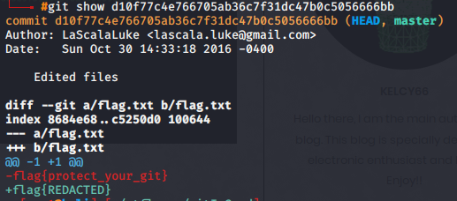

flag{protect\_your\_git}