POST PRACTICE

These website requires authentication, via POST. However, it seems as if someone has defaced our site. Maybe these is still some way to authenticate? http://165.227.106.113/post.php

**Tool Used: Burpsuite**

After opening this url it shows this message:



After reading this I understood this has something to do with GET/POST requests. Also I inspected this webpage and found username and password. I didn’t know in the beginning what to do with them.

I opened burpsuite and foxyproxy on my firefox. After intercepting the request I send the request to repeater and then right click on that area and changed the request method to post. After that I passed the username and password in the request section. It looked like this:

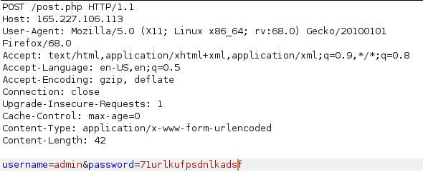

After this I clicked on send and I got the flag: 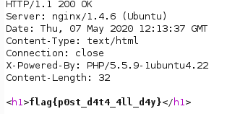

Flag is: flag{p0st_d4t4_4ll_d4y}