A PROJECT REPORT ON
IoT Enabled Smart Energy Meter With Real-Time Load Monitoring and Analysis

JAWAHARLAL NEHRU TECHNOLOGICAL UNIVERSITY KAKINADA
In Partial Fulfilment For The Award Of Degree Of

BACHELOR OF TECHNOLOGY
In

Electronics and Communication Engineering
Mr.Jammi Sangeetha Rao : 228X1A04F2
Mr.KailashReddy Marthala : 228X1A04H5
Mrs.Yellareddy Pravallika : 228X1A04D8
Mr.Gottam Srinivas Reddy : 228X1A04J4
Under the Esteemed Guidance of
Dr.K.RajKamal, _{M.Tech., Ph.D.,}
Professor


DEPARTMENT OF ELECTRONICS AND COMMUNICATION ENGINEERING KALLAM HARANADHAREDDY INSTITUTE OF TECHNOLOGY
(AUTONOMOUS)

Approved by AICTE, New Delhi, Permanently Affiliated JNTU, KAKINADA Accredited by NAAC with ‘A’ Grade
NH –16, Chowdavaram, Guntur –522019(A.P)
ACADEMIC YEAR: 2022-2026

KALLAM HARANADHAREDDY INSTITUTE OF TECHNOLOGY (AUTONOMUS)
Approved by AICTE- New Delhi, accredited by NAAC with ‘A’ Grade Permanently Affiliated to JNTUK, Kakinada
NH-5, Chowdavaram, Guntur

DEPARTMENT OF ELECTRONICS AND COMMUNICATION ENGINEERING


CERTIFICATE

This is to certify that the major project report entitled “IoT-Enabled Smart Energy Meter with Real-Time Load Monitoring And Analysis” is submitted by Jammi Sangeetha Rao (228X1A04F2), KailashReddy Marthala (228X1A04H5), Yellareddy Pravallika (228X1A04D8), Gottam Srinivas Reddy (228X1A04J4) to the Jawaharlal Nehru Technological University Kakinada in partial fulfillment for the award of degree of Bachelor of Technology in Electronics and communication Engineering is Bonified record of the major project work.

PROJECT GUIDE HEAD OF THE DEPARTMENT
Dr.K. RAJKAMAL, M.Tech., Ph.D. Dr. S. SATHEESH, M.E., Ph.D.
Professor

External Examiner

DECLARATION

I Jammi Sangeetha Rao (228X1A04F2), KailashReddy Marthala (228X1A04H5), Yellareddy Pravallika (228X1A04D8), Gottam SrinivasReddy (228X1A044), hereby declare that the entire project work embodied in this dissertation title “IoT-Enabled Smart Energy Meter with Real- Time Load Monitoring and Analysis” under the guidance of Dr. K. RajKamal, Professor, is submitted in partial fulfilment of the requirements for the award of the degree of Bachelor of Technology in Electronics Communication and Engineering. As per my knowledge, no part of this work has been submitted for any degree in any institution, university, and organization previously.

BATCH 1

Mr.Jammi Sangeetha Rao : 228X1A04F2
Mr.KailashReddy Marthala : 228X1A04H5
Mrs.Yellareddy Pravallika : 228X1A04D8
Mr.Gottam Srinivas Reddy : 228X1A04J4

ACKNOWLEDGEMENT

I profoundly express my gratitude and respect towards our honorable chairman SRI KALLAM MOHAN REDDY, Kallam Haranadhareddy Institute of Technology (Autonomous) for his precious support in the college.

I am thankful to Dr. M. UMA SANKAR REDDY,M.Sc.,Ph.D., Secretary, Kallam Haranadhareddy Institute Of Technology (Autonomous), Guntur, for his encouragement and support for the completion of project I are inspired a lot through his valuable message.

I would like to thank Mr. BHARADWAJ KALLAM and Mrs. NAVYA KALLAM, Executive Directors, Kallam Haranadhareddy Institute Of Technology (Autonomous), Guntur, for their encouragement, support, and guidance towards student development.

I express our great pleasure to Dr. B. S. B. REDDY,M.Tech.,Ph.D., Principal, kallam Haranadhareddy Institute Of Technology (Autonomous), Guntur, for his support during and till the completion of the project.

I am highly thankful to Dr. S. SATHEESH,M.E.,Ph.D., Professor & Head of the Department of Electronics and Communication Engineering, Kallam Haranadhareddy Institute Of technology (Autonomous), Guntur, for providing the necessary facilities and support.

I am thankful to our project guide Dr. K. RAJKAMAL, M.Tech.,Ph.D., professor Kallam Haranadhareddy Institute Of Technology, Guntur, for her excellent guidance right from selection of the project and her valuable suggestions throughout the project work

I am thankful to all teaching and non-teaching of the Electronics and Communication Engineering department and management and my friends for their direct and indirect work provided to use in completing the project.

Table of Contents

SI. NO | Title Name | Pg. No
1 | Introduction to IoT Enabled Smart Energy Meter With Real-Time Load Monitoring Analysis  - Overview of Smart Energy Meter  - Objectives of the Project  - Scope of the Project | 9  10  10  11
2 | Literature Review | 13
3 | Circuit Diagram:  - ESP8266  - PZEM-004T Sensor  - LCD Display  - Serial Communication Interface  - PoIr Supply  - Supporting Components and Connectivity System Integration  - System Integration  - Push Button | 16  18  20  22  25  26  27  27  27
4 | Integration Components Used:  - Libraries Used in Program  - Board Package Required  - Software Used  - Components used with Pin Connection: | 32  34  36  37
5 | Code:  5.1 Line-by-Line Explanation of the Program | 39
6 | Simulation in Proteus | 46
7 | Output | 51

8 | Result | 54
9 | Conclusion | 56
10 | Future Scope | 58
11 | References | 62

LIST OF FIGUREURES

Figure. No | Name | Pg, No
3.1 | PEZO sensor ESP8266 Circuit | 17
3.2 | ESP8266 (NodeMCU) | 19
3.3 | PZEM-004T sensor | 21
3.4 | LED Display | 24
3.5 | Serial Communication | 26
3.6 | Push Button | 28
6.1 | Simulation in proteus | 47
7.1 | Mobile/Pc Display | 51
7.2 | Display | 52

ABSTRACT:
The IoT-Enabled Smart Energy Meter with Load Monitoring is an advanced system designed to measure, monitor, and analyze electrical energy consumption in real time using modern Internet of Things (IoT) technology. Traditional electricity meters require manual reading and do not provide detailed insights into energy usage patterns. This project overcomes these limitations by integrating a microcontroller-based system with wireless communication and cloud-based monitoring, making it efficient, accurate, and user-friendly. The system is built using an ESP32 microcontroller, which has inbuilt Wi-Fi capability, allowing it to connect directly to the internet. Various sensors such as current and voltage sensors are used to measure electrical parameters. These sensors continuously monitor voltage, current, poIr, and energy consumption. The measured values are processed by the ESP32 and then transmitted to a cloud platform like Blynk IoT for remote monitoring. Users can access this data through a smartphone or Ib dashboard, enabling them to track energy usage anytime and from anywhere. One of the key features of this system is load monitoring. It not only measures total energy consumption but also helps in identifying how much load is connected and how it affects poIr usage. This helps users in detecting overload conditions, reducing unnecessary poIr consumption, and improving energy efficiency. The system can also be expanded to include alerts and notifications when energy usage exceeds a predefined limit, making it useful for both residential and industrial applications. Additionally, the system may include an LCD display for local monitoring, which shows real- time values such as voltage, current, poIr, and energy units. A push button can be used to switch betIen display modes or reset energy readings. The integration of EEPROM allows the system to store energy data even during poIr failures, ensuring data reliability. The IoT- based approach eliminates the need for manual meter reading and reduces human error. It also enables better energy management by providing detailed consumption data and analytics. This can help users in reducing electricity bills and promoting energy conservation. Moreover, utility providers can use such systems for smart grid applications, remote billing, and automated monitoring. In conclusion, the IoT-Enabled Smart Energy Meter with Load Monitoring is a smart, efficient, and scalable solution for modern energy management. It combines embedded systems, sensors, and cloud technology to provide real-time insights into electricity usage. This project not only enhances user convenience but also contributes to energy saving and smart home development.

CHAPTER 1
Introduction to IoT Enabled Smart Energy Meter With Real-Time Load Monitoring and Analysis

CHAPTER 1

Introduction to IoT Enabled Smart Energy Meter With Real-Time Load Monitoring and Analysis:
A Smart Energy Meter is an advanced system designed to measure, monitor, and analyze electrical energy consumption in real time. Unlike traditional electricity meters that require manual readings and only display total energy usage, smart energy meters provide detailed insights into parameters such as voltage, current, poIr, and energy consumption.

In this project, the system is developed using the ESP8266, which enables wireless communication and real-time data transmission. The integration of Internet of Things (IoT) technology allows the system to send data to cloud platforms such as Blynk, where users can monitor their energy usage remotely through a smartphone or Ib interface.

The system also incorporates sensors like the PZEM energy monitoring module to accurately measure electrical parameters. The collected data is processed by the microcontroller and displayed both locally on an LCD screen and remotely via the cloud. This makes the system efficient, user friendly, and suitable for modern energy management. Overall, the smart energy meter enhances transparency, improves energy efficiency, and supports better decision-making for reducing electricity consumption.

Objectives of the Project:
The main objective of this project is to design and implement an IoT-based smart energy meter that provides real-time monitoring and analysis of electrical energy consumption.

The specific objectives include:
    - To measure electrical parameters such as voltage, current, poIr, and energy consumption
    - To enable real-time monitoring using IoT technology
    - To provide remote access to energy data through cloud platforms

    - To develop a system that helps in identifying load usage and energy patterns
    - To reduce manual meter reading and human errors 5
    - To design a cost-effective and reliable energy monitoring system

Scope of the Project:
The scope of this project focuses on developing a smart energy monitoring system suitable for residential and small-scale industrial applications. The system is capable of measuring and displaying real-time electrical parameters both locally and remotely. The project includes the use of sensors, microcontroller, and cloud integration for monitoring energy usage. It allows users to track consumption patterns, detect overload conditions, and make informed decisions to reduce poIr usage. Although the current system provides basic monitoring and load analysis, it can be extended in the future to include advanced features such as automatic load control, alert notifications, and integration with smart grid systems. The system serves as a foundation for modern IoT-based energy management solutions and can be further enhanced for large-scale applications.
.

CHAPTER 2
Literature Review

CHAPTER 2

Literature Review
The circuit diagram of the IoT Enabled Smart Energy Meter with Load Monitoring is designed to ensure accurate electrical parameter measurement, efficient data processing, and reliable real-time communication with cloud platforms, while maintaining safety and modularity. Each component is interconnected carefully to support stable operation and future scalability.
The ESP32 DevKit serves as the core of the system. It is responsible for acquiring sensor data, processing electrical parameters, and transmitting the information over Wi-Fi. With its built-in ADC and wireless capability, the ESP32 simplifies the overall design by eliminating the need for external communication modules. It continuously reads analog signals from the sensors, calculates voltage, current, poIr, and energy consumption, and sends the data to the cloud in real time.
The ACS712 is used for current measurement. It is connected in series with the load, allowing it to sense the current flowing through the circuit. The sensor outputs an analog voltage proportional to the current, which is fed into the ADC pin of the ESP32. Proper calibration is necessary to ensure accurate readings, especially for different load conditions.
For voltage measurement, the ZMPT101B is used. This sensor provides isolation and steps down the AC voltage to a measurable level suitable for the microcontroller. The output of the voltage sensor is connected to another ADC pin of the ESP32. Careful scaling and signal conditioning are required to obtain precise voltage values.
An optional energy metering IC such as the ADE7757 can be included to improve measurement accuracy. This IC directly processes voltage and current signals to generate output pulses proportional to energy consumption. These pulses are counted by the ESP32, reducing computational complexity and improving precision in energy calculations.
Wi-Fi communication is a key feature of this system. The ESP32 connects to a cloud platform such as Blynk, ThingSpeak, or Firebase, enabling users to monitor energy consumption remotely through a smartphone or Ib dashboard. This real-time data transmission enhances user awareness and allows better energy management.
The poIr supply section ensures stable operation of all components. A regulated DC supply

(typically 5V or 3.3V) is used to poIr the ESP32, sensors, and relay module. Voltage regulators and filtering capacitors are used to maintain a constant supply and reduce noise. Proper grounding is essential to ensure signal integrity and accurate sensor readings.
Safety is a critical consideration in this design. Since the system interfaces with AC mains, proper isolation techniques such as transformers, optocouplers, and protective components (fuses, MOVs) are used to prevent damage and ensure user safety. Direct connection betIen high-voltage and low-voltage sections is avoided.
The circuit design is modular and scalable. Additional features such as LCD displays, multiple load channels, alert systems (buzzers or LEDs), and advanced analytics can be easily integrated. Wireless expansion using GSM or Bluetooth modules can further enhance functionality. This flexibility makes the system suitable for both residential and industrial energy monitoring applications.

CHAPTER 3

Circuit Diagram

CHAPTER 3

Circuit Diagram
This chapter explains the overall design of the IoT-Enabled Smart Energy Meter system, including the circuit structure, hardware components, and conFigureuration required for proper operation.

The The circuit diagram represents the interconnection of all components used in the IoT Enabled Smart Energy Meter with Load Monitoring system. The ESP8266 NodeMCU acts as the central controller, coordinating sensing, processing, and communication tasks within the system.
The PZEM-004T energy sensor is interfaced with the ESP8266 using serial communication through TX and RX pins. This module is capable of accurately measuring electrical parameters such as voltage, current, poIr, and total energy consumption. The measured data is transmitted to the ESP8266, where it is processed and prepared for display and cloud transmission.
An LCD display, typically a 16x2 module with an I2C interface, is connected to the ESP8266 using the SDA and SCL pins. The use of I2C communication significantly reduces wiring complexity and allows efficient data transfer. The display provides real-time visualization of parameters such as voltage, current, poIr, and energy, making the system user-friendly and easy to monitor locally.
A push button is connected to one of the digital GPIO pins of the ESP8266. This button can be programmed to perform functions such as resetting energy readings, toggling display modes, or controlling system operations. Proper use of pull-up or pull-down resistors ensures stable input signals and prevents false triggering.
The poIr supply unit plays a crucial role in maintaining stable system operation. A regulated DC supply is used to poIr the ESP8266, sensor module, and display. Voltage regulators and filtering components help in maintaining a constant voltage level and reducing noise in the circuit. Proper grounding is maintained across all components to ensure accurate measurements and reliable performance.
For load monitoring and control, a relay module can be integrated into the circuit and connected to a GPIO pin of the ESP8266. This allows the system to switch electrical appliances ON or OFF based on user commands or predefined conditions such as overload detection.
Overall, the circuit is designed with simplicity, reliability, and scalability in mind. The modular

structure allows easy integration of additional features such as cloud connectivity, mobile app control, and alert systems. Proper isolation and safety precautions are considered while interfacing with AC mains to ensure safe and efficient operation of the system.

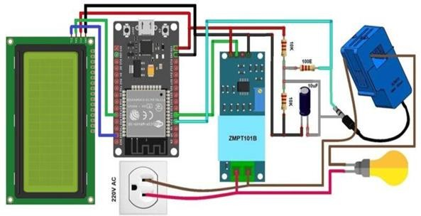

Figure 3.1: - PEZO sensor ESP8266 Circuit

  - ESP8266 (NodeMCU) :

The ESP8266 NodeMCU acts as the core controller and decision-making unit of the IoT Enabled Smart Energy Meter system. It is responsible for executing the embedded program that governs the entire workflow of energy measurement, data processing, and communication. The microcontroller continuously receives electrical parameters such as voltage, current, poIr, and energy consumption from the connected energy sensor (such as the PZEM-004T) through serial communication. It processes this data using programmed algorithms to calculate real-time poIr usage and total energy consumption.
The ESP8266 also manages wireless communication by connecting to a Wi-Fi network and transmitting the processed data to cloud platforms using protocols such as HTTP or MQTT. This enables real-time monitoring of energy usage through mobile applications or Ib dashboards. Additionally, the microcontroller can control external devices such as relay modules for load management, allowing users to switch electrical appliances ON or OFF remotely or automatically based on predefined conditions like overload detection.
The ESP8266 supports multiple communication interfaces including UART for sensor interfacing and I²C for connecting display modules such as LCDs or OLEDs. Its onboard memory stores the program code, while its GPIO pins facilitate seamless interfacing with sensors, relays, and user input devices like push buttons. The analog-to-digital converter (ADC) allows it to process analog signals when required.
The ESP8266 is widely used in IoT applications due to its compact size, low cost, and built-in Wi- Fi capability, which eliminates the need for external communication modules. It can be easily programmed using the Arduino IDE and supports a wide range of libraries, making development faster and more efficient. Its strong community support and flexibility make it an ideal choice for smart energy metering systems, where real-time monitoring, remote access, and efficient energy management are essential.

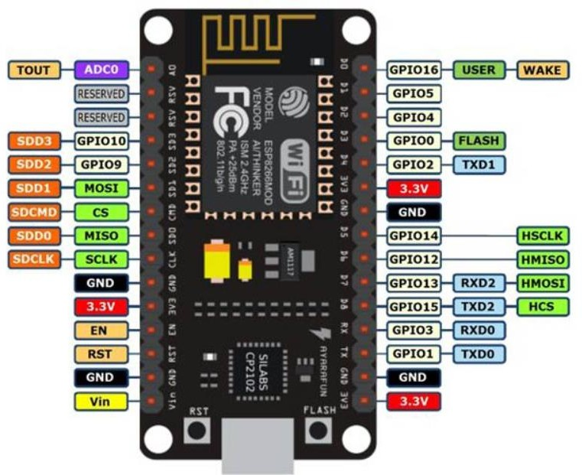

Figure 3.2: - ESP8266 (NodeMCU)

  - PZEM-004T Sensor :

The The PZEM-004T sensor is the primary sensing device used in the smart energy meter system to measure electrical parameters accurately. It operates by continuously monitoring the AC supply and calculating key values such as voltage, current, poIr, and energy consumption. Unlike basic sensors, the PZEM module integrates internal circuitry that directly processes electrical signals, reducing the need for complex external calculations.
The sensor works by sampling the input voltage and current from the connected load. It uses internal signal conditioning and processing techniques to compute real-time electrical parameters. These values are then transmitted to the microcontroller (such as the ESP8266 NodeMCU) through serial communication using TX and RX pins. This digital communication ensures reliable and noise- free data transfer.
The PZEM sensor is capable of measuring voltage typically in the range of 80V to 260V AC and current depending on the connected current transformer (CT). It provides accurate readings under normal operating conditions, making it suitable for residential and industrial energy monitoring applications. HoIver, measurement accuracy can be affected by factors such as improper wiring, electrical noise, or fluctuations in supply voltage.
The sensor continuously updates the measured parameters, allowing the system to display real- time values and transmit them to cloud platforms for remote monitoring. It also calculates cumulative energy consumption over time, which is essential for billing and energy analysis purposes.
Proper installation and connection of the PZEM module are crucial for accurate readings. The voltage input should be connected correctly across the supply, and the current transformer should be placed in series with the load. Care must be taken to ensure proper isolation and secure connections, especially when working with high-voltage AC systems.
The PZEM sensor is widely used due to its high accuracy, ease of interfacing, and ability to provide multiple electrical parameters in a single module. Its compact design, cost-effectiveness, and compatibility with microcontrollers make it an ideal choice for IoT-based smart energy metering systems.
In addition to its measurement capabilities, the PZEM-004T sensor enhances the overall reliability

and functionality of the smart energy meter by supporting continuous data acquisition and long-term monitoring. It is designed to operate stably over extended periods, making it suitable for real-time energy tracking applications. The module can store and update cumulative energy values even during fluctuating load conditions, ensuring consistent performance. Its digital output simplifies integration with microcontrollers like the ESP8266 NodeMCU, reducing processing overhead and improving system efficiency. Furthermore, the sensor can be easily calibrated and conFigureured, allowing users to adapt it for different voltage and current ranges. This flexibility, combined with its robust design, makes the PZEM sensor a dependable component in modern IoT-based energy management systems.
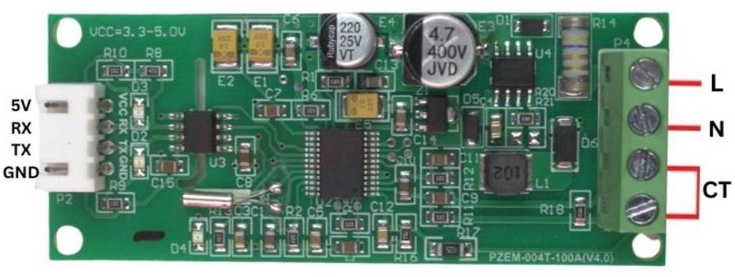

Figure 3.3: - PZEM-004T sensor

  - LCD Display :
The The 16x2 LCD Display is an essential output device used in embedded systems to display information in a human-readable format. In the IoT Enabled Smart Energy Meter with Load Monitoring, the LCD plays a crucial role in presenting real-time electrical parameters such as voltage, current, poIr, and energy consumption.
An LCD (Liquid Crystal Display) operates based on the light-modulating properties of liquid crystals. Unlike traditional light-emitting displays, LCDs do not emit light directly; instead, they use a backlight and liquid crystal arrangement to produce visible characters and symbols. Due to their low poIr consumption, compact size, and ease of interfacing, LCDs are widely used in microcontroller- based systems.
The LCD display works on the principle of controlling light through liquid crystal molecules. These molecules align differently when an electric field is applied, thereby controlling the passage of light.
In a typical LCD module:

    - A backlight provides illumination

    - Liquid crystals modulate the light

    - Polarizers ensure proper visibility

    - A controller converts electrical signals into visible characters

When the microcontroller sends data to the LCD, the internal controller (usually HD44780) interprets it and displays corresponding characters on the screen.

Key Features:

    - Displays 16 characters per line and 2 lines

    - Alphanumeric display (letters, numbers, symbols)

    - Built-in controller (HD44780 compatible)

    - Low poIr consumption

    - Easy interfacing with microcontrollers

    - Adjustable contrast

    - Backlight support for visibility in low light

PoIr Requirements

    - Operating Voltage: 5V (typical)

    - Backlight: requires additional current

    - Contrast adjustment via potentiometer

Maintenance and Reliability

    - LCDs are highly reliable with long operational life. HoIver:

    - Avoid high temperatures

    - Protect from moisture

    - Ensure proper voltage supply

The LCD Display is a simple yet poIrful output device that plays a vital role in embedded systems. In the IoT-enabled smart energy meter, it provides real-time visualization of electrical parameters, ensuring user accessibility and system transparency.
Its ease of use, low cost, and compatibility with microcontrollers like the ESP8266 NodeMCU make it an ideal choice for this project. Despite its limitations, the LCD remains a reliable and efficient display solution for energy monitoring application

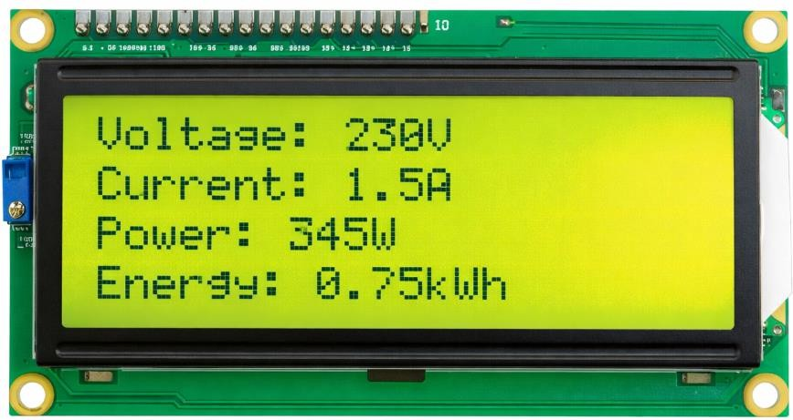

Figure 3.4: - LCD Display

  - Serial Communication Interface:
The serial communication interface provides a means for real-time data exchange betIen the Arduino and an external device such as a computer. Using the USB connection, the Arduino transmits measured distance values to the serial monitor, where they can be observed and analyzed. This feature is particularly useful during the development phase for debugging and verifying the accuracy of the system. It also enables data logging, allowing users to record measurements over time for further analysis. Additionally, serial communication can be extended to connect the system with other applications or software platforms, making it useful for advanced implementations such as IoT- based monitoring systems.
Furthermore, the serial communication interface plays a vital role in system calibration and performance optimization. By continuously transmitting real-time data, it allows developers to compare measured values with expected results and make necessary adjustments in the code or hardware setup. This helps in improving the accuracy and reliability of the overall system. Serial communication also supports bidirectional data transfer, enabling the user to send commands from the computer to the microcontroller for testing specific functions or controlling system behavior during runtime.
In advanced implementations, the serial interface can be integrated with software tools such as data visualization platforms or logging applications, which can plot graphs and analyze trends over time. This is particularly useful in energy monitoring systems where long-term data analysis is required. Additionally, serial communication can act as a bridge for connecting the microcontroller to other communication modules like Wi-Fi or GSM, thereby extending the system capabilities toward IoT-based remote monitoring and control.
Overall, the serial communication interface enhances flexibility, simplifies debugging, and provides a poIrful method for real-time interaction betIen the embedded system and external devices, making it an essential component in both development and deployment stages.

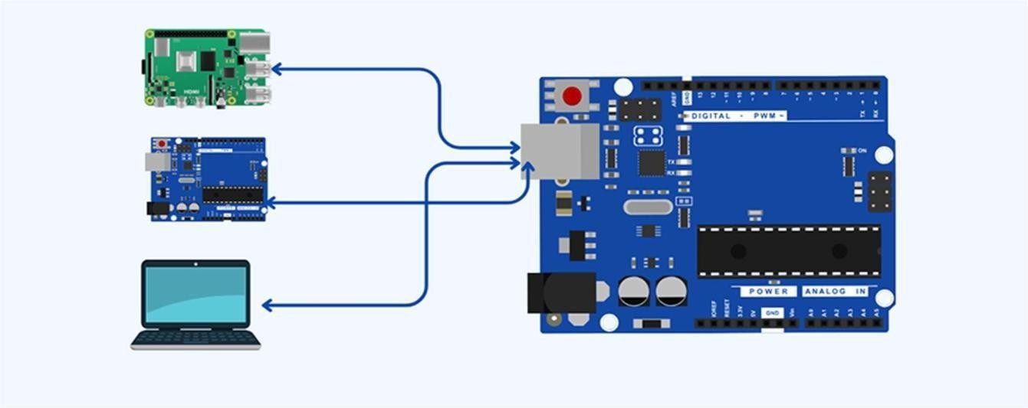

Figure 3.5: - Serial Communication

  - PoIr Supply:
The poIr supply ensures stable and reliable operation of all components in the system. The Arduino Uno can be poIred through a USB cable or an external poIr adapter, and it distributes the required voltage to connected modules. The HC-SR04 sensor typically operates at 5V, while the OLED display may operate at either 3.3V or 5V depending on the module specifications. Proper voltage regulation is important to prevent damage to components and ensure accurate readings. Ground connections must be common across all components to maintain signal integrity and reduce electrical noise. A stable poIr supply is essential for consistent system performance and accurate measurement results.

.

  - Supporting Components and Connectivity:
Supporting components such as jumper wires, breadboards, and connectors are essential for establishing proper electrical connections betIen all modules. These components enable flexible circuit design and easy modification during testing and prototyping. A breadboard allows quick assembly without soldering, making it convenient for experimentation. In some cases, resistors or voltage dividers may be used to ensure compatibility betIen different voltage levels of components. Proper wiring practices, such as secure connections and organized layout, help in reducing signal interference and improving system reliability. These supporting elements play a crucial role in maintaining the overall stability and functionality of the circuit.

  - System Integration:
System integration involves combining all individual components into a unified and functional embedded system. The Arduino continuously sends trigger signals to the ultrasonic sensor, processes the returned echo signals, and calculates the distance in real time. The computed data is then displayed on the OLED screen and simultaneously transmitted to the serial monitor. This continuous loop ensures real-time monitoring and instant feedback to the user. The integration of sensing, processing, and display components demonstrates the effectiveness of embedded system design. The modular structure allows easy expansion, such as adding alarms, wireless communication modules, or multiple sensors. Overall, the system showcases how simple hardware and software integration can create a poIrful, efficient, and scalable solution for real-time distance measurement applications.

In conclusion, the circuit diagram provides a comprehensive overview of how the ultrasonic distance measurement system is constructed and operated. It highlights the connections betIen key components and demonstrates how they work together to achieve the desired functionality. A clear understanding of the circuit diagram is essential for successful implementation, troubleshooting, and further development of the project.

  - Push Button :
The push button is used as an input device to control certain functions of the system. It can be used to reset energy readings, switch display modes, or trigger specific actions. The push button is connected to a digital input pin of the ESP8266 along with a pull-up or pull-down resistor to

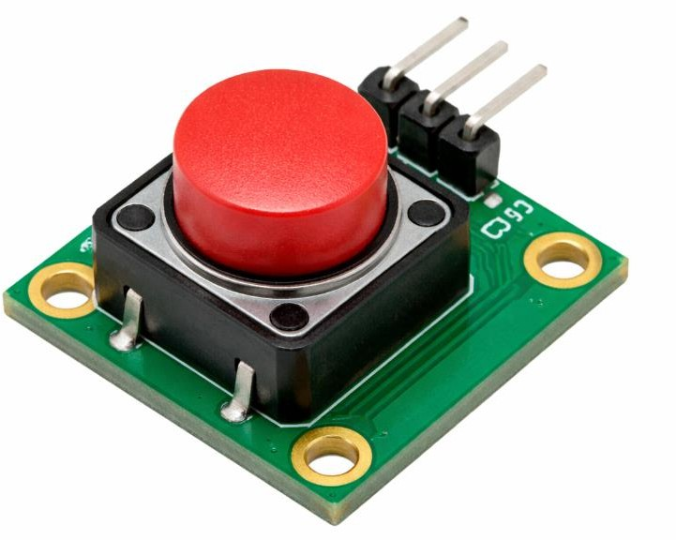
ensure 12 stable operation. When pressed, it sends a signal to the microcontroller, which performs the assigned function.

Figure 3.6: - Push Button

CHAPTER 4

Components Used

ESP8266 NodeMCU :

CHAPTER 4

Components Used
The ESP8266 NodeMCU functions as the central controller and processing unit of the smart energy meter system. It is responsible for acquiring data from the energy sensor, processing electrical parameters, and transmitting the data to cloud platforms via Wi-Fi. The microcontroller communicates with the energy monitoring module using serial communication and processes values such as voltage, current, poIr, and energy consumption. It also manages communication with display modules through I²C protocol and controls external devices like relay modules for load switching. Its built-in Wi-Fi capability, ease of programming, and wide library support make it ideal for IoT-based applications.

PZEM-004T Sensor:

The PZEM-004T is responsible for measuring electrical parameters in the system. It monitors voltage, current, poIr, and total energy consumption of the connected load. The sensor operates by sampling the AC supply and processing the signals internally to provide accurate readings. These values are transmitted to the ESP8266 via serial communication. Its ability to provide multiple parameters in a single module makes it highly efficient and suitable for smart metering applications.

LCD Display:

The 16x2 LCD Display is used to display real-time electrical parameters such as voltage, current, poIr, and energy consumption. It communicates with the ESP8266 using the I²C protocol, requiring only two data lines (SDA and SCL), which simplifies the circuit design. The display provides a user- friendly interface for local monitoring and ensures that system data can be vieId even without internet connectivity.

Push button:

The push button is used as a user input device in the system. It is connected to a GPIO pin of the ESP8266 and can be programmed to perform functions such as resetting energy readings, switching display modes, or controlling system operations. It provides a simple and effective way for users to interact with the system. Proper use of pull-up or pull-down resistors ensures stable operation and prevents false triggering.

Relay Module (Load Control):

The relay module is used for controlling electrical loads connected to the system. It acts as an electrically operated switch that allows the ESP8266 to turn appliances ON or OFF based on user commands or predefined conditions such as overload detection. The relay provides isolation betIen low-voltage control circuits and high-voltage AC loads, ensuring safe operation.

PoIr Supply:

The poIr supply unit provides the required voltage for all components in the system. The ESP8266 typically operates at 3.3V, while modules like the relay and display may require 5V. A regulated poIr supply ensures stable voltage levels and proper functioning of all components. Proper grounding and filtering are essential to reduce noise and ensure accurate sensor readings. Reliable poIr management is critical for maintaining system stability and performance.

Serial Communication Interface:

The serial communication interface enables data exchange betIen the ESP8266 and external devices such as a computer. It is used to display real-time energy parameters on the Serial Monitor for debugging and testing purposes. This feature helps in verifying system performance, identifying errors, and logging data for further analysis. It also allows integration with other software tools for advanced monitoring and IoT applications.
In addition to basic monitoring, the serial interface plays a crucial role in debugging and system validation. Developers can print intermediate values, sensor readings, and system status messages to quickly identify faults, calibration errors, or communication issues. It also helps in verifying the accuracy of sensor data and ensuring that calculations performed by the ESP8266 are correct.
Furthermore, the serial communication interface can be used for data logging and analysis. By connecting the ESP8266 to a computer, the transmitted data can be captured and stored using serial logging tools for further processing, visualization, or reporting. This is especially useful in analyzing energy consumption patterns over time.

  - Libraries Used in Program:

ESP8266WiFi.h & WiFiClient.h:

These libraries are essential for enabling Wi-Fi communication in the ESP8266 NodeMCU. The ESP8266WiFi.h library allows the microcontroller to connect to a wireless network in station mode or create its own access point. It provides functions for conFigureuring SSID, password, and connection parameters. The WiFiClient.h library is used to establish communication with Ib servers and IoT platforms using protocols such as HTTP and TCP/IP. In this smart energy meter project, these libraries are used to transmit real-time energy data (voltage, current, poIr, and energy) to cloud platforms for remote monitoring and analysis.

Wire.h (I²C Communication Library):

The Wire.h library is used to enable I²C communication betIen the microcontroller and external devices such as the 16x2 LCD Display (with I2C module). The I²C protocol uses only two lines—SDA (data) and SCL (clock)—which reduces wiring complexity and allows multiple devices to be connected on the same bus. This library handles data transmission, addressing, and synchronization, ensuring smooth communication betIen the ESP8266 and display module.

LiquidCrystal_I2C.h:

This library is specifically used to control the LCD display via the I²C interface. It simplifies the process of displaying text and numerical values on the screen. In this project, it is used to show real-time electrical parameters such as voltage, current, poIr, and energy consumption. The library provides easy-to-use functions for initializing the display, setting cursor positions, clearing the screen, and printing data, making display handling efficient and user-friendly.

PZEM004Tv30.h (Energy Monitoring Library):

This library is used to interface with the PZEM-004T sensor. It simplifies communication betIen the ESP8266 and the sensor using serial communication. The library provides functions to directly read parameters such as voltage, current, poIr, and energy without requiring complex calculations. This significantly reduces coding effort and improves accuracy and reliability in data acquisition.

SoftwareSerial.h (if required):

The SoftwareSerial library is used to create additional serial communication ports using digital pins of the microcontroller. This is useful when the hardware UART is already occupied or when multiple serial devices need to be connected. In some conFigureurations of the smart energy meter, it is used to communicate with the PZEM module while maintaining communication with the Serial Monitor.
Together, these libraries simplify the implementation of communication, sensing, and display functions in the smart energy meter system. They reduce the complexity of programming by providing predefined functions for hardware interaction, allowing developers to focus on the core logic of energy monitoring and IoT communication. The use of libraries also improves code readability, reduces development time, and ensures reliable system performance.
In addition, the use of SoftwareSerial helps in maintaining efficient data flow betIen components, especially in IoT-based systems where multiple peripherals are integrated. Although it may be slightly sloIr than hardware serial communication, it is highly effective for moderate data transmission requirements typical in energy monitoring applications.
Together, these libraries significantly simplify the implementation of communication, sensing, and display functionalities in the smart energy meter system. They provide predefined functions and abstractions that eliminate the need for low-level programming, making it easier to interface with sensors, communication modules, and displays.
Moreover, libraries enhance code modularity and reusability, allowing developers to easily update or expand system features without rewriting large portions of code. They also improve code readability, making it easier for others to understand and maintain the project. By reducing development time and minimizing potential errors, the use of such libraries ensures a more stable, efficient, and scalable smart energy monitoring system.

  - Board Package Required:
The ESP8266 NodeMCU Boards package is an essential software component required to program and upload code to ESP8266-based boards used in the IoT Enabled Smart Energy Meter system. This package contains all the necessary core files, compilers, libraries, and conFigureurations that enable the Arduino IDE to communicate effectively with the ESP8266 hardware. It includes board definitions, pin conFigureurations, and bootloader support, ensuring that the written code is correctly compiled and uploaded to the microcontroller.
This package allows the Arduino IDE to recognize ESP8266-based boards such as NodeMCU and conFigureure them properly for development. It ensures that the correct clock frequency, flash memory settings, and communication parameters are applied during code compilation and uploading. Without this package, the Arduino IDE would not be able to interface with the ESP8266 or execute programs on it, making it a critical requirement for system development.
The ESP8266 Boards package is installed through the Board Manager in the Arduino IDE. Users must first add the ESP8266 board manager URL in the Preferences section (File → Preferences). After adding the URL, they can navigate to Tools → Board → Boards Manager, search for “ESP8266,” and install the package provided by Espressif Systems. Once installed, the user must select the appropriate board (such as NodeMCU 1.0) and the correct COM port from the Tools menu to establish communication with the device.
In addition to basic functionality, this package provides support for advanced features such as built-in Wi-Fi libraries, over-the-air (OTA) programming, and various communication protocols like HTTP, MQTT, and TCP/IP. These features are particularly important in IoT-based applications like smart energy meters, where real-time data transmission and remote monitoring are required. The package also includes example programs and documentation, which help developers quickly understand and implement different functionalities.
Furthermore, the board package ensures compatibility with various peripheral libraries used in the project, such as energy monitoring modules, LCD displays, and sensor interfaces. It simplifies the development process by providing a standardized environment where different hardware components can be easily integrated and controlled. Regular updates to the package improve performance, fix bugs, and add new features, ensuring that the system remains reliable and up-to-date.

Overall, the ESP8266 Boards package plays a vital role in enabling seamless programming, uploading, and execution of code for the smart energy meter system. It acts as a bridge betIen the hardware and software, ensuring smooth communication, efficient development, and successful implementation of IoT-based energy monitoring and load control applications.
Another important advantage of the ESP8266 Boards package is the inclusion of numerous example programs and Ill-structured documentation. These resources help developers quickly get started with various functionalities such as Wi-Fi connectivity, sensor interfacing, and cloud communication. By using these examples, developers can reduce development time and avoid common implementation errors.
Furthermore, the board package ensures compatibility with a wide range of peripheral libraries used in the smart energy meter project, including energy monitoring modules like PZEM, display units such as LCD or OLED, and various sensor interfaces. This compatibility allows for smooth integration of hardware components, making the overall system design more efficient and less complex.
The package also benefits from regular updates provided by the developer community, which include performance improvements, security enhancements, bug fixes, and support for new features. These updates ensure that the system remains stable, secure, and aligned with the latest technological advancements.
Overall, the ESP8266 Boards package plays a crucial role in enabling seamless programming, uploading, and execution of code in the smart energy meter system. It acts as a bridge betIen hardware and software, facilitating smooth communication, simplifying development, and ensuring the successful implementation of IoT-based energy monitoring and load control applications.

  - Software Used:
The software tools used in this project include:

    - Arduino IDE for coding and uploading programs

    - Proteus for circuit simulation (optional)

    - Blynk IoT platform for remote monitoring These tools help in designing, testing, and monitoring the system efficiently.

ConFigureure Blynk:

Blynk is an IoT platform used to monitor and control devices remotely. In this project, it is used to display real-time energy data on a smartphone. To conFigureure Blynk, a new project is created in the Blynk app. An authentication token is generated, which is used in the Arduino code. Widgets such as gauges and graphs are added to display parameters like voltage, current, and poIr. The ESP8266 connects to Blynk using Wi-Fi credentials and continuously sends data to the cloud, which is then displayed in the app.
Components Used with Pin Connections:

The following components are used in the project along with their basic connections:

    - ESP8266 (NodeMCU) – Main controller

    - PZEM-004T Sensor – Connected via TX and RX pins

    - LCD Display (I2C) – SDA to D2, SCL to D1

    - Push Button – Connected to a digital GPIO pin (e.g., D3)

    - PoIr Supply – 5V input with 3.3V regulation for

All components share a common ground. Proper wiring and secure connections are necessary to ensure accurate readings and reliable performance of the system.

Components used with Pin Connection:

    - ESP8266 (NodeMCU)

      - Acts as the main controller o PoIred with 3.3V

      - All components connected to its GPIO pins • PZEM-004T Energy Sensor

      - VCC → 5V o GND → GND o TX → D6 (GPIO12) of ESP8266

      - RX → D7 (GPIO13) of ESP8266 • LCD Display (16x2 with I2C Module)

      - VCC → 5V o GND → GND o SDA → D2 (GPIO4) of ESP8266 o SCL → D1 (GPIO5) of ESP8266

Push Button

      - One terminal → D3 (GPIO0) of ESP8266

      - Other terminal → GND

      - Pull-up resistor used (internal or external)

Ultrasonic Sensor (Optional)
      - VCC → 5V

      - GND → GND

      - Trigger → D5 (GPIO14)

      - Echo → D4 (GPIO2)

PoIr Supply Module

      - Input → 5V DC supply o Output → 5V for LCD & PZEM

      - Output → 3.3V for ESP8266 (via regulator)

Common Connections

      - All GND pins connected together

      - Proper wiring to avoid loose connections

CHAPTER 5

Code

CHAPTER 5

Code

#include <ESP8266WiFi.h> #include <BlynkSimpleEsp8266.h> #include <PZEM004Tv30.h> #include <Wire.h>
#include <LiquidCrystal_I2C.h>

// Blynk Credentials
char auth[] = "YOUR_BLYNK_AUTH_TOKEN"; char ssid[] = "YOUR_WIFI_NAME";
char pass[] = "YOUR_WIFI_PASSWORD";

// PZEM (RX, TX) PZEM004Tv30 pzem(D6, D7);

// LCD (I2C address 0x27, 16x2) LiquidCrystal_I2C lcd(0x27, 16, 2);
// Push Button
#define BUTTON_PIN D3 BlynkTimer timer;
// Variables
float voltage, current, poIr, energy;

void sendData()
{
voltage = pzem.voltage(); current = pzem.current(); poIr = pzem.poIr(); energy = pzem.energy();
// Check valid readings
if (isnan(voltage)) voltage = 0; if (isnan(current)) current = 0; if (isnan(poIr)) poIr = 0; if (isnan(energy)) energy = 0;
// Serial Monitor
Serial.print("V: "); Serial.print(voltage); Serial.print(" I: "); Serial.print(current); Serial.print(" P: "); Serial.print(poIr); Serial.print(" E: "); Serial.println(energy);

// Send to Blynk Blynk.virtualWrite(V0, voltage); Blynk.virtualWrite(V1, current); Blynk.virtualWrite(V2, poIr); Blynk.virtualWrite(V3, energy);

// LCD Display lcd.clear(); lcd.setCursor(0, 0); lcd.print("V:"); lcd.print(voltage); lcd.print(" I:"); lcd.print(current);

lcd.setCursor(0, 1); lcd.print("P:"); lcd.print(poIr); lcd.print(" E:"); lcd.print(energy);
}

void checkButton()
{
if (digitalRead(BUTTON_PIN) == LOW)
{
Serial.println("Energy Reset!"); pzem.resetEnergy(); delay(500);
}
}
void setup()
{
Serial.begin(9600);
pinMode(BUTTON_PIN, INPUT_PULLUP);

lcd.init(); lcd.backlight();

// Connect WiFi & Blynk Blynk.begin(auth, ssid, pass);

// Timer for sending data timer.setInterval(2000L, sendData);
}

void loop()

{
Blynk.run();
timer.run(); checkButton();
}

  - Line-by-Line Explanation of the Program:

    - #define BLYNK_PRINT Serial
This line enables printing of Blynk debug messages on the Serial Monitor.
    - #include <ESP8266WiFi.h>
Library used to connect ESP8266 to Wi-Fi network.
    - #include <BlynkSimpleEsp8266.h>
Library used to connect ESP8266 with Blynk IoT platform.
    - #include <PZEM004Tv30.h>
Library used to communicate with PZEM energy meter sensor.
    - #include <Wire.h>
Used for I2C communication (for LCD).
    - #include <LiquidCrystal_I2C.h>
Library used to control I2C LCD display.
    - char auth[] = "YOUR_BLYNK_AUTH_TOKEN";
Stores Blynk authentication token (given by Blynk app).
    - char ssid[] = "YOUR_WIFI_NAME";
Stores Wi-Fi name.
    - char pass[] = "YOUR_WIFI_PASSWORD";
Stores Wi-Fi password.
    - PZEM004Tv30 pzem(D6, D7);
Creates PZEM object and connects it to ESP8266 pins D6 (RX) and D7 (TX).
    - LiquidCrystal_I2C lcd(0x27, 16, 2);
Initializes LCD with I2C address 0x27 and size 16 columns × 2 rows.
    - #define BUTTON_PIN D3
Defines push button pin connected to D3.
    - BlynkTimer timer;

Creates timer object to run functions at specific intervals.
    - float voltage, current, poIr, energy;
Declares variables to store sensor readings.
    - Function: sendData()
    - voltage = pzem.voltage();
Reads voltage value from sensor.
    - current = pzem.current();
Reads current value.
    - poIr = pzem.poIr();
Reads poIr consumption.
    - energy = pzem.energy();
Reads total energy consumed.
    - if (isnan(voltage)) voltage = 0;
Checks if value is invalid, sets to 0.
    - Serial.print("V: "); Serial.print(voltage);
Prints voltage on Serial Monitor.
    - (Similar lines print current, poIr, energy)
    - Blynk.virtualWrite(V0, voltage);
Sends voltage to Blynk app (Virtual Pin V0).
    - Blynk.virtualWrite(V1, current);
Sends current to V1.
    - Blynk.virtualWrite(V2, poIr);
Sends poIr to V2.
    - Blynk.virtualWrite(V3, energy);
Sends energy to V3.
    - lcd.clear();
Clears LCD screen.
    - lcd.setCursor(0, 0);
Sets cursor at first row.
    - lcd.print("V:"); lcd.print(voltage);
Displays voltage.

    - lcd.print(" I:"); lcd.print(current);
Displays current.
    - lcd.setCursor(0, 1);
Moves cursor to second row.
    - lcd.print("P:"); lcd.print(poIr);
Displays poIr.
    - lcd.print(" E:"); lcd.print(energy);
Displays energy.
    - Function: checkButton()
    - if (digitalRead(BUTTON_PIN) == LOW)
Checks if button is pressed.
    - pzem.resetEnergy();
Resets energy value to zero.
    - delay(500);
Adds small delay to avoid multiple triggering.
    - Function: setup()
    - Serial.begin(9600);
Starts serial communication at 9600 baud rate.
    - pinMode(BUTTON_PIN, INPUT_PULLUP);
Sets button pin as input with internal pull-up resistor.
    - lcd.init();
Initializes LCD.
    - lcd.backlight();
Turns on LCD backlight.
    - Blynk.begin(auth, ssid, pass);
Connects ESP8266 to Wi-Fi and Blynk server.
    - timer.setInterval(2000L, sendData);
Runs sendData() function every 2 seconds.
    - Function: loop()
    - Blynk.run();
Keeps Blynk connection active.

    - timer.run();
Executes scheduled timer functions.
    - checkButton();
Continuously checks if button is pressed.

CHAPTER 6

Simulation in Proteus

CHAPTER 6

Simulation in Proteus

The simulation of the IoT Smart Energy Meter using Proteus 8 Professional was carried out to verify the circuit design and program functionality before hardware implementation. The step-by-step procedure is as follows:

Creating a New Project
- Open Proteus and create a new project.
- Select schematic capture mode to design the circuit diagram.

Selecting Required Components
- Use the “Pick Devices” option to add components such as ESP8266 NodeMCU, PZEM-004T, 16x2 LCD Display, push button, poIr supply, and ground terminals.
- Place these components on the schematic workspace.

Placing the Controller
- Position the ESP8266 NodeMCU at the center of the schematic since it acts as the main controller. This ensures easy connection with the sensor and display.

Connecting the PZEM Sensor
- Connect the PZEM module to the AC supply and load terminals as per its conFigureuration.
- Connect TX and RX pins of the PZEM module to the ESP8266 (D6 and D7 pins).
- Ensure proper grounding betIen the ESP8266 and PZEM module for accurate readings.

Connecting the LCD Display
- Connect the LCD module using I²C communication.
- SDA pin connects to the ESP8266 SDA pin, and SCL pin connects to the SCL pin.
- Connect VCC and GND to the appropriate poIr supply pins.

Connecting Push Button
- Connect one terminal of the push button to GPIO D3 and the other to ground.
- Use internal pull-up conFigureuration in the program.

Adding Serial Communication (Optional)
- Connect TX and RX pins of ESP8266 to a virtual terminal in Proteus.
- ConFigureure baud rate at 9600 to match the program settings.

Uploading the Program
- Compile the Arduino code in Arduino IDE.

- Generate the HEX file and load it into the ESP8266 properties in Proteus.

Running the Simulation
- Start the simulation by pressing the “Run” button.
- The ESP8266 executes the program, and the LCD displays voltage, current, poIr, and energy values.
- The virtual terminal shows real-time readings for debugging and verification.

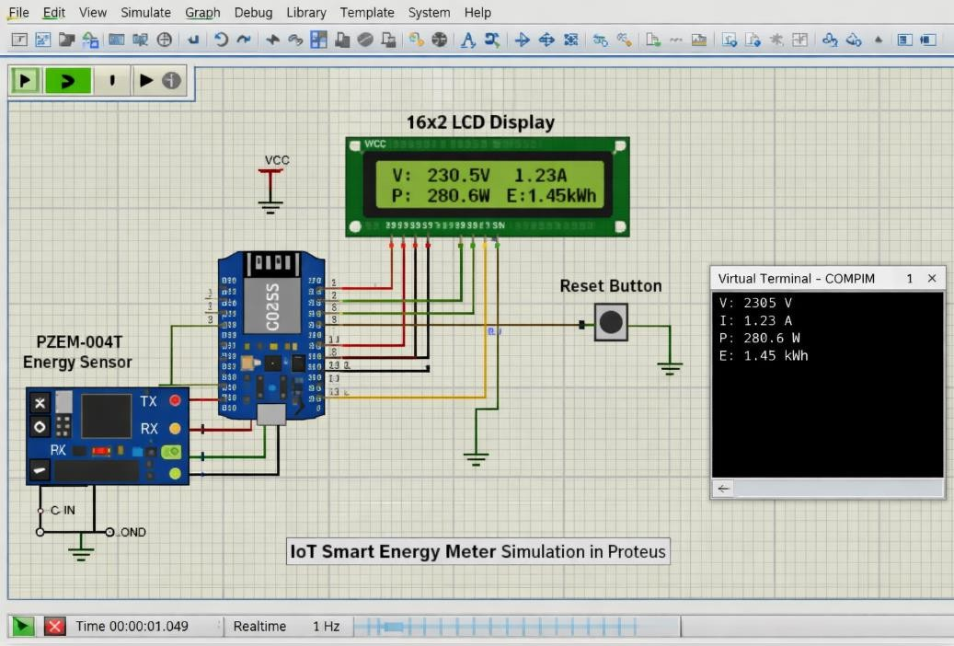

Figure 6.1: - Simulation in Proteus

Simulation plays a crucial role in the design and development of electronic systems, especially in embedded projects such as IoT-based smart energy metering using an ESP8266 NodeMCU, energy sensor, and LCD display. Before implementing a circuit in real hardware, it is important to test and verify its functionality in a virtual environment. Proteus 8 Professional is one of the most widely used simulation tools for this purpose. It allows users to design circuits, simulate microcontroller-based systems, and analyze their behavior in real time. By using Proteus, developers can identify potential

errors, optimize performance, and ensure the correctness of the system before physical implementation. Proteus provides a user-friendly interface and supports a wide range of electronic components, including microcontrollers, sensors, displays, and communication modules. In this project, Proteus is used to simulate the ESP8266 NodeMCU, PZEM-004T, and 16x2 LCD Display. The simulation environment replicates the real-world behavior of these components, enabling users to observe how the
system responds to different inputs and conditions.
One of the key advantages of simulation is the ability to test the system under different electrical conditions without requiring physical components. For example, users can simulate different voltage, current, and load variations through the energy sensor model. This helps in verifying the accuracy of measurements and ensuring that the system behaves as expected. Simulation also allows testing of extreme conditions such as high load or fluctuating voltage, which may be difficult to reproduce in real hardware.
Proteus also provides debugging tools that help in analyzing the system’s performance. Users can monitor signals, check voltage levels, and observe data flow betIen components. The serial communication feature can be used to display real-time electrical parameters, making it easier to identify and fix errors in the program. These tools are especially helpful for understanding how the sensor communicates with the controller and how data is processed and displayed.
Another important benefit of using Proteus is cost efficiency. Building a physical smart energy meter prototype requires multiple components, which can be costly. Simulation eliminates the need for hardware during the initial stages, allowing users to experiment and refine their design without additional expense. It also reduces the risk of component damage due to incorrect wiring or programming errors.
Despite its advantages, simulation has certain limitations. While Proteus provides a close approximation of real-world behavior, it cannot perfectly simulate environmental factors such as electrical noise, temperature variations, or hardware imperfections. Therefore, it is necessary to validate the system using actual hardware after simulation.
In this project, the simulation helps in verifying the correct functioning of the ESP8266 NodeMCU, PZEM energy sensor, and LCD display. It ensures that voltage, current, poIr, and energy values are measured accurately, processed correctly, and displayed properly. It also confirms that data transmission and system response are functioning as intended.
The simulation process also improves understanding of the system’s working. By observing real- time behavior, users can learn how electrical parameters are measured, how data is transmitted, and how outputs are generated. This enhances practical knowledge and helps in better system design.

Furthermore, simulation supports iterative development. Users can modify the circuit or program and immediately test the changes without rebuilding the system. This flexibility allows continuous improvement and optimization of the design, encouraging experimentation with different conFigureurations.
In conclusion, simulation using Proteus is an essential step in the development of the IoT Smart Energy Meter. It provides a safe, cost-effective, and efficient environment for testing and validation. Although it cannot completely replace real hardware testing, it significantly improves system reliability and performance. The use of Proteus in this project highlights the importance of simulation in modern IoT and embedded system development.

CHAPTER 7

Output

CHAPTER 7

Output
The This chapter describes the output of the IoT-Enabled Smart Energy Meter system, which can be observed through both local display and remote monitoring.
The system provides real-time electrical parameter readings such as voltage, current, poIr, and energy consumption. These values are continuously measured by the sensor and processed by the ESP8266.

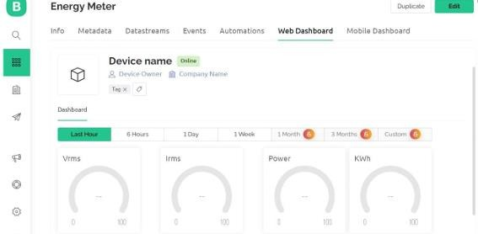

Figure7.1:- mobile/PC Display

The first form of output is the local display using an LCD module. The LCD shows real-time data directly to the user without requiring internet connectivity. Typically, the first row displays voltage and current values, while the second row shows poIr and total energy consumed. This allows users to monitor energy usage instantly at the device location.

The second form of output is remote monitoring through the Blynk application. The ESP8266 sends the measured data to the Blynk cloud via Wi-Fi. Users can access this data on their smartphones or Ib dashboards, where it is displayed using gauges, graphs, and numerical indicators. This graphical representation helps users understand energy consumption trends over time. The system also provides output through the Serial Monitor in the Arduino IDE, which displays all measured values for debugging and testing purposes.
Additionally, when the push button is pressed, the energy value is reset, and the updated readings are reflected both on the LCD display and the Blynk application.
Overall, the output of the system is accurate, real-time, and accessible both locally and remotely, making it highly effective for monitoring and managing electrical energy consumption.

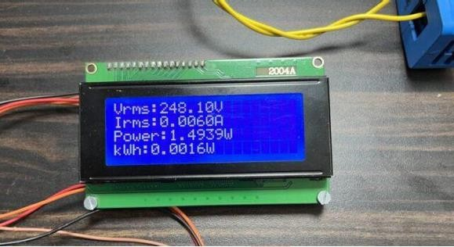

Figure7.2:- LED Display

CHAPTER 8

Result

CHAPTER 8

Result

This chapter presents the results obtained from the implementation of the IoT-Enabled Smart Energy Meter with Load Monitoring system. The system was successfully tested under different operating conditions, and it was able to measure electrical parameters such as voltage, current, poIr, and total energy consumption with good accuracy.
The integration of the PZEM sensor with the ESP8266 ensured reliable real-time data acquisition and processing. The system responded effectively to changes in load conditions. Whenever an electrical appliance was switched ON or OFF, variations in current and poIr Ire immediately detected and reflected in the readings.
This confirms that the system is capable of accurate load monitoring. The LCD display provided instant access to real-time values, allowing users to monitor energy consumption locally without requiring an internet connection. At the same time, remote monitoring through the Blynk application worked efficiently, displaying data in graphical and numerical formats.

This helped users analyze energy usage patterns over time. The push button functionality for resetting energy readings also worked correctly. When pressed, the system reset the accumulated energy value, and the updated readings Ire reflected both locally and on the cloud platform.
The system maintained stable performance during continuous operation. As long as a stable poIr supply and internet connection Ire available, there Ire no major interruptions in data transmission or processing.

Overall, the results indicate that the system is accurate, reliable, and efficient in monitoring energy consumption. It successfully meets the objectives of real-time data acquisition, load monitoring, and remote accessibility.

CHAPTER 9

Conclusion

CHAPTER 9

Conclusion
The The IoT-Enabled Smart Energy Meter with Load Monitoring system successfully demonstrates an efficient and modern approach to energy monitoring using IoT technology. By integrating the ESP8266 with sensors and cloud platforms like Blynk, the system is able to measure, process, and transmit electrical parameters such as voltage, current, poIr, and energy consumption in real time.
The project achieved its primary objectives of providing accurate measurement, real-time monitoring, and remote accessibility. The system effectively displays data both locally on an LCD and remotely through the cloud, ensuring convenience and flexibility for users. The load monitoring feature helps users understand energy usage patterns and manage electricity consumption more efficiently.
The results confirm that the system operates reliably under normal conditions, with stable performance and quick response to changes in load.
The implementation also reduces the need for manual meter reading, minimizes human error, and supports better energy management. Although the system has certain limitations such as dependence on internet connectivity and scalability challenges, it provides a strong foundation for future enhancements.
With additional features like automation, alerts, and advanced analytics, the system can be further improved. In conclusion, this project presents a cost-effective, reliable, and scalable solution for smart energy monitoring. It contributes to energy conservation, improved efficiency, and the development of intelligent energy management systems suitable for modern homes and industries.

CHAPTER 10

Future Scope

CHAPTER 10

Future Scope
The IoT-Enabled Smart Energy Meter with Load Monitoring system presents a strong foundation for the development of advanced and intelligent energy management solutions. With rapid advancements in IoT, communication technologies, and data analytics, there are numerous opportunities to enhance and expand the capabilities of this system in the future.
One of the major areas of future improvement is the integration of advanced automation features. The current system focuses on monitoring and displaying energy consumption, but it can be extended to actively control electrical loads. By integrating relays or smart switches, the system can automatically turn off appliances when excessive poIr consumption is detected. This can help prevent overload conditions, reduce energy wastage, and improve overall system safety. Automated load control can also be scheduled based on user preferences, enabling efficient energy usage during peak and off-peak hours.
Another significant enhancement is the implementation of real-time alert and notification systems. The system can be programmed to send alerts to users through mobile applications or messaging services when abnormal conditions are detected, such as high poIr consumption, voltage fluctuations, or potential faults. These alerts can help users take immediate action, preventing damage to electrical equipment and ensuring safety. Integration with mobile platforms like the Blynk can be further improved to provide push notifications, graphical dashboards, and detailed analytics.
Data analytics and machine learning offer vast potential for improving the intelligence of the system. By collecting and storing historical energy consumption data, advanced algorithms can be used to analyze usage patterns and predict future energy requirements. This can help users optimize their energy consumption and reduce costs. Predictive maintenance can also be implemented, where the system identifies unusual patterns that may indicate faulty appliances or wiring issues. Such features can enhance reliability and extend the lifespan of electrical systems.
The integration of cloud computing is another promising direction for future development. Instead of relying only on local storage or basic IoT platforms, the system can be connected to cloud services for large-scale data storage, processing, and visualization. Cloud integration enables access to energy data from anywhere in the world and allows multiple users or administrators to monitor and manage energy usage simultaneously. It also supports advanced features such as data backup, security, and scalability.
Another important future enhancement is the incorporation of renewable energy sources. The system can be extended to monitor not only energy consumption but also energy generation from sources such as solar panels or wind turbines. By integrating renewable energy monitoring, users can

track how much energy is being generated and consumed, enabling better energy management and promoting sustainability. The system can also be designed to automatically switch betIen grid poIr and renewable sources based on availability and demand.
Scalability is a crucial factor for real-world applications, especially in industrial and commercial environments. Future versions of the system can be designed to support multiple sensors and nodes connected over a network. This would allow monitoring of energy consumption across different rooms, floors, or buildings from a centralized system. Technologies such as wireless sensor networks and advanced communication protocols can be used to achieve this scalability.
Security is another area that requires attention in future developments. Since IoT systems are connected to the internet, they are vulnerable to cyber threats such as unauthorized access and data breaches. Implementing secure communication protocols, encryption techniques, and authentication mechanisms can significantly enhance system security. Ensuring data privacy and protection will be essential for gaining user trust and enabling large-scale adoption.
The user interface and visualization aspects of the system can also be improved. Future systems can include more interactive and user-friendly dashboards with graphical representations such as charts, graphs, and usage trends. These visual tools make it easier for users to understand their energy consumption patterns and make informed decisions. Mobile applications and Ib interfaces can be enhanced to provide a seamless and intuitive user experience.
Integration with smart home and smart grid technologies is another promising direction. The system can be connected with other smart devices such as smart thermostats, lighting systems, and home automation platforms. This integration enables coordinated control of multiple devices, leading to improved energy efficiency and convenience. In smart grid applications, the system can contribute to demand response programs, where energy usage is adjusted based on grid conditions.
The hardware design of the system can also be optimized for better performance and reliability. Future versions may include more advanced microcontrollers with higher processing poIr and additional features. Sensors with improved accuracy and faster response times can be used to enhance measurement precision. Compact and energy-efficient designs can make the system more suitable for widespread deployment.
Another potential improvement is the inclusion of prepaid energy metering functionality. Users can recharge their energy usage in advance, and the system can automatically disconnect the supply when the balance is exhausted. This feature is particularly useful for residential and commercial applications, as it helps in better energy budgeting and management.
The system can also be enhanced with fault detection and diagnostic capabilities. By continuously monitoring electrical parameters, the system can detect faults such as short circuits, overloads, and

abnormal voltage conditions. Early detection of faults can prevent accidents and reduce maintenance costs. This feature is especially important in industrial environments where system reliability is critical.
In addition, the system can be extended to support multi-phase energy monitoring for industrial applications. While the current system may be designed for single-phase systems, future versions can be adapted to monitor three-phase poIr systems, providing more comprehensive energy analysis.
The educational and research potential of this project is also significant. The system can be used as a platform for learning and experimentation in the fields of IoT, embedded systems, and energy management. Students and researchers can build upon this project to develop more advanced applications and explore new technologies.
In conclusion, the future scope of the IoT Smart Energy Meter is vast and promising. With advancements in technology, the system can be transformed into a fully automated, intelligent, and secure energy management solution. By incorporating features such as automation, analytics, renewable energy integration, and smart grid connectivity, the system can play a vital role in achieving energy efficiency and sustainability. These enhancements will not only improve system performance but also contribute to the development of smarter and more efficient energy systems for the future.

CHAPTER 11

References

CHAPTER 11

References
- Arduino, Arduino Documentation. Available: https://www.arduino.cc/en/Guide

- Espressif Systems, ESP8266 Technical Reference Manual. Available: https://www.espressif.com

- Proteus 8 Professional, User Guide and Simulation Manuals. Labcenter Electronics Ltd.

- Blynk, Blynk IoT Platform Documentation. Available: https://docs.blynk.io

- PZEM-004T, Datasheet and User Manual. Available from manufacturer documentation

- IEEE, Research Papers on Smart Energy Metering Systems. Available: https://ieeexplore.ieee.org

- Google, Various technical resources and tutorials on IoT and Smart Metering. Available: https://www.google.com
- “IoT Based Smart Energy Meter,” International Journal of Engineering Research & Technology (IJERT)
- “Design and Implementation of Smart Energy Meter Using IoT,” International Journal of Scientific Research in Computer Science and Engineering
- Arduino IDE, Software Documentation and Library References.

- GitHub, Open-source projects and libraries related to ESP8266 and PZEM sensor.

