PRACTICAL NO : 3

**AIM : Design an application using hibernate to achieve inheritance mapping by using annotations.**

**CODE :**

inheritance_mapping/pom.xml :

<project xmlns="<http://maven.apache.org/POM/4.0.0>" xmlns:xsi="<http://www.w3.org/2001/XMLSchema-instance>"  
  xsi:schemaLocation="<http://maven.apache.org/POM/4.0.0> <http://maven.apache.org/xsd/maven-4.0.0.xsd>">  
  <modelVersion>4.0.0</modelVersion>  
  
  <groupId>com.practical3</groupId>  
  <artifactId>inheritance_mapping</artifactId>  
  <version>0.0.1-SNAPSHOT</version>  
  <packaging>jar</packaging>  
  
  <name>inheritance_mapping</name>  
  <url>[http://maven.apache.org](http://maven.apache.org/)</url>  
  
  <properties>  
    <project.build.sourceEncoding>UTF-8</project.build.sourceEncoding>  
  </properties>  
  
  <dependencies>  
   
  <!-- <https://mvnrepository.com/artifact/org.hibernate/hibernate-core> -->  
<dependency>  
    <groupId>org.hibernate</groupId>  
    <artifactId>hibernate-core</artifactId>  
    <version>5.6.5.Final</version>  
</dependency>  
  
<!-- <https://mvnrepository.com/artifact/mysql/mysql-connector-java> -->  
<dependency>  
    <groupId>mysql</groupId>  
    <artifactId>mysql-connector-java</artifactId>  
    <version>8.0.29</version>  
</dependency>  
  
    <dependency>  
      <groupId>junit</groupId>  
      <artifactId>junit</artifactId>  
      <version>3.8.1</version>  
      <scope>test</scope>  
    </dependency>  
  </dependencies>  
</project>

App.java :

package com.practical3.inheritance_mapping;  
  
import org.hibernate.*;  
import org.hibernate.cfg.Configuration;  
public class App  
{  
    public static void main( String[] args )  
    {  
        System.out.println( "Hello World!" );  
        Configuration cfg = new Configuration();  
        cfg.configure("hibernate.cfg.xml");  
        SessionFactory factory = cfg.buildSessionFactory();  
         
        Session session = factory.openSession();  
         
        Transaction t = session.beginTransaction();  
         
        Employee e1 = new Employee();  
        e1.setName("shaan alam");  
         
        Regular_Employee e2 = new Regular_Employee();  
        e2.setName("aprajit sharma");  
        e2.setSalary(50000);  
        e2.setBonus(5);  
         
        Contract_Employee e3 = new Contract_Employee();  
        e3.setName("aditya aiyer");  
        e3.setPay_per_hour(1000);  
        e3.setContract_duration("15 Hours");  
         
        session.save(e1);  
        session.save(e2);  
        session.save(e3);  
        t.commit();  
        session.close();  
        System.out.println("success");  
    }  
}

hibernate.cfg.xml :

<?xml version="1.0" encoding="UTF-8"?>  
  
<!DOCTYPE hibernate-configuration PUBLIC  
"-//Hibernate/Hibernate Configuration DTD 3.0//EN"  
"<http://www.hibernate.org/dtd/hibernate-configuration-3.0.dtd>">  
  
<hibernate-configuration>  
<session-factory>  
<property name="connection.driver_class">com.mysql.jdbc.Driver</property>  
<property name="connection.url">jdbc:mysql://localhost:3306/hiber</property>  
<property name="connection.username">root</property>  
<property name="connection.password">root75</property>  
<property name="dialect">org.hibernate.dialect.MySQL5Dialect</property>  
<property name="hbm2ddl.auto">update</property>  
<property name="show_sql">true</property>  
<mapping class="com.practical3.inheritance_mapping.Employee"/>  
<mapping class="com.practical3.inheritance_mapping.Regular_Employee"/>  
<mapping class="com.practical3.inheritance_mapping.Contract_Employee"/>  
</session-factory>  
</hibernate-configuration>

Employee.java :

package com.practical3.inheritance_mapping;  
  
import javax.persistence.*;  
  
@Entity  
@Table(name="Employee")  
@Inheritance(strategy=InheritanceType.SINGLE_TABLE)  
@DiscriminatorColumn(name="type",discriminatorType=DiscriminatorType.STRING)  
@DiscriminatorValue(value="employee")  
  
public class Employee {  
@Id  
@GeneratedValue(strategy=GenerationType.AUTO)  
@Column(name="id")  
private int id;  
@Column(name="name")  
private String name;  
public int getId() {  
return id;  
}  
public void setId(int id) {  
[this.id](http://this.id/) = id;  
}  
public String getName() {  
return name;  
}  
public void setName(String name) {  
[this.name](http://this.name/) = name;  
}  
  
}

Regular_Employee.java :

package com.practical3.inheritance_mapping;  
  
import javax.persistence.*;  
  
@Entity  
@DiscriminatorValue("regular_employee")  
  
public class Regular_Employee extends Employee{  
@Column(name="salary")  
private float salary;  
@Column(name="bonus")  
private int bonus;  
public float getSalary() {  
return salary;  
}  
public void setSalary(float salary) {  
this.salary = salary;  
}  
public int getBonus() {  
return bonus;  
}  
public void setBonus(int bonus) {  
this.bonus = bonus;  
}  
}

Contract_Employee.java :

package com.practical3.inheritance_mapping;  
  
import javax.persistence.*;  
  
@Entity  
@DiscriminatorValue("contract_employee")  
  
public class Contract_Employee extends Employee {  
@Column(name="pay_per_hour")  
private float pay_per_hour;  
@Column(name="contract_duration")  
private String contract_duration;  
public float getPay_per_hour() {  
return pay_per_hour;  
}  
public void setPay_per_hour(float pay_per_hour) {  
this.pay_per_hour = pay_per_hour;  
}  
public String getContract_duration() {  
return contract_duration;  
}  
public void setContract_duration(String contract_duration) {  
this.contract_duration = contract_duration;  
}  
  
  
  
}

**OUTPUT :**

Hibernate Output :

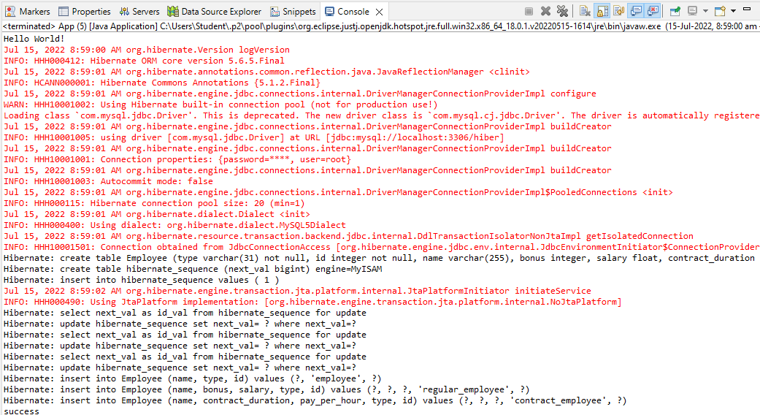

MySQL Output :



