

COLLEGE OF TECHNOLOGY AND ENGINEERING
Information Technology Department

USER ACCEPTANCE TESTING
Test Case ID | TC0001
Capstone Project Title: | Student Affairs and Services System
Team | LOWCODE
 | Project Leader: |  | Honzel Babe Chavez
 |  |  | Kimberly Silvano
 | Front-End Programmer: |  | Jhudiel Anthony Carzano
 | QA Engineer: |  | Mharion Jay P. Sayson
 | Technical Writer: |  | Francis Xavier Sagarino
Title / Business Scenario | Enter a valid Student ID, Email and Password
Preconditions | User account created
Test Data | Student ID: 7220138 | Email: testuser@gmail.com | Password: Test@123 Confirm Password: Test@123
Steps | 1.Go to the Sign-Up page.
 | 2.Fill in all fields with valid data.
 | 3. Click the “Register” button.
Expected Result | User should see alert message “Student account created successfully. Please log in.”
Actual Result (Pass/Fail) | Pass
Comments / Attachments (Screenshots, Logs) | Screenshot attached to the next page
Tester Name / Date | Mharion Jay P. Sayson / 10/03/2025
Panelist's Remarks

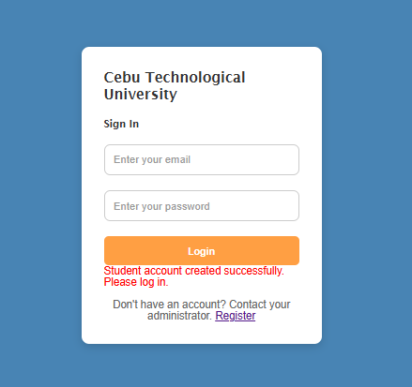
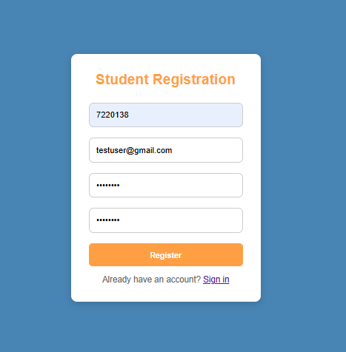


COLLEGE OF TECHNOLOGY AND ENGINEERING
Information Technology Department

USER ACCEPTANCE TESTING
Test Case ID | TC0002
Capstone Project Title: | Student Affairs and Services System
Team | LOWCODE
 | Project Leader: |  | Honzel Babe Chavez
 |  |  | Kimberly Silvano
 | Front-End Programmer: |  | Jhudiel Anthony Carzano
 | QA Engineer: |  | Mharion Jay P. Sayson
 | Technical Writer: |  | Francis Xavier Sagarino
Title / Business Scenario | Enter invalid Student ID, valid email and valid password.
Preconditions | Account not created
Test Data | Student ID: 12345 | Email: test@gmail.com | Password: Test@123 Confirm Password: Test@123
Steps | 1.Go to the Sign-Up page.
 | 2. Fill in fields using invalid Student ID.
 | 3. Click the “Register” button.
Expected Result | User should be able to see alert message "Invalid ID. No matching student or staff found."
Actual Result (Pass/Fail) | Pass
Comments / Attachments (Screenshots, Logs) | Screenshot attached to the next page
Tester Name / Date | Mharion Jay P. Sayson / 10/03/2025
Panelist's Remarks

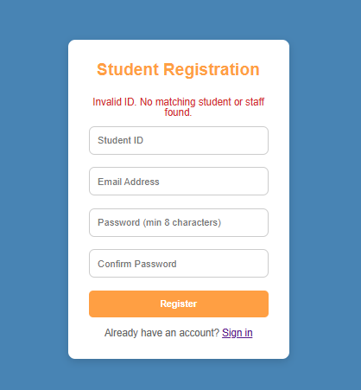
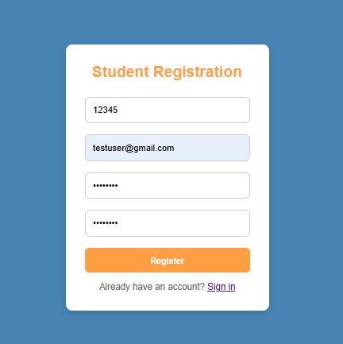


COLLEGE OF TECHNOLOGY AND ENGINEERING
Information Technology Department

USER ACCEPTANCE TESTING
Test Case ID | TC0003
Capstone Project Title: | Student Affairs and Services System
Team | LOWCODE
 | Project Leader: |  | Honzel Babe Chavez
 |  |  | Kimberly Silvano
 | Front-End Programmer: |  | Jhudiel Anthony Carzano
 | QA Engineer: |  | Mharion Jay P. Sayson
 | Technical Writer: |  | Francis Xavier Sagarino
Title / Business Scenario | Enter valid Student ID but invalid Email
Preconditions | Account not created
Test Data | Student ID: 7220138 | Email: testuser | Password: Test@123 Confirm Password: Test@123
Steps | 1.Go to the Sign-Up page.
 | 2. Enter valid Student ID and invalid Email.
 | 3. Click the “Register” button.
Expected Result | User should see alert message “Please include '@' in email address.”
Actual Result (Pass/Fail) | Pass
Comments / Attachments (Screenshots, Logs) | Screenshot attached to the next page
Tester Name / Date | Mharion Jay P. Sayson / 10/03/2025
Panelist's Remarks

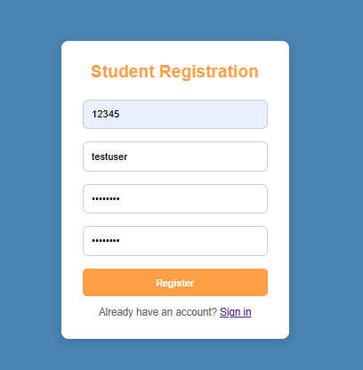
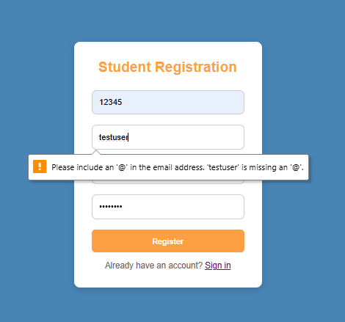


COLLEGE OF TECHNOLOGY AND ENGINEERING
Information Technology Department

USER ACCEPTANCE TESTING
Test Case ID | TC0004
Capstone Project Title: | Student Affairs and Services System
Team | LOWCODE
 | Project Leader: |  | Honzel Babe Chavez
 |  |  | Kimberly Silvano
 | Front-End Programmer: |  | Jhudiel Anthony Carzano
 | QA Engineer: |  | Mharion Jay P. Sayson
 | Technical Writer: |  | Francis Xavier Sagarino
Title / Business Scenario | Enter valid Student ID and Email but mismatched Passwords
Preconditions | Account not created
Test Data | Student ID: 12345 | Email: testuser@gmail.com | Password: Test@123 Confirm Password: Test1234
Steps | 1. Go to the Sign-Up page.
 | 2. Enter valid Student ID and Email but mismatched Passwords.
 | 3. Click the “Register” button.
Expected Result | User should see alert message “Passwords do not match.”
Actual Result (Pass/Fail) | Pass
Comments / Attachments (Screenshots, Logs) | Screenshot attached to the next page
Tester Name / Date | Mharion Jay P. Sayson / 10/03/2025
Panelist's Remarks

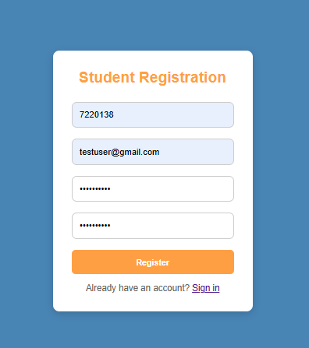
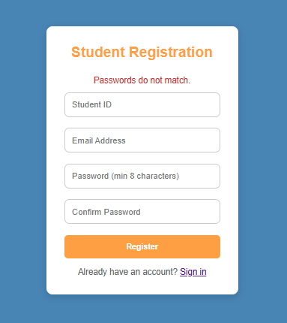


COLLEGE OF TECHNOLOGY AND ENGINEERING
Information Technology Department

USER ACCEPTANCE TESTING
Test Case ID | TC0005
Capstone Project Title: | Student Affairs and Services System
Team | LOWCODE
 | Project Leader: |  | Honzel Babe Chavez
 |  |  | Kimberly Silvano
 | Front-End Programmer: |  | Jhudiel Anthony Carzano
 | QA Engineer: |  | Mharion Jay P. Sayson
 | Technical Writer: |  | Francis Xavier Sagarino
Title / Business Scenario | Try registering without filling all required fields.
Preconditions | Valid URL (Sign-Up page)
Test Data | Student ID: ________ | Email: testuser@gmail.com | Password: test@12345  Confirm Password: ________
Steps | 1.Go to the Sign-Up page.
 | 2. Leave one or more fields empty.
 | 3. Click the “Register” button.
Expected Result | User should see alert message "Please fill out this field."
Actual Result (Pass/Fail) | Pass
Comments / Attachments (Screenshots, Logs) | Screenshot attached to the next page
Tester Name / Date | Mharion Jay P. Sayson / 10/03/2025
Panelist's Remarks

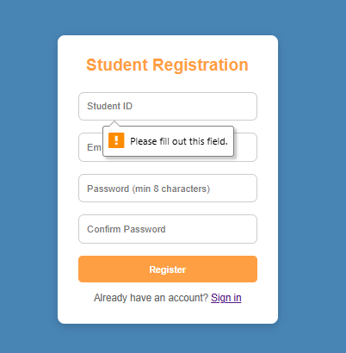
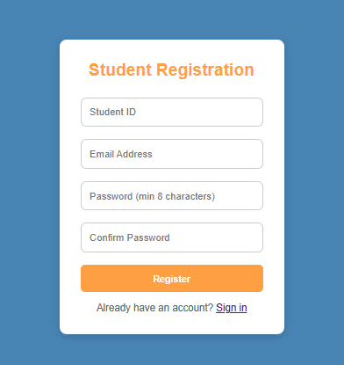


COLLEGE OF TECHNOLOGY AND ENGINEERING
Information Technology Department

USER ACCEPTANCE TESTING
Test Case ID | TC0006
Capstone Project Title: | Student Affairs and Services System
Team | LOWCODE
 | Project Leader: |  | Honzel Babe Chavez
 |  |  | Kimberly Silvano
 | Front-End Programmer: |  | Jhudiel Anthony Carzano
 | QA Engineer: |  | Mharion Jay P. Sayson
 | Technical Writer: |  | Francis Xavier Sagarino
Title / Business Scenario | Enter a password less than 8 characters
Preconditions | Valid URL (Sign-Up page)
Test Data | Student ID: 7220138 | Email: testuser@gmail.com | Password: 1234  Confirm Password: 1234
Steps | 1.Go to the Sign-Up page.
 | 2. Fill in all fields but enter a password shorter than 8 characters.
 | 3. Click the “Register” button.
Expected Result | User should see alert message “Password must be at least 8 characters.”
Actual Result (Pass/Fail) | Pass
Comments / Attachments (Screenshots, Logs) | Screenshot attached to the next page
Tester Name / Date | Mharion Jay P. Sayson / 10/03/2025
Panelist's Remarks

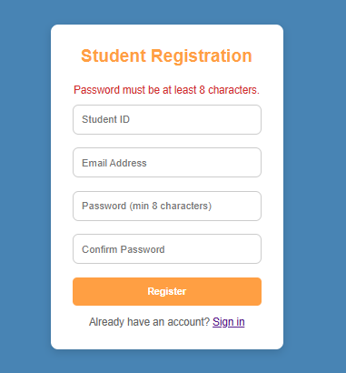
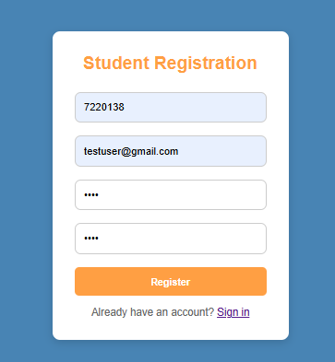

COLLEGE OF TECHNOLOGY AND ENGINEERING
COLLEGE OF TECHNOLOGY AND ENGINEERING
Information Technology Department

USER ACCEPTANCE TESTING
Test Case ID | TC0007
Capstone Project Title: | Student Affairs and Services System
Team | LOWCODE
 | Project Leader: | Honzel Babe Chavez
 |  | Kimberly Silvano
 | Front-End Programmer: | Jhudiel Anthony Carzano
 | QA Engineer: | Mharion Jay P. Sayson
 | Technical Writer: | Francis Xavier Sagarino
Title / Business Scenario | Leave email and password fields empty
Preconditions | All required fields on the login form must be fully filled out.
Test Data | Email: ____________ | Password: ___________
Steps | 1. Go to the Login page.
 | 2. Leave both fields empty.
 | 3. Click the “Login” button.
Expected Result | User should see alert “Please fill out this field.”
Actual Result (Pass/Fail) | Pass
Comments / Attachments (Screenshots, Logs) | Screenshot attached to the next page
Tester Name / Date | Mharion Jay P. Sayson / 10/03/2025
Panelist's Remarks


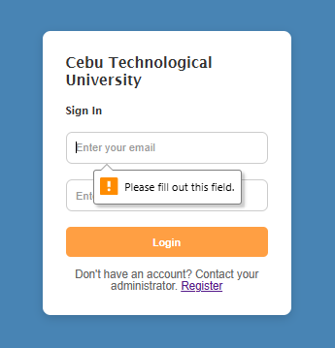

COLLEGE OF TECHNOLOGY AND ENGINEERING
Information Technology Department

USER ACCEPTANCE TESTING
Test Case ID | TC0008
Capstone Project Title: | Student Affairs and Services System
Team | LOWCODE
 | Project Leader: | Honzel Babe Chavez
 |  | Kimberly Silvano
 | Front-End Programmer: | Jhudiel Anthony Carzano
 | QA Engineer: | Mharion Jay P. Sayson
 | Technical Writer: | Francis Xavier Sagarino
Title / Business Scenario | Enter invalid email and valid password
Preconditions | User must enter correct and valid login credentials.
Test Data | Email: test124@gmail.com | Password: Test@123
Steps | 1. Go to the Login page.
 | 2. Enter invalid Email and valid Password.
 | 3. Click the “Login” button.
Expected Result | User should see alert message “Account does not exist.”
Actual Result (Pass/Fail) | Pass
Comments / Attachments (Screenshots, Logs) | Screenshot attached to the next page
Tester Name / Date | Mharion Jay P. Sayson / 10/03/2025
Panelist's Remarks

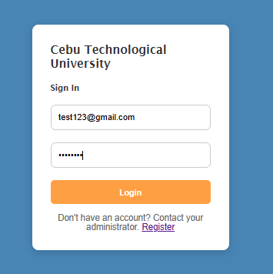
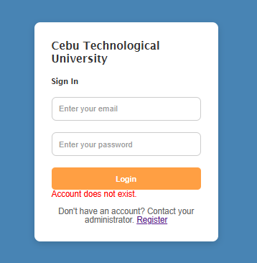

COLLEGE OF TECHNOLOGY AND ENGINEERING
Information Technology Department

USER ACCEPTANCE TESTING
Test Case ID | TC0009
Capstone Project Title: | Student Affairs and Services System
Team | LOWCODE
 | Project Leader: | Honzel Babe Chavez
 |  | Kimberly Silvano
 | Front-End Programmer: | Jhudiel Anthony Carzano
 | QA Engineer: | Mharion Jay P. Sayson
 | Technical Writer: | Francis Xavier Sagarino
Title / Business Scenario | Enter valid email and invalid password
Preconditions | All required fields on the login form must be fully filled out.
Test Data | Email: testuser@gmail.com | Password: test12
Steps | 1. Go to the Login page.
 | 2. Enter valid email and invalid password
 | 3. Click the “Login” button.
Expected Result | User should see “Incorrect password.”
Actual Result (Pass/Fail) | Pass
Comments / Attachments (Screenshots, Logs) | Screenshot attached to the next page
Tester Name / Date | Mharion Jay P. Sayson / 10/03/2025
Panelist's Remarks

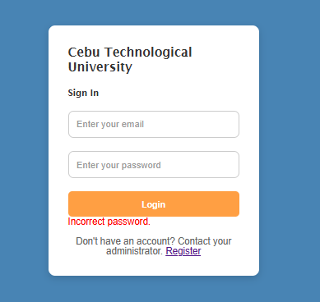
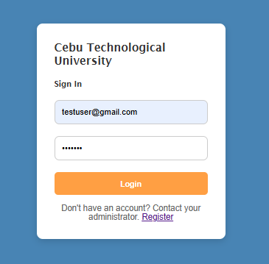



COLLEGE OF TECHNOLOGY AND ENGINEERING
Information Technology Department

USER ACCEPTANCE TESTING
Test Case ID | TC0010
Capstone Project Title: | Student Affairs and Services System
Team | LOWCODE
 | Project Leader: | Honzel Babe Chavez
 |  | Kimberly Silvano
 | Front-End Programmer: | Jhudiel Anthony Carzano
 | QA Engineer: | Mharion Jay P. Sayson
 | Technical Writer: | Francis Xavier Sagarino
Title / Business Scenario | Login with valid Email and Password
Preconditions | The user must have entered a valid registered email address and corresponding password in the login fields.
Test Data | Email: testuser@gmail.com | Password: Test@123
Steps | 1. Go to the Login page.
 | 2. Enter valid Email and Password.
 | 3. Click the “Login” button.
Expected Result | User should be redirected to the dashboard or homepage.
Actual Result (Pass/Fail) | Pass
Comments / Attachments (Screenshots, Logs) | Screenshot attached to the next page
Tester Name / Date | Mharion Jay P. Sayson / 10/03/2025
Panelist's Remarks

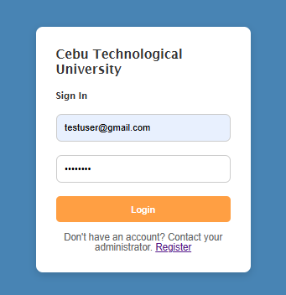
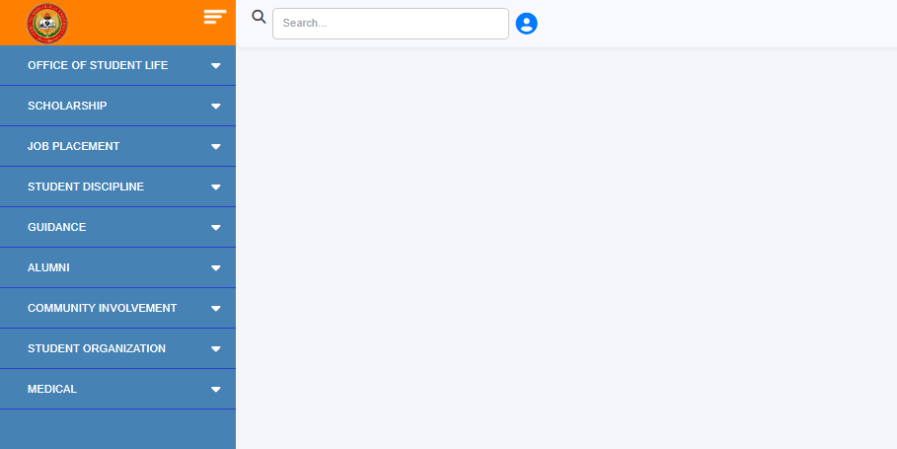


COLLEGE OF TECHNOLOGY AND ENGINEERING
Information Technology Department

USER ACCEPTANCE TESTING
Test Case ID | TC0011
Capstone Project Title: | Student Affairs and Services System
Team | LOWCODE
 | Project Leader: | Honzel Babe Chavez
 |  | Kimberly Silvano
 | Front-End Programmer: | Jhudiel Anthony Carzano
 | QA Engineer: | Mharion Jay P. Sayson
 | Technical Writer: | Francis Xavier Sagarino
Title / Business Scenario | Submit a Good Moral Certificate Request successfully.
Preconditions | The Test User must be logged in and able to access the "Office of Student Life" module.
Test Data | Scholarship Type: (Select one)
Steps | 1. Navigate to Office of Student Life → Good Moral Certificate Issuance.
 | 2. Select a Reason for Request from the dropdown (e.g., Scholarship Application).
 | 3. Click Submit Request button.
Expected Result | Application is saved in the database under the user's ID.
Actual Result (Pass/Fail) | Pass
Comments / Attachments (Screenshots, Logs) | Screenshot attached to the next page
Tester Name / Date | Mharion Jay P. Sayson / 10/03/2025
Panelist's Remarks

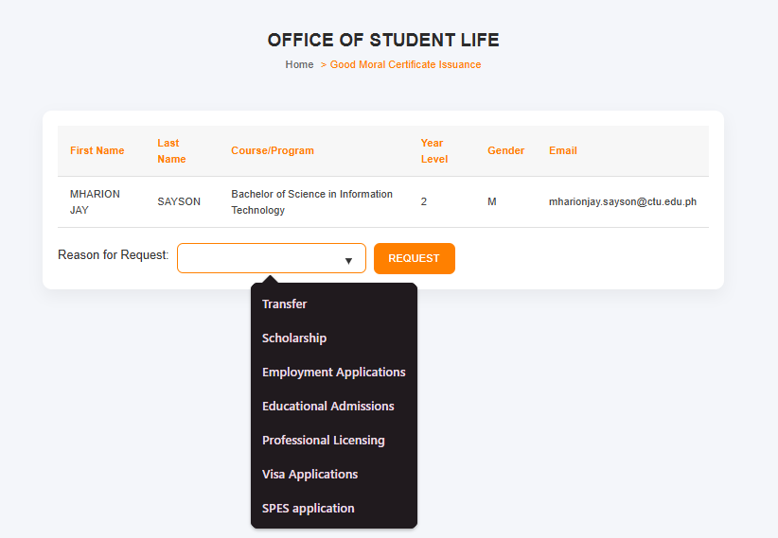
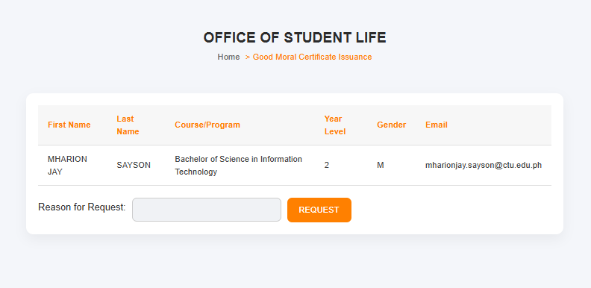
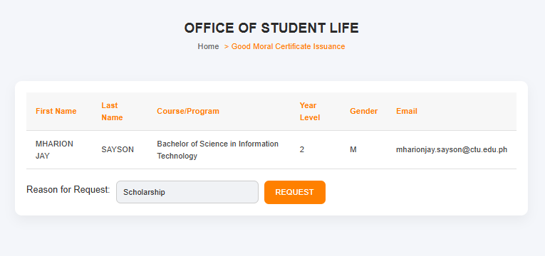
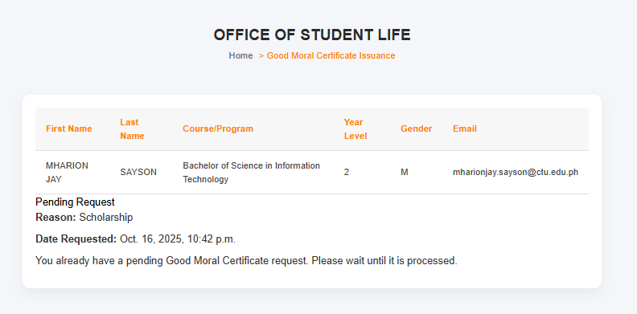


COLLEGE OF TECHNOLOGY AND ENGINEERING
Information Technology Department

USER ACCEPTANCE TESTING
Test Case ID | TC0012
Capstone Project Title: | Student Affairs and Services System
Team | LOWCODE
 | Project Leader: |  | Honzel Babe Chavez
 |  |  | Kimberly Silvano
 | Front-End Programmer: |  | Jhudiel Anthony Carzano
 | QA Engineer: |  | Mharion Jay P. Sayson
 | Technical Writer: |  | Francis Xavier Sagarino
Title / Business Scenario | Verify that students can view their equipment records in the Equipment Tracker.
Preconditions | The student must have previously borrowed at least one equipment record registered in the system.
Test Data | Scholarship Type: (Select one) | Files: 3 valid images/PDFs |  | GPA: (Enter your GPA)
Steps | 1. Go to Office of Student Life → Equipment Tracker.
 | 2. Review equipment list.
Expected Result | The equipment list with Date Borrowed and Date Returned is displayed.
Actual Result (Pass/Fail) | Pass
Comments / Attachments (Screenshots, Logs) | Screenshot attached to the next page
Tester Name / Date | Mharion Jay P. Sayson / 10/03/2025
Panelist's Remarks

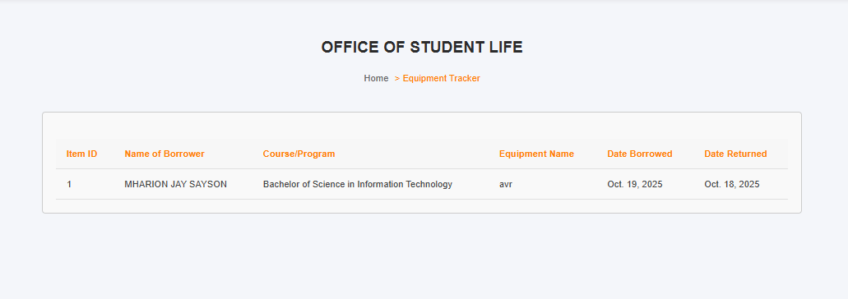
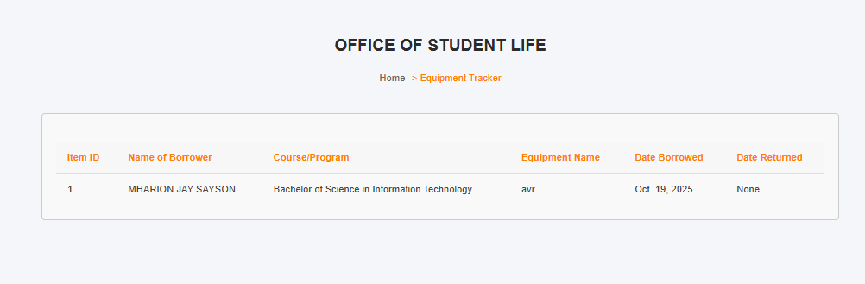


COLLEGE OF TECHNOLOGY AND ENGINEERING
Information Technology Department

USER ACCEPTANCE TESTING
Test Case ID | TC0013
Capstone Project Title: | Student Affairs and Services System
Team | LOWCODE
 | Project Leader: | Honzel Babe Chavez
 |  | Kimberly Silvano
 | Front-End Programmer: | Jhudiel Anthony Carzano
 | QA Engineer: | Mharion Jay P. Sayson
 | Technical Writer: | Francis Xavier Sagarino
Title / Business Scenario | View the Monthly Calendar of Activities.
Preconditions | The calendar must have at least one scheduled activity in the selected month.
Test Data | Month: October 2025
Steps | 1. Go to Office of Student Life → Monthly Calendar of Activities.
 | 2. Select the desired month to view.
Expected Result | Student can view all upcoming events and activities for the selected month.
Actual Result (Pass/Fail) | Pass
Comments / Attachments (Screenshots, Logs) | Screenshot attached to the next page
Tester Name / Date | Mharion Jay P. Sayson / 10/13/2025
Panelist's Remarks

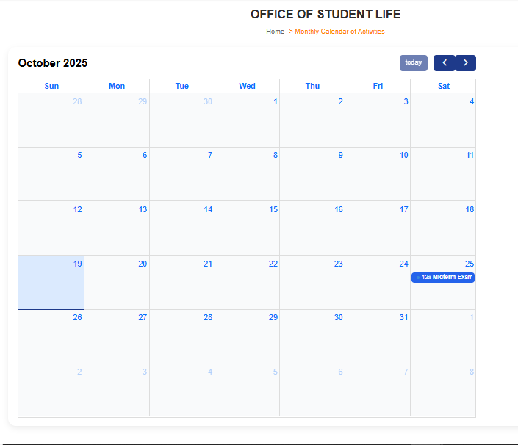
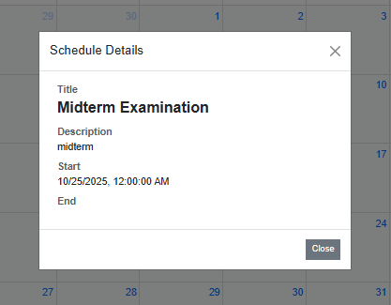


COLLEGE OF TECHNOLOGY AND ENGINEERING
Information Technology Department

USER ACCEPTANCE TESTING
Test Case ID | TC0014
Capstone Project Title: | Student Affairs and Services System
Team | LOWCODE
 | Project Leader: | Honzel Babe Chavez
 |  | Kimberly Silvano
 | Front-End Programmer: | Jhudiel Anthony Carzano
 | QA Engineer: | Mharion Jay P. Sayson
 | Technical Writer: | Francis Xavier Sagarino
Title / Business Scenario | Submit a Scholarship Application Form successfully.
Preconditions | The student must be logged in and able to access the Scholarship Application Form page.
Test Data | Email: testuser@gmail.com | Password: Test@123
Steps | 1. Select Scholarship Type.
 | 2. Upload required documents: Grade, School ID, and COR.
 | 3. Enter GPA and click Submit.
Expected Result | Application is recorded in the system and pending for admin review.
Actual Result (Pass/Fail) | Pass
Comments / Attachments (Screenshots, Logs) | Screenshot attached to the next page
Tester Name / Date | Mharion Jay P. Sayson / 10/03/2025
Panelist's Remarks

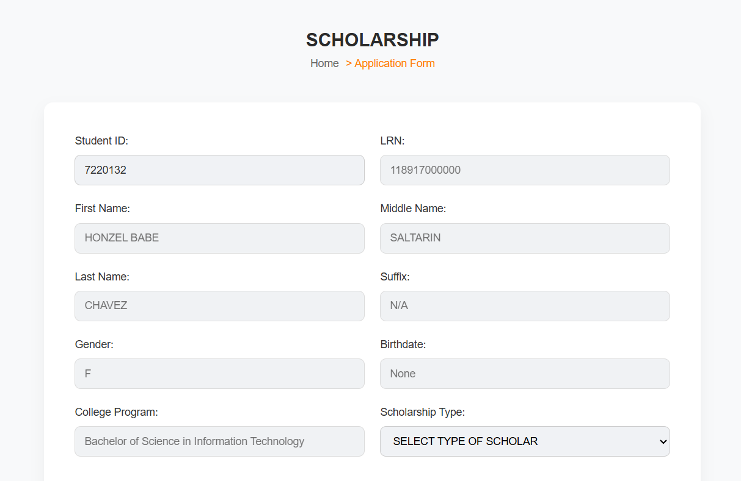



COLLEGE OF TECHNOLOGY AND ENGINEERING
Information Technology Department

USER ACCEPTANCE TESTING
Test Case ID | TC0015A
Capstone Project Title: | Student Affairs and Services System
Team | LOWCODE
 | Project Leader: | Honzel Babe Chavez
 |  | Kimberly Silvano
 | Front-End Programmer: | Jhudiel Anthony Carzano
 | QA Engineer: | Mharion Jay P. Sayson
 | Technical Writer: | Francis Xavier Sagarino
Title / Business Scenario | View personal and scholarship information and apply for a scholarship if none is currently active.
Preconditions | The student must be logged in and have access to the Scholars Profile page.
Test Data | Scholarship Status: None
Steps | 1. Navigate to Scholarship → Scholars Profile.
 | 2. Verify that Personal Information and Scholarship Information are displayed.
 | 3. If Scholarship Status is “None,” click Apply Scholarship to proceed to the application form.
Expected Result | Personal and scholarship details are displayed; clicking Apply Scholarship redirects successfully.
Actual Result (Pass/Fail) | Pass
Comments / Attachments (Screenshots, Logs) | Screenshot attached to the next page
Tester Name / Date | Mharion Jay P. Sayson / 10/03/2025
Panelist's Remarks

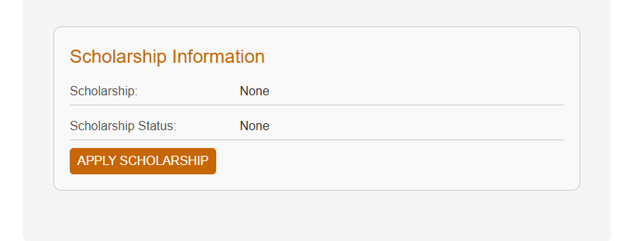
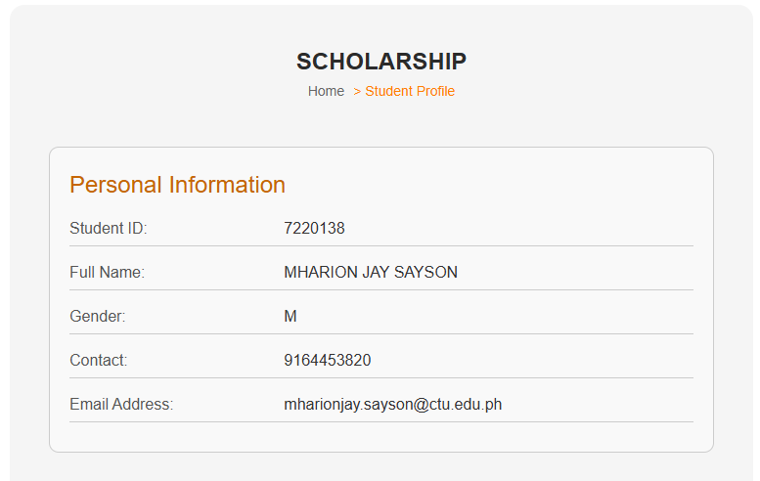



COLLEGE OF TECHNOLOGY AND ENGINEERING
Information Technology Department

USER ACCEPTANCE TESTING
Test Case ID | TC0015B
Capstone Project Title: | Student Affairs and Services System
Team | LOWCODE
 | Project Leader: | Honzel Babe Chavez
 |  | Kimberly Silvano
 | Front-End Programmer: | Jhudiel Anthony Carzano
 | QA Engineer: | Mharion Jay P. Sayson
 | Technical Writer: | Francis Xavier Sagarino
Title / Business Scenario | Display a message if the student has already submitted a scholarship application.
Preconditions | The student must have already submitted a scholarship application.
Test Data | Scholarship Status: None
Steps | 1. Navigate to Scholarship → Application Form.
 | 2. Verify that a message appears indicating the student already applied.
 | 3. Click Check Profile button to view current scholarship details.
Expected Result | User should be redirected to the dashboard or homepage.
Actual Result (Pass/Fail) | Pass
Comments / Attachments (Screenshots, Logs) | Screenshot attached to the next page
Tester Name / Date | Mharion Jay P. Sayson / 10/03/2025
Panelist's Remarks

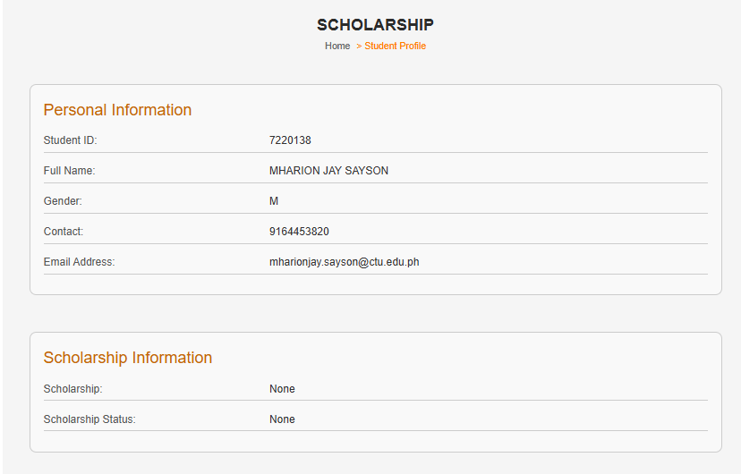
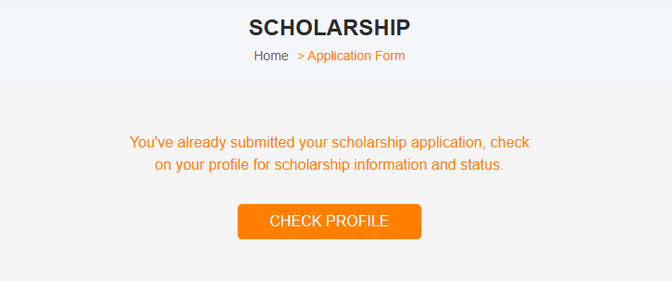


COLLEGE OF TECHNOLOGY AND ENGINEERING
Information Technology Department

USER ACCEPTANCE TESTING
Test Case ID | TC0016
Capstone Project Title: | Student Affairs and Services System
Team | LOWCODE
 | Project Leader: | Honzel Babe Chavez
 |  | Kimberly Silvano
 | Front-End Programmer: | Jhudiel Anthony Carzano
 | QA Engineer: | Mharion Jay P. Sayson
 | Technical Writer: | Francis Xavier Sagarino
Title / Business Scenario | View list of companies with internship opportunities.
Preconditions | The student must be logged in and have access to the OJT Hiring page under Job Placement.
Test Data | None
Steps | 1. Navigate to Job Placement → OJT Hiring.
 | 2. Wait for the system to load available companies.
 | 3. Observe the displayed list showing Company Name, Address, Position Offered, and Duration.
Expected Result | System displays a list of companies offering internship opportunities with details like company name, address, position offered, and duration.
Actual Result (Pass/Fail) | Pass
Comments / Attachments (Screenshots, Logs) | Screenshot attached to the next page
Tester Name / Date | Mharion Jay P. Sayson / 10/03/2025
Panelist's Remarks

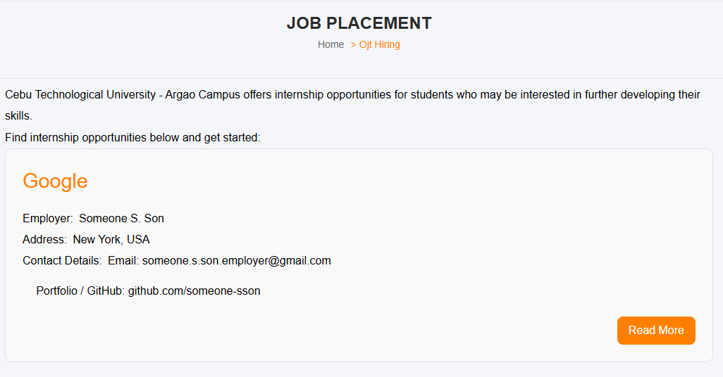


COLLEGE OF TECHNOLOGY AND ENGINEERING
Information Technology Department

USER ACCEPTANCE TESTING
Test Case ID | TC0017
Capstone Project Title: | Student Affairs and Services System
Team | LOWCODE
 | Project Leader: | Honzel Babe Chavez
 |  | Kimberly Silvano
 | Front-End Programmer: | Jhudiel Anthony Carzano
 | QA Engineer: | Mharion Jay P. Sayson
 | Technical Writer: | Francis Xavier Sagarino
Title / Business Scenario | View more information about a specific company by clicking “Read more.”
Preconditions | The student must be logged in and have access to the OJT Hiring page under Job Placement.
Test Data | None
Steps | 1. On the OJT Hiring page, locate a company from the list.
 | 2. Click “Read more” beside the selected company.
 | 3. The system displays detailed information such as Company Overview, Contact Information, Job Description, and Requirements.
Expected Result | Student remains on the same page or redirected to a detail view showing complete company info.
Actual Result (Pass/Fail) | Pass
Comments / Attachments (Screenshots, Logs) | Screenshot attached to the next page
Tester Name / Date | Mharion Jay P. Sayson / 10/03/2025
Panelist's Remarks

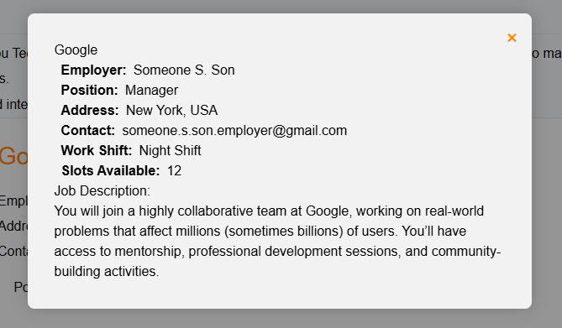


COLLEGE OF TECHNOLOGY AND ENGINEERING
Information Technology Department

USER ACCEPTANCE TESTING
Test Case ID | TC0018
Capstone Project Title: | Student Affairs and Services System
Team | LOWCODE
 | Project Leader: | Honzel Babe Chavez
 |  | Kimberly Silvano
 | Front-End Programmer: | Jhudiel Anthony Carzano
 | QA Engineer: | Mharion Jay P. Sayson
 | Technical Writer: | Francis Xavier Sagarino
Title / Business Scenario | Verify that the user can successfully submit the Individual Profile with Guidance Concern form.
Preconditions | The user must be logged in and have access to all required form fields with a stable internet connection.
Test Data | All required fields filled in with valid information across pages of the form.
Steps | 1. Navigate to Guidance → Individual Profile with Guidance Concern.
 | 2. Fill in all required fields across multiple pages.
 | 3. Review all entered information for accuracy.
 | 4. Click Submit to complete the process.
Expected Result | A confirmation message appears (e.g., “Form submitted successfully”) and the submitted data is stored in the database under guidance records.
Actual Result (Pass/Fail) | Pass
Comments / Attachments (Screenshots, Logs) | Screenshot attached to the next page
Tester Name / Date | Mharion Jay P. Sayson / 10/15/2025
Panelist's Remarks



COLLEGE OF TECHNOLOGY AND ENGINEERING
Information Technology Department

USER ACCEPTANCE TESTING
Test Case ID | TC0019
Capstone Project Title: | Student Affairs and Services System
Team | LOWCODE
 | Project Leader: |  | Honzel Babe Chavez
 |  |  | Kimberly Silvano
 | Front-End Programmer: |  | Jhudiel Anthony Carzano
 | QA Engineer: |  | Mharion Jay P. Sayson
 | Technical Writer: |  | Francis Xavier Sagarino
Title / Business Scenario | Verify that the user can successfully submit a completed Intake Interview form and the record appears in the data table.
Preconditions | The user must be logged in and have access to all required form fields with a stable internet connection.
Test Data | Completed entries for:  - Individual Inventory Service  - Appraisal Service  - Counseling Service | - Follow-up Service  - Information Service  - Consultation Service
Steps | 1. Navigate to Guidance → Intake Interview.
 | 2. Fill out all required information in the six service sections.
 | 3. Review all entered information for accuracy and click Submit.
Expected Result | A confirmation message appears (e.g., “Form submitted successfully”), and a new record is displayed in the Intake Interview table.
Actual Result (Pass/Fail) | Pass
Comments / Attachments (Screenshots, Logs) | Screenshot attached to the next page
Tester Name / Date | Mharion Jay P. Sayson / 10/15/2025
Panelist's Remarks

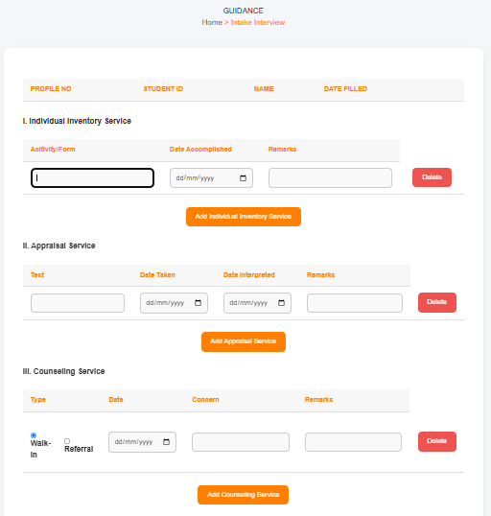
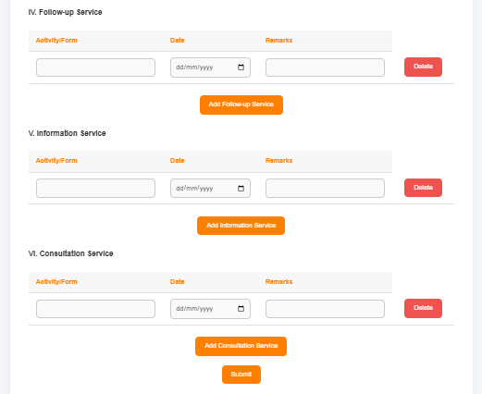


COLLEGE OF TECHNOLOGY AND ENGINEERING
Information Technology Department

USER ACCEPTANCE TESTING
Test Case ID | TC0020
Capstone Project Title: | Student Affairs and Services System
Team | LOWCODE
 | Project Leader: |  | Honzel Babe Chavez
 |  |  | Kimberly Silvano
 | Front-End Programmer: |  | Jhudiel Anthony Carzano
 | QA Engineer: |  | Mharion Jay P. Sayson
 | Technical Writer: |  | Francis Xavier Sagarino
Title / Business Scenario | Verify that the user can add a new record under Individual Inventory Service.
Preconditions | The user must be logged in and have access to all required form fields with a stable internet connection.
Test Data | Activity/Form: “Personality Check Form” | Date Accomplished: 15/10/2025 |  | Remarks: “Completed”
Steps | 1. In the Individual Inventory Service section, click Add Individual Inventory Service.
 | 2. Enter valid data and click Save.
Expected Result | The new Individual Inventory Service entry appears in the table under that section.
Actual Result (Pass/Fail) | Pass
Comments / Attachments (Screenshots, Logs) | Screenshot attached to the next page
Tester Name / Date | Mharion Jay P. Sayson / 10/15/2025
Panelist's Remarks

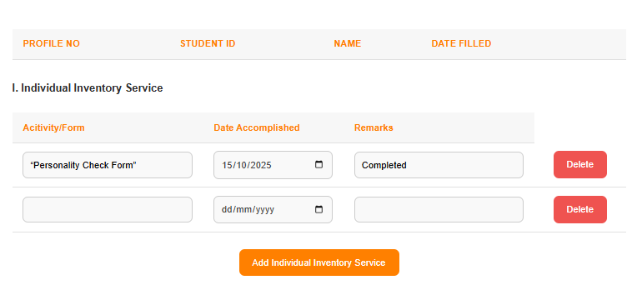
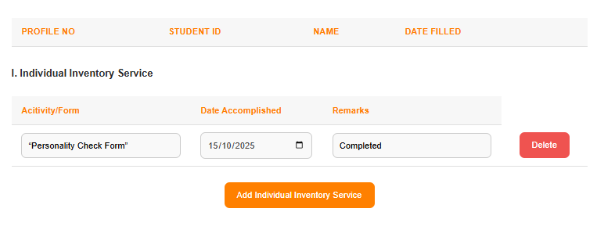


COLLEGE OF TECHNOLOGY AND ENGINEERING
Information Technology Department

USER ACCEPTANCE TESTING
Test Case ID | TC0021
Capstone Project Title: | Student Affairs and Services System
Team | LOWCODE
 | Project Leader: | Honzel Babe Chavez
 |  | Kimberly Silvano
 | Front-End Programmer: | Jhudiel Anthony Carzano
 | QA Engineer: | Mharion Jay P. Sayson
 | Technical Writer: | Francis Xavier Sagarino
Title / Business Scenario | Exit Interview – Display and Confirmation of Informed Consent Form
Preconditions | User must be logged in and navigated to the Exit Interview page.
Test Data | Valid user login credentials
Steps | 1. Open the “Exit Interview” page.
 | 2. Observe the pop-up modal for the “Informed Consent Form.”
 | 3. Read the displayed content.
 | 4. Check the box labeled “I agree.” And click the Proceed button to continue.
Expected Result | The consent form closes, and the user gains access to the Exit Interview Sheet page.
Actual Result (Pass/Fail) | Pass
Comments / Attachments (Screenshots, Logs) | Screenshot attached to the next page
Tester Name / Date | Mharion Jay P. Sayson / 10/16/2025
Panelist's Remarks
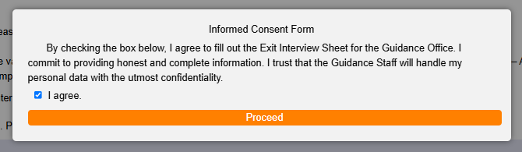
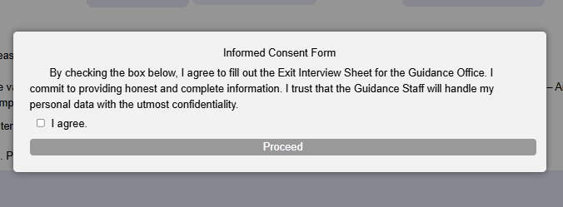



COLLEGE OF TECHNOLOGY AND ENGINEERING
Information Technology Department

USER ACCEPTANCE TESTING
Test Case ID | TC0022
Capstone Project Title: | Student Affairs and Services System
Team | LOWCODE
 | Project Leader: | Honzel Babe Chavez
 |  | Kimberly Silvano
 | Front-End Programmer: | Jhudiel Anthony Carzano
 | QA Engineer: | Mharion Jay P. Sayson
 | Technical Writer: | Francis Xavier Sagarino
Title / Business Scenario | Verify that the user can successfully submit an Alumni ID Request form.
Preconditions | User must be logged in and have access to the Alumni ID Request page.
Test Data | All required fields filled in with valid information.
Steps | 1. Navigate to Alumni → ID Request.
 | 2. Fill in all required fields with valid information.
 | 3. Click the Submit Request button.
 | 4. Wait for confirmation or system feedback.
Expected Result | “Your request is successful! Your alumni ID requested is [ID].”  The system then displays the request details with a status such as “Pending Approval.”  The request record is successfully saved in the database and visible for admin processing.
Actual Result (Pass/Fail) | Pass
Comments / Attachments (Screenshots, Logs) | Screenshot attached to the next page
Tester Name / Date | Mharion Jay P. Sayson / 10/16/2025
Panelist's Remarks
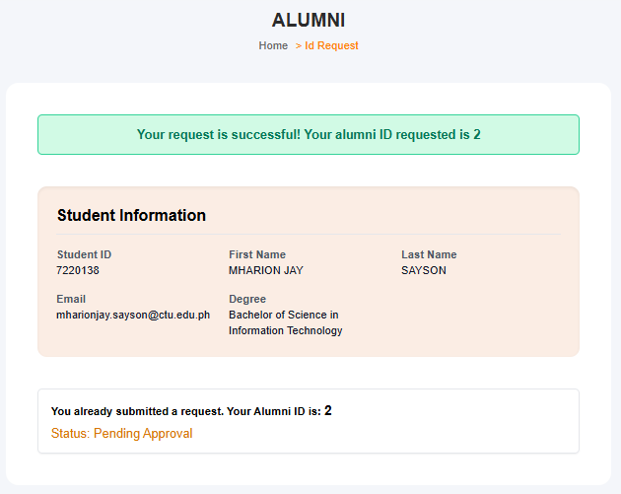



COLLEGE OF TECHNOLOGY AND ENGINEERING
Information Technology Department

USER ACCEPTANCE TESTING
Test Case ID | TC0023
Capstone Project Title: | SAO WEB APPLICATION
Team | LOWCODE
 | Project Leader: | Honzel Babe Chavez
 |  | Kimberly Silvano
 | Front-End Programmer: | Jhudiel Anthony Carzano
 | QA Engineer: | Mharion Jay P. Sayson
 | Technical Writer: | Francis Xavier Sagarino
Title / Business Scenario | Verify that the user can view current and upcoming community involvement events under the “Events” page.
Preconditions | The user must be logged in to access the Community Involvements > Events page.
Test Data | Valid user login credentials (e.g., Student/Alumni account).
Steps | 1. From the sidebar menu, navigate to Community Involvements.
 | 2. Click on Events.
 | 3. Observe the displayed list of events (current or upcoming).
 | 4. Check that event details such as Event Title, Date, Venue, and Description are visible.
Expected Result | The system should display all current and upcoming events with complete details. The user can only view the events and cannot add, edit, or delete them.
Actual Result (Pass/Fail) | Pass
Comments / Attachments (Screenshots, Logs) | Screenshot attached to the next page
Tester Name / Date | Mharion Jay P. Sayson / 10/03/2025
Panelist's Remarks

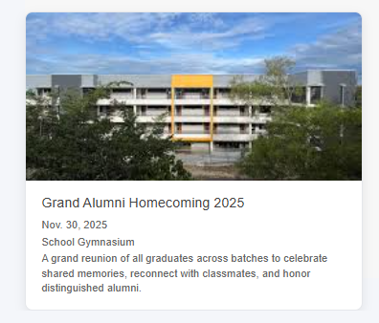


COLLEGE OF TECHNOLOGY AND ENGINEERING
Information Technology Department

USER ACCEPTANCE TESTING
Test Case ID | TC0024
Capstone Project Title: | Student Affairs and Services System
Team | LOWCODE
 | Project Leader: | Honzel Babe Chavez
 |  | Kimberly Silvano
 | Front-End Programmer: | Jhudiel Anthony Carzano
 | QA Engineer: | Mharion Jay P. Sayson
 | Technical Writer: | Francis Xavier Sagarino
Title / Business Scenario | Verify that the user can view available job postings under the “Job Fairs” section in the Alumni module.
Preconditions | User must be logged in to access the Alumni > Job Fairs page.
Test Data | Valid user login credentials (e.g., Student/Alumni account).
Steps | 1. Log in to the system using valid credentials.
 | 2. Navigate to the Alumni section on the sidebar menu.
 | 3. Click on Job Fairs.
 | 4. Observe the displayed job listings, including Job Title, Company Name, Location, Employment Type, Salary, Application Deadline, Date Posted, and Job Description.
Expected Result | The system should display all available job postings with complete details in a readable format. The user cannot edit, add, or delete any job postings—only view them.
Actual Result (Pass/Fail) | Pass
Comments / Attachments (Screenshots, Logs) | Screenshot attached to the next page
Tester Name / Date | Mharion Jay P. Sayson / 10/16/2025
Panelist's Remarks

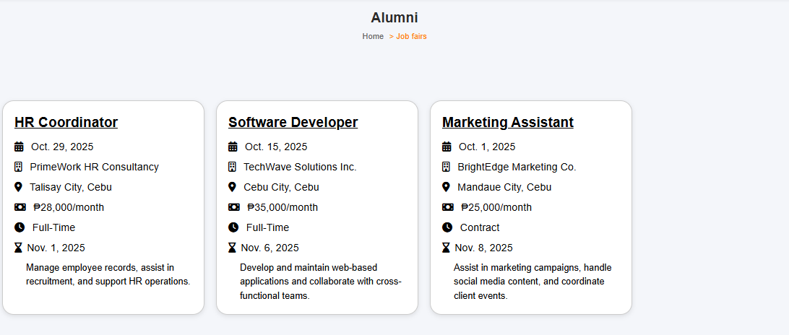


COLLEGE OF TECHNOLOGY AND ENGINEERING
Information Technology Department

USER ACCEPTANCE TESTING
Test Case ID | TC0025
Capstone Project Title: | Student Affairs and Services System
Team | LOWCODE
 | Project Leader: | Honzel Babe Chavez
 |  | Kimberly Silvano
 | Front-End Programmer: | Jhudiel Anthony Carzano
 | QA Engineer: | Mharion Jay P. Sayson
 | Technical Writer: | Francis Xavier Sagarino
Title / Business Scenario | Verify that the user can open and view the selected organization’s Constitution and By-Laws (CBL).
Preconditions | The user must be logged in and have access to the Org Profile page with at least one organization having a CBL file uploaded.
Test Data | Organization with CBL file available.
Steps | 1. Navigate to Student Organization → Org Profile.
 | 2. Select an organization.
 | 3. Click the View CBL button.
 | 4. Verify that the CBL document is displayed or downloadable.
Expected Result | The system opens or downloads the organization’s CBL document successfully.
Actual Result (Pass/Fail) | Pass
Comments / Attachments (Screenshots, Logs) | Screenshot attached to the next page
Tester Name / Date | Mharion Jay P. Sayson / 10/16/2025
Panelist's Remarks

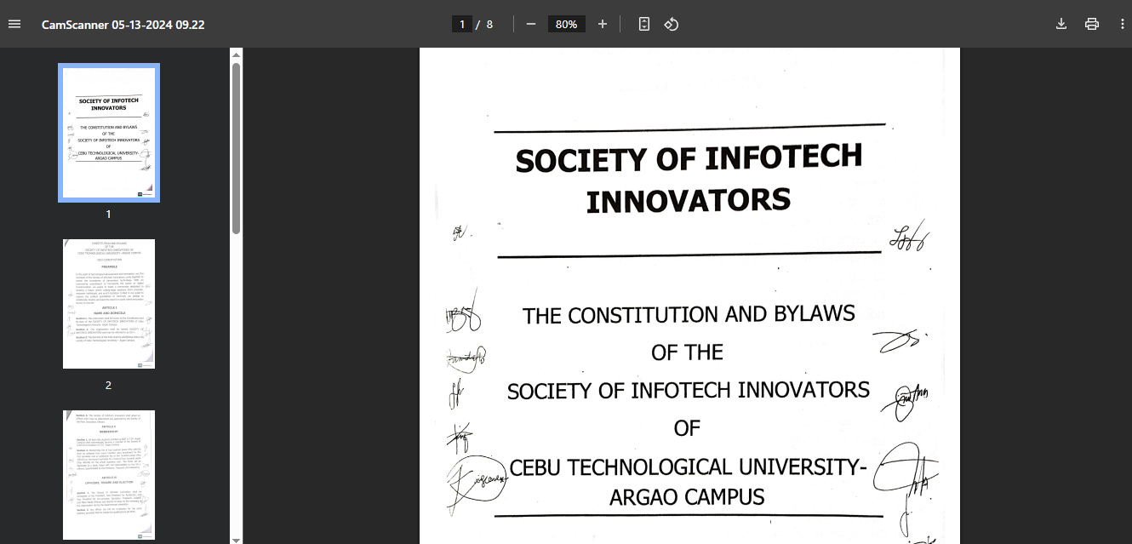
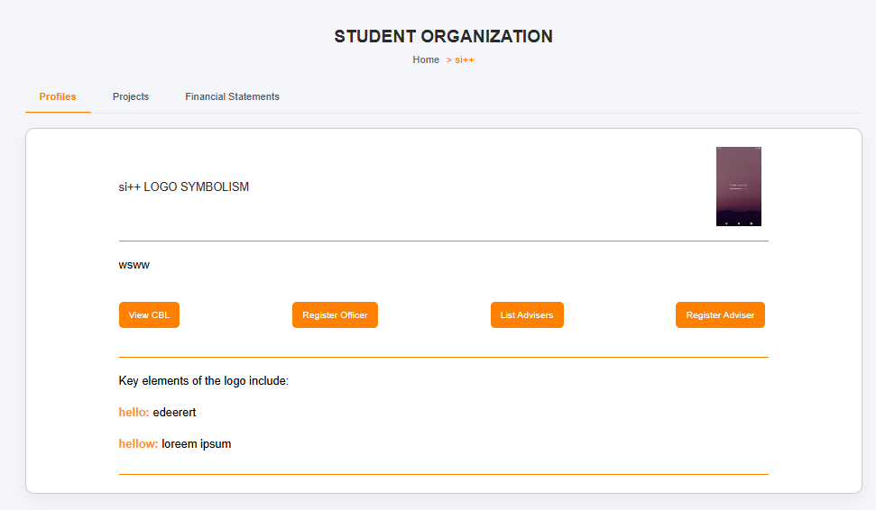


COLLEGE OF TECHNOLOGY AND ENGINEERING
Information Technology Department

USER ACCEPTANCE TESTING
Test Case ID | TC0026
Capstone Project Title: | Student Affairs and Services System
Team | LOWCODE
 | Project Leader: | Honzel Babe Chavez
 |  | Kimberly Silvano
 | Front-End Programmer: | Jhudiel Anthony Carzano
 | QA Engineer: | Mharion Jay P. Sayson
 | Technical Writer: | Francis Xavier Sagarino
Title / Business Scenario | Verify that the system displays a message if no medical records are found and provides a button to complete the medical form.
Preconditions | The user must be logged in and have access to the Medical section in the Student Dashboard.
Test Data | Valid student account without existing medical records.
Steps | 1. Log in to the system as a student.
 | 2. Navigate to Student Dashboard → Medical.
 | 3. Observe the displayed content on the page.
Expected Result | The system displays the message “No medical records found. Please complete your medical form.” and shows a “Complete Medical Form” button.
Actual Result (Pass/Fail) | Pass
Comments / Attachments (Screenshots, Logs) | Screenshot attached to the next page
Tester Name / Date | Mharion Jay P. Sayson / 10/03/2025
Panelist's Remarks

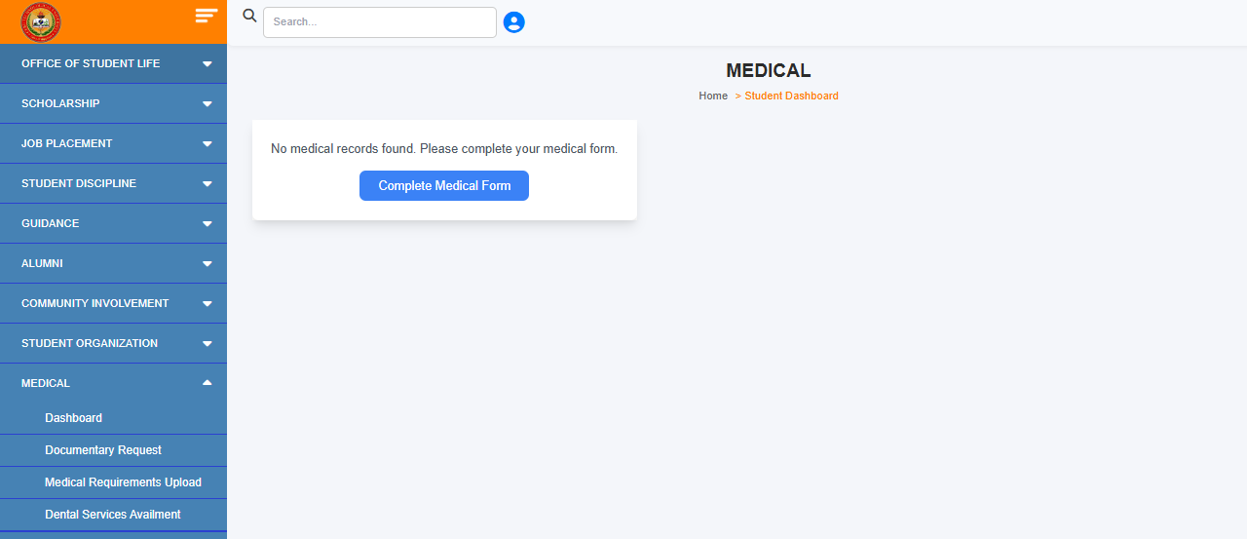
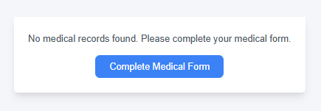


COLLEGE OF TECHNOLOGY AND ENGINEERING
Information Technology Department

USER ACCEPTANCE TESTING
Test Case ID | TC0027
Capstone Project Title: | Student Affairs and Services System
Team | LOWCODE
 | Project Leader: | Honzel Babe Chavez
 |  | Kimberly Silvano
 | Front-End Programmer: | Jhudiel Anthony Carzano
 | QA Engineer: | Mharion Jay P. Sayson
 | Technical Writer: | Francis Xavier Sagarino
Title / Business Scenario | Verify that the user can successfully complete and submit the medical information form.
Preconditions | The user must be logged in and redirected to the Patient Information Form page.
Test Data | All required fields must be filled with valid data.
Steps | 1. Fill out all required fields in the Patient Information Form.
 | 2. Review entered details for accuracy.
 | 3. Click Submit Information.
Expected Result | The system saves the entered medical information successfully and updates the student’s medical record.
Actual Result (Pass/Fail) | Pass
Comments / Attachments (Screenshots, Logs) | Screenshot attached to the next page
Tester Name / Date | Mharion Jay P. Sayson / 10/03/2025
Panelist's Remarks

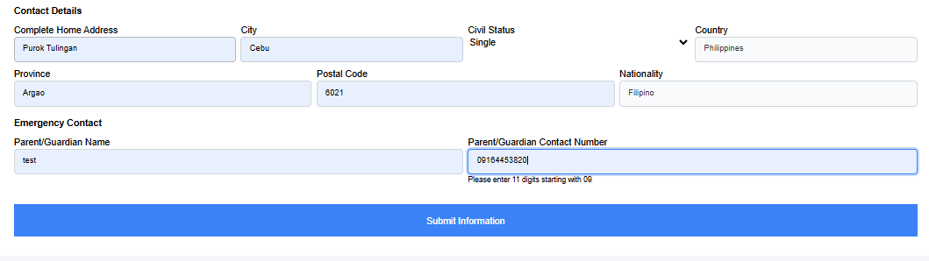
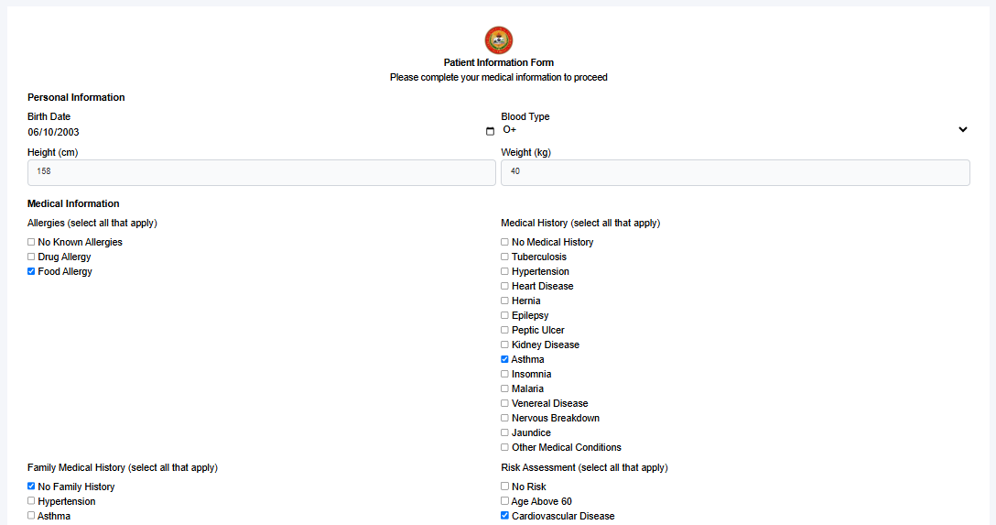
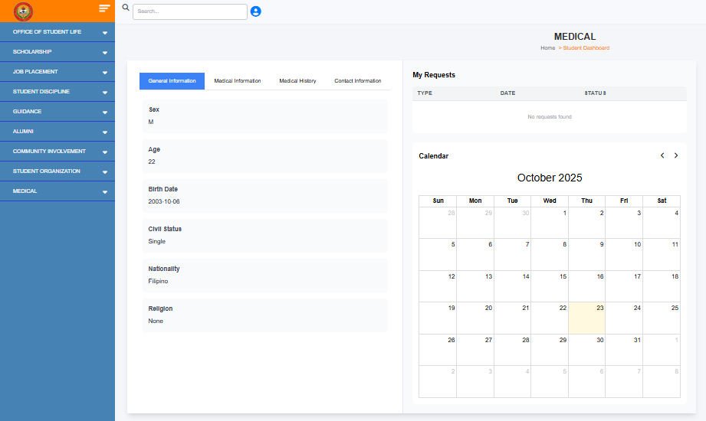



COLLEGE OF TECHNOLOGY AND ENGINEERING
Information Technology Department

USER ACCEPTANCE TESTING
Test Case ID | TC0027
Capstone Project Title: | Student Affairs and Services System
Team | LOWCODE
 | Project Leader: | Honzel Babe Chavez
 |  | Kimberly Silvano
 | Front-End Programmer: | Jhudiel Anthony Carzano
 | QA Engineer: | Mharion Jay P. Sayson
 | Technical Writer: | Francis Xavier Sagarino
Title / Business Scenario | Verify that the logged-in student can request documents (Eligibility Form or Medical Certificate) using their stored Student ID
Preconditions | The student must be logged in to the system. Their Student ID should already be stored in their account.
Test Data | All required fields must be filled with valid data.
Steps | 1. From the Request Type dropdown, select Eligibility Form.
 | 3. Click Submit Information.
Expected Result | The system saves the entered medical information successfully and updates the student’s medical record.
Actual Result (Pass/Fail) | Pass
Comments / Attachments (Screenshots, Logs) | Screenshot attached to the next page
Tester Name / Date | Mharion Jay P. Sayson / 10/03/2025
Panelist's Remarks
