Project Progress Update Date: November 4, 2025
- Input the list of your system’s features in the table provided below, and indicate the status of each feature (Completed, Ongoing, or Not Yet Started).
- Submit screenshots of each page of your program. For every screenshot, provide a detailed explanation describing what the page is about, what happens on that page, what the user is expected to do, and how to operate or navigate it.
- Save your file using the format: yourGroupName.pdf

- Each member should fill in what they worked on or contributed to the project in the provided spreadsheet. The group leader will review and verify everyone’s entry.

This activity will help me check your current progress and monitor the status of your project development.

Refer to the following rubrics as your guide in completing the task.

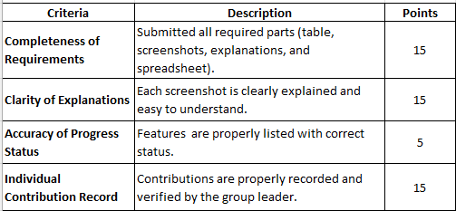
Total Points (by Group) = 35
Total Points (per Individual) = 15

Total Points (by Group) + Total Points (per Individual) = Your Total Points

Note: The Total Points (per Individual) are based on the Individual Contribution Record indicated in the evaluation criteria.
Project Progress Update Date: 11/5/2025

Title: CleanUpTrack

Features | Status
Real-time collection schedules | Completed
Report uncollected garbage | On-Going
Get instant notifications | On-going
Rate collector performance | Completed
Barangay Announcement | Completed
Mark as complete/didn’t collect sched | On-going
Appeal/recollect reports from resident | On-going
Status of Garbage Collector | Completed
Send Announcement | Completed
Display All reports | On-going
Display All collector | Completed
Create/Edit Schedule | Completed
Stats viewer(avg performance score, avg reports , resolve, pending) | Completed

Insert your screenshots with explanations here. You may add additional pages if necessary.

- Real-time collection schedules
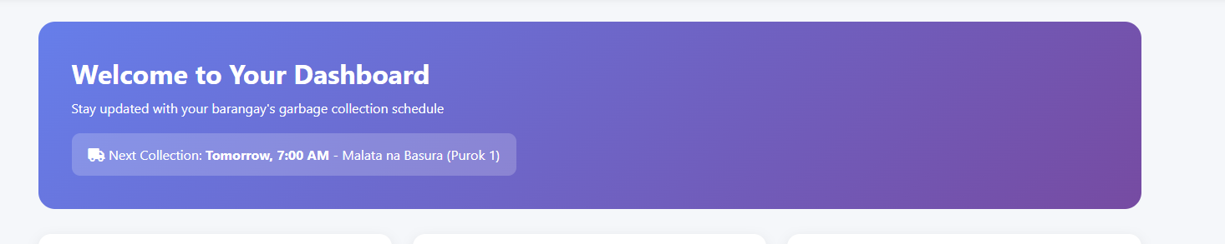
Users(residents) will see the upcoming schedules for their puroks, status for this one is Completed/working properly

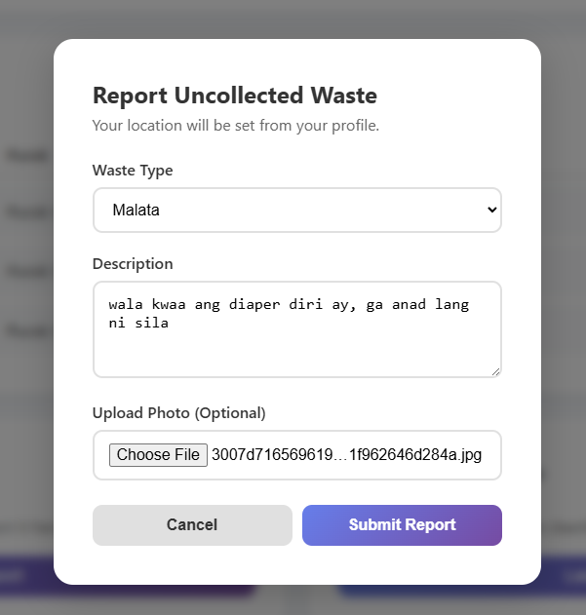
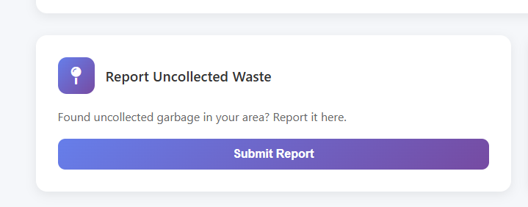
- Report uncollected garbage
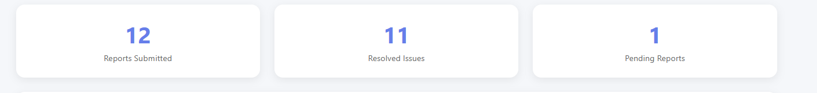
User can report if there is an unallocated garbage, they can attach a photo if they want and after submitted it will count as pending reports. The status for this one is On-going since im still finding any bugs for this feature.

- Get instant notifications
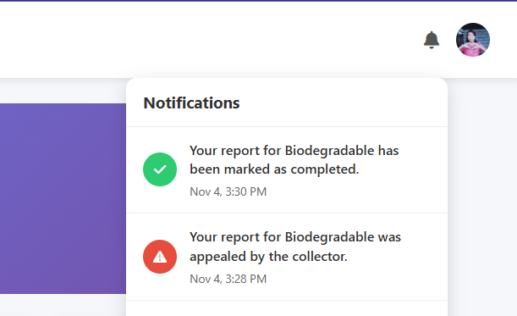
In this feature the user will get the notifications once the report she/he made was appealed or mark as completed and also it will also notify if this day(today) is the schedule for your puroks with the starting and end time of the schedule. Status for this feature is On-going since there’s so much bugs, where if the report is marked as completed the timestamp that will display was the time you made the report.
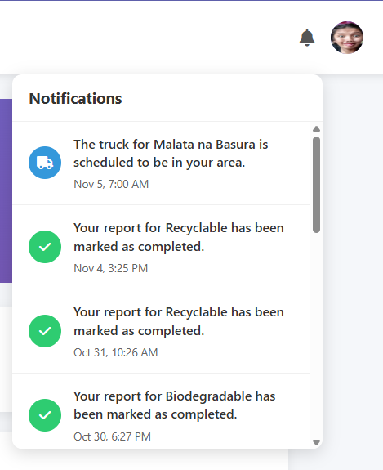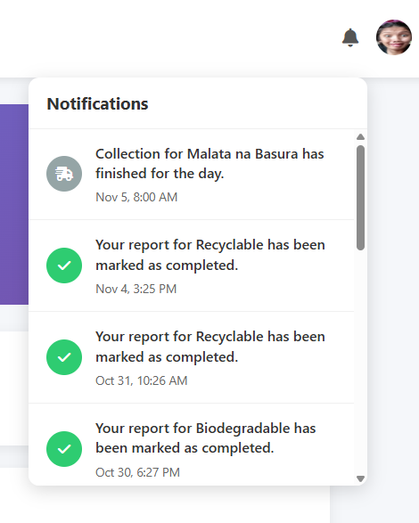

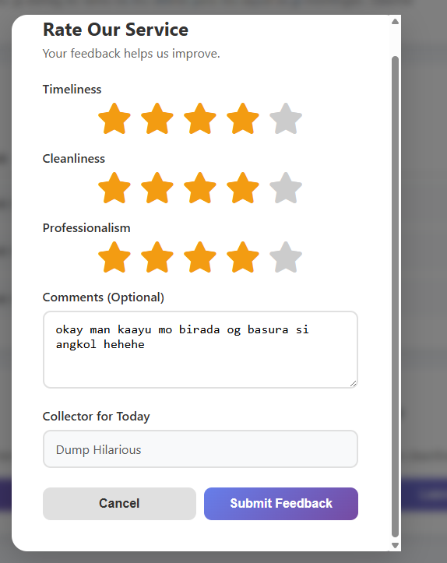
- Rate collector performance
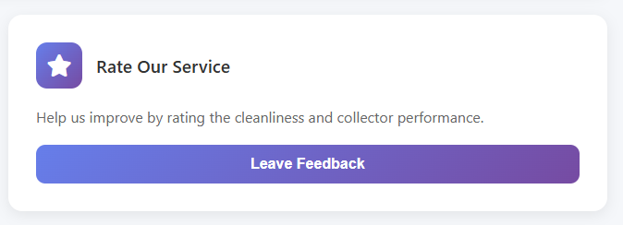
User can rate the performance of the garbage collector and the collector will automatically fetch base from the current schedule and also user can rate once per day only to avoid data gibberish as for its status its Completed.

- Barangay Announcement
User can get the announcement, for its status it is Completed
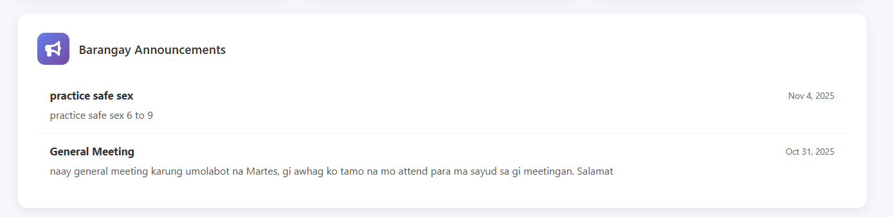
- Mark as complete/didn’t collect sched
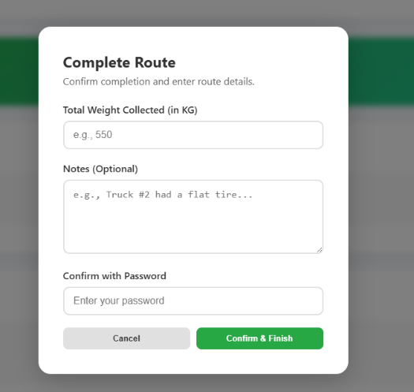
For this, the garbage collector will manually mark as done or not the entire schedule. If its done a modal will show up and input the details for the statics purposes in admin(barangay official page). And for the status for this is On-going since im having a hard time for the logic for this.
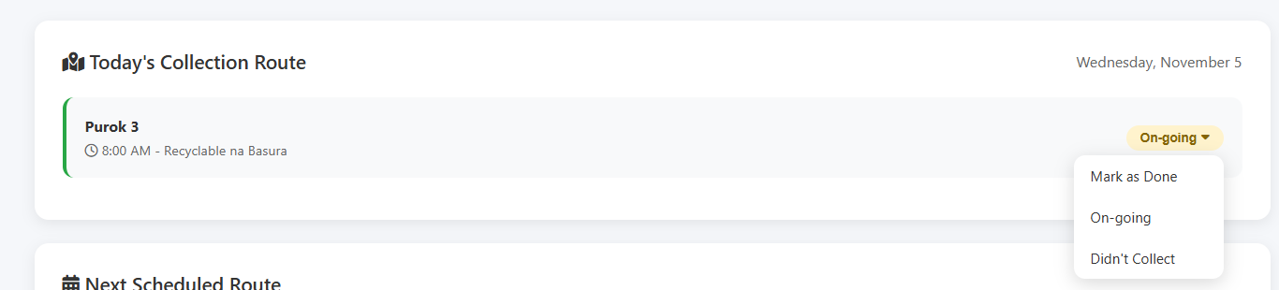

- Appeal/recollect reports from resident
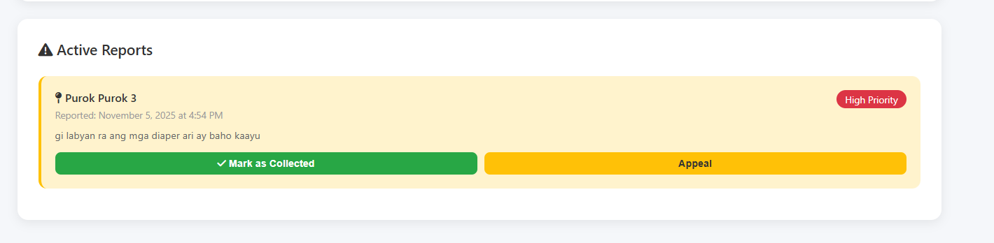
In this feature this is the reports made by the residents, the garbage collector can appeal what is the reason why he skip that specifics garbages, and later on the collector can mark it as collected and attached a photo for proof but this feature is still on going.

- Status of Garbage Collector
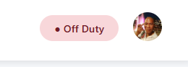
In this feature it will display the status of the collector, the logic I made with this is if that collector has a schedule regardless of the time frame it will mark as on duty otherwise off duty and for the status its Completed.

- Send Announcement
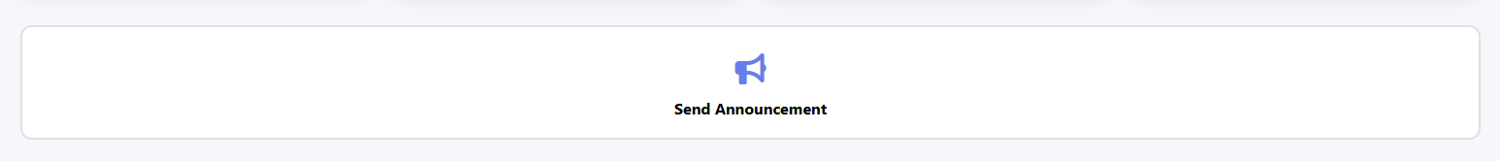
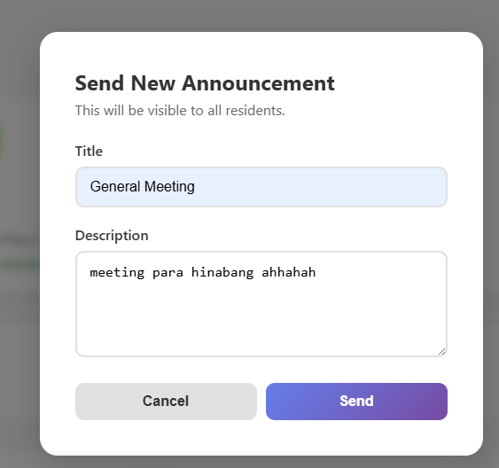
In this feature the Barangay Official can create an announcement and it will display to all the user(resident) the status for this is completed.


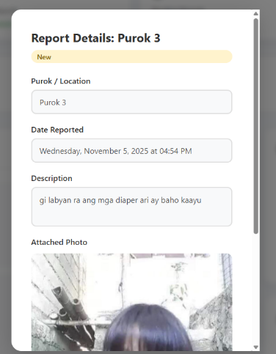
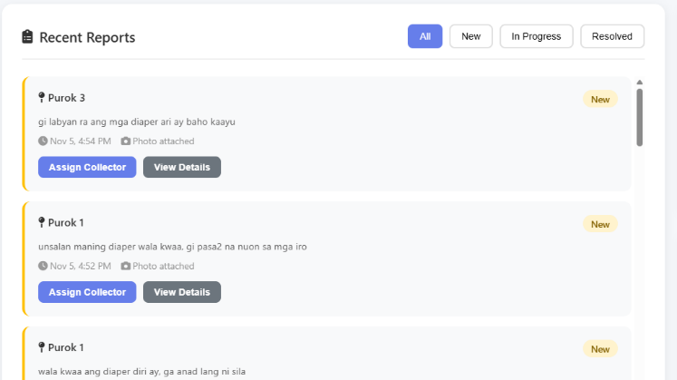
- Display All reports

The barangay officials can see all reports and can reassign collector if the current collector is busy atm. For its status I would say ongoing since there is some logic need to fix.
- Display All collector
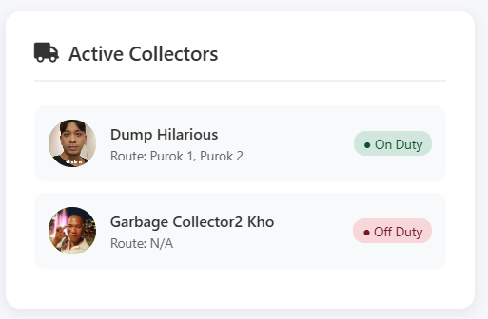
For this feature it also display all the collector with their names, profile picture and status. For this its completed.

- Create/Edit Schedule
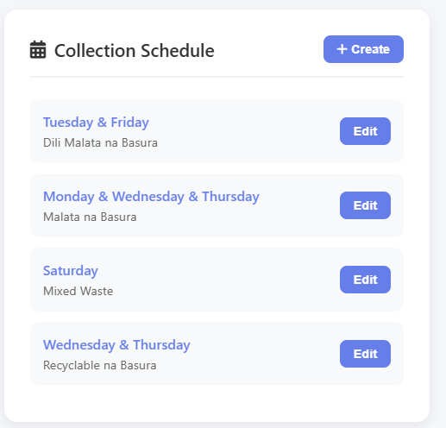
In this feature the barangay official can create and edit the schedules, actually its already working but im gonna add more logic to this to avoid conflict so it will be consider as on-going atm.

- Stats viewer(avg performance score, avg reports , resolve, pending)
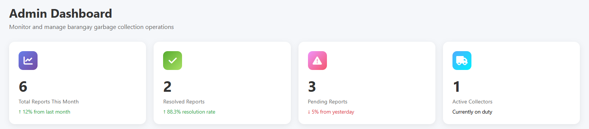
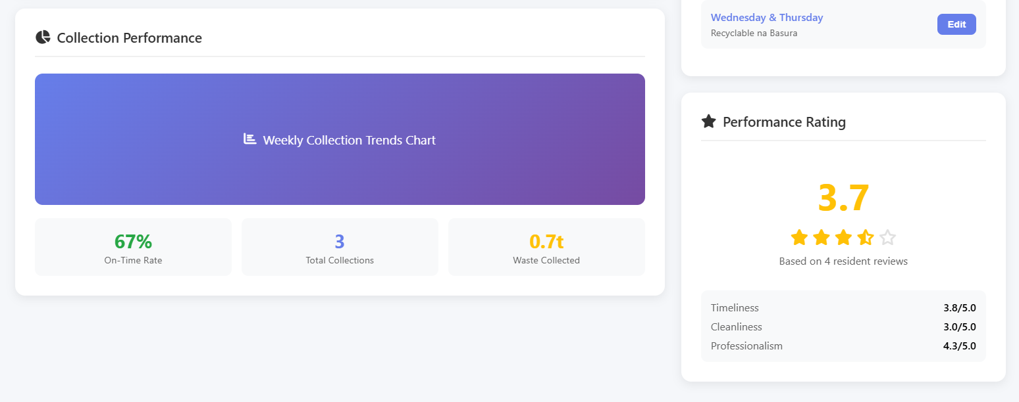

This is the analytics and its already working fine but still im gonna add a logic to avoid other issues.

