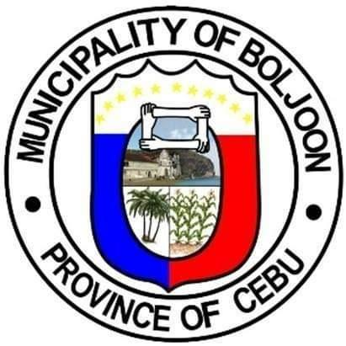

Kwentas Klaras: A Digital Project Management Information
System an Innovation Project

User Manual

Table of Contents

Account Management (Left Panel) 5
Main Modules (Center Panel) 5
Actions 9
2. Payee – Enter the name of the person, supplier, or entity to be paid. 10
3. Date – Select the obligation date using the calendar picker (mm/dd/yyyy). 10
4. Amount – Input the amount to be obligated in Philippine Peso (₱). 10
5. Submit – Save the obligation details into the system. 11
6. Exit – Cancel the process and return to the previous page. 11
7.4 ADD BUDGET 11
Steps: 14
How to Use 21
Steps: 22
Main Sections 23
How to Use 23

1. Getting Started

- The Utilization Rate Chart provides a visual representation of the budget spent versus the remaining budget.
- If a project is underutilized, a red “Budget Underutilized” label appears.
- The system automatically calculates the Utilization Rate (%) based on the total budget vs. expenses.
- The Remaining Balance reflects the unused portion of the budget.
- Users can track how efficiently funds are allocated and spent in real-time.

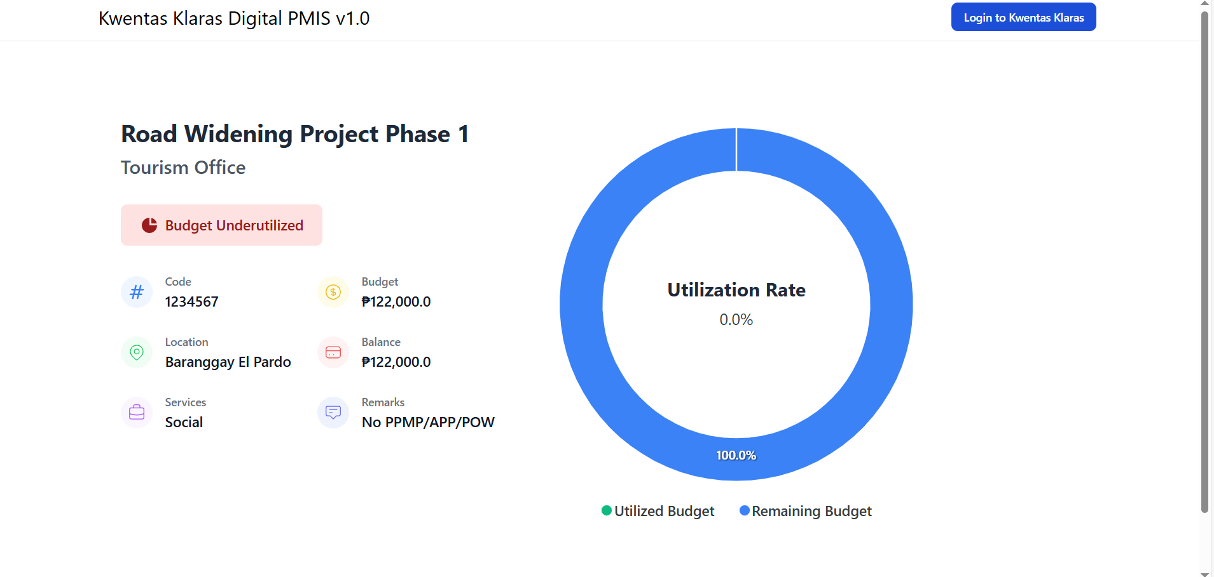

2 Login
- Enter Username
- Input your password
- Click the eye icon to show/hide password if needed.
- VerificationComplete the Cloudflare verification for security.
- Click “Login to Kwentas Klaras” to access your account.

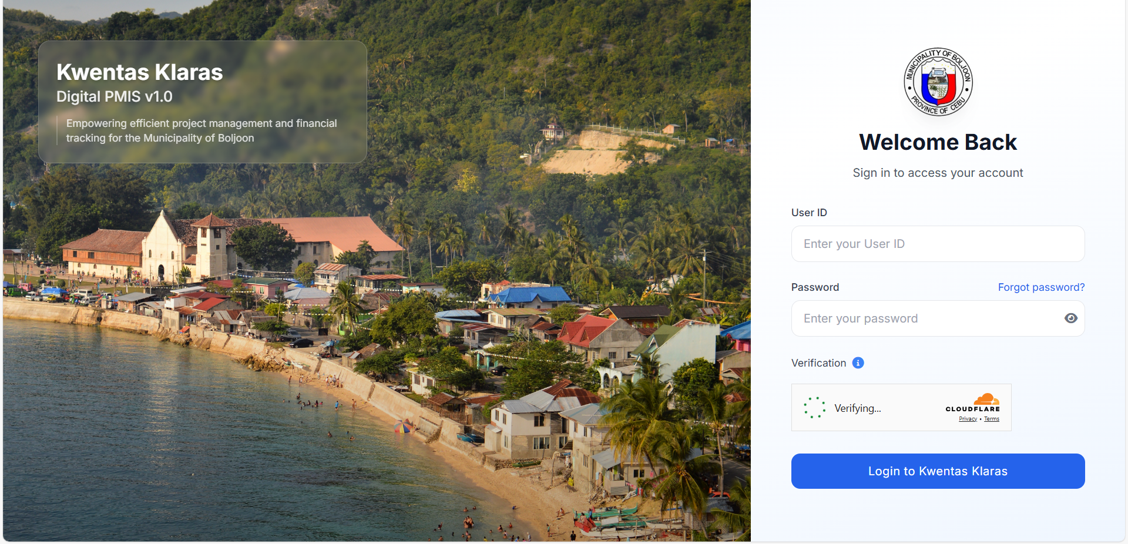

3. Forgot Password
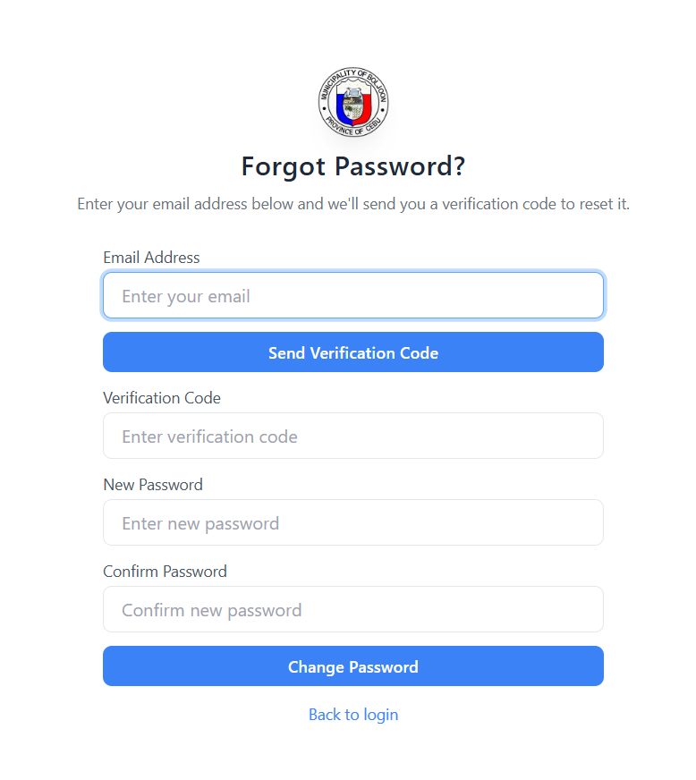

- Enter your Email Address
- Click Send Verification Code
- Enter the Verification Code sent to your email
- Enter your New Password
- Confirm your New Password
- Click Change Password
- Click Back to login to return to the login page

4. Dashboard

Account Management (Left Panel)
- Admin Dashboard – Go to main admin view
- Add Account – Create a new user account
- Enable 2FA – Secure your account with two-factor authentication
- Logout – Sign out of the system

Main Modules (Center Panel)
- PPA under 20% Local Development Fund
  - Continuing Projects – View ongoing projects
  - Current Projects – Track active projects
  - Add Project – Register a new project
- Procurements
  - View Procurements – Monitor and manage procurement activities
- Financial Management
  - Obligations – Track financial commitments
  - Disbursements – Monitor released funds
  - Check Payment – Verify payment status
- Monitoring & Evaluation
  - Monitor and evaluate existing projects – Track progress and performance
- Reports
  - Dashboard – View summary of reports and analytics
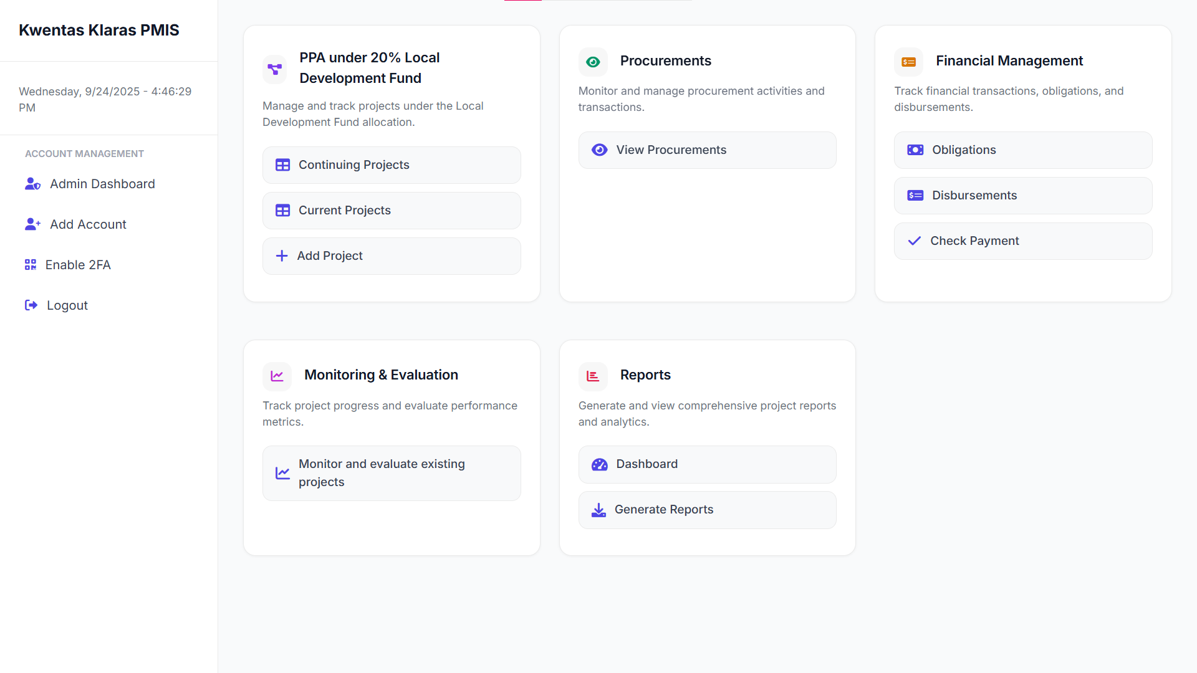
  - Generate Reports – Create detailed project reports
5. Add new project
5.1 Adding a new Project
- Select PPA (Programs, Projects, Activities)
- Choose Implementing Unit
- Enter Location
- Input Appropriation (budget)
- Set Start Date and End Date
- Add Remarks if needed
- Enter Project Code
- Choose Services category
- Select Year
- Click Create Project to save
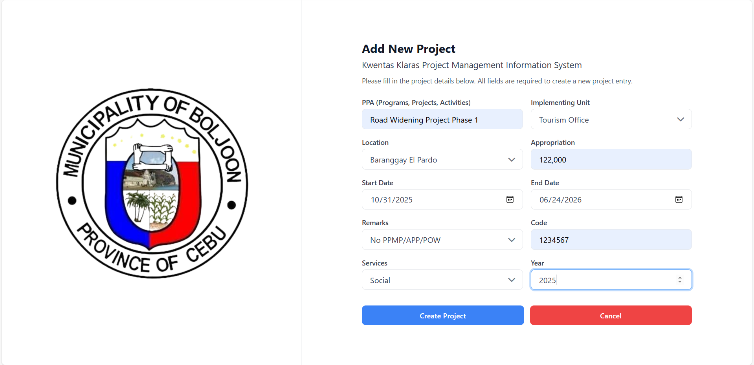
- Click Cancel to discard

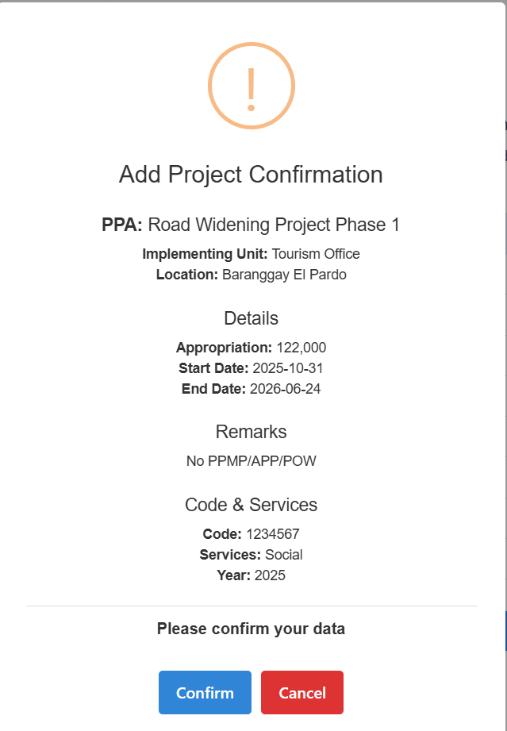
5.2 Confirmation after clicking the create project button.
Add Project Confirmation
- Review project details:
  - PPA (Project Title)
  - Implementing Unit
  - Location
  - Appropriation (budget)
  - Start Date & End Date
  - Remarks
  - Project Code
  - Services & Year
- If all details are correct → Click Confirm
- If changes are needed → Click Cancel to go back
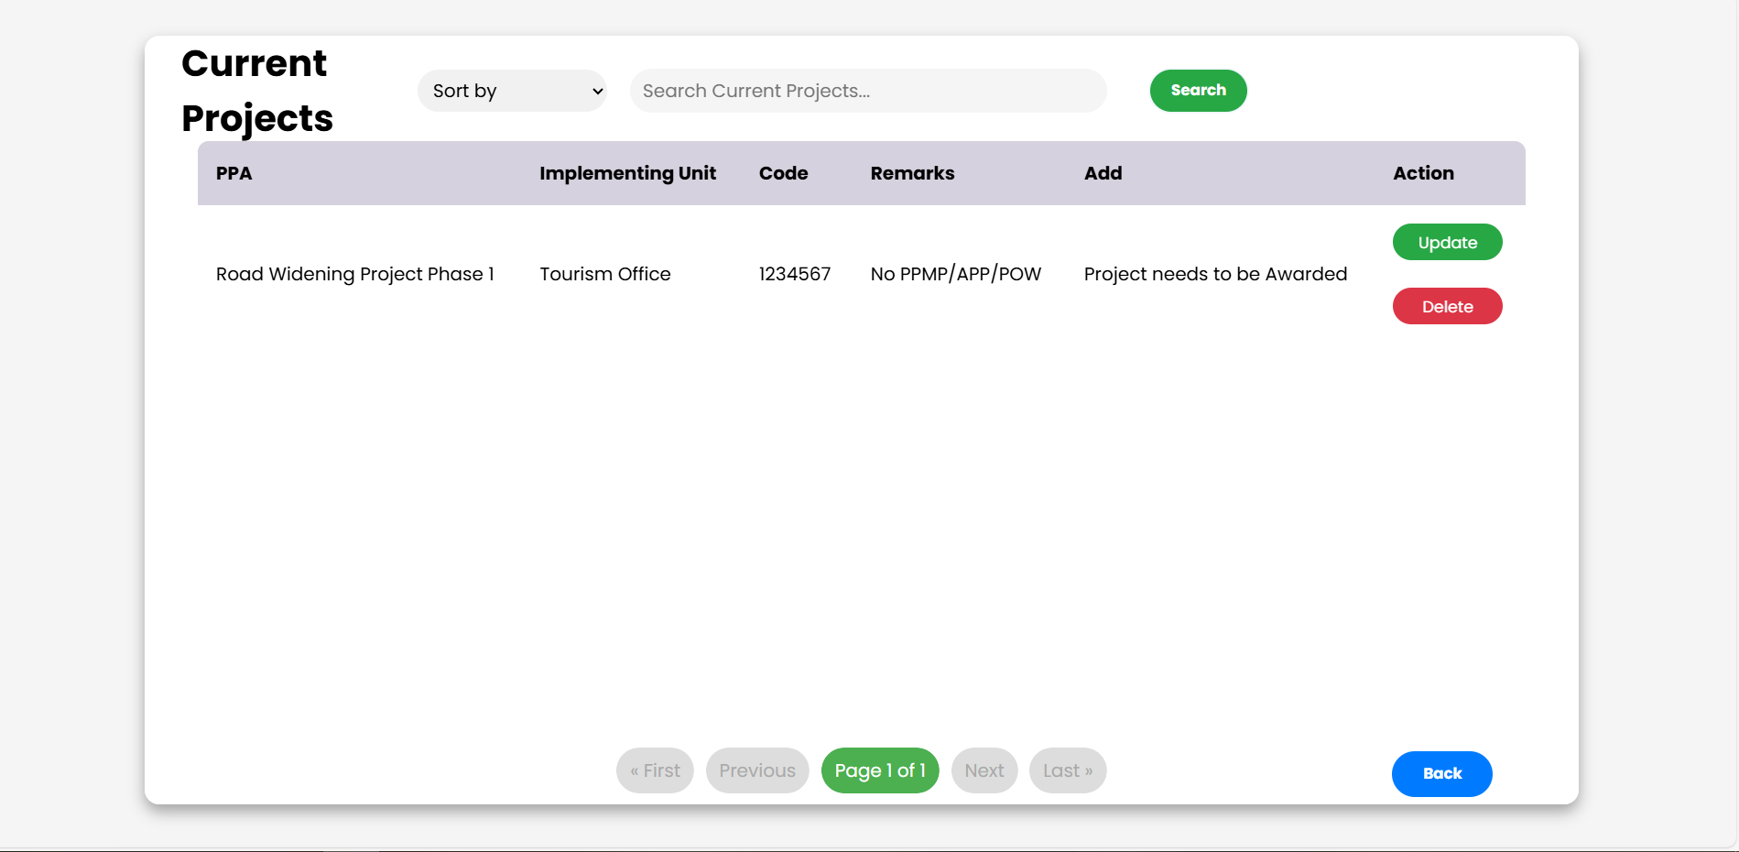
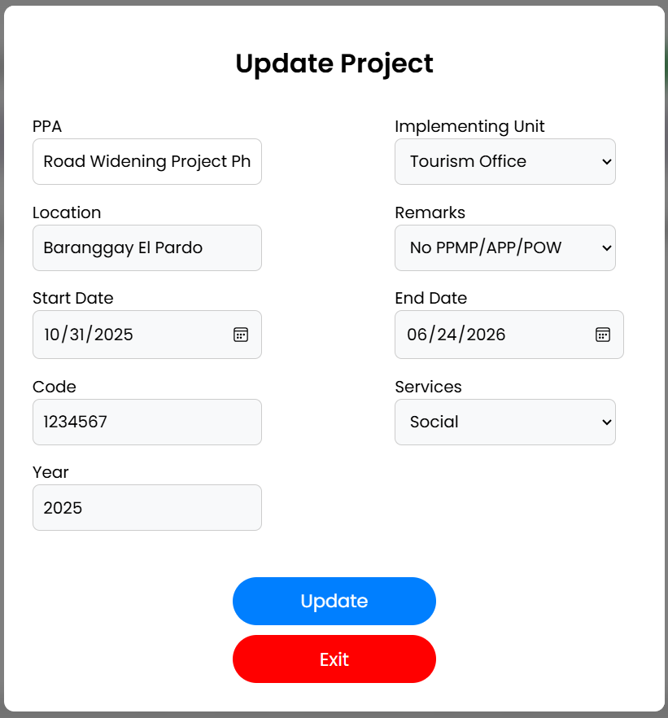
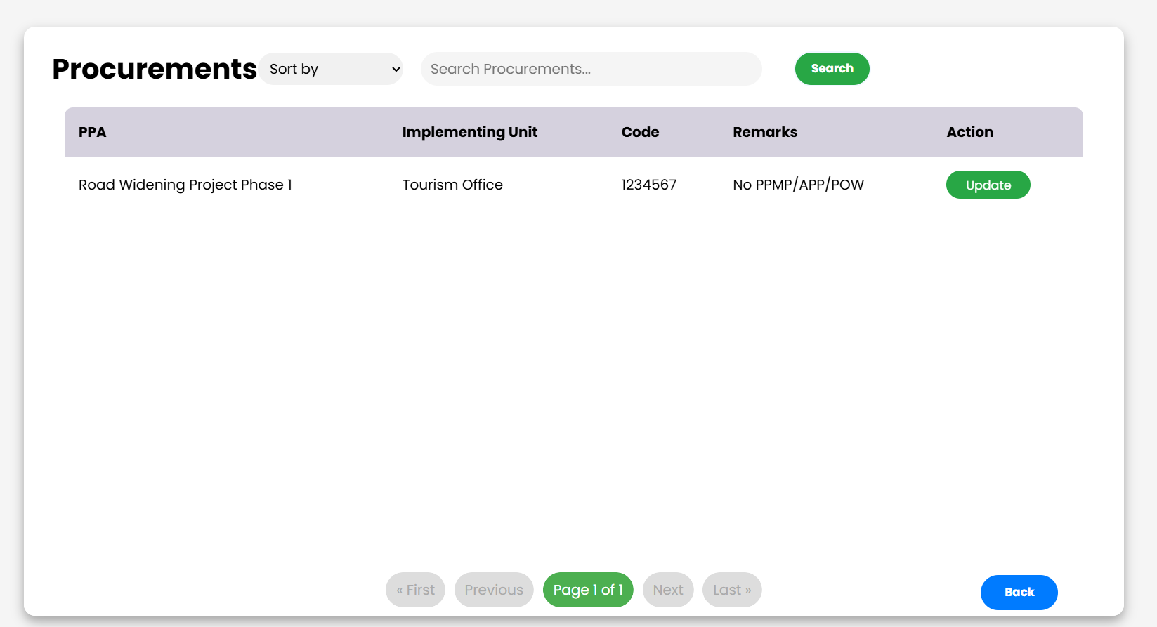
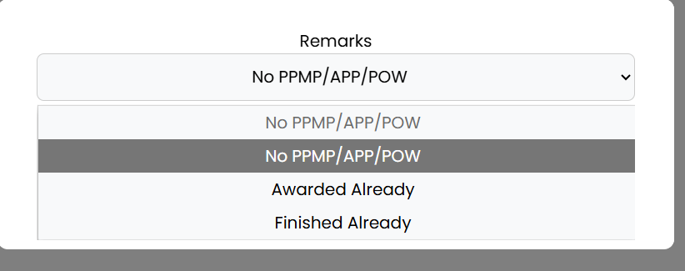
6. Continuing Projects
Sort by – Filter projects based on criteria
Search – Look up a specific project
Project List – Displays:
- PPA (Project Title)
- Implementing Unit
- Code
- Remarks
- Additional Notes
- Action buttons (if available)
If no projects are available → Message “No projects found.” will be shown
Back – Return to the previous page
Use navigation buttons (First, Previous, Next, Last) if multiple pages exist

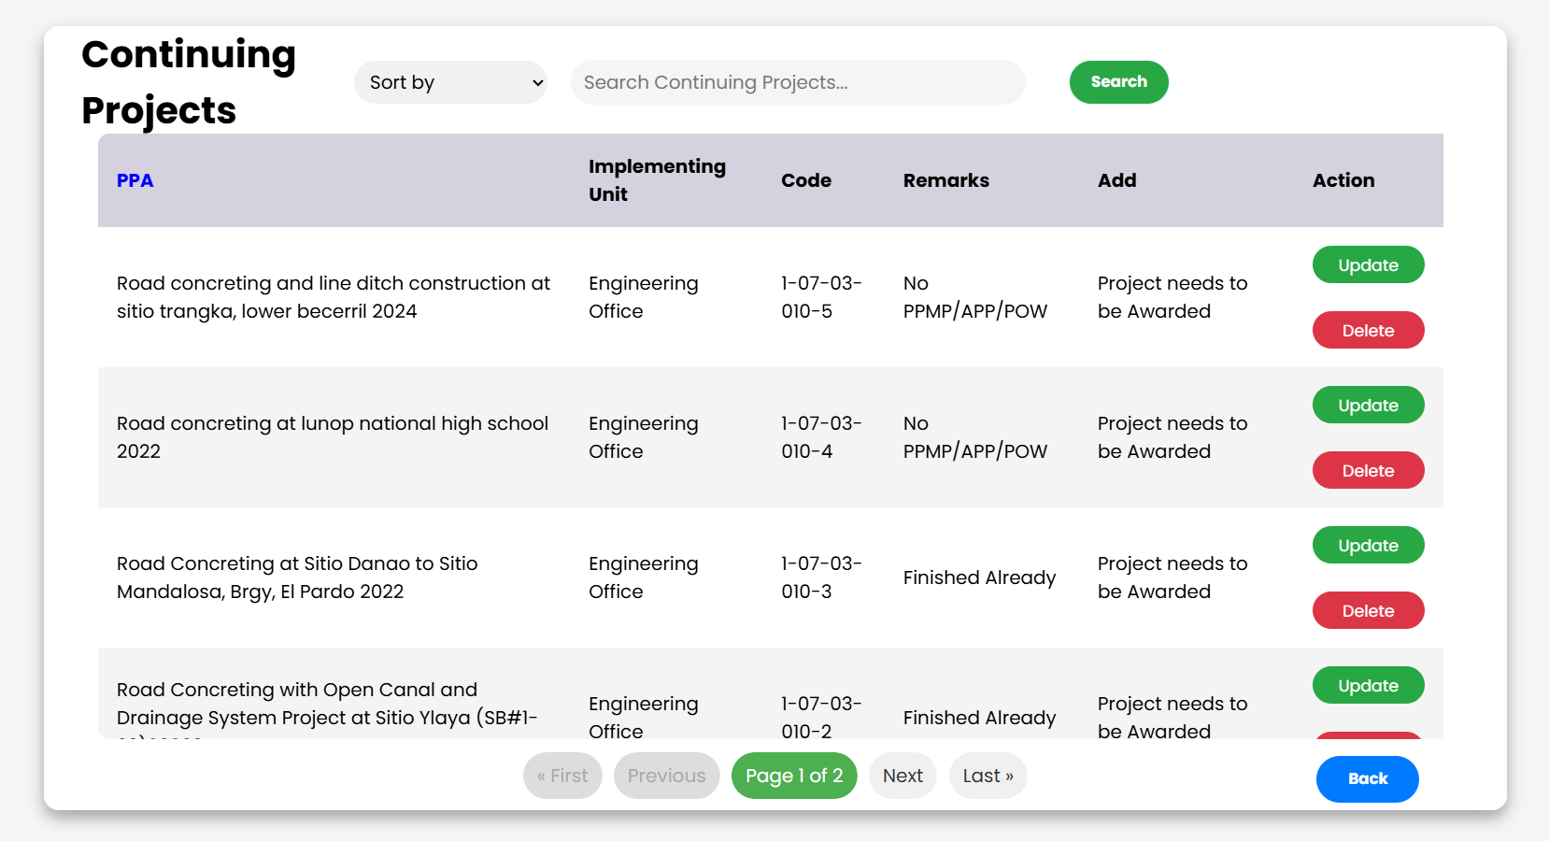

7. Current Projects
- Project List – Displays:
  - PPA (Project Title)
  - Implementing Unit
  - Code
  - Remarks
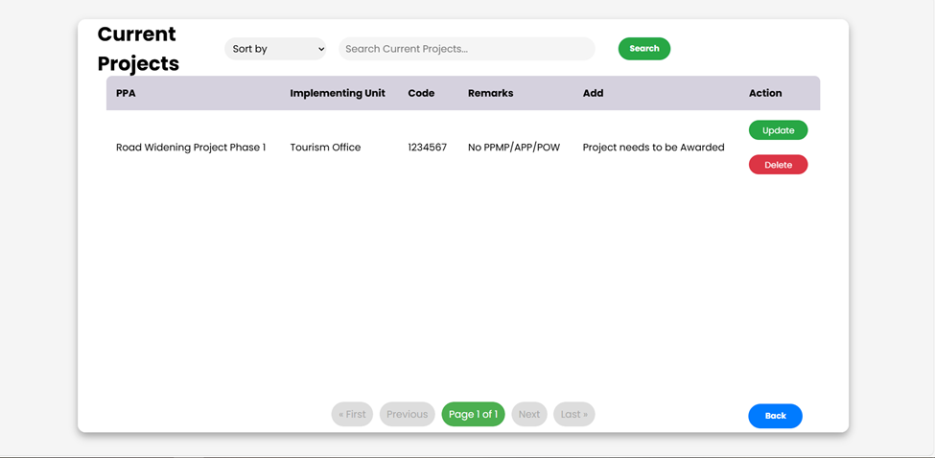
  - Additional Notes

Actions
- Update – Edit project details
- Delete – Remove project from the list
- Back – Return to the previous page
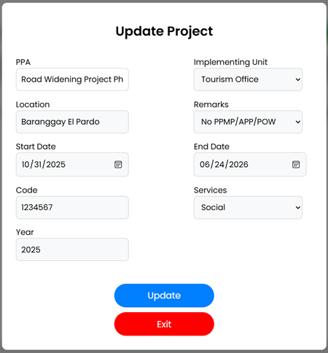
- Use navigation buttons (First, Previous, Next, Last) to browse multiple pages of projects
The Update Project form is used to modify the details of an existing project. Users can update information such as project title, location, implementing unit, start and end dates, and remarks. Once updates are complete, the user can save the changes or exit without saving.
- PPA (Program/Project/Activity)
  - Enter or edit the project name.
  - Example: Road Widening Project Ph.
- Location
  - Specify the project site.
  - Example: Barangay El Pardo.
- Start Date
  - Select the date when the project begins using the calendar picker.
  - Example: 10/31/2025.
- Code
  - Enter the project’s unique identification code.
  - Example: 1234567.
- Year
  - Indicates the project year.
  - This field may be auto-filled and not editable.
  - Example: 2025.
- Implementing Unit
  - Select the department or office responsible for executing the project.
  - Example: Tourism Office.
- Remarks
  - Additional notes or classifications about the project.
  - Example: No PPMP/APP/POW.
- End Date
  - Select the expected project completion date.
  - Example: 06/24/2026.
- Services
  - Choose the type of service category related to the project.
  - Example: Social.
7.2 Project Needs to Be awarded to display the obligation and budget
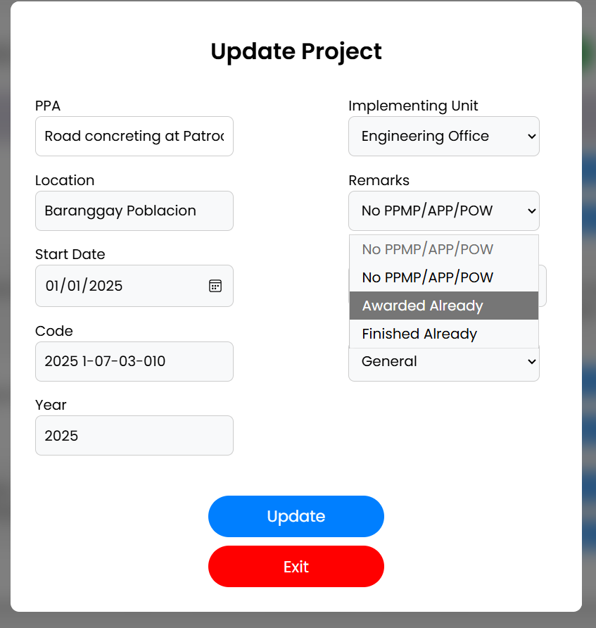
Once the project is awarded already you can add obligation and budget.

7.3 Add obligation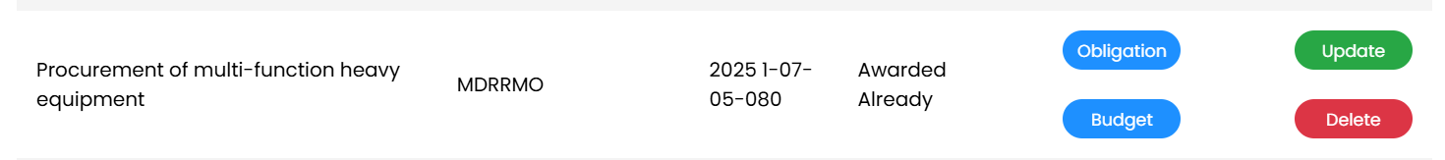
STEPS
- Click obligation button

Payee – Enter the name of the person, supplier, or entity to be paid.

Date – Select the obligation date using the calendar picker (mm/dd/yyyy).

Amount – Input the amount to be obligated in Philippine Peso (₱).

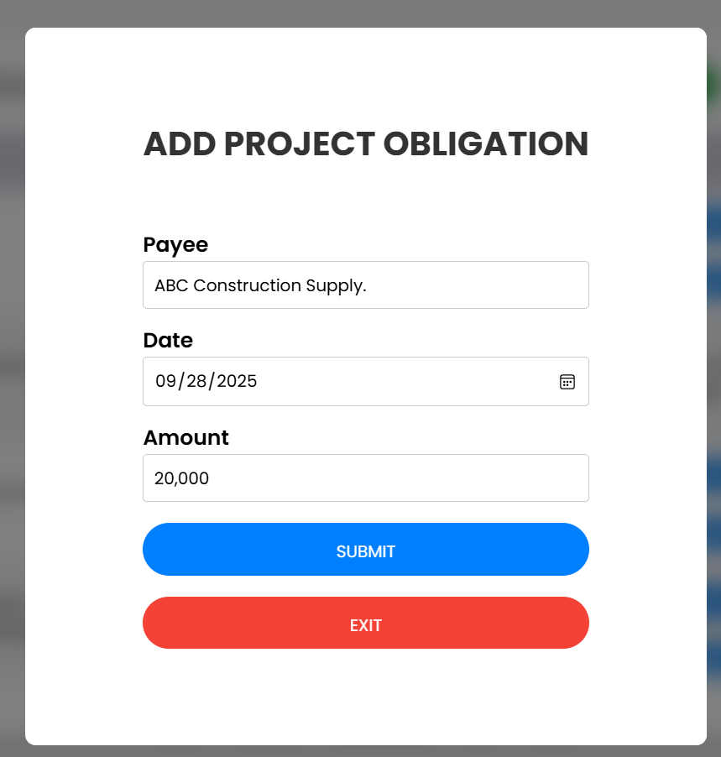

Submit – Save the obligation details into the system.

6. Exit – Cancel the process and return to the previous page.

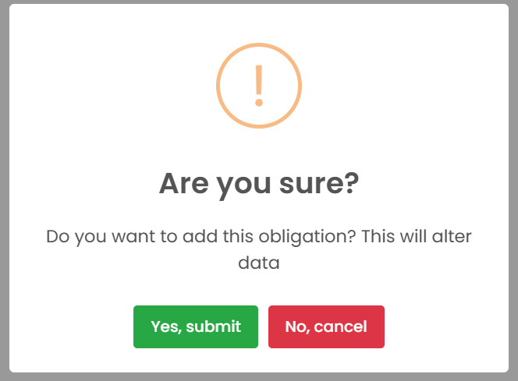

7.4 ADD BUDGET
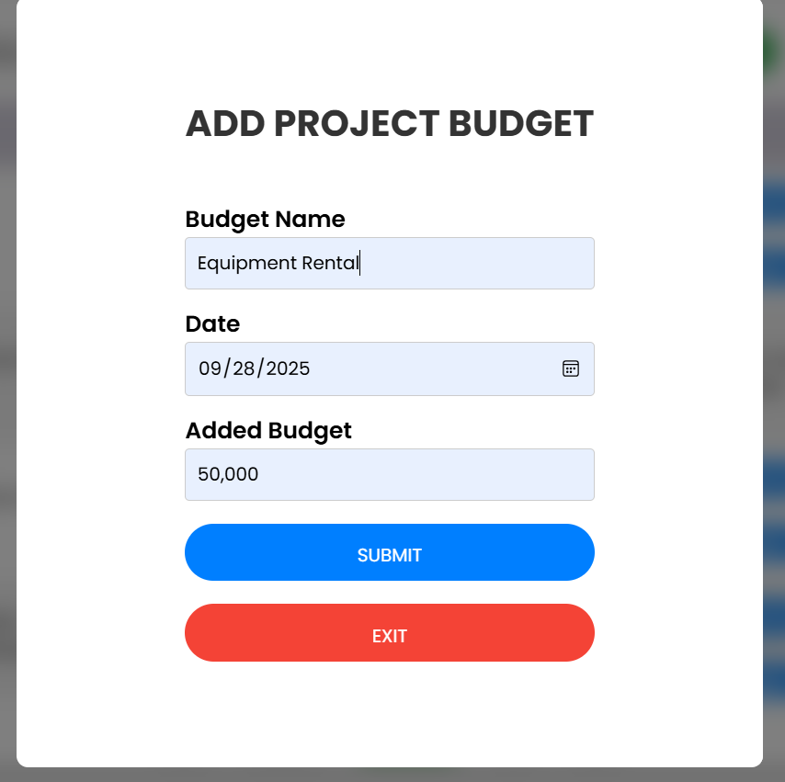
This form is for adding a project budget, which means you’re recording money that will be allocated or added to your project.
Steps:
- Click Budget button
- Enter Budget Name (e.g., Materials, Labor).
- Select Date (budget approval/added date).
- Input Added Budget amount.
- Click Submit to save or Exit to cancel.
Example:
- Budget Name: Equipment Rental
- Date: 09/28/2025
- Added Budget: 50,000

8. Procurements
The Procurements module allows users to view, search, and manage procurement projects within the system. Each procurement entry provides details such as the project name, implementing unit, project code, remarks, and available actions.

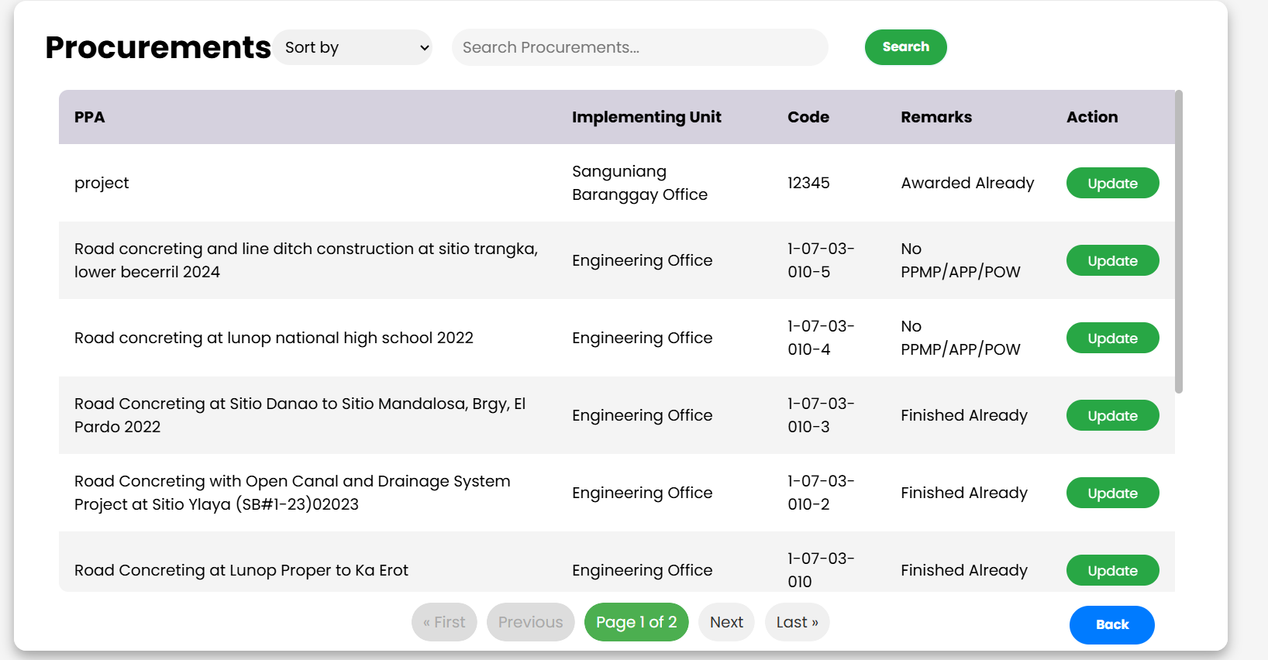
8.1 Updating a Procurement
- To update a procurement, click the green "Update" button in the "Action" column for the corresponding item.
- This will open a new dialog box where you can edit the "Remarks" field.
- After making your changes, click the blue "Update" button to save them.
- If you do not want to save the changes, click the red "Exit" button.

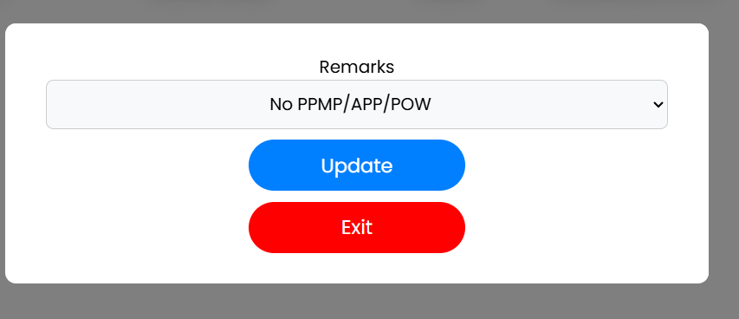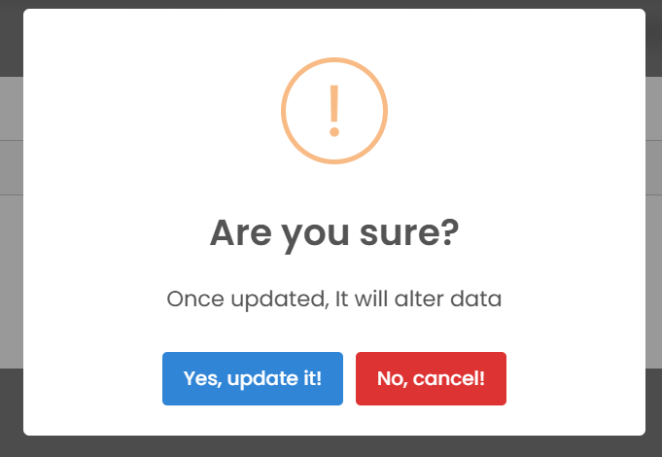

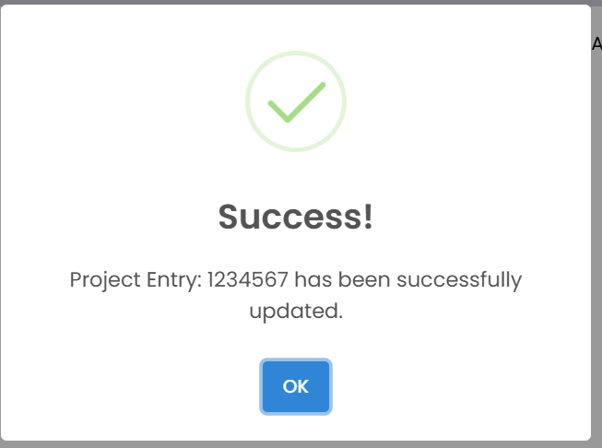
8.2 Confirming the Update
- After you click the "Update" button, a confirmation dialog box will appear.
- This dialog warns you that updating the data is a permanent action.
- To proceed with the update, click the blue "Yes, update it!" button.
- After that success pop up will display.
- To cancel the update and go back to the previous screen, click the red "No, cancel!" button.
9. Disbursement
Disbursement means the actual release or payment of money from a budget or fund.
- The main screen displays a list of projects and their disbursement status in a table.
- The table includes the following columns:
  - PPA: The name of the project.
  - Total Disbursed: The total amount of funds that have been disbursed for the project.
  - Balance: The remaining balance of the project's funds.
  - Add: This column shows the status regarding adding new disbursements. The message "Project needs to be Awarded" indicates that you cannot add disbursements until the project is officially awarded.
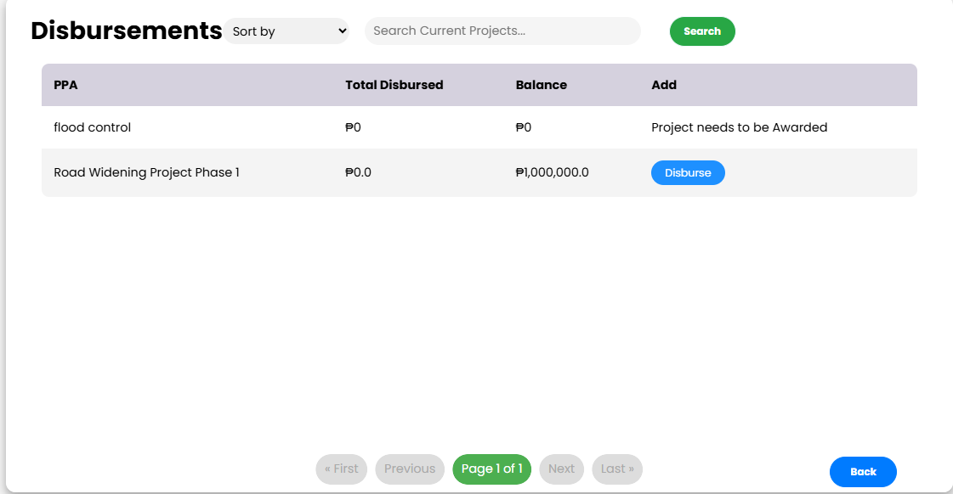

9.1 DISBURSE
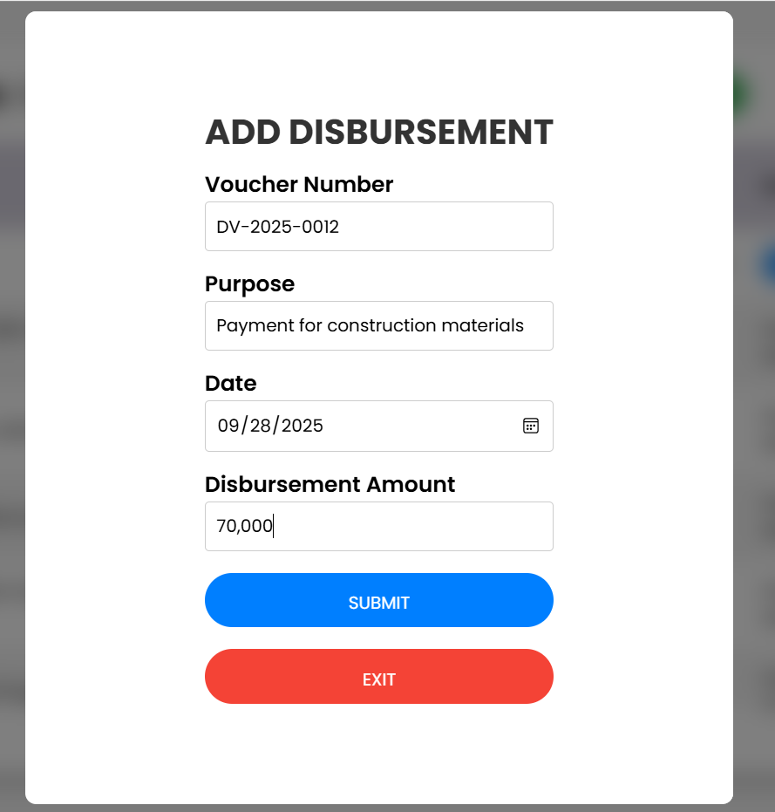

Steps:
- Voucher Number → Enter the official voucher reference (e.g., DV-2025-0012).
- Purpose → State the reason for payment (e.g., Payment for construction materials).
- Date → Select the payment date (e.g., 09/28/2025).
- Disbursement Amount → Enter the amount paid (e.g., 70,000).
- Click Submit to save or Exit to cancel.

10. Check Payment
The main screen shows a table of projects and their payment status.
- PPA: The name of the project.
- Remaining Obligations: The amount of money still owed for the project. In the example, it shows ₱0.
- Total Obligation: The total amount of money that has been obligated for the project. In the example, it also shows ₱0.
- Add: This column indicates the status for adding a new payment. The message "Project needs to be Awarded" tells you that payments can't be added until the project has been officially awarded.
- Project List
  - The table displays important payment details for each project:
    - PPA – Project Title
    - Remaining Obligations – The unpaid amount left for the project
    - Total Obligation – The overall project financial obligation
    - Add – Notes about the project’s payment status (e.g., “Project needs to be Awarded”)

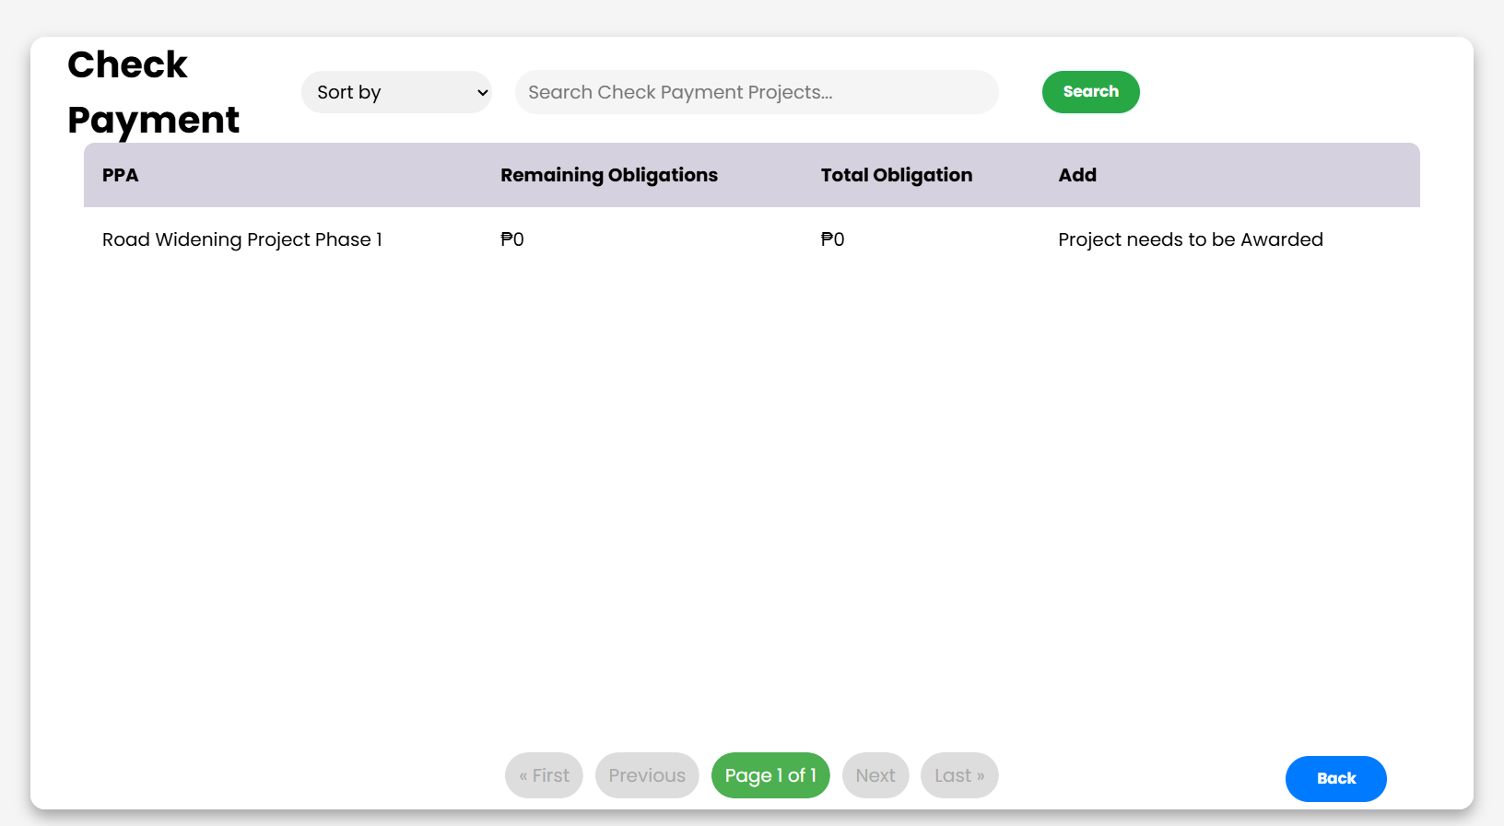

Click a PPA and we can see the detailed information about a specific project.
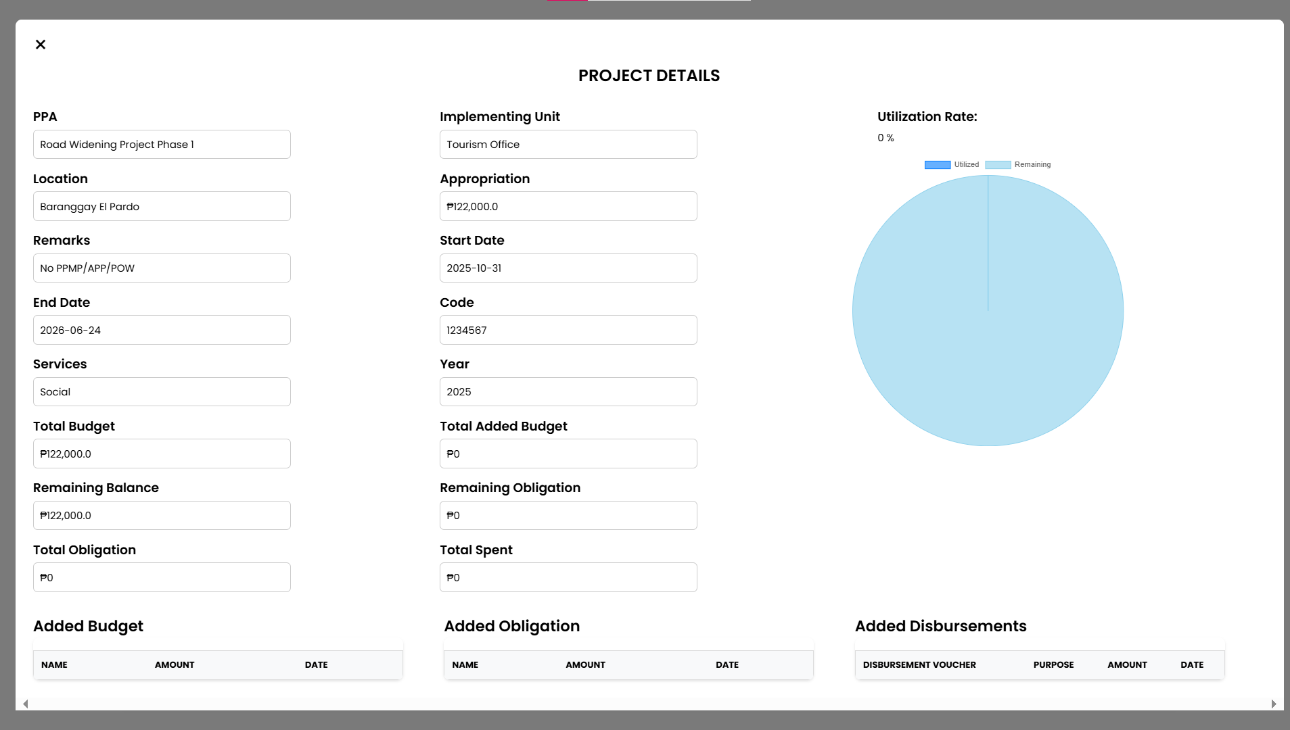

11. Obligation
- The main screen displays a table of projects and their financial obligations.
- Each row represents a single obligation and includes the following information:
  - PPA: The name of the project.
  - Implementing Unit: The department or office responsible for the project.
  - Code: A unique identifier for the obligation.
  - Year: The year the obligation was created.
  - Total Disbursed: The total amount of funds that have been disbursed for this obligation.
  - Balance: The remaining balance of the obligated funds.
- To search for a specific obligation, type a keyword into the "Search Obligations..." bar.
- To sort the list, click the dropdown menu next to "Sort by."
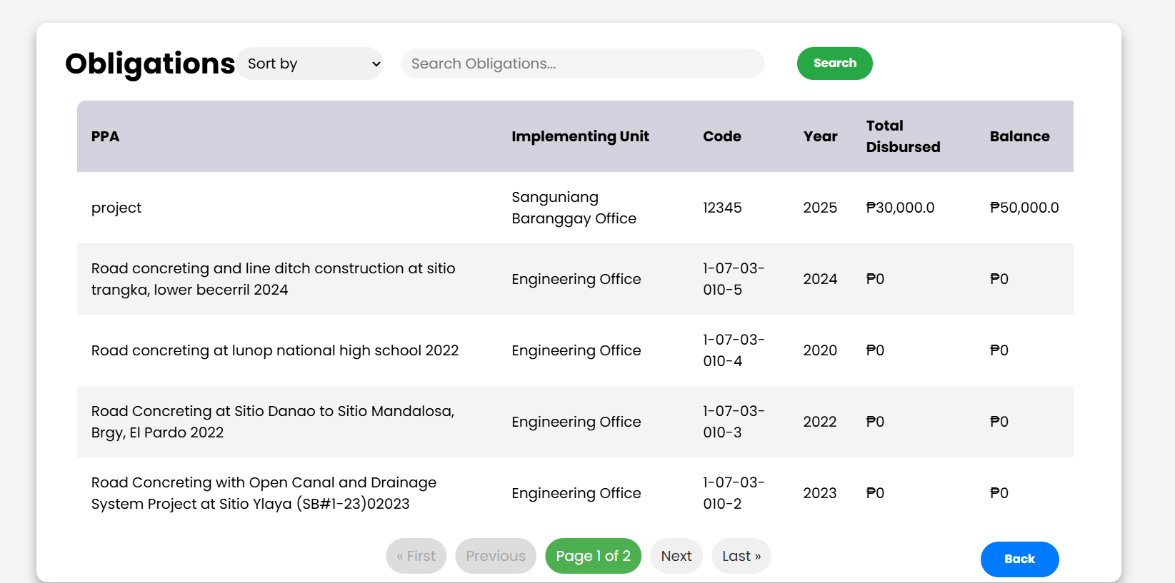
- Click the green Search button to apply your search or sort criteria.
2. Viewing Project Details
- A separate pop-up screen titled "PROJECT DETAILS" provides a more detailed breakdown.
- It displays the Remaining Obligation and Total Obligation for the selected project.
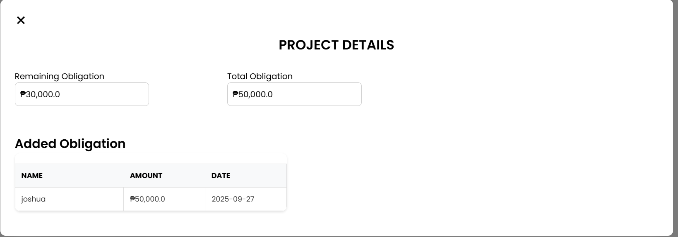
- It also shows a list of individual added obligations with columns for "NAME," "AMOUNT," and "DATE."

12.Generate Project Reports
This screen is used to create and download reports about ongoing projects.
- View Projects: The table lists projects by their PPA (Project name), Implementing Unit, Code, and Services.
- Search and Filter: Use the Sort by dropdown and the search bar to find specific projects. Click the green Search button to apply your filters.
- Download Reports:
  - To download a report for a specific project, click the green checkmark in the Download All column.
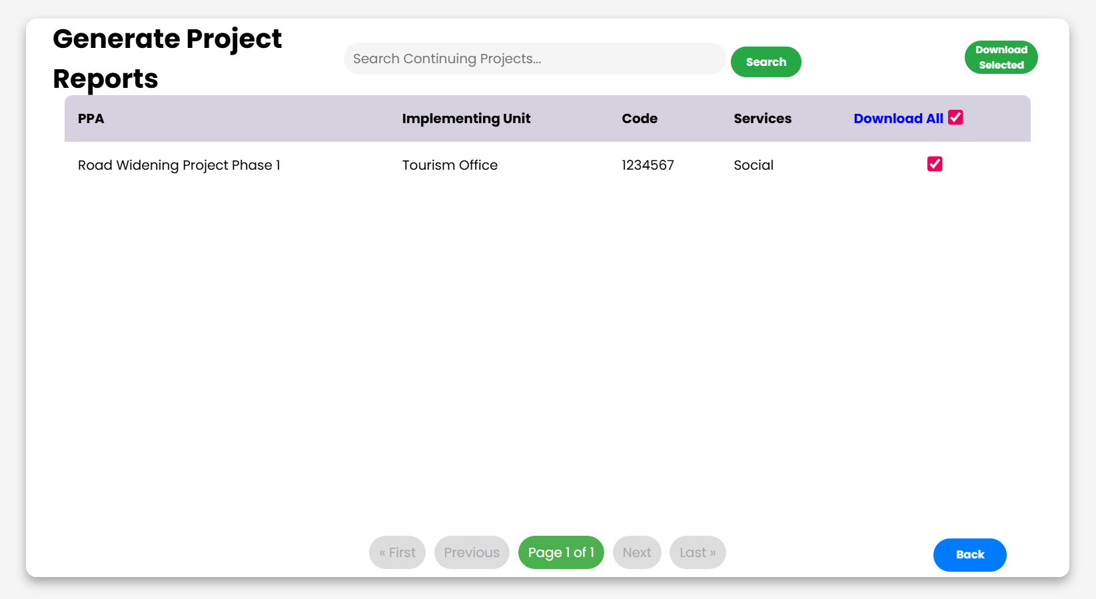
  - To download reports for all listed projects, click the green Download All button in the top-right corner.

  - Clicking either option will open a pop-up window, allowing you to open or save the generated report file (e.g., Projects Report (2).xlsx).
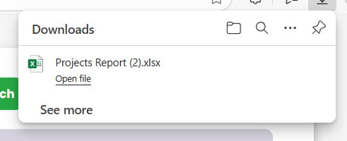

13. Monitoring and Evaluation

- Utilization Rate Summary: At the top of the screen, you'll see a quick summary:
  - Projects Above 50% Utilization Rate: This box shows the number of projects that have used more than half of their budget.
  - Projects Below 50% Utilization Rate: This box highlights projects that have used less than half of their budget, potentially indicating a slow start or underutilization.
- Detailed Project View: The main section below the summary shows a detailed view for specific projects, such as "Road Widening Project Phase 1."
  - You can see key financial details including Project Budget, Project Obligation, Project Remaining Balance, and the Utilization Rate.
  - The red box around the project details highlights a potential issue, with the "budget underutilized" tag indicating that the project is not spending funds at an expected rate.
- Visual Reports Mode: You can switch between a simple data view and a visual one by clicking the "Switch to visual reports mode" button. This likely shows charts or graphs for a more intuitive understanding of the data.
- Navigation: Click the blue Back button to return to the previous screen.

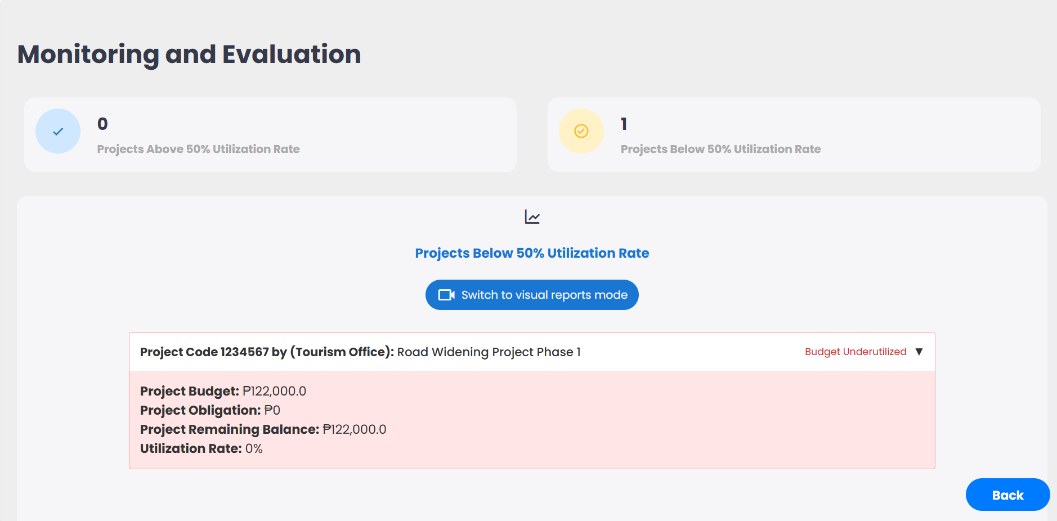

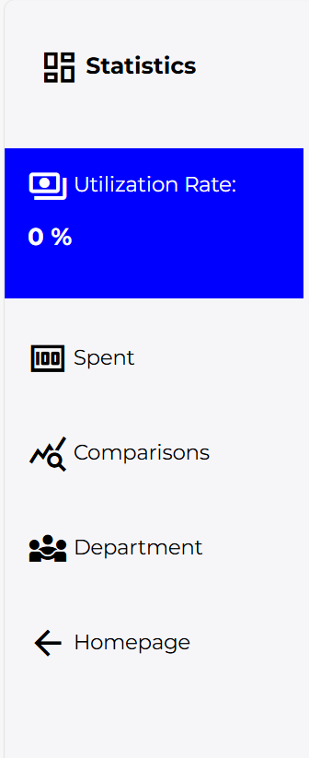
14. Navigation
Navigation Menu (Left Side)
- Utilization Rate – Displays overall project utilization percentage (currently selected).
- Spent – Shows spending breakdown by month/day.
- Comparisons – Compares different financial or performance metrics.
- Department – View utilization and spending data grouped by department.
- Homepage – Return to the main dashboard.

15. Utilization Rate
Utilization Rate Display
- Overall Utilization Rate – Shown inside a circular chart/indicator.
- The percentage reflects the actual progress or spending utilization across projects.
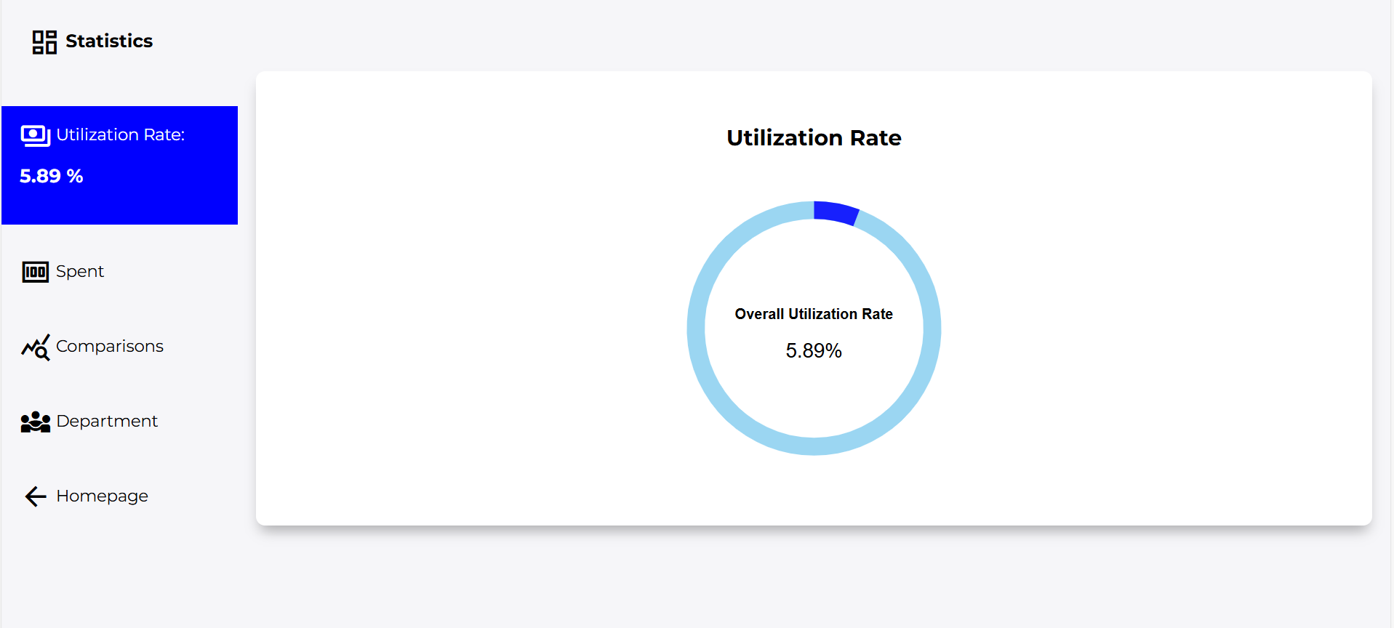

16. Spent
Spent Page Content
  - Graph/Table View – Displays project spending over months.
  - Switch to Daily View – Toggle between monthly and daily breakdown of spending.
Y-Axis (Vertical)
  - Shows amount spent in Philippine Peso (₱).
X-Axis (Horizontal)
  - Shows timeline in Months.
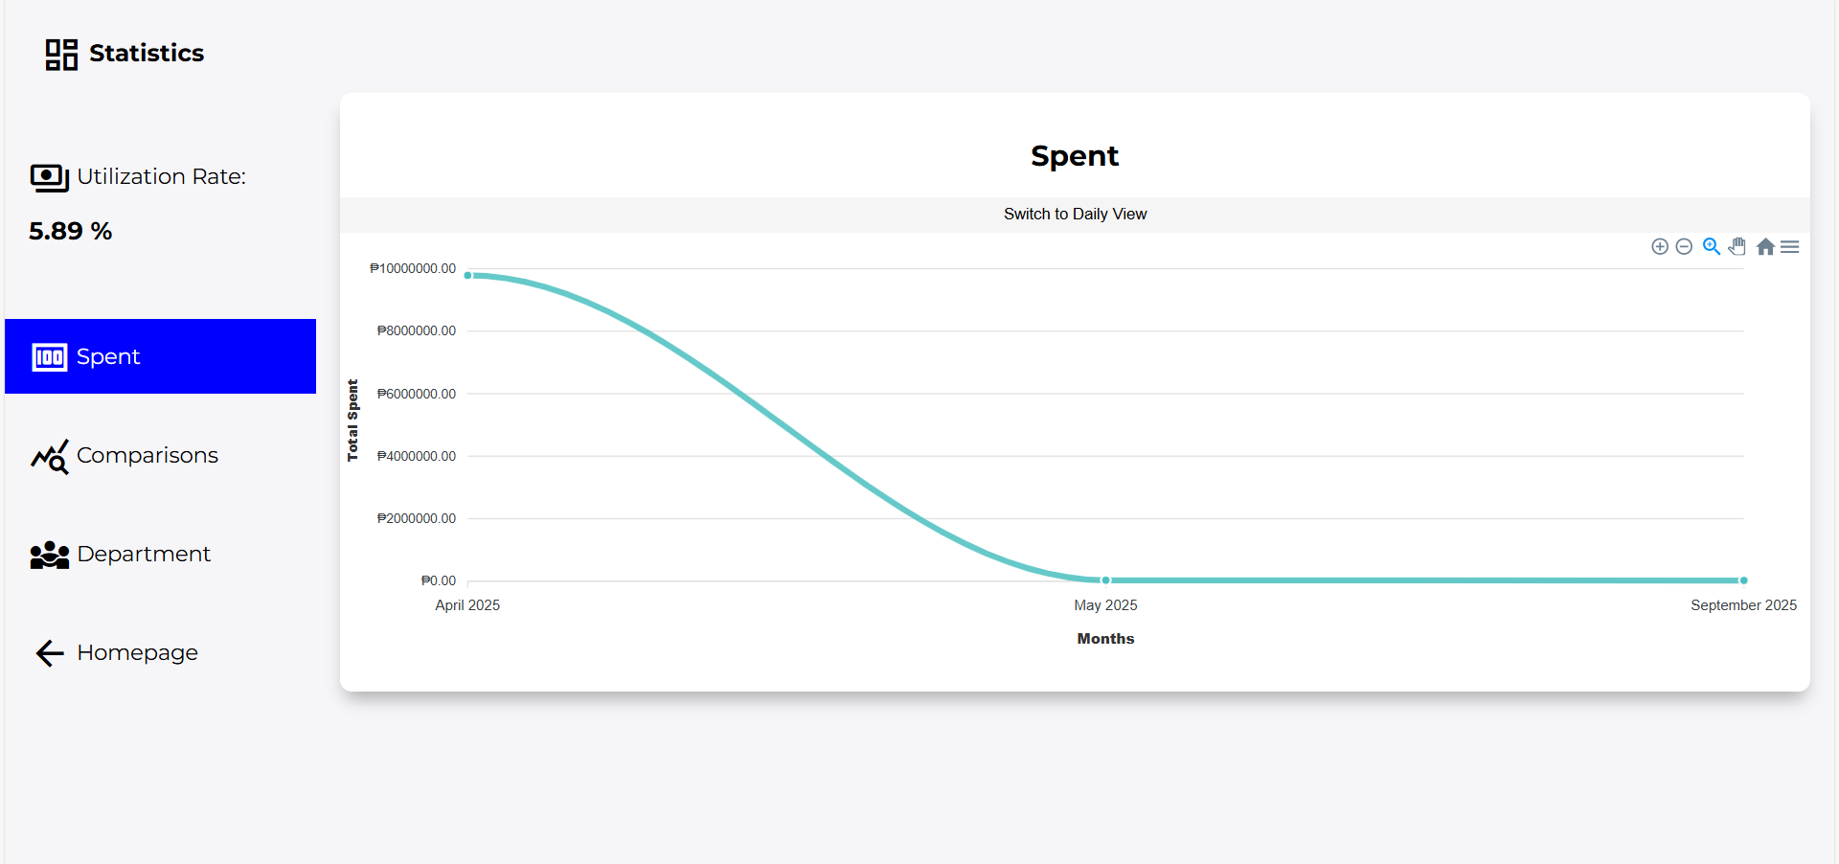
17. Comparison
This page is designed to help you analyze and compare financial data over time. The main graph visualizes two key metrics: Disbursements and Obligations.
- Graph/Table View – The primary display area shows the "Monthly Comparison of Disbursements and Obligations."
- Y-Axis (Vertical) – Displays the Amount of money in a financial unit. This represents the total value for each data point.
- X-Axis (Horizontal) – Represents the timeline in months, allowing for a clear visual comparison of how each metric changes over the year.

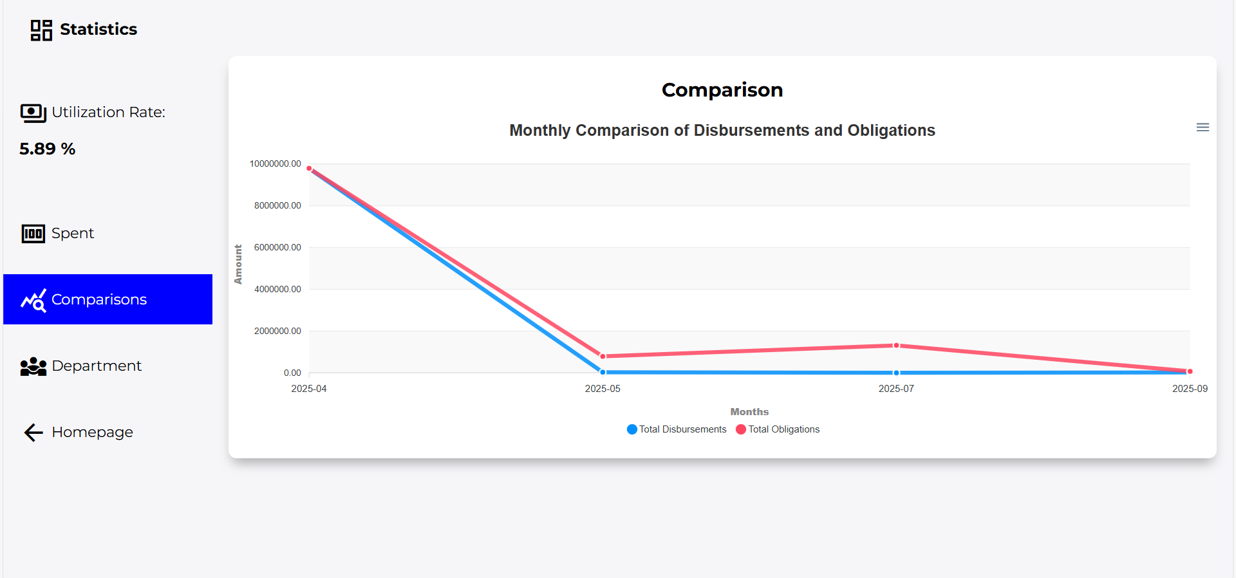
18. Department Utilization Rates
This chart shows the percentage of resource utilization per department.
- Title: Department Utilization Rates
- Y-Axis: Utilization Rate (%)
- X-Axis: Departments (e.g., Tourism Office)
- Bars/Points: Represent each department’s utilization rate
- Menu (top-right): Export or adjust chart view (if enabled)

How to Use
- Check the bar height to see a department’s utilization rate.
- Compare departments to identify high or low utilization.
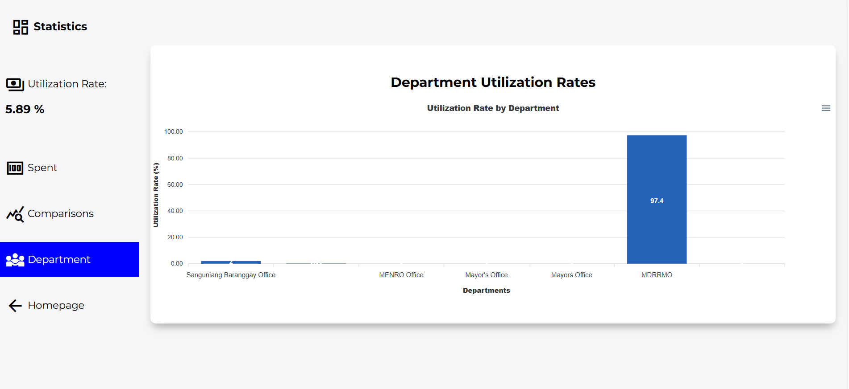
- Use the menu to export/download the chart if needed.

19. Create Admin Account
This page is used to register a new administrator account for the Kwentas Klaras Project Management Information System.

Steps:
- Enter Account Username – unique system login name.
- Enter Full Name – administrator’s complete name.
- Enter Employee Email – official government email (e.g., @boljoon.gov.ph).
- Select Department – choose the department you belong to.
- Set Password – create a strong password.
- Confirm Password – re-enter the password to verify.
- Request OTP Code – click Send Code, check your email, and enter the 6-digit OTP.
- Click Create Account – to finalize registration.
- Click Cancel – to stop and return to the previous page.

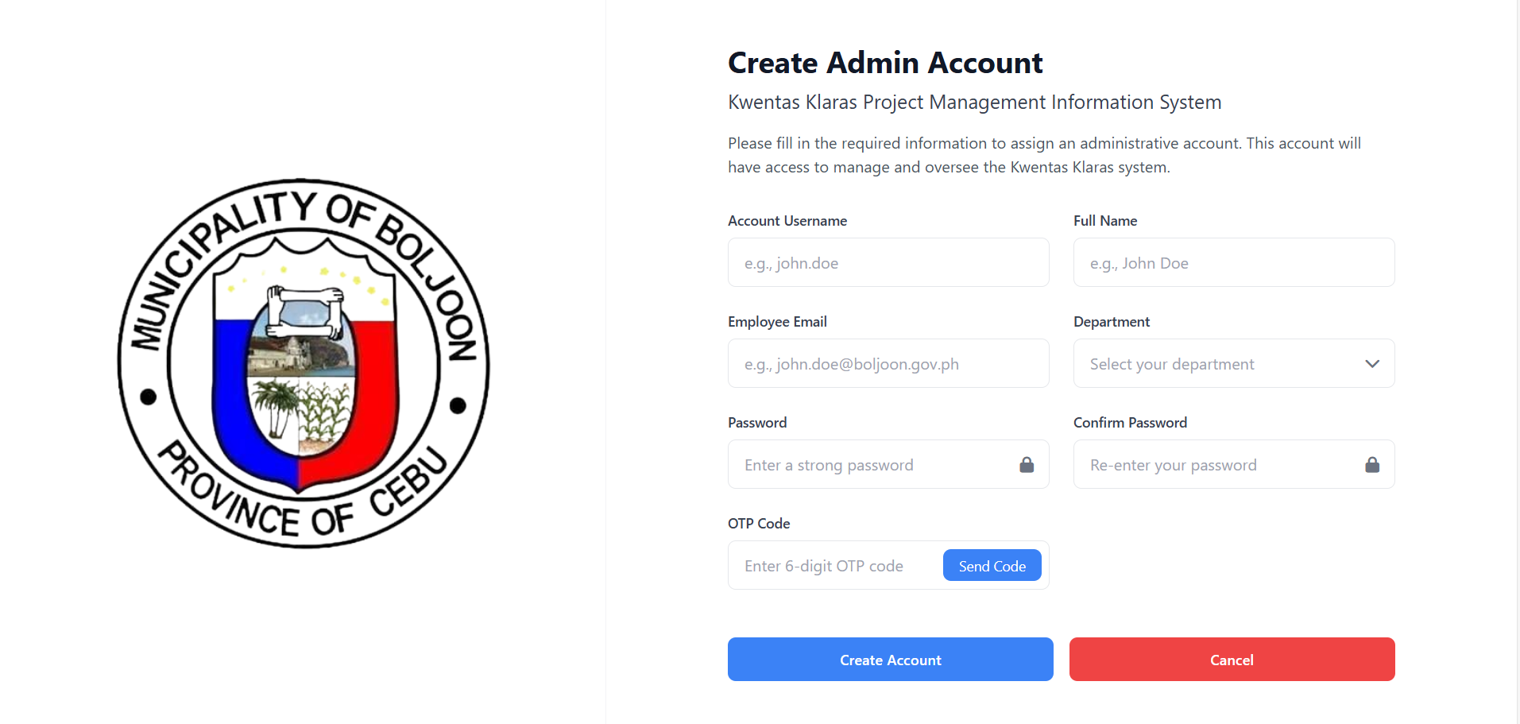

20. Admin Dashboard
The Admin Panel allows system administrators to manage users, groups, and track system events.

Main Sections
- Authentication and Authorization
  - Groups – Manage user groups and their permissions.
- Easy Audit Application
  - CRUD Events – Track Create, Read, Update, Delete actions.
  - Login Events – Monitor user login activities.
  - Request Events – View system requests for auditing.
- Kwentasapp
  - Users – Manage Kwentas Klaras system users (add, edit, or remove accounts).
- Recent Actions (Right Panel)
  - Displays the latest activities performed in the admin panel.

How to Use
- Log in with your admin account.
- Select a section (e.g., Users, Groups, CRUD events) from the left sidebar.
- Perform management tasks (add, edit, delete, view logs).
- Check Recent Actions for quick tracking of latest updates.

