EVALUATING THE SATISFACTION LEVEL AND EFFECTIVENESS OF A DIGITAL PROJECT MANAGEMENT INFORMATION SYSTEM

A Capstone Project

Presented to Information Technology Department
Cebu Technological University
Argao Campus
Lamacan, Argao, Cebu

In Partial Fulfillment of the Requirements for the Degree of
BACHELOR OF SCIENCE IN INFORMATION TECHNOLOGY

CARZANO, JHUDIEL ANTHONY
CHAVEZ, HONZEL BABE
SAGARINO, FRANCIS XAVIER
SAYSON, MHARION JAY
SILVANO, KIMBERLY

OCTOBER 2025

TABLE OF CONTENTS
Page
TITLE PAGE I
TABLE OF CONTENTS II
LIST OF TABLES IV
LIST OF FIGURES V
CHAPTER 1 1
INTRODUCTION 1
Rationale of the Study 1
Statement of the Problem 2
Review of Related Literature 3
Review of Related Studies 7
Review of Related Systems 9
Comparative Matrix for Related Systems 11
Conceptual Framework 12
Significance of the Study 15
Scope and Limitations 16
RESEARCH METHODOLOGY 18
Research Design 18
Flow of the Study 20
Research Locale 22
Research Respondent 23
Research Instrument 24
Data Treatment 28
SYSTEM METHODOLOGY 29
External Interface Requirements 29
Functional Requirements 30
Performance Requirements 53
Design Constraints 54
Software System Attributes 55
Schedule Feasibility 57
Data Design 59
System Architecture 61
CHAPTER 2 63
Presentation, Analysis, and Interpretation of Data 63
Definition of Terms 78
References 85
Appendices 88

LIST OF TABLES
Comparative Matrix 11
Conceptual Framework of the Study 13
Research Respondents 23
Rating Scale for System Effectiveness 24
Rating Scale for Effectiveness of Kwentas Klaras 25
Rating Scale for User Satisfaction 26
Rating Scale for Challenges and Limitations 27
Rating Scale for Contributions 28
Weighted Mean Scores for System Effectiveness 65
Weighted Mean Scores for Effectiveness 67
Weighted Mean Scores for User Satisfaction 69
Weighted Mean Scores for Challenges and Limitations 71
Weighted Mean Scores for Contribution 73
Summary of Themes 75

LIST OF FIGURES
Rapid Application Development (RAD) Model 18
Flow of the Study Model 21
Research Locale (Map of Boljoon, Cebu) 22
Use Case for Logging In 30
GUI for Logging In 31
Use Case for View Dashboard 32
GUI for Dashboard 33
Use Case for Manage Procurement 34
GUI for View Procurement 35
GUI for Update Procurement 36
Use Case for Manage Obligations 37
GUI for View Obligations 38
Use Case for Monitor and Evaluate Project 39
GUI for Monitor and Evaluate Project 39
Use Case for Manage Disbursement 40
GUI for Manage Disbursement 41
Use Case for Manage 20% LDF Project 42
GUI for Manage Continuing Project 43
GUI for Manage Current Project 44
GUI for Adding Project 45
Use Case for Generate Reports 46
GUI for View Reports 47
GUI for Generate Reports 48
Use Case for Manage Users and Admin Dashboard 49
GUI for Managing Admin Dashboard 50
GUI for Viewing Uploaded Files 51
GUI for Viewing Users 52
Schedule Feasibility 57
Data Design - Class Diagram 59
System Architecture 61
CHAPTER 1
INTRODUCTION
Rationale of the Study
The Philippine Local Government Units (LGUs) are legally required to place 20% of their Internal Revenue Allotment (IRA) under the Local Development Fund (LDF) for purposes of financing constituent-remitting development projects. Nonetheless, the majority of the LGUs are still experiencing on-going financial management issues, more so in utilizing funds, project monitoring, and provision of basic services.
Boljoon, a 5th-class municipality in Cebu, has struggled to meet the required utilization targets for its 20% Local Development Fund (LDF). In 2021, it received a score of just 2.85 out of 4 in spending management from the Electronic Public Financial Management Assessment Tool (ePFMAT). In the last five years, Boljoon has averaged a utilization rate of only 50.50% for its Local Development Fund (LDF), which is considerably below the 80% standard established by the Seal of Good Local Governance (SGLG). The Commission on Audit (COA) pointed out these inefficiencies in its 2022 Annual Audit Report, identifying the absence of a real-time financial management system, insufficient community engagement, and inadequate monitoring and evaluation (M&E) practices as significant factors contributing to this shortfall.
These repeated issues highlight the imperative necessity for enhanced financial tracking and project management systems in the LDF. To address this, the LGU of Boljoon launched Kwentas Klaras, an online Project Management Information System (PMIS) that aims to facilitate financial monitoring and ease development fund tracking and assessment. Kwentas Klaras is designed to assist Local Government Unit (LGU) personnel and the Local Project Monitoring Committee (LPMC) by providing accurate, real-time information to facilitate decision-making, ensure transparency in fund disbursement, and uphold accountability in project implementation. This system functions as a secure, role-based platform that is accessible solely to authorized users, thereby preventing misuse and ensuring the integrity of the data.

This study focuses on assessing user satisfaction with Kwentas Klaras in terms of its usability, reliability, system features, and contribution to transparency and accountability. User satisfaction serves as an indicator of the system’s practical value, long-term usability, and institutional acceptance. Measuring satisfaction also helps identify areas for improvement, ensuring the system is not only implemented but meaningfully adopted.
Through the automation of conventional manual operations, Kwentas Klaras provides LGUs with a more effective way of financial tracking and public service provision. This research seeks to provide actionable insights that may aid Boljoon and potentially other local government units (LGUs) in enhancing governance practices via digital innovation. Ultimately, the findings are expected to contribute to a deeper comprehension of how digital technology can improve transparency, foster public trust, and facilitate a more efficient allocation of public resources.
Statement of the Problem
This study examines the influence and efficacy of Kwentas Klaras in enhancing financial oversight, fund allocation, and overall transparency in the management processes of Boljoon's LDF. In particular, the research aims to explore how Kwentas Klaras impacts:
- Does Kwentas Klaras enhance the punctuality and thoroughness of project reporting, resulting in greater utilization of the LDF?
- How does Kwentas Klaras improve the Monitoring and Evaluation (M&E) work of the Local Project Monitoring Committee (LPMC) by providing timely and sufficient data that helps make the process more efficient and accurate?
- How satisfied are the system users—including LGU staff and LPMC members—with Kwentas Klaras in terms of its features, ease of use, reliability, and the accuracy of the data it provides?
- What obstacles or limitations have users faced in the adoption and use of Kwentas Klaras, and what suggestions do they provide for the enhancement of the system?
- How does Kwentas Klaras contribute to enhanced transparency and accountability in local government financial management, ultimately leading to increased public trust and institutional credibility?
This research aims to explore how Kwentas Klaras might improve transparency, accountability, and public trust in local governance by addressing these key questions. The findings could offer practical insights that help other local government units (LGUs) adopt similar digital tools to strengthen the management of development funds.
Review of Related Literature
In this section, the value creation, fiscal accountability, and transparency in the execution of projects are addressed by the roles of Web-Based Project Management Systems (WPMS), Project Management Information Systems (PMIS), and e-governance of Local Government Units (LGUs). Good PMIS supports the utilization of resources and decision-making, while e-governance and electronic accounting systems enhance financial integrity and compliance. WPMS enhances real-time monitoring and coordination of projects. The review also discusses how the level of the use of transparency and accountability mechanisms stops corruption and enhances public trust in LGU projects.
The public sector's decision-making and overall operations are greatly facilitated by Project Management Information Systems (PMIS). The existence of a properly functioning PMIS that is designed to correspond with the various stages of the project life cycle and is maintained by competent personnel is mandatory for efficient execution of government projects (Karim, 2011). With the use of PMIS, project managers are able to optimize the processes, protect their resources, and take responsibility for the projects.
Chykarenko et al. (2021) in their research indicate the existence of two main patterns of PMIS usage in nations. The first pattern centers around the evolution of e-governance, the evaluation and prediction of capital expenditure in infrastructure enhancements. This is consistent with the digital-era governance paradigm where the government aims to utilize information systems for improved productivity, openness, and decision-making. In relative terms, the digital transformation of governance leads to improved investment control by determining cost recovery and efficiency in the public domain.
The second trend highlights the enduring issues of public project delivery, especially with respect to corruption, institutional inefficiencies, and democratic development. As digital governance enhances transparency and accountability, the root causes of systemic problems in project management, including ambiguous responsibility, investment risks, and stakeholders' confidence, are still substantial hindrances. Transparency issues, particularly in lower and upper-middle-income economies, prevent private investors from participating due to the concealment of main financial information and project risks.
In spite of these problems, PMIS remains an important public sector tool for project management. Its capacity to improve monitoring, forecasting, and accountability lends itself to better governance. Successful implementation, however, hinges on overcoming institutional weaknesses and ensuring that sound and transparent information informs decision-making.
Similarly, Web-Based Project Management System (WPMS) implementation is necessary to enhance efficiency, coordination, and cost control in delivering projects. According to Liu, Chen, and Cui (2012), the use of a Project Integrated Management Information System (PIMIS) is capable of highly enhancing project performance through effective communication, optimal utilization of resources, and minimizing contract disputes.
The major finding of theirs is that PIMIS, while being just a tool otherwise, is integral to a well-defined project management methodology. An adoption of any web-based system is not itself a guarantee for project success. Also, the web-based character of such systems provides enhanced accessibility, where project managers, contractors, and other interested parties can monitor project status from anywhere. This feature is particularly beneficial for large-scale infrastructure projects with several teams operating in various geographical locations.
Hence, successful deployment of WPMS in an organizational project management system leads to better project outcomes, better coordination, and better efficiency in delivering government and private projects. Resistance to change, technology adjustment, and integration issues, however, must be countered to be able to achieve its full potential.
In the context of financial management, the adoption of the Electronic New Government Accounting System (e-NGAS) has made great strides on the accounting and financial reporting of Local Government Units (LGUs). As stated by Edgardo Jr. et al., e-NGAS is able to enhance the processing of transactions, increase the accuracy of data, and facilitate the keeping of financial records. It allows for more efficient updating of the general ledger and generation of financial statements, which guarantees the timely issuance of financial reports. These improvements aid in promoting financial control and accountability within LGUs.
Quezon City is a notable instance of e-governance success, as the city continuously improves digital governance initiatives. The city is focused on transparency, participatory governance, and effective service delivery (Jagdon et al., 2024). Through the use of online platforms, services from Quezon City can be rendered without losing the trust of the public. There are, however, challenges such as a shortage of digital literacy, inadequate internet connectivity, and privacy data challenges. For e-governance to reach its full potential, the city would have to act more in making the digital infrastructure better, making the country's cybersecurity stronger, and citizen involvement programs aimed at enhancing transparency and the effectiveness of governance.
With the enhancements to the government system of finance, the need for increased transparency of finances still remains a significant problem. Guinigundo (2006) cites the lack of disclosure and low appraisal standards as equally causes for bad financial statements and low public confidence. Furthermore, external auditors often fail to fulfill their social responsibilities because of their business obligations which enhance the neglect of supervision over finances. The weakness of the system in respect to the unverified information sent through different communication channels intensifies the lack of proper policies and laws needing disclosure and change. These problems pose a great challenge that can only be solved by establishing more rigorous standards of financial reporting and auditing in order to enable the public to have confidence in the public finances.
Lastly, the implementation of E-Government systems has emerged as a top strategy in public service delivery transformation and governance transparency. The Philippines, despite undergoing robust economic growth in the recent past, has been faced with underinvestment in public infrastructure and ICT digitalization. In order to counter these challenges, the government has accorded top priority to the use of technology for effective public expenditure, improved service delivery, and improved governance (Diokno, 2017). Utilization of the E-Government Fund for the purpose of facilitating the implementation of ICT projects within the public sector is one of the top strategies in the transition.
In spite of this, studies have established that bureaucratic resistance to change remains a major hindrance to the roll-out of E-Government. The risk-averse culture of the conventional government structure impedes the successful roll-out of computer programs (Lallana, Pascual, & Soriano, 2002). Governments can implement performance-based incentives, grants, and bonuses for the successful roll-out of E-Government to overcome these hindrances. Additionally, there was no centralized ICT management framework in the previous context that hindered digital development in the nation. Institutionalizing a Department of Information and Communications Technology (DICT) in 2016 undid this limitation on digital development in terms of policy coherence, digital mainstreaming, and ICT-related policy leadership (Magno, 2018).
Outside the Philippines, digital governance issues in the building of open and inclusive societies globally are significant. The accelerated evolution of digital technologies revolutionized government-citizen relationships, bringing politics closer and more efficiently (Berch et al., 2024). Social media and the Internet offer new spaces for public participation, where citizens can receive information, discuss, and share views on governance issues. Electronic voting and digital public services also promote accessibility, moving towards equal opportunity for all, including the disabled.
Despite all these benefits, the digital divide remains a pressing problem. Technology access disparities can exacerbate social inequalities and limit marginalized communities' access to government. Moreover, disinformation, cybercrime, and privacy issues are concerns that can best be mitigated by strong regulatory frameworks so that digital technology contributes to democratic rule and not imperils it (Berch et al., 2024). Lastly, E-Government and e-governance policies have a lot to offer in terms of increasing transparency, efficiency, and trust between governments and citizens. Their success, however, will be based on the adoption of proper policies, Internet connectivity, and a strong will to overcome institutional obstacles.
Review of Related Studies
The Government Internal Supervisory Agency (APIP) is responsible for conducting internal supervision within government institutions. With the development of the Electronic-Based Government System (SPBE), business processes in government governance have transitioned from manual to digital operations. The implementation of SPBE in government activities has resulted in an extensive accumulation of digital data and documents. However, despite this transition, internal audit processes within APIP are still conducted manually, with limited utilization of digital data and no integrated audit management system in place. This gap in digital adoption creates inefficiencies and challenges in audit activities.
To address this issue, a study was conducted to design an integrated electronic-based audit system (e-Audit) that aligns with SPBE in the APIP environment. Using a qualitative research approach with a case study methodology, the study focused on one of the Inspectorates of Non-Ministry Government Institutions. The findings led to the development of an integrated e-audit system model, which is described using a System Context Diagram, Data Flow Diagram (DFD), and Entity Relationship Diagram (ERD). This research highlights the importance of digital transformation in government auditing processes and serves as a reference for future developments in automated audit management systems.
This study is relevant to the design of a Purchase Request and Financial Tracking System, as both research efforts emphasize the need for digital integration in government financial processes. Just like the inefficiencies in audit processes, old financial tracking and purchase request systems within government agencies are delayed and mismanaged through manual processes. Through the application of digital technologies like an integrated tracking system and formal modeling methods, government agencies are able to promote efficiency, transparency, and accountability in financial management.
New technology advancements support some sectors, like government agencies and financial services. These technologies improve efficiency, accuracy, and transparency in financial transactions (Office of Technology Assessment, 1984). Government institutions use procurement procedures to purchase goods and services needed for their operations (Vicente, 2008). Nevertheless, conventional procurement and financial monitoring systems are usually slow, resulting in delays and financial mismanagement (Salcedo, 2016). In response to such issues, Agile Prototyping has been used extensively in system development to enable fast software iteration in accordance with feedback from users in real time (Beck et al., 2001). Research suggests that Agile methodologies enhance user participation and system usability through the ability to make iterative improvements prior to large-scale adoption (Highsmith, 2002). Furthermore, process and data modeling methodologies, like the Unified Modeling Language (UML), are vital in creating well-organized financial monitoring systems (Booch, Rumbaugh, & Jacobson, 1999). Proper data models contribute to accurate budget allocation and expense monitoring, ensuring better financial management (Jose, 2012). Even with these technological improvements, government institutions tend to resist adopting automated solutions because of bureaucratic opposition and dependency on conventional processes (Ritchie, 2014). The persistence of using simple office applications for procurement and financial monitoring leads to inefficiencies, delayed processes, and the absence of real-time financial monitoring (Salcedo, 2016).
To overcome these issues, the proposed Purchase Request and Financial Tracking System is designed to streamline procurement workflows, enhance transparency, and optimize budget allocation through Agile Prototyping and UML-based modeling. Moreover, incorporating features such as PR mapping, document upload capabilities, and machine learning for budget prediction will further improve the system’s functionality. This research adds value to the current body of work by presenting an extensive framework to update financial operations in government departments, providing a platform for system implementation and further research. Government institutions can adopt emerging technologies and shift towards effective and transparent systems of financial management to ensure enhanced service delivery and accountability.
Review of Related Systems
Over the past few years, there have been various digital systems developed and implemented internationally to enhance public financial management and service delivery. These systems, apart from bolstering financial oversight and accountability, also promote transparency, efficiency, and user satisfaction in government processes. This chapter discusses some related systems that showcase how technology enhances the management and assessment of public sector projects, offering applicable insights into how Kwentas Klaras can potentially benefit.
An example of such a system is FreeBalance, which has been proven to positively affect public service quality. Through enhancing financial management practices, the system allows governments to make more efficient use of resources, thus improving service delivery. For instance, with regard to the Directorate General of State Treasury of East Timor, it was discovered that the system helped boost the quality of public services as it facilitated a better allocation of funds to civil society organizations. This consequently promoted greater public satisfaction with government services (Gama, 2014).
Additionally, the performance of FreeBalance in terms of improving the quality of public service can be supported by various attributes, such as enhanced transparency, accountability, and financial management efficiency. Through offering real-time data and high-caliber reporting capability, the system allows governments to track expenses, pinpoint inefficiency, and inform data-based choices. Such capacity is most necessary within the field of public sector financial management due to the required transparency and accountability to uphold people's confidence (Gama, 2014).
Alongside financial systems, Monitoring and Evaluation (M&E) tools also contribute significantly towards the effective application of development projects. These systems give critical feedback on the impact, efficiency, and effectiveness of interventions. M&E systems aim to produce credible data that is used to make decisions, facilitate accountability, and maximize project impact. Importantly, the use of M&E processes tends to involve multiple stakeholders. In Machakos County, Kenya, stakeholder engagement was discovered to enhance M&E by aligning project planning with the needs of the community and feedback to enhance project delivery (Kimote & Muchai, 2024).
Another key development in public sector systems is Integrated Financial Management Information Systems (IFMIS) use. These are solutions that are meant to enhance the financial operations through consolidating various processes for government institutions. By automating and integrating data processing, IFMIS raises transparency, accountability, and efficiency in handling public finances. In addition to that, its use has been demonstrated to strongly affect fraud detection, fiscal reporting, and overall fiscal discipline, and thus it is an essential driver for enhancing operational efficiency in the public sector.

Table 1
Comparative Matrix for Related Systems
System Features | FreeBalance: Government Financial Management System | DevResults: Monitoring & Evaluation (M&E) for Development Projects | Integrated Financial Management Information System (IFMIS) | Kwentas Klaras: A Digital Project Management Information System
Utilization Management Development Fund | ✔ |  | ✔ | ✔
Procurements | ✔ |  | ✔ | ✔
Obligations/  Disbursement | ✔ |  | ✔ | ✔
Monitoring and Evaluation |  | ✔ |  | ✔
Reports | ✔ | ✔ | ✔ | ✔
Account Management | ✔ | ✔ | ✔ | ✔
Total Percentage | 83.33% | 66.67% | 83.33% | 100%

The comparative matrix (Table 1) emphasizes the unique strengths and functional coverage of different financial and monitoring systems employed for public sector project management. Of the systems compared (FreeBalance, DevResults, IFMIS, and Kwentas Klaras), Kwentas Klaras stands out as the most comprehensive, with all the main features across financial tracking, procurement, reporting, and monitoring. Whereas FreeBalance and IFMIS exhibit strong strengths in handling obligations, disbursements, and procurements, they lack strength in project-specific monitoring and evaluation functions. DevResults, however, emphasizes more on M&E processes and stakeholder participation but does not have fundamental financial management tools like procurement and disbursement tracking.
By comparison, Kwentas Klaras combines financial management and M&E, in particular, designed to enable effective utilization of the 20% Local Development Fund (LDF). Kwentas Klaras fills gaps found in other systems by giving real-time project monitoring, detailed reporting, and user-driven interface for LGU staff members and LPMC representatives. With 100% feature implementation, Kwentas Klaras not only supports the operational needs of local government but also increases accountability, efficiency, and service delivery.
Conceptual Framework
The creation and assessment of Kwentas Klaras: A Digital Project Management Information System are informed by the Input-Process-Output (IPO) model. This model offers a systematic way of understanding how the system is conceptualized, deployed, and evaluated, especially in terms of improving financial transparency, project tracking, and utilization of the 20% Local Development Fund (LDF) in Boljoon, Cebu. The incorporation of user satisfaction measurement into the evaluation phase guarantees that not only is the system functionally efficient but also user-friendly and meets user needs and expectations. The IPO model has a direct sequence from the initial requirements to the concrete results of the system.

Table 2
Conceptual Framework of the Study
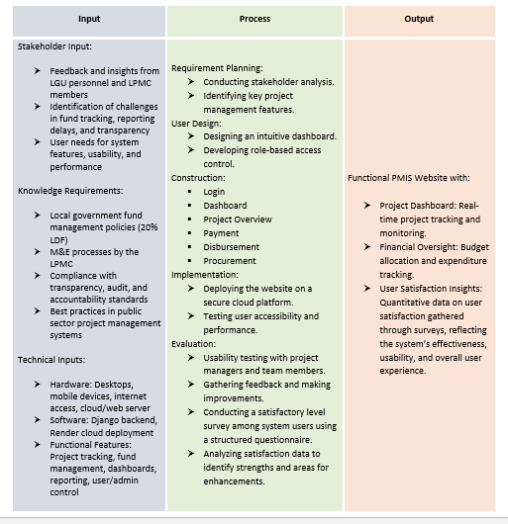
The Input-Process-Output (IPO) model, shown in Table 2, defines the formal flow of elements and activities essential to developing and assessing the Kwentas Klaras Project Management Information System (PMIS). This conceptual model not only directs the technical processes of system design and implementation but also highlights the need for testing user satisfaction to ensure the system's relevance, usability, and lasting influence.
During the input stage of the conceptual framework focuses on gathering essential information from stakeholders, domain knowledge, and technical resources to support the development of Kwentas Klaras. Stakeholder input includes feedback and operational insights from LGU personnel and Local Project Monitoring Committee (LPMC) members, identification of existing challenges in fund tracking, reporting delays, and transparency issues, as well as user expectations regarding system features and usability. Knowledge requirements involve a thorough understanding of local government fund management policies, specifically the 20% Local Development Fund (LDF), existing monitoring and evaluation (M&E) procedures conducted by the LPMC, compliance standards for transparency and audit readiness, and best practices in public sector project management. Technical inputs consist of the necessary hardware such as desktop computers, mobile devices, internet access, and a cloud-based server environment, as well as software tools including Django for backend development and Render for cloud deployment. The required functional features include modules for project tracking, fund obligation and disbursement management, reporting dashboards, and role-based user administration.
The process stage starts with planning requirements by involving stakeholders and the determination of basic project tracking needs. User design emphasizes the development of a readable, user-oriented interface with access control based on roles to strengthen security and ease of use. Construction is accomplished by developing significant system modules (e.g., login, dashboard, procurement, and disbursement tracking) with implementation activities that follow them in the form of cloud deployment and performance testing for smooth functioning.
One major improvement in this IPO model is in the evaluation stage, which extends beyond technical performance testing. In this stage, formal satisfaction level questionnaires are taken among system users, such as LGU staff and Local Project Monitoring Committee (LPMC) members. The questionnaires measure user experiences in terms of system reliability, interface, ease of use, and data accuracy quantitatively. The lessons gleaned from such an assessment are employed to critique the strengths and weaknesses of the system. With the inclusion of immediate user comments, the procedure makes sure that the PMIS is not merely functionally appropriate but also user needs and expectation-sensitive.
Lastly, the result is a complete working Kwentas Klaras PMIS site with a live project dashboard and financial tracking facilities. Notably, it also provides a data-based insight into user satisfaction, which captures the usability, functionality, and general effectiveness of the system. The feedback loop reinforces both system quality and user adoption are important indicators of effective digital governance solutions.
Significance of the Study
This research is of great importance since it targets the main issue of finance management and transparency in the local government of Boljoon, Cebu, by presenting Kwentas Klaras: A Digital Project Management Information System (PMIS). The main purpose of this system is to enhance project monitoring, use of funds, and governance as a whole in the municipality. As local authorities work towards maximizing the utilization of public funds and improving service delivery, the results of this research will be instrumental in informing such efforts, hence an important contribution to public sector management and transparency.
The findings of this research will benefit stakeholders across different fields, each of which will witness practical enhancement of local governance execution. They encompass the local government staff, residents, project managers, municipal personnel, and potential researchers. Through investigating the user satisfaction and efficacy of Kwentas Klaras, this study will furnish statistics that will have implications on the development and inclusion of electronic project management systems in the conduct of local government processes.
Local Government Officials. The findings of this study will provide local government officials with a digital instrument meant to advance financial management in order to optimize the use of public funds for effectiveness and efficiency. The system promotes increased transparency and accountability in the execution of local government projects, which will enable the officials to make informed decisions based on current information. The findings of the research will help improve governance procedures and increase the public's confidence in the municipal administration.
Residents of Boljoon. For the residents, the results of the study will offer an understanding of how the local government spends development funds, enhancing the transparency and accountability of public expenditures. The greater clarity will contribute to building confidence in local governance and that public resources are being used effectively, resulting in improved public services and a healthier relationship between the municipality and the people.
Project Managers and Municipal Employees. The study will help the project managers and municipal employees by optimizing the management of the project resources, budgets, and timelines. Kwentas Klaras will reduce the risks of financial mismanagement, minimize errors, and simplify project monitoring. Consequently, the results will enhance efficiency, reduce delays, and overall project performance in the provision of government services.
Future Researchers. Future researchers who would like to pursue research on issues surrounding financial transparency, governance, and project management systems will find the research useful. The findings will be a starting point for more research such that scholars can build on this work, look for future areas of development, and add to the body of knowledge in local government management as well as digital solutions.
Lastly, this research gives a great value to the digital tools in the public governance given that it includes a holistic analysis of the effectiveness of Kwentas Klaras in public governance processes as well as satisfaction of the tool's users.
Scope and Limitations
This research mainly aims to measure the level of satisfaction of the users, which include municipal officials, municipal personnel, and project implementers with the Kwentas Klaras system when implemented in the management of municipal development projects funded by the 20% Local Development Fund (LDF) in Boljoon, Cebu. The ultimate goal is to determine the degree to which the system is responsive to user needs, focusing on usability, user interface, accessibility, and overall contentment with the functions and features of the platform.
The research involves a comprehensive survey in order to provide feedback on whether the system enhances financial tracking, reporting, and monitoring of projects. In particular, the study will quantify users' satisfaction levels with the user-friendliness of the system, ease of use, validity and reliability of the information provided, and overall effect on efficiency in local government operations.
Although the system is made available to the people of Boljoon for transparency, their access to the system is only for viewing financial and project updates. Thus, this study does not take into account the level of satisfaction of citizens since their interaction is mostly passive without direct control over system operation or data management.
The study is bounded to only the Municipality of Boljoon and does not cover other municipalities or government initiatives. It also excludes private sector undertakings and development projects that are financed from other sources outside the 20% LDF. Further, the study recognizes that there might be factors such as internet connectivity, user flexibility, and dedication of the LGU in integrating and sustaining the system, which can be potential drivers of user satisfaction. These factors are not the focal point of research but are understood as possible shortcomings that may have an impact on the overall satisfaction and user experience.

RESEARCH METHODOLOGY
Research Design
This research utilized the Rapid Application Development (RAD) methodology to support the evaluation of user satisfaction with Kwentas Klaras: A Digital Project Management Information System (PMIS). Though RAD was primarily applied to guide the system’s design and implementation through iterative development and active stakeholder involvement, the research also incorporated a mixed-methods approach to assess system effectiveness. In particular, a quantitative survey with a 5-point Likert scale was carried out to assess user satisfaction in different areas like usability, accuracy, and performance. Furthermore, qualitative data were collected using open-ended questions to identify user recommendations, problems, and observations not addressed by the rating scale. This blend of quantitative and qualitative analysis permits a wider consideration, such that the platform is not simply technically operational, but also intuitive, effective, and properly aligned with its practical purposes and expectations of end users.
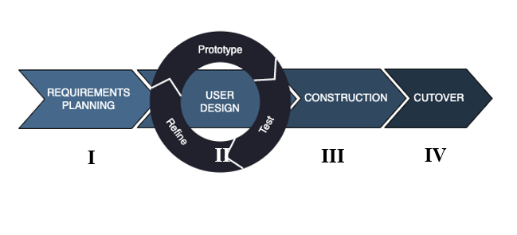
Fig 1. Rapid Application Development (RAD) Model
Kwentas Klaras was developed using the Rapid Application Development (RAD) paradigm that focuses on user participation, incremental prototyping, and quicker delivery. In the Requirements Planning phase, the most critical issues of the LGU of Boljoon in addressing its 20% Local Development Fund (LDF) were identified. By means of discussions with local officials and members of the Local Project Monitoring Committee (LPMC), the team was able to collect system requirements aimed at resolving issues relating to delayed financial reports, inefficient project tracking, and lack of transparency. These inputs were used to shape the goals and functional scope of the system.
The second phase, User Design, was driven by creating and iterating over interactive prototypes. In this stage, the users were keenly involved in giving feedback about prototype versions of the system interface and features. Cycles of prototyping, testing, and iteration permitted the development team to fine-tune the system in real-time, making sure that it was in sync with the workflow and monitoring requirements of the LGU. Core modules (i.e., dashboards, procurement and disbursement management, and project monitoring) were defined through direct user feedback, enhancing ease of use and functionality.
During the third phase, Construction, the final system was constructed based on the tested prototypes. With Django and supporting web development frameworks, the technical team combined all elements of the system into a robust, secure platform. Parallel testing guaranteed functionality, and bug fixes and performance improvements were implemented to ensure the system for real-life usage. In this stage, other aspects like data accuracy, user validation, and report generation were also enhanced for deployment suitability.
The final stage, Cutover, was the complete deployment and implementation of Kwentas Klaras at the LGU. This entailed final data migration, user account creation, and live staff training sessions. Surveys and assessments were done to measure user satisfaction and system performance after deployment. The final adjustments were made as per feedback received, and documentation was done to facilitate the research defense. Overall, the RAD model helped the team provide a user-based solution within the condensed timeline, where the system reflected the precise financial monitoring and project assessment requirements of LGU Boljoon.

Flow of the Study
Input
The study gathered data from LGU personnel and LPMC members in Boljoon, Cebu, individuals directly involved in project tracking, fund monitoring, and system use. Survey instruments and usability tests served as the main input tools to measure satisfaction.
Process
The system was evaluated through usability testing and the administration of a structured, Likert-scale questionnaire. The survey focused on five core areas: (1) financial tracking and fund use, (2) monitoring and evaluation support, (3) functionality and usability, (4) problems encountered, and (5) transparency and accountability. Additional qualitative feedback was gathered to highlight strengths and identify opportunities for system improvement. Data were analyzed using weighted mean computation and thematic categorization of open-ended responses.
Output
The study produced both a fully functional PMIS with real-time dashboards and a comprehensive set of satisfaction data from end users. These outputs offer practical insights into system usability, reliability, and its role in enhancing financial and project management processes.
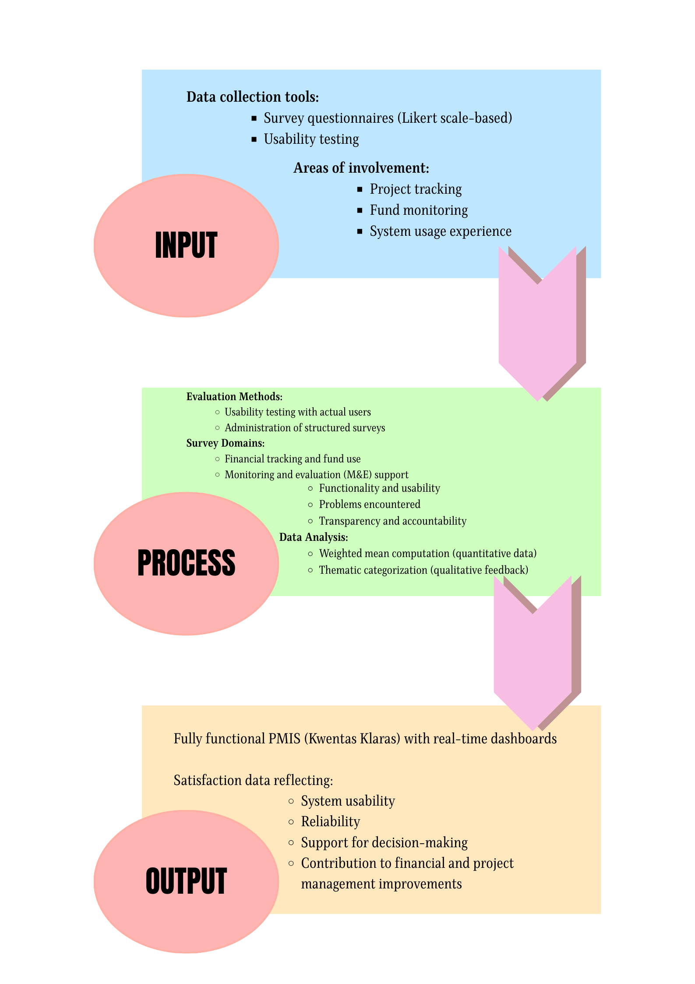
Fig 2. Flow of the Study Model

Research Locale
The research was conducted in the Municipality of Boljoon, Cebu. Participants were purposively selected from personnel of the Local Government Unit (LGU) and members of the Local Project Monitoring Committee (LPMC), given their active involvement in the planning, monitoring, and implementation of local development projects.

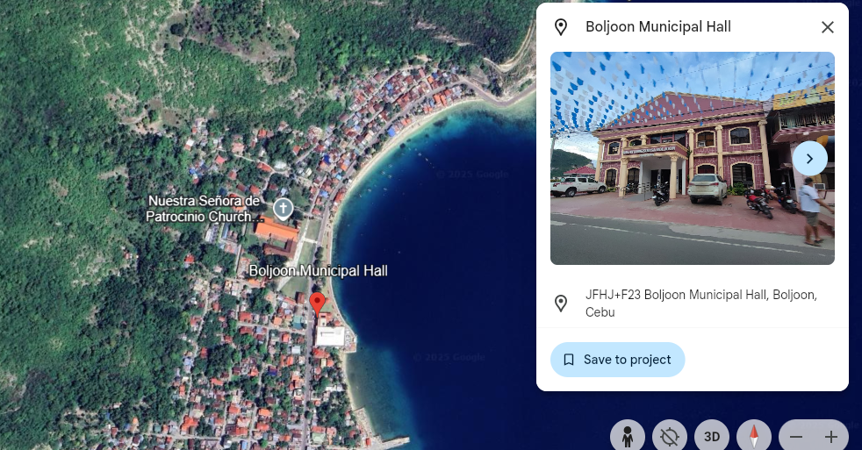
Fig 3. Research Locale (Map of Boljoon, Cebu)

Research Respondent
The participants of this study were chosen from the Local Government Unit (LGU) staff, Local Project Monitoring Committee (LPMC) members, and IT specialists in Boljoon, Cebu. These people were purposively chosen because they are directly engaged in financial management, project monitoring, system utilization, and technical assistance in the municipality. Their technical and practical knowledge of Kwentas Klaras made them perfect to assess the efficacy of the system and give constructive feedback on its strengths, weaknesses, and technicalities.
The desired number of respondents was based on the population size covering project monitoring, financial monitoring, and IT support that exist in the LGU and LPMC. Overall numbers of respondents were set out to be representative of the different positions for system utilization and management so as to consider a holistic and well-balanced assessment.
Table 3
Research Respondent

Group | Estimated Number of Respondents | Notes
LGU Personnel | 15 | Includes finance and project management staff
IT Experts | 10 | Includes system administrators and technical support staff
TOTAL RESPONDENTS | 25 | Ensures diverse input from LGU staff, committee members, and technical experts

Research Instrument
A quantitative survey questionnaire using a 5-point Likert scale served as the main research tool to assess user satisfaction across key areas such as system interface, data accuracy, accessibility, reliability, and support for financial and project management. Questions were based on the IPO model to ensure broad coverage of user experience. Open-ended items were also included to gather qualitative insights on unexpected benefits, challenges, workflow changes, and suggestions for improvement. Responses were analyzed through thematic analysis to capture recurring themes beyond the numerical data.
Table 4
Rating Scale for System Effectiveness in Financial Monitoring and Fund Utilization

This section evaluates how effectively Kwentas Klaras supports financial monitoring and the utilization of the 20% Local Development Fund (LDF). Respondents rated each item using the following scale:
Rating | Categorical Response | Verbal Description
4.21 – 5.00 | Strongly Agree | The system is very effective in enhancing financial monitoring, data accuracy, and fund utilization.
3.41 – 4.20 | Agree | The system is effective in supporting financial monitoring and project tracking, with only minor issues.
2.61 – 3.40 | Neutral | The system is moderately effective, showing average performance without notable strengths or weaknesses.
1.81 – 2.60 | Disagree | The system is ineffective in supporting financial monitoring and proper fund utilization.
1.00 – 1.80 | Strongly Disagree | The system is very ineffective and fails to meet the monitoring and tracking needs of the LGU.

Table 5

Rating Scale for Effectiveness of Kwentas Klaras in Supporting Monitoring and Evaluation (M&E)

This section measures how effective Kwentas Klaras is in supporting the Monitoring and Evaluation (M&E) efforts of the Local Project Monitoring Committee (LPMC). Respondents rated each statement based on the following scale:
Rating | Categorical Response | Verbal Description
4.21 – 5.00 | Strongly Agree | The system is very effective in significantly improving M&E functions by providing real-time, accurate, and organized data.
3.41 – 4.20 | Agree | The system is effective in consistently supporting M&E activities and improving coordination and access to data.
2.61 – 3.40 | Neutral | The system is moderately effective, offering average support for M&E with noticeable areas for improvement.
1.81 – 2.60 | Disagree | The system is ineffective in supporting M&E functions and falls short in meeting monitoring needs.
1.00 – 1.80 | Strongly Disagree | The system is very ineffective and fails to support M&E processes, thereby hindering efficient project oversight.

Table 6

Rating Scale for User Satisfaction with Features and Usability of Kwentas Klaras
This section assesses the user satisfaction with the features, usability, and reliability of the Kwentas Klaras system. Respondents rated each statement using the scale below:
Rating | Categorical Response | Verbal Description
4.21 – 5.00 | Strongly Agree | The user is highly satisfied with the system’s features, design, accessibility, and overall reliability.
3.41 – 4.20 | Agree | The user is satisfied, and the system meets expectations and performs well during regular use.
2.61 – 3.40 | Neutral | The user is moderately satisfied, finding the system acceptable but in need of improvements in some areas.
1.81 – 2.60 | Disagree | The user is dissatisfied, as the system lacks adequate usability or functionality, affecting the overall experience.
1.00 – 1.80 | Strongly Disagree | The user is highly dissatisfied, with the system failing to meet expectations and presenting significant usability issues.

Table 7
Rating Scale for Challenges and Limitations in Using Kwentas Klaras
This section evaluates the challenges and limitations users have experienced while using Kwentas Klaras. Respondents rated the extent to which they agree with each statement using the following scale:
Rating | Categorical Response | Verbal Description
4.21 – 5.00 | Strongly Agree | Users severely experienced the challenge, which significantly affects the system’s usability or performance.
3.41 – 4.20 | Agree | Users noticeably experienced the challenge, and it regularly impacts system use or satisfaction.
2.61 – 3.40 | Neutral | Users moderately experienced the challenge, encountering it occasionally but managing to proceed.
1.81 – 2.60 | Disagree | Users seldom experienced the challenge, and it has only a minimal effect on their use of the system.
1.00 – 1.80 | Strongly Disagree | Users did not experience the challenge, or it is considered negligible in their interaction with the system.

Table 8
Rating Scale for Contribution of Kwentas Klaras to Transparency and Accountability
This section measures the perceived contribution of Kwentas Klaras to transparency and accountability in local governance. Respondents assessed each statement using the following scale:
Rating | Categorical Response | Verbal Description
4.21 – 5.00 | Strongly Agree | The contribution of the system is very evident, significantly enhancing transparency and accountability.
3.41 – 4.20 | Agree | The contribution of the system is clearly evident, with a noticeable and meaningful positive impact.
2.61 – 3.40 | Neutral | The contribution of the system is moderately evident, showing some benefits but with room for improvement.
1.81 – 2.60 | Disagree | The contribution of the system is slightly evident, offering minimal or inconsistent benefits.
1.00 – 1.80 | Strongly Disagree | The contribution of the system is not evident, with no clear impact on transparency or accountability.

Data Treatment
Quantitative responses from the Likert-scale questionnaire were analyzed using weighted mean computation to measure overall user satisfaction and identify the most and least effective system features. In parallel, qualitative data from open-ended questions were examined through thematic analysis, allowing the researchers to extract recurring themes and insights. This mixed-method approach provided a more comprehensive understanding of user experiences, combining statistical trends with deeper, narrative-based feedback.

SYSTEM METHODOLOGY
External Interface Requirements
User Interfaces
The system will feature a web-based graphical user interface (GUI) that is easy to use by multiple user roles such as Admins, LGU staff, and LPMC members. Users will be interacting with user-friendly dashboards, navigation menus, modals, forms, and tables. Interfaces are responsive and mobile-enabled, making them accessible on any device. Login screens, dashboards, report generators, project and financial tracking pages, and user management panels for admins are key UI components.
Hardware Interfaces
The system will be accessed through common computing devices like desktops, laptops, tablets, or smartphones. No special hardware is needed. The server running the application should be able to support HTTP/HTTPS protocols and have the minimum hardware requirements to be scalable and responsive (e.g., 8GB RAM, quad-core CPU, SSD storage). Client-side devices must have a recent web browser and stable internet connectivity.
Software Interfaces
The system will be built with common web technologies (HTML5, CSS3, JavaScript) and back-end technologies like PHP or Node.js, coupled with a relational database like MySQL or PostgreSQL. It can integrate with external software for reporting and exporting (e.g., PDF libraries, spreadsheet modules). The system is deployed on a web server (e.g., Apache or NGINX) and can utilize APIs for internal communication between modules (e.g., project tracking and financial records).

Communication Interfaces
All client-server communication will be encrypted using HTTPS to provide data encryption and privacy for the users. TCP/IP protocols will be supported by the system in all network communication. Notification capabilities (e.g., sending email or writing to a system log) will be based on SMTP or RESTful API services, if used. Future integration with government portals or audit systems is also possible using RESTful APIs in the architecture.
Functional Requirements
Use Case Diagram
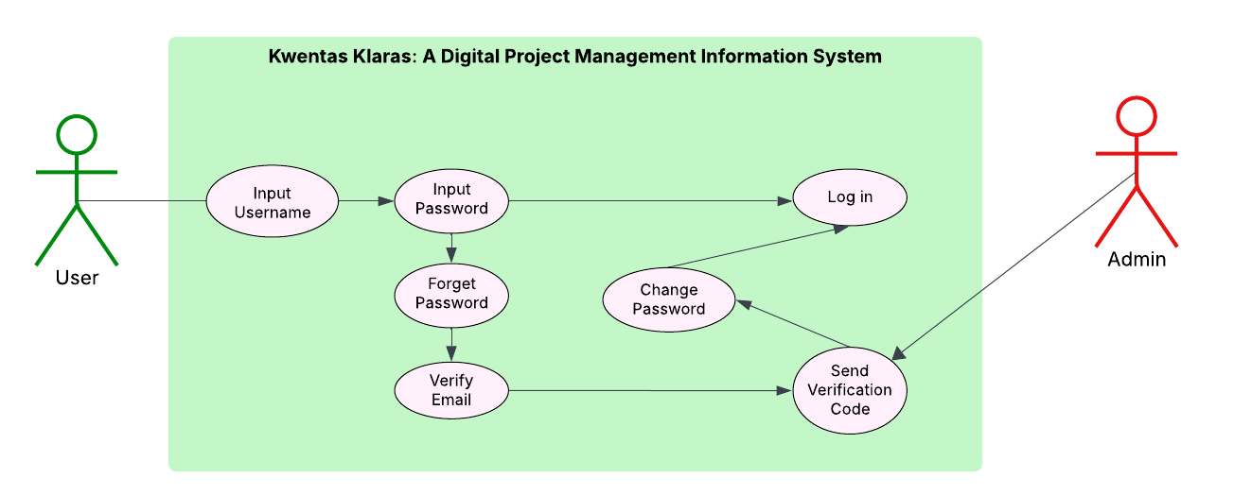
Fig 4. Use Case for Logging In
The Use Case for Logging In (Fig. 4) describes how different types of users interact with the system to access their respective dashboards. Users, such as Admins, LGU staff, and LPMC members, initiate the login process by providing valid credentials. The system verifies these credentials and, if valid, grants access based on their assigned roles. If the login attempt fails (e.g., wrong password), the system returns an error and prompts for retry. The use case also includes a "Forgot Password" option to initiate a secure password recovery process. This use case ensures secure authentication, role-based access control, and restricted entry for unauthorized users.
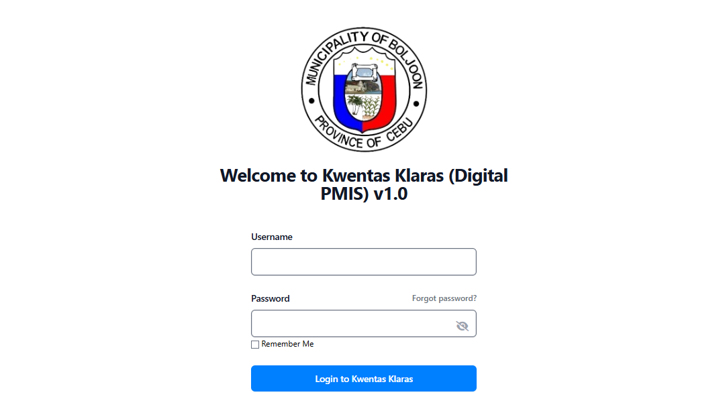
Fig 4.1. GUI for Logging In
The login interface (Fig. 4.1) functions as the primary entry point for users of the Kwentas Klaras system. Designed with a simple and user-friendly layout, the interface allows users to enter their username and password efficiently. It includes essential features such as clear input fields, feedback messages for incorrect login attempts, and a “forgot password” link to support credential recovery. Upon successful authentication, the system automatically redirects users to their role-specific dashboards, ensuring a seamless transition into the system. The GUI is focused on usability, accessibility, and security, offering a streamlined experience while safeguarding user data and system integrity.

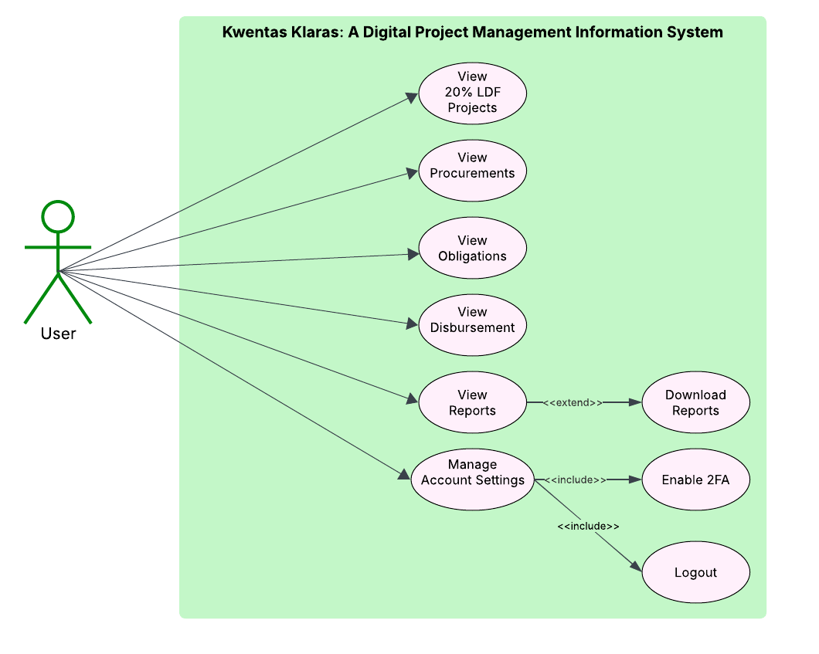
Fig 5. Use Case for View Dashboard
The View Dashboard use case (Fig. 5) begins immediately after a user logs in successfully. The system redirects the user to a role-specific dashboard that summarizes key data relevant to their role. For instance, administrators can view consolidated information on procurements, obligations, disbursements, project statuses, and user accounts. The use case allows users to quickly assess system activity, monitor financial and project metrics, and access links to perform further actions such as generating reports or updating records. This use case emphasizes real-time visibility, efficiency, and role-based access to centralized data and controls.
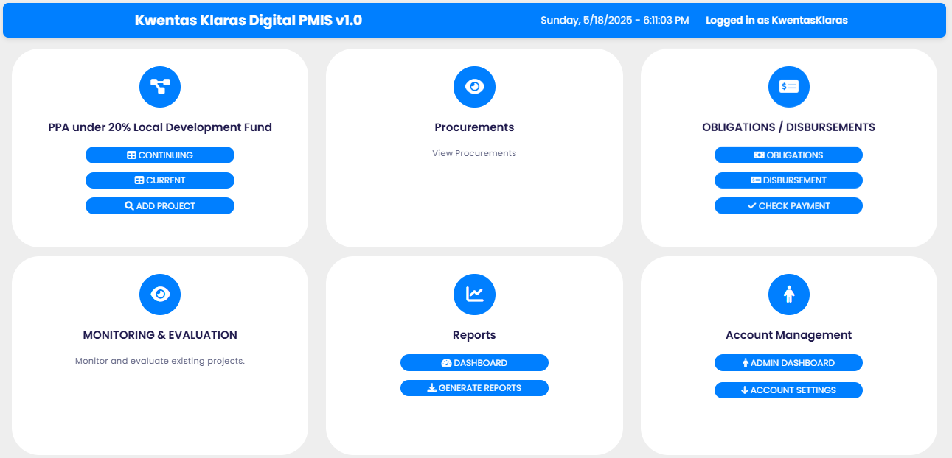
Fig 5.1. GUI for Dashboard
The Dashboard GUI (Fig 5.1) is specifically designed for the provision of an obvious and well-organized overview of the system activity through the visual interface. It comprises graphs, tables, and status indicators displaying condensed data at a glance. The dashboard contains clickable modules, enabling deeper functionality such as report viewing, data entry, and monitoring. The system adapts its delivery according to the role of the user, with certain information sets available to Admins, LGU staff, or LPMC members. The goal is to manage key information and help streamline navigation through the entire system so that it can enhance productivity.
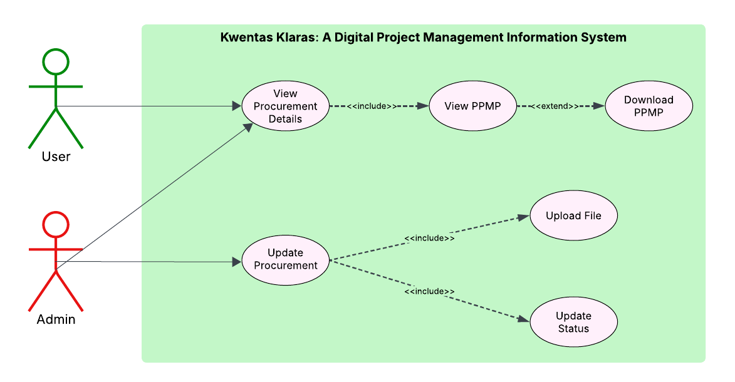
Fig 6. Use Case for Manage Procurement
The Manage Procurement use case (Fig. 6) allows administrators to handle procurement activities within the system. By accessing the procurement module from the dashboard, admins can view records, input new procurement details, or update existing ones. The module supports entering structured data such as item descriptions, suppliers, costs, dates, and status. This functionality ensures procurement is aligned with the approved budget and schedule, improves tracking of goods and services, reduces errors, and promotes transparency in public spending.

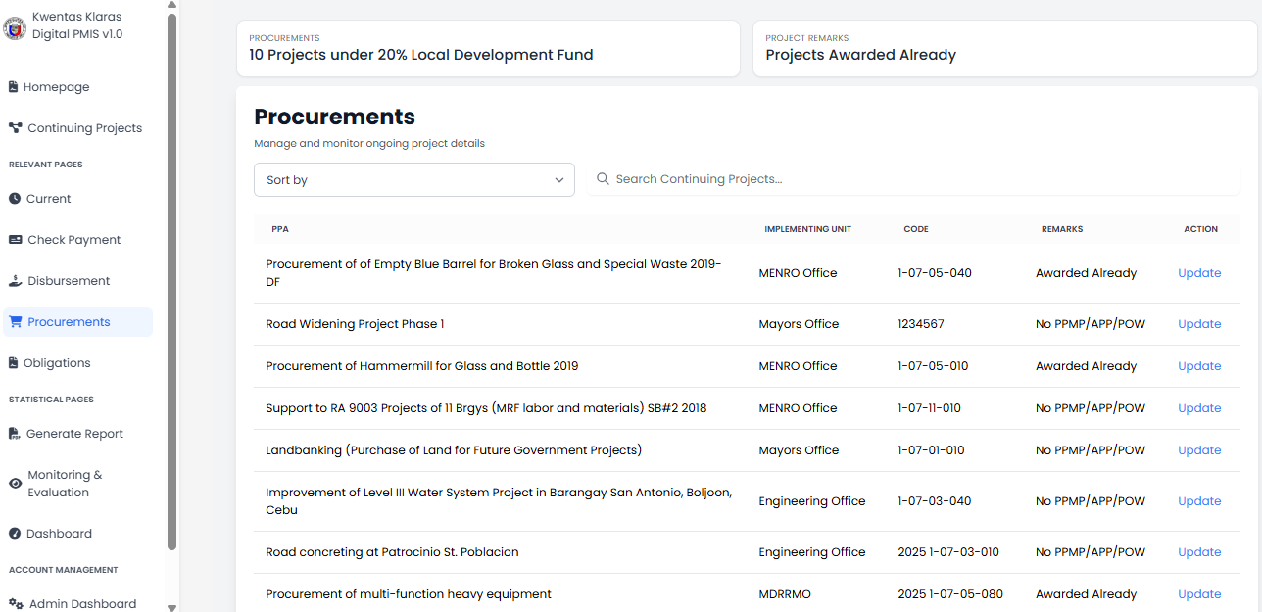
Fig 6.1. GUI for View Procurement
The View Procurement GUI (Fig. 6.1) presents procurement data in a well-organized tabular format. Users can see itemized records, procurement dates, supplier names, and status indicators. Search and filter features allow quick access to specific procurement entries. A view link or button beside each record opens detailed information, including associated PPMPs and downloadable files if applicable. The interface is designed for readability and ease of access.

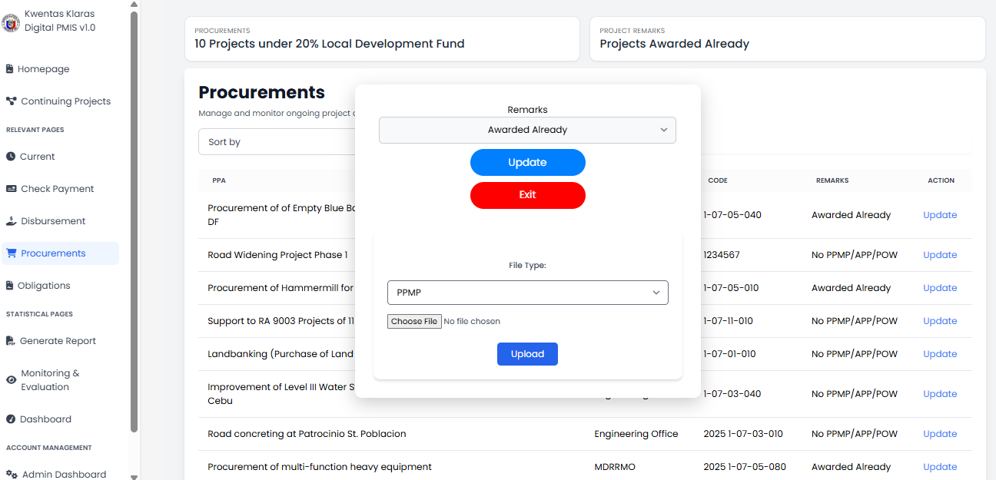
Fig 6.2. GUI for Update Procurement
The Update Procurement GUI (Fig. 6.2) allows admins to modify procurement entries via editable forms. It includes fields for item details, costs, supplier information, procurement status, and file uploads. Dropdown menus and status selectors ensure standardized input. Validation mechanisms alert the user of missing or incorrect data before submission. This GUI supports efficient record maintenance and enhances data integrity across the procurement module.

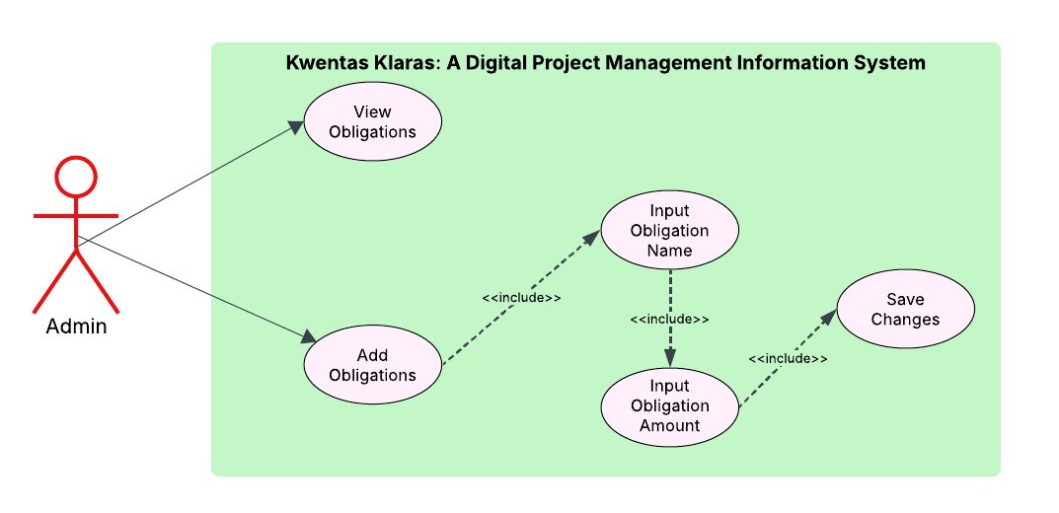Fig 7. Use Case for Manage Obligations
The Manage Obligation use case (Fig. 7) allows administrators to create, update, and oversee financial obligations tied to municipal projects. After logging in, the admin can access the obligations module to record details such as obligation request numbers, funding sources, amounts, recipients, and associated project codes. This system gives support to addition of new entries as well as review of existing entries. It serves as a central record of financial liabilities under the 20 % Local Development Fund (LDF) and other budgetary allocations. The features deliver accurate liability tracking, enhanced budget compliance, and reliability of financial reporting for governance and transparency.

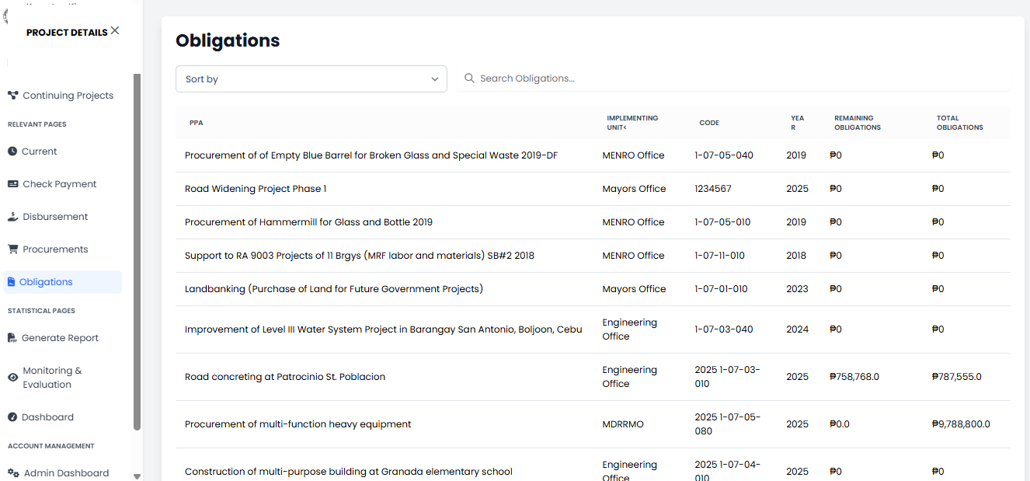
Fig 7.1 GUI for View Obligations
The View Obligation GUI (Fig. 7.1) displays obligation records in a structured and sortable table. Each entry shows key information such as obligation number, project code, funding source, amount, and status. Users can filter records based on date, fund source, or project, and click on individual entries to view complete obligation details. The interface ensures that important financial data is easy to access and understand, helping users monitor budget usage and obligations effectively.

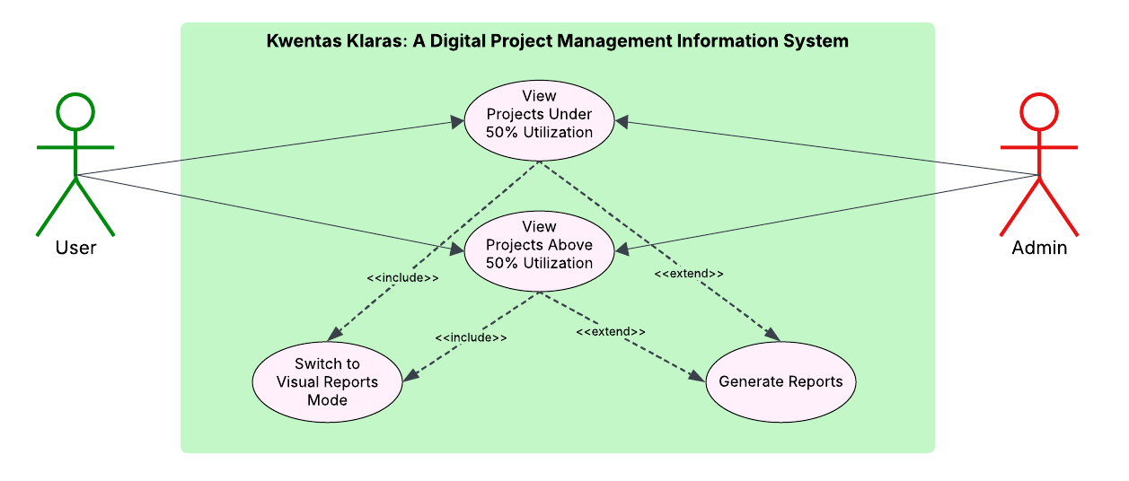Fig 8. Use Case for Monitor and Evaluate Project
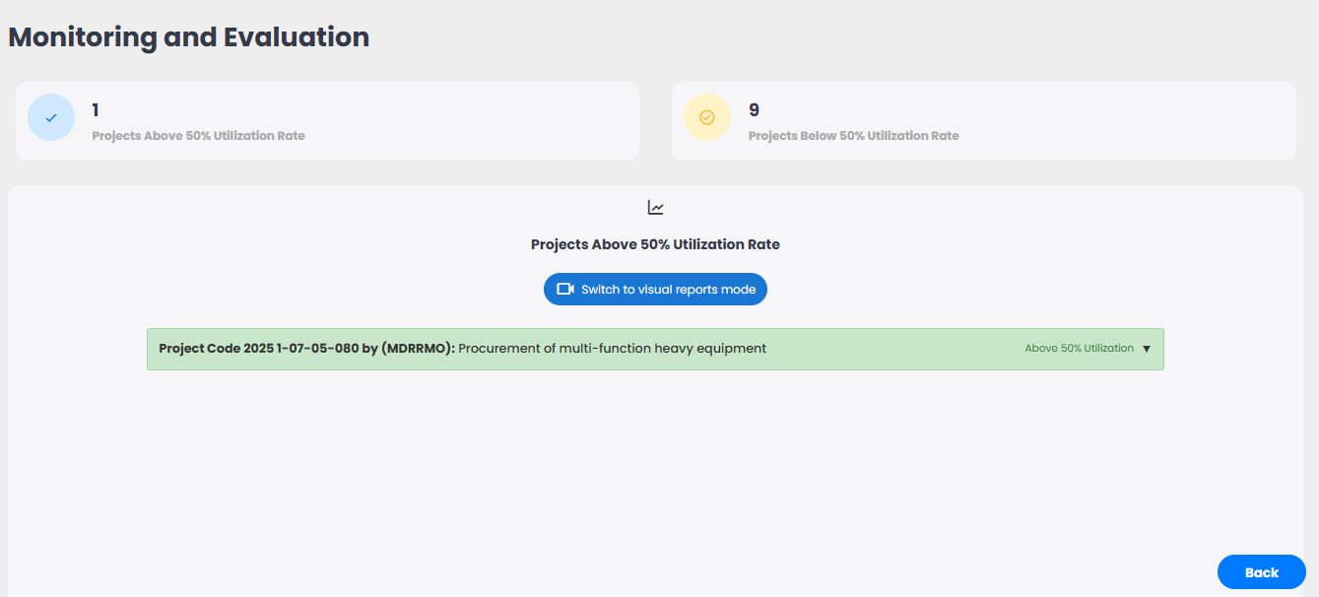
Fig 8.1 GUI for Monitor and Evaluate Project
The Monitor and Evaluate Project use case (Fig. 8) enables administrators to monitor the status, progress, and performance of completed and ongoing projects. Through the implementation of this function, users can gauge milestones, timelines of implementation, and updates on projects. The system provides a systematic image of key performance indicators (KPIs), timelines, and financial utilization (Fig. 8.1). This enables the Local Government Unit (LGU) and Local Project Monitoring Committee (LPMC) to identify delays, impose adherence to scheduled activities, and carry out timely interventions. Overall, this use case promotes transparency and improves strategic decision-making in implementation of projects.
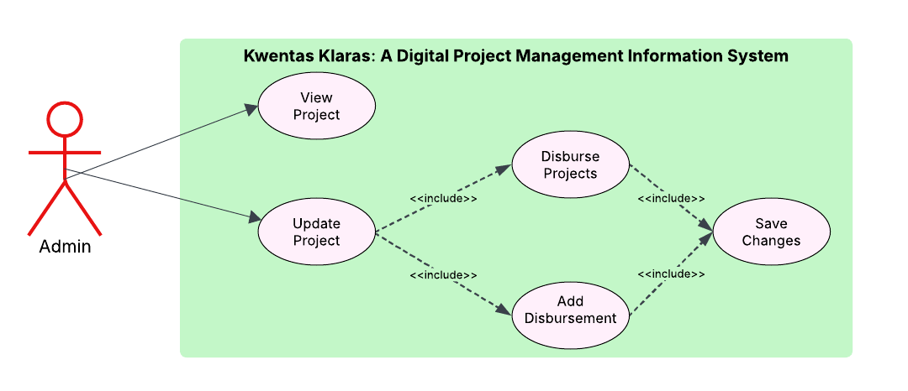Fig 9. Use Case for Manage Disbursement
The Manage Disbursement use case (Fig. 9) allows administrators to oversee the release of funds aligned with approved obligations. Through this function, users can view disbursement schedules, validate obligation references, and update the status of each disbursement. It maintains a record of past disbursements and links each transaction to its source obligation and project. By automating this workflow, the system ensures traceability, strengthens compliance with budget rules, and supports accurate financial reporting.

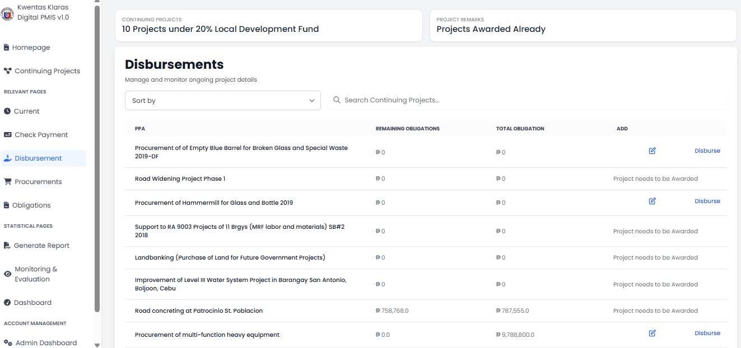
Fig 9.1 GUI for Manage Disbursement
The Manage Disbursement GUI (Fig. 9.1) presents a list or table of disbursement records, showing relevant fields such as disbursement ID, project title, obligation reference, amount, status, and date. Admins can filter records, edit entries, and confirm fund releases through action buttons. Visual indicators show pending, completed, or flagged transactions. The interface provides a clear, organized view for managing financial outflows and supports accountability through linked documentation and audit-ready summaries.
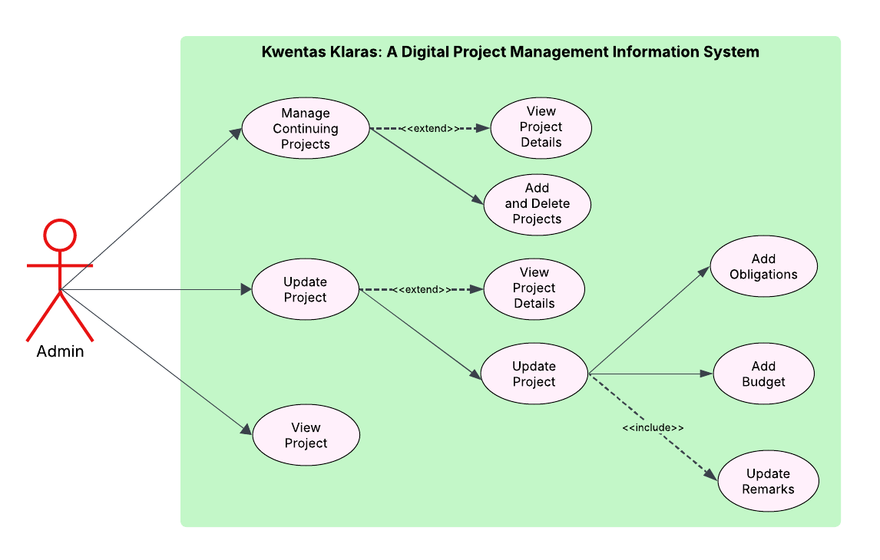Fig 10. Use Case for Manage 20% LDF Project
This use case (Fig. 10) allows administrators to manage projects funded under the 20% Local Development Fund (LDF). Administration may add new projects, update information on ongoing or continuing projects, and delete projects that have been duly completed and terminated. The project record will include important details-the project title, type, budget allocation, implementation status, and responsible department. This use case maintains a central current database for the proper management of budgets, monitoring activities, and policy implementation for community development projects by Local Government Units (LGUs).
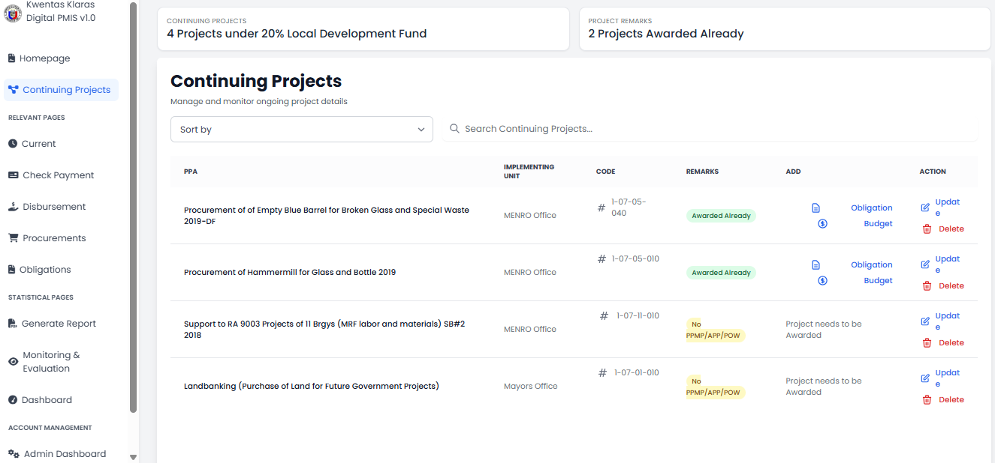
Fig 10.1 GUI for Manage Continuing Project
The Manage Continuing Project GUI (Fig. 10.1) offers administrators a clear and organized interface to oversee projects that are currently in progress. The system displays key project details including status updates, milestones, budget consumption, and estimated completion dates. It provides sorting and filtering options to help users quickly find specific projects by department or status. The interface also allows users to update progress information and add notes, making it easier to monitor ongoing activities and address any challenges promptly.

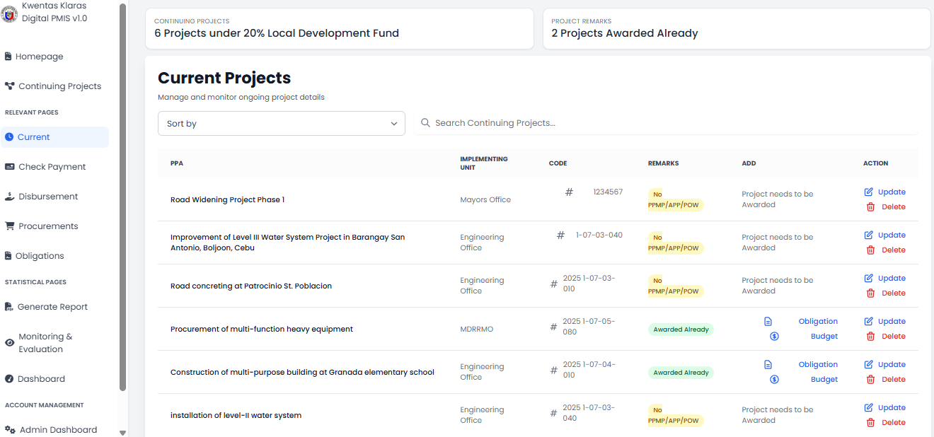
Fig 10.2 GUI for Manage Current Project
This GUI (Fig. 10.2) serves as a centralized dashboard for managing all active projects under implementation. It provides a summary view of each project’s timeline, budget usage, and current status to give administrators a quick overview. Detailed sections enable access to financial data, implementation logs, and relevant documentation. This organized layout helps ensure projects are tracked accurately and any issues are identified and resolved in a timely manner.

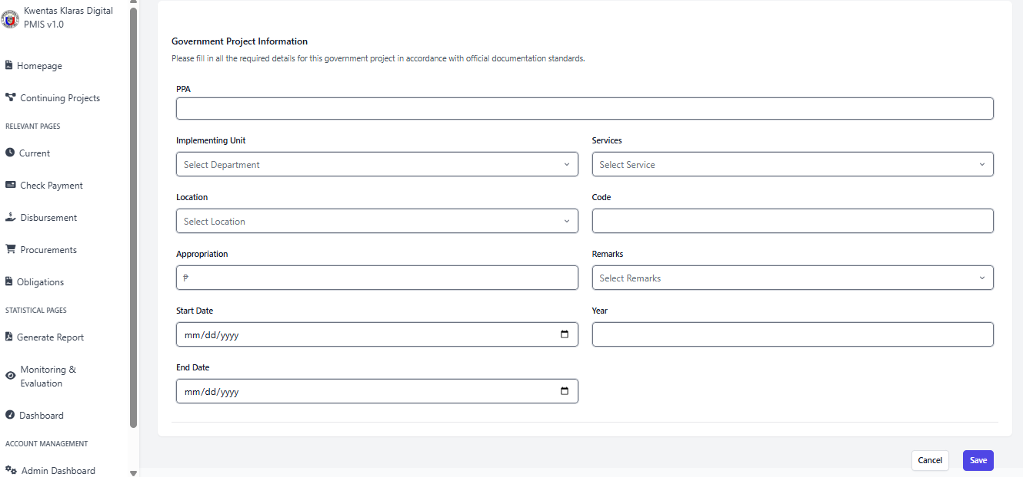
Fig 10.3 GUI for Adding Project
The Adding Project GUI (Fig. 10.3) streamlines the process of entering new project information into the system. It guides administrators through a structured form that captures essential data such as project title, description, type, budget allocation, responsible department, and expected start and end dates. Validation features ensure all necessary fields are completed correctly before submission, minimizing errors and helping maintain data integrity from the start.

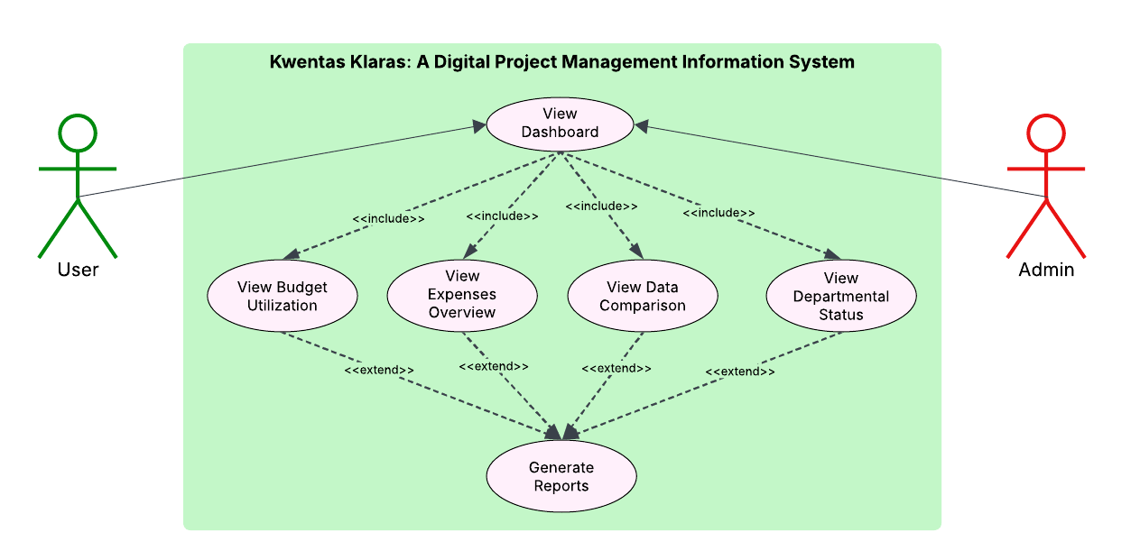Fig 11. Use Case for Generate Reports
The Generate Reports use case (Fig. 11) allows administrators to create a variety of reports such as budget usage, expense summaries, comparative analyses, and departmental performance evaluations. The system automatically gathers relevant data from procurement, obligation, disbursement, and monitoring modules to compile accurate and up-to-date reports. These reports can be printed or exported for further use. They support internal audits, promote transparency, and serve as essential tools for performance evaluation and accountability within the organization.

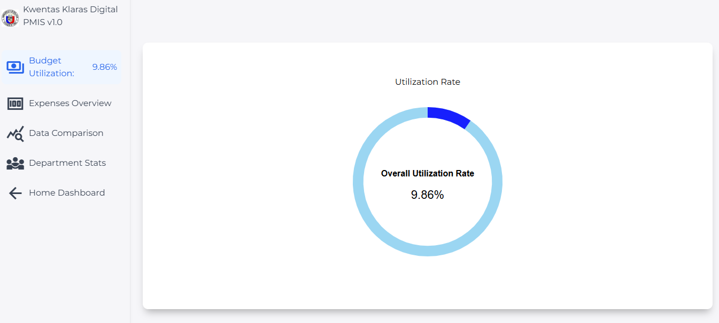
Fig 11.1 GUI for View Reports
The View Reports GUI (Fig. 11.1) provides administrators with a user-friendly interface to browse and review generated reports. Users can easily select from available report types and view detailed summaries and visualizations such as charts and tables. The interface supports searching, filtering, and sorting reports by date, type, or department, making it simple to find specific information quickly.

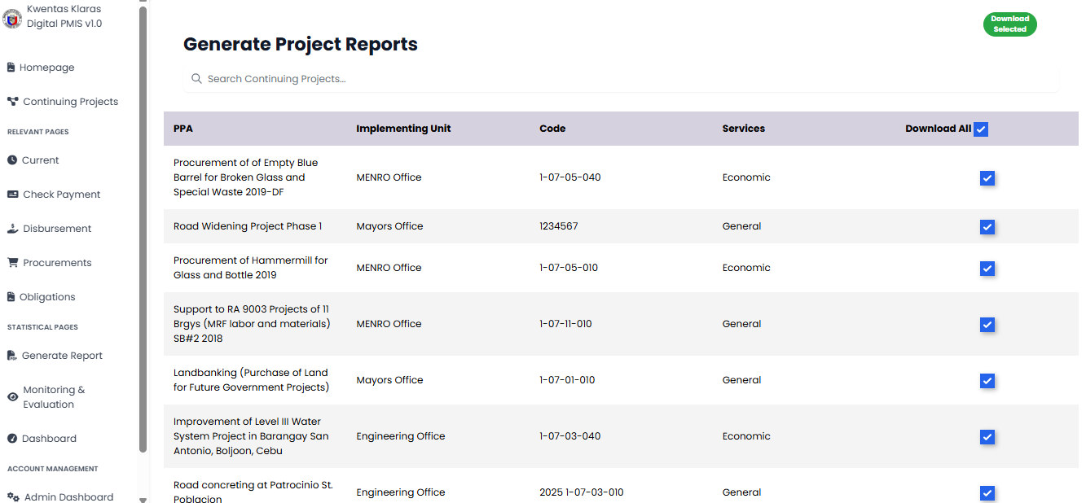
Fig 11.2 GUI for Generate Reports
The Generate Reports GUI (Fig. 11.2) guides administrators through the process of selecting report parameters and generating customized reports. Users can choose report categories, date ranges, and specific departments or projects to include. Once configured, the system compiles the report and provides options to preview, print, or export it in various formats. This interface ensures efficient report creation tailored to organizational needs.
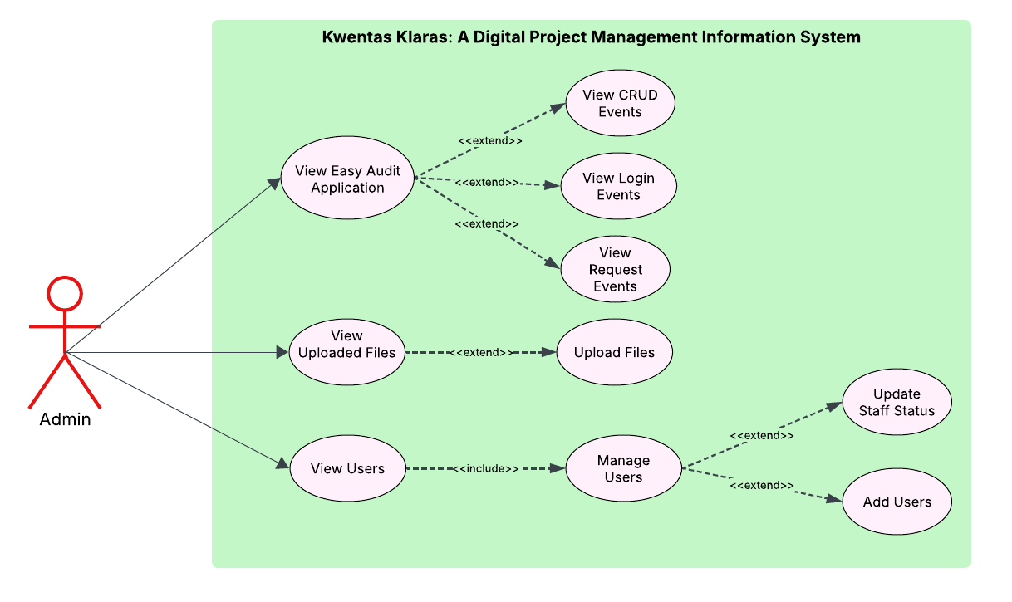Fig 12. Use Case for Manage Users and Admin Dashboard
The use case of Manage Users and Admin Dashboard (Fig. 12) permits the system administrator to conveniently add, update, and remove users and assign appropriate roles and permissions according to their duties. It entails the management of several users’ types-who are actually the financial officer, project monitor, and department head-thereby ensuring that each can only access the features related to his or her duties. Admin Dashboard hence presents a consistent interface for high-level monitoring of system-wide activities, user interaction, and performance metrics. This control hub provides secure access and prevents any unauthorized use while encouraging effective management of users and systems in line with organizational policies.
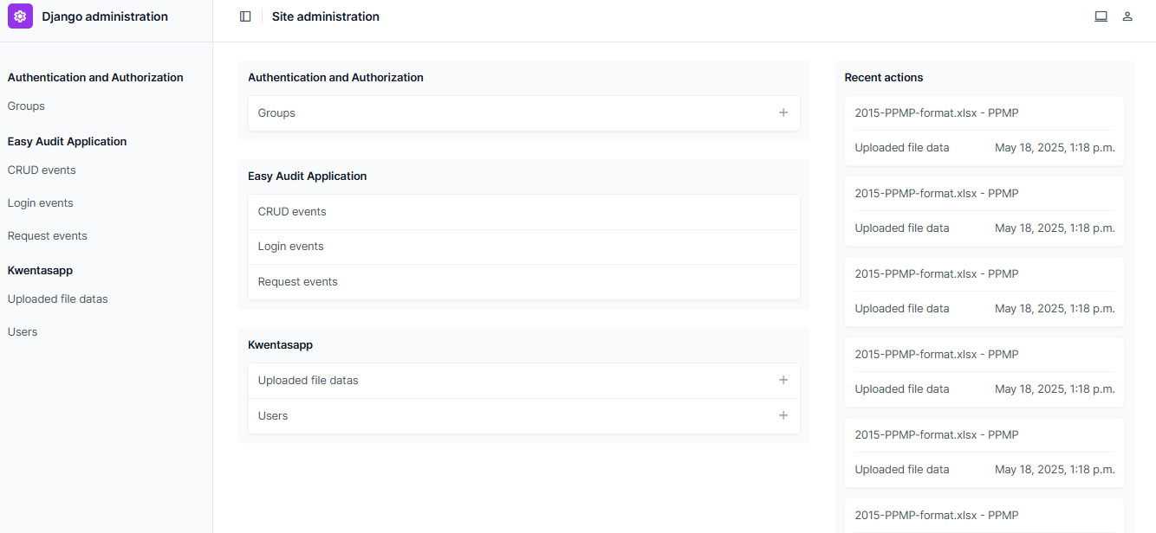
Fig 12.1. GUI for Managing Admin Dashboard
The Managing Admin Dashboard GUI (Fig. 12.1) displays all essential information needed by administrators to evaluate the current system status. All performance statistics and alert notifications appear in a structured format which enables immediate access to user controls and system parameters. The interface design supports efficient navigation and real-time decision-making which leads to secure and efficient system operation.

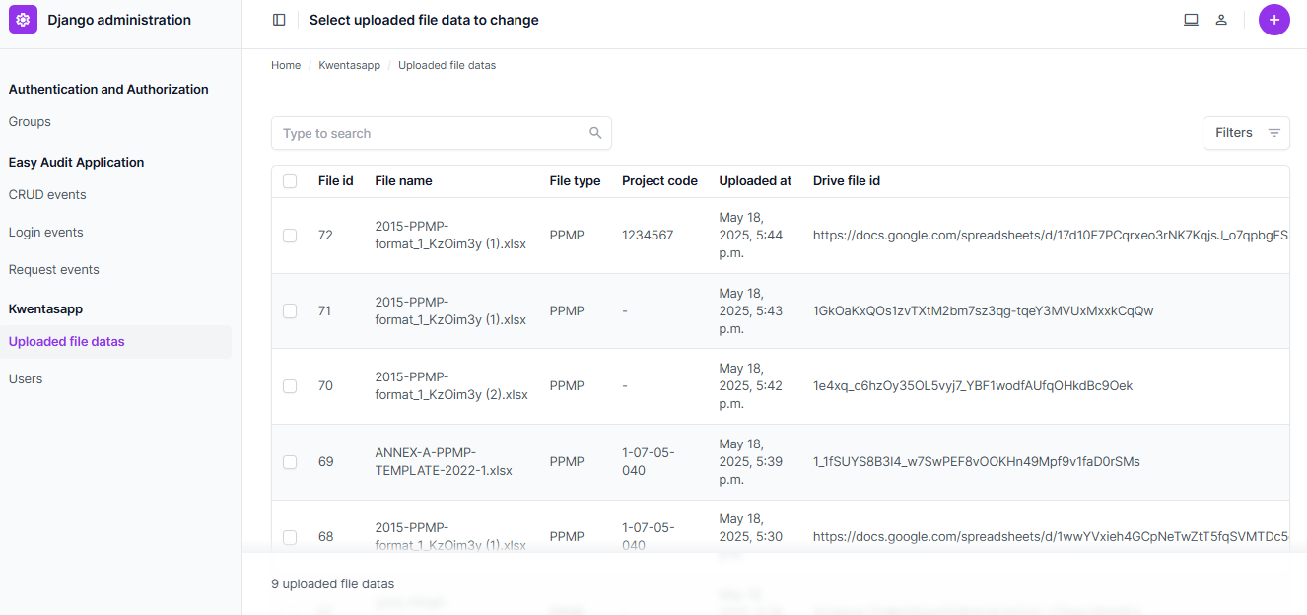
Fig 12.2. GUI for Viewing Uploaded Files
The Viewing Uploaded Files GUI (Fig. 12.2) allows administrators and authorized users to access, search, and review documents and files uploaded to the system. It provides a clear list or grid view with file details such as name, upload date, file type, and uploader identity. Users can open, download, or filter files based on categories or departments, supporting easy document management and retrieval.

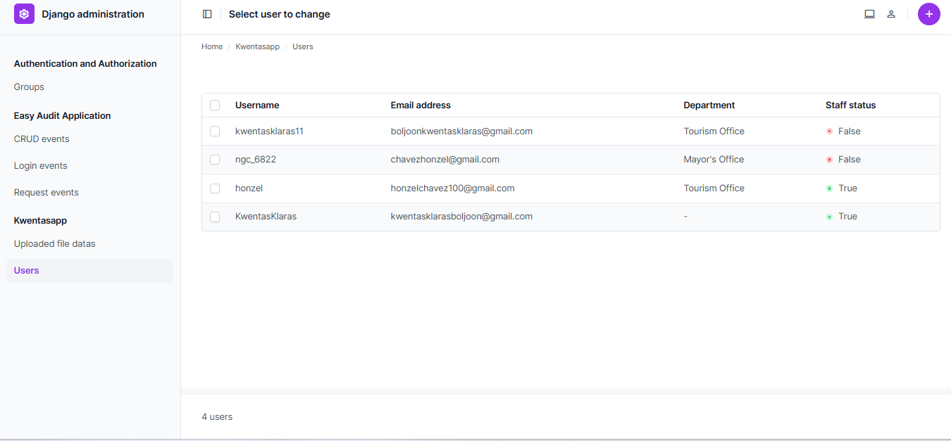
Fig 12.3. GUI for Viewing Users
The Viewing Users GUI (Fig. 12.3) displays a detailed list of all system users, including their roles, status (active or inactive), and recent activity. The interface includes search and filter options to quickly find specific users by name, role, or department. Administrators can also access user profiles to update permissions or deactivate accounts as needed, ensuring user information remains accurate and secure.

Performance Requirements
Software
The system, Kwentas Klaras, must run at its best under typical usage of the Local Government Unit (LGU) staff and Local Project Monitoring Committee (LPMC) members. The application must be able to support multi-user mode without substantial lag or system crashes. It must load dashboards and data-driven pages (reports, project records, and financial summaries) within 3–5 seconds in the presence of a stable internet connection. System response must remain fast even during high usage, especially in the generation of reports and reconciliation of budgets. The backend must ensure data integrity and correctness between modules such as procurement, obligations, disbursements, and monitoring activities.
Measurement Points
Performance will be measured through a set of key indicators such as page load time, system uptime, response time to user action, and integrity of data processing. Targeted load time for mission-critical interfaces such as dashboard, report, and project tracking is less than 5 seconds. Uptime needs to be 99% and above to enable continuous access. Count of bugs or user complaints post-deployment will also be used as a performance measure. User feedback questionnaires and usability test results (quantifying attributes such as usability, reliability, and navigation efficiency) will be used as indirect measures to determine system performance from the end-user's point of view.

Design Constraints
The design of Kwentas Klaras: A Project Management Information System (PMIS) was influenced by a number of design constraints to make it compatible with the working realities of the LGU of Boljoon and the nature of an academic capstone project. Firstly, the system must be compatible with common web browsers such as Chrome, Firefox, and Edge without the need for specialized hardware or software. It must be responsive and accessible on different devices, including desktops, tablets, and mobile phones, in light of the different digital accessibility of the LGU staff. Security was of utmost limitation, considering that the system has sensitive financial information. Hence, strong authentication processes and role-based access control (RBAC) were applied to limit access and confirm that only approved users can handle certain financial or project information.
Further, the design of the system also fell under the government regulations and rules of finance management, particularly those governing the 20% Local Development Fund (LDF), procurement, and budget reporting. This also placed limitations on some of the flexibility of system features to accommodate compliance with guideline settings from government bodies such as the Commission on Audit (COA) and the Department of the Interior and Local Government (DILG). The diverse technical skills of the personnel of the LGUs also presented a limitation; the user interface was made simple and intuitive, ensuring that little training or technical assistance would be necessary. Because of this, complicated workflows and jargon were thus eliminated.
In addition, although the system was originally designed for Boljoon, Cebu, the architecture should be designed to cater to future scalability if other LGUs would be using it. This necessitated a modular and sustainable design to facilitate future improvements and add-ons. Finally, the system was coded under strict time and resource limitations since it was subjected to the academic calendar. The short development window in February through May for assessment and defense, and the following documentation period, cut into the scope and polish of system features. These limitations cumulatively shaped the system's functionality, usability, and deployment plan.
Software System Attributes
Usability
The system is user-centric in its design. It comes with an intuitive interface comprising well-differentiated menus, dashboards, and navigation that require minimal technical training for non-technical users as well as technical users. This allows LGU personnel and LPMC members to effectively utilize the platform for financial tracking and project monitoring activities.
Reliability
Reliability is paramount for providing uninterrupted system functionality, particularly during operating hours when decisions rely on up-to-date information. The system must be down only for minimal periods and should quickly recover in the event of small errors or interruptions to ensure crucial tasks are not held up.
Scalability
Kwentas Klaras is built to scale with the future needs of the municipality. Whether more users, increased data storage, or expanded functionalities are needed, the system can accommodate growth without significant architectural changes. This allows it to evolve alongside local government digital transformation goals.
Performance
High-performance systems are required to process real-time financial updates and data transactions. The system is optimized for quick response time, particularly in encoding, data retrieval, and loading of the dashboards. Performance standards target all critical tasks to be accomplished within a few seconds to ensure user productivity.

Security
The system uses role-based access control (RBAC) to restrict user access based on pre-configured permissions. This minimizes the threat of unauthorized data access or data leaks. Other security features include secure data transmission via encryption, secure login authentication, and activity logging for traceability.
Maintainability
The system adopts a modular design, making it simple for developers or IT personnel to isolate and correct bugs, apply updates, or add new features without affecting the whole platform. Accurate documentation and version control also aid in effortless maintenance and future upgrades.
Portability
Kwentas Klaras can be accessed through typical web browsers using multiple operating systems and devices, including desktops, tablets, and laptops. This makes the system available for use by those who have authority, no matter their hardware or location, further enhancing flexibility in project management.
Availability
The system is designed to meet a minimum of 95% availability monthly, with it being accessible to use during peak hours. Scheduled maintenance or updating is done at off-peak times to limit disruption. Such availability sustains continuity in government operations and provision of public services.

Schedule Feasibility
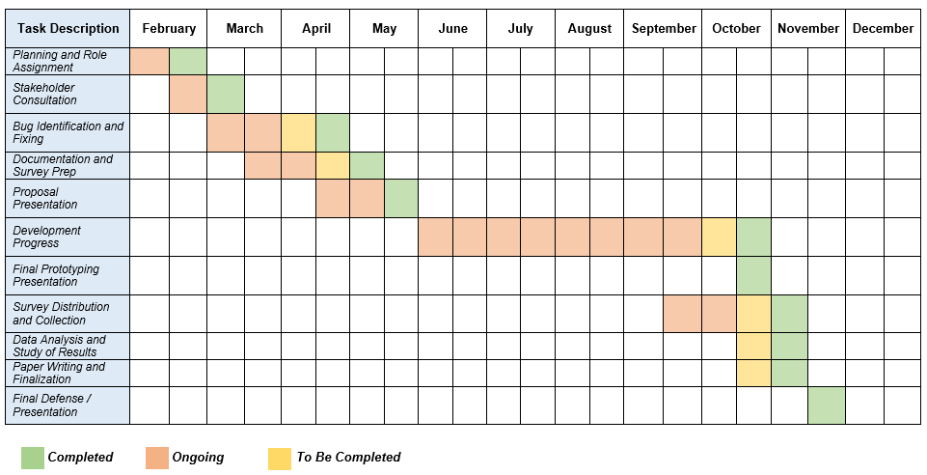Fig 13. Schedule Feasibility
The project schedule for Kwentas Klaras demonstrates a well-organized and feasible timeline spanning from February to December. The phases are arranged logically, ensuring smooth progress from planning to final presentation.
The project begins with the Planning and Role Assignment phase in February, allowing the team to establish clear roles and responsibilities early on. This is immediately followed by Stakeholder Consultation, which extends from February through March and into early April. This overlap ensures that stakeholder feedback can guide early system adjustments and align project goals with user expectations.
By March, Bug Identification and Fixing starts and concludes in April, focusing on refining the system to ensure reliability and performance. Simultaneously, Documentation and Survey Preparation begins in March and continues through May, ensuring that evaluation tools are properly developed before data collection. The Proposal Presentation in April formally marks the transition to the implementation stage.
The Development Progress spans from May to October, representing the most extensive phase of the project. This long duration provides adequate time for system development, testing, and iterative improvements. The Final Prototyping Presentation and Survey Distribution and Collection occur around September to October, overlapping with the Data Analysis and Study of Results, which extends into November. This overlap reflects an efficient workflow, where preliminary results can guide revisions.
Finally, the Paper Writing and Finalization phase takes place from October to November, culminating in the Final Defense/Presentation in December. This sequence ensures the project is fully refined and ready for presentation before the year ends.
Overall, the schedule is feasible and well-balanced, allowing for continuous progress without excessive overlap. Each task is given an appropriate timeframe, supporting both technical development and academic preparation. The inclusion of feedback, testing, and revision periods further enhances the project’s likelihood of success.

Data Design (Class Diagram)
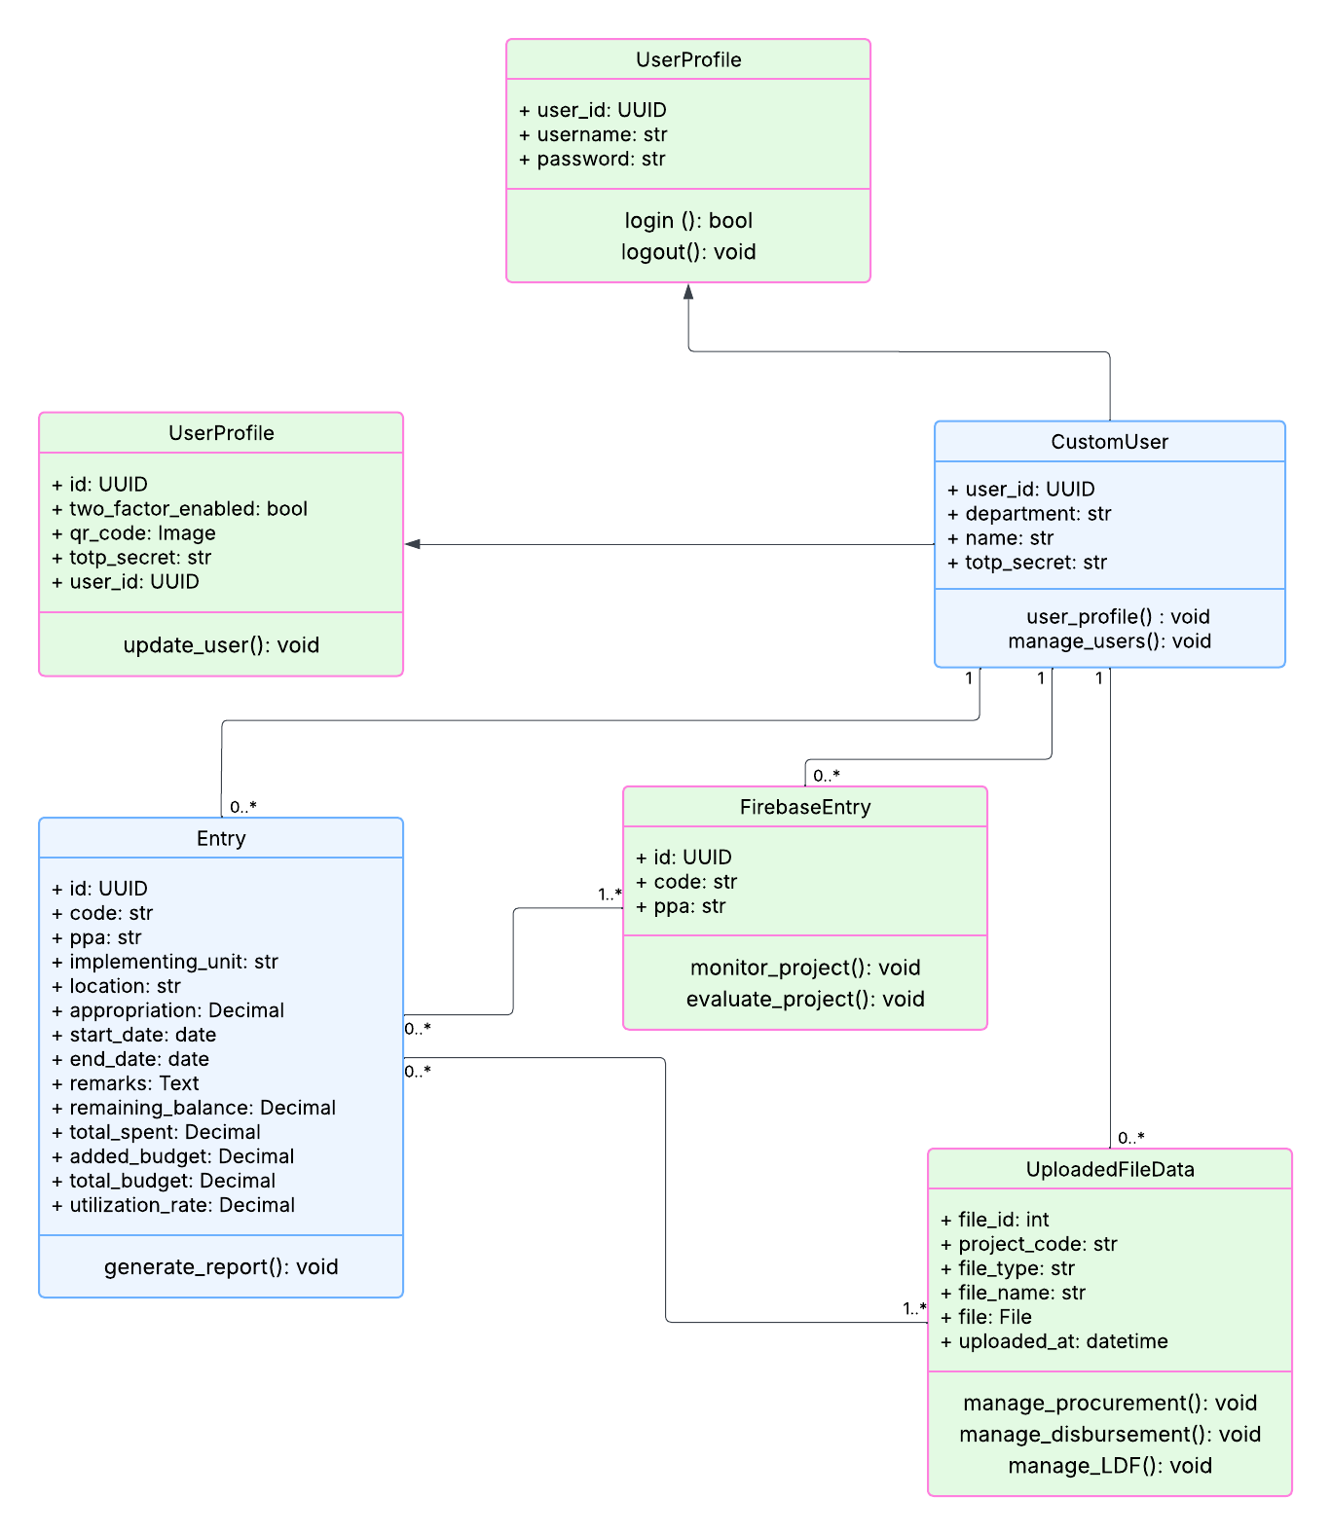Fig 14. Data Design - Class Diagram

The class diagram for Kwentas Klaras outlines the key system components and their relationships, representing the structural blueprint of the Project Management Information System (PMIS). The system was designed with a modular and object-oriented approach, ensuring clarity in roles, data interaction, and access control. At the core is the CustomUser class, which represents the authenticated users within the LGU—such as administrators or project officers. Each user is uniquely identified by user_id and associated with a department. Through this class, user management is facilitated via the manage_users() method, while linking directly to the UserProfile class to handle login credentials and two-factor authentication (2FA) security features.
The UserProfile class, associated 1:1 with CustomUser, stores sensitive user authentication data such as username, password, and 2FA elements (qr_code, totp_secret). It includes methods for logging in and out, and another overloaded version of the class is included for updating user profiles, particularly those with 2FA enabled. The Entry class encapsulates the core project data being tracked. Each project entry includes attributes such as code, ppa, appropriation, total_budget, utilization_rate, and financial breakdowns like total_spent and remaining_balance. This class is essential for budget tracking and includes the method generate_report() to support report generation functions. Supporting real-time monitoring features, the FirebaseEntry class is associated with multiple Entry records. It captures essential mirrored project data such as code and ppa, and provides the methods monitor_project() and evaluate_project() for real-time project oversight. Meanwhile, UploadedFileData handles all documents and attachments related to projects. Each file is linked by project_code and includes metadata like file_type, file_name, and uploaded_at. This class supports procurement tracking, disbursement management, and LDF documentation through dedicated methods.
The diagram models a clear 1-to-many relationship between user accounts and project entries, and between projects and uploaded files, indicating the system's ability to support multiple data entries under one user while maintaining granular access and recordkeeping. Overall, the class diagram illustrates a secure, scalable structure aligned with the goal of enhancing transparency, budget monitoring, and project accountability for the LGU of Boljoon.
System Architecture
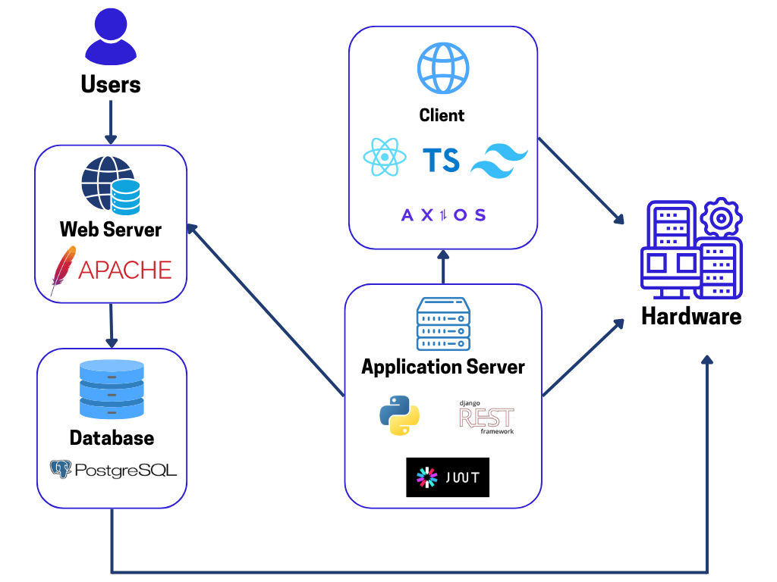
Fig 15. System Architecture
The Kwentas Klaras: A Digital Project Management Information System adopts a multi-tier architecture that consists of four main layers: the Client, Application Server, Web Server, and Database, all integrated to provide a scalable, secure, and efficient system to address the needs of LGU personnel overseeing local development projects.
At the Client Side, the application employs recent web technologies including React, TypeScript, Tailwind CSS, and Axios. These technologies provide a responsive and interactive user interface for maximum accessibility via desktops, tablets, and smartphones. Axios makes it easy to have secure communication between the client and backend via RESTful APIs.
The Application Server performs the business logic and API layer with Python, the Django REST Framework, and JWT (JSON Web Tokens) for secure user authentication and role-based access control. This separation of concerns provides that sensitive operations and validation processes are securely executed on the server side.
The Apache-powered Web Server acts as the middleman between the application and the end-users and the backend system. It handles HTTP requests and sends them accordingly to the application server or the database for efficient load handling and request management.
At the storage level of data, the structured project data, financial records, user profiles, and document metadata are stored in the PostgreSQL database. It is reliability-, query performance-, and data integrity-oriented to support transparent and accurate reporting as well as LGU financial monitoring.
Lastly, the system runs on suitable hardware infrastructure that supports deployment, storage, and processing needs. The architecture provides an unperturbed data and operation flow from the client to the server and vice versa, ensuring maintainability, scalability, and effective monitoring of project money.
This architecture enables Kwentas Klaras to offer a safe, responsive, and role-aware platform for LGU stakeholders in terms of budgeting, procurement, and project monitoring.

CHAPTER 2
PRESENTATION, ANALYSIS, AND INTERPRETATION OF DATA

This chapter presents, analyzes, and interprets the data collected from the respondents regarding the use and effectiveness of the Kwentas Klaras system. The study utilized a quantitative survey questionnaire as the primary research instrument, employing a 5-point Likert scale to capture user perceptions on several key aspects of the system, including financial monitoring, monitoring and evaluation (M&E) support, usability, system features, challenges, and contributions to transparency and accountability. Open-ended items supplemented the quantitative data, providing qualitative insights into user experiences, workflow changes, and suggestions for system improvement.
The collected data were subjected to rigorous analysis through a mixed-method approach. Quantitative responses were examined using weighted mean computations, which enabled the identification of trends, overall satisfaction levels, and the most and least effective components of the system. Qualitative responses were analyzed thematically to uncover recurring patterns, insights, and recommendations that go beyond the numerical results. Together, these approaches provided a comprehensive understanding of the system's performance, reliability, and its impact on financial management, project monitoring, and governance processes.
The presentation of results is organized into the following sections:
- System Effectiveness in Financial Monitoring and Fund Utilization – This section evaluates how the Kwentas Klaras system supports the management of the 20% Local Development Fund (LDF), including data accuracy, fund tracking, and reporting capabilities.
- Effectiveness in Supporting Monitoring and Evaluation (M&E) – Focuses on how the system assists the Local Project Monitoring Committee (LPMC) in overseeing projects, ensuring timely reporting, and improving coordination.
- User Satisfaction with System Features and Usability – Assesses users’ perceptions regarding the system’s design, accessibility, functionality, and overall ease of use.
- Challenges and Limitations in System Use – Identifies difficulties experienced by users, including technical and operational constraints.
- Contribution to Transparency and Accountability – Measures the perceived impact of Kwentas Klaras on promoting openness and responsible management within local governance.
Each section presents the data in tabular form, accompanied by descriptive analysis and interpretation. The results are expressed in terms of the weighted mean, which is then categorized based on the predefined rating scales ranging from “Strongly Disagree” to “Strongly Agree,” ensuring clarity in evaluating system effectiveness and user satisfaction. The integration of qualitative findings further enriches the analysis by providing narrative evidence of system performance, usability issues, and user suggestions for enhancement.
The tables that follow summarize the responses collected from the survey, serving as the basis for the subsequent analysis and interpretation. Each table is accompanied by a brief explanation of the context, highlighting significant trends and patterns that emerged from the data.

System Effectiveness in Financial Monitoring and Fund Utilization
This section evaluates how effectively Kwentas Klaras supports financial monitoring and the utilization of the 20% Local Development Fund (LDF) in the LGU of Boljoon. Respondents were asked to rate their agreement with ten statements reflecting various aspects of the system, including improvements in financial tracking, accuracy of data, timeliness of reporting, decision-making, fund utilization, and transparency in financial processes. The survey involved 12 respondents who actively use the system for project and financial monitoring tasks.

Table 9 presents the weighted mean scores for each item, providing an overview of user perceptions of the system’s effectiveness. The ratings were interpreted using the 5-point Likert scale, with a score range of 4.21–5.00 corresponding to “Strongly Agree,” indicating a very high level of satisfaction and perceived effectiveness.
Table 9
Weighted Mean Scores for System Effectiveness in Financial Monitoring and Fund Utilization
Item | Statement | Weighted Mean | Interpretation
1 | Kwentas Klaras has improved the overall financial monitoring process on project allocation in the LGU of Boljoon. | 4.83 | Strongly Agree
2 | The system contributes to better tracking of the 20% Local Development Fund (LDF). | 4.92 | Strongly Agree
3 | The financial data generated by the system is complete and timely. | 4.58 | Strongly Agree
4 | Kwentas Klaras helps ensure accurate and updated project reports. | 4.83 | Strongly Agree
5 | There has been an observable improvement in the timeliness of project reporting. | 4.83 | Strongly Agree
6 | The system enables faster decision-making regarding project implementation and fund use. | 4.92 | Strongly Agree
7 | There has been a noticeable increase in the utilization rate of the 20% LDF since using the system. | 4.75 | Strongly Agree
8 | Kwentas Klaras has minimized fund mismanagement or project delays. | 4.83 | Strongly Agree
9 | The system supports more efficient use of the municipality’s development budget. | 4.83 | Strongly Agree
10 | Kwentas Klaras has made the financial reporting process more transparent. | 4.92 | Strongly Agree
N = 12
The results indicate that users overwhelmingly perceive Kwentas Klaras as highly effective in enhancing financial monitoring and fund utilization. All items received weighted mean scores between 4.58 and 4.92, falling within the “Strongly Agree” category. This suggests that the system significantly improves financial processes by ensuring accurate, complete, and timely data, which in turn facilitates faster decision-making and more efficient use of the 20% LDF.
Respondents particularly highlighted the system’s role in improving transparency, minimizing fund mismanagement, and ensuring timely project reporting. The highest-rated items (Items 2, 6, and 10) underscore the system’s impact on tracking fund allocation, enabling prompt managerial decisions, and promoting transparency in financial reporting. Overall, the findings confirm that Kwentas Klaras is an effective tool in supporting the financial management objectives of the LGU of Boljoon.

Effectiveness in Supporting Monitoring and Evaluation (M&E)
This section assesses how effectively Kwentas Klaras supports the Monitoring and Evaluation (M&E) functions of the Local Project Monitoring Committee (LPMC). Respondents evaluated ten statements that reflect the system’s contribution to real-time data access, performance tracking, process organization, coordination among LPMC members, and timely identification of project delays. A total of 12 respondents, who actively utilize the system for M&E-related tasks, participated in the survey.
Table 10 displays the weighted mean scores for each item, providing insight into users’ perceptions of the system’s impact on M&E activities. The ratings were interpreted using the 5-point Likert scale, with a score range of 4.21–5.00 corresponding to “Strongly Agree,” indicating that users perceive the system as highly effective in improving M&E processes.

Table 10
Weighted Mean Scores for Effectiveness in Supporting M&E Functions
Item | Statement | Weighted Mean | Interpretation
1 | Kwentas Klaras effectively supports the monitoring and evaluation (M&E) functions of the Local Project Monitoring Committee (LPMC). | 5.00 | Strongly Agree
2 | The system provides real-time data that is crucial for informed decision-making. | 4.92 | Strongly Agree
3 | The financial and project data available through Kwentas Klaras is sufficient for performance tracking. | 4.92 | Strongly Agree
4 | The system reduces the time needed to gather M&E-related information. | 4.75 | Strongly Agree
5 | Kwentas Klaras increases the accuracy of project monitoring compared to previous manual methods. | 4.83 | Strongly Agree
6 | The M&E processes using Kwentas Klaras are more organized and systematic. | 4.75 | Strongly Agree
7 | The system enhances coordination among LPMC members during monitoring and evaluation activities. | 4.92 | Strongly Agree
8 | Kwentas Klaras allows for timely identification of project delays or implementation issues. | 4.92 | Strongly Agree
9 | The system has improved the LPMC’s ability to ensure that projects align with approved timelines and budgets. | 4.83 | Strongly Agree
10 | Kwentas Klaras strengthens the role of the LPMC in project oversight and accountability. | 4.92 | Strongly Agree
N = 12

The results indicate that Kwentas Klaras is highly effective in supporting M&E functions within the LGU of Boljoon. All ten items received weighted mean scores ranging from 4.75 to 5.00, which falls under the “Strongly Agree” category. This demonstrates that respondents perceive the system as providing real-time, accurate, and organized data that significantly improves monitoring efficiency and decision-making.
Particularly notable are the highest-rated items (Items 1, 2, 3, 7, 8, and 10), which emphasize the system’s effectiveness in supporting LPMC oversight, facilitating coordination among members, ensuring timely identification of project delays, and strengthening accountability in project implementation. The findings suggest that the implementation of Kwentas Klaras has considerably enhanced the capacity of the LPMC to monitor projects accurately, systematically, and in a timely manner, surpassing the limitations of previous manual methods.
Overall, the data confirm that Kwentas Klaras is an essential tool for improving the efficiency, accuracy, and effectiveness of M&E processes, contributing to better project oversight and governance.

User Satisfaction with Features and Usability
This section measures the level of user satisfaction with the features, usability, and overall performance of the Kwentas Klaras system. Respondents rated ten statements reflecting the system’s interface design, accessibility, reliability, accuracy of data, workflow support, and general functionality. The survey included 12 users who regularly interact with the system for financial tracking and project monitoring tasks.
Table 11 presents the weighted mean scores for each statement, interpreted using the 5-point Likert scale. Scores within the range of 4.21–5.00 indicate “Strongly Agree,” reflecting high satisfaction and positive user experiences with the system.

Table 11
Weighted Mean Scores for User Satisfaction with Features and Usability
Item | Statement | Weighted Mean | Interpretation
1 | The system has a user-friendly interface that is easy to navigate. | 5.00 | Strongly Agree
2 | The system is accessible and can be used without major technical issues. | 4.92 | Strongly Agree
3 | The features of the system meet the needs of my role in financial tracking or project monitoring. | 4.83 | Strongly Agree
4 | I can easily find the information I need within the system. | 4.83 | Strongly Agree
5 | The layout and design of the system support efficient workflow. | 5.00 | Strongly Agree
6 | The data generated and presented by the system is accurate and reliable. | 4.92 | Strongly Agree
7 | System downtime or technical issues are minimal and do not affect productivity. | 4.75 | Strongly Agree
8 | I feel confident using the system in performing my duties. | 5.00 | Strongly Agree
9 | Satisfaction on the usability and functionality of Kwentas Klaras. | 4.83 | Strongly Agree
10 | Satisfaction on the overall performance of the Kwentas Klaras system. | 5.00 | Strongly Agree

N = 12
The results reveal that users are highly satisfied with the features, usability, and overall performance of Kwentas Klaras. All items scored between 4.75 and 5.00, corresponding to the “Strongly Agree” category, indicating that the system meets or exceeds user expectations.
Users particularly emphasized the system’s intuitive interface, efficient workflow support, reliability, and confidence in performing their duties (Items 1, 5, 6, and 8), suggesting that Kwentas Klaras significantly enhances productivity and ease of use. Minimal technical issues or downtime (Item 7) further contribute to a positive user experience. The consistently high ratings across all items demonstrate that the system effectively addresses the needs of its users, providing a dependable and user-friendly environment for financial tracking and project monitoring.
Overall, the findings confirm that Kwentas Klaras delivers a high level of satisfaction in terms of usability, functionality, and reliability, supporting the LGU of Boljoon in achieving efficient project and financial management.

Challenges and Limitations in System Use
This section identifies the challenges and limitations experienced by users while interacting with the Kwentas Klaras system. Respondents evaluated ten statements that reflect potential technical, operational, and organizational barriers, as well as areas where additional guidance, training, or system enhancements may be necessary. The survey included 12 respondents who regularly use the system for financial tracking and project monitoring.
Table 12 presents the weighted mean scores for each item, interpreted using the 5-point Likert scale. Scores within the range of 4.21–5.00 correspond to “Strongly Agree,” indicating that users have significantly experienced the challenges described, which may affect usability or overall system performance.

Table 12
Weighted Mean Scores for Challenges and Limitations in Using Kwentas Klaras
Item | Statement | Weighted Mean | Interpretation
1 | Encountered technical issues (e.g., bugs, system crashes, loading delays) while using Kwentas Klaras. | 4.67 | Strongly Agree
2 | Internet connectivity issues affect my ability to access and use the system efficiently. | 4.42 | Strongly Agree
3 | Some features of the system are difficult to use or require additional guidance. | 4.33 | Strongly Agree
4 | There is insufficient technical support or user assistance when problems arise. | 4.58 | Strongly Agree
5 | More training is needed for users to fully utilize the system’s features. | 4.67 | Strongly Agree
6 | Organizational policies or internal processes sometimes hinder the full implementation of the system. | 4.50 | Strongly Agree
7 | The system does not yet fully align with all the operational needs of the LGU or LPMC. | 4.25 | Strongly Agree
8 | There is limited opportunity within the system to provide feedback or suggest improvements. | 4.50 | Strongly Agree
9 | There is a need for ongoing updates and enhancements to adapt to user requirements. | 4.50 | Strongly Agree
10 | There are challenges or barriers that limit the system's full potential. | 4.42 | Strongly Agree

N = 12
The results indicate that users perceive several significant challenges and limitations in using Kwentas Klaras. All items scored between 4.25 and 4.67, falling within the “Strongly Agree” range, suggesting that respondents regularly experience issues that can impact usability, efficiency, and the system’s full potential.
The highest-rated items (Items 1 and 5) highlight recurring technical issues, including system bugs and crashes, and the need for additional user training to fully leverage system features. Other notable challenges include insufficient technical support (Item 4), organizational or procedural barriers (Item 6), and the need for ongoing system enhancements (Items 8 and 9).
These findings suggest that while Kwentas Klaras is highly effective and satisfactory in its core functionalities, attention must be given to technical stability, user support, training, and system alignment with operational requirements. Addressing these challenges would enhance overall usability and further optimize the system’s contribution to financial monitoring and project management.

Contribution to Transparency and Accountability
This section evaluates the perceived contribution of Kwentas Klaras to transparency and accountability in the LGU of Boljoon. Respondents rated ten statements concerning the system’s impact on financial transaction transparency, project monitoring, responsible decision-making, compliance, public reporting, and stakeholder confidence. The survey included 12 respondents who interact with the system in monitoring, reporting, and oversight roles.
Table 13 presents the weighted mean scores for each statement. Scores within the range of 4.21–5.00 correspond to “Strongly Agree,” indicating that users perceive the system as significantly enhancing transparency and accountability.

Table 13
Weighted Mean Scores for Contribution to Transparency and Accountability
Item | Statement | Weighted Mean | Interpretation
1 | Kwentas Klaras improves transparency in financial transactions and fund disbursements. | 5.00 | Strongly Agree
2 | The system makes project statuses and expenditures more accessible for review and oversight. | 4.75 | Strongly Agree
3 | The system has reduced the possibility of fund mismanagement or misuse. | 4.83 | Strongly Agree
4 | The use of Kwentas Klaras encourages more responsible and accountable decision-making by LGU officials. | 4.92 | Strongly Agree
5 | The system supports internal audit and compliance monitoring by providing accurate, real-time data. | 4.92 | Strongly Agree
6 | The digital tracking of PPAs has improved public reporting practices. | 4.92 | Strongly Agree
7 | LGU personnel and LPMC members are more accountable in their roles due to the presence of the system. | 4.92 | Strongly Agree
8 | The system has helped increase public trust in the municipality's financial governance. | 4.83 | Strongly Agree
9 | Stakeholders (internal or external) have expressed greater confidence in the LGU’s financial transparency. | 4.92 | Strongly Agree
10 | Kwentas Klaras contributes positively to improving transparency and accountability in local government. | 4.83 | Strongly Agree

N = 12
The results indicate that Kwentas Klaras has a highly positive impact on transparency and accountability within the LGU of Boljoon. All items received weighted mean scores between 4.75 and 5.00, placing them in the “Strongly Agree” category. This reflects that users perceive the system as significantly enhancing oversight, reducing the possibility of fund mismanagement, and promoting responsible decision-making among LGU officials.
Notably, Items 1, 4, 5, 6, 7, and 9 received the highest ratings, highlighting the system’s effectiveness in improving financial transaction transparency, supporting compliance and internal audits, strengthening accountability of personnel, and increasing stakeholder confidence. Respondents also recognized the system’s contribution to public reporting and transparency in fund disbursements.
Overall, these findings confirm that Kwentas Klaras plays a crucial role in fostering transparency, accountability, and trust in local governance processes, thereby supporting the LGU’s goals for efficient and responsible financial management.

Insights from Open-Ended Questions
In addition to the quantitative survey, respondents provided qualitative feedback on their experiences with the Kwentas Klaras system through open-ended questions. This feedback was analyzed thematically to identify recurring patterns, unexpected benefits, unique challenges, changes in daily work processes, and suggested system improvements. Thematic analysis allows a deeper understanding of user experiences beyond numerical ratings, capturing nuanced insights into how the system impacts workflow, efficiency, and governance practices.

Table 13
Summary of Themes from Open-Ended Responses
Question | Themes | Representative Responses
1. Unexpected benefits discovered | Automation and efficiency, Improved transparency | “The system automates the process from budget.” “Transparency.” “Automates and digitalized tracking.”
2. Unique challenges encountered | Technical constraints, slow system performance | “Slow process of the system due to slow internet connection.” “None.”
3. Changes in daily work processes | Increased efficiency, easier tracking, some additional workload | “Makes work easier and less time-consuming.” “Users can easily keep track and audit.” “Additional workload but worth it.”
4. Features suggested for addition or improvement | Remarks/annotations, enhanced security, better search and tracking | “Should have remarks.” “Engineering (MPDC) shall see the remarks.” “Additional logging for users, IP tracking DB and improved security.” “Additional filter for searching specific projects.”

Analysis and Interpretation
Thematic analysis of the open-ended responses provided several significant insights regarding the Kwentas Klaras system.
Unexpected Benefits – Respondents consistently emphasized automation and enhanced efficiency as key advantages of the system. Kwentas Klaras effectively reduces manual workload, streamlines budget tracking, and promotes transparency in financial processes. These benefits corroborate the quantitative findings on system effectiveness and user satisfaction, demonstrating that the system contributes meaningfully to improved administrative and financial management.
Unique Challenges – While most respondents did not report challenges beyond those addressed in the survey, one participant noted that slow system performance due to internet connectivity occasionally affected usability. This highlights the influence of technical infrastructure on the system’s overall performance and user experience.
Impact on Daily Work Processes – Users reported that the system facilitates faster and more manageable workflows, particularly in tasks related to tracking, auditing, and reporting. Although some respondents mentioned a minor increase in workload, they generally regarded this trade-off as worthwhile due to the significant gains in efficiency and productivity.
Suggested Features for Improvement – Participants suggested enhancements to further optimize system functionality, including the addition of remarks or annotations visible to specific roles, improved logging and security measures, and more advanced search filters. These recommendations reflect a desire for more customized tracking, enhanced oversight, and strengthened data security.
Overall, the qualitative findings reinforce the positive perceptions identified in the quantitative survey while highlighting opportunities for refinement and further enhancement. The integration of thematic insights with the weighted-mean analysis provides a comprehensive understanding of Kwentas Klaras’s effectiveness, usability, and potential for continuous improvement.
The findings presented in this chapter demonstrate that Kwentas Klaras is highly effective in supporting the financial management, project oversight, and Monitoring and Evaluation (M&E) functions of the LGU of Boljoon. Quantitative data from the survey indicate that respondents perceive the system as significantly enhancing financial monitoring, accuracy of reports, timeliness of project tracking, and overall decision-making processes. Weighted mean scores across all sections consistently fall within the “Strongly Agree” category, reflecting high levels of user satisfaction with the system’s features, usability, reliability, and contribution to transparency and accountability.
The qualitative analysis of open-ended responses further reinforces these findings, revealing that users highly value the system’s automation, efficiency, and ability to streamline complex administrative tasks. Respondents noted that Kwentas Klaras reduces manual workload, facilitates easier tracking and auditing, and improves transparency in fund utilization and project implementation. Additionally, the feedback highlights that the system has positively transformed daily work processes, making tasks faster and more manageable while enhancing oversight and reporting capabilities.
Despite these positive outcomes, users identified some challenges that may affect system performance and usability, such as occasional technical issues, dependence on internet connectivity, and areas requiring additional training or guidance. Suggestions for improvement, including the addition of remarks or annotations, enhanced security features, and advanced search filters, indicate opportunities for continuous development to better meet user needs and operational requirements.
Overall, the findings from both quantitative and qualitative analyses collectively demonstrate that Kwentas Klaras not only fulfills its intended objectives but also contributes meaningfully to efficient, transparent, and accountable governance. The system’s positive impact on financial monitoring, project management, and M&E processes underscores its value as a critical tool for the LGU of Boljoon. The insights gained from this study provide a solid foundation for ongoing system improvements, ensuring that Kwentas Klaras continues to support the municipality in achieving effective public administration, enhanced decision-making, and strengthened stakeholder confidence.

Definition of Terms
For comprehension and a clearer understanding of the major concepts utilized in this research, the following are the definitions of the key terms. These key terms are central to the study, especially concerning the Kwentas Klaras system and how it contributes to strengthening transparency, accountability, and accounting in local government projects. The following definitions are used as a basis to interpret the results of the study and comprehend the effect of the system on Boljoon, Cebu's local governance. These are used repeatedly and are part of the research context:
20% Local Development Fund (LDF) – A financial allocation mandated by the Philippine Local Government Code (RA 7160), requiring each Local Government Unit (LGU) to allocate at least 20% of its Internal Revenue Allotment (IRA) for the funding of development projects aimed at improving public services and community development.
Access Control – A security mechanism within the Kwentas Klaras system that manages who can view or modify project data, ensuring that only authorized personnel have access to sensitive financial and project information.
Cloud Deployment – The process of hosting a system or application on cloud infrastructure, ensuring accessibility and scalability. In this context, the Kwentas Klaras system is deployed in the cloud to ensure real-time data access, high availability, and improved reliability for users.
Data Accuracy – The correctness and precision of data provided by the system. In this study, data accuracy refers to the reliability of financial and project information presented by Kwentas Klaras to users.
Digital Project Management Information System (PMIS) – A software platform used to assist in the planning, execution, and monitoring of public projects, specifically in managing resources, timelines, finances, and tasks to enhance accountability and transparency in local governance.
Electronic New Government Accounting System (e-NGAS) – A system designed to improve the financial reporting and accounting practices of Local Government Units (LGUs). e-NGAS facilitates accurate and timely financial transactions, enhancing accountability and transparency in local government finances.
Electronic Public Financial Management Assessment Tool (ePFMAT) – A tool used to assess the effectiveness and efficiency of financial management systems at the local government level, focusing on areas such as budgeting, financial reporting, and accountability.
E-Governance – The use of digital technologies to improve government processes, including public administration, decision-making, service delivery, and communication with citizens. E-Governance aims to increase transparency, accountability, and the efficiency of public services.
Financial Oversight and Project Monitoring Support – The system's capability to assist in the monitoring of project finances and overall project performance, ensuring that budgets are adhered to and that projects are progressing according to plan.
Interface Design – The layout and organization of the system's user interface, including the visual elements and interaction patterns that users interact with. Well-designed interfaces enhance user satisfaction by making the system easy to navigate and understand.
Integrated Financial Management Information System (IFMIS) – A system that integrates various financial operations within government institutions to improve efficiency, transparency, and accountability. IFMIS helps streamline financial processes like budgeting, accounting, reporting, and auditing, which are essential for effective public financial management.
Input-Process-Output (IPO) Model – A conceptual framework used to describe the flow of activities in the development and evaluation of a system. In this research, it outlines the stages of Kwentas Klaras’ design, implementation, and evaluation: input (resources and requirements), process (development and testing), and output (functional system and user feedback).
Interface Design – The layout and organization of the system's user interface, including the visual elements and interaction patterns that users interact with. Well-designed interfaces enhance user satisfaction by making the system easy to navigate and understand.
Internal Revenue Allotment (IRA) – The share of national taxes allocated to local government units (LGUs) in the Philippines for use in public services and development projects, as prescribed by the Local Government Code.
Iterative Development – A software development approach where the system is developed and refined in cycles (iterations), with each iteration adding or improving features based on user feedback and testing. This method helps to create a more adaptable and responsive system.
Kwentas Klaras – A digital Project Management Information System (PMIS) designed to enhance the monitoring, financial tracking, and governance of projects funded by the Local Development Fund (LDF) in Boljoon, Cebu. This system aims to improve transparency, accountability, and efficiency in the management of municipal projects.
Likert Scale – A psychometric scale commonly used in surveys to measure attitudes, perceptions, or opinions. Respondents indicate their level of agreement or satisfaction on a scale (e.g., 1-5), with 1 representing strong disagreement or dissatisfaction and 5 representing strong agreement or satisfaction.
Local Development Fund (LDF) – A fund allocated by Local Government Units (LGUs) for development projects within their jurisdiction. According to the Philippine Local Government Code, LGUs are mandated to allocate 20% of their Internal Revenue Allotment (IRA) to this fund, aimed at promoting local development.
Local Project Monitoring Committee (LPMC) – A legislative body under the Local Development Council responsible for overseeing the monitoring and evaluation (M&E) of development projects within the municipality to ensure proper implementation and utilization of allocated funds.
Monitoring and Evaluation (M&E) – A process used to assess the performance of projects, programs, or policies. M&E systems track the progress and impact of interventions, ensure accountability, and help improve decision-making and project outcomes by providing credible data and feedback from stakeholders.
Open-Ended Survey Responses – Qualitative answers provided by respondents in a survey, where they can freely express their opinions, experiences, and suggestions. These responses are analyzed to uncover themes and provide a fuller understanding of user satisfaction and concerns.
Project Implementation – The phase of a project where the planning is put into action. In the case of the Kwentas Klaras system, it involves using the system to execute financial tracking, procurement, and project disbursement activities.
Project Management Information System (PMIS) – A system designed to track and manage projects, including monitoring budgets, timelines, and resources. In this context, Kwentas Klaras functions as a PMIS specifically for tracking the implementation and financial oversight of local government development projects.
Project Monitoring – The process of overseeing the progress and performance of projects to ensure they meet objectives and are on track. Kwentas Klaras is designed to enhance project monitoring, particularly for projects funded by the LDF.
Quantitative Questionnaire – A survey tool used to collect numerical data from respondents, often involving scaled questions (such as Likert scales) to assess opinions or experiences. In this study, the quantitative questionnaire measured user satisfaction with various aspects of the Kwentas Klaras system.
Rapid Application Development (RAD) – A software development methodology that emphasizes iterative development and user feedback to quickly create and refine software systems. RAD prioritizes user involvement and frequent prototyping to ensure the system meets user needs and expectations.
Role-Based Access Control (RBAC) – A security model used to restrict system access based on users' roles. The Kwentas Klaras system uses RBAC to ensure that users can access only the data and functions relevant to their responsibilities, thereby enhancing security.
Seal of Good Local Governance (SGLG) – An award given by the Department of the Interior and Local Government (DILG) to LGUs that demonstrate good governance practices, including financial transparency, effective fund utilization, and efficient public service delivery.
Stakeholder Engagement – The process of involving key participants, such as local government personnel, project managers, and the Local Project Monitoring Committee (LPMC), in the development and assessment of systems like Kwentas Klaras to ensure their needs are met and the system is used effectively.
Stakeholders – Individuals or groups who have an interest in or are affected by a project, including government officials, municipal staff, residents, project managers, and external researchers. In this research, stakeholders are the individuals who interact with or are impacted by the Kwentas Klaras system.
System Evaluation – The process of assessing a system's performance, usability, and effectiveness. This includes both technical assessments (such as system performance testing) and user-centered evaluations (such as user satisfaction surveys) to ensure the system meets intended objectives and user needs.
System Feedback Loop – A process of collecting user feedback, such as satisfaction surveys, to assess and improve the system’s performance. This loop ensures continuous system refinement and responsiveness to user needs, ultimately leading to improved adoption and usability.
System Reliability – The ability of a system to consistently perform its intended functions without failure. In the context of Kwentas Klaras, reliability refers to the system's stability and its capacity to handle tasks like financial tracking and project monitoring without errors or downtime.
Thematic Insights – Qualitative data analysis where themes or patterns are identified from open-ended responses, providing deeper insights into user perceptions, experiences, and areas for improvement beyond numerical data.
Transparency and Accountability – The principles that ensure that government financial activities and project implementation are open to public scrutiny, with mechanisms in place to hold officials accountable for the proper use of public funds.
User Interface (UI) – The design and layout of a system’s interface that users interact with. A well-designed UI is essential for user satisfaction, making the system intuitive and easy to navigate.
User Satisfaction – A measure of how well the Kwentas Klaras system meets the expectations and needs of its users, including system functionality, usability, accessibility, and overall effectiveness in achieving its goals, such as improving financial transparency and accountability.
Usability – The ease with which users can interact with the Kwentas Klaras system, including its interface, navigation, and the extent to which it meets user needs for tracking and managing project data.
Usability Testing – The process of evaluating a system by testing it with real users to determine how easily they can use the system to achieve specific goals. The goal is to identify usability issues and refine the system based on user feedback.
Weighted Mean Computation – A statistical method used to calculate the average of a set of data points, giving more weight to certain values. In this study, the weighted mean was used to analyze user satisfaction scores, accounting for the relative importance of different survey questions.
Web-Based Project Management System (WPMS) – A digital platform that allows project managers and stakeholders to access, manage, and collaborate on project activities in real-time via the internet. WPMS enhances the efficiency of project coordination and improves project outcomes, especially for large-scale initiatives.

References
Commission on Audit. (2022). Annual audit report 2022. Cebu City, Philippines.
Department of Budget and Management, Department of Finance, & Department of the Interior and Local Government. (2020). Joint Memorandum Circular No. 1. Manila, Philippines.
Department of the Interior and Local Government. (2019). Memorandum Circular No. 2019-118. Manila, Philippines.
Department of the Interior and Local Government. (2022). Local Project Monitoring Committee handbook. Manila, Philippines.
Immaniar, M., Mulyati, Y., & Musliawati, M. (2019). By applying an e-budgeting system, such efforts could be prevented because the data that has been input cannot be manipulated again and the data can be viewed publicly. International Journal of Accounting Information Systems, 15(2), 45-60.
LGU of Boljoon. (2022). Statement of comparison on budget and actual amounts FY 2018, 2019, 2020, 2021, 2022 of the Municipality of Boljoon. Cebu City, Philippines.
LGU of Boljoon. (2023). Annual budget FY 2021, 2022, 2023 of the Municipality of Boljoon. Cebu City, Philippines.
LGU of Boljoon. (2023). Comprehensive development plan 2023-2028 of the Municipality of Boljoon. Cebu City, Philippines.
Setiawan, A., & Agustina, R. (2024). The implementation of accounting information systems improves the quality of financial reporting in regional government agencies. Journal of Public Financial Management, 18(1), 112-130.
Yan, X. (2023). The new governmental accounting system introduces a dual accounting model that separates budget accounting and financial accounting, ensuring more accurate financial reporting. Asian Journal of Government Accounting, 27(3), 98-115.
Diokno-Sicat, C. E. (2020). Baseline study on policy and governance gaps for the Local Government Support Fund Assistance to Municipalities (LGSF-AM) program. PIDS Philippine Journal for Development, 82-83.
Karim, A. J. (2011). Project management information systems (PMIS) factors: An empirical study of their impact on project management decision making (PMDM) performance. Research Journal of Economics, Business and ICT, 2.
Chykarenko, I., Chykarenko, O., Kravtsova, Т., & Kravtsov, O. (2021). Information systems in project management of the public sphere.
Edgardo Jr, M. A., Catabay, C. J., Herbert, C. J. D., Darlene, A., Ponce, R. M. A., & Gumatay, J. Effects of Electronic New Government Accounting System (E-NGAS) on accounting, reporting and financial control of Local Government Units (LGUs) in the province of Cagayan.
Jagdon, M. C. J., Vigonte, F., Abante, M. V., Balidoy, E., & Saavedra, C. (2024). E-Governance Initiatives and Their Impact on Transparency and Service Delivery: A Study in Local Government Unit E-Governance Initiatives and Their Impact on Transparency and Service Delivery: A Study in Local Government.
Guinigundo, D. C. (2006, August). The Philippine financial system: issues and challenges. In Participants in the meeting (p. 295).
Liu, Y., Chen, C., & Cui, C. (2012). Study on a Web-based Project Integrated Management Information System in A/E/C Industry. J. Softw., 7(8), 1713-1720.
Berch, V., Lankevych, A., Naturkach, R., Bysaha, Y., & Prodan, V. (2024). The role of digital technologies in building an inclusive and transparent society: an analysis of the legal mechanisms of democratic governance. Amazonia Investiga, 13(79), 177-188.
Diokno, B. (2017). Public spending and digital transformation in the Philippines.
Lallana, E., Pascual, P., & Soriano, C. (2002). E-Government in the Philippines: Strategies and Challenges.
Magno, F. A. (2018). E-government and Philippine development. Journal of Asia-Pacific Studies, 32, 153-167.
Buladaco, M. V. M., & Sabugaa, J. E. (Year). An Agile Prototyping Approach on the Design of the Purchase Request and Financial Tracking System. Institute of Information Technology, Davao del Norte State College & College of Computing and Information Sciences, Caraga State University, Philippines.
Jurnal Akuntansi Audit dan Sistem Informasi Akuntansi. (2021). E-Government Integrated E-Audit System: Design and Analysis in the Internal Audit Unit of the Indonesian Government (APIP).
FreeBalance. (2024). The Philippines adopts FreeBalance for budget management system.
DevResults. (2025). Monitoring & evaluation software for global development.
Jack Diamond & Pokar Khemani. (2005). Introducing Financial Management Information Systems in Developing Countries (IMF Working Paper 05/196). International Monetary Fund.

Appendices
User Satisfaction and System Effectiveness Survey on Kwentas Klaras: A Digital Project Management Information System for Local Government Financial Management
Dear Participant,
Your candid and comprehensive feedback is invaluable in helping us understand the full impact of Kwentas Klaras. Please indicate the extent to which you agree with the following statements by selecting the appropriate rating from 5 (Strongly Agree) to 1 (Strongly Disagree). And please use the space below to share any additional thoughts, experiences, or suggestions that were not captured in the previous questions.
I. Please evaluate the following statements by selecting the rating that best reflects your experience with the Kwentas Klaras system.
Instructions
- 5 – Strongly Agree
- 4 – Agree
- 3 – Neutral
- 2 – Disagree
- 1 – Strongly Disagree

Section A: System Effectiveness in Financial Monitoring and Fund Utilization
No. | Statement | 5 | 4 | 3 | 2 | 1
1 | Kwentas Klaras has improved the overall financial monitoring process on project allocation in the LGU of Boljoon.
2 | The system contributes to better tracking of the 20% Local Development Fund (LDF).
3 | The financial data generated by the system is complete and timely.
4 | Kwentas Klaras helps ensure accurate and updated project reports.
5 | There has been an observable improvement in the timeliness of project reporting.
6 | The system enables faster decision-making regarding project implementation and fund use.
7 | There has been a noticeable increase in the utilization rate of the 20% LDF since using the system.
8 | Kwentas Klaras has minimized fund mismanagement or project delays.
9 | The system supports more efficient use of the municipality’s development budget.
10 | Kwentas Klaras has made the financial reporting process more transparent.

Section B: Effectiveness of Kwentas Klaras in Supporting Monitoring and Evaluation (M&E)
No. | Statement | 5 | 4 | 3 | 2 | 1
1 | Kwentas Klaras effectively supports the monitoring and evaluation (M&E) functions of the Local Project Monitoring Committee (LPMC).
2 | The system provides real-time data that is crucial for informed decision-making.
3 | The financial and project data available through Kwentas Klaras is sufficient for performance tracking.
4 | The system reduces the time needed to gather M&E-related information.
5 | Kwentas Klaras increases the accuracy of project monitoring compared to previous manual methods.
6 | The M&E processes using Kwentas Klaras are more organized and systematic.
7 | The system enhances coordination among LPMC members during monitoring and evaluation activities.
8 | Kwentas Klaras allows for timely identification of project delays or implementation issues.
9 | The system has improved the LPMC’s ability to ensure that projects align with approved timelines and budgets.
10 | Kwentas Klaras strengthens the role of the LPMC in project oversight and accountability.

Section C: User Satisfaction with Features and Usability of Kwentas Klaras
No. | Statement | 5 | 4 | 3 | 2 | 1
1 | The system has a user-friendly interface that is easy to navigate.
2 | The system is accessible and can be used without major technical issues.
3 | The features of the system meet the needs of my role in financial tracking or project monitoring.
4 | I can easily find the information I need within the system.
5 | The layout and design of the system support efficient workflow.
6 | The data generated and presented by the system is accurate and reliable.
7 | System downtime or technical issues are minimal and do not affect productivity.
8 | I feel confident using the system in performing my duties.
9 | Satisfaction on the usability and functionality of Kwentas Klaras.
10 | Satisfaction on the overall performance of the Kwentas Klaras system.

Section D: Challenges and Limitations in Using Kwentas Klaras
No. | Statement | 5 | 4 | 3 | 2 | 1
1 | Encountered technical issues (e.g., bugs, system crashes, loading delays) while using Kwentas Klaras.
2 | Internet connectivity issues affect my ability to access and use the system efficiently.
3 | Some features of the system are difficult to use or require additional guidance.
4 | There is insufficient technical support or user assistance when problems arise.
5 | More training is needed for users to fully utilize the system’s features.
6 | Organizational policies or internal processes sometimes hinder the full implementation of the system.
7 | The system does not yet fully align with all the operational needs of the LGU or LPMC.
8 | There is limited opportunity within the system to provide feedback or suggest improvements.
9 | There is a need for ongoing updates and enhancements to adapt to user requirements.
10 | There are challenges or barriers that limit the system's full potential.

Section E: Contribution of Kwentas Klaras to Transparency and Accountability
No. | Statement | 5 | 4 | 3 | 2 | 1
1 | Kwentas Klaras improves transparency in financial transactions and fund disbursements.
2 | The system makes project statuses and expenditures more accessible for review and oversight.
3 | The system has reduced the possibility of fund mismanagement or misuse.
4 | The use of Kwentas Klaras encourages more responsible and accountable decision-making by LGU officials.
5 | The system supports internal audit and compliance monitoring by providing accurate, real-time data.
6 | The digital tracking of PPAs has improved public reporting practices.
7 | LGU personnel and LPMC members are more accountable in their roles due to the presence of the system.
8 | The system has helped increase public trust in the municipality's financial governance.
9 | Stakeholders (internal or external) have expressed greater confidence in the LGU’s financial transparency.
10 | Kwentas Klaras contributes positively to improving transparency and accountability in local government.
II. Please answer the following questions based on your personal experience using the Kwentas Klaras system. Your honest feedback is highly valuable and will contribute to further improving the system.
- What unexpected benefits have you discovered from using Kwentas Klaras?

- What unique challenges have you encountered that were not addressed in the survey?

- How has the system changed your daily work processes?

- What features would you most like to see added or improved?

Thank you for your thoughtful contribution!

