REPUBLIC OF THE PHILIPPINES

CEBU TECHNOLOGICAL UNIVERSITY
ARGAO CAMPUS
Ed Kintanar St. Lamacan, Argao, Cebu, Philippines Website: http://www.argao.ctu.edu.ph Email:cdargao@ctu.edu.ph
Phone No.: (032) 485-8290/485- 5109 loc 1700 Fax No. (032)-4858-290

O F F I C E O F T H E S T U D E N T L I F E

present this

PROGRAMMER OF THE
YEAR
to

FLORDELIZA TANGPOS
in recognition of her remarkable problem-solving abilities and mastery of multiple programming languages. He demonstrates an innate talent for analyzing intricate problems, breaking down into manageable components, and devising efficient and effective solutions.

Given this November 08, 2025, during the Ring Hop Ceremony and tribute to Parents held at CTU-AC Kalampusan Gym.


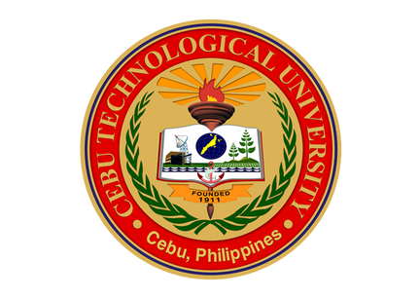


MELANIE R. ALBARRACIN
Dean, Student Life
EINGILBERT C. BENOLIRAO
Campus Director

