REPUBLIC OF THE PHILIPPINES

CEBU TECHNOLOGICAL UNIVERSITY
ARGAO CAMPUS
Ed Kintanar St. Lamacan, Argao, Cebu, Philippines Website: http://www.argao.ctu.edu.ph Email:cdargao@ctu.edu.ph
Phone No.: (032) 485-8290/485- 5109 loc 1700 Fax No. (032)-4858-290

O F F I C E O F T H E S T U D E N T L I F E

present this
STUDENT LEADERSHIP AWARD
to

[firstname] [lastname]
in recognition of her exceptional leadership skills, exemplary dedication, and outstanding contribution as the President of the Equationers during the Academic Year [academic_year].

Given this [date_given], during the Ring Hop Ceremony and tribute to Parents held at CTU-AC Kalampusan Gym.


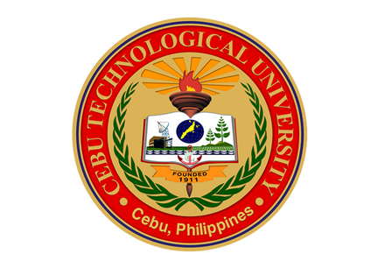


MELANIE R. ALBARRACIN
Dean, Student Life
EINGILBERT C. BENOLIRAO
Campus Director

