REPUBLIC OF THE PHILIPPINES

CEBU TECHNOLOGICAL UNIVERSITY
ARGAO CAMPUS
Ed Kintanar St. Lamacan, Argao, Cebu, Philippines Website: http://www.argao.ctu.edu.ph Email:cdargao@ctu.edu.ph
Phone No.: (032) 485-8290/485- 5109 loc 1700 Fax No. (032)-4858-290

O F F I C E O F T H E S T U D E N T L I F E

present this
OUTSTANDING
ATHLETE
to
[firstname] [lastname]
in recognition of her participation of SCUAA National Basketball Women Tournament last year. Her remarkable abilities, unwavering commitment, and admirable sportsmanship showcased during her involvement in our university's basketball program elevate our institution's reputation with pride.

Given this [date_given], during the Ring Hop Ceremony and tribute to Parents held at CTU-AC Kalampusan Gym.


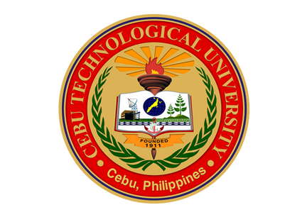


MELANIE R. ALBARRACIN
Dean, Student Life
EINGILBERT C. BENOLIRAO
Campus Director

