Contents

1 Introduction 3
1.1 Purpose 3
1.2 Scope 3
1.3 Definitions, Acronyms and Abbreviations 3
1.4 References 4
1.5 Overview 4
2 Overall Description 5
2.1 Product Perspective 5
2.2 Product Functions 5
2.3 User Characteristics 5
2.4 Constraints 6
2.5 Assumptions and dependencies 6
3 Specific Requirements 7
3.1 External Interfaces 7
3.2 Functional Requirements. 7
3.3 Performance Requirements 11
3.4 Maintainability 12
3.5 Design Constraints 12
3.5.1 Placement and overall Design 12
3.5.2 Form of the Functions 12
3.5.3 Programming Languages 12
3.5.4 Errors 12
3.5.5 Complexity 13
4 Supporting Information 14

Revision History

Date | Version | Description | Author(s)
03.10.2017 | 1.1 | First discussion, allocation of tasks. | Jurilj, Huber, Fuchs
06.10.2017 | 1.2 | Creation of scaffolding. | Jurilj, Huber, Fuchs
07.10.2017 | 1.3 | Extension in many chapters. | Jurilj, Huber, Fuchs
10.10.2017 | 1.4 | Revision and formatting. | Jurilj, Huber, Fuchs
14.10.2017 | 1.5 | Minor revisions and creation of final version 1.5. | Jurilj, Huber, Fuchs
28.10.2017 | 2.0 | Edit after discussion with TA | Jurilj, Huber, Fuchs

Introduction

Purpose
This document represents the Software Requirements Specifications for the Markup Language (MaLa) Generator Library for the Eiffel programming language. It is written and designed for the stake holders, such as the teaching assistants and the professor, as well as fellow students, lastly it is for the developers involved in the project (namely Dominik Jurilj, Ramon Huber, Basil Fuchs). Its purpose is to describe the scope of both functional and non-functional requirements for the software. Lastly it describes the design constraints of the MaLa Generator Library.

Scope
The goal of this project is to develop an extensible library for the programming language Eiffel, its purpose is to simplify the task of presenting output i.e. testing statistics or simulation results. The main markup language we will focus on will be HTML, but the goal is to construct the library in such a way, that it does not matter what language will be used. The library shall be easily usable for individuals acquainted with Eiffel without the need for them to have knowledge of the output language. The library will include being able to create a string for the markup language and to generate a new file. In its base version it will include various functions to display markup language forms such as plain text, titles, images, bullet lists, tables, etc.

Definitions, Acronyms and Abbreviations
Bullet lists: Tool for listing elements, every new element starts on a new line and with a bullet (circle) in front (as first character).
Browser: Program to illustrate Websites and Documents (e.g. HTML Files). Well-known examples: Firefox, Chrome, Internet Explorer, Edge, Safari.
CSS: Cascading Style Sheets, language used to add visualization and customization to HTML code.
Eiffel: Object-oriented programming language used in this project.
Forms: The most used HTML elements are called forms and include things like images, text, titles etc.
(HTML-)ID/Name: HTML-forms use IDs to differentiate them while using complementary languages like JavaScript or CSS.
initiate-string: String created by the initiate function and filled by other functions.
Injections: Unwanted additions of code, mostly in form of strings.
JavaScript: High-level, object-oriented programming language used together with HTML (and CSS) on almost all webpages.
HTML: Hypertext Markup Language, mostly used for creating and designing websites.
LaTex: Document preparation System, that will generate a PDF, as an opposite to most writing programs nowadays, with LaTex you have to compile first to see the output properly.
Markup: Language to format text and similar data. Closely related to HTML.
PHP: Server-side scripting language.
Regarding the requirements in 3.2:
ID: Unique identifier for the requirements.
Priority: The priority of the requirements, which ones are the most essential for the project, ranging from one to three (one being the highest priority)

References
IEEE 830-1998 (IEEE Standards Organization, https://standards.ieee.org/findstds/standard/830-1998.html)
Eiffel Programming Language (https://www.eiffel.org/)
Lecture Slides “Software Construction” (Bertrand Meyer, Universität Zürich, 2017)
Examples for SRS provided by the Teaching Assistants.
EiffelStudio System Requirements (from: Eiffel Software, https://www.eiffel.com/eiffelstudio/system-requirements/, (13.10.2017))

Overview
The next points, mainly in the second chapter, in this SRS are dedicated to show what the base library contains, what its flaws and constraints are, what it can be used for and how. We will also discuss who will be the typical user of our library.
In the third chapter we present the specific requirements, which show the software requirements in detail in order to give the programmers a good understanding of what they have to implement. This is divided into the subsections of Functional Requirements, Performance Requirements and Maintainability Requirements.
Chapter four provides supporting information.

Overall Description

Product Perspective
Our Product is intended to be used as a library inside the programming language Eiffel. All functions of the MaLa generator can be imported into the programming language and therefore any Eiffel system. Our Product is very dependant on the programming language and it’s version, it can only be used with an Eiffel Compiler, as seen in Figure 1, and cannot run on its own. An interface for our product would be EiffelStudio for example.

Figure 1: Shows the flow from the user input, using the library, to creating a HTML file

Product Functions
The functions presented are implementations of basic markup languag code to easen the creation of a file. The most important duo consists of initiate() and generate() which are respectively used to start filling the output-string and to create an file with said string as input. What follows is a list of functionalities used in the base library of this product.
- Initiate and create a string or file, that will store the code created with our library.
- Insert text into the file that is either in normal, bold or italic print. Additionally, there’s the option to input a title which is in bigger print.
- Insert a link to a webpage or another file through a linked text or an action button.
- Insert an image.
- Create an ordered or unordered list.
- Create a table.
- Insert an already existing snippet, from the regarding markup language, into the file.
In section 3.2 follows a more detailed description of the functions.
Features that are explicitly not supported in the base form of the library are all features that would require the use of CSS or JavaScript.

User Characteristics
This library is mostly aimed at users who want to create a simple document in markup language or who just want to create a few basic forms, in form of a string, without much hassle.
The extensibility of the library adds possibilities for users who are more experienced with the respective language to add functions of their own to counter the later mentioned constraints of the base library.
It is however not recommended to be used by people well acquainted with the markup language, especially if they need complementary languages like JavaScript, PHP and CSS.

Constraints
Since the library is aimed at creating a file and/or filling an empty string with the data, it does not contain the means to delete functions or files, or to edit them in any way. Once the string generated by initiate is no longer empty, the user has to start over again. If they intend to add something in-between or to delete a form which means that once a function is used it is irreversible with the base library.
In its base form, the library does not contain any form of additional design possibilities, which are vital for visualization and for calculations and communications on bigger websites. While it is still possible to add those, this project concentrates on the purpose of creating a simple one-page documents or only the string for it.
More about constraints in chapter 3.5 Constraints.

Assumptions and dependencies
The user must be acquainted with the Eiffel programming language, to be able to use the library, and has to have a basic understanding of variables and features (functions).

Specific Requirements

External Interfaces
The Eiffel Programming environment (which comes from another source) will be the main interface for our library. The environment we will be working with during this project is EiffelStudio.

Functional Requirements
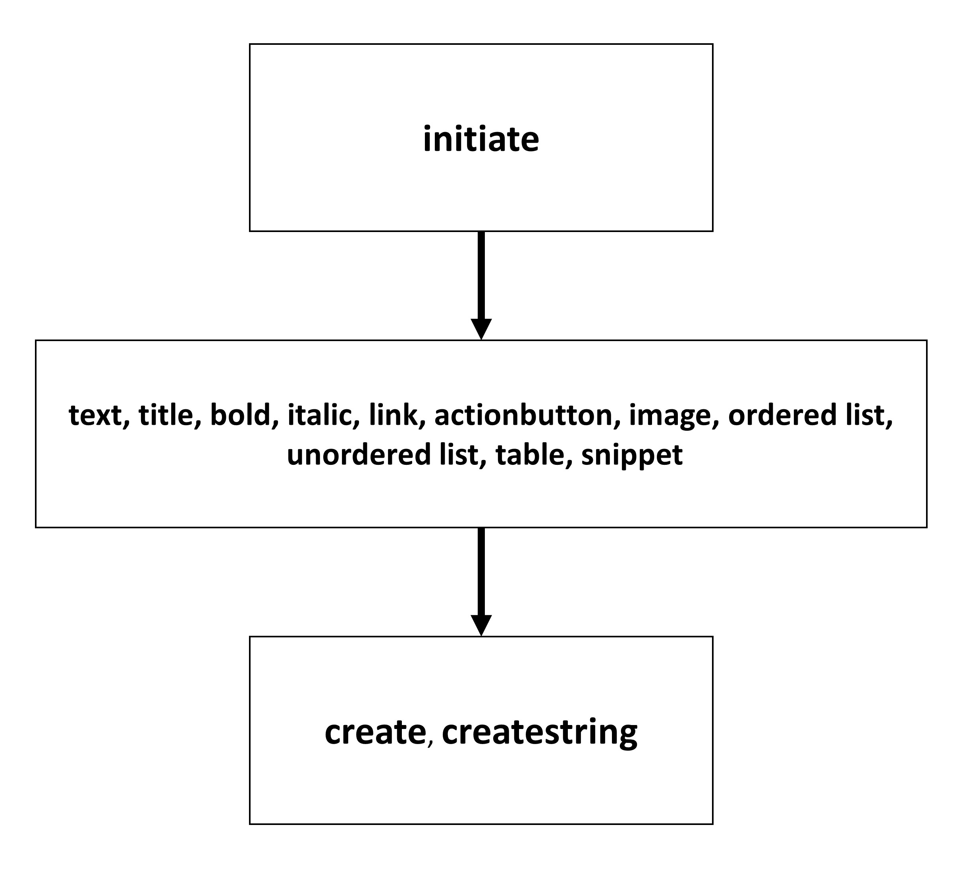
ID  Name  Description  Priority  References | R1.1  generate  Let’s the user decide to generate either a string or a file. The purpose is, that it gives the user the possibility to get all the strings from previous features and turns them into a possible file, for the markup language. If the user chooses to retrieve a string, he will have to manually add that to a file of the language, for example, if he already has an existing file and wants to add features. Otherwise he should be able to get a complete file for his language of choice, containing previous created snippets (in the form of strings).  1  All following features
ID  Name  Description  Priority  References | R2.1  text  Adds the possibility to write plain text into the output string. It will take a string as input, where the user specifies what will be written in the text.  2  title
ID  Name  Description  Priority  References | R2.2  title  Lets the user choose from a range of titles. The title text makes use of the built in function of most markup languages, this function contains a preset of title font styles.  2  text
ID  Name  Description  Priority  References | R2.3  bold  Similar to the text feature, except it uses the inbuilt functions of bold from the markup language. Returns a string that can be put into a file and would be converted by the language to bold.  3  text, italic
ID  Name  Description  Priority  References | R2.4  italic  Similar to the text feature, except it uses the inbuilt functions of italic from the markup language. Returns a string that can be put into a file and would be converted by the language to italic.  3  text, bold
ID  Name  Description  Priority  References | R2.5  link  Returns a string that will be seen by the used language as a link, this link will be to another place in the document, an external link or a link to a file (e.g. an image). This string can be put into the file of the markup language.  2  actionbutton
ID  Name  Description  Priority  References | R2.7  Object_link  The output will be a string that will be (if put into a file of the markup language) a link to an object (e.g. document of markup language).  2  None
ID  Name  Description  Priority  References | R2.8  ordered list  Takes an array as input. Each element of the element will be taken as separate element of the list. The output will be a string that can be put into a file and will be converted into an ordered list through the language.  2  unordered list
ID  Name  Description  Priority  References | R2.9  unordered list  Same principle as the ordered list, it takes an array as input and the elements of this array will be turned into for example bullet points. The output will again be a string comprehensible by the markup language. The main difference to the ordered list will be that it won’t be enumerated (1., 2., 3.) but unordered (bulletpoints).  2  ordered list
ID  Name  Description  Priority  References | R2.10  arraytable  Takes multiple arrays as input. Each array has to include the same amount of elements. The arrays will be taken as separate rows of the output table. The elements will be the content of the fields. The output of the feature is a string that can be converted by the markup language.  2  None
ID  Name  Description  Priority  References | R2.11  snippet  Gives the user the possibility to add pre-existing snippets of string that are written in the markup language. Takes a string  2  All the other forms

All R2.X requirements (X stands for any number) create HTML code that can later be stored in a file or a string, through the functions create or createstring.

Performance Requirements
Most of the computational power will be needed to run EiffelStudio since the functions itselves are not of a high complexity.
See chapter 4. Supporting Information for the system requirements of EiffelStudio.

Maintainability
The nature of the library makes it easily maintainable and extensible if using the Eiffel programming language. If a user wants to add more complex elements like CSS (with HTML) or wants to have functions to delete/edit an already existing string or file, they additionally need to know to code in the used language. In order to simplify maintainability the programmers should write in a way that their code is easy to read and simple to understand.

Design Constraints
The usage of simple forms like text-forms or adding images are easy enough to efficiently implement with Eiffel. The addition of more complex possibilities like editing existing pages however need too big of an effort for it to be worth, it would include regular expressions and would make the features much less efficient if it had to search through the entire string or file.

Placement and overall Design
The functions are designed to add a single form into the string/file after calling it. Without extending the library or modifying the functions, it is impossible to swap places of previously added forms or change its styles with CSS.

Form of the Functions
The main functions used for generating the string and new file, generate is vital in the way the library works. If one does not follow the design pattern of adding to the generate-string at the end of each function, the output will not be changed.

Programming Languages
Creating a new file by using the base library only demands knowledge about Eiffel, while adding new functions automatically assumes familiarity with the respective markup language or more.

Errors
In its base form, none of the functions are able to detect or remove errors or injections done by the user. It is possible by extending the library with checking for regular expressions.

Complexity
This chapter concludes the previously mentioned chapters (3.5.1, 3.5.2, 3.5.3, 3.5.4).
Most elements in the base library are easily comprehensible even for a user without knowledge of markup languages. Changing an existing file in a desired way or adding communication in form of PHP and JavaScript add a lot of complexity to functions and makes room for more errors and bugs.
Let us take a look at the text function:
The only input needed is a string to be added in the generate-string respectively added as an snippet in the file.
If one were to add the possibility to give the text-form an ID and make it another class to be separately modified through CSS, the function would need two more arguments in the best case. Furthermore, the function automatically needs more lines of code to use those values and add them to the generate-string. The option to add a CSS file would still be missing which means that either the text function permanently needs to use a certain CSS template (saved in the function), you need one more argument for the function, or the generate-function needs to be adapted to usage of CSS.
If we now additionally want to use JavaScript or PHP it quickly leads to exceptionally complicated functions.

Supporting Information
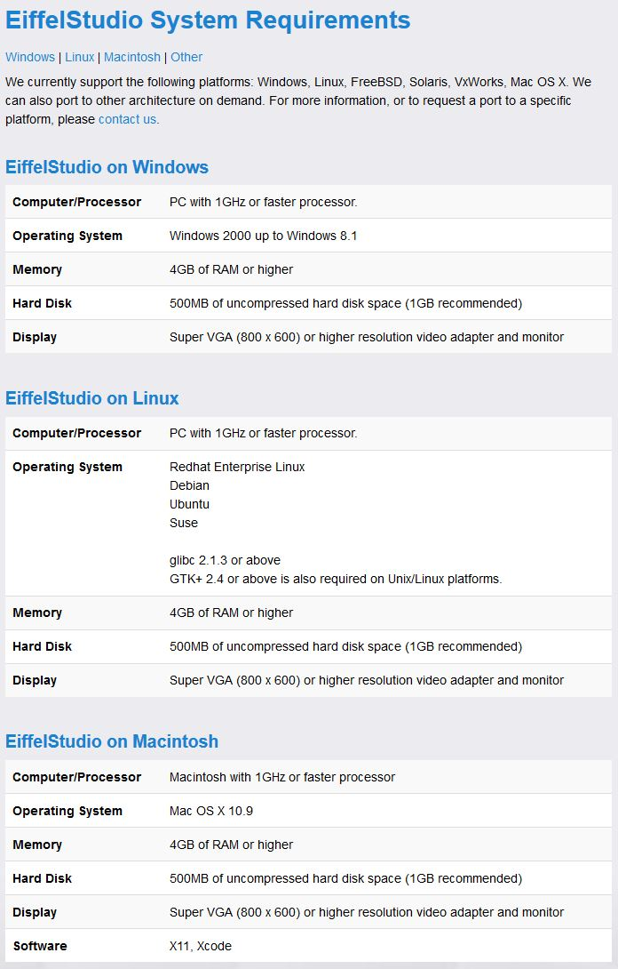
(See References for source declaration)

