

AWS First Cloud AI Journey – Project Plan

[Project team : Furious Five ]

[FPT University]

[Online Shopping Website: Furious Five Fashion (FFF)]-[12/12/2025]
Table of Contents
1 BACKGROUND and motivation 3
1.1 executive summary 3
1.2 PROJECT SUCCESS CRITERIA 3
1.3 Assumptions 3
2 SOLUTION ARCHITECTURE / ARCHITECTURAL DIAGRAM 3
2.1 Technical Architecture Diagram 3
2.2 Technical Plan 4
2.3 Project Plan 4
2.4 Security Considerations 4
3 Activities AND Deliverables 5
3.1 Activities and deliverables 5
3.2 OUT OF SCOPE 5
3.3 PATH TO PRODUCTION 5
4 EXPECTED AWS COST BREAKDOWN BY SERVICES 5
5 TEAM 6
6 resources & cost estimates 6
7 Acceptance 7

BACKGROUND and motivation

executive summary
The client is a small-sized business specializing in fashion products for young customers. They aim to build an online clothing e-commerce website using AWS and AI, with the ability to scale flexibly, support long-term growth, and optimize operational costs.
The goal of this project is to shift from traditional manual management on physical servers to a flexible, intelligent, and cost-efficient cloud-based model. AWS enables the system to scale at any time, maintains fast access speed, and allows the business to focus on product development instead of infrastructure.
The system is designed to support end-to-end e-commerce operations: hosting and distributing web content, managing product and order databases, supporting payments, and monitoring system performance. Everything aims toward stability, security, and long-term scalability.
The Furious Five implementation team will accompany the client throughout the process—advising, designing the architecture, and configuring key AWS services such as Lambda, S3, DynamoDB, CloudFront, and Route 53. Beyond building the system, they also help optimize costs, ensure security, and train the internal team to manage the infrastructure effectively.

PROJECT SUCCESS CRITERIA
To ensure the success of the Furious Five Fashion project, the following clear and measurable criteria must be met, representing both business goals and technical effectiveness:
System Performance
The website must maintain response times under 2 seconds for all user actions, even during peak hours.
Availabilit
The system must achieve 99.9% uptime, monitored and automatically reported through services like CloudWatch.
Scalability
AWS infrastructure must scale automatically when traffic increases by at least 2× without causing service disruption.
Cost Optimization
Monthly operating costs must remain below 30% of the projected budget, supported by AWS cost-monitoring tools such as Cost Explorer and Trusted Advisor.
Security
No data leaks or unauthorized access. All customer data must be protected by AWS security standards (IAM policies, encryption, HTTPS,).
Deployment & Operations
Infrastructure must be fully deployed within 4 weeks, with complete documentation so the internal team can manage the environment effectively.

Assumptions
To ensure alignment and smooth execution of the FFF project, the following assumptions have been made:
The team already has access to AWS accounts with required permissions and has basic knowledge of essential AWS services such as Lambda, S3, IAM, and Route 53. Stable Internet connectivity is assumed since all infrastructure runs in the cloud. The team is also aware of basic security and compliance requirements before deployment.
The project depends on many external factors: stable service availability in the selected AWS region, smooth domain routing via Route 53, and effective collaboration between development teams to ensure the web application operates properly in the cloud environment.
The project is part of an internship, so the budget is limited—favoring free-tier usage and low-cost service configurations. Due to limited experience and tight timelines, the chosen architecture remains simple and practical.
Potential risks include IAM misconfigurations, accidental overspending due to unused resources, AWS regional outages, service incompatibilities, or limited expertise in troubleshooting cloud systems.
Despite these risks, the project is built on clear expectations: this is a pilot environment, with layered monitoring, backup, and cost-management strategies in place. Every challenge is considered an opportunity to learn and grow in cloud engineering.

SOLUTION ARCHITECTURE / ARCHITECTURAL DIAGRAM

Technical Architecture Diagram
The following architecture is designed for FFF, deployed in AWS Region Singapore (ap-southeast-1). It enhances flexibility, security, automation, scalability, and simplicity—appropriate for an internship-level project while following AWS best practices.
The system follows a multi-layer design consisting of six key components:
Frontend & Security Layer
Users access the website through Route 53. Incoming traffic is protected with AWS WAF and optimized via CloudFront . Source code is managed and deployed through GitLab CI/CD using CloudFormation templates.
API & Compute Layer
API Gateway routes all requests to AWS Lambda, which handles application logic. Cognito manages authentication and access control.
Storage Layer
Two S3 buckets store static content (StaticData) and user uploads.
Data Layer
DynamoDB stores product metadata and unstructured data. IAM ensures secure interactions between components.
AI Layer
Amazon Rekognition and Amazon Bedrock power image processing and generative AI features.
Observability & Security Layer
CloudWatch, SNS, and SES provide monitoring, alerting, and system notifications.
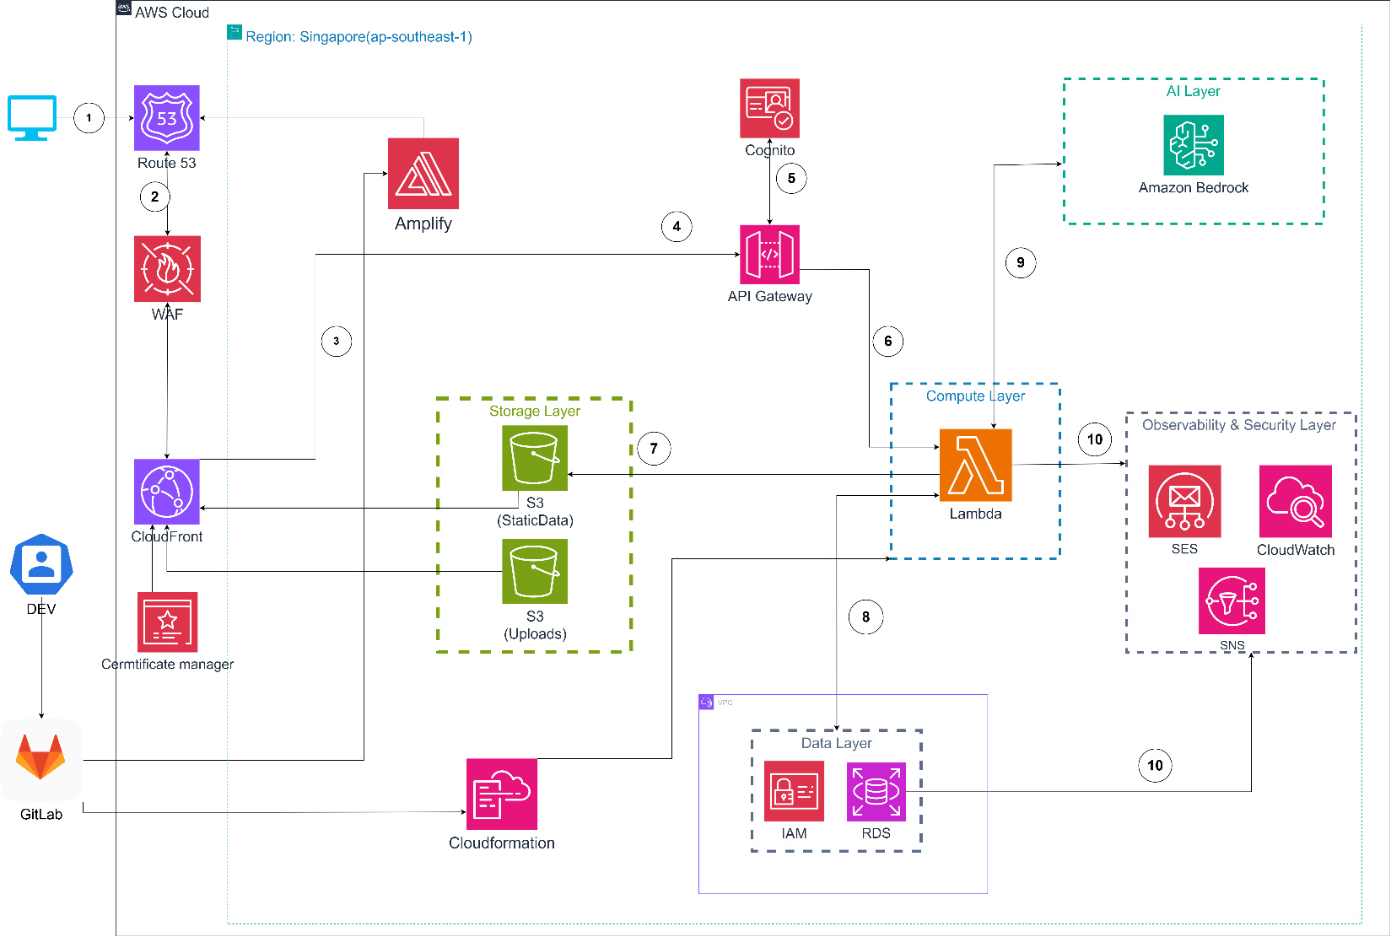

Technical Plan
Infrastructure will be managed and deployed using Infrastructure as Code (IaC) with AWS CloudFormation to ensure repeatability, stability, and ease of maintenance.
Key AWS components—S3, Lambda, API Gateway, VPC, RDS , Cognito, and CloudWatch—will be defined entirely through CloudFormation templates stored in GitLab for version control and rollback capability.
Sensitive configurations such as IAM permissions or WAF rules require approval before deployment and follow the internal governance process with review and validation.
All critical system paths—from authentication to data processing—are covered by automated and manual test cases to ensure stability, security, and scalability.
This technical plan enables the FFF team to deploy and manage a professional cloud environment, learning real DevOps and AWS best practices.

Project Plan
The project follows Agile Scrum over 3 months, divided into 4 sprints.
Sprint Structure
- Sprint Planning
- Setup AWS foundational services (S3, Route 53, IAM)
- Configure security (WAF, CloudFront)
- Integrate backend (Lambda, API Gateway,RDS)
- Testing, optimization, and demo preparation
- Daily Stand-up 30-minute updates to address blockers and track status.
- Sprint Review Review deliverables, demo on real AWS environment, fix issues.
- Retrospective Improve DevOps workflows and automation pipeline.
Team Roles
- Product Owner: Business alignment, backlog prioritization
- Scrum Master: Coordination, Agile process enforcement
- DevOps/Technical Team: Backend, infrastructure, CI/CD
- Mentor / AWS Partner: Architecture validation, AI testing, cost & security review
Communication Rhythm
- Daily Stand-ups (23:00)
- Weekly Sync
- End-of-Sprint Demo
Knowledge Transfer After the final sprint, the technical team will deliver hands-on training on operations, monitoring (Budgets, CloudWatch), scaling, and recovery procedures.

Security Considerations
Access Management:
MFA for admin users; IAM roles with least privilege; auditing through CloudTrail.
Infrastructure Security:
dedicated VPC, services are restricted using resource policies; all public endpoints use HTTPS.
Data Protection:
S3 and RDS encryption; TLS data transfer; manual periodic backups.
Detection & Monitoring:
CloudTrail, Config, and CloudWatch for visibility; GuardDuty for threat detection.
Incident Response:
Clear incident workflows with log collection, analysis, and periodic simulations.

Activities AND Deliverables

Activities and deliverables

Project Phase | Timeline | Activities | Deliverables/Milestones | Total man-day
Infrastructure Setup | Week 1-2 | Requirements gathering, architecture design, AWS configuration (S3, CloudFront, API, Lambda, RDS, Cognito), GitLab CI/CD setup | - item 1 | [X man-day]
Frontend Development | Week 3-5 | UI/UX design, FE pages (Home, Catalog, Product Detail, Cart, Checkout), API integration | - item 1 | [X man-day]
Backend & Database | Week 6-9 | Lambda APIs, RDS setup, order/user/product logic, Cognito IAM setup | - item 1 | [X man-day]
Testing & Validation | Week 10-11 | Functional, security, performance testing, integration testing | - item 1 | [X man-day]
Production Launch | Week 12 | Deploy to production, domain & SSL setup, training & handover | - item1 | [X man-day]

OUT OF SCOPE
The following items were discussed during the requirements definition phase, but were determined to be out of scope for the FFF Web Clothing project at the current stage.
Items out of scope include:
- Mobile App development for the system (Android/iOS).
- Integration of real-world inventory, shipping and logistics management systems (Fast Delivery, GHN, Viettel Post, etc.).
- Advanced administrative functions such as multi-level authorization, automatic revenue reporting, advanced statistical charts.
- Integration of third-party CRM (Customer Relationship Management) or ERP (Enterprise Resource Planning).
- Use of AWS services with higher, more expensive automatic security features.
-Integration of real-world payment gateways (VNPay, Momo, ZaloPay, Stripe, PayPal, etc.)
- Multilingual and multi-currency

PATH TO PRODUCTION
Phase 1 – Prototype (POC)
Activities:
Build a test version of FFF Web Sales with basic interface (Home, Category, Product Details, Cart).
- Connect backend via API Gateway – Lambda – DynamoDB.
- Deploy static website on Amazon S3 + CloudFront.
- Configure admin account and demo trial order process.
Phase 2 – Complete system and test (UAT)
Activities:
- Add user functions: login/register, authentication via AWS Cognito.
- Add trial payment feature via sandbox.
- Add monitoring with Amazon CloudWatch and error handling log.
- Perform internal user testing (User Acceptance Test).
Phase 3 - Official Operation Deployment (Production)
Activities:
- Move the entire system from the test environment to Production AWS.
- Configure Route53 for the official domain and SSL certificate via AWS Certificate Manager.
- Set up external security with AWS WAF.
- Optimize S3 capacity and CDN structure on CloudFront.
Phase 4 – Stabilization & optimization after deployment
Activities:
- Monitor actual AWS costs, optimize storage and logs.
- Adjust Lambda configuration to reduce cold start time.
- Perform periodic backups and test data recovery.
- Update operational documentation for the administration team.
Summary:
The FFF Web Sales system has been successfully deployed on the AWS Serverless platform with a cost-optimized, highly secure and scalable architecture.
The stages were completed on schedule, ensuring that all functions were tested, refined and operated stably.
The project is now ready to expand real users and integrate more advanced e-commerce features.

EXPECTED AWS COST BREAKDOWN BY SERVICES
Estimated monthly cost:
- Route 53: $1.00
- AWS WAF : $5.00
- CloudFront: $3.90
- Amplify: $10.00
- S3 (StaticData): $0.50
- S3 (Uploads): $0.75
- S3 (Bucket): $0.75
- AWS Lambda: $0.25
- API Gateway: $3.50
- Amazon Bedrock: $3.00
- RDS: $21.00
- IAM: Free
- CloudWatch: $2.00
- SNS: $0.10
- SES: $0.20
- CloudFormation: Free
- GitLab CI/CD : $3.00
- WS Config / Setup & Test migration tools $5.00 (1 time)
- Estimated monthly total cost: ~ $50.00 – $55.00 USD
KEY ASSUMPTIONS
Region: ap-southeast-1 (Singapore).
User access: 100–200/month.
The system is always running 24/7 but low load.
Mostly API via Lambda.
Small data (<30GB total).
CI/CD 1–2 deployments per week.
Free-tier is valid for the first 12 months.
AI is used for demo purposes, not large-scale inference.
SUGGESTED COST OPTIMISATION
Enable S3 Intelligent-Tiering to automatically move less frequently accessed data.
Limit CloudWatch Logs to 14–30 days.
Use AWS Budgets to alert if it exceeds $40/month.
If deploying long-term → consider Savings Plan for Lambda (30–40% reduction).

TEAM
Partner Executive Sponsor
Name | Title | Description | Email / Contact Info
Nguyen Gia Hung | FCJ Vietnam Training Program Director | Responsible for overall oversight of the FCJ internship program | hunggia@amazon.com

Project Stakeholders
Name | Title | Stakeholder for | Email / Contact Info
Van Hoang Kha | Support Teams | Responsible for overall supervision of the FCJ internship program as the Executive Support person. | Khab9thd@gmail.com

Partner Project Team
Name | Title | Role | Email / Contact Info
Duong Minh Duc | Project Team Leader | Manage project progress, coordinate between team and mentor, and oversee AWS infrastructure deployment (S3, Lambda, IAM). | ducdmse182938@fpt.edu.vn
Quach Nguyen Chi Hung | Member | In charge of UI/UX and user interface | bacon3632@gmail.com
Nguyen Tuan Xuan | Member | Responsible for Backend and server logic processing | xuanntse184074@fpt.edu.vn
Nguyen Hai Dang | Member | Manage AWS infrastructure deployment (S3, Lambda, IAM) and AI chat bot | dangnhse184292@fpt.edu.vn
Pham Le Huy Hoang | Member | Testing, quality assurance and GitLab CI/CD integration, and AI chat bot | hoangplhse182670@fpt.edu.vn
Project Escalation Contacts
Name | Title | Role | Email / Contact Info
Duong Minh Duc | Project Team Leader | Represent the internship team to contact the mentor and sponsor directly | ducdmse182938@fpt.edu.vn

resources & cost estimates

Resource | Responsibility | Rate (USD) / Hour
Solution Architect(1) | Design overall solution, ensure technical feasibility, select appropriate AWS service | 35
Cloud Engineer(2) | Deploy AWS infrastructure, configure services (S3, IAM…), test and optimize system | 20
Project Manager (1) | Monitor progress, coordinate team, manage scope and risk for the project. | 15
Support / Documentation (1) | Prepare communication documents, user manuals and summary reports. | 10

Project Phase | Solution Architects | Engineers | Other  (Please specify) | Total Hours
Survey & Solution Design | 53 | 40 | 13 | 13
Implementation & Testing | 67 | 160 | 21 | 19
Handover & Support | 27 | 53 | 21 | 19
Total Hours | 147 | 253 | 55 | 51
Total Amount | $5145 | $5060 | $825 | $510
Survey & Solution Design | 53 | 40 | 13 | 13

Cost Contribution distribution between Partner, Customer, AWS:
Party | Contribution (USD) | % Contribution of Total
Customer | 4616 | 40%
Partner | 2308 | 20%
AWS | 4616 | 40%

Acceptance
Since this project is currently at the presentation stage and has not yet been formally evaluated by a customer, the following acceptance process is proposed for future delivery phases:

7.1 Acceptance Criteria (Proposed)
A deliverable will be considered acceptable when it meets the following criteria:
-Functional features work as specified (authentication, recipe management, social features, AI functions).
-All APIs respond correctly and integrate with AWS services (Lambda, API Gateway, RDS, S3).
- Security requirements are met (JWT verification, HTTPS, access control, data encryption).
- UI works as expected on supported devices.
- No critical errors appear during test execution.
7.2 ACCEPTANCE PROCESS
- Review period: 8 business days for evaluation and testing.
- If accepted → Deliverable is signed off.
- If issues are found → A rejection notice will be issued with feedback.
- Fixes will be applied and a revised version will be resubmitted for review.
- If no response is received by the end of the review period → Deliverable is considered accepted.
- After completing each milestone, the team submits the deliverables and documentation.

