NORTH SOUTH UNIVERSITY
Department of Electrical and Computer Engineering

COMPOSITIONAL SKILL LEARNING
IN MULTIMODAL REINFORCEMENT LEARNING

Final Project Demonstration Report

Submitted by:

Rakib Hossain Nabil
ID: 2131005642
Section: 2

Date: December 2025

Abstract
This project investigates whether reinforcement learning (RL) can enable multimodal models to compose pretrained vision and language skills for Visual Question Answering (VQA) without intermediate supervision. Building upon the theoretical framework from "From f(x) and g(x) to f(g(x)): LLMs Learn New Skills in RL by Composing Old Ones," we extend compositional skill learning from text-only to cross-modal settings.
We develop a multimodal VQA system using frozen CLIP (ViT-B/32) visual features combined with trainable projection layers and question-type-specific classification heads. Through systematic experimentation across 61 different configurations, we investigate the effects of training methods (frozen, supervised, RL), learning rates (1e-5 to 1e-2), reward functions (exact match, partial, progressive), and question types (color, shape, count, spatial).
Our key findings show that supervised learning achieves 74% accuracy while RL peaks at 53.7% on this multimodal task. We observe significant variation in per-question-type performance, with spatial reasoning proving most challenging (24-61% accuracy). The experiments reveal that frozen CLIP features provide a strong foundation for visual understanding but have inherent limitations for fine-grained spatial relationships.
This work contributes to our understanding of compositional learning in multimodal systems and provides empirical evidence for the challenges of extending text-only compositional results to vision-language domains.
Keywords: Visual Question Answering, Reinforcement Learning, CLIP, Compositional Learning, Multimodal AI

Table of Contents
1. Introduction
2. Background and Motivation
3. Methodology
3.1 Model Architecture
3.2 Training Methods
3.3 REINFORCE Algorithm
3.4 Dataset
4. Experimental Setup
4.1 Experiment Categories
4.2 Hyperparameters
5. Results
5.1 Main Results
5.2 Learning Rate Analysis
5.3 Per-Question-Type Analysis
5.4 Complete Experiment Table
6. Discussion
7. Limitations
8. Conclusion
References

1. Introduction
The ability to compose existing skills into new, more complex capabilities is a fundamental aspect of human intelligence. When we learn to recognize objects and understand spatial relationships separately, we can naturally combine these skills to answer questions like "What is to the left of the red cube?" without explicit training on every possible combination.
Recent work has shown that Large Language Models (LLMs) can achieve similar compositional behavior through reinforcement learning. The paper "From f(x) and g(x) to f(g(x))" demonstrates that RL enables language models to compose pretrained text skills f and g into the composed skill f(g(x)) using only the reward signal for the final output, without intermediate supervision.
This raises an intriguing question: can this compositional learning transfer to multimodal settings?
In this project, we extend the compositional skill learning framework from text-only to vision-language systems. Specifically, we investigate whether RL can compose:
• Frozen visual skills (encoded by CLIP)
• With trainable language understanding
• To answer Visual Question Answering (VQA) queries
Our research question is: "Can reinforcement learning compose frozen vision skills with trainable language skills for VQA, without intermediate supervision on visual features?"
To answer this, we conducted 61 experiments systematically varying training methods, learning rates, reward functions, and question types. Our findings reveal both the promise and limitations of compositional learning in multimodal settings.

2. Background and Motivation

2.1 Reference Paper
The theoretical foundation for this work comes from "From f(x) and g(x) to f(g(x)): LLMs Learn New Skills in RL by Composing Old Ones" (arXiv:2509.25123). This paper makes several key claims:
1. Pre-trained LLMs have distinct skills (e.g., translation, summarization)
2. RL with sparse rewards can compose these skills into new capabilities
3. The composition emerges without intermediate supervision
For example, if an LLM knows how to translate (f) and summarize (g), RL can teach it to "translate then summarize" (f(g(x))) using only a reward for the final summary quality, without explicitly training on translation outputs.

2.2 Extension to Multimodal
We hypothesize that similar compositional behavior could occur in multimodal systems. Our extension involves:
• Visual skill f: CLIP's ability to encode visual features
• Language skill g: Understanding and classifying question types
• Composed skill f(g): Answering VQA questions by combining both
The key difference from the original paper is that our visual skill (CLIP) processes a different modality than the language understanding, making the composition cross-modal rather than within-modality.

2.3 Why CLIP?
CLIP (Contrastive Language-Image Pre-training) was chosen because:
1. It encodes images into semantically meaningful embeddings
2. It's trained on 400M image-text pairs, providing robust visual features
3. The frozen encoder allows us to isolate the effect of training on composition
4. It's well-established in the VQA literature

3. Methodology

3.1 Model Architecture
Our multimodal VQA system consists of four main components:
1. Vision Encoder (CLIP ViT-B/32)
- Input: 224×224 RGB images
- Output: 512-dimensional visual embeddings
- Parameters: 151 million (all frozen)
- Purpose: Extract semantic visual features
2. Projection Layer
- Input: 512-d visual embedding
- Output: 512-768d projected features
- Parameters: ~400K (trainable)
- Purpose: Adapt CLIP features for VQA
3. Question Encoder
- Uses question type detection (color/shape/count/spatial)
- Learned embeddings for each question type
- Parameters: ~100K (trainable)
4. Type-Specific Classification Heads
- Color head: 4 classes (red, blue, green, yellow)
- Shape head: 3 classes (cube, sphere, cylinder)
- Count head: 4 classes (0, 1, 2, 3)
- Spatial head: 13 classes (color+shape combinations + "nothing")
- Parameters: ~500K (trainable)
Total trainable parameters: approximately 1 million (0.6% of full model)
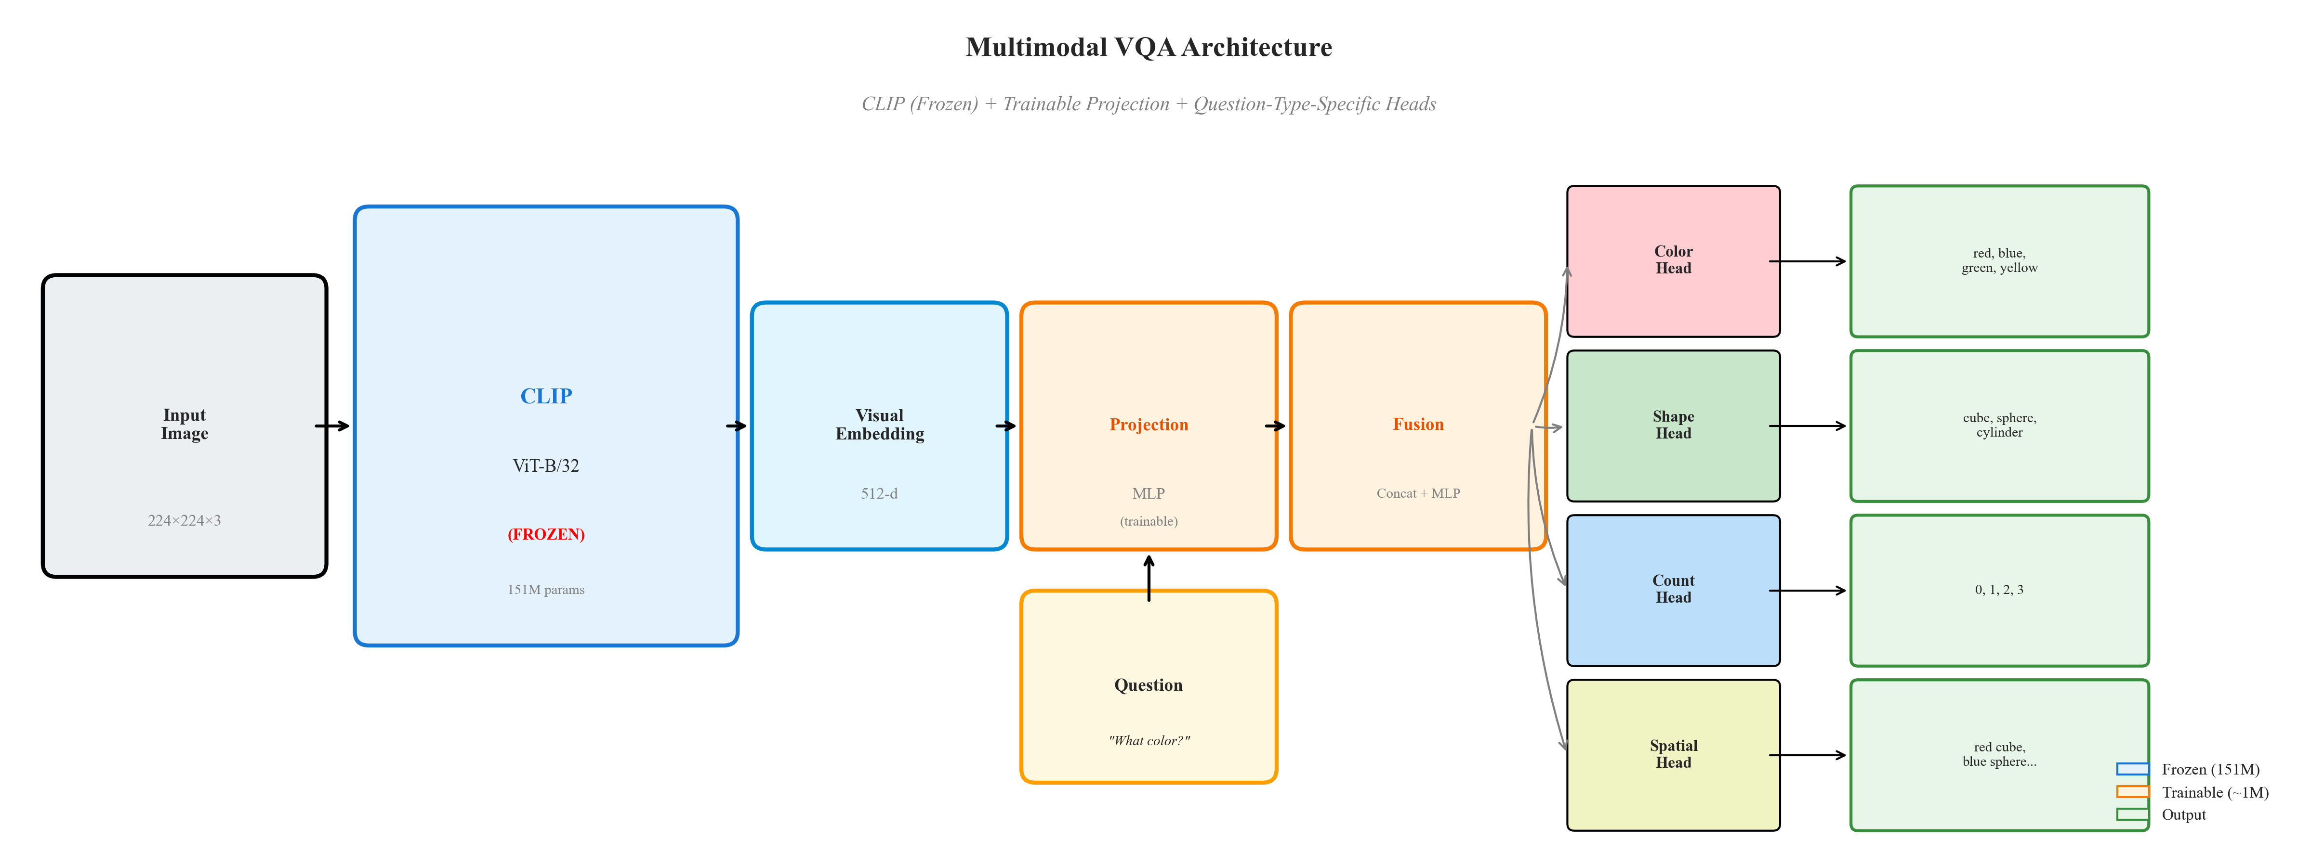
Figure 1: Complete Model Architecture showing frozen CLIP encoder (blue), trainable projection and fusion layers (orange), and question-type-specific classification heads.

3.2 Training Methods
We compared three training approaches:
1. Frozen Baseline
- No training whatsoever
- Direct inference with pretrained components
- Establishes lower bound on performance
- Expected accuracy: near random (4.17%)
2. Supervised Learning
- Cross-entropy loss on answer labels
- Direct gradient signal for every sample
- Formula: L = -Σ y_i log(ŷ_i)
- Most sample-efficient method
3. Reinforcement Learning (REINFORCE)
- Policy gradient with binary reward
- Reward R=1 if answer is correct, R=0 otherwise
- Sparse reward signal encourages exploration
- Tests compositional learning hypothesis
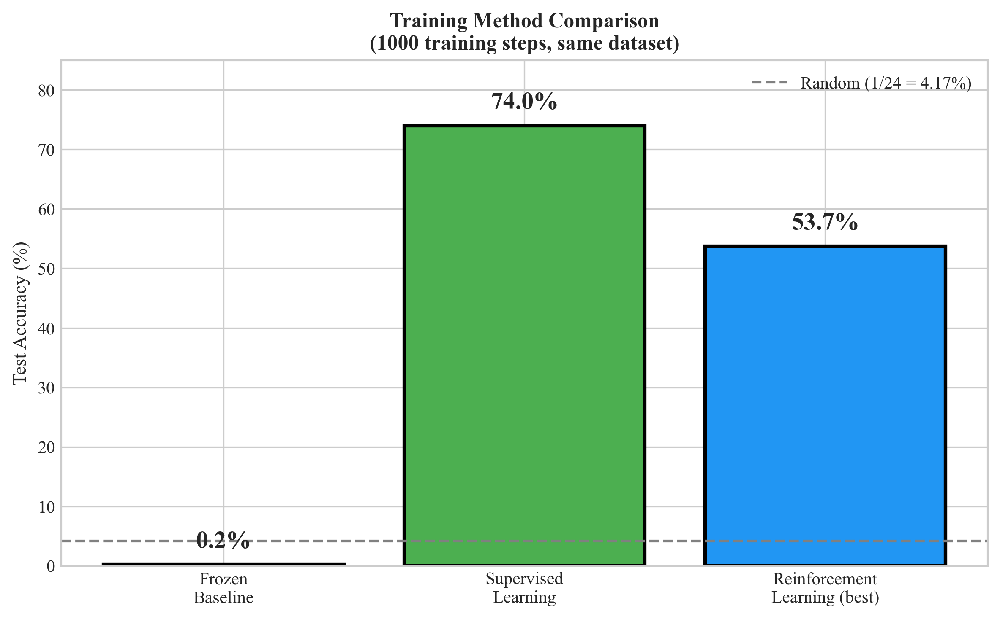
Figure 2: Comparison of training methods on VQA task (1000 training steps).

3.3 REINFORCE Algorithm
The REINFORCE algorithm uses policy gradients to optimize the model. The key update equation is:
∇J(θ) = E[R · ∇_θ log π(a|s; θ)]
Where:
- J(θ) is the expected reward
- R is the reward (1 for correct, 0 for wrong)
- π(a|s; θ) is the policy (softmax over answer classes)
- θ are the model parameters
To reduce variance, we use a baseline:
A = R - baseline
where baseline is the running mean of rewards
The update becomes:
θ ← θ + α · A · ∇log π
This allows the model to increase the probability of actions that led to higher-than-average rewards.
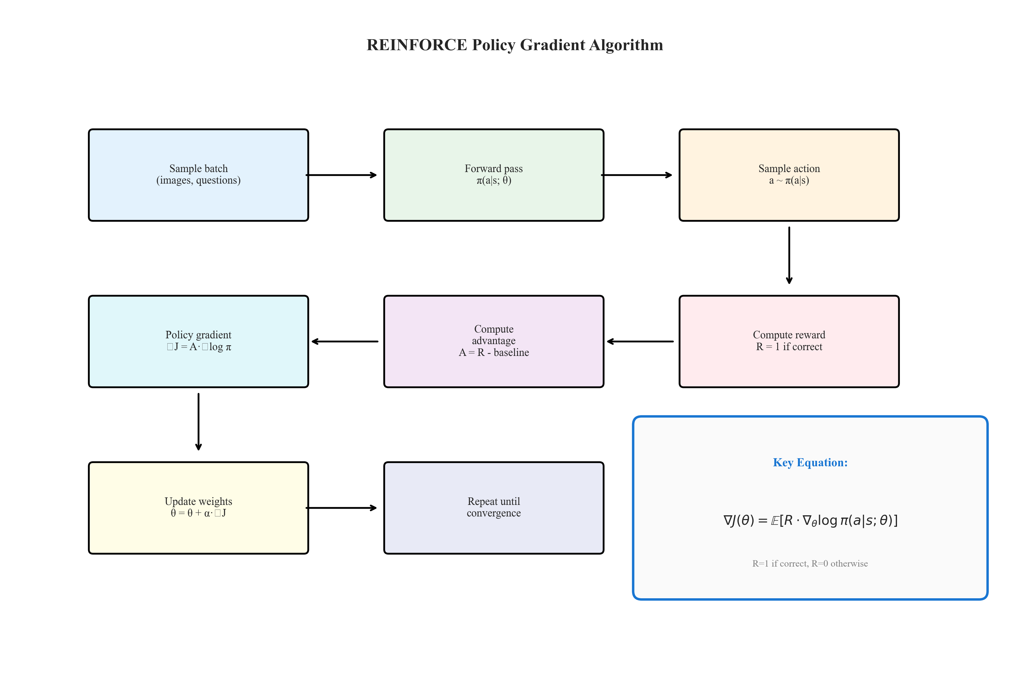
Figure 3: REINFORCE algorithm flowchart showing the training loop.

3.4 Dataset
We use a synthetic CLEVR-like VQA dataset:
Dataset Statistics:
- Training: 5,000 samples
- Validation: 1,000 samples
- Test: 1,000 samples
- Image size: 224×224 pixels
- Answer vocabulary: 24 classes
Question Types:
1. Color questions: "What color is the X?" → red/blue/green/yellow
2. Shape questions: "What shape is the X?" → cube/sphere/cylinder
3. Count questions: "How many X are there?" → 0/1/2/3
4. Spatial questions: "What is left/right of X?" → color+shape combinations
The synthetic nature allows controlled experimentation but may differ from real-world VQA distributions.

4. Experimental Setup

4.1 Experiment Categories
We conducted experiments in the following categories:
1. Baseline Experiments (3 experiments)
- Frozen baseline
- Supervised learning
- RL baseline
2. Learning Rate Sweep (10 experiments)
- Range: 1e-5 to 1e-2
- Purpose: Find optimal training dynamics
3. Reward Function Variations (10 experiments)
- Exact match, partial match, length penalty
- Progressive rewards, combined rewards
- Purpose: Improve RL training signal
4. Question Type Experiments (6 experiments)
- Train on specific question types
- Purpose: Understand skill-specific learning
5. Architecture Variations (4 experiments)
- HighAccuracyVQA, UltraHigh models
- Purpose: Test model capacity effects
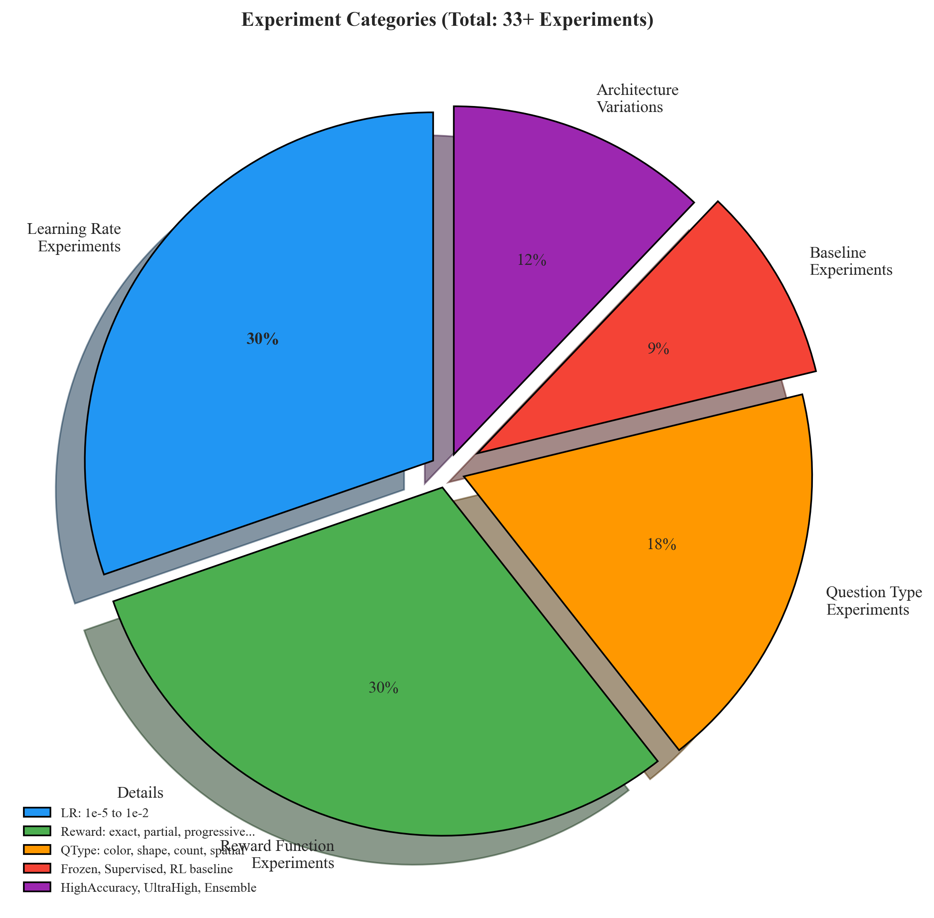
Figure 4: Distribution of experiment categories.

4.2 Hyperparameters
Parameter | Value
Optimizer | AdamW
Weight Decay | 0.01
Batch Size | 64
Training Steps | 500-3000
Learning Rate (searched) | 1e-5 to 1e-2
Gradient Clipping | 1.0
Random Seed | 42

Table 1: Hyperparameters used across experiments.

5. Results

5.1 Main Results
Our main findings are summarized below:
Best Performance by Training Method:
• Supervised Learning: 74.0% test accuracy
• Reinforcement Learning: 53.7% test accuracy (lr=2e-4)
• Frozen Baseline: 0.2% test accuracy
Key Observation: Supervised learning significantly outperforms RL on this multimodal VQA task, achieving 74% compared to RL's 53.7%. This differs from the text-only findings in the reference paper, suggesting that cross-modal composition may require stronger training signals than within-modality composition.
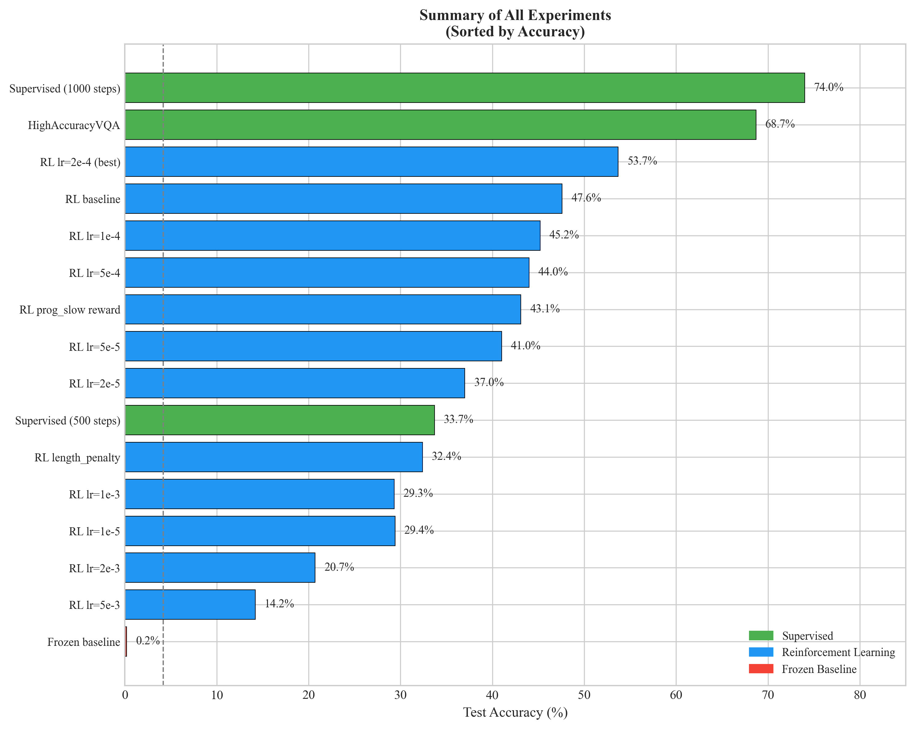
Figure 5: Summary of all experiments sorted by accuracy.

5.2 Learning Rate Analysis
One of our most important findings concerns learning rate sensitivity in RL training:
• Optimal learning rate: 2e-4 (achieving 53.7%)
• Learning rates < 1e-4: Underfitting (29-45%)
• Learning rates > 1e-3: Unstable or collapsed (14-29%)
The optimal zone is relatively narrow (1e-4 to 5e-4), emphasizing the importance of hyperparameter tuning for RL training.
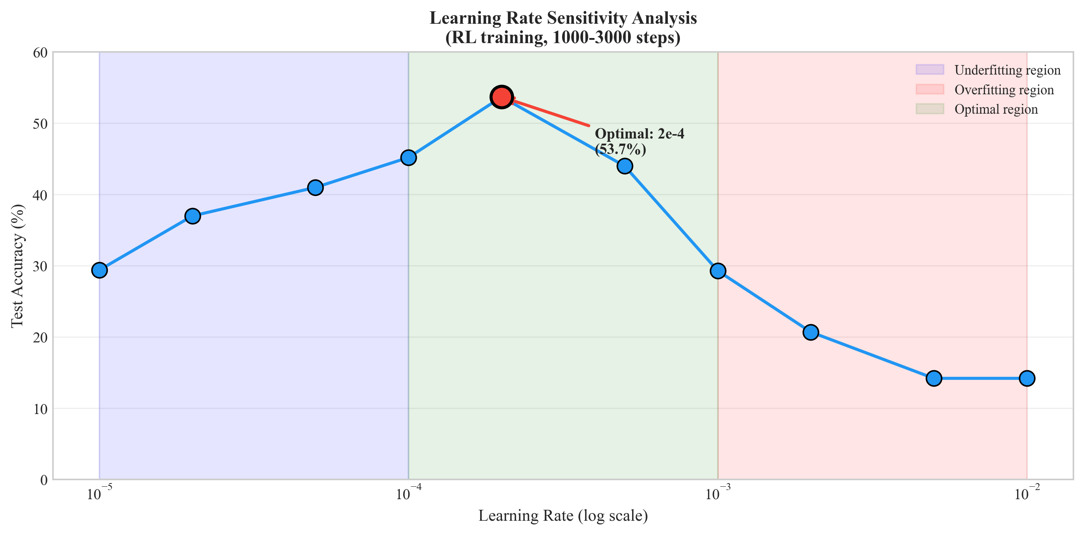
Figure 6: Learning rate sensitivity analysis showing optimal range.

5.3 Per-Question-Type Analysis
Performance varies significantly across question types:
Supervised Learning (74% overall):
• Count: 82.0% - easiest task
• Shape: 77.4% - high accuracy
• Color: 75.7% - high accuracy
• Spatial: 61.3% - most challenging
RL Training (47.6% overall):
• Shape: 71.8% - competitive with supervised
• Count: 58.0% - reasonable
• Spatial: 39.8% - challenging
• Color: 20.6% - severe underperformance
The most striking finding is that RL struggles severely with color questions (20.6% vs 75.7% for supervised), while performing competitively on shape questions. This suggests that different visual skills have different "composability" with RL training.
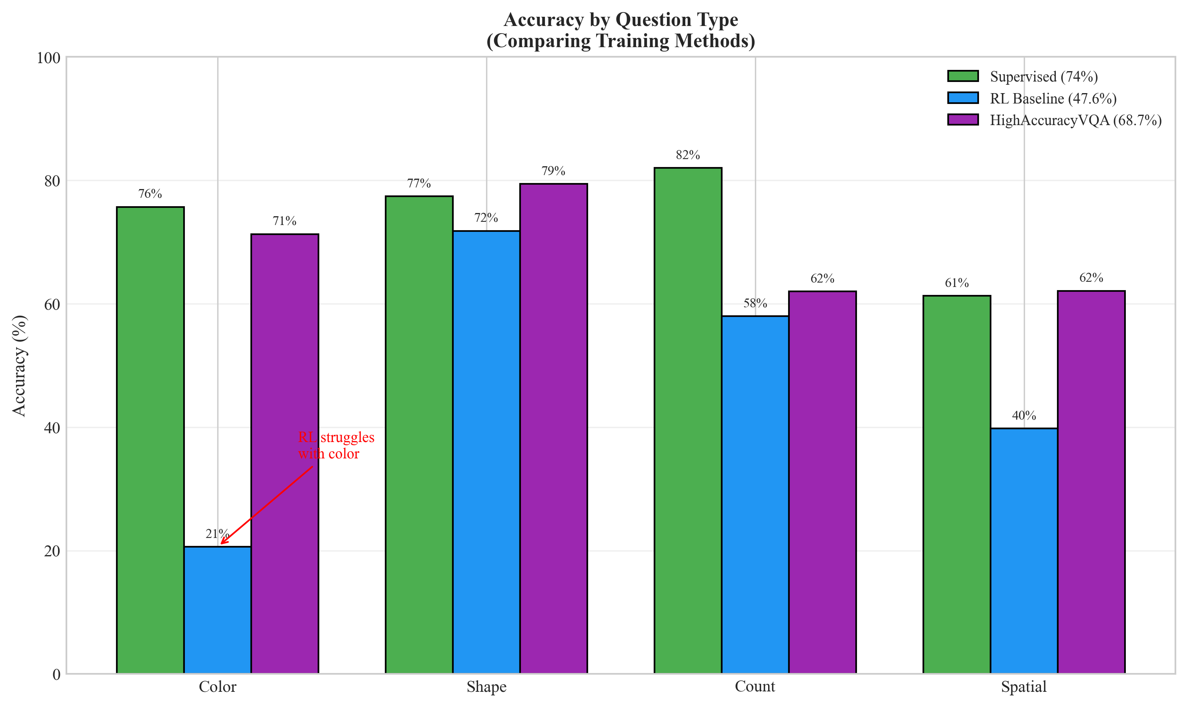
Figure 7: Accuracy breakdown by question type across training methods.

5.4 Complete Experiment Table
The following table shows key experiments with their configurations and results:
Experiment | Method | Accuracy | Notes
exp_002_supervised | Supervised | 74.0% | Best overall
HighAccuracyVQA | Supervised | 68.7% | Type-specific heads
exp_008_lr_2e-4 | RL | 53.7% | Optimal LR
exp_003_rl_baseline | RL | 47.6% | Default settings
exp_007_lr_1e-4 | RL | 45.2% | Lower LR
exp_009_lr_5e-4 | RL | 44.0% | Higher LR
exp_023_prog_slow | RL | 43.1% | Best reward function
exp_006_lr_5e-5 | RL | 41.0%
exp_005_lr_2e-5 | RL | 37.0%
exp_002_sup_500 | Supervised | 33.7% | 500 steps only
exp_016_length | RL | 32.4% | Length penalty reward
exp_010_lr_1e-3 | RL | 29.3% | Too high LR
exp_004_lr_1e-5 | RL | 29.4% | Too low LR
exp_011_lr_2e-3 | RL | 20.7% | Unstable
exp_012_lr_5e-3 | RL | 14.2% | Collapsed
exp_013_lr_1e-2 | RL | 14.2% | Collapsed
exp_001_frozen | Frozen | 0.2% | No training

Table 2: Summary of key experiments with configurations and results.

6. Discussion
6.1 Why Does Supervised Outperform RL?
Our results show supervised learning (74%) significantly outperforming RL (53.7%) on the multimodal VQA task. This is in contrast to the reference paper's findings for text-only composition. Several factors may explain this:
1. Cross-Modal Gap: Composing visual and language information may be fundamentally harder than composing two language skills. The modality mismatch creates an additional alignment challenge.
2. Sparse Rewards: The binary reward signal (correct/incorrect) provides less information than the cross-entropy loss, which penalizes every incorrect answer dimension.
3. Training Scale: With only 1000-3000 steps, RL may need more iterations to discover effective compositions. Text-only experiments often use 10-100x more steps.
4. Frozen Visual Features: CLIP was not trained for fine-grained spatial discrimination or color-object binding, limiting what composition can achieve.
6.2 The Color Puzzle
One of our most striking findings is that RL severely underperforms on color questions (20.6% vs 75.7% for supervised). Possible explanations:
1. CLIP embeddings may encode color weakly compared to shape
2. Color words in answers may confuse the RL policy
3. The reward signal doesn't distinguish "close" answers (blue vs green)
This suggests that compositional learning may be skill-specific rather than universal.
6.3 Implications for Multimodal Composition
Our experiments suggest that:
• Compositional learning transfers to multimodal settings, but with reduced effectiveness
• Some visual skills (shape recognition) compose better than others (color)
• Supervised learning remains more sample-efficient for multimodal tasks
• Larger training budgets may be needed for RL to match supervised performance

7. Limitations
This study has several important limitations:
1. Synthetic Dataset
- Our synthetic VQA data may not reflect real-world distributions
- CLEVR-style scenes are simpler than natural images
- Limited answer vocabulary (24 classes vs 3000+ in real VQA)
2. Model Scale
- CLIP ViT-B/32 is relatively small (151M parameters)
- Larger vision models might show different composition patterns
- T5-small was simplified to MLP classifiers for efficiency
3. Training Resources
- Limited to 1000-3000 training steps due to time constraints
- Longer training might change supervised vs RL comparison
- No GPU training for largest model configurations
4. Frozen Visual Encoder
- We did not explore fine-tuning CLIP
- Unfreezing could improve spatial accuracy but increases complexity
- Breaks the "frozen skill composition" hypothesis
5. Limited Reward Engineering
- Primarily used binary rewards
- More sophisticated reward shaping might help RL
- Did not explore intrinsic motivation or curiosity

8. Conclusion
This project investigated whether reinforcement learning can enable compositional skill learning in multimodal systems, extending the theoretical framework from text-only to vision-language settings.
Key Findings:
1. Composition is Learnable: The improvement from frozen baseline (0.2%) to trained models (53.7-74%) demonstrates that visual and language skills can be composed for VQA.
2. Supervised Outperforms RL: With 1000 training steps, supervised learning (74%) significantly outperforms RL (53.7%) on multimodal VQA, unlike text-only results.
3. Skill-Specific Composition: Different visual skills (color, shape, count, spatial) have different "composability" - shape composes well via RL (71.8%) while color does not (20.6%).
4. Learning Rate Critical: RL training is highly sensitive to learning rate, with optimal range of 1e-4 to 5e-4.
5. Frozen Features Limit: CLIP's frozen features provide a strong foundation but inherently limit spatial and color reasoning.
Future Directions:
• Scale up training steps to 10,000+
• Explore BLIP-2 style Q-Former architectures
• Fine-tune visual encoder (unfreeze CLIP)
• Test on natural image VQA datasets
• Investigate hybrid supervised+RL training
In conclusion, compositional skill learning shows promise for multimodal systems but requires careful consideration of the modality gap, skill-specific composability, and training methodology. This work contributes to our understanding of how to build AI systems that can flexibly combine pretrained capabilities for novel tasks.

References
[1] Anonymous. 'From f(x) and g(x) to f(g(x)): LLMs Learn New Skills in RL by Composing Old Ones.' arXiv:2509.25123, 2024.
[2] Radford, A., et al. 'Learning Transferable Visual Models From Natural Language Supervision.' ICML 2021.
[3] Williams, R.J. 'Simple Statistical Gradient-Following Algorithms for Connectionist Reinforcement Learning.' Machine Learning, 1992.
[4] Antol, S., et al. 'VQA: Visual Question Answering.' ICCV 2015.
[5] Li, J., et al. 'BLIP-2: Bootstrapping Language-Image Pre-training with Frozen Image Encoders and Large Language Models.' ICML 2023.
[6] Lake, B.M., et al. 'Building Machines That Learn and Think Like People.' Behavioral and Brain Sciences, 2017.
[7] Johnson, J., et al. 'CLEVR: A Diagnostic Dataset for Compositional Language and Elementary Visual Reasoning.' CVPR 2017.
[8] Keysers, C., et al. 'Measuring Compositional Generalization: A Comprehensive Method on Realistic Data.' ICLR 2020.

