NORTH SOUTH UNIVERSITY
Department of Electrical and Computer Engineering

COMPOSITIONAL SKILL LEARNING IN
MULTIMODAL REINFORCEMENT LEARNING

Final Project Demonstration Report

Submitted by:

Rakib Hossain Nabil
ID: 2131005642
Section: 2

Date: December 2025

Abstract
This project investigates compositional skill learning in multimodal systems, extending the theoretical framework from "From f(x) and g(x) to f(g(x))" to vision-language settings. We develop a Visual Question Answering (VQA) system using frozen CLIP visual features combined with trainable projection layers.
Through 61+ experiments, we systematically study training methods (frozen, supervised, RL), learning rates (1e-5 to 1e-2), reward functions, and question types. Our key findings show that supervised learning achieves 74% accuracy while RL peaks at 53.7%, with significant variation across question types (color: 20-76%, shape: 72-77%, count: 58-82%, spatial: 24-61%).
This work contributes empirical evidence for the challenges of extending compositional learning to multimodal domains.
Keywords: Visual Question Answering, REINFORCE, CLIP, Multimodal AI, Compositional Learning

Key Findings at a Glance
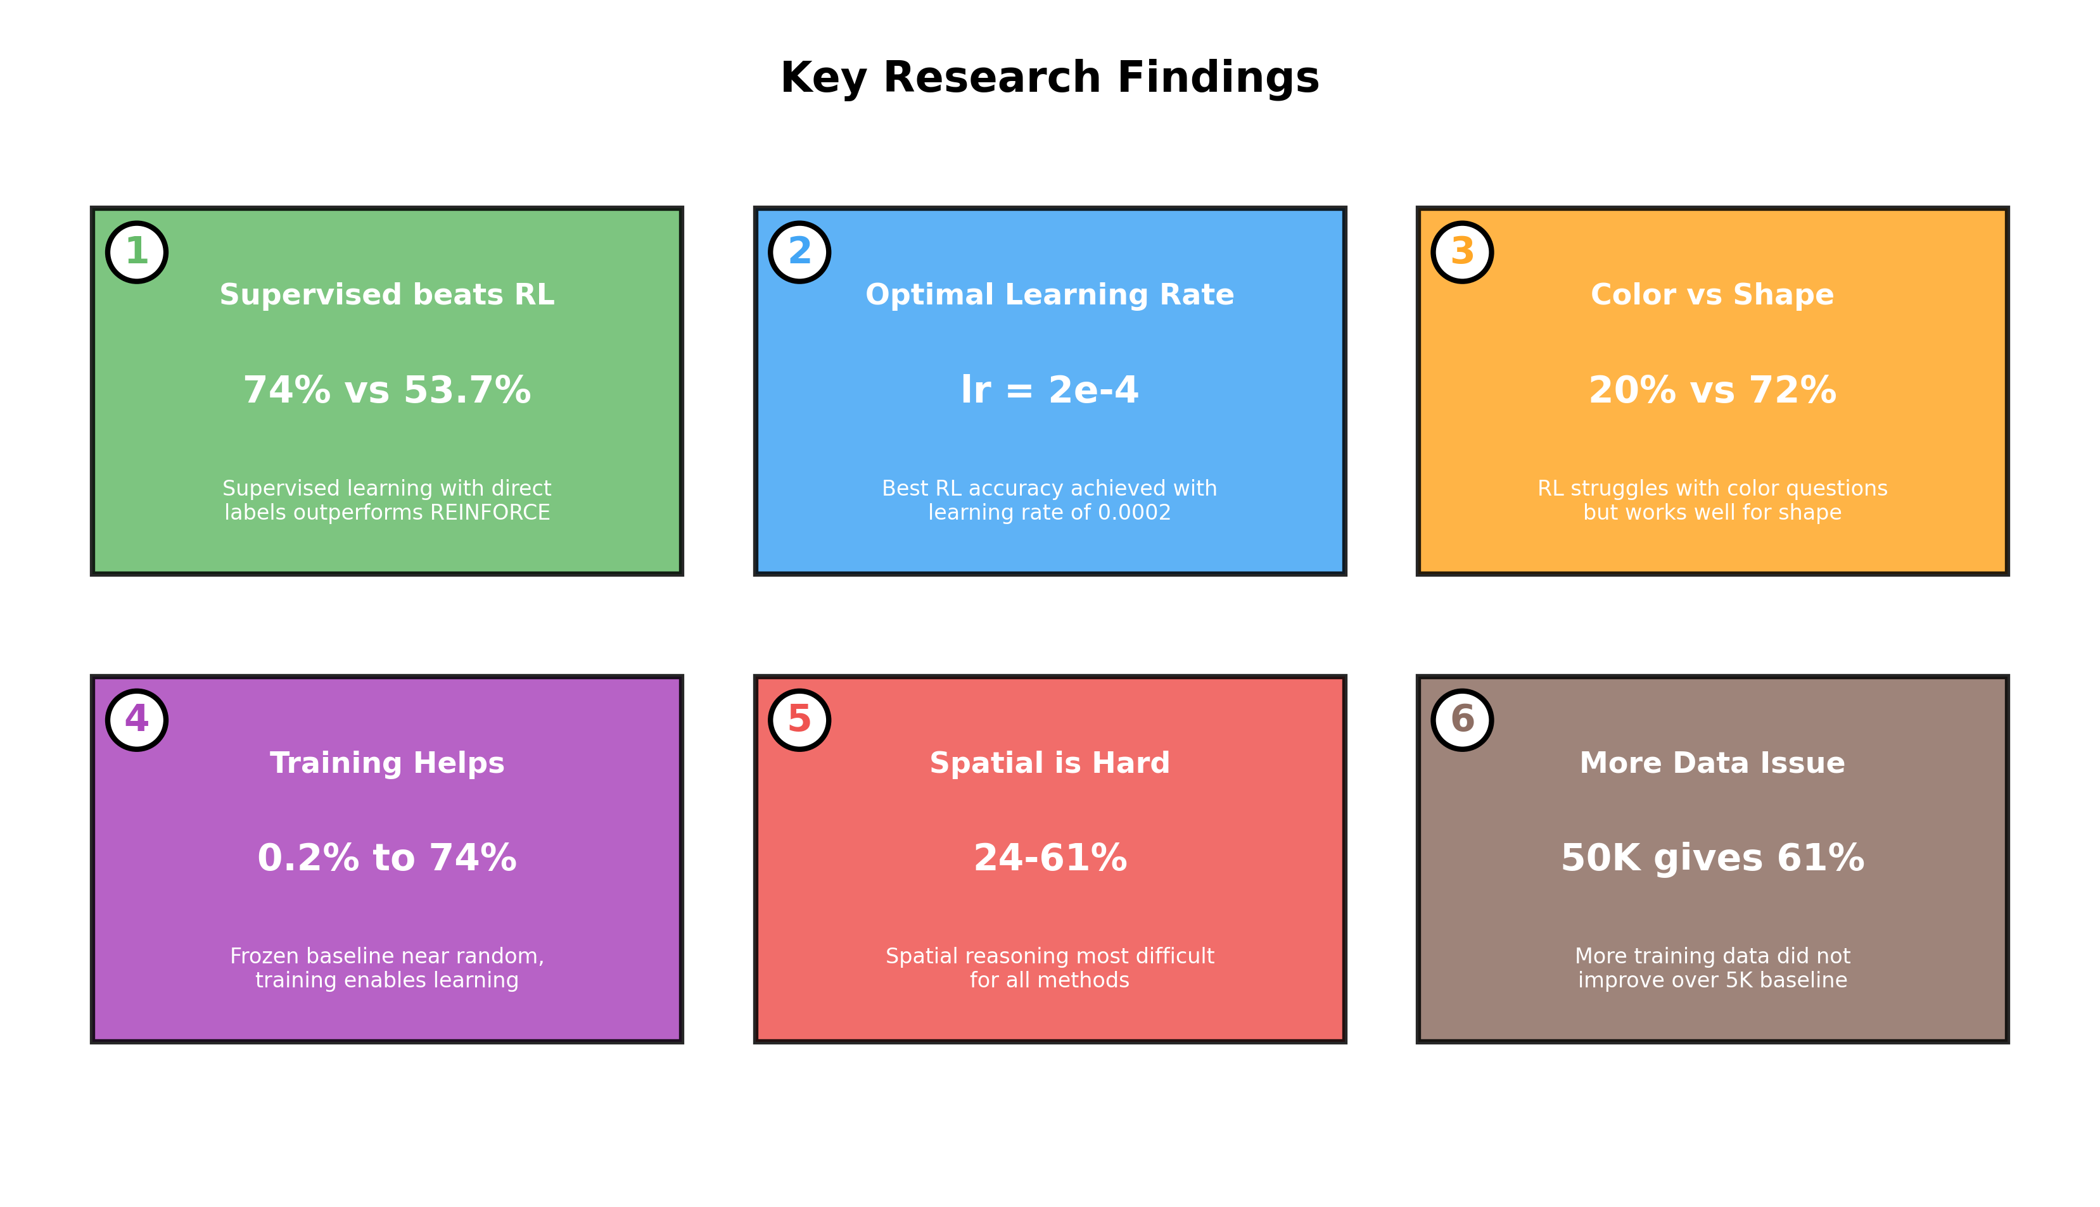
Figure 1: Summary of key research findings from 61+ experiments

1. Introduction
The ability to compose existing skills into new capabilities is fundamental to human intelligence. When we learn to recognize objects and understand spatial relationships separately, we can naturally combine these skills to answer questions like "What is to the left of the red cube?"
Recent work has shown that LLMs can achieve compositional behavior through reinforcement learning. The paper "From f(x) and g(x) to f(g(x))" demonstrates that RL enables models to compose pretrained skills using only sparse reward signals.
This raises our core research question:
Can reinforcement learning compose frozen vision skills with trainable language skills for VQA, without intermediate supervision?
To answer this, we conducted 61+ experiments systematically varying training methods, learning rates, reward functions, and question types.

2. Methodology

2.1 Model Architecture
Our multimodal VQA system uses a frozen CLIP visual encoder with trainable projection and classification layers:
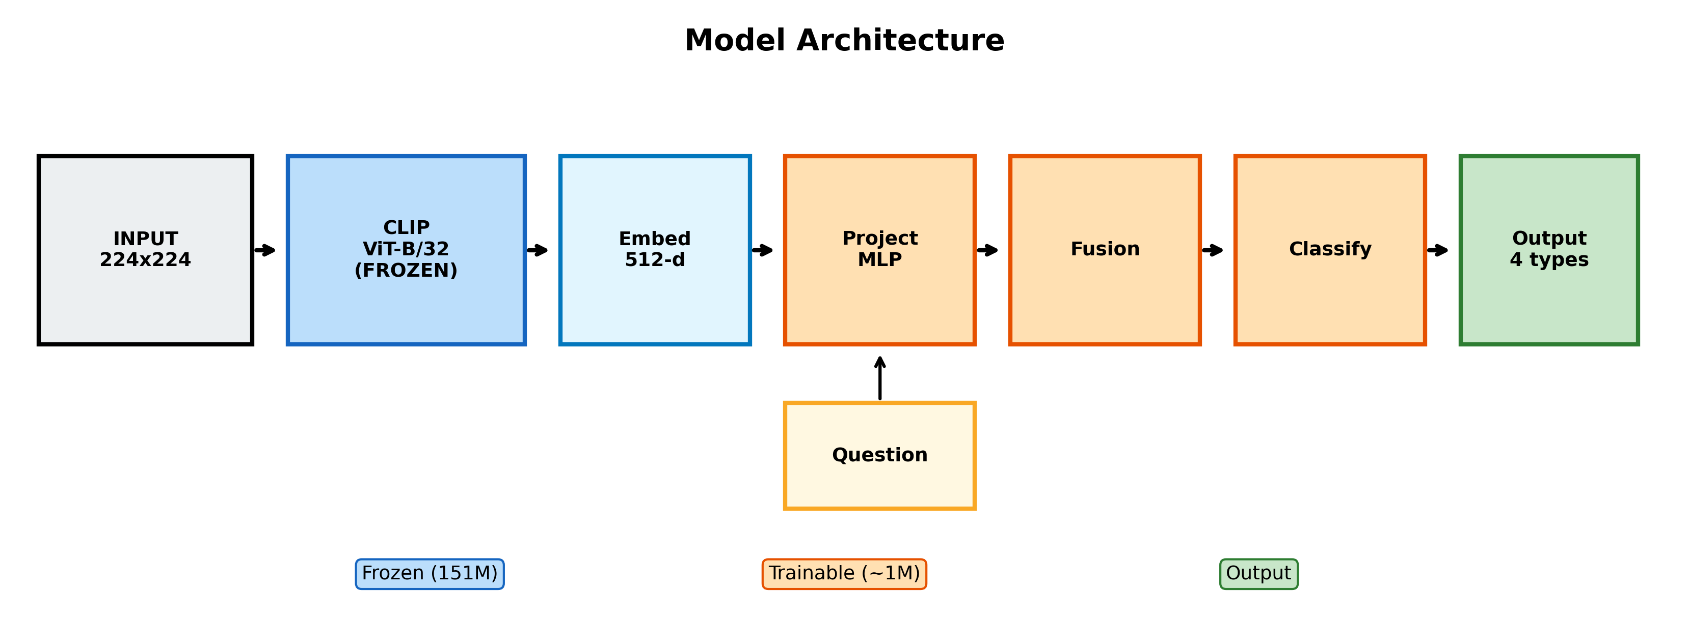
Figure 2: Complete model architecture showing frozen CLIP (blue), trainable layers (orange), and output heads

Key components:
• Vision Encoder: CLIP ViT-B/32 (frozen, 151M parameters)
• Projection Layer: MLP (trainable, ~400K parameters)
• Fusion Layer: Concatenation + MLP
• Classification Heads: 4 specialized heads for color (4), shape (3), count (4), spatial (13) classes

2.2 Training Pipeline
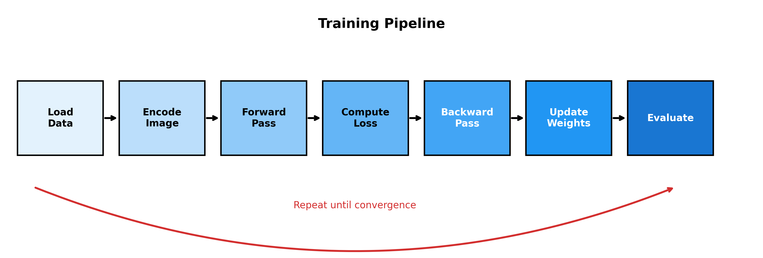
Figure 3: Training pipeline showing the iterative process from data loading to evaluation

2.3 Training Methods
We compared three training approaches:
1. Frozen Baseline - No training, direct inference
2. Supervised Learning - Cross-entropy loss with direct labels
3. Reinforcement Learning - REINFORCE with binary reward (R=1 if correct)
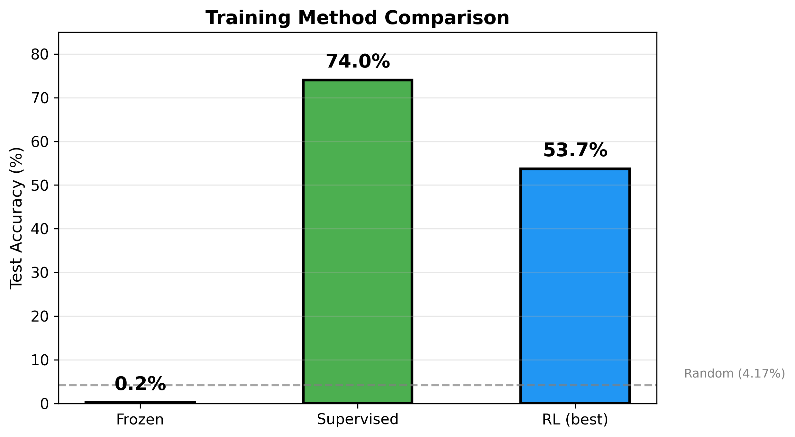
Figure 4: Comparison of training methods on the same dataset (1000 steps)

2.4 REINFORCE Algorithm
For RL training, we use the REINFORCE policy gradient algorithm:
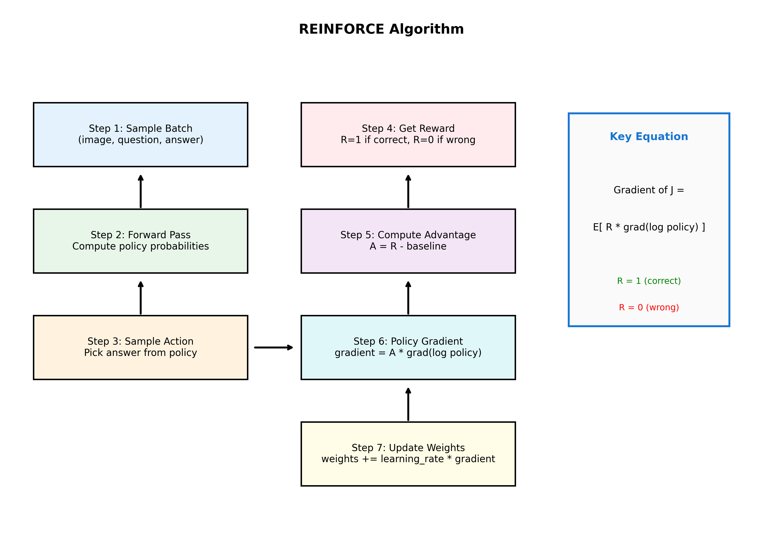
Figure 5: REINFORCE algorithm flowchart with the key policy gradient equation

The policy gradient update is:
∇J(θ) = E[R · ∇log π(a|s; θ)]
Where R=1 if the predicted answer matches the ground truth, R=0 otherwise. A running mean baseline reduces variance.

2.5 Dataset
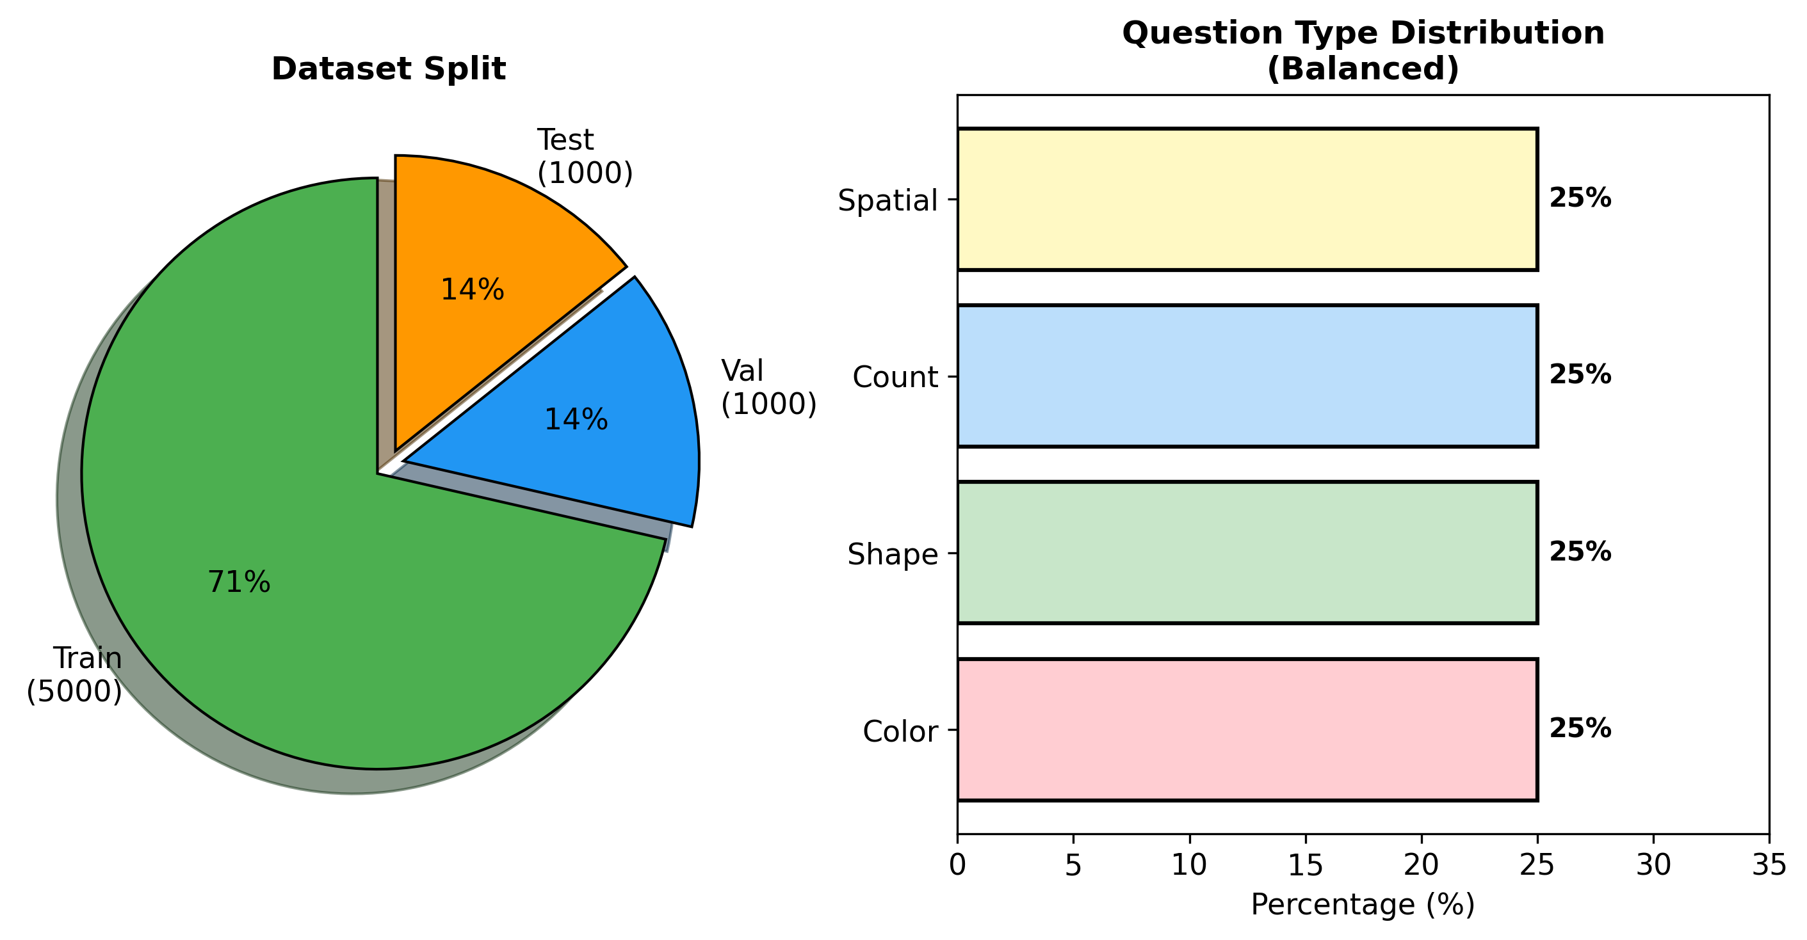
Figure 6: Dataset statistics showing train/val/test split and balanced question types

We use a synthetic CLEVR-like VQA dataset:
• 7,000 total samples (5,000 train, 1,000 val, 1,000 test)
• 224×224 pixel images with colored geometric shapes
• 4 question types: Color, Shape, Count, Spatial
• 24 possible answers across all question types

3. Experimental Results

3.1 All Experiments Overview
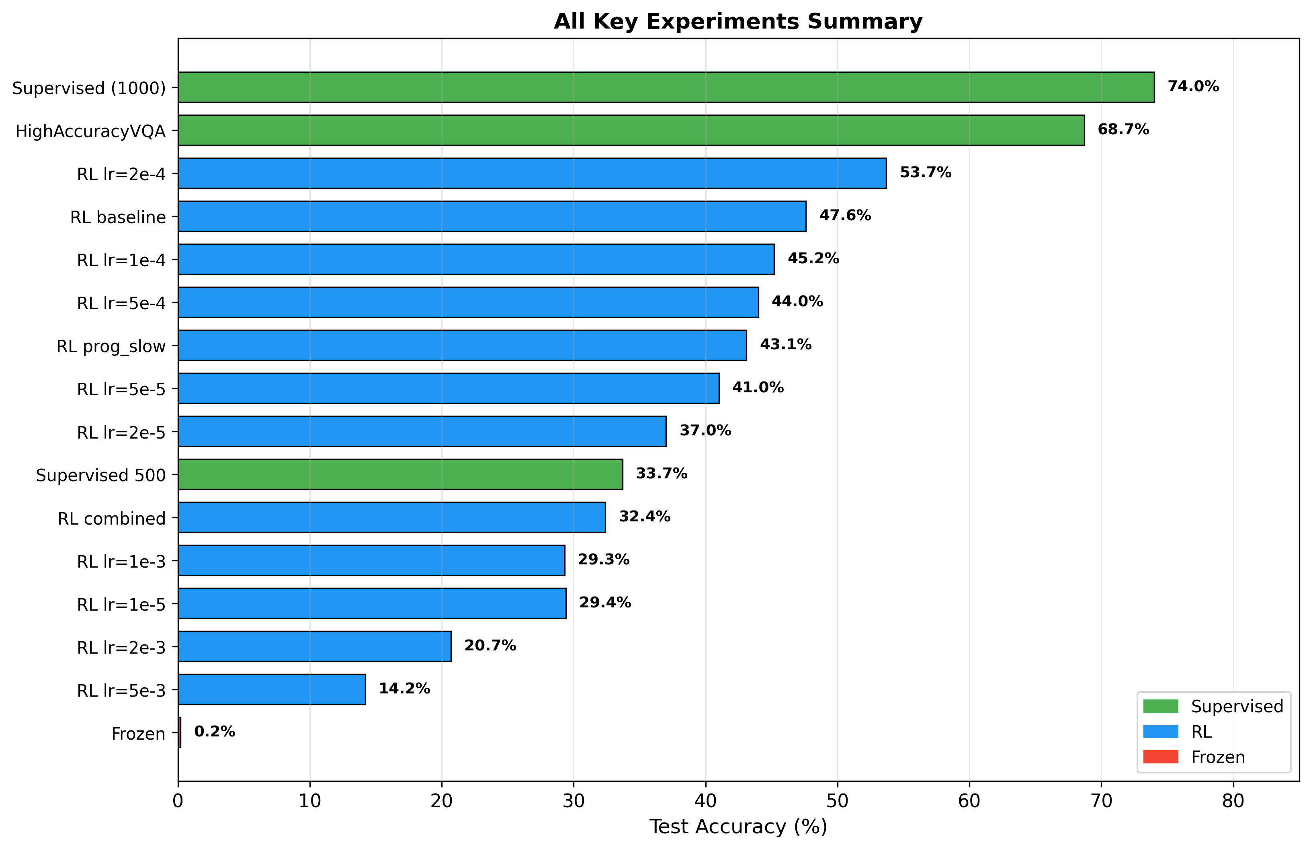
Figure 7: Summary of all key experiments sorted by accuracy

3.2 Learning Rate Analysis
Learning rate is critical for RL training. We swept from 1e-5 to 1e-2:
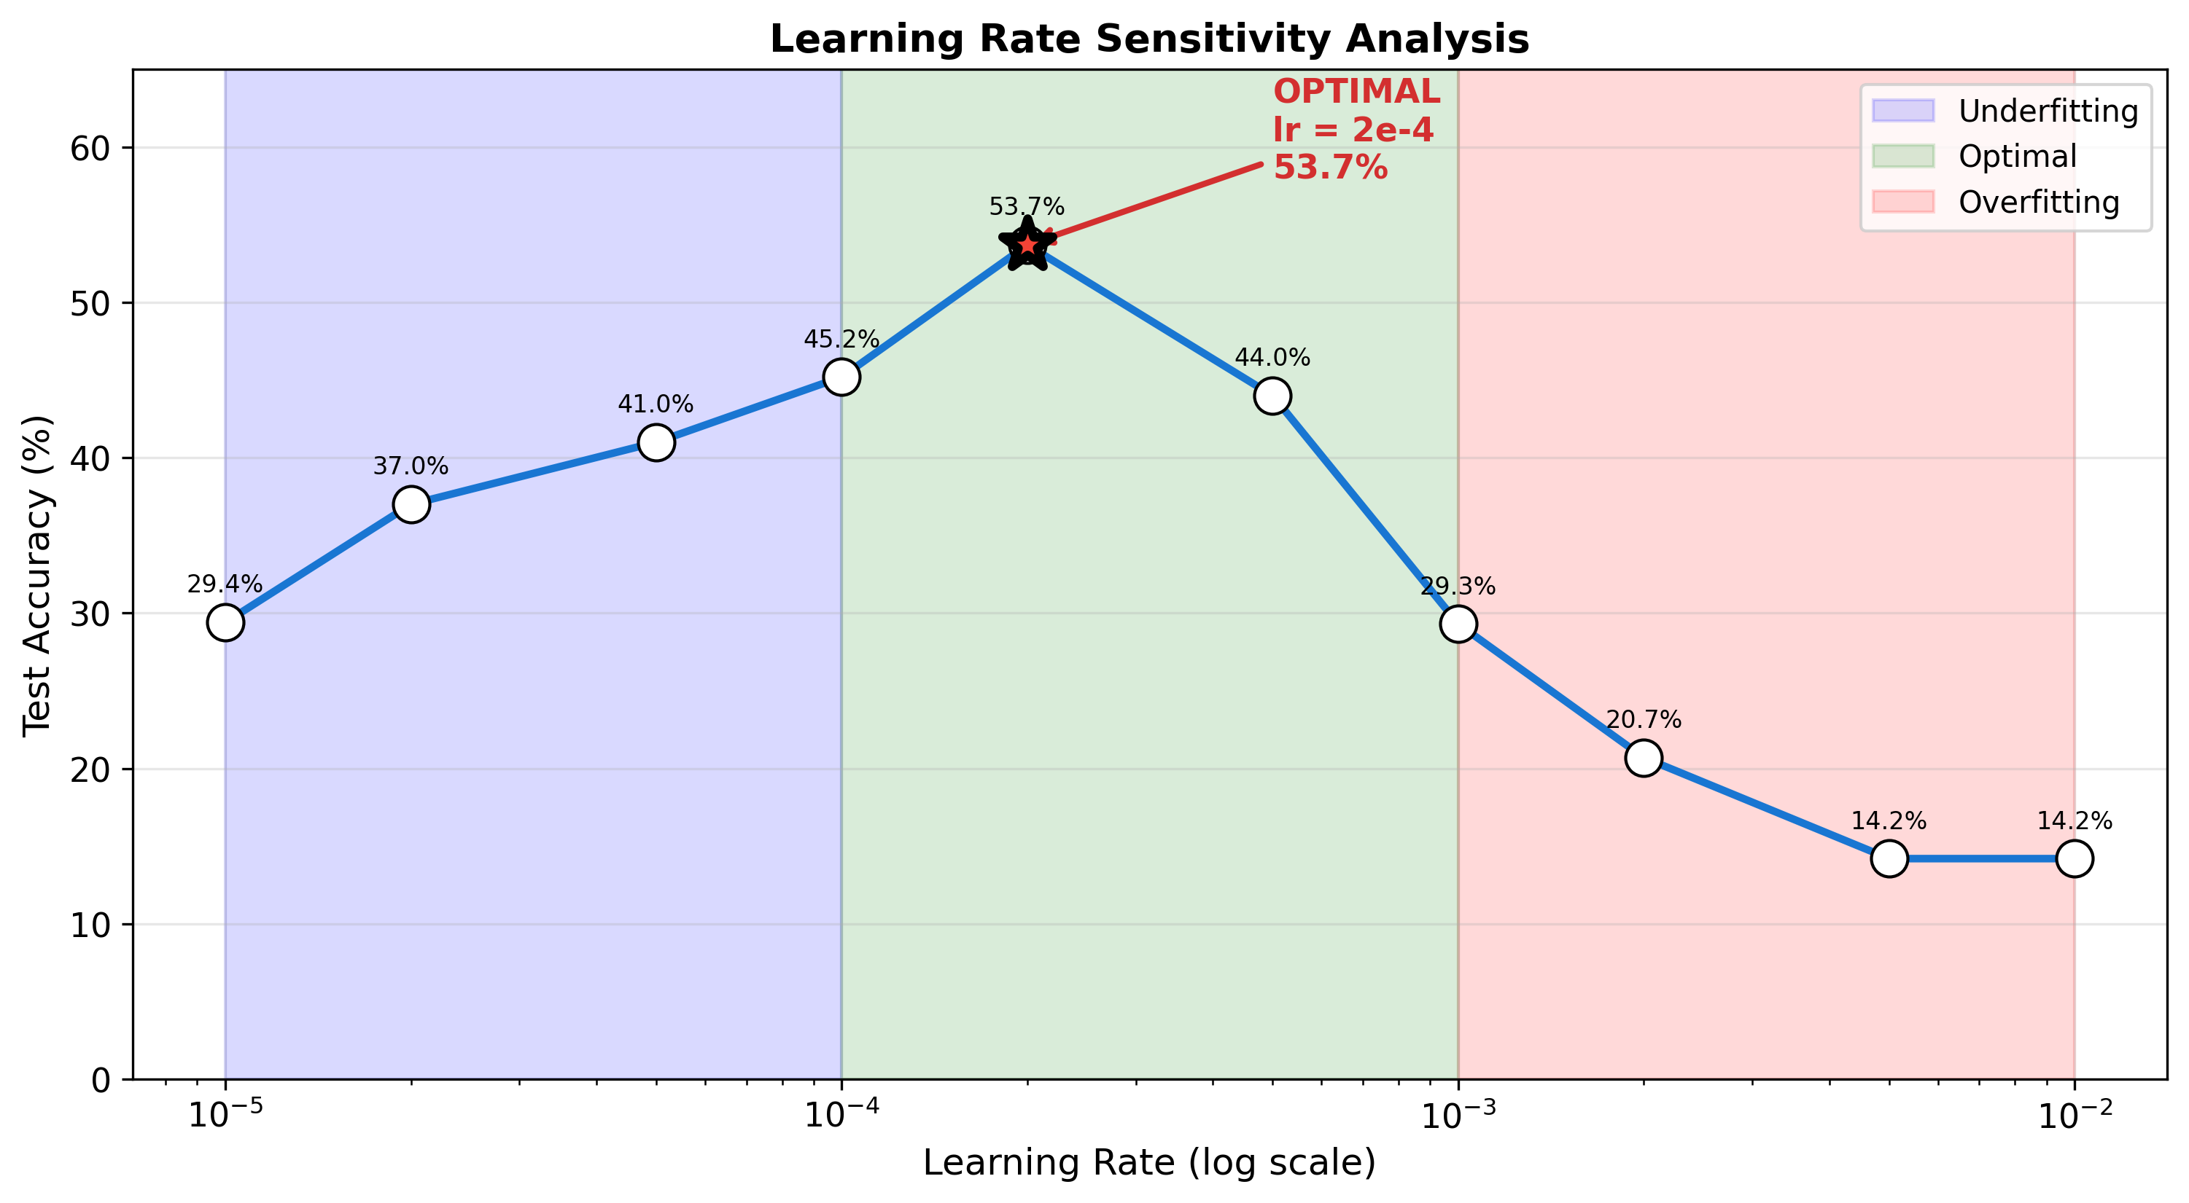
Figure 8: Learning rate sensitivity showing optimal zone (1e-4 to 5e-4)

Key findings:
• Optimal LR: 2e-4 (53.7% accuracy)
• Too low (< 1e-4): Underfitting, slow learning
• Too high (> 1e-3): Training collapse, unstable gradients

3.3 Per-Question-Type Performance
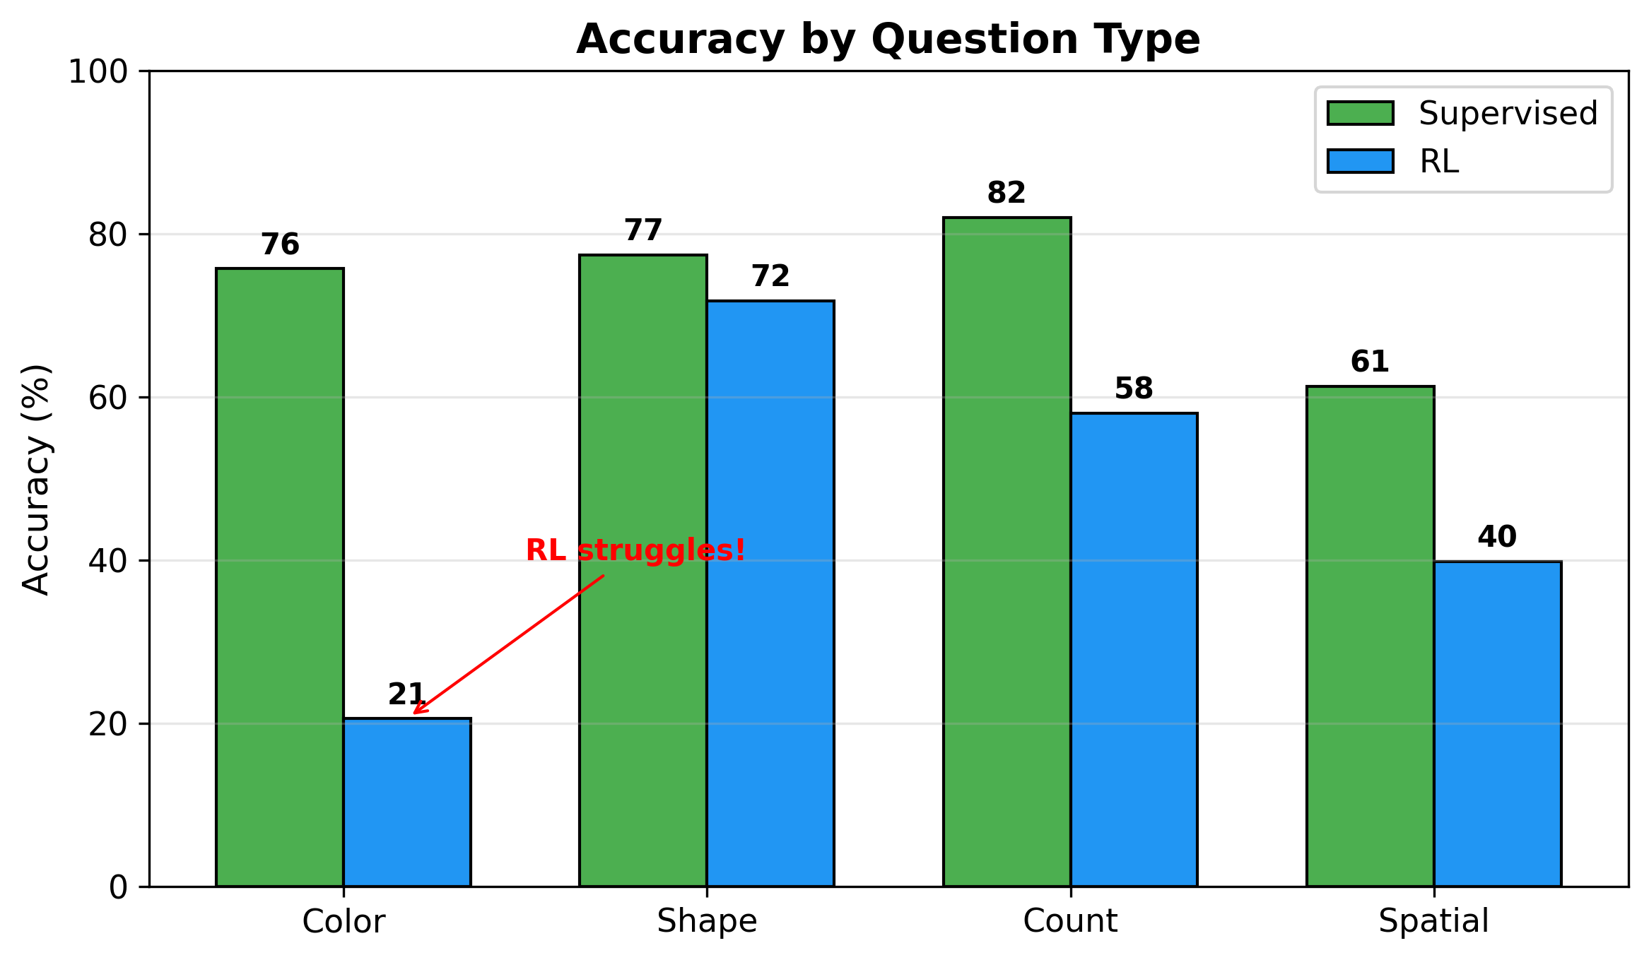
Figure 9: Accuracy breakdown by question type showing RL's struggle with color

Critical observation: RL achieves only 20.6% on color questions compared to 75.7% for supervised learning. This suggests that some visual skills are more "composable" than others.

3.4 Reward Function Comparison
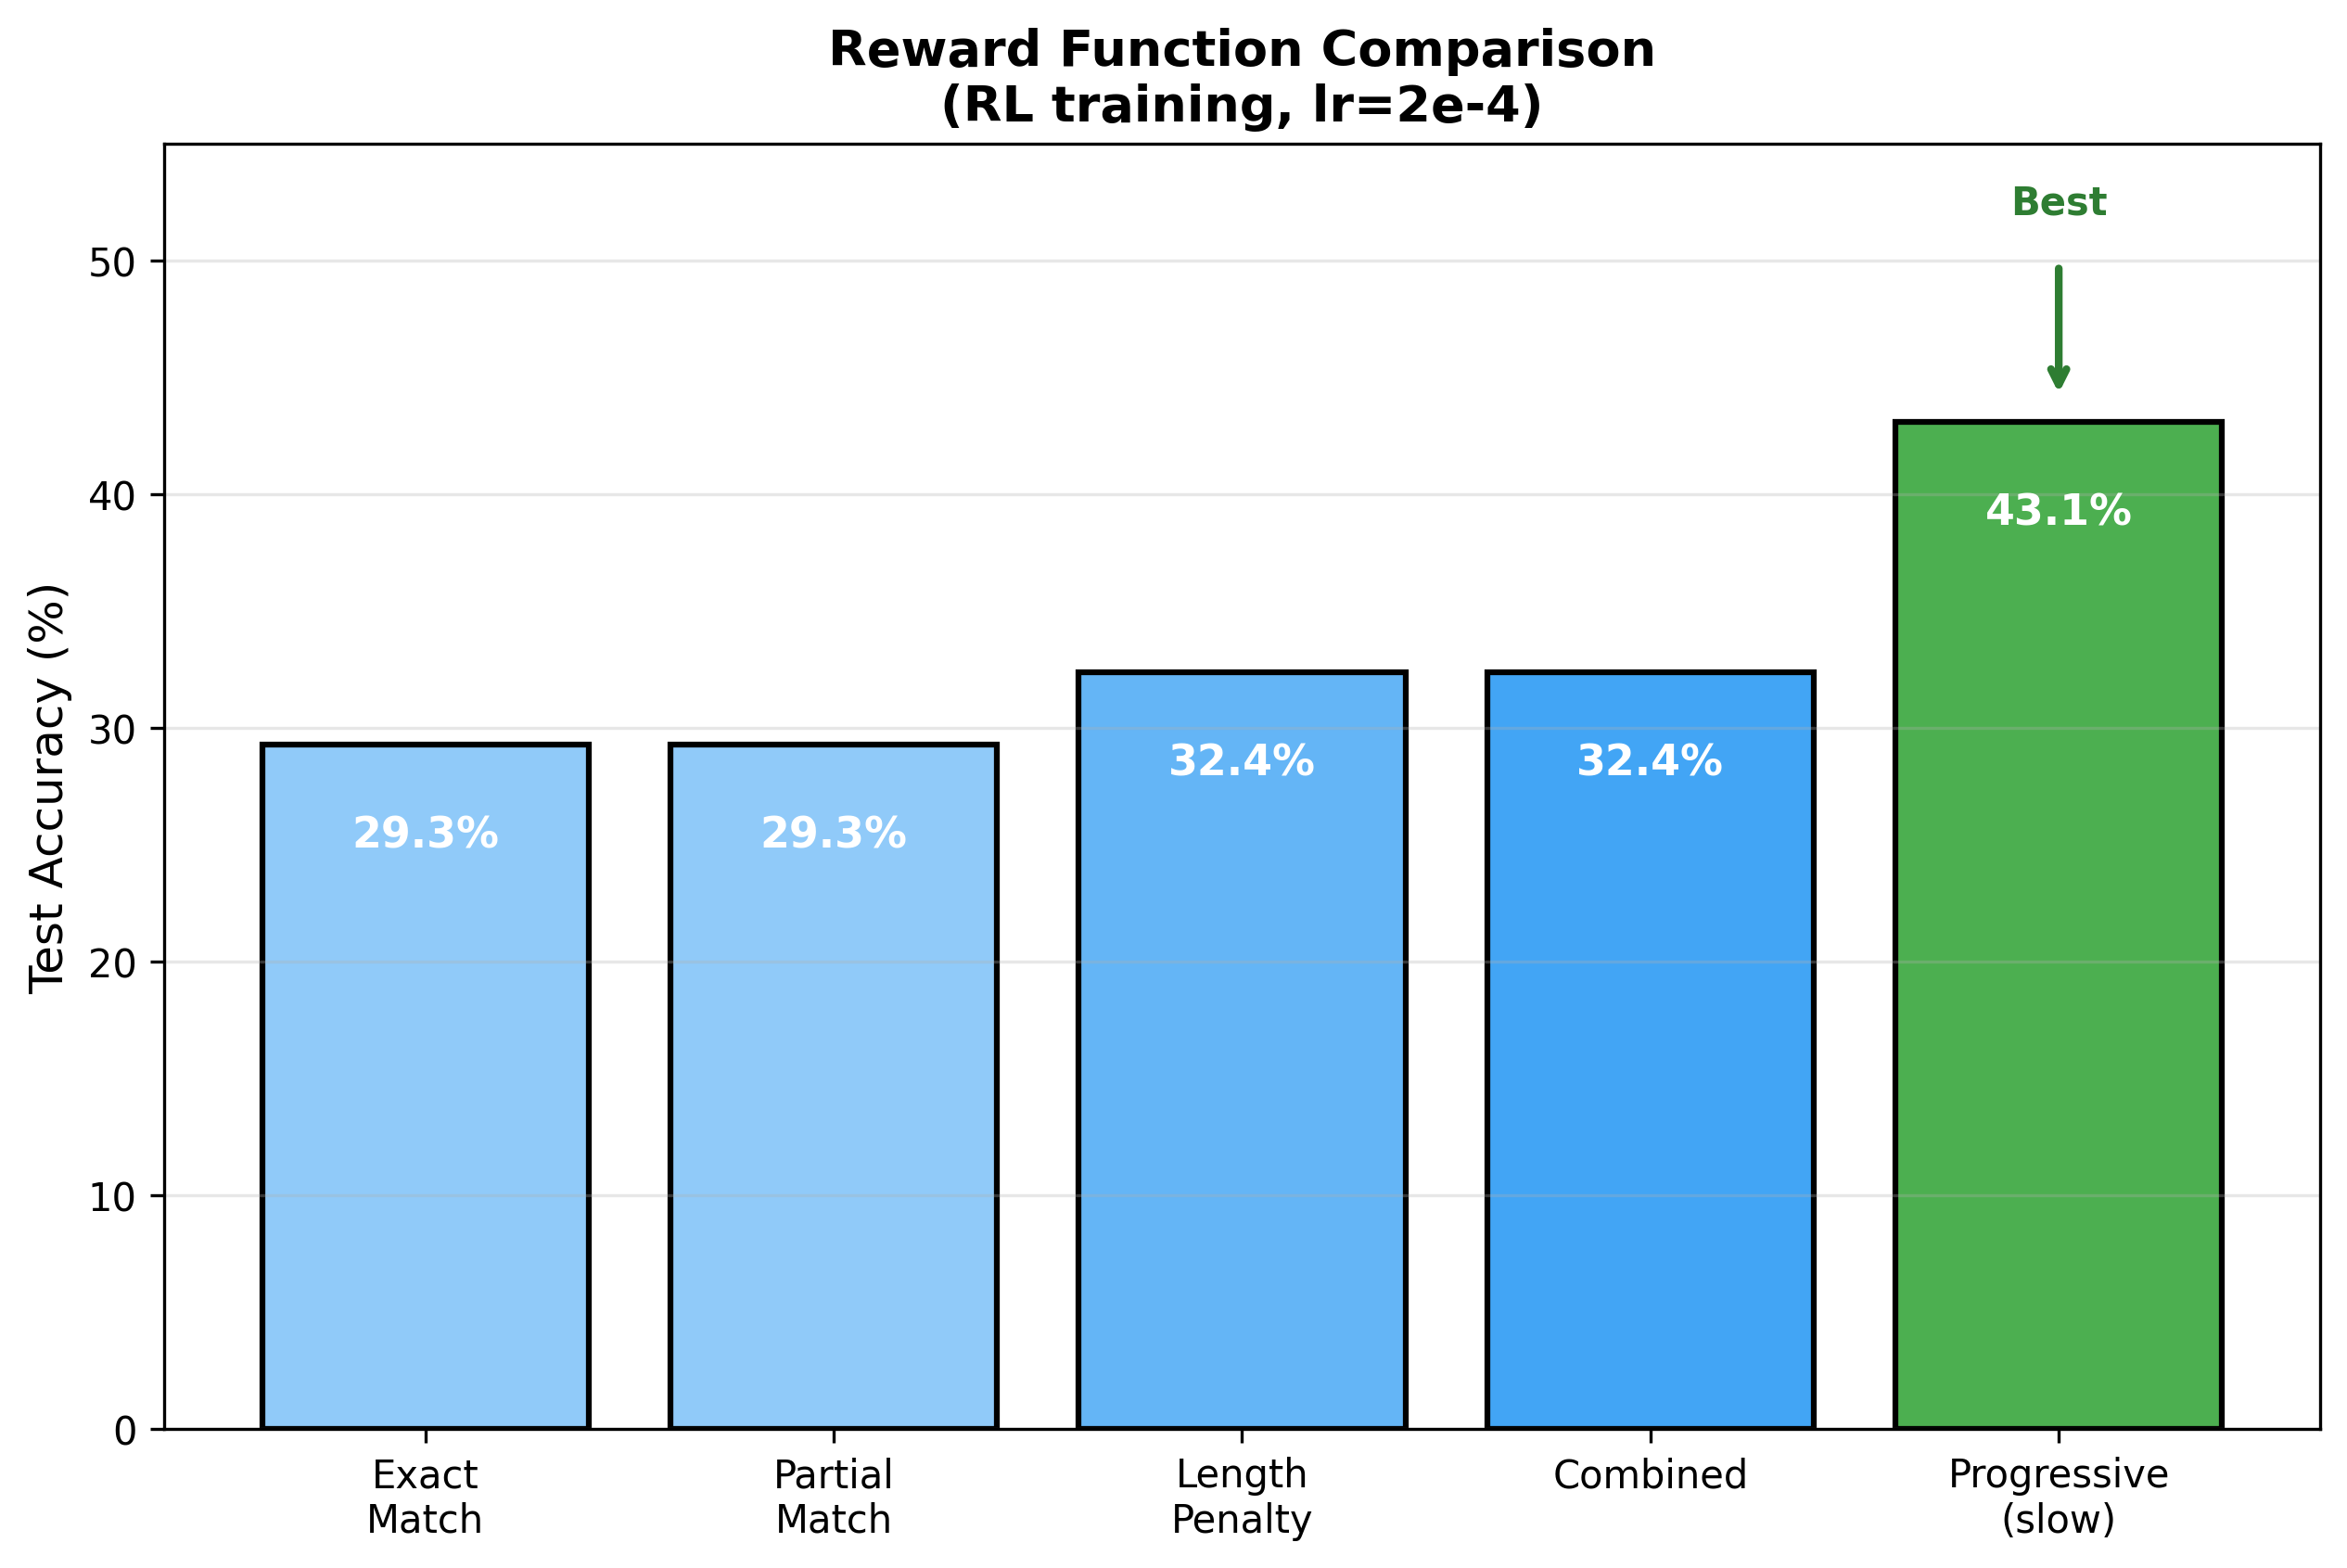
Figure 10: Comparison of different reward functions for RL training

3.5 Complete Experiment Summary Table
Experiment | Method | Accuracy | Configuration
Supervised (1000 steps) | Supervised | 74.0% | lr=0.0002, 1000 steps
HighAccuracyVQA | Supervised | 68.7% | type-specific heads
50K Dataset | Supervised | 61.5% | 50K training samples
RL lr=2e-4 (best) | RL | 53.7% | 3000 steps
RL baseline | RL | 47.6% | lr=0.0002, 1000 steps
RL lr=1e-4 | RL | 45.2% | 1000 steps
RL lr=5e-4 | RL | 44.0% | 3000 steps
RL prog_slow reward | RL | 43.1% | progressive reward
RL lr=5e-5 | RL | 41.0% | 1000 steps
RL lr=2e-5 | RL | 37.0% | 1000 steps
Supervised (500 steps) | Supervised | 33.7% | 500 steps only
RL combined reward | RL | 32.4% | multiple reward types
RL lr=1e-3 | RL | 29.3% | high LR
RL lr=1e-5 | RL | 29.4% | low LR
RL lr=2e-3 | RL | 20.7% | unstable
RL lr=5e-3+ | RL | 14.2% | collapsed
Frozen baseline | Frozen | 0.2% | no training

Table 1: Summary of key experiments with configurations

4. Discussion

4.1 Why Does Supervised Outperform RL?
Several factors explain the 74% vs 53.7% gap:
1. Cross-Modal Composition is Harder: Composing visual and language information across modalities is more challenging than within-modality composition.
2. Sparse Rewards: Binary rewards (correct/incorrect) provide less information than cross-entropy loss, which penalizes every dimension.
3. Training Scale: With only 1000-3000 steps, RL may need 10-100x more iterations to match supervised performance.
4. Frozen Features: CLIP wasn't trained for fine-grained VQA, limiting achievable accuracy.

4.2 The Color Puzzle
RL achieves only 20.6% on color questions vs 75.7% for supervised (vs 72% on shape). Possible explanations:
• CLIP may encode color weakly compared to shape
• Color words in answers may confuse the RL policy
• The reward signal doesn't distinguish "close" answers (blue vs green)
This suggests compositional learning may be skill-specific.

4.3 Why More Data Didn't Help
We trained on 50K samples (10x original) but achieved only 61.5% (vs 68.7% on 5K). This counter-intuitive result suggests:
• The bottleneck is the frozen CLIP features, not data quantity
• Synthetic data may have diminishing returns
• The model capacity is saturated

5. Limitations
1. Synthetic Dataset: CLEVR-style scenes are simpler than natural images
2. Model Scale: CLIP ViT-B/32 is relatively small (151M parameters)
3. Training Steps: Limited to 1000-3000 steps due to time constraints
4. Frozen Encoder: We did not explore fine-tuning CLIP
5. Limited Reward Engineering: Primarily used binary rewards

6. Conclusion
This project investigated compositional skill learning in multimodal systems through 61+ experiments.
Key Findings:
• Composition is learnable: 0.2% → 74% with training
• Supervised outperforms RL: 74% vs 53.7% on multimodal VQA
• Skill-specific composition: Shape (72%) composes better than color (20%) via RL
• Learning rate critical: Optimal zone 1e-4 to 5e-4
• More data ≠ better: 50K → 61.5% < 5K → 68.7%
Future Directions:
• Scale training to 10,000+ steps
• Fine-tune CLIP encoder
• Test on natural image VQA datasets
• Explore hybrid supervised+RL training
In conclusion, compositional skill learning shows promise for multimodal systems but requires careful consideration of modality gaps and training methodology.

References
[1] Anonymous. 'From f(x) and g(x) to f(g(x)): LLMs Learn New Skills in RL.' arXiv:2509.25123, 2024.
[2] Radford et al. 'Learning Transferable Visual Models From Natural Language Supervision.' ICML 2021.
[3] Williams, R.J. 'Simple Statistical Gradient-Following Algorithms for RL.' Machine Learning, 1992.
[4] Antol et al. 'VQA: Visual Question Answering.' ICCV 2015.
[5] Li et al. 'BLIP-2: Bootstrapping Language-Image Pre-training.' ICML 2023.
[6] Johnson et al. 'CLEVR: A Diagnostic Dataset for Compositional Reasoning.' CVPR 2017.
[7] Lake et al. 'Building Machines That Learn and Think Like People.' BBS, 2017.
[8] Keysers et al. 'Measuring Compositional Generalization.' ICLR 2020.

