**SOFTWARE SPECIFICATION**

***Jolly Online Shopping – JOS  
(e-commerce website)***

**1. Software Architecture**

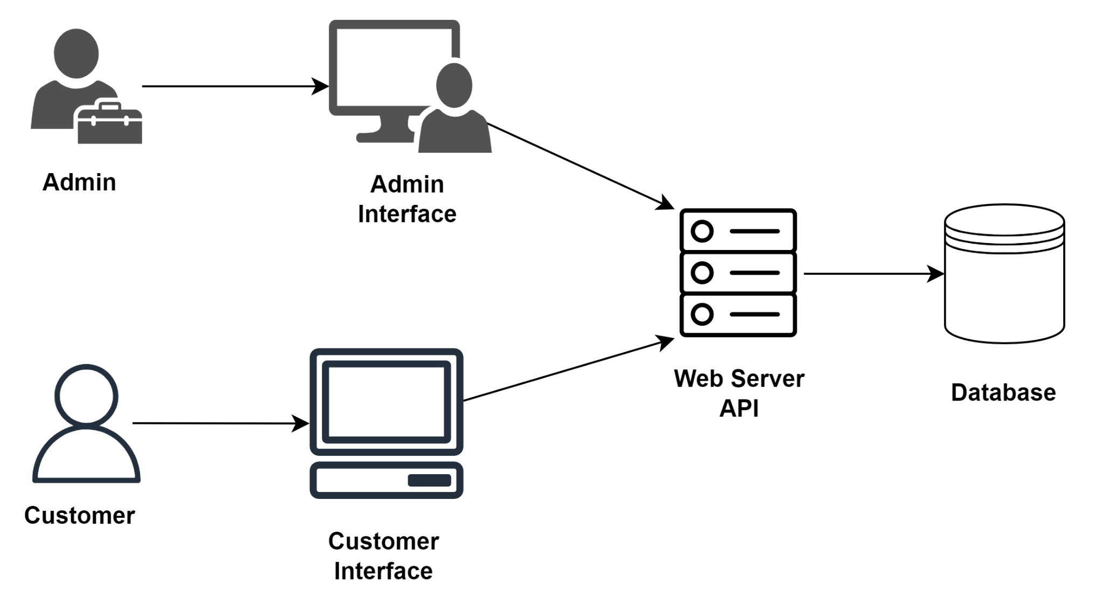

**2. Use Case Diagram**

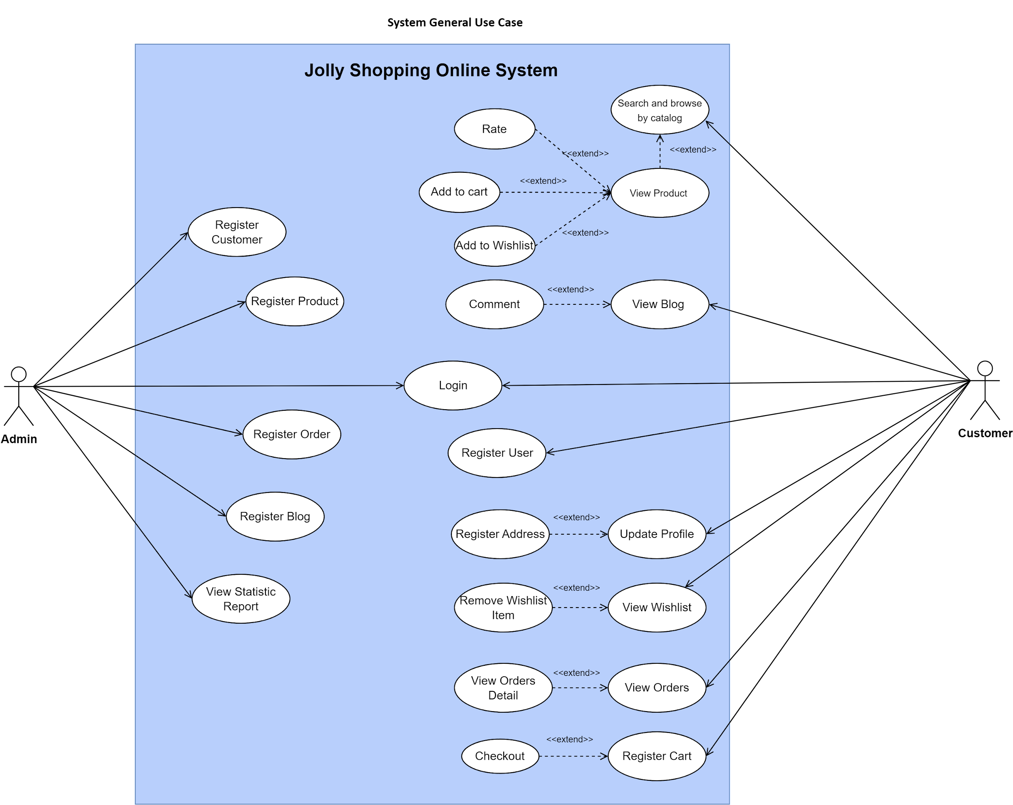

**3. ERD**

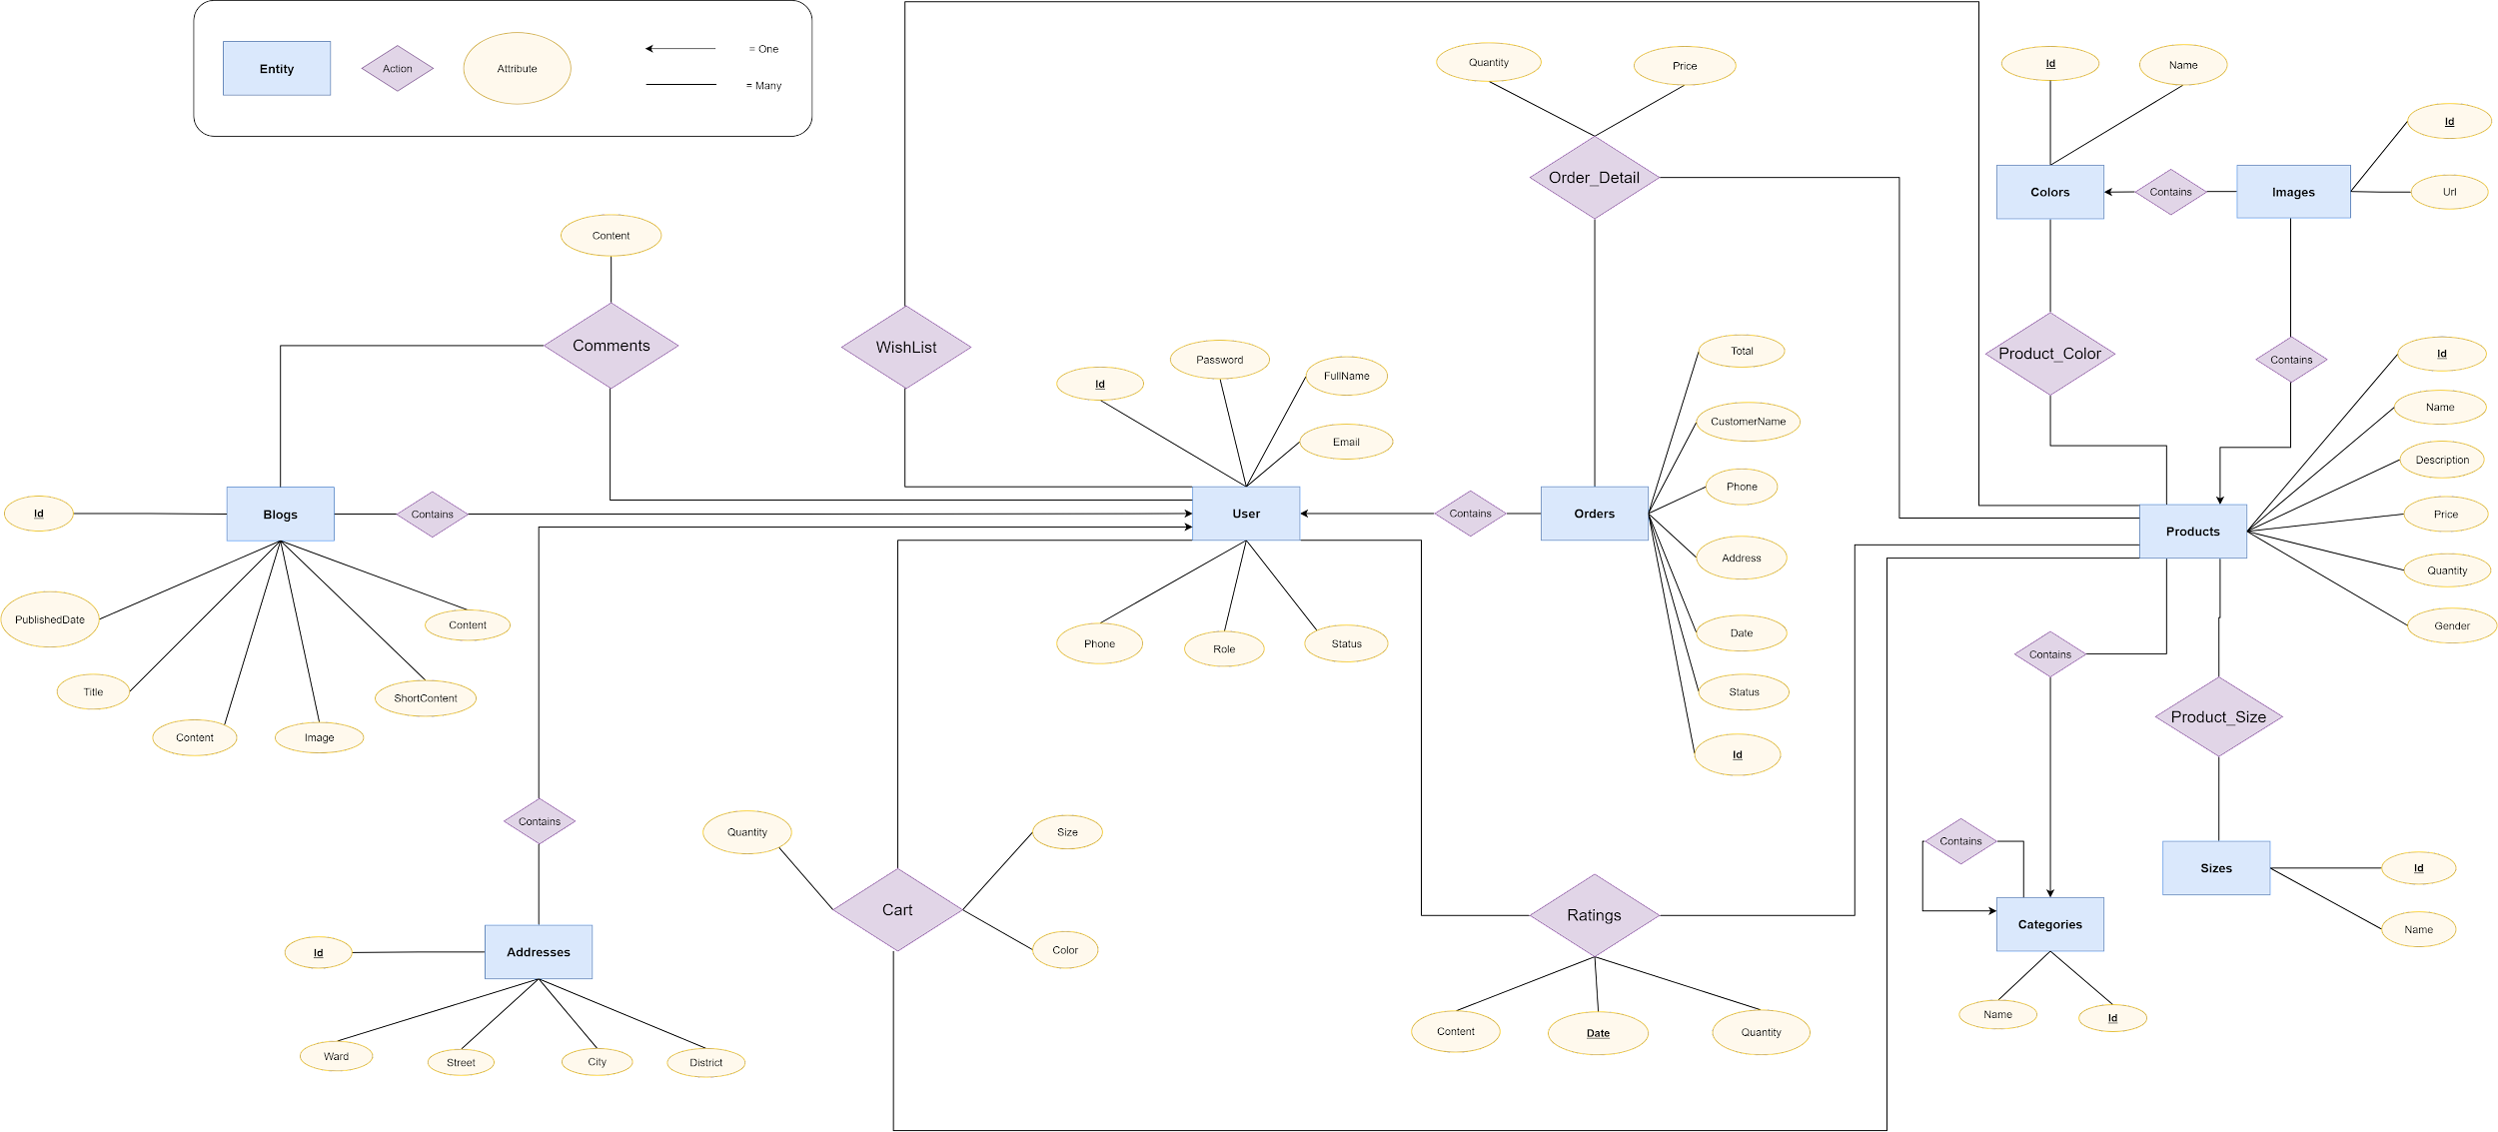

**4. Data Diagram**

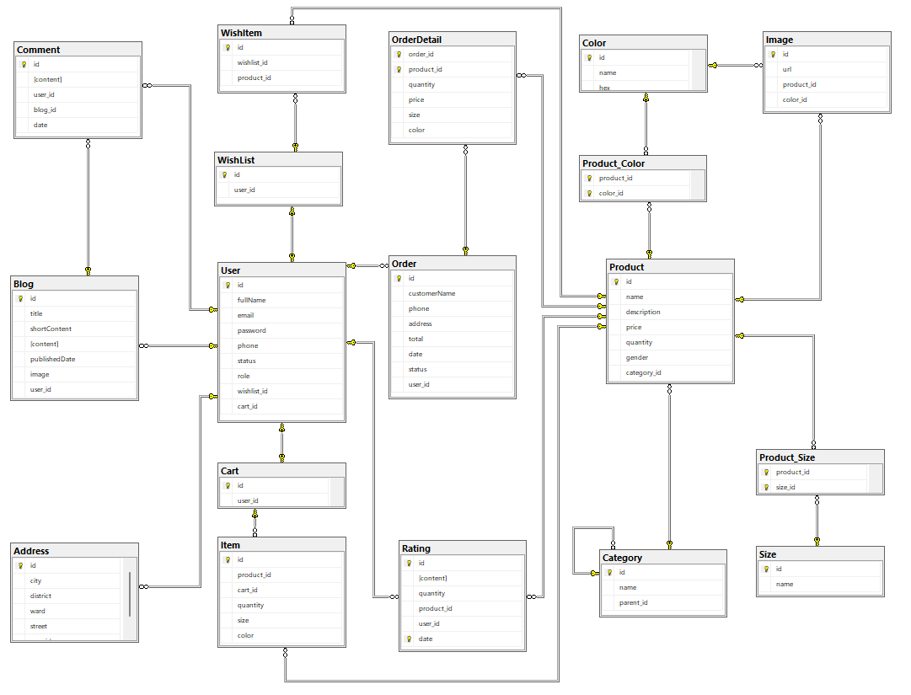

**5. Class Diagram**

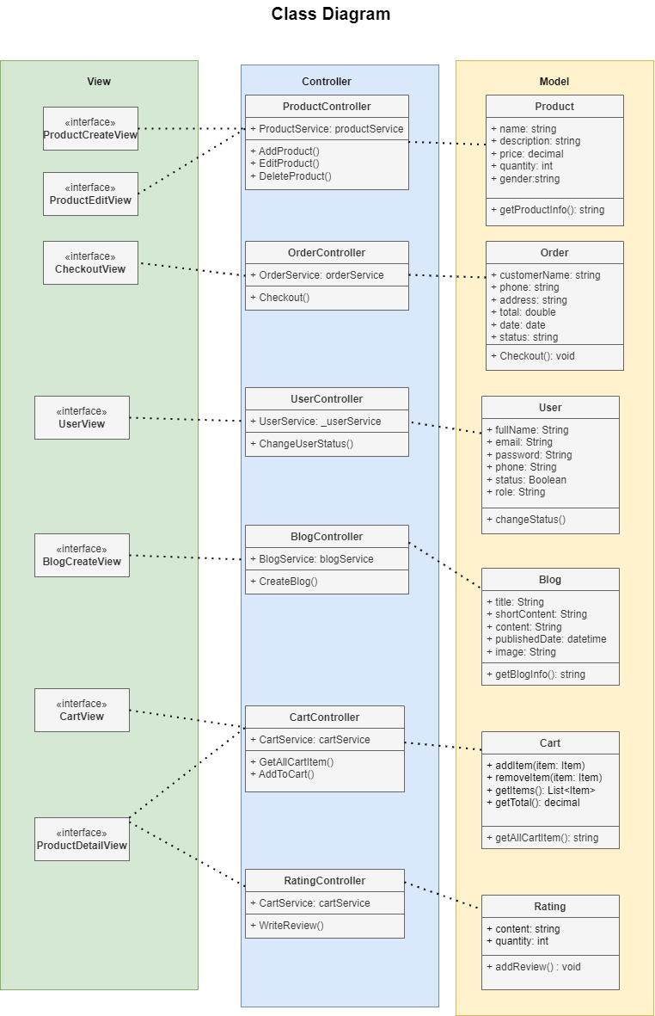

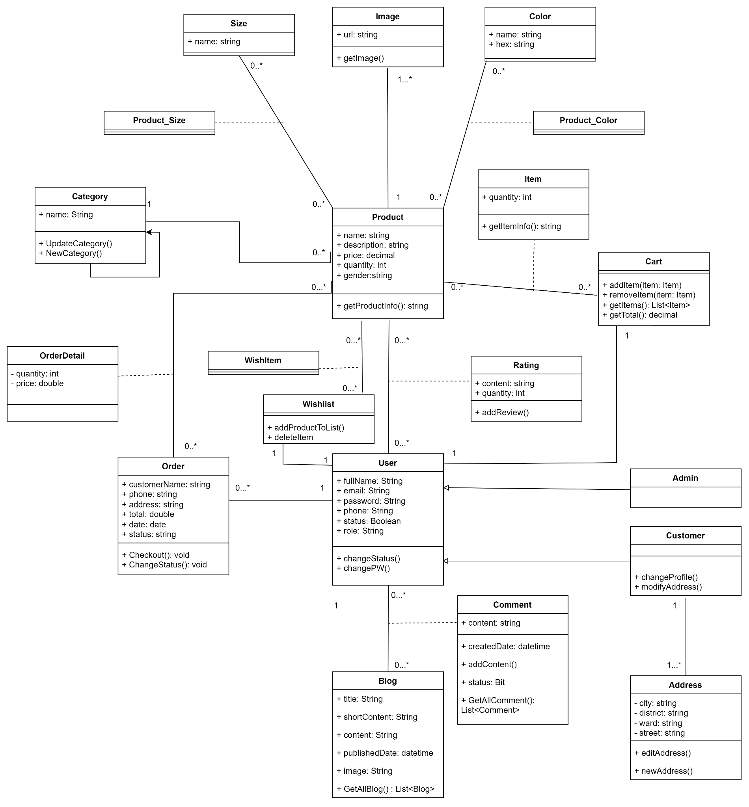

**6. Activity Diagram  
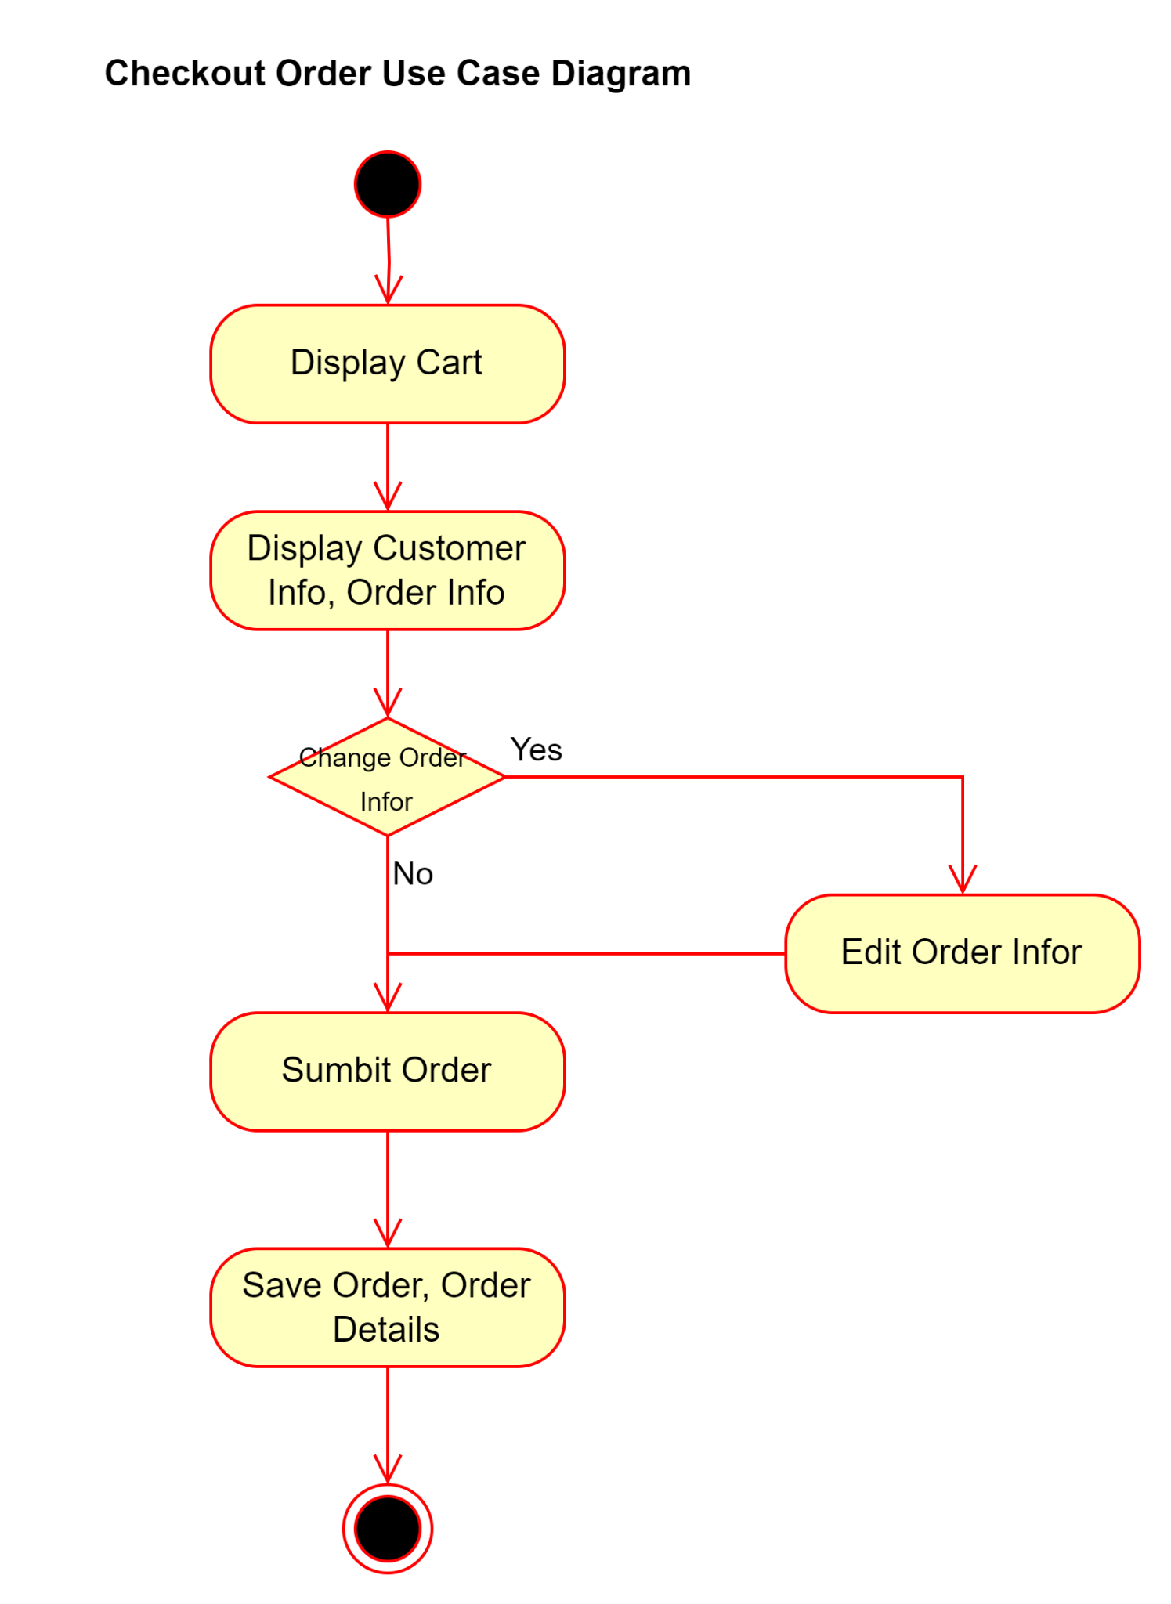**

**7. Sequence Diagram**

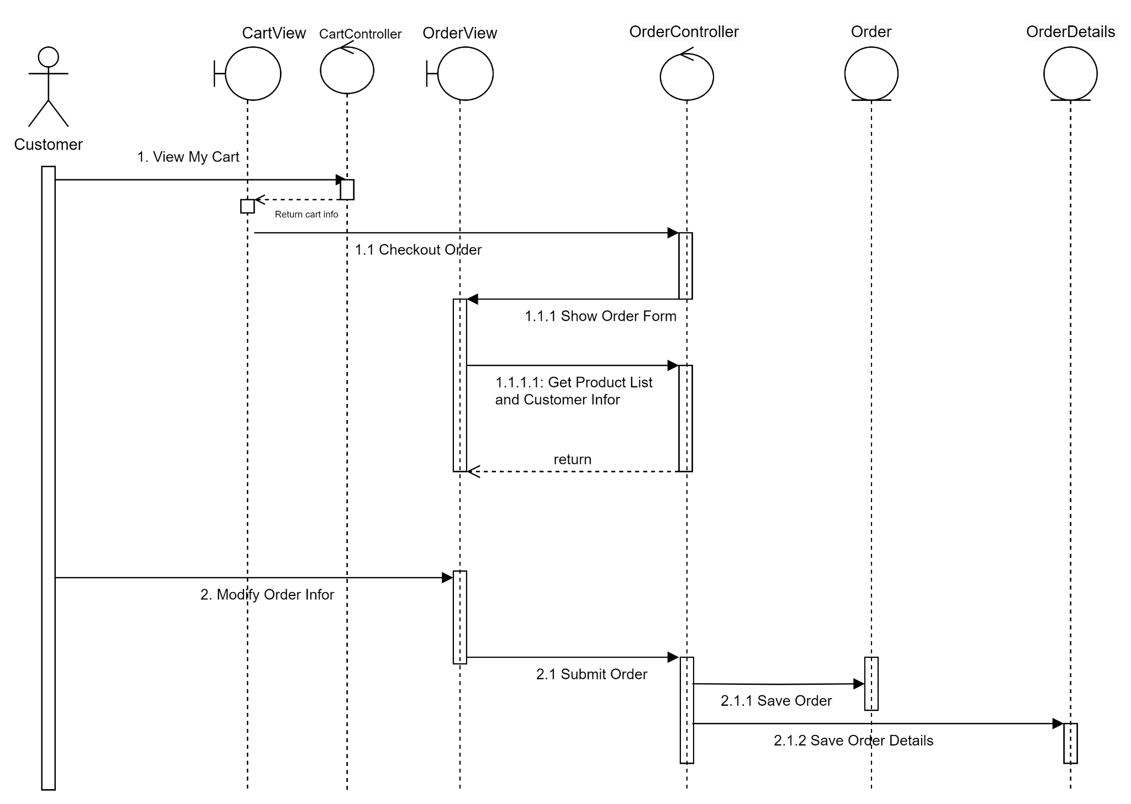

**8. Flow of screen***8.1 Customer Client ScreenFlow*

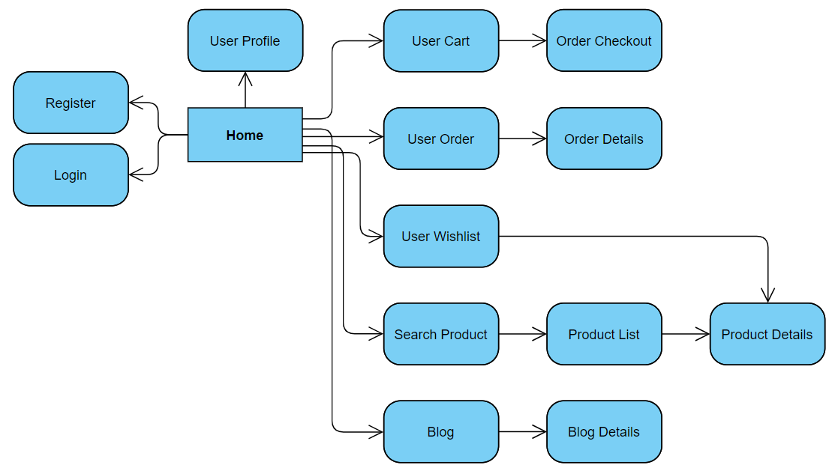

*8.2 Admin Client ScreenFlow*

