DESIGN AND ANALYSIS OF ALGORITHM-CSA0619
CO1: ASSESMENT TOOL 1
Qn. 2: Source code
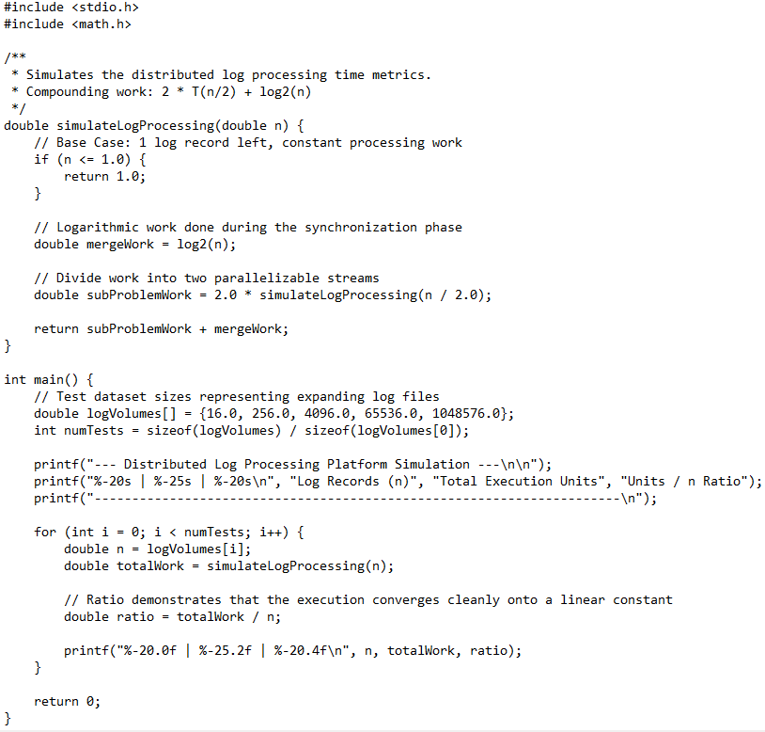
Output:
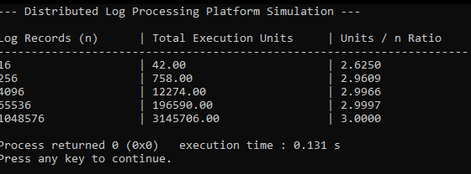

Analysis:
1. Complexity & Resource Metrics
Metric | Complexity | Operational Behavior
Time Complexity | $Θ\left(n\right)$ (Linear) | The linear work of processing leaf nodes ($n$) dominates the much smaller logarithmic merge step ($\log{n}$). Doubling logs simply doubles runtime.
Space Complexity | $$Θ\left(\log{n}\right)$$ | Requires $\log_{2}{n}$ frames on the call stack. Tail Call Optimization (TCO) is impossible because the merge work happens after the recursive returns.
2. Execution Snapshot ($n=4$)
Root Merge [log2(4) = 2.0]
/ \
Merge [log2(2) = 1.0] Merge [log2(2) = 1.0]
/ \ / \
Leaf(1) Leaf(1) Leaf(1) Leaf(1) --> [Base: 4 * 1.0 = 4.0]
- Total Work: $4.0\text{ (Base)}+2.0\text{ (Layer 1)}+2.0\text{ (Root)}=8.0\text{ units}$.
- Convergence: The ratio of $\text{Work}/n$ strictly converges to $2.0$ as $n$ scales, validating the linear $Θ\left(n\right)$ complexity.
3. Critical Production Risks
- Stack Limits: While $\log_{2}{n}$ growth is highly efficient (under 60 stack frames for ${10}^{18}$ entries), it can still cause stack overflows in multi-threaded environments with tightly constrained thread stack sizes (e.g., embedded systems).
- Data Typings: Using double for structural splitting introduces potential floating-point precision drift. Production platforms should use unsigned integers (uint64_t) to track exact record offsets.
- Zero Payloads ($n=0$): Values below $1.0$ instantly trigger the base case and return 1.0. This prevents crashes but falsely reports processing work on empty log files. Empty datasets must be caught at the entry gate.

