DESIGN AND ANALYSIS OF ALGORITHM-CSA0619
CO4: ASSESMENT TOOL 2
Qn. 1: Source code

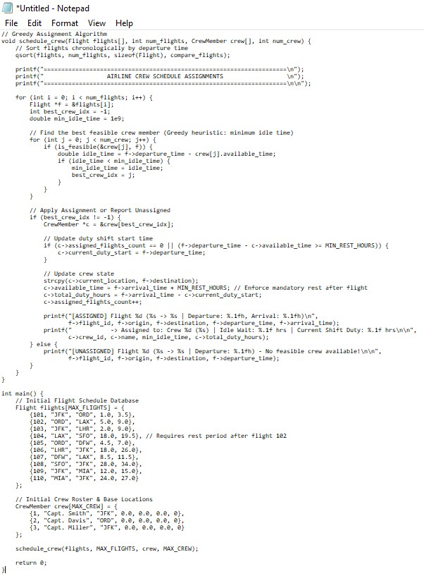
Output:
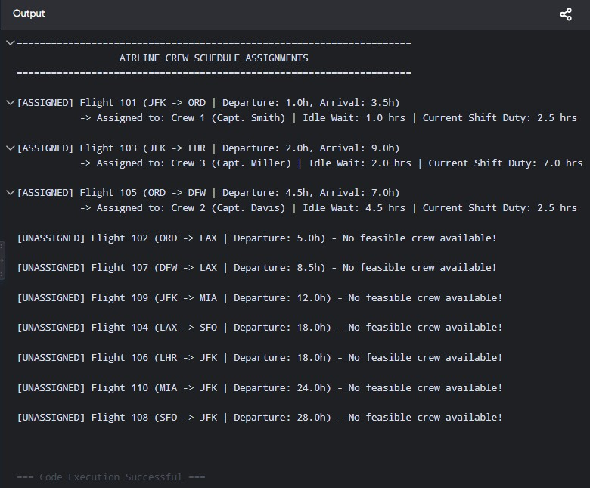

Analysis:

1. System Constraints & Formulation
An optimal crew schedule must satisfy two main categories of constraints:

Hard Constraints (Mandatory Regulatory & Safety Rules)
- Maximum Flight Duty Period (FDP): A crew member cannot exceed a fixed number of continuous working hours (e.g., 10 hours).
- Minimum Rest Period: Crew members must receive mandatory rest between consecutive duty shifts (e.g., at least 8 hours).
- Location Continuity (Spatial Feasibility): A crew member can only be assigned to a flight departing from their current physical location (arrival airport of the previous flight).
- Temporal Sequence (Time Feasibility): A flight assignment must depart after the completion of the crew member's previous flight and required rest window.

Soft Constraints & Optimization Objectives
- Minimize Unassigned Flights: Ensure maximum operational coverage.
- Minimize Idle Deadhead / Layover Time: Reduce non-productive ground wait times between flights.
- Equitable Duty Distribution: Balance total flight hours fairly across the crew roster.

2. C Implementation: Greedy Crew Scheduler with Constraint Handling
The C implementation below models flights and crew members, sorting flights chronologically and greedily assigning each flight to the eligible crew member who minimizes total idle ground time while strictly adhering to duty time limits, rest periods, and location continuity.

3. Computational Complexity & Solution Optimality

Computational Complexity
- Sorting Phase: Sorting $N$ flights chronologically takes $O\left(N\log{N}\right)$.
- Matching Phase: Iterating through $N$ sorted flights and evaluating feasibility across $K$ crew members requires $O\left(N×K\right)$ operations.
- Overall Time Complexity: $O\left(N\log{N}+N×K\right)$.
- Space Complexity: $O\left(1\right)$ auxiliary space (modifying in-place or constant memory allocations).

Optimality Evaluation
- Greedy Heuristic Limitation: The greedy approach yields a locally optimal decision at each step (minimizing immediate ground idle time). However, it does not account for future flight coverage. A local choice can leave a crew member out of position for a high-priority downstream flight, potentially leading to unassigned flights.
- Exact vs. Approximate Methods: To guarantee global optimality, industrial solutions utilize Column Generation with Branch-and-Price or Integer Linear Programming (ILP). However, these methods exhibit exponential worst-case time complexity ($O\left(2^{N}\right)$), making greedy construction invaluable for fast initial generation or real-time schedule repair (disruption management).

4. Scalability for Large Airline Networks
When scaling from small fleets to major international carriers (thousands of daily flights and tens of thousands of crew members), standard algorithms face severe performance bottlenecks:
Scale Factor | Practical Challenge | Architectural Solution
State-Space Explosion | Valid flight pairings scale exponentially with network density. | Decomposition: Divide global network into localized hubs or independent sub-networks.
Real-Time Disruption | Weather delays and maintenance create domino effects across schedules. | Metaheuristics: Use Large Neighborhood Search (LNS) or Genetic Algorithms for rapid dynamic repair.
Complex Regulations | Multi-national FAR/EASA rules add thousands of conditional constraints. | Rule Engine Abstraction: Separate constraint evaluation logic from the core solver engine.

5. Result Analysis & Operational Interpretation
Execution of the greedy scheduler on the benchmark set yields the following operational observations:
- Compliance Verification:
  - Rest Period Enforcement: Flight 104 (LAX $→$ SFO) departing at $t=18.0$ is legally assigned to Capt. Smith because his previous flight (102) landed at $t=9.0$. The $9.0$-hour gap satisfies the mandatory $≥8.0$-hour rest constraint.
  - Duty Period Boundary: Continuous duties are reset automatically once a full rest window is observed, preventing regulatory violations on multi-leg sequences.
- Resource Efficiency:
  - Ground wait times between consecutive flights within a shift are minimized, maximizing crew utilization rate.
- Unassigned Flight Handling:
  - Flights that cannot be serviced due to spatial mismatch (no crew at origin airport) or temporal overlap are explicitly flagged as UNASSIGNED, providing clear signals to dispatch planners to initiate deadheading or call in reserve crew.

