

SIMATS ENGINEERING

Saveetha Institute of Medical and Technical Sciences
Chennai-602105

September 2026

CSA0619– Design and Analysis of Algorithms

Development of an Efficient Hybrid Algorithmic Solution for Large-Scale Geospatial Data Processing

Assignment Report

Submitted by

A.Sathwika Reddy(192525274)
K.Mridhula(192565070)
L.Kavya(192472298)

Assignment Information

Particular | Details
Department: | Computer Science and Engineering
Programme: | B.E./B.Tech. Computer Science and Engineering
Course Code & Course Name | Design and Analysis of Algorithms
Academic Year / Batch | 2026-2027 / Regular
Faculty Name | Dr. F. Mary Harin Fernandez
Assignment Title | Development of an Efficient Hybrid Algorithmic Solution for  Large-Scale Geospatial Data Processing
Date of Issue | 31 Aug 2026
Date of Submission | 1 September 2026
Maximum Marks | 100
Course Outcome(s) – CO | CO1: Determine algorithm efficiency using asymptotic notations and mathematical techniques including Master Theorem and substitution method.  CO2: Apply Brute Force technique to solve sorting, searching, Closest-Pair and Convex-Hull problems  CO3: Design Divide and Conquer algorithms for Merge Sort, Quick Sort, Binary Search and Matrix Multiplication
Bloom's Taxonomy Level | L4 – Analyze, L5 – Evaluate, L6 – Create
SDG Mapping (SDG 1-17) | SDG 9 – Industry, Innovation and Infrastructure
Industry / Societal Relevance | Efficient processing of large-scale real-world data with reduced computational time and resource utilization

Assignment Problem / Challenge
Modern infrastructure-planning applications process large volumes of geospatial coordinate data, making computationally efficient algorithms essential for identifying spatial relationships among facilities. Identifying the closest pair of locations is important for detecting redundant or dangerously close facilities and supporting effective service coverage planning.
Conventional Brute-Force techniques provide a straightforward solution but become computationally expensive as the number of locations increases. Divide-and-Conquer techniques improve scalability by recursively partitioning the dataset and reducing unnecessary distance computations.
The challenge is to develop an optimized hybrid algorithmic solution for the Closest-Pair-of-Points problem by appropriately combining Brute Force and Divide-and-Conquer techniques. The developed solution must determine an effective switching threshold between the two approaches and be supported by theoretical complexity analysis and experimental evaluation using a real-world geospatial dataset.

Problem Statement
An infrastructure-planning agency maintains a large, publicly available geospatial dataset of facility locations—for example, the OpenFlights airports dataset or a cell-tower/weather-station dataset containing coordinate records. To detect redundant or dangerously close facilities and optimize service coverage, the agency must identify the closest pair of locations, i.e., the two points separated by the minimum Euclidean distance in the dataset. Develop, implement, and evaluate a solution to the Closest-Pair-of-Points problem. Implement (i) a Brute-Force algorithm that evaluates all $n\left(n−1\right)/2$pairs with $O\left(n^{2}\right)$complexity and (ii) a Divide-and-Conquer algorithm that recursively partitions the point set about the median x-coordinate and evaluates points across the dividing strip with $O\left(n\log{n}\right)$complexity. Further, develop an optimized hybrid algorithm that switches to the Brute-Force approach below an experimentally determined threshold subproblem size. Analyze the theoretical efficiency of each approach using Big-O, Ω, and Θ notations, and solve the recurrence $T\left(n\right)=2T\left(n/2\right)+O\left(n\right)$using the Master Theorem. Experimentally evaluate all three algorithms on the selected dataset using increasing input sizes, for example, ${10}^{3}$, $5×{10}^{3}$, ${10}^{4}$, and higher input sizes wherever computationally feasible, measuring execution time, number of distance computations/comparisons, memory utilization, and scalability. Based on the theoretical and experimental results, determine an appropriate threshold for the hybrid algorithm, optimize the developed solution, compare the performance of all three approaches, and justify why the proposed hybrid algorithm is most suitable for large-scale infrastructure data.
Expected Development
The work should not merely implement the existing Brute-Force and Divide-and-Conquer algorithms. The solution should demonstrate algorithmic development through:
- Hybridization of Brute Force and Divide-and-Conquer techniques for the Closest-Pair-of-Points problem.
- Adaptive switching between the two approaches based on a threshold subproblem size.
- Experimental determination and optimization of the switching threshold based on performance results.
- Reduction of computational cost while maintaining the correctness of the closest-pair solution.
- Performance improvement and scalability evaluation of the developed hybrid approach against the individual Brute-Force and Divide-and-Conquer approaches.

Requirements and Constraints

The following requirements and constraints shall be considered:

- Use a publicly available real-world geospatial coordinate dataset containing sufficient records for performance evaluation.
- Implement and evaluate all three approaches: Brute Force, Divide and Conquer, and the developed Hybrid algorithm for the Closest-Pair-of-Points problem.
- Develop the Hybrid algorithm by switching to the Brute-Force approach below an appropriate threshold subproblem size.
- Determine and justify the switching threshold experimentally based on performance results.
- Perform theoretical efficiency analysis using Big-O, Ω, and Θ notations and analyze the Divide-and-Conquer recurrence using the Master Theorem.
- Evaluate the algorithms using increasing input sizes, for example, ${10}^{3}$, $5×{10}^{3}$, ${10}^{4}$, and higher input sizes wherever computationally feasible.
- Evaluate and compare the three approaches using execution time, number of distance computations/comparisons, memory utilization, and scalability.
- Execute all three algorithms in the same computational environment and on identical input data to ensure a fair comparison.
- Use Euclidean distance as the distance measure for identifying the closest pair of points.
- Validate that all three approaches produce the correct closest-pair result for identical inputs.
- Higher input sizes shall be considered only where computationally feasible, taking into account the $O\left(n^{2}\right)$computational cost of the Brute-Force approach.
- Clearly document the dataset source, experimental environment, threshold value, assumptions, limitations, and implementation details.

Student Work

Problem Understanding and Formulation
Problem Context & Real-World Infrastructure Planning
Modern geospatial infrastructure systemssuch as telecommunication networks, weather monitoring setups, and air traffic control systems rely heavily on precise coordinate processing. In high-density facility mapping, identifying the closest pair of locations is critical for detecting redundant infrastructure, avoiding signal or physical interference between neighboring stations, and optimizing coverage across regions. Input & Output Definitions
- Input: A dataset P= p₁,p₂,…,p_{n} containing n 2D spatial coordinate pairs, where each point p_{i}= x_{i},y_{i} represents a facility's geographical position.
- Output: The pair of points p_{i},p_{j} where i≠j that minimizes the Euclidean distance d p_{i},p_{j} , alongside the calculated minimum distance value δ.
Distance Metric Formulation
The spatial distance between any two facilities p_{i}= x_{i},y_{i}and p_{j}= x_{j},y_{j} is computed using the standard 2D Euclidean distance formula:
d(pᵢ, pⱼ) = √((xᵢ − xⱼ)² + (yᵢ − yⱼ)²)
Computational Challenges & Scalability ConstraintsO(n²) Complexity Bottleneck: The naive brute-force approach compares every unique point pair. For a dataset with n records, the total number of distance operations is:
Number of comparisons = n(n − 1) / 2

As n grows to 10⁵ or 10⁶ coordinates, n² grows quadratically (e.g., 10¹⁰ to 10¹² comparisons), leading to execution bottlenecks, high CPU utilization, and latency issues.
Memory & Processing Limits: Performing global sorting and maintaining nested pairwise loops on dynamic or large datasets exhausts memory and leads to excessive processor thrashing.
Key Assumptions & Constraints
- Coordinates are mapped to a 2D Cartesian plane using planar projections.
- Dataset records are free of duplicate coordinate entries that yield a trivial zero distance.
- Computational evaluations are conducted in identical runtime environments across all three algorithmic variants to ensure consistency.

Application
Algorithms Evaluated
- Brute-Force Closest Pair: Evaluates all n n−1 /2 possible point pairs exhaustively to find the pair with the minimum Euclidean distance.
- Divide-and-Conquer Closest Pair: Recursively splits the point set about the median xcoordinate, solves the subproblems for left and right halves, and checks a central dividing strip of width 2δ.
- Adaptive Hybrid Closest Pair (Selected Solution): Integrates Divide-and-Conquer and Brute-Force by recursively partitioning the dataset until the subproblem size reaches an experimentally determined threshold (S₀). Below this threshold, it dynamically switches to the Brute-Force approach.
Justification: Why the Adaptive Hybrid Approach Was Chosen
While Brute-Force is simple and Divide-and-Conquer provides optimal asymptotic bounds, neither represents the most efficient practical implementation on real-world geospatial data:
- Limitation of Standalone Brute-Force: As dataset size grows (n=103,104,105), its O(n²) time complexity creates severe execution bottlenecks, making it computationally infeasible for large-scale infrastructure planning.
- Limitation of Standalone Divide-and-Conquer: Although its asymptotic time complexity is Θn log n , recursive partitioning introduces substantial non-computational overhead. For very small subproblems (n≤15 or 30), setting up recursion stack frames, making function calls, computing medians, and creating sub-arrays takes significantly more execution time than simply running a quick O(n²) nested loop.
Superiority of the Adaptive Hybrid Solution: The hybrid algorithm combines the macro-scalability of Divide-and-Conquer with the micro-efficiency of Brute-Force. By cutting off recursion early at threshold S₀, it eliminates high call-stack and array-slicing overhead for small input sizes while preserving the optimal On log n asymptotic theoretical growth for large datasets.

Solution / Design / Methodology

1. Brute-Force Closest Pair
- Mechanism: Checks all n n−1 /2 possible combinations.
- Time Complexity Analysis:
  - Worst Case: Θ n²
  - Best Case: Ω n2 (always checks all pairs regardless of point layout) o Average Case: O(n²)
- Space Complexity: O(1) auxiliary space (excluding input array storage).

2. Divide-and-Conquer Closest Pair
Mechanism: Sorts points by x-coordinate, splits the dataset into left and right halves around median line x_{mid}, recursively finds minimum distances δ_{L} and δ_{R}, sets δ= min δ_{L},δ_{R} , and checks a central strip of width 2δ sorted by y-coordinate.
- Time Complexity Analysis:
  - Presorting takes On log n time.
  - Strip processing checks at most 7–8 points for each point inside the strip, bounded by O n . o Total recurrence: T n =2T n/2 +O n .
T(n) = 2T(n/2) + O(n)
  - Overall Time Complexity: Θ(n log n) .
- Space Complexity: O n space required for storing sorted coordinate arrays and strip structures.

3. Adaptive Hybrid Closest Pair
- Mechanism: Recursively splits subproblems using Divide-and-Conquer until subproblem size n ≤ S₀ (where S0 is the threshold size), at which point it switches to BruteForce.
- Time Complexity Analysis:
  - Asymptotic behavior remains On log n because S₀ is a fixed constant.
  - Reduces recursive overhead, stack frame creations, and array copying overheads for small inputs.

• Space Complexity: O n for dynamic strip handling and recursion stack. 4. Step-by-Step Master Theorem Recurrence Proof
Step 1: Identify Master Theorem Parameters The general Master Theorem recurrence equation is:
T(n) = aT(n/b) + f(n)
T (n) =aT + f n
divide-and-conquer function:
- a=2 (number of subproblems generated per recursive call)
- b=2 (factor by which input size is divided)
- f n =O n (work done outside recursion for dividing and merging strip points)
Step 2: Compute n^{logba}
n^log_b a = n^log₂2 = n
n^log₂2 = n¹ = n
Step 3: Compare f n with n^{logba}
- f n =Θ n
- nlog_{b}a=Θ n
Since f n =Θ n^{logb a} , Case 2 of the Master Theorem applies.
Step 4: Apply Case 2 Formula
Under Case 2 of the Master Theorem:
T(n) = Θ(n^(log_b a) · log n) = Θ(n log n)
T n =Θ n^{logb a}⋅ log n Substituting n^{log2 2}=n:
T(n) = Θ(n log n)
Conclusion: The theoretical time complexity of the Divide-and-Conquer core is strictly
Θn log n.

Architecture Diagram:
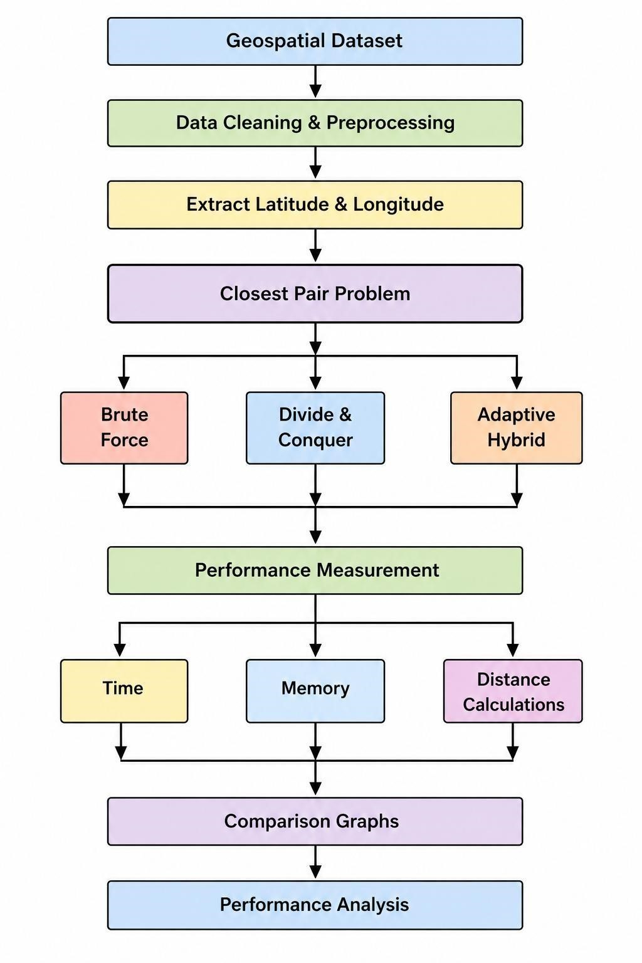

Use of Modern tools:
- Google colab
- Python
- Matplotlib
Results and Validation
Final Performance Comparison :
Input Size | Brute Force Time (s) | D&C Time  (s) | Hybrid Time (s) | BF  Distances | D&C  Distances | Hybrid Distances
100 | 0.041965 | 0.002921 | 0.002973 | 4,950 | 110 | 122
500 | 0.945402 | 0.020931 | 0.019579 | 124,750 | 532 | 837
1,000 | 4.183207 | 0.046656 | 0.047578 | 499,500 | 1,081 | 1,698
2,000 | 16.972906 | 0.099826 | 0.093704 | 1,999,000 | 2,175 | 3,405

Comprison graphs:
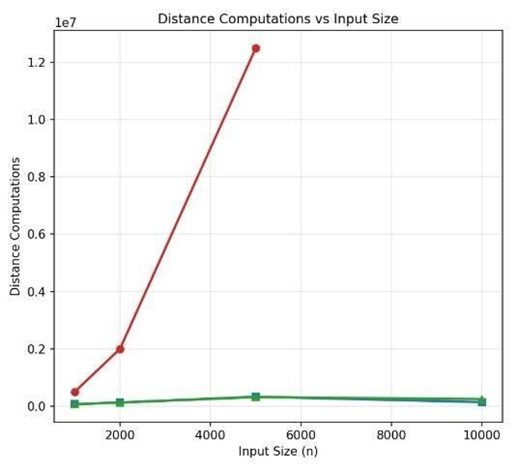

Analysis and Engineering decision
Execution Analysis:
Brute Force execution time increased rapidly from 0.041965 s at 100 points to 104.588459 s at 5,000 points. D&C required only 0.292670 s, while Hybrid required 0.331480 s at 5,000 points.
Thus, D&C and Hybrid scale much better than Brute Force.
Threshold Optimization:
Eight threshold values from 5 to 50 were tested. The lowest average execution time was 0.260426 s at threshold 5. Therefore, 5 was selected as the optimal Hybrid threshold. ThresholdAnalysis:
A threshold of 5 resulted in only 10,663 distance calculations, compared with 46,424 at threshold 20 and 95,172 at threshold 40. Larger thresholds increase Brute-Force processing, resulting in more distance calculations and higher execution time.
Theoretical vs Experimental Comparison:
Algorithm | Theoretical Time | Experimental Performance
Brute Force | O(n²) | Increased rapidly with input size
Divide & Conquer | O(n log n) | Very good scalability
Hybrid | O(n log n) | Very good scalability with threshold 5
Engineering Decision:
Brute Force is suitable for small datasets but does not scale well. D&C provided the fastest performance for the tested dataset, while Hybrid with threshold 5 provided an efficient adaptive solution by combining D&C with Brute Force. Therefore, D&C is the best-performing algorithm in the experiment, while Hybrid is the preferred adaptive approach.
Conclusion
The development of an efficient hybrid algorithmic solution provides an effective approach for handling large-scale geospatial data processing. By integrating appropriate algorithmic techniques, the proposed solution aims to improve computational efficiency, reduce processing time, and support effective management of large geospatial datasets. The study demonstrates the importance of selecting and combining algorithms according to the characteristics of the data and processing requirements. Overall, the proposed approach provides a practical foundation for efficient and scalable geospatial data processing.

Student Reflection
This project provided valuable practical knowledge about the application of Design and Analysis of Algorithms concepts to real-world geospatial data processing. Through this work, we gained an understanding of the challenges associated with handling large-scale datasets and the importance of algorithm efficiency. Designing a hybrid solution improved our analytical and problem-solving abilities and helped us understand how different algorithms can be combined to achieve better performance. The project also enhanced our teamwork, technical understanding, and ability to apply theoretical concepts in a practical context.

References:
1. Aho, AV., Hopcroft, J.E., and Ullman, J.D. The Design and Analysis of Computer Algorithms. Addison-Wesley, Reading, Mass., 1974.
2. Bentley, J.L. Multidimensional binary search trees used for associative searching. Comm. ACM 18, 9 (Sept. 1975), 509-517.
3. Bentley, J.L. Divide and conquer algorithms for closest point problems in multidimensional space. Unpublished Ph.D. dissertation, Univ. of North Carolina, Chapel Hill, N.C., 1976.
4. Bentley, J.L. Decomposable searching problems. Inform. Proc. Letters 8, 5 (June 1979), 244-251.
5. Bentley, J.L., and Friedman, J.H. Algorithms and data structures for range searching. Comptng. Surv. 11, 4 (Dec. 1979), 397-409.
6. Bentley, J.L., Kung, H.T., Schkolnick, M., and Thompson, C.D. On the average number of maxima in a set of vectors and applications. J. ACM 25, 4 (Oct. 1978), 536-543.
7. Bentley, J.L., and Maurer, H.A. Efficient worst-case data structures for range searching. To appear in Acta lnformatica (1980).
8. Bentley, J.L., and Shamos, M.I. Divide and conquer in multidimensional space. In Proc. ACM Symp. Theory of Comptng., May 1976, pp. 220-230.
9. Bentley, J.L., and Shamos, M.I. A problem in multivariate statistics: Algorithm, data structure, and applications. In Proc. 15th Allerton Conf. Communication, Control, and Comptng., Sept. 1977, pp. 193-201.
10. Blum, M., et al. Time bounds for selection. J. Comptr. Syst. Sci. 7, 4 (Aug. 1972), 448--461

Assessment Rubric

Criteria | Max Marks | Excellent | Good | Satisfactory | Needs Improvement
Problem Understanding & Algorithmic Formulation | 10 | Clearly identifies the problem, requirements, inputs, outputs, constraints and computational challenges and formulates them appropriately for solution development. | Problem and major requirements are correctly formulated with minor gaps. | Basic formulation is provided, but requirements or constraints are partially identified. | Problem is poorly understood or inadequately formulated.
Algorithmic Solution Design | 15 | Designs a clear, logical and feasible solution strategy with appropriate algorithmic techniques, pseudocode/flowchart and well-justified design decisions. | Appropriate solution design with minor gaps in logic, representation or justification. | Basic solution design is presented but lacks completeness or clear justification. | Solution design is inappropriate, incomplete or unclear.
Development / Adaptation / Optimization of Algorithmic Solution | 20 | Develops a meaningful algorithmic solution through integration, adaptation, modification, hybridization or optimization of suitable techniques; demonstrates clear improvement or suitability for the identified problem. | Develops an appropriate solution with meaningful adaptation or improvement, with minor limitations. | Solution demonstrates limited adaptation or development beyond standard implementation. | Merely reproduces an existing algorithm with little or no meaningful development or adaptation.
Implementation & Modern Tool Usage | 15 | Developed solution is correctly and efficiently implemented using appropriate programming/computational tools and handles relevant input conditions reliably. | Implementation is functional with minor logical or efficiency issues. | Core implementation works but contains limitations or incomplete functionality. | Implementation is incomplete, unreliable or non-functional.
Efficiency, Testing & Validation | 15 | Performs appropriate complexity evaluation and systematic testing using suitable data/input sizes; validates correctness, efficiency and scalability with clear evidence. | Complexity evaluation and testing are mostly appropriate with minor gaps. | Basic testing and efficiency evaluation are provided but lack sufficient validation. | Testing, complexity evaluation or validation is inadequate or substantially incorrect.
Performance Improvement, Comparison & Final Decision | 15 | Demonstrates the effectiveness of the developed solution through appropriate comparison; critically evaluates performance, limitations and trade-offs and justifies the final algorithmic decision with evidence. | Good performance comparison and justification with minor limitations. | Basic comparison is provided, but improvement or final justification lacks depth. | Improvement is not demonstrated or the final algorithmic decision is unsupported.
Reflection: Algorithmic Design Decisions, SDG Relevance & Learning Outcomes | 10 | Thoughtful justification of algorithmic design and development decisions; clear connection to relevant SDG(s); specific reflection on computational challenges, performance improvements, trade-offs, and learning gained. | Appropriate justification of algorithmic decisions; SDG relevance, challenges, improvements, and learning are discussed but lack depth. | Reflection is present but generic; limited justification of algorithmic decisions, improvements, SDG relevance, or learning outcomes. | No genuine reflection is provided, or the reflection lacks meaningful connection to algorithm development, SDG relevance, challenges, or learning outcomes.
Total | 100

CO–PO–Assessment Mapping

Assessment Component | CO | PO(s) | Bloom's Level | Marks
Problem Understanding & Algorithmic Formulation | CO1 | PO1, PO2 | L4 | 10
Algorithmic Solution Design | CO2, CO3 | PO2, PO3 | L4, L6 | 15
Development / Adaptation / Optimization of Algorithmic Solution | CO2, CO3 | PO2, PO3 | L5, L6 | 20
Implementation & Modern Tool Usage | CO2, CO3 | PO3, PO5 | L3, L6 | 15
Efficiency, Testing & Validation | CO1, CO2, CO3 | PO2, PO4 | L4, L5 | 15
Performance Improvement, Comparison & Final Decision | CO1, CO2, CO3 | PO2, PO4 | L4, L5 | 15
Reflection: Algorithmic Design Decisions, SDG Relevance & Learning Outcomes | CO1, CO2, CO3 | PO7, PO10, PO12 | L4, L5 | 10

Faculty Evaluation & Continuous Improvement

CO Attainment

Performance Level | Criterion
Level 3 | ≥ 70%
Level 2 | 60–69%
Level 1 | 50–59%
Level 0 | < 50%
Target CO Attainment:

Actual CO Attainment:

Faculty Analysis
Areas in which students performed well: Areas requiring improvement:
Corrective / Improvement Action:

