DESIGN AND ANALYSIS OF ALGORITHM-CSA0619
CO4: ASSESMENT TOOL 2
Qn. 1: Source code
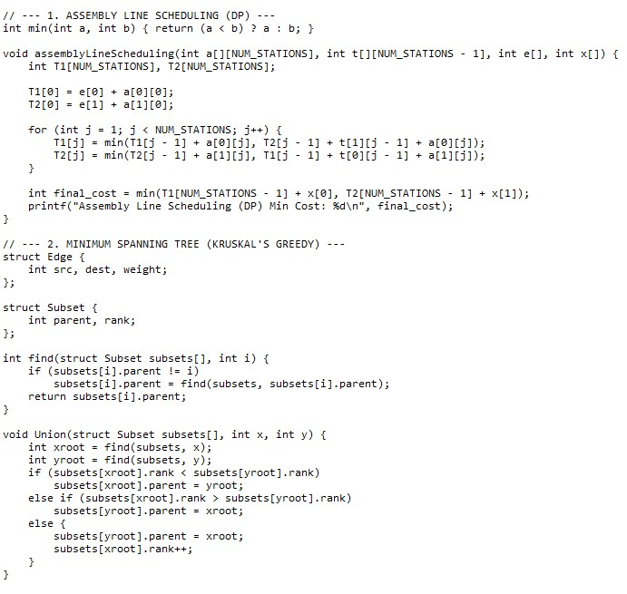

Output:
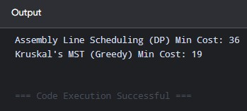

Analysis:

1. Problem Formulations & Solution Approaches

Assembly Line Scheduling (Dynamic Programming)
Given two parallel assembly lines, each with $n$ stations, processing time $a_{i,j}$, line-transfer penalty $t_{i,j}$, entry cost $e_{i}$, and exit cost $x_{i}$:
- Recurrence Relations:
$$T_{1}\left[j\right]=\min\left(T_{1}\left[j-1\right]+a_{1,j},T_{2}\left[j-1\right]+t_{2,j-1}+a_{1,j}\right)$$
$$T_{2}\left[j\right]=\min\left(T_{2}\left[j-1\right]+a_{2,j},T_{1}\left[j-1\right]+t_{1,j-1}+a_{2,j}\right)$$
- Base Cases: $T_{1}\left[0\right]=e_{1}+a_{1,0}$, $T_{2}\left[0\right]=e_{2}+a_{2,0}$
- Final Result: $\min\left(T_{1}\left[n-1\right]+x_{1},T_{2}\left[n-1\right]+x_{2}\right)$

Minimum Spanning Tree (Greedy - Kruskal & Prim)
Given a connected, weighted graph $G=\left(V,E\right)$:
- Kruskal's Strategy: Sort all edges by weight in non-decreasing order. Iteratively add the smallest edge that does not form a cycle (using Disjoint Set Union).
- Prim's Strategy: Maintain a growing tree $T$. Iteratively add the minimum-weight edge connecting a vertex in $T$ to a vertex outside $T$ (using a Priority Queue).

3. Decision-Making & Algorithmic Property Analysis

Decision-Making Process
- DP (Assembly Line): Delayed commitment. It computes all candidate optimal paths for subproblem stages and retains the optimal state up to stage $j$. Final decisions depend on future accumulated values.
- Greedy (MST): Immediate commitment. It evaluates options strictly by local criteria (e.g., minimum edge weight) and locks them in permanently without reconsidering.

Optimal Substructure vs. Greedy Choice Property
- Optimal Substructure (Both DP & Greedy): An optimal solution to the overall problem contains optimal solutions to its subproblems.
  - In Assembly Line Scheduling, the shortest path to station $j$ relies on the shortest path to station $j-1$.
  - In MST, if an edge $e$ is part of the MST, removing $e$ creates an MST for the remaining components.
- Greedy Choice Property (Greedy Only): A globally optimal solution can be reached by choosing the locally optimal option at each step. MST possesses this property (proved via the Cut Property). Assembly Line Scheduling lacks this property because taking the cheaper station at step $j$ may lead to a large transfer penalty at step $j+1$.

4. Time & Space Complexity Evaluation
Algorithm | Time Complexity | Space Complexity | Execution Determinants
Assembly Line Scheduling (DP) | $$O\left(n\right)$$ | $O\left(n\right)$ (or $O\left(1\right)$ optimized) | Linear scan over total stations ($n$).
Kruskal's MST (Greedy) | $O\left(E\log{E}\right)$ or $O\left(E\log{V}\right)$ | $$O\left(V+E\right)$$ | Edge sorting and Union-Find operations.
Prim's MST (Greedy - Binary Heap) | $$O\left(\left(V+E\right)\log{V}\right)$$ | $$O\left(V+E\right)$$ | Priority Queue insertions and key decreases.

5. Scalability & System Application Insights

Industrial Scalability
- Dynamic Programming: Ideal for sequential, state-dependent systems (e.g., manufacturing lines, automated vehicle routing with state changes). High scalability for sequential pipelines ($O\left(n\right)$ time). However, when state variables grow (curse of dimensionality), DP memory demands grow exponentially.
- Greedy Algorithms: Ideal for large-scale network infrastructure (e.g., electric power grids, telecommunication routing, internet backbone topology). Highly scalable for dynamic environments due to low computational overhead per step.

Selection Framework
- Choose Greedy when: The problem satisfies the Greedy Choice Property (e.g., Matroid structure, Cut Property). Greedy delivers optimal results faster and with lower memory overhead.
- Choose Dynamic Programming when: Local decisions depend on dynamic downstream effects, cross-over costs, or overlapping state constraints where local choices fail to yield global optimality.

