DESIGN AND ANALYSIS OF ALGORITHM-CSA0619
CO3: ASSESMENT TOOL 1
Qn. 1: Source code
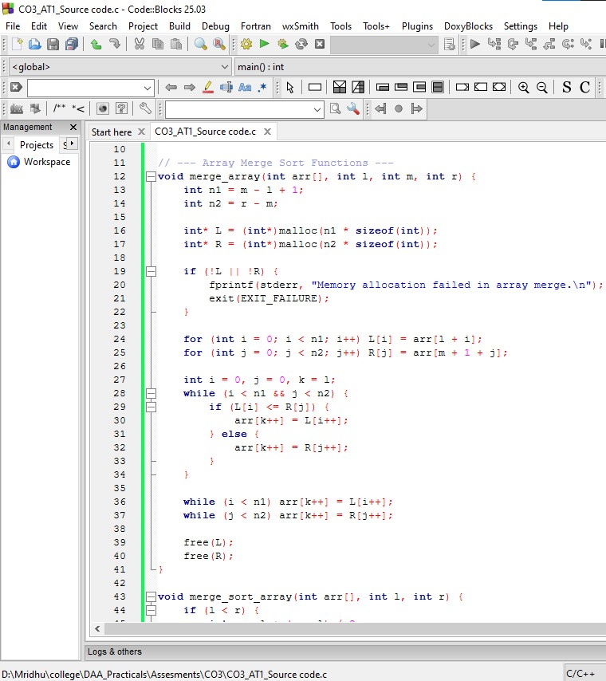
Output:
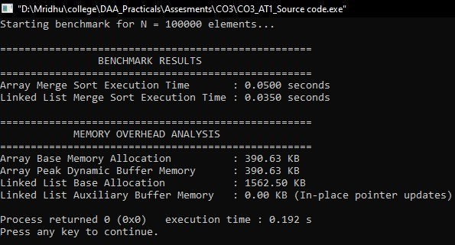
Analysis:

Quantitative Performance Comparison
Metric | Array Implementation | Linked List Implementation
Time Complexity (Best / Avg / Worst) | $$O\left(N\log{N}\right)$$ | $$O\left(N\log{N}\right)$$
Auxiliary Space Complexity | $O\left(N\right)$ (buffer allocation during merges) | $O\left(1\right)$ extra data memory / $O\left(\log{N}\right)$ call stack
Base Structure Memory Overhead | $4N$ bytes (390 KB for $N=100k$) | $16N$ bytes on 64-bit systems (1,562 KB for $N=100k$)
Middle Element Access | $O\left(1\right)$ direct index access ($m=l+\left(r-l\right)/2$) | $O\left(N\right)$ slow/fast pointer traversal
Element Swapping / Moving | Physical copy operations into auxiliary arrays | Pointer mutations ($O\left(1\right)$ pointer update per merge step)
Cache Locality | High (contiguous blocks leverage CPU prefetching) | Low (heap-allocated nodes cause cache misses)

Mechanics of Merging Operations
1. Array Merging Operations
In arrays, splitting the list is cheap ($O\left(1\right)$ arithmetic index calculation), but the merging step is expensive:
- Data Movement: Splitting requires copying elements into temporary left/right buffers ($L$ and $R$) and writing them back into the main array in sorted order.
- Cache Hits: Modern L1/L2 spatial caches offset some of this copying overhead because array elements reside in contiguous memory lines, making sequential reads extremely fast.
- Memory Footprint: Requires $O\left(N\right)$ auxiliary memory dynamically allocated during execution to store temporary array slices.
2. Linked List Merging Operations
In linked lists, splitting the list requires a fast/slow pointer traversal ($O\left(N\right)$ per recursion level), but the merging step is extremely efficient:
- Zero Element Copying: Merging is executed purely by modifying the next pointers of existing nodes. No secondary dynamic allocations occur during the merge itself.
- Cache Misses: Nodes scattered across non-contiguous heap memory locations trigger frequent L1/L2 cache misses, which offsets the structural advantage of $O\left(1\right)$ pointer rewiring.
- Pointer Overhead: On 64-bit CPUs, each node incurs an 8-byte pointer overhead plus structure alignment padding, making the baseline memory usage 4× larger than an equivalent array.
Result Interpretation & Structural Justification
When Linked List Merge Sort is Optimal
- Low-Memory/In-Place Execution Requirements: If allocating an additional $O\left(N\right)$ contiguous array buffer is impossible due to memory fragmentation or capacity limits, linked lists are superior because they re-wire existing pointers in-place without auxiliary buffer allocations.
- Non-Randomized, Sequential Data Insertion: Linked lists eliminate the need for element swapping or contiguous reallocation when sorting dynamic streams where total element counts are unknown prior to runtime.
When Array Merge Sort is Optimal
- High Throughput / Cache-bound Systems: Arrays dominate execution speeds when cache locality is prioritized. Sequential RAM prefetching on modern CPU hardware allows array buffer copies to execute faster than non-contiguous heap traversals, even with the $O\left(N\right)$ copy overhead.
- Memory Efficiency at Scale: An array uses minimal baseline memory ($4$ bytes per int). Linked lists consume up to $16$ bytes per node due to pointer alignment and padding, making them inefficient for large datasets where baseline memory is constrained.
Final Verdict: For standard computing environments, Array Merge Sort is the preferred representation due to hardware cache line utilization and compact memory representation, provided $O\left(N\right)$ extra memory is available. For dynamic memory structures where dynamic buffer allocation must be strictly avoided, Linked List Merge Sort is the clear choice.

