DESIGN AND ANALYSIS OF ALGORITHM-CSA0619
CO5: ASSESMENT TOOL 1
Qn. 1: Source code

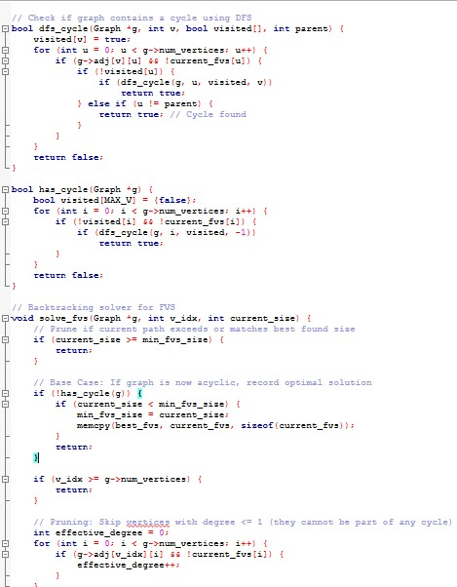

Output:
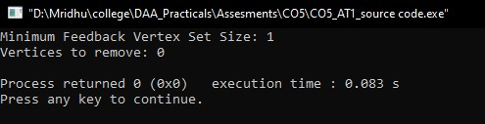

Analysis:

Problem Definition & Constraints
Let $G=\left(V,E\right)$ be an undirected graph with vertex set $V$ and edge set $E$.

Constraints for Cycle Elimination
- Acyclicity Constraint:
The induced subgraph $G\left[V∖S\right]$ must contain no cycles. Formally, for every simple cycle $C=\left(v_{1},v_{2},…,v_{k},v_{1}\right)$ in $G$:
$$C∩S≠∅$$
Every cycle in $G$ must share at least one vertex with the removal set $S$.
- Minimality Objective:
Minimize the total size of the feedback vertex set:
$$\min{|}S| \text{subject to }G\left[V∖S\right]\text{ being acyclic}$$

Impact of Constraints on Feasible Solutions
- Solution Space Traversal: Since a graph with $n$ vertices has $2^{n}$ candidate subsets of vertices, checking every subset quickly becomes infeasible.
- Tightness of Constraints: Adding an edge to $G$ can introduce multiple new cycles, forcing a larger feedback vertex set. Conversely, isolated vertices or vertices with a degree $≤1$ can never be part of a simple cycle and can be immediately excluded from $S$.
- Component Reduction: Removing a vertex $v∈S$ breaks all cycles containing $v$, potentially reducing the remaining graph into independent sub-trees or isolated components, which drastically narrows the search space for subsequent choices.

Backtracking Algorithm with Pruning
To find an optimal solution, we can explore state-spaces using a decision tree where each vertex is either included in $S$ or excluded from $S$.

Pruning Strategies
- Degree-Based Rules:
  - Degree 0 or 1: Vertices with degree $≤1$ cannot participate in any cycle. We prune branches that consider removing these vertices.
  - Degree 2: If a vertex $v$ has degree 2 with neighbors $u$ and $w$, any cycle passing through $v$ must also pass through $u$ and $w$. We can compress $v$ by replacing edges $\left(u,v\right)$ and $\left(v,w\right)$ with direct edge $\left(u,w\right)$ (or self-loop if $u=w$).
- Cycle Existence Pruning (Bounding):
  - If the current graph $G$ already contains no cycles, the current candidate set $S$ is valid, and we bound the branch by checking if $|S|$ beats our global minimum.
- Branch and Bound Cost Limit:
  - If $|S|+\text{lower_bound}≥\text{best_so_far}$, terminate the branch early. A quick lower bound is the number of disjoint cycles currently identified.

Correctness of Algorithm
- Exhaustive Decision Search: The backtracking routine explores both choices (include/exclude) for every candidate vertex, generating all subset combinations.
- Cycle Check Verification: At every terminal node or intermediate state, $G\left[V∖S\right]$ is tested for cycles via Depth-First Search (DFS). DFS is guaranteed to detect any back-edge in $O\left(|V|+|E|\right)$ time.
- Validity of Degree Pruning: A vertex $v$ with effective degree $≤1$ can never belong to a simple cycle (a cycle requires every participating vertex to have degree $≥2$). Excluding such vertices from removal preserves completeness while cutting search paths.

NP-Completeness Classification
- NP-Membership:
Given a candidate vertex subset $S⊆V$ and an integer $k$:
  - We can verify in polynomial time $O\left(|V|+|E|\right)$ using DFS whether $|S|≤k$ and whether removing $S$ leaves an acyclic graph. Hence, FVS is in NP.
- NP-Hardness (Reduction from Vertex Cover):
  - The Vertex Cover problem (given graph $G=\left(V,E\right)$ and integer $k$, find if a subset $V'⊆V$ of size $k$ touches all edges) is known to be NP-complete.
  - We transform any instance of Vertex Cover $G=\left(V,E\right)$ into an instance of FVS $G'=\left(V',E'\right)$ as follows:
    - Replace every edge $e=\left(u,v\right)∈E$ with a 2-cycle by introducing duplicate parallel edges or adding a dummy node $w_{e}$ to form a triangle $\left(u,v,w_{e}\right)$.
    - Any cycle in $G'$ corresponds directly to an edge in $G$. Thus, breaking all cycles in $G'$ is equivalent to covering all edges in $G$.
  - Since Vertex Cover reduces to FVS in polynomial time, Feedback Vertex Set is NP-Hard.
Combining both results proves that the Feedback Vertex Set Problem is NP-Complete.

Result Analysis
- Time Complexity: The naive recursive solution evaluates $O\left(2^{|V|}\right)$ subsets, with an $O\left(|V|+|E|\right)$ cycle check at each step, yielding $O\left(|V|⋅2^{|V|}\right)$. With degree-pruning and cost-bounding, sparse sub-trees are pruned early, drastically lowering runtime in practice.
- Space Complexity: Recursion depth is bounded by $O\left(|V|\right)$, with $O\left(|V|2\right)$ auxiliary space for graph representations and DFS state arrays.

