DESIGN AND ANALYSIS OF ALGORITHM-CSA0619
CO1: ASSESMENT TOOL 1
Qn. 1: Source code
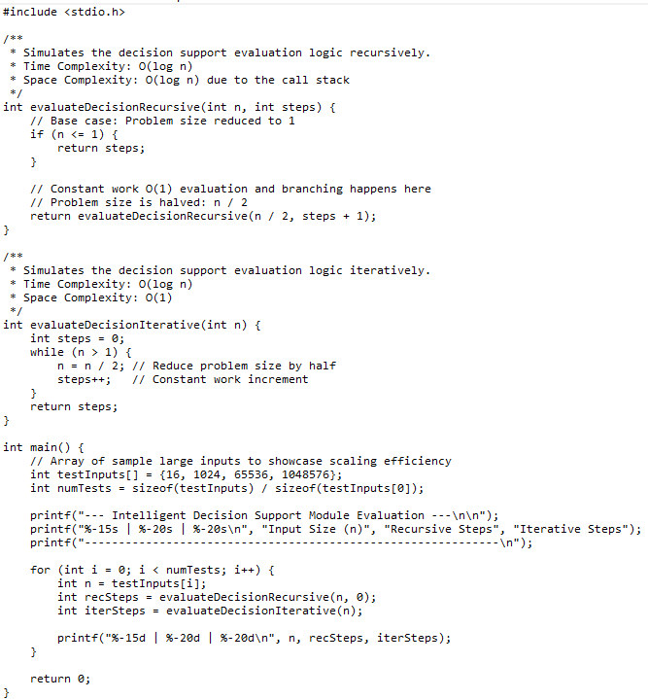
Output:
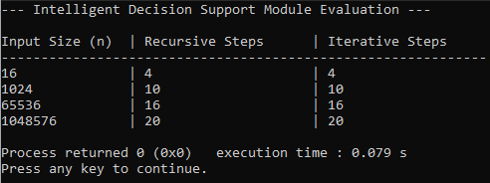

Analysis:
Metric | Iterative Approach | Recursive Approach
Time Complexity | $$Θ\left(\log{n}\right)$$ | $$Θ\left(\log{n}\right)$$
Space Complexity | $Θ\left(1\right)$ (Constant) | $Θ\left(\log{n}\right)$ (Call stack memory)

Time Mechanics: Both split the problem size in half (n / 2) at each step. The operations per step (halving, loop checking, incrementing) take constant $O\left(1\right)$ time, yielding logarithmic runtime.
- Space Mechanics: The iterative method modifies variables in-place. The recursive method builds a call stack proportional to the number of splits ($\log_{2}{n}$). Note: Modern compilers can optimize this tail-recursion down to $Θ\left(1\right)$ automatically.
2. Execution Flow ($n=16$)
- Iterative Loop: 16 $→$ 8 $→$ 4 $→$ 2 $→$ 1 (Loop terminates, updates internal state in place).
- Recursive Stack: Rec(16,0) $→$ Rec(8,1) $→$ Rec(4,2) $→$ Rec(2,3) $→$ Rec(1,4) (Base case hits, returns result back up the chain).
3. Edge Cases & Safety
- $n≤0$: Both functions safely return 0 immediately without entering infinite loops or blowing up the stack.
- Data Scale: The code uses standard 32-bit signed int. For inputs exceeding $2.14×{10}^{9}$, variables should be upgraded to uint64_t to avoid integer overflow.

