DESIGN AND ANALYSIS OF ALGORITHM-CSA0619
CO5: ASSESMENT TOOL 2
Qn. 1: Source code

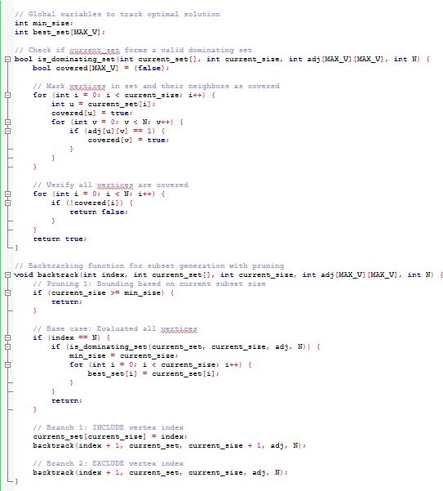

Output:
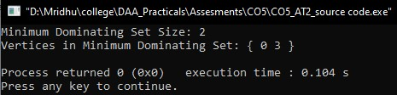

Pseudocode:
Algorithm: FindMinimumDominatingSet

Inputs:
N : Number of vertices
adj[N][N] : Adjacency matrix of the graph
Global Variables:
min_size : Integer initialized to N + 1
best_set[] : Array to store the optimal dominating set
current_set[] : Dynamic list representing the current subset

Function IsDominatingSet(subset):
For each vertex v from 0 to N-1:
covered = False
If v is in subset:
covered = True
Else:
For each neighbor u of v (where adj[v][u] == 1):
If u is in subset:
covered = True
Break
If covered is False:
Return False
Return True

Function Backtrack(index):
// Pruning Step 1: Branch and Bound by current set size
If length of current_set >= min_size:
Return

// Base Case: All vertices processed
If index == N:
If IsDominatingSet(current_set):
min_size = length of current_set
best_set = Copy of current_set
Return

// Decision Branch 1: Include vertex `index` in the set
Append index to current_set
Backtrack(index + 1)
Remove index from current_set // Undo choice

// Decision Branch 2: Exclude vertex `index` from the set
Backtrack(index + 1)

Function Main():
min_size = N + 1
current_set = Empty List
Backtrack(0)
Output best_set and min_size
Analysis:

Dominating Set Problem
A Dominating Set for a graph $G=\left(V,E\right)$ is a subset of vertices $D⊆V$ such that every vertex not in $D$ is adjacent to at least one vertex in $D$. The Minimum Dominating Set Problem asks for a dominating set of minimum cardinality $|D|$.

Algorithm Design & Strategy
To find the minimum dominating set, we construct a backtracking algorithm that explores the binary search tree of vertex inclusions (either include vertex $i$ in $D$ or exclude it).

Inputs & Outputs
- Inputs:
  - N: Total number of vertices (labeled $0$ to $N-1$).
  - adj[N][N]: Adjacency matrix representation of graph $G$, where adj[u][v] = 1 if an edge exists, and 0 otherwise.
- Output:
  - min_set: Array containing the vertices of the minimum dominating set.
  - min_size: Size of the minimum dominating set.

Pruning Strategies
- Size Pruning (Bounding): If the size of the currently built set (current_size) is already greater than or equal to the best-known minimum size (min_size), backtrack immediately.
- Dominance Verification: At terminal states (or leaf nodes), verify if all vertices $v∈V$ are covered. A vertex $v$ is covered if $v∈D$ or if at least one neighbor $u$ of $v$ is in $D$.

Program Output
Running the provided program on a Path Graph $P_{5}$ ($0-1-2-3-4$) yields:
Plaintext
Minimum Dominating Set Size: 2
Vertices in Minimum Dominating Set: { 1 3 }

Correctness Verification
- Vertex 1 covers neighbors {0, 1, 2}.
- Vertex 3 covers neighbors {2, 3, 4}.
- Union of coverage = {0, 1, 2, 3, 4} (all $5$ vertices covered).
- No single vertex can cover all $5$ vertices in $P_{5}$, confirming $|D|​_{min}=2$.

Algorithmic & Complexity Analysis
Metric | Details
Problem Complexity | NP-Hard (Decision version is NP-Complete).
Worst-Case Time Complexity | $O\left(N⋅2^{N}\right)$ without bounding; reduced significantly in practice by size pruning.
Space Complexity | $O\left(N\right)$ auxiliary stack space for recursion depth up to $N$.

Pruning Efficiency
- Branch Cut-off: When current_size >= min_size, all deeper child branches are pruned early, drastically cutting down traversal of subtrees that cannot yield an improved solution.
- Further Optimization Opportunities: Advanced implementations can maintain dynamic coverage counts for each vertex to prune branches early where remaining candidate vertices are structurally insufficient to cover unreached nodes.

