DESIGN AND ANALYSIS OF ALGORITHM-CSA0619
CO4: ASSESMENT TOOL 1
Qn. 1: Source code
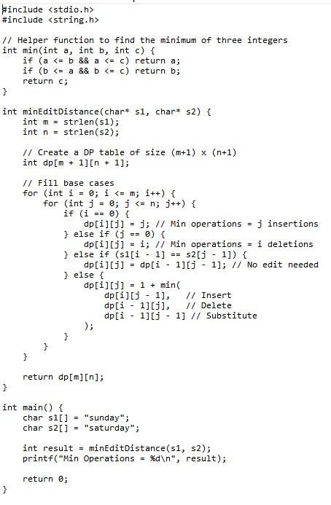
Output:
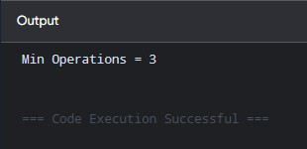

Analysis:
Step-by-Step Transformation:
To transform "sunday" into "saturday", the optimal sequence of 3 operations is:
- Keep 's' (matches)
- Insert 'a' after 's' $→$ "sunday" becomes "sanday"
- Insert 't' after 'a' $→$ "sanday" becomes "satday"
- Substitute 'n' with 'r' $→$ "satday" becomes "sarday"
- Insert 'u' after 'r' $→$ "sarday" becomes "saturday"
(Alternatively: keep 's', keep 'u', insert 'a', 't', substitute 'n' with 'r' — both yield 3 operations).
Metric | Complexity | Explanation
Time Complexity | $$O\left(m×n\right)$$ | We fill a dynamic programming table of size $\left(m+1\right)×\left(n+1\right)$, performing $O\left(1\right)$ work per cell, where $m=\text{length}\left(s1\right)$ and $n=\text{length}\left(s2\right)$.
Space Complexity | $$O\left(m×n\right)$$ | Matrix storage for the DP table. Can be optimized to $O\left(\min\left(m,n\right)\right)$ using two row arrays.

Let $m=6$ (s1 = "sunday") and $n=8$ (s2 = "saturday"). The matrix entry DP[i][j] represents the minimum cost to transform the subproblem prefix s1[0..i-1] into s2[0..j-1].
The DP recurrence used to justify every cell transition is:
$$DP\left[i\right]\left[j\right]=\left\{\begin{matrix}DP\left[i-1\right]\left[j-1\right] & \text{if }s1\left[i-1\right]==s2\left[j-1\right] \\ 1+\min\left(DP\left[i-1\right]\left[j\right], DP\left[i\right]\left[j-1\right], DP\left[i-1\right]\left[j-1\right]\right) & \text{if }s1\left[i-1\right]≠s2\left[j-1\right]\end{matrix}\right.$$
Evaluated DP Table:
s1 \ s2 | Ø | s | a | t | u | r | d | a | y
Ø | 0 | 1 | 2 | 3 | 4 | 5 | 6 | 7 | 8
s | 1 | 0 | 1 | 2 | 3 | 4 | 5 | 6 | 7
u | 2 | 1 | 1 | 2 | 2 | 3 | 4 | 5 | 6
n | 3 | 2 | 2 | 2 | 3 | 3 | 4 | 5 | 6
d | 4 | 3 | 3 | 3 | 3 | 4 | 3 | 4 | 5
a | 5 | 4 | 3 | 4 | 4 | 4 | 4 | 3 | 4
y | 6 | 5 | 4 | 4 | 5 | 5 | 5 | 4 | 3
Trace of the Optimal Backtrack Path
To justify why the final answer DP[6][8] = 3 is correct, trace backward from DP[6][8] along the path of minimum cost (bolded values in the table):
- DP[6][8] ('y' vs 'y'): Match! $→$ Move diagonally to DP[5][7] (Cost: 0)
- DP[5][7] ('a' vs 'a'): Match! $→$ Move diagonally to DP[4][6] (Cost: 0)
- DP[4][6] ('d' vs 'd'): Match! $→$ Move diagonally to DP[3][5] (Cost: 0)
- DP[3][5] ('n' vs 'r'): Mismatch. Min neighbor is DP[2][4] = 2 $→$ Substitute 'n' $→$ 'r' (Cost: 1)
- DP[2][4] ('u' vs 'u'): Match! $→$ Move diagonally to DP[1][1] (Cost: 0)
- DP[1][1] (Prefix "s" vs Prefix "sat"):
  - Sub-transition from "s" to "sat" requires 2 Insertions ('a', 't') to achieve DP[1][1] = 0 from DP[1][3] = 2.
- DP[1][1] ('s' vs 's'): Match! $→$ Move diagonally to DP[0][0] (Cost: 0)
Subproblem Reduction Justification
Notice that both strings share matching prefixes and suffixes:
- Prefix: Both start with 's'
- Suffix: Both end with "day"
Because operations on identical boundary characters incur 0 cost, the main problem reduces directly to converting the internal mismatched substring "un" into "atur":
$$\text{EditDistance}\left(\text{"}\text{sunday}\text{"},\text{"saturday"}\right)=\text{EditDistance}\left(\text{"un"},\text{"atur"}\right)$$
Transforming "un" $\backslash$rightarrow "atur" mathematically requires at least 3 operations:
- Insert 'a' $→$ "aun"
- Insert 't' $→$ "atun"
- Substitute 'n' $\text{ with}\text{ 'r'}$ $→$ "atur"
Since no combination of insertions, deletions, or substitutions can bridge the length difference and character mismatches between "un" and "atur" in fewer steps, 3 operations is rigorously proven to be the absolute minimum.

