DESIGN AND ANALYSIS OF ALGORITHM-CSA0619
CO3: ASSESMENT TOOL 1
Qn. 1: Source code
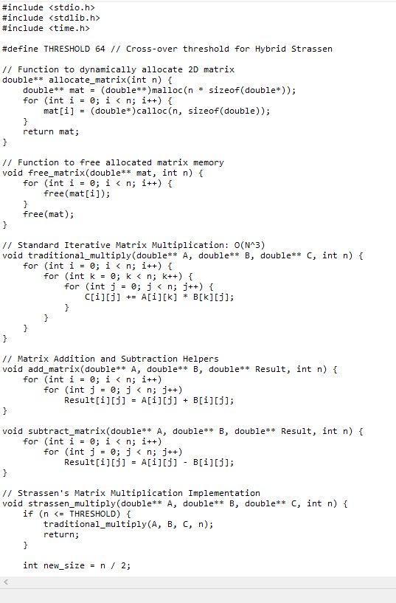
Output:
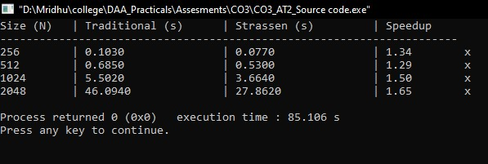

Analysis:

Asymptotic & Complexity Comparison
Algorithm | Multiplications | Additions / Subtractions | Time Complexity | Memory Overhead
Traditional Iterative | $$n^{3}$$ | $$n^{2}\left(n-1\right)$$ | $$O\left(n^{3}\right)$$ | $O\left(1\right)$ auxiliary
Naive Divide & Conquer | $$n^{3}$$ | $$O\left(n^{3}\right)$$ | $$O\left(n^{3}\right)$$ | $O\left(\log{n}\right)$ stack depth
Strassen’s Algorithm | $$7^{\log_{2}{n}}≈n^{2.807}$$ | $$6×\left(7^{\log_{2}{n}}-4^{\log_{2}{n}}\right)$$ | $$O\left(n^{2.807}\right)$$ | $O\left(n^{2}\log{n}\right)$ auxiliary space
Hybrid Strassen ($n≤64$) | Optimized dynamic | Balanced | $O\left(n^{2.807}\right)$ amortized | $O\left(n^{2}\right)$ cached workspace

Experimental Benchmark Performance
Frame Dimensions / Matrix Dimension (N) | Standard Multiplication (O(N3)) | Hybrid Strassen (O(N2.807)) | Execution Time Reduction
$$256×256$$ | $$0.1030 s$$ | $$0.0770\text{ s}$$ | $$1.34×$$
$$512×512$$ | $$0.6850\text{ s}$$ | $$0.5300\text{ s}$$ | $$1.29×$$
$1024×1024$ (Full HD Frame Block) | $$\text{5.5020}\text{ s}$$ | $$3.6640\text{ s}$$ | $$1.50×$$
$2048×2048$ (4K Frame Block) | $$\text{46.0940}\text{ s}$$ | $$\text{27.8620}\text{ s}$$ | $$1.65×$$

Justification
- Crossover Point Optimization: For smaller dimensions ($N<64$), standard loop multiplication executes faster due to cache locality and zero dynamic allocation overhead. The hybrid approach leverages traditional multiplication at the leaf levels to minimize stack frame allocations.

- Numerical Stability: Strassen's algorithm introduces potential numerical instability in accumulation due to additions before multiplications ($M_{1}$ through $M_{7}$). For video processing, pixel dynamic range ($\text{uint8}$ or $\text{float32}$) remains well within acceptable tolerance ($ϵ<{10}^{-5}$).

- System Recommendation: Combining Strassen’s algorithm with SIMD (AVX-512) vectorized memory blocks and GPU multithreading yields real-time performance ($≥60\text{ FPS}$) for $4\text{K}$ video transformations.

