Photon Docs

1. Regions

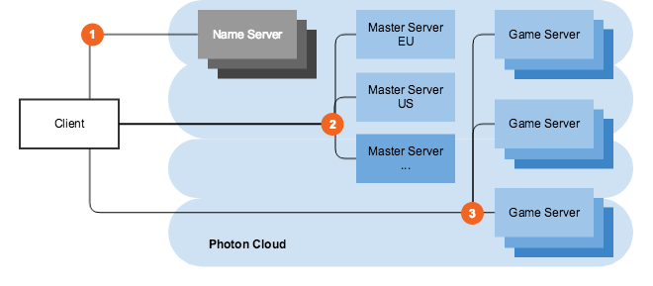

The initial connection of clients goes to a Photon Name Server, which provides the list of available regions.

Each region is completely separate from the others and consists of a Master Server (for matchmaking) and Game Servers (hosting rooms).

1. C# Realtime API

When clients tries to connect to photon server it first fetches the list of available regions from the NameServer, these are up to date regions but if we already have our best-region selected then we will use that.

If not then we ping the servers and select the one with lowest latency.

Without results from a previous session, all regions will be pinged, which takes a moment longer. If a previous result is available, the client will check:

a. if the region list changed (covers the case if the "previous best region" is still available)  
b. if the ping is no longer acceptable (>= 1.5x slower than previously saved reference value)

If either applies, all regions are pinged and a new result gets picked.

1. PUN

“Best Region” is selected by default by using PhotonNetwork.ConnectUsingSettings()

When we select the “best region” its result is automatically stored in player prefrences. So on subsequent start photon pings the same region again.

1. Best Region Considerations

"Best Region" option is not deterministic. Sometimes it may be "random" due to little variations or exact same ping calculations.

1. have the same exact ping to multiple regions from the same device. So its random, if you end up with different regions on clients connected to the same network.
2. different ping values for the same region on different devices (or different retries on the same device) connected to the same network.
3. Development Region(PUN v2.17)

To avoid matchmaking errors during build stage we have “dev region”. "Development build" is enabled automatically when the PhotonServerSettings gets created and the "Dev Region" is set during the first run (PlayMode) in Unity Editor.

***“Remove the Dev Region”***

The "Dev Region" is only used in Unity Editor and in "Development" builds, when you use PhotonNetwork.ConnectUsingSettings() to connect. You can also disable the "Dev Region" in Unity Editor and "Development Build" by simply deleting the value.

You will notice that "Development Build" is enabled now from Build Settings and should remain this way during the development period. This way, all clients (Unity Editor and builds) will connect to the same "Dev Region".

1. Available Regions

If we want to connect to the specific region we can use PhotonNetwork.ConnectToRegion to connect. We need to specify the “region tokens”. you need to configure the networking client manually (mainly AppId and AppVersion) as PhotonServerSettings will not be used in this case.