**ASSIGNMENT 1**

Complete the following steps for implementing a CICD Pipeline

1. Create a Maven Project for a Calculator in Java

2. Push it in GitHub Repo.

3. Create a Jenkins Job to Make a Build of It using Maven.

4. Create a Docker Image for the build.

5. Push the Docker Image on DockerHub.

6. Pull the image

7. Create Docker Container

8. Run your application using Container.

**Calculator Java Project**

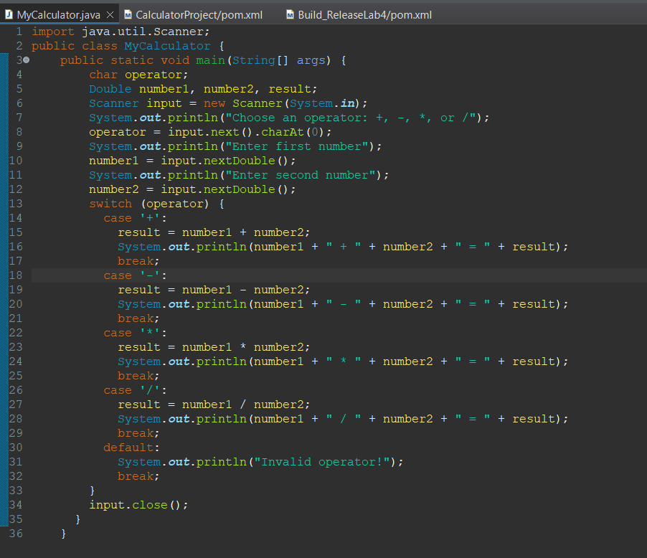

**POM File**

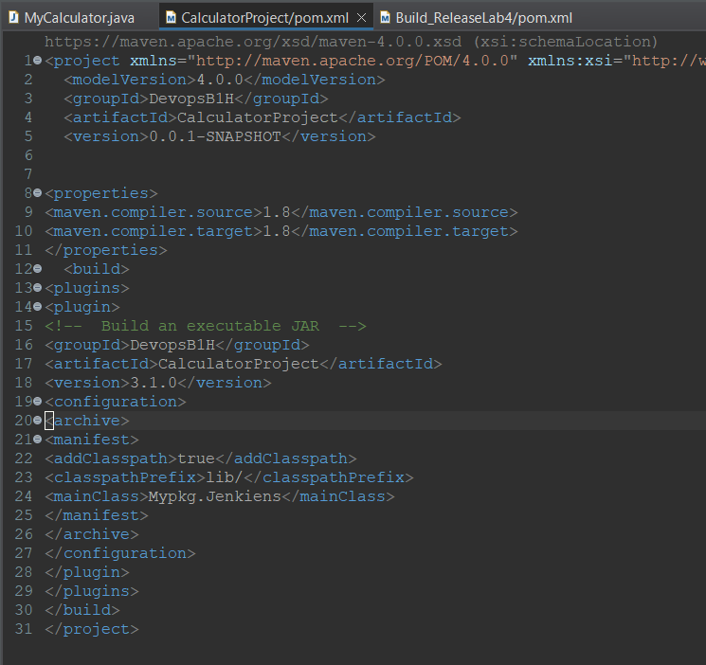

**Push It on Git Hub**

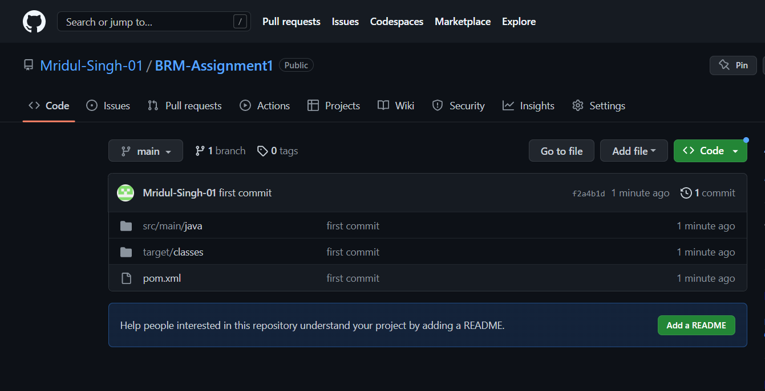

**With the help of Jenkins make the build**

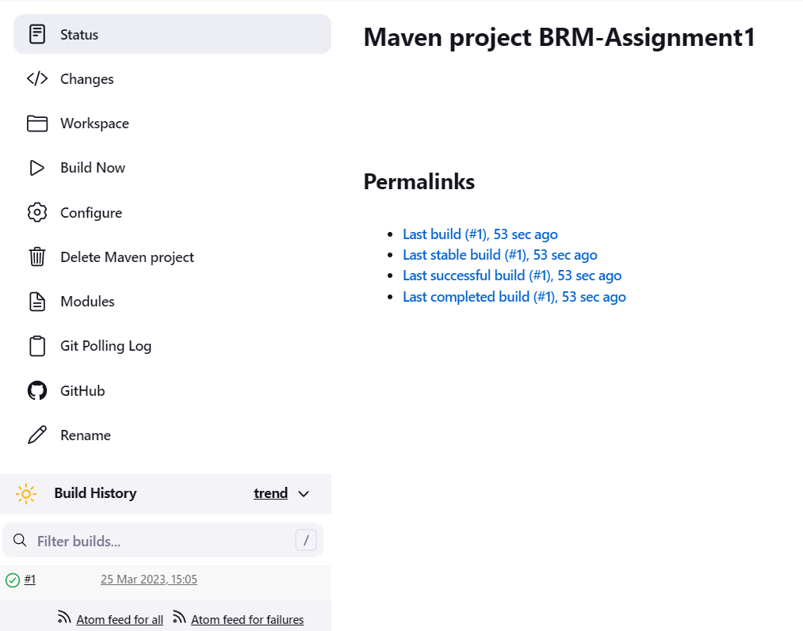

**Jar file is created**

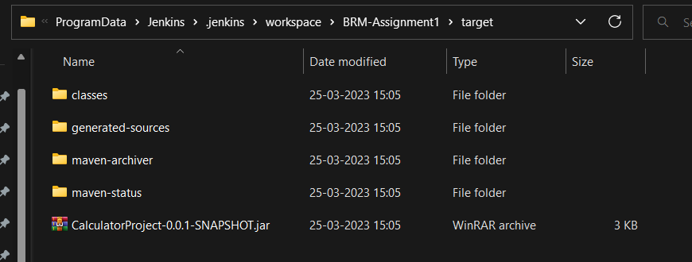

**Make Docker Image**

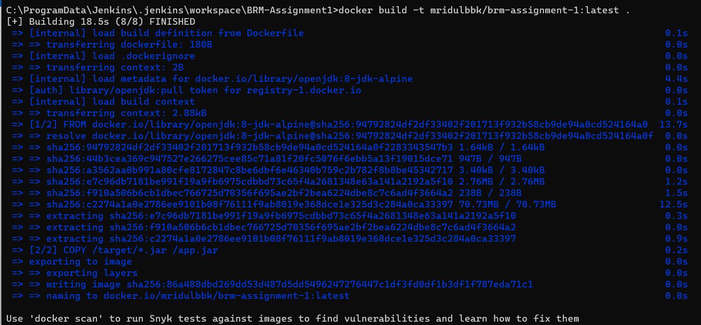

**Push docker image to DockerHub and then pull image and run it.**

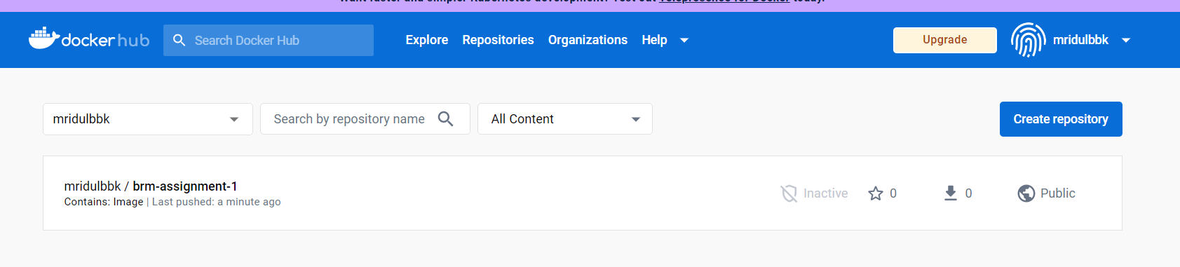

**Pull Docker image and run it using container .**

