**School of Computer Science**

**UNIVERSITY OF PETROLEUM AND ENERGY STUDIES**

**DEHRADUN, UTTARAKHAND**



**Development Automation and Linux**

**Lab Assignment – 1**

**Submitted by: Mridul Singh**

**SAP ID: 500094181**

**Roll No. R2142210501**

**Batch: B1(H) Devops**

Objective: Write a shell script to implement a command line snakes and ladder game of one player. There is a board of size NxN and an unbiased dice (numbered 1 to 6). Take N=10 in your program, so there are total of 100 cells numbered from 1 to 100. At the start of the game, you are standing at position 0 and the position is updated gradually as you play the dice. There are some snakes and ladders (both greater than or equal to 5) residing on different cells. If after the play of a dice in a single move, you land up on a snake your current position will fall depending upon the snake’s tail position. Similarly, if after the play of a dice in a single move, you land up on a ladder, your current position will rise depending upon the ladder’s head position. If your next position is on a cell which do not contain either a snake or a ladder, then you will simply update the new position. Your game will end when you reach the 100th cell, where you will win the game and the program ends.

CODE:

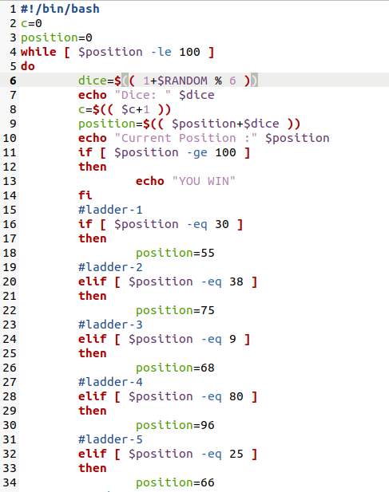

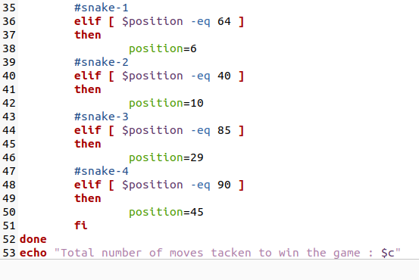

**OUTPUT:**

