**Development Automation and Linux Lab**

**Experiment No. 2**

1. Write a script to enter marks by user in the terminal. If the entered mark is greater than 35 then output pass, otherwise output fail.

**Output:**

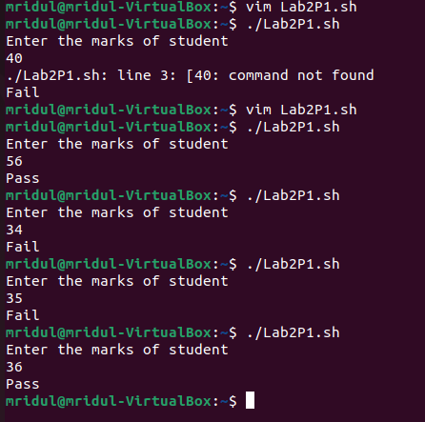

**Code:**

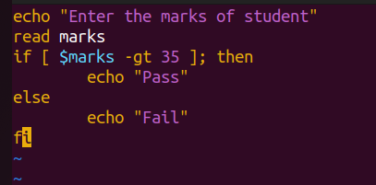

2. Write a script to enter marks by user in the terminal. If marks are greater than 80output distinction, if marks between 60 and 80 then output first division. If marks are less than 60 and greater than or equal to 35 then output pass, otherwise output fail.

**OUTPUT:**

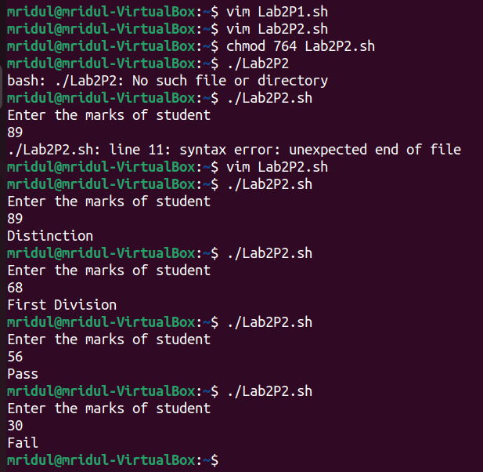

**CODE:**

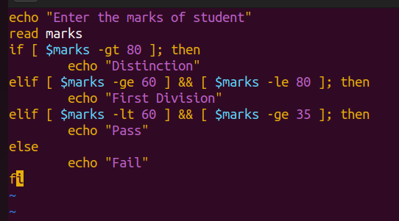

3. Write a script to print numbers from 1 to 10 using while loop.

**OUTPUT:**

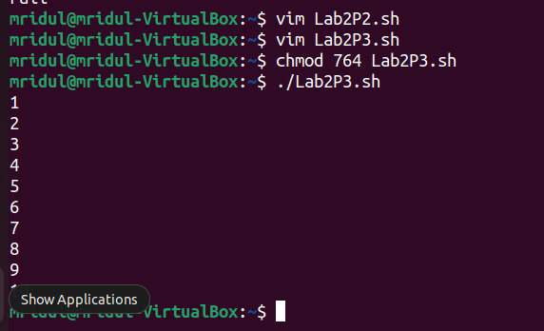

**CODE:**

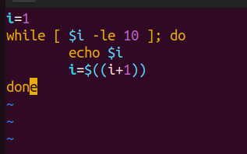

4. Write a script to find the average of first N natural numbers, where N is entered by the user at the terminal.

**OUTPUT:**

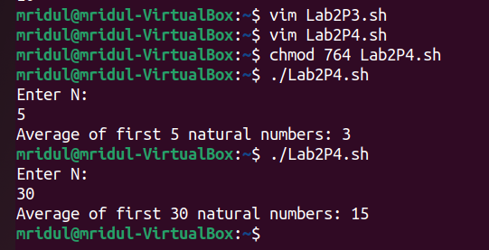

**CODE:**

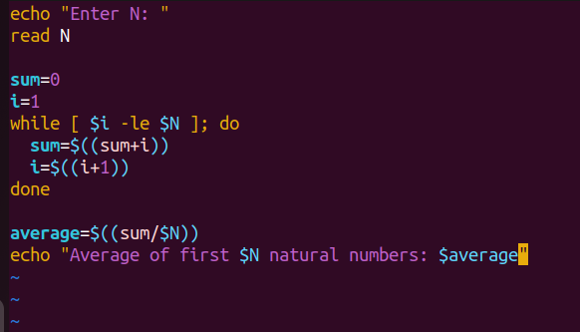

5. Write a script to find the average of N numbers of an array (of size N). The values of the array are entered by the user at the terminal. (Use while loop)

**OUTPUT:**

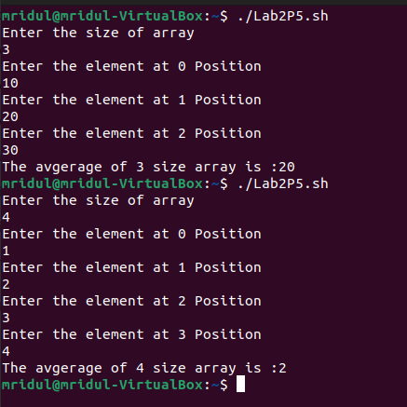

**CODE**

