Development Automation and Linux

LAB 3

1. Write a shell script to fetch two command line arguments (Integers) and then add them and display the result.

Output:

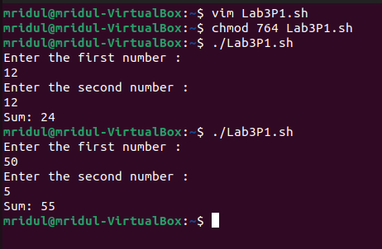

Code:

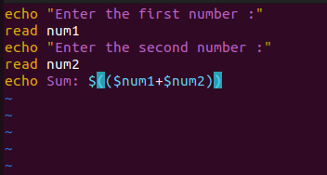

1. Write a shell script to implement a menu driven calculator with basic functionalities of addition, subtraction, division and multiplication. Your script will read two number from users and an operation and display the result

OUTPUT:

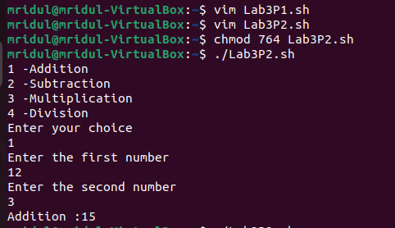

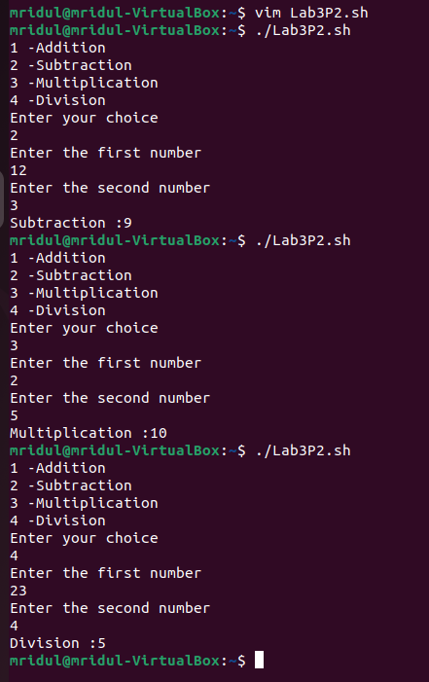

Code:

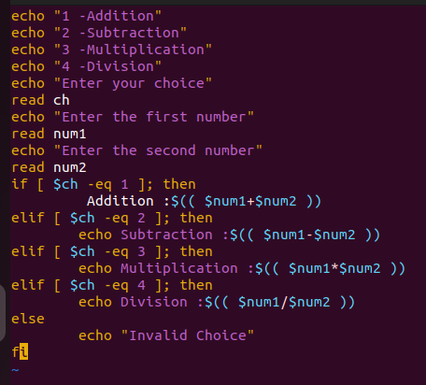

1. Write a shell script that prints all the ordinary files in the current working directory.

OUTPUT:

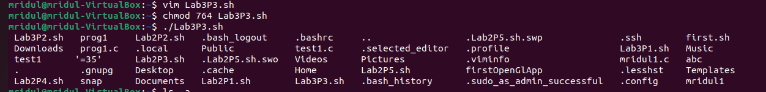

1. Write a shell script that takes a command line argument (the argument entered by the user is the absolute path of any file, directory etc.) and reports on whether it is a directory, a file, or something else.

OUTPUT:

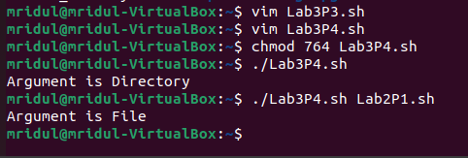

CODE:

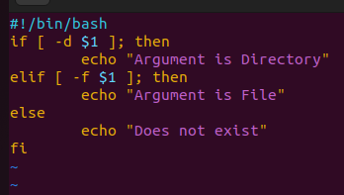

1. Write a shell script to compute factorial of a number entered by the user

OUTPUT:

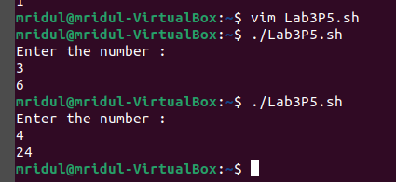

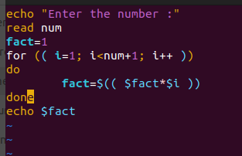

6. Write a shell script to generate Fibonacci series for a positive integer N which is entered by the user.

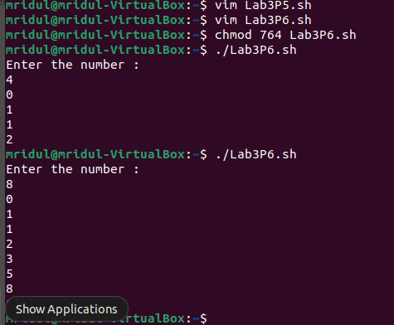

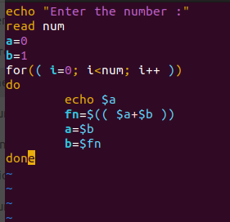

7. Write a shell script to print the value of nCk (read as n choose k), where n and k are entered by the user in the terminal. For example 5C2 is 10 and 10C3 is 120.

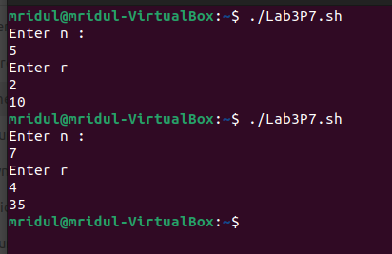

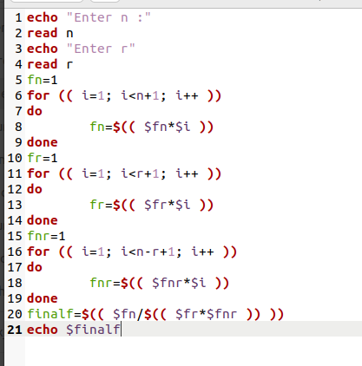

8. Write a shell script to find out the total instances of “the” in a given file.

