**Experiment No 4**

**Functions in Shell Scripting**

1. Write a function to fetch two command line arguments (Integers) and then add them and display the result.

CODE:

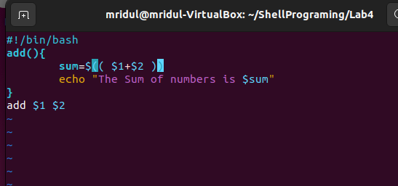

OUTPUT: ((Error is coming))

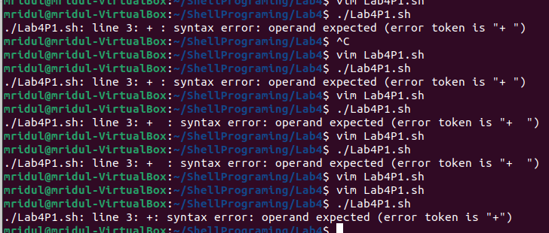

1. Write a function to input a three-digit number from the user and check if the number is even or odd. If the number is even then return the sum of the digits of the number, otherwise return the product of the digits of the given number.

CODE:

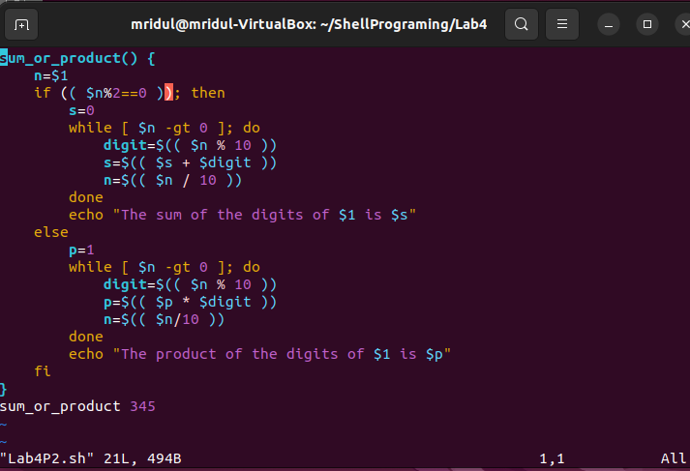

OUTPUT:

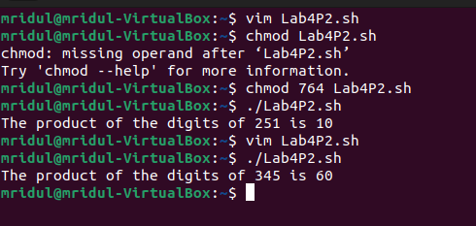

1. Write a function to compute the factorial of a given number N which is input by the user from the terminal

CODE:

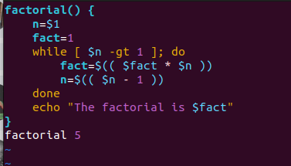

OUTPUT:

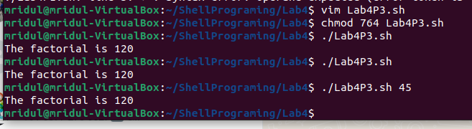

1. Write a function to read the number of lines of a given text file (starting from line 1) as specified by the user. For example, if there is a file demo.txt, and user specifies that he needs first 7 lines of the text then display first 7 lines of demo.txt. Similarly, if the user specifies last 10 lines, then first 10 lines of demo.txt should be printed on the terminal.

OUTPUT:

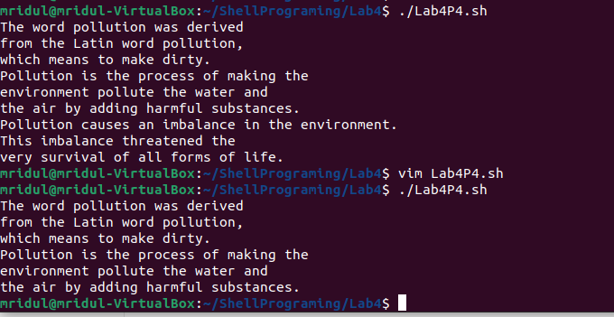

CODE:

