**Experiment – 6**

1. Write a shell script to search and replace a given text input by the user with a new text across multiple files.

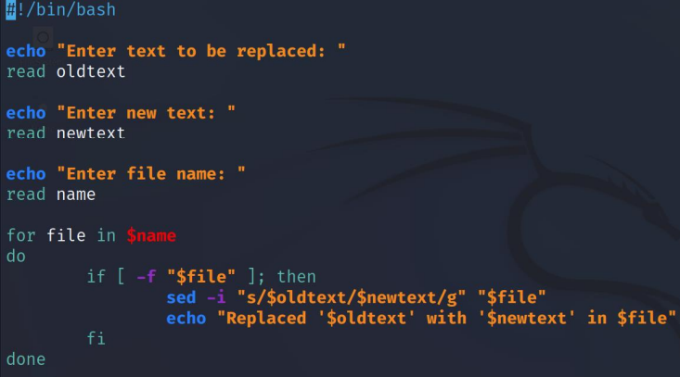

1. Write a shell script to check whether the given input is a valid Alphanumeric character.

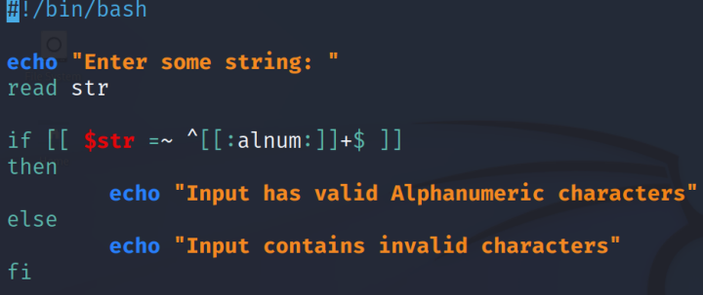

Output

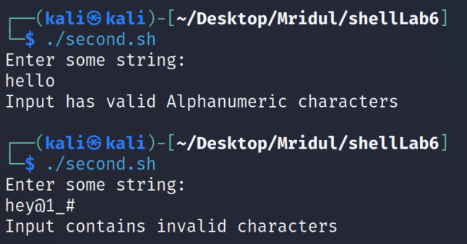

1. Write a shell script to transform the given input text to lowercase, uppercase and first letter uppercase.

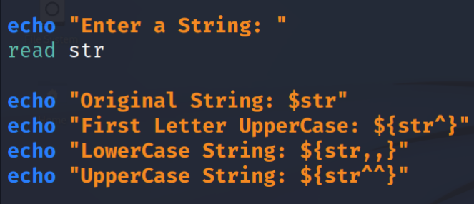

OUTPUT:

