**Experiment No 7**

**Working with Make and Make file**

1. Write a C program for calculator with basic functionality subtraction, addition, division and multiplication. Each functionality (addition, subtraction, etc.,) should be written in separate source files along with a single main source file. Use make utility to create an executable file for the calculator.

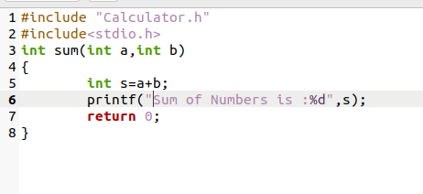

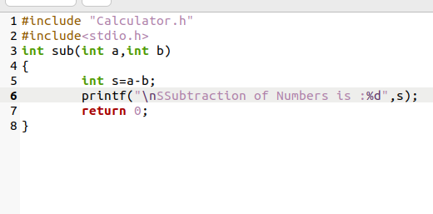

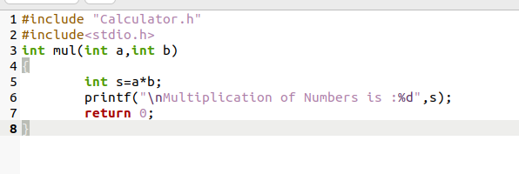

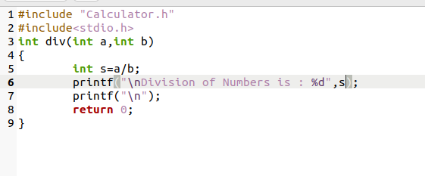

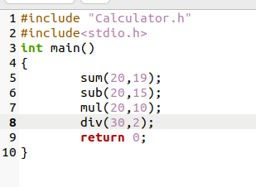

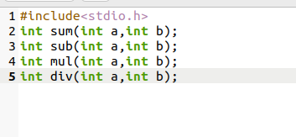

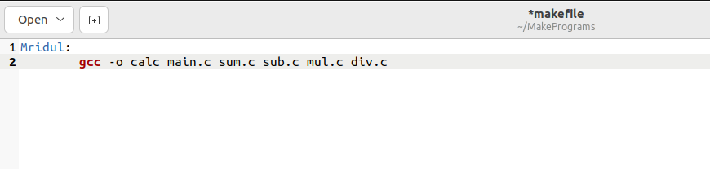

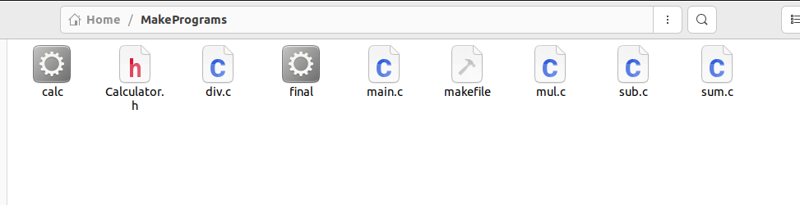

Output:

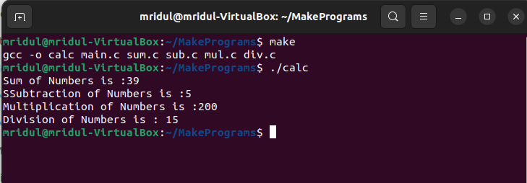

1. In the above program include two additional features for computing power and modulus of given numbers in the calculator program. Use Make utility to automatically build the second version of the calculator with additional features included in it.

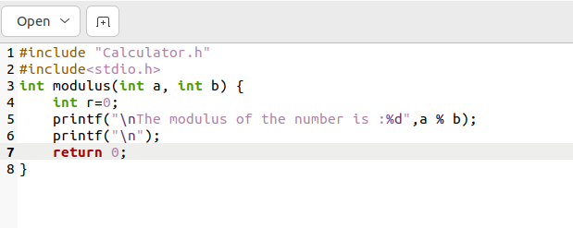

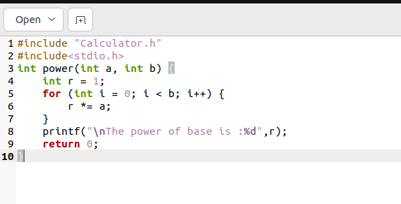

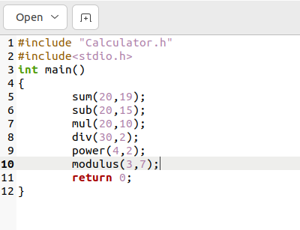

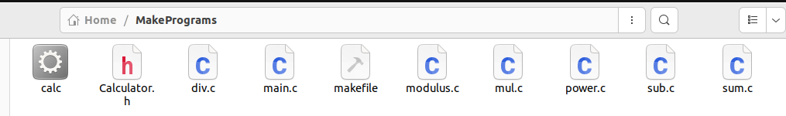

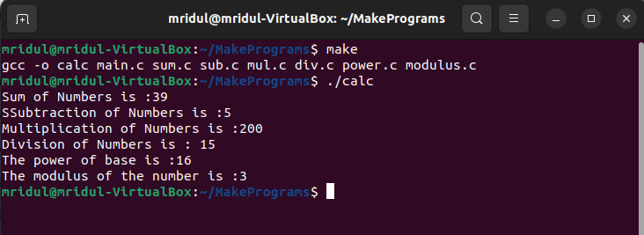

1. Write Make file in above program using the best practices (You may take help of the Lab manual given by Xebia)

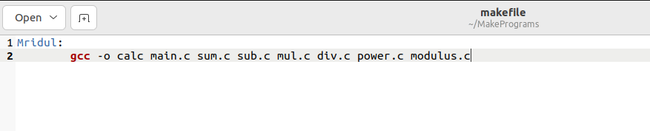

1. Use make utility to archive the log files and move it to some other location.

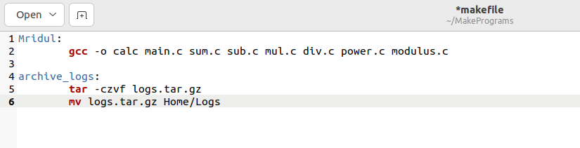

1. Demonstrate the usage of conditional statements in a Make file for a simple C/shell script program.
2. a=10
3. b=20
5. #Check whether they are equal
6. **if** [ $a == $b ]
7. then
8. echo "a is equal to b"
9. fi
11. #Check whether they are not equal
12. **if** [ $a != $b ]
13. then
14. echo "a is not equal to b"
15. fi