**Lab Experiment 8**

**File System Commands and Directory**

* **More**

As 'cat' command displays the file content. Same way 'more' command also displays the content of a file. Only difference is that, in case of larger files, 'cat' command output will scroll off your screen while 'more' command displays output one screenful at a time.

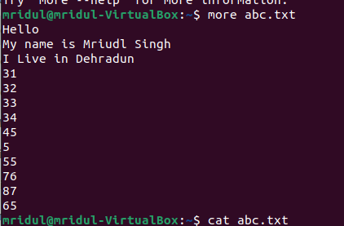

* **/boot directory**

**The boot directory contains everything required for the boot process.**

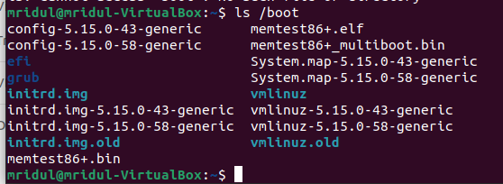

* **/etc directory**

**It contains all the system related configuration files.**

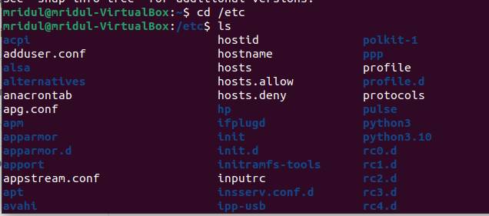

* **The /srv, /sys and /tmp directories**

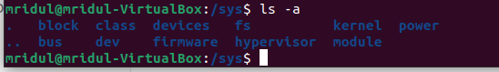

* **The /var directory**

The /var (short for variable data) hierarchy contains files to which the system writes data during the course of its operation.

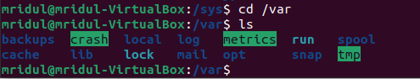

* **Ls -l**

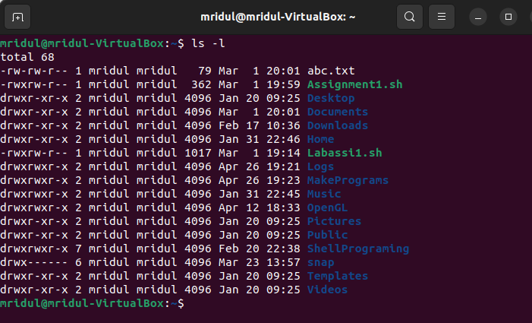

**Add a user**

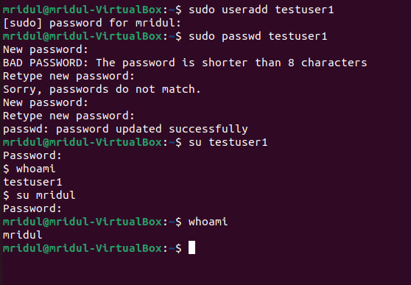

**Delete User**

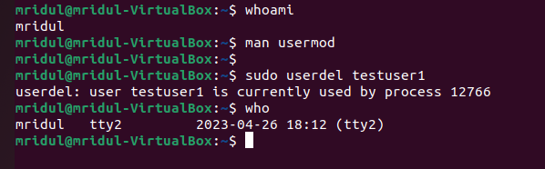

**Add Group**

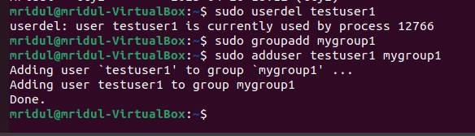

**Delete user from group**

