**Experiment 9**

**Networking Commands**

Hostname

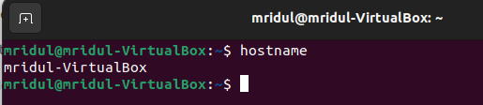

Ifconfig

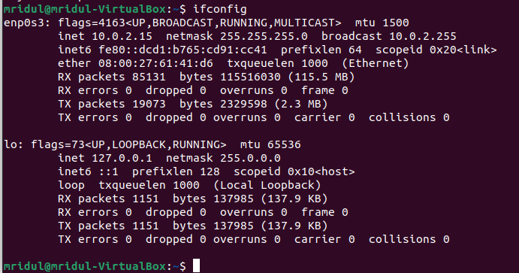

ARP

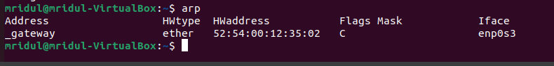

Route

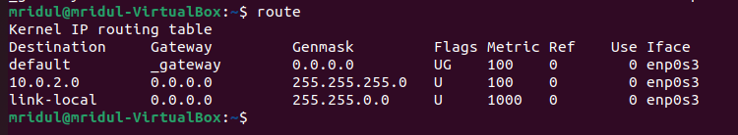

IP

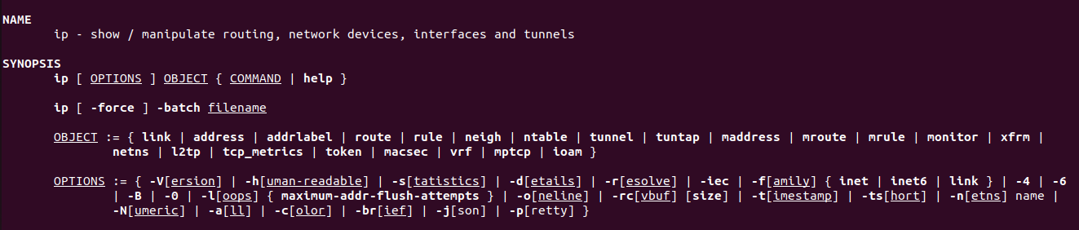

SS

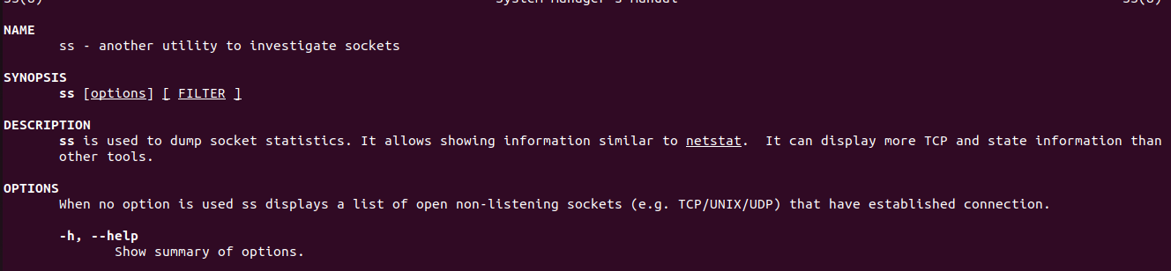

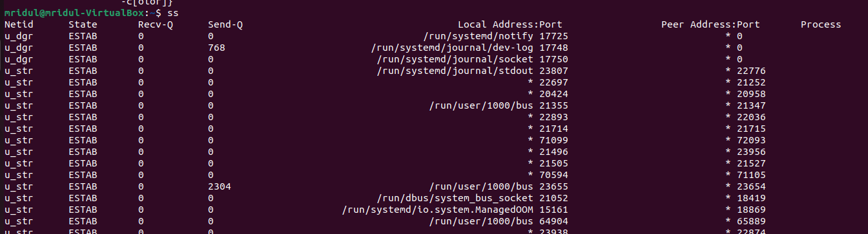

Nmcli

