# Data Communication & Computer Networks

# Lab-1

# Bus Topology

# Every computer and network device in a bus topology network is linked to a single cable. It has two directions. It is a multiple-point connection and a non-robust topology since the topology crashes if the backbone fails.

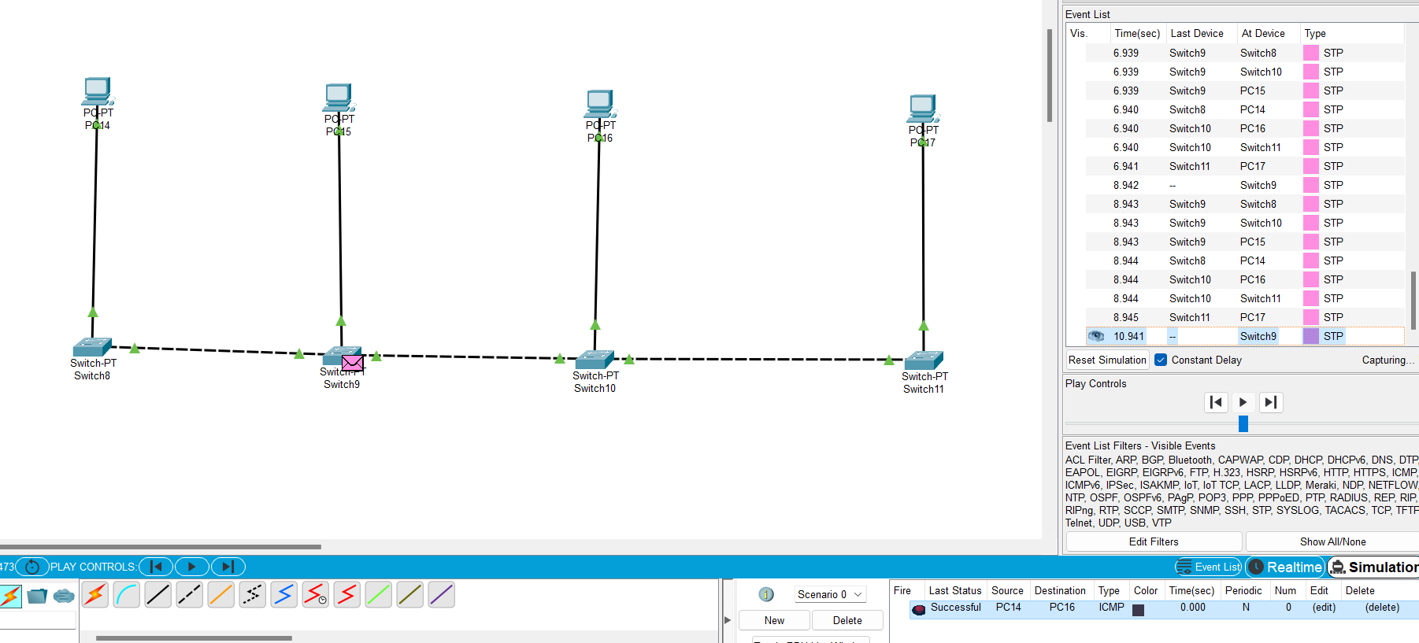

Star Topology

In a star topology, a cable connects each device to a single hub. All other nodes are connected to this hub, which serves as the core node. The hub may have a passive character, meaning that it is not intelligent, like broadcasting devices, but it may also be intelligent and known as an active hub.

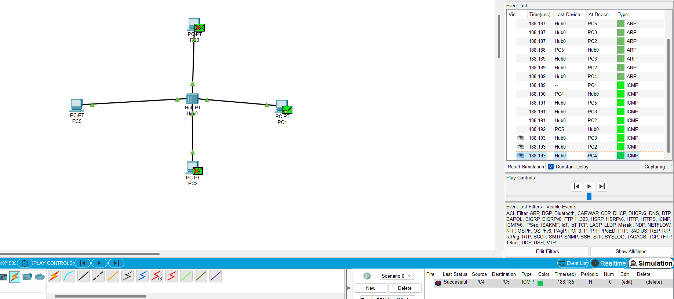

Mesh Topology

Every device in a mesh topology is linked to every other device over a specific channel. Ad Hoc Configuration Protocols (AHCP), Dynamic Host Configuration Protocol (DHCP), and other protocols are utilised in Mesh Topology.

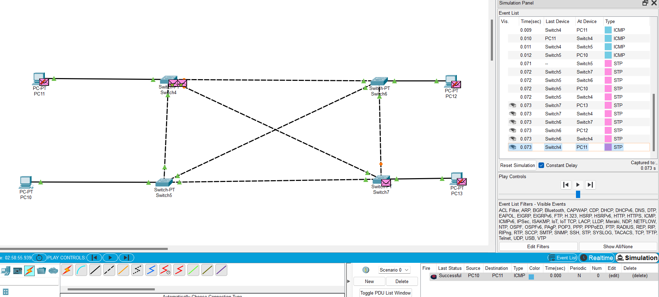

Ring Topology

It creates a ring connecting devices in this topology that have exactly two neighbouring devices.

With a large number of nodes, a ring topology requires a number of repeaters because, in order to convey data to the last node in a ring topology with 100 nodes, the data must first go via 99 nodes. Therefore, repeaters are utilised in the network to prevent data loss.

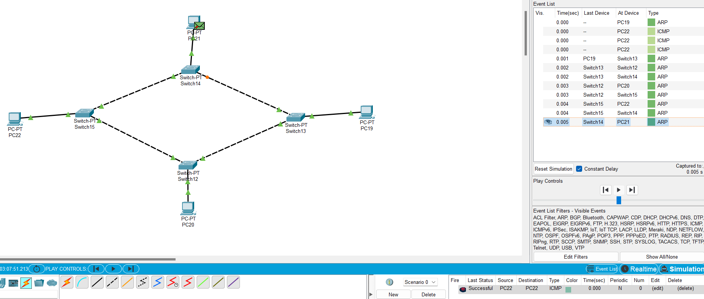

Hybrid Topology

A hybrid topology is a kind of network topology that is a combination of two or more network topologies, such as mesh topology, bus topology, and ring topology.

A network topology known as a hybrid topology employs two or more different network topologies. Bus topology, mesh topology, ring topology, star topology, and tree topology are some possible combinations of these topologies.

