Data Communication and Computer Networks Lab-8

**DHCP- Dynamic Host Configuration Protocol.**

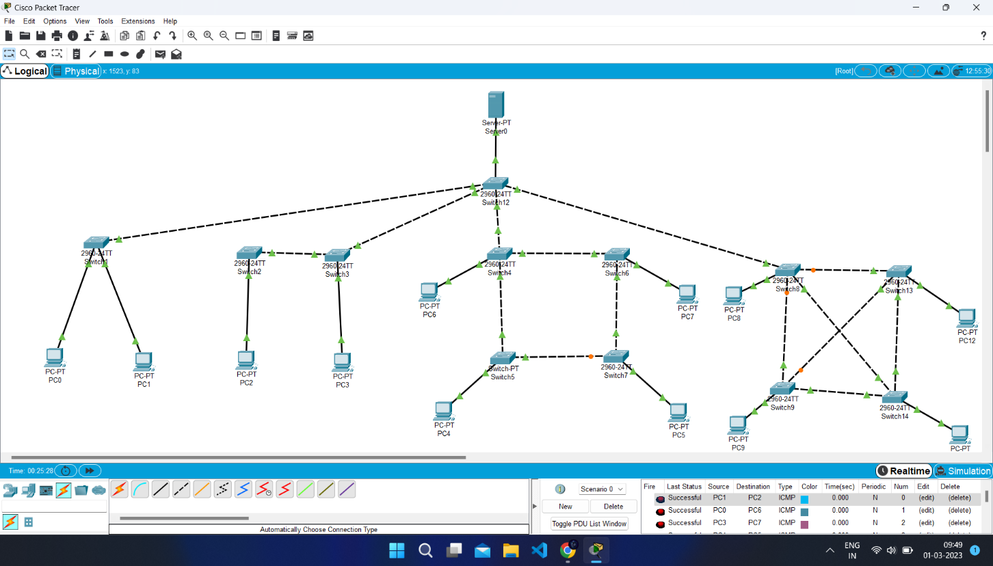

Bit Stuffing Program

