Software Requirements
Specification
for

CivicSync

Version 1.0 approved

Prepared by Mrityunjay Pandey

Idea Troopers

03/09/2025

Table of Contents
Table of Contents ii
Revision History ii
- Introduction 1
  - Purpose 1
  - Document Conventions 1
  - Intended Audience and Reading Suggestions 1
  - Product Scope 1
  - References 1
- Overall Description 2
  - Product Perspective 2
  - Product Functions 2
  - User Classes and Characteristics 2
  - Operating Environment 2
  - Design and Implementation Constraints 2
  - User Documentation 2
  - Assumptions and Dependencies 3
- External Interface Requirements 3
  - User Interfaces 3
  - Hardware Interfaces 3
  - Software Interfaces 3
  - Communications Interfaces 3
- System Features 4
  - System Feature 1 4
  - System Feature 2 (and so on) 4
- Other Nonfunctional Requirements 4
  - Performance Requirements 4
  - Safety Requirements 5
  - Security Requirements 5
  - Software Quality Attributes 5
  - Business Rules 5
- Other Requirements 5
Appendix A: Glossary 5
Appendix B: Analysis Models 5
Appendix C: To Be Determined List 6

Revision History

Name | Date | Reason For Changes | Version

Introduction

Purpose
The purpose of this Software Requirements Specification (SRS) document is to define the functional and non-functional requirements of CivicSync – Crowdsourced Civic Issue Reporting and Resolution System (Version 1.0). CivicSync is designed to provide citizens with a unified platform to report civic issues such as potholes, malfunctioning streetlights, overflowing garbage bins, or other public infrastructure concerns.
This document specifies the requirements for the first release of the system, which will include a mobile application for citizens, a web-based dashboard for municipal staff, and a backend API for handling reports, authentication, and notifications. The scope of this SRS is limited to the core features necessary to demonstrate a working Minimum Viable Product (MVP) during the Smart India Hackathon 2025, while also laying the foundation for future enhancements such as AI-powered issue categorization, predictive analytics, and gamification for citizen engagement.
The primary audience of this document includes:
- Development Team – for implementation and testing.
- Municipal and Administrative Stakeholders – for validation of requirements.
- Hackathon Mentors and Jury – to evaluate feasibility, scalability, and innovation.
By clearly defining the purpose and scope, this SRS ensures that all stakeholders share a common understanding of the goals, constraints, and expectations of CivicSync.

Document Conventions
CivicSync is a crowdsourced civic issue reporting and resolution system that bridges the communication gap between citizens and local government bodies. The system empowers community members to report real-world civic issues with photos, location data, and descriptions, while providing municipal staff with a centralized dashboard to monitor, prioritize, and resolve these issues efficiently.
The scope of this system covers the following components:
- Citizen Mobile/Web Application – allows users to report issues, track their status, and receive notifications of progress or resolution.
- Backend Services – provide APIs for handling user authentication, issue submission, status updates, and email notifications.
- Administrative Dashboard – enables municipal staff to view reported issues, filter by type or location, assign tasks, update statuses, and generate reports.
- Notification Module – uses Gmail SMTP to notify users when their reports are acknowledged, updated, or resolved.
Key objectives of CivicSync:
- Transparency – Citizens can track the progress of their reports in real time.
- Efficiency – Automated routing and categorization reduce manual delays.
- Engagement – Increases citizen participation in improving community well-being.
- Scalability – Designed to support multiple cities and departments with minimal modification.
- Future-readiness – Provides a base for advanced features like AI-based issue detection, WhatsApp/IVR integration, and gamification.
This SRS document defines the requirements for the first functional release of CivicSync. While advanced features are envisioned as part of the long-term roadmap, this release focuses on delivering a robust MVP that demonstrates end-to-end functionality.

Intended Audience and Reading Suggestions
This SRS document is intended for multiple stakeholders involved in the development, evaluation, and use of CivicSync. Each type of reader will focus on specific sections of the document depending on their role:
- Developers & Designers – will use the detailed functional and non-functional requirements (Section 3 and Section 5) as the basis for implementation and design decisions.
- Project Managers / Team Leads – will focus on the overall scope (Section 1.2), assumptions and constraints (Section 2.5), and requirement prioritization to plan resources, timelines, and deliverables.
- Testers & Quality Assurance Engineers – will refer to the functional requirements (Section 3), external interfaces (Section 4), and use cases (Section 6) to create test plans and validation strategies.
- End Users (Citizens and Municipal Staff) – may review the product scope (Section 1.2) and system features (Section 3) to understand the system’s capabilities and intended benefits.
- Documentation Writers – will use the definitions (Section 1.4), functional requirements (Section 3), and use cases (Section 6) to prepare user manuals, FAQs, and training materials.
- SIH Mentors and Jury – will primarily review the introduction (Section 1), product perspective (Section 2.1), innovation and uniqueness (Section 7), and overall system requirements to assess feasibility and impact.
Reading Suggestions
- All readers should begin with the Introduction (Section 1) to understand the purpose, scope, and conventions of the document.
- Section 2 (Overall Description) provides context, product perspective, and user classes, which is useful for stakeholders and evaluators.
- Section 3 (System Features) and Section 5 (System Requirements) are critical for developers, testers, and managers.
- Section 4 (External Interfaces) is relevant for integration and technical teams.
- Section 6 (Use Cases) is highly recommended for both developers and testers.
- Section 7 (Other Requirements/Future Enhancements) should be read by stakeholders to understand long-term vision.
This structured approach ensures that each stakeholder can focus on the sections most relevant to their role, while still maintaining a shared understanding of the system as a whole.

Product Scope
CivicSync is a crowdsourced civic issue reporting and resolution platform that enables citizens to report problems in their communities (such as potholes, broken streetlights, overflowing garbage bins, or water supply issues) and empowers municipal authorities to manage and resolve these issues efficiently. The system integrates a mobile/web application for citizens, a web-based dashboard for municipal staff, and a backend service that ensures secure data handling, real-time updates, and transparent communication.
The primary purpose of CivicSync is to improve the responsiveness of local governance by reducing delays, enhancing accountability, and creating a transparent, two-way communication channel between citizens and authorities.

Key Benefits:
- For Citizens: Provides a simple, accessible way to submit and track issues in real time, improving civic engagement and trust in governance.
- For Municipal Authorities: Offers a centralized platform to view, categorize, and resolve issues with clear prioritization, reducing administrative overhead and improving service delivery.
- For Policy Makers: Generates data-driven insights and analytics that support planning, budgeting, and long-term infrastructure improvement.

Objectives and Goals:
- Provide an easy-to-use mobile and web application for reporting civic issues with photo, description, and location details.
- Enable real-time tracking and transparency of reported issues.
- Provide a dashboard for administrators to categorize, assign, and resolve issues efficiently.
- Ensure secure authentication (JWT) and communication (SMTP-based notifications).
- Reduce operational inefficiencies through automation and digital record-keeping.
- Support scalability for adoption by multiple municipalities, cities, and state governments.

Alignment with Organizational Goals:
This project aligns with the broader Digital India and Smart City Mission initiatives by:
- Leveraging technology to promote citizen participation in governance.
- Encouraging data-driven decision-making for urban development.
- Reducing paperwork, improving transparency, and ensuring accountability.
In the long term, CivicSync supports the Government’s strategy of digital transformation in civic administration and contributes to cleaner, greener, and more citizen-friendly cities.

References
The following documents, websites, and standards have been referred to while preparing this SRS for CivicSync – Crowdsourced Civic Issue Reporting and Resolution System:
- IEEE Std 830-1998 – IEEE Recommended Practice for Software Requirements Specifications.
  - Author: IEEE Computer Society
  - Published: 1998
  - Source: IEEE Standards Association
- Smart India Hackathon 2025 Problem Statement – PS ID: 25031
  - Title: Crowdsourced Civic Issue Reporting and Resolution System
  - Organization: Government of Jharkhand, Department of Higher and Technical Education
  - Year: 2025
  - Source: SIH Official Portal
- Digital India Programme – Initiative of the Government of India
  - Year: 2015 (and ongoing updates)
  - Source: https://digitalindia.gov.in
- Smart Cities Mission – Ministry of Housing and Urban Affairs, Government of India
  - Year: 2015 (and ongoing updates)
  - Source: https://smartcities.gov.in
- FixMyStreet – Example of an existing civic issue reporting platform
  - Organization: mySociety
  - Source: https://www.fixmystreet.com
- Municipal Civic Engagement Applications – A Comparative Study
  - Author: P. Kumar & R. Gupta
  - Journal: International Journal of E-Governance
  - Year: 2022
  - Source: Google Scholar

Overall Description

Product Perspective
CivicSync is a new, self-contained product designed to address gaps in the existing civic grievance reporting and resolution mechanisms in India. While some systems such as helpline numbers (e.g., 112), municipal websites, and city-specific mobile apps exist, they often suffer from limited adoption, fragmented data management, lack of transparency, and absence of real-time tracking.
CivicSync integrates multiple functionalities into a single unified platform that connects citizens and municipal authorities seamlessly. Unlike traditional helplines that focus on emergency response, CivicSync focuses on day-to-day civic issues such as potholes, streetlight failures, garbage management, and sanitation, making it complementary rather than a replacement for existing emergency systems.
This product will function as:
- Mobile/Web App for Citizens → to report issues (photo, description, location).
- Backend Services (API) → for authentication, data storage, and routing of issues.
- Admin Dashboard → for municipal staff to view, filter, categorize, assign, and resolve issues.

Relationship with Larger Systems
- CivicSync can integrate with existing municipal ERP and Smart City systems through APIs, providing additional channels for data entry and analysis.
- It complements national initiatives such as Digital India and Smart Cities Mission by promoting participatory governance.
- It reduces duplication of effort by acting as a centralized hub for citizen issue tracking instead of multiple scattered systems.

High-Level System Components
- Citizen Application (Mobile/Web)
  - Input: Civic issue details (photo, location, description).
  - Output: Acknowledgment, status tracking, email/SMS notifications.
- Backend (Node.js + Express + MongoDB)
  - Handles authentication, issue storage, report routing, and notifications.
- Admin Dashboard (Web)
  - Provides tools for filtering issues, assigning tasks, and updating statuses.
  - Generates analytics for reporting trends and performance monitoring.
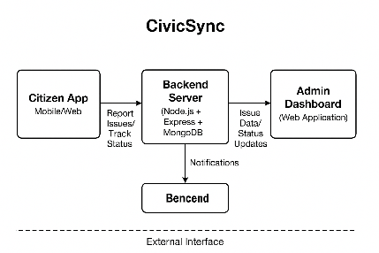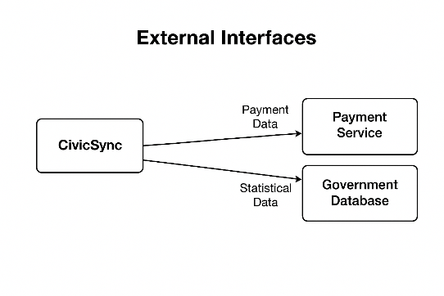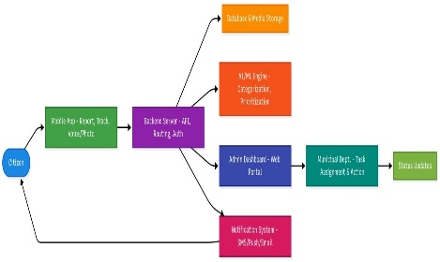
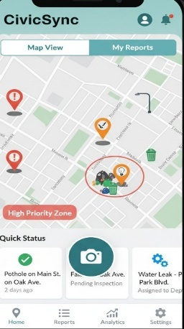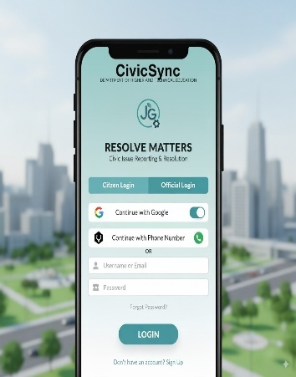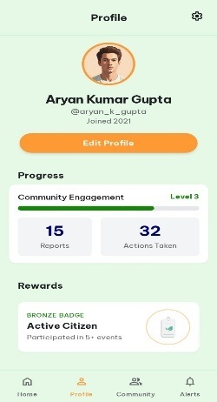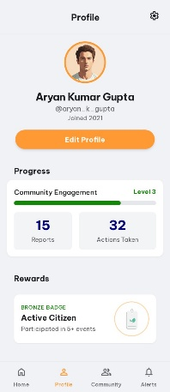

Product Functions
The CivicSync system will provide the following high-level functions to ensure efficient civic issue reporting, management, and resolution:
- Citizen App (Mobile/Web)
  - Report civic issues with photo, description, and GPS tagging.
  - Track the status of submitted issues.
  - Receive notifications about updates, acknowledgments, and resolutions.
- Backend Server
  - Handle user authentication and authorization (JWT).
  - Store and manage issue reports in a centralized database.
  - Route issues to the appropriate municipal department.
  - Generate notifications via Gmail SMTP.
  - Provide analytics and reporting services.
- Admin Dashboard (Web)
  - View, filter, and categorize reported issues.
  - Assign tasks to relevant departments.
  - Update issue resolution status.
  - Generate reports for internal evaluation and policy audits.
- External Interfaces
  - Integration with GPS services for accurate location tagging.
  - Integration with MongoDB for data storage.
  - Integration with SMTP service for email notifications.
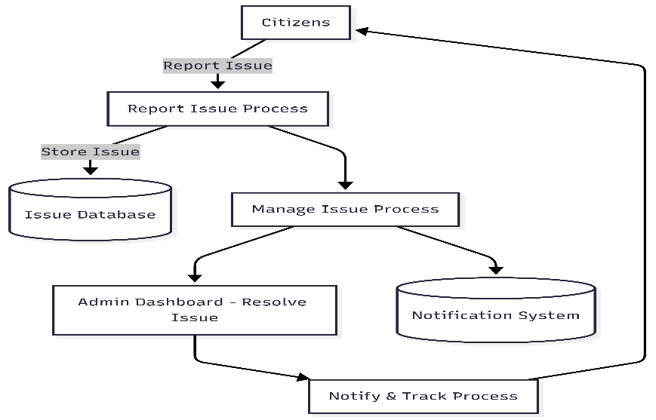

User Classes and Characteristics
The CivicSync system will serve multiple categories of users with distinct roles, access levels, and usage patterns. Each user class is described below:

1. Citizens (General Users)
- Role/Purpose: Primary reporters of civic issues.
- Functions Used:
  - Submit issues (photo, description, GPS location).
  - Track issue status.
  - Receive notifications and updates.
- Characteristics:
  - Wide range of technical expertise (from basic smartphone users to advanced digital natives).
  - Use frequency: occasional (when issues arise).
  - Requires a simple, intuitive, and multilingual user interface.
- Importance: High – System adoption and success depend on active citizen participation.

2. Municipal Staff (Operators/Field Workers)
- Role/Purpose: Handle and resolve reported issues.
- Functions Used:
  - Access assigned issues through dashboard.
  - Update issue resolution status.
  - Provide feedback on issue handling.
- Characteristics:
  - Moderate technical expertise (trained for using admin dashboard).
  - Use frequency: daily.
  - Needs mobile/web access with easy filtering and update options.
- Importance: High – Their responsiveness ensures trust in the system.

3. Municipal Administrators (Supervisors/Managers)
- Role/Purpose: Oversee issue management and generate reports.
- Functions Used:
  - Monitor all reported issues across categories and regions.
  - Assign/reassign tasks to departments or field staff.
  - Generate analytics for audits, performance tracking, and planning.
- Characteristics:
  - Higher technical expertise.
  - Use frequency: regular (weekly/monthly for reporting and monitoring).
  - Require advanced filters, dashboards, and analytics views.
- Importance: High – They ensure accountability and strategic decision-making.

4. System Administrators (Technical Team)
- Role/Purpose: Maintain system uptime, security, and performance.
- Functions Used:
  - Manage user accounts and permissions.
  - Monitor server/database health.
  - Handle bug reports, patches, and feature rollouts.
- Characteristics:
  - High technical expertise.
  - Use frequency: continuous (as needed for system stability).
  - Require admin privileges and monitoring tools.
- Importance: Medium – Essential for technical stability, but not part of daily civic workflows.

5. Policy Makers / Auditors (Optional/Future Users)
- Role/Purpose: Analyze aggregated data for governance, audits, and policy-making.
- Functions Used:
  - View analytics reports.
  - Compare issue resolution trends over time.
- Characteristics:
  - Moderate technical expertise.
  - Use frequency: low (monthly/quarterly).
- Importance: Medium – Adds long-term value for government transparency and planning.
Most Important User Classes:
- Citizens (for adoption and engagement).
- Municipal Staff and Administrators (for ensuring responsiveness and trust).

Operating Environment
The CivicSync system is designed to operate in a modern, cross-platform environment, ensuring accessibility for both citizens and municipal staff. The following environments are supported:

1. Hardware Platforms
- Citizen Side (Mobile/Web Users):
  - Smartphones with minimum 2 GB RAM, 16 GB storage.
  - Desktop/laptop with minimum 4 GB RAM.
  - Internet connectivity (3G/4G/5G/Wi-Fi).
- Municipal Staff/Admin Side:
  - Desktop or laptop with minimum 4 GB RAM, 500 MB free storage.
  - Smartphone/tablet access for field operators.
- Server Infrastructure:
  - Cloud-hosted (AWS, Azure, or equivalent).
  - Minimum 2-core CPU, 4 GB RAM, 20 GB storage for MVP.
  - Scalable architecture for production deployment.

2. Operating Systems
- Mobile Application:
  - Android version 8.0 (Oreo) and above.
  - iOS version 13.0 and above.
- Web Applications (Citizen Portal & Admin Dashboard):
  - Compatible with Windows 10 and above, macOS 10.15 and above, Linux Ubuntu 20.04+.
- Server Environment:
  - Node.js runtime (v18 LTS or later).
  - Runs on Linux-based servers (Ubuntu 20.04 LTS recommended).

3. Software Dependencies
- Frontend (Next.js + Tailwind):
  - Next.js v14+, React v18+.
  - Tailwind CSS v3+.
  - Modern browsers: Chrome, Firefox, Safari, Edge (latest two versions supported).
- Backend (Node.js + Express + MongoDB):
  - Node.js v18 LTS or above.
  - Express.js framework.
  - MongoDB v6+ (cloud-hosted preferred: MongoDB Atlas).
- Authentication:
  - JWT for session management.
- Notification System:
  - Gmail SMTP for email notifications.

4. Coexistence with Other Applications
- Must coexist with municipal ERP systems and Smart City dashboards (future API integrations).
- Must not conflict with OS-native services (camera, GPS, push notifications).
- Should integrate seamlessly with email clients for SMTP services.
📌 This ensures that CivicSync is lightweight enough for everyday users, yet scalable and robust for government-level deployment.

Design and Implementation Constraints
The design and implementation of CivicSync are subject to the following constraints that may limit developer choices or impact system design:

1. Regulatory and Policy Constraints
- The system must comply with Government of India data protection and privacy regulations (e.g., IT Act 2000, DPDP Bill 2023).
- For future scalability, compliance with GDPR-like international standards may be necessary if deployed beyond India.
- Accessibility guidelines (WCAG 2.1) should be considered for inclusive design.

2. Hardware and Performance Constraints
- The mobile application must operate efficiently on entry-level smartphones (minimum 2 GB RAM).
- Backend servers must handle at least 1,000 concurrent users in the MVP stage, with scalability options for production environments.
- Network dependency: Users with poor internet access may face delayed uploads (images, GPS data). Offline submission mode is future scope.

3. Technology and Tooling Constraints
- Backend is restricted to Node.js (v18+) with Express.js as per team expertise and hackathon requirements.
- Frontend must be implemented using Next.js + Tailwind CSS.
- Database must use MongoDB Atlas (cloud-hosted) for quick scalability.
- Authentication must use JWT; alternative authentication systems (OAuth, SAML) are considered future scope.
- Notifications are limited to Gmail SMTP for MVP (no SMS or push notifications in initial release).

4. Integration and Interface Constraints
- Integration with municipal ERP or Smart City platforms is not part of MVP but must be enabled through REST APIs for future scope.
- GPS integration depends on smartphone device services and permissions.
- File upload (photos of issues) must be limited to <5 MB per image to reduce bandwidth and storage overhead.

5. Security Considerations
- All communication between frontend, backend, and database must use HTTPS/TLS encryption.
- Sensitive data (e.g., user credentials, JWT tokens) must not be stored in plaintext.
- Email notifications via SMTP must use secure OAuth2 or app passwords.
- Role-based access must be enforced (citizen, municipal staff, admin).

6. Design Conventions / Standards
- Code must follow Airbnb JavaScript/TypeScript style guide for consistency.
- Git workflow requires feature branching and pull requests for merging into main.
- Documentation must follow IEEE SRS format for hackathon submission.

User Documentation
<List the user documentation components (such as user manuals, on-line help, and tutorials) that will be delivered along with the software. Identify any known user documentation delivery formats or standards.>

Assumptions and Dependencies
The design and implementation of CivicSync are based on the following assumptions and dependencies. Any changes to these may affect the scope, requirements, or performance of the system:

Assumptions
- User Accessibility
  - Citizens will have access to smartphones or desktops with internet connectivity.
  - Municipal staff and administrators will have access to desktops/laptops and stable internet for dashboard usage.
- Technical Environment
  - MongoDB Atlas, Gmail SMTP, and GPS services will remain available and reliable during system operation.
  - Node.js and Next.js frameworks will remain actively maintained and supported.
- User Adoption
  - Citizens are willing to participate in civic reporting when provided with an easy-to-use platform.
  - Municipal authorities are cooperative and committed to using the system for timely resolution of reported issues.
- Data Volumes
  - Initial deployment will have limited data volume (under 5,000 issue reports per month per municipality) as the system scales gradually.

Dependencies
- Third-Party Services
  - MongoDB Atlas – for cloud database hosting.
  - Gmail SMTP – for sending email notifications.
  - GPS services – for location tagging of reported issues.
  - Future scope may depend on WhatsApp API or SMS gateways for alternative notifications.
- Integration with External Systems
  - Future integration with municipal ERP systems or Smart City dashboards will depend on their API availability and policies.
- Hackathon Infrastructure
  - Development timeline and resources are limited by SIH 2025 hackathon constraints.
  - Deployment environment may initially rely on free-tier services (Heroku, Vercel, MongoDB Atlas free cluster).
- Team Expertise
  - Successful delivery of the MVP assumes that all team members are able to collaborate effectively on GitHub using the chosen tech stack (Next.js, Node.js, MongoDB, JWT, Tailwind).

External Interface Requirements

User Interfaces
The CivicSync system will provide intuitive, consistent, and responsive user interfaces for all user classes (citizens, municipal staff, and administrators). The design will follow minimalistic and mobile-first principles, ensuring accessibility for a wide range of users with varying technical skills.

1. General UI Standards
- Consistent color scheme and typography (defined via Tailwind CSS).
- Mobile-first responsive layouts that adapt to tablets and desktops.
- Standard navigation components (header, sidebar, footer) for all dashboards.
- Error and success messages displayed in toast/alert format.
- Accessibility support (alt text for images, ARIA labels, high contrast mode).
- Multilingual support (English + regional languages in future scope).

2. User Interfaces by User Class
(a) Citizen Application (Mobile/Web)
- Home Screen: Quick access to "Report an Issue" and "Track Issues".
- Report Issue Form: Input fields for description, photo upload, and automatic GPS tagging.
- Status Tracker: Timeline view of submitted issues (Submitted → Acknowledged → In Progress → Resolved).
- Notifications Panel: Alerts about status updates and resolutions.
(b) Municipal Staff Dashboard
- Login Page: Secure authentication via JWT.
- Assigned Issues Panel: List of issues assigned to staff with filtering by priority/location.
- Issue Detail View: Photo, description, location map, citizen details, and update/resolution options.
- Update Status Form: Mark issue as acknowledged, in progress, or resolved.
(c) Municipal Admin Dashboard
- Dashboard Overview: Visual analytics (charts, graphs) for reported issues.
- Issue Management Panel: Ability to view, filter, and categorize all reported issues.
- Task Assignment Module: Assign/reassign issues to departments/staff.
- Reporting Tools: Export reports (CSV, PDF) for audits and policy evaluations.

3. Standard Features Across All Interfaces
- Help & Support Button on every screen.
- Logout Button visible at all times.
- Error Handling: Friendly error messages instead of raw system errors.
- Confirmation Dialogs before destructive actions (e.g., deleting an issue).

4. Example Screen Mockups (Future Documentation)
- Citizen Mobile App → "Report Issue" screen.
- Admin Dashboard → "Analytics Overview" screen.
- Staff Dashboard → "Assigned Issues" panel.
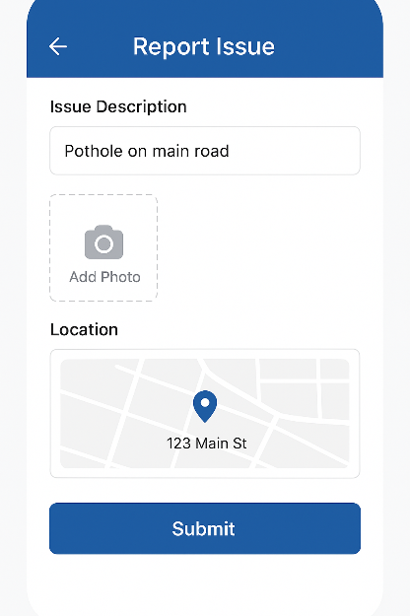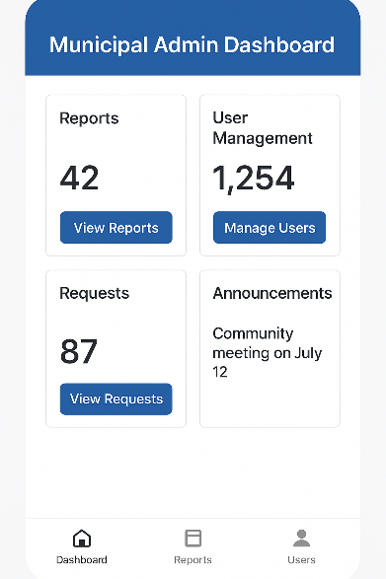

Hardware Interfaces
The CivicSync system interacts with several hardware components to ensure smooth functioning across citizen devices, municipal infrastructure, and server-side operations.
- Citizen Devices (Mobile/Web Clients):
  - Supported on smartphones (Android 9.0+ and iOS 13+) and desktop/laptop browsers.
  - Interfaces: Touchscreen for input, smartphone camera for image capture, GPS module for location tagging, microphone for optional voice reporting.
  - Data exchanged: Issue reports (text, photo, location, voice), status updates, and notifications.
- Municipal Admin Systems:
  - Desktop or laptop computers (minimum specs: 4 GB RAM, dual-core processor, modern browser support).
  - Interfaces: Keyboard and mouse for input, display monitors for dashboards and analytics.
  - Data exchanged: Report management, analytics visualization, task assignment.
- Backend Server Hardware:
  - Cloud-hosted servers or on-premises data centers with minimum specifications:
    - CPU: Quad-core, 3.0 GHz or higher
    - RAM: 16 GB
    - Storage: 500 GB SSD (expandable)
  - Interfaces: Supports REST APIs over HTTPS for communication with frontend clients and external services.
- Communication Protocols:
  - HTTPS (TLS 1.2/1.3): For secure data transfer between mobile/web clients and backend.
  - SMTP (Gmail API): For email notifications.
  - GPS/Location Services: Standard NMEA protocols accessed via mobile OS APIs.

Software Interfaces
The CivicSync system integrates with various software components to ensure seamless data processing, storage, communication, and user experience.

1. Operating Systems
- Mobile App: Android (9.0 and above), iOS (13.0 and above).
- Web Client: Runs on modern browsers (Google Chrome, Mozilla Firefox, Microsoft Edge, Safari – latest two versions).
- Server Backend: Runs on Linux-based servers (Ubuntu 20.04 LTS or later).

2. Databases
- MongoDB Atlas (v6.0+):
  - Stores issue reports (text, images, geolocation metadata).
  - Stores user profiles (citizens, municipal staff, administrators).
  - Tracks issue status updates (submitted → acknowledged → in progress → resolved).
  - Data exchanged: JSON-based requests and responses.
  - Communication via MongoDB drivers for Node.js.

3. Backend Frameworks and Services
- Node.js (v18 LTS) with Express.js (v4+):
  - Provides RESTful APIs for frontend communication.
  - Handles request validation, authentication, and routing.
  - Supports real-time updates (future scope: WebSockets).
- Authentication (JWT):
  - JSON Web Tokens for stateless session management.
  - Data exchanged: Signed tokens containing user identity and roles.
- Email Notification (Gmail SMTP API):
  - Sends automated emails to citizens (acknowledgment, updates, resolution notifications).
  - Secure authentication via OAuth2 or App Passwords.

4. Frontend Frameworks and Libraries
- Next.js (v14+) with React (v18+):
  - Provides user-facing web applications (citizen portal, municipal dashboard).
  - Fetches data from backend REST APIs via HTTPS.
  - Uses server-side rendering for performance optimization.
- Tailwind CSS (v3+):
  - Provides a consistent, responsive UI design system.
  - Shared styling across citizen and admin dashboards.

5. Data Exchange Mechanisms
- Input Data (into the system):
  - Citizen-reported issue details (text, photo, location, category).
  - Staff/admin updates (status changes, comments, task assignments).
- Output Data (out of the system):
  - Notifications and acknowledgments (via email).
  - Dashboard visualizations (charts, heatmaps, reports).
  - API responses in JSON format (issue details, status, analytics).

6. External Integrations (Future Scope)
- Open311 API Compliance: For interoperability with municipal ERP and Smart City systems.
- WhatsApp Business API / SMS Gateway: For citizen notifications.
- GIS Tools (PostGIS/Map APIs): For advanced spatial analytics and visualization.

Communications Interfaces
The CivicSync system requires secure and reliable communication between user devices, backend servers, and external services. The following communication requirements apply:

1. Web and API Communication
- Protocols: HTTPS (TLS 1.2/1.3) is mandatory for all communications between frontend (citizen app, admin dashboard) and backend servers.
- Message Format: JSON (JavaScript Object Notation) will be used for all API requests and responses.
- Data Types:
  - Text descriptions of issues.
  - Multimedia uploads (JPEG/PNG images).
  - Metadata (GPS coordinates, timestamps, user IDs).
- Synchronization:
  - Near real-time updates ensured through REST APIs.
  - Future scope: WebSocket-based real-time updates for dashboards.

2. Email Communication
- Service: Gmail SMTP with OAuth2/App Password authentication.
- Protocols: SMTP over TLS (STARTTLS).
- Purpose:
  - Send acknowledgment emails to citizens after submission.
  - Notify citizens of status updates (acknowledged, in progress, resolved).
  - Notify staff/admins of assigned tasks.
- Message Format:
  - Plain text and/or HTML-formatted emails with CivicSync branding.

3. Mobile Device Communication
- Interfaces:
  - GPS service API (location tagging).
  - Camera API (image capture for issue reporting).
- Message Flow: Captured data packaged into JSON and transmitted securely via HTTPS.

4. Database Communication
- Interface: MongoDB Atlas (cloud-hosted).
- Protocol: MongoDB driver for Node.js over TLS-encrypted channels.
- Message Format: BSON (Binary JSON) for internal storage and retrieval.
- Purpose: Securely store and retrieve citizen reports, user details, and analytics data.

5. Security Requirements
- Encryption: All communications must be encrypted using TLS 1.2/1.3.
- Authentication:
  - JWT for session management between frontend and backend.
  - OAuth2/App Passwords for Gmail SMTP.
- Data Privacy: Sensitive user data (emails, tokens) must not be logged or transmitted in plaintext.

6. Performance Constraints
- Minimum Bandwidth: 1 Mbps recommended for mobile users to upload issue reports with images.
- Latency: System must respond to API requests within 2 seconds under normal load.
- Data Transfer Limits: Image uploads restricted to 5 MB per file.

System Features
This section describes the functional requirements of CivicSync, organized by system features. Each feature includes a description, stimulus/response sequences, and detailed functional requirements.

Description and Priority

Description and Priority
Description: Enables citizens to report civic issues by submitting photos, descriptions, and GPS locations.
Priority: High (Benefit = 9, Penalty = 9, Cost = 5, Risk = 4). Core functionality.

Stimulus/Response Sequences
Citizen selects “Report Issue” → enters description, uploads photo, location auto-tagged → System validates → Stores in DB → Acknowledges.
Citizen submits incomplete/invalid issue → System prompts correction.
Citizen submits successfully → System generates unique Issue ID → Sends acknowledgment email.

Functional Requirements
REQ-1: The system shall allow citizens to submit an issue with text description, image, and GPS cation.
REQ-2: The system shall validate input fields (mandatory description, valid image format).
REQ-3: The system shall restrict image size to ≤5 MB.
REQ-4: The system shall automatically capture GPS coordinates (with user consent).
REQ-5: The system shall generate a unique Issue ID.
REQ-6: The system shall store issue data in MongoDB.
REQ-7: The system shall send acknowledgment emails via SMTP.

4.2 Issue Tracking for Citizens

4.2.1 Description and Priority
- Description: Allows citizens to monitor the status of their reported issues.
- Priority: High (Benefit = 8, Penalty = 7, Cost = 4, Risk = 3).

4.2.2 Stimulus/Response Sequences
- Citizen logs in → “My Issues” → System retrieves list of issues.
- Citizen selects an issue → System displays timeline (Submitted → Acknowledged → In Progress → Resolved).
- Citizen tries to view unauthorized issue → System denies access.

4.2.3 Functional Requirements
- REQ-8: The system shall display all issues submitted by a citizen.
- REQ-9: The system shall show current status (submitted, acknowledged, in progress, resolved).
- REQ-10: The system shall update issue status in near real-time.
- REQ-11: The system shall provide a timeline of issue progression.
- REQ-12: The system shall enforce access control to restrict unauthorized views.

4.3 Notifications and Alerts

4.3.1 Description and Priority
- Description: Sends automated notifications to users about issue progress.
- Priority: High (Benefit = 9, Penalty = 8, Cost = 3, Risk = 3).

4.3.2 Stimulus/Response Sequences
- Issue submitted → System sends acknowledgment email.
- Issue assigned to staff → System sends notification to staff.
- Status updated → Citizen receives email update.

4.3.3 Functional Requirements
- REQ-13: The system shall send acknowledgment notifications after submission.
- REQ-14: The system shall notify staff when issues are assigned.
- REQ-15: The system shall notify citizens when status changes.
- REQ-16: The system shall use Gmail SMTP for sending emails securely.

4.4 Municipal Staff Dashboard

4.4.1 Description and Priority
- Description: Provides field staff with tools to view, filter, and update assigned issues.
- Priority: High (Benefit = 8, Penalty = 8, Cost = 5, Risk = 4).

4.4.2 Stimulus/Response Sequences
- Staff logs in → System displays assigned issues.
- Staff selects issue → System shows details with image, description, location.
- Staff updates issue status → System saves update and notifies citizen.

4.4.3 Functional Requirements
- REQ-17: The system shall allow staff to log in securely.
- REQ-18: The system shall display all issues assigned to staff.
- REQ-19: The system shall allow staff to update issue statuses.
- REQ-20: The system shall notify citizens upon staff updates.

4.5 Municipal Admin Dashboard

4.5.1 Description and Priority
- Description: Provides municipal administrators with oversight, task assignment, and reporting capabilities.
- Priority: High (Benefit = 9, Penalty = 9, Cost = 6, Risk = 5).

4.5.2 Stimulus/Response Sequences
- Admin logs in → Dashboard overview with analytics.
- Admin filters issues by category/location → System displays results.
- Admin assigns issue to staff → System routes assignment.
- Admin generates report → System exports CSV/PDF.

4.5.3 Functional Requirements
- REQ-21: The system shall provide role-based login for administrators.
- REQ-22: The system shall allow filtering of issues by category/location/priority.
- REQ-23: The system shall allow assigning/reassigning issues to staff.
- REQ-24: The system shall provide analytics dashboards.
- REQ-25: The system shall export reports in CSV and PDF formats.

4.6 Analytics and Reporting

4.6.1 Description and Priority
- Description: Generates visual insights and statistical reports for administrators.
- Priority: Medium (Benefit = 7, Penalty = 5, Cost = 6, Risk = 4).

4.6.2 Stimulus/Response Sequences
- Admin selects “Analytics” → System generates charts of issue trends.
- Admin requests “Export Report” → System provides CSV/PDF file.

4.6.3 Functional Requirements
- REQ-26: The system shall display resolved vs pending issues in charts.
- REQ-27: The system shall display average resolution time.
- REQ-28: The system shall allow export of analytics as CSV/PDF.

4.7 Authentication and Security

4.7.1 Description and Priority
- Description: Provides secure authentication and authorization for all user classes.
- Priority: High (Benefit = 9, Penalty = 9, Cost = 4, Risk = 5).

4.7.2 Stimulus/Response Sequences
- User enters login credentials → System verifies → Grants access with JWT.
- User enters wrong credentials → System denies access with error message.
- User tries to access unauthorized resource → System blocks and logs attempt.

4.7.3 Functional Requirements
- REQ-29: The system shall authenticate users using JWT.
- REQ-30: The system shall enforce role-based access (citizen, staff, admin).
- REQ-31: The system shall encrypt all sensitive data in transit using TLS.
- REQ-32: The system shall log failed login attempts.

Other Nonfunctional Requirements

Performance Requirements
The CivicSync system must perform reliably under varying loads, ensuring responsiveness and scalability to support both citizens and municipal staff.

1. Response Time
- The system shall respond to standard API requests (issue submission, status retrieval) within ≤ 2 seconds under normal network conditions.
- The system shall display analytics dashboards within ≤ 5 seconds for datasets up to 10,000 issues.
- Notifications (emails) shall be sent within ≤ 30 seconds of an event trigger (submission, assignment, status update).

2. Concurrent Users
- The MVP system shall support at least 1,000 concurrent users without degradation of performance.
- The architecture must be scalable to support 10,000+ concurrent users in production environments.

3. Data Throughput
- The system shall process at least 50 issue submissions per minute during peak usage without failure.
- The database shall support read/write operations of up to 500 queries per second (QPS) under load.

4. Image/File Handling
- The system shall support issue submissions with image uploads of size ≤ 5 MB per file.
- Upload time for images shall not exceed 10 seconds under a stable 1 Mbps connection.

5. Scalability
- The system shall allow horizontal scaling of backend services to handle increased load.
- MongoDB shall be configured with auto-scaling clusters to manage large volumes of data.

6. Availability and Uptime
- The system shall provide ≥ 99.5% uptime for municipal staff and administrators.
- Scheduled downtime for maintenance shall not exceed 2 hours per month.

7. Rationale
These requirements ensure that:
- Citizens experience fast and reliable submissions, encouraging continued use.
- Municipal staff/admins can manage issues efficiently without delays.
- The system remains operational and responsive even under heavy load, aligning with the SIH objective of creating scalable, real-world solutions.

Safety Requirements
The CivicSync system must ensure the safety of both data and operations to prevent loss, damage, or harm resulting from its use. The following requirements apply:

1. Data Protection and Loss Prevention
- The system shall implement automated daily database backups to prevent data loss.
- The system shall support rollback and recovery mechanisms in case of accidental deletions or corruption.
- All critical logs and records shall be stored in redundant storage (e.g., MongoDB Atlas replication).

2. Failover and Disaster Recovery
- The system shall include failover mechanisms to switch to backup servers in case of primary server failure.
- Recovery Time Objective (RTO) shall be ≤ 4 hours, and Recovery Point Objective (RPO) shall be ≤ 24 hours.
- The system shall be hosted on a cloud infrastructure with geographic redundancy (multiple data centers).

3. User Safety and Misuse Prevention
- The system shall prevent submission of harmful or malicious files by restricting uploads to supported formats (JPEG/PNG).
- The system shall sanitize all user inputs to prevent injection attacks that could damage the system or expose sensitive data.
- The system shall restrict unauthorized access to sensitive data using role-based permissions.

4. Compliance and Regulatory Requirements
- The system must comply with relevant data safety standards, including:
  - Government of India IT Act, 2000 and Digital Personal Data Protection Bill (DPDP), 2023.
  - OWASP security guidelines to prevent common vulnerabilities.
- For future international deployment, compliance with GDPR and ISO/IEC 27001 is recommended.

5. Safety Certifications (Future Scope)
- If scaled to national implementation, the system may require certification under CERT-In (Computer Emergency Response Team India) for security and safety validation.
- For municipal/government adoption, additional audits may be required to meet Smart City IT safety frameworks.

Security Requirements
The CivicSync system must ensure that all data and operations are secure, protecting user privacy and maintaining system integrity. The following requirements apply:

1. Authentication and Access Control
- The system shall require unique user authentication (email/username + password) for all users.
- The system shall issue JWT tokens to maintain secure, stateless sessions.
- The system shall enforce role-based access control (RBAC) with different privilege levels for:
  - Citizens (report/track issues).
  - Municipal Staff (view/update assigned issues).
  - Administrators (manage issues, assign tasks, generate reports).
- The system shall automatically invalidate expired or revoked tokens.

2. Data Privacy and Protection
- The system shall encrypt all sensitive data in transit using TLS 1.2/1.3.
- The system shall encrypt stored passwords using strong hashing algorithms (e.g., bcrypt).
- The system shall ensure that citizens can only access their own issue records.
- Personal Identifiable Information (PII) such as email addresses must not be shared with other users without explicit consent.

3. Security Against Threats
- The system shall sanitize all user inputs to prevent SQL/NoSQL injection, cross-site scripting (XSS), and cross-site request forgery (CSRF).
- The system shall implement rate limiting and CAPTCHA mechanisms to prevent brute-force login attempts.
- The system shall log all failed login attempts and alert administrators if suspicious activity is detected.
- The system shall restrict file uploads to specific formats (JPEG/PNG) and maximum size limits to prevent malicious file injection.

4. Compliance with Standards and Regulations
- The system must comply with:
  - IT Act 2000 (India) and DPDP Bill 2023 for data protection.
  - OWASP Top 10 security guidelines for web applications.
- For future scalability, compliance with ISO/IEC 27001 and GDPR should be considered.

5. Security Certifications (Future Scope)
- If deployed nationwide, the system may require CERT-In certification for cybersecurity compliance.
- Third-party penetration testing and audits shall be conducted before production deployment.

Software Quality Attributes
The CivicSync system must satisfy the following software quality attributes to ensure usability, maintainability, and long-term adoption.

1. Usability
- The system shall provide a minimalistic, mobile-first UI that is accessible to both tech-savvy and non-technical citizens.
- The citizen app shall allow reporting of an issue within ≤ 3 steps (open → describe → submit).
- The system shall support multilingual interfaces (English + regional languages in future versions).

2. Availability and Reliability
- The system shall ensure ≥ 99.5% uptime for municipal dashboards and citizen applications.
- All critical services (issue reporting, authentication) shall include failover mechanisms.
- The system shall recover from transient errors (e.g., network drops) within ≤ 10 seconds.

3. Maintainability
- The codebase shall follow modular design principles to allow independent updates to frontend, backend, and database services.
- All code shall be version-controlled in GitHub with proper branching strategy.
- Developers shall provide documentation and inline comments for maintainability.

4. Scalability and Flexibility
- The system architecture shall support horizontal scaling (adding more servers) for handling high traffic.
- Database shall be configured for sharding and replication to handle large datasets.
- The system shall allow integration with external APIs (e.g., Smart City dashboards, ERP systems) without major redesign.

5. Interoperability
- The system shall use REST APIs with JSON format for communication, ensuring compatibility with third-party tools.
- Future versions should comply with Open311 API standards for civic issue reporting.

6. Portability
- The mobile application shall run on Android 9.0+ and iOS 13.0+ devices.
- The web application shall support major browsers (Chrome, Firefox, Safari, Edge – latest two versions).
- Backend services shall be deployable on Linux-based servers (Ubuntu 20.04+), both cloud and on-premises.

7. Testability
- All functional requirements shall include unit, integration, and system tests.
- The system shall achieve ≥ 80% automated test coverage for critical modules.
- Logging and monitoring shall be implemented for error tracking and debugging.

8. Robustness and Correctness
- The system shall handle invalid or malicious inputs gracefully, without crashing.
- In case of failed submissions (e.g., network issues), the system shall allow users to retry without data loss.
- All issue IDs, logs, and records shall remain consistent even during concurrent submissions.

Business Rules
The CivicSync system must operate according to the following business rules that govern roles, permissions, and operational principles. These rules are not functional requirements themselves but guide system behavior and access control:

1. Role-Based Access
- Citizens can report issues, track their own issues, and receive notifications, but cannot view or modify other users’ issues.
- Municipal staff can view and update issues assigned to them, but cannot reassign or delete issues.
- Municipal administrators can view all issues, assign/reassign tasks, update statuses, and generate reports.
- System administrators (technical team) can manage user accounts, permissions, and system settings, but cannot alter issue content.

2. Issue Handling Rules
- Each issue must have a unique Issue ID generated by the system.
- An issue cannot be marked as resolved without being first marked as acknowledged and in progress.
- Citizens cannot submit duplicate issues for the same location within 24 hours (to prevent spamming).
- Administrators must assign each reported issue to a department/staff within 48 hours of submission.

3. Notification Rules
- Citizens must receive an acknowledgment notification immediately after issue submission.
- Citizens must be notified whenever an issue status changes (acknowledged, in progress, resolved).
- Staff must be notified when new issues are assigned to them.

4. Data and Privacy Rules
- Only authenticated users may submit or track issues.
- Personally Identifiable Information (PII) such as citizen email and phone numbers must not be shared with municipal staff unless required for direct communication.
- Data must be retained for at least 5 years for audit and governance purposes, unless otherwise directed by government policy.

5. Reporting and Analytics Rules
- Administrators can generate reports only for the regions/departments under their jurisdiction.
- Reports must include issue counts, resolution times, and department performance.
- Reports must be exportable in CSV and PDF formats for audits.

Other Requirements
This section captures additional requirements not addressed in earlier sections but essential for the complete functioning and adoption of CivicSync.

6.1 Database Requirements
- The system shall use MongoDB Atlas (v6.0+) as the primary database.
- Database must support:
  - Replication for fault tolerance.
  - Sharding for handling large datasets in future scalability.
  - Indexing to optimize queries for fast retrieval of issue records.
- Sensitive user data (e.g., passwords) shall be hashed and salted before storage.
- Audit logs shall be stored for all administrative actions.

6.2 Internationalization and Localization
- The system shall support multilingual interfaces, beginning with English, with provisions for Hindi and other regional languages in future updates.
- Dates, times, and currency formats must be adaptable to local preferences.
- Right-to-left (RTL) language support (e.g., Urdu) may be required in future expansion.

6.3 Legal and Regulatory Requirements
- The system must comply with:
  - IT Act 2000 (India) and DPDP Bill 2023 for data security and privacy.
  - OWASP Top 10 for secure coding practices.
- Future compliance may include:
  - ISO/IEC 27001 for information security.
  - GDPR if deployed internationally.
- Data retention and access must follow government-mandated audit requirements.

6.4 Reuse Objectives
- The codebase shall be designed in a modular and reusable manner, allowing components (authentication, notifications, dashboards) to be reused in other government or institutional applications.
- APIs shall be designed as RESTful services so they can be reused by external applications (e.g., Smart City dashboards, ERP systems).

6.5 Deployment Requirements
- The MVP shall be deployed on cloud platforms such as Vercel (frontend) and Heroku/Render (backend) with MongoDB Atlas.
- The system shall provide easy migration to on-premises servers if required by municipalities.
- Deployment pipelines shall use GitHub Actions for CI/CD automation.

6.6 Environmental and Cultural Requirements
- The system must be designed to work in low-bandwidth environments (≥1 Mbps).
- The UI must be simple, icon-driven, and multilingual to be accessible for citizens with varying literacy levels.
- The system must avoid culturally sensitive imagery, wording, or color schemes that may limit adoption.

Appendix A: Glossary
This glossary defines acronyms, abbreviations, and domain-specific terms used throughout this SRS to ensure clarity and consistent interpretation.

General Terms
- Citizen: End-user of the CivicSync mobile/web application who reports civic issues.
- Municipal Staff: Field workers or department employees responsible for resolving assigned issues.
- Municipal Administrator (Admin): Supervisors/managers overseeing all reported issues, assigning tasks, and generating reports.
- System Administrator: Technical personnel responsible for maintaining and securing the CivicSync system.

Technical Terms
- API (Application Programming Interface): A set of rules and protocols that allows software components to communicate with each other.
- Backend: The server-side software (Node.js + Express.js) that processes requests, manages data, and handles business logic.
- Frontend: The client-side application (Next.js + Tailwind CSS) used by citizens and administrators to interact with the system.
- Database: MongoDB Atlas, used for storing structured and unstructured data such as issue reports and user details.
- JWT (JSON Web Token): A compact, URL-safe token used for securely transmitting authentication and authorization information.
- SMTP (Simple Mail Transfer Protocol): A standard protocol for sending email notifications, implemented via Gmail SMTP.
- GPS (Global Positioning System): Technology used to automatically tag the geographic location of reported issues.
- REST (Representational State Transfer): An architectural style used for communication between frontend and backend via HTTP.
- UI (User Interface): The visual elements that allow users to interact with the software.

Project-Specific Terms
- CivicSync: The proposed system for crowdsourced civic issue reporting and resolution.
- Issue ID: A unique identifier automatically assigned to each reported issue.
- Acknowledged: Status indicating the issue has been reviewed by municipal staff/admin.
- In Progress: Status indicating the issue is currently being worked on.
- Resolved: Status indicating the issue has been successfully addressed.
- Analytics Dashboard: Visualization module for administrators to track trends and performance.

Appendix B: Analysis Models
This appendix includes relevant analysis models to illustrate the structure and behavior of the CivicSync system.

B.1 Use Case Diagram
- Actors:
  - Citizen (reports/tracks issues).
  - Municipal Staff (updates issue status).
  - Municipal Administrator (assigns/reports issues).
  - System Administrator (manages users/system).
- Description: Shows interactions between user roles and system features.

B.2 Data Flow Diagram (Level 0 – Context Diagram)
- Description: Represents the overall data flow between external actors (citizens, staff, admin) and the system.
- Flow:
  - Citizen → Report Issue → CivicSync System → Admin/Staff.
  - Staff/Admin → Update/Assign Issue → CivicSync System → Citizen (status updates).

B.3 Data Flow Diagram (Level 1 – Subsystem View)
- Processes:
  - Report Management (input validation, storage).
  - Status Tracking.
  - Notifications Service (SMTP).
  - Analytics Engine.
- Data Stores:
  - MongoDB (issues, users, logs).

B.4 Entity–Relationship (ER) Diagram
- Entities:
  - User (Citizen, Staff, Admin).
  - Issue (IssueID, description, category, location, status).
  - Notification (NotificationID, type, recipient, timestamp).
- Relationships:
  - User submits Issue.
  - Staff updates Issue.
  - Admin assigns Issue.
  - System sends Notification.

B.5 State-Transition Diagram (for Issues)
- States: Submitted → Acknowledged → In Progress → Resolved.
- Transitions: Triggered by staff/admin actions; rollback not permitted except by admin override.

Appendix C: To Be Determined List
This appendix lists all items that are not yet finalized in the current version of the SRS. These will be tracked and updated in future iterations of CivicSync development.

C.1 Functional Requirements
- TBD-1: Maximum number of issue submissions allowed per user per day (currently assumed to be 3–5).
- TBD-2: Specific categories of issues to be standardized across municipalities (e.g., garbage, potholes, water supply, streetlights).
- TBD-3: Multilingual support – exact set of languages to be provided in Phase 1 deployment.

C.2 Non-Functional Requirements
- TBD-4: Exact concurrency limits for production deployment (beyond hackathon MVP).
- TBD-5: Data retention policy (currently assumed to be 5 years, subject to government regulation).
- TBD-6: Integration timeline with municipal ERP and Smart City dashboards.

C.3 Business Rules
- TBD-7: Time limit for administrators to acknowledge reported issues (assumed 48 hours, requires confirmation from stakeholders).
- TBD-8: Escalation mechanism if issues remain unresolved beyond a threshold (e.g., auto-escalation after 7 days).

C.4 External Dependencies
- TBD-9: Choice of cloud hosting provider for production deployment (AWS, Azure, or NIC Cloud).
- TBD-10: Notification channel expansion (SMS, WhatsApp API) – subject to approval and budget.

