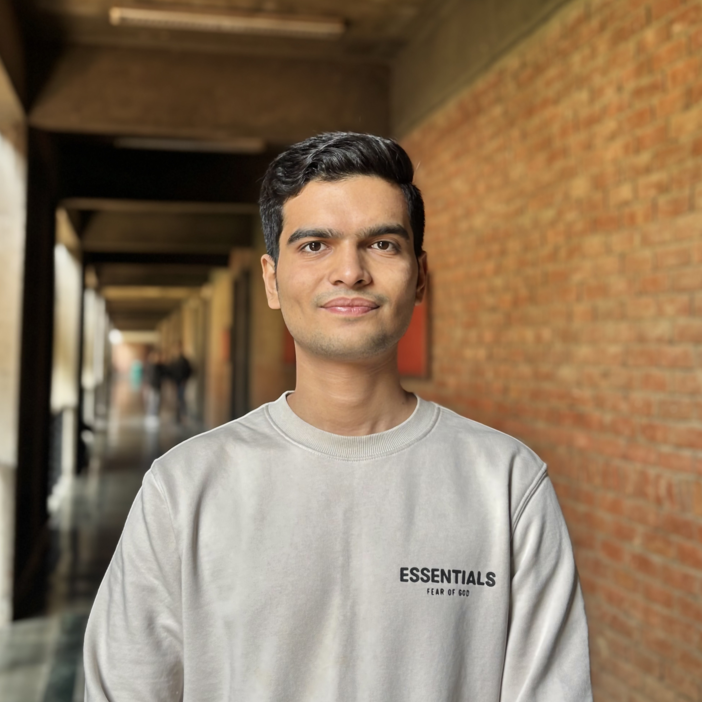
Mridul Tyagi
+91 7017208693 | mridul.mt88@gmail.com | www.linkedin.com/in/mridul-tyagi |
https://github.com/Mridul0603

Education
Bachelor of Technology in Electronics and Communication Engineering Jul 2023 – May 2027
Jaypee Institute Of Information Technology Noida, India
Secondary Education Mar 2007 – May 2022
K.L. International School Meerut, India

Experience
Web Developer Intern Jun 2025 – Jul 2025
Persistent Infotech India
- Developed responsive web pages using HTML, CSS, and JavaScript, improving UI speed by 20%.
- Integrated REST APIs, reducing data load time by 15% and improving performance.
- Ensured cross-browser compatibility, achieving 100% functional support across major browsers.
- Refactored frontend code into reusable components, reducing future development effort by 10% % and improving maintainability.
Deloitte - Technology Job Simulation (Forage)
Virtual Experience Program Dec 2025
- Completed hands-on tasks simulating real-world software development and coding workflows
- Gained practical exposure to problem-solving, development practices, and technical decision-making
- Demonstrated ability to translate requirements into working technical solutions in a corporate context

Volunteer, Jaypee Youth Club Aug 2024 – May 2025
Campus India
- Organized cultural fests and ethnic nights, increasing student participation by 30%.
- Coordinated multiple student events, ensuring smooth execution and 100% on-time completion.
- Facilitated collaboration between 5+ student teams, improving event efficiency and communication.

Projects
YouTube Clone | HTML, CSS, JavaScript Jun 2025 – Jul 2025
  - Built a YouTube-like video platform, increasing user engagement by 40%.
  - Developed responsive UI using HTML, CSS, and JavaScript, improving mobile retention by 35%.
  - Implemented video playback and search, reducing load time by 25%.
  - Designed an intuitive interface, boosting session duration by 20%.

Technical Skills
Languages: C++, Python, JavaScript (ES6+), SQL, PHP
Frontend: HTML5, CSS3, React.js, Bootstrap Backend: RESTful APIs, CodeIgniter, Laravel (basic) Tools: Git, GitHub, VS Code, PyCharm
Libraries: Pandas, NumPy, Matplotlib

Certifications & Achievements
- Certified C++ Programming – Udemy
- Completed Data Structures & Algorithms – Abdul Bari (Udemy)
- Finished Full-Stack Web Development – Hitesh Choudhary (Udemy)

