**INDIAN INSTITUTE OF INFORMATION TECHNOLOGY, ALLAHABAD**

**Software Engineering**

Instructor: Abhishek Sir

DIAGRAMS

For

**SPOTR**



A PROFILE GENERATION

WEB APPLICATION

Group Members:

IIT2019127 MRIDUL MITTAL [iit2019127@iiita.ac.in](mailto:iit2019127@iiita.ac.in)

IIT2019145 PARAS AGRAWAL [iit2019145@iiita.ac.in](mailto:iit2019145@iiita.ac.in)

IIT2019146 KSHITIJ KUMAR [iit2019146@iiita.ac.in](mailto:iit2019146@iiita.ac.in)

IIT2019148 PIYUSH GURJAR [iit2019148@iiita.ac.in](mailto:iit2019148@iiita.ac.in)

1. **SEQUENCE DIAGRAM**

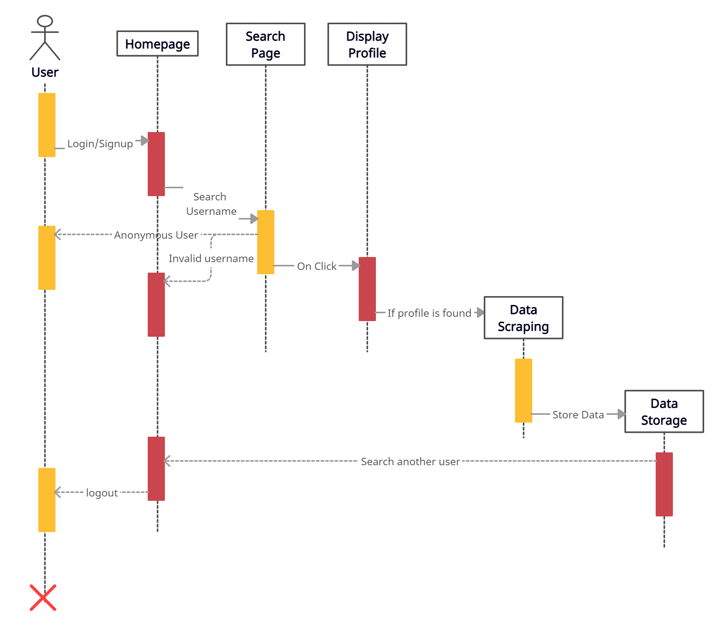

1. **DATA FLOW DIAGRAM**

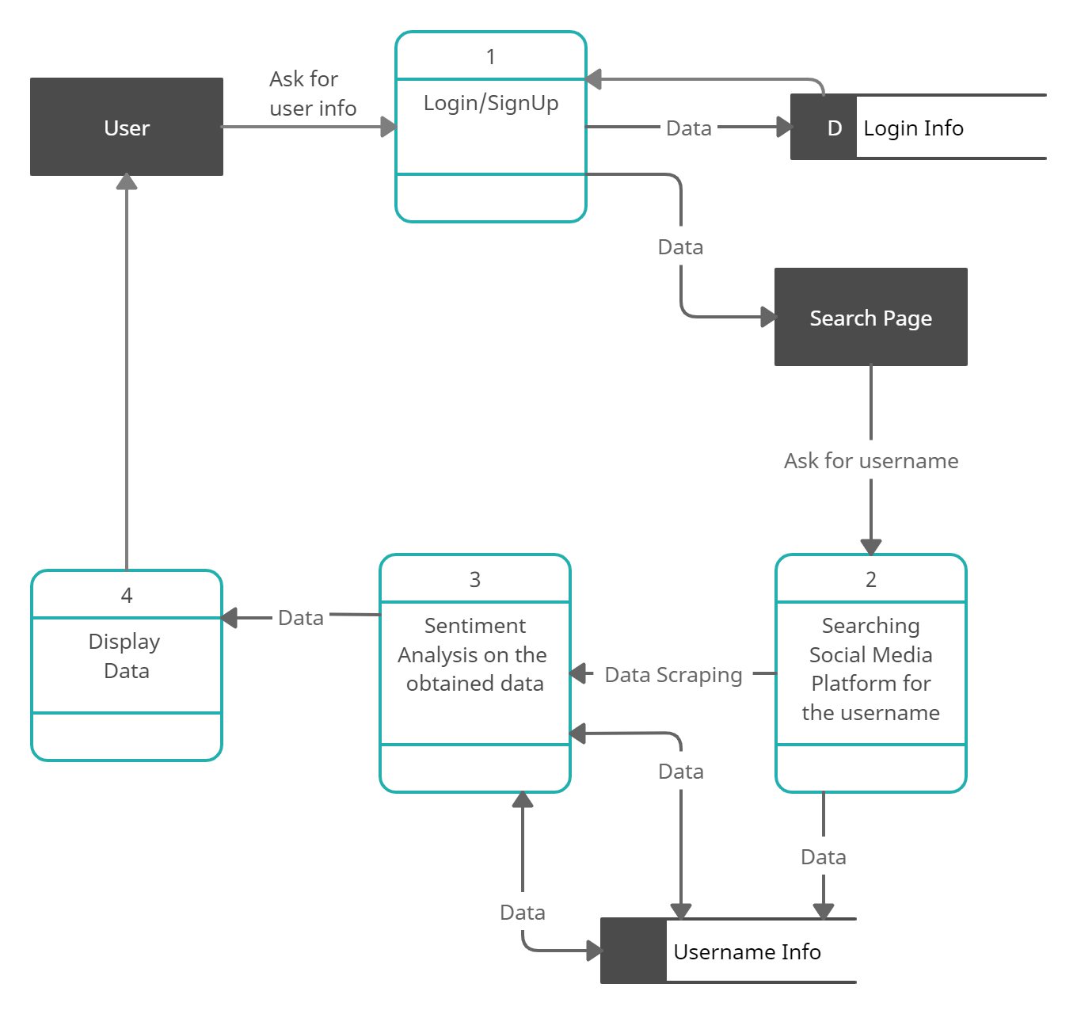

1. **ER DIAGRAM**

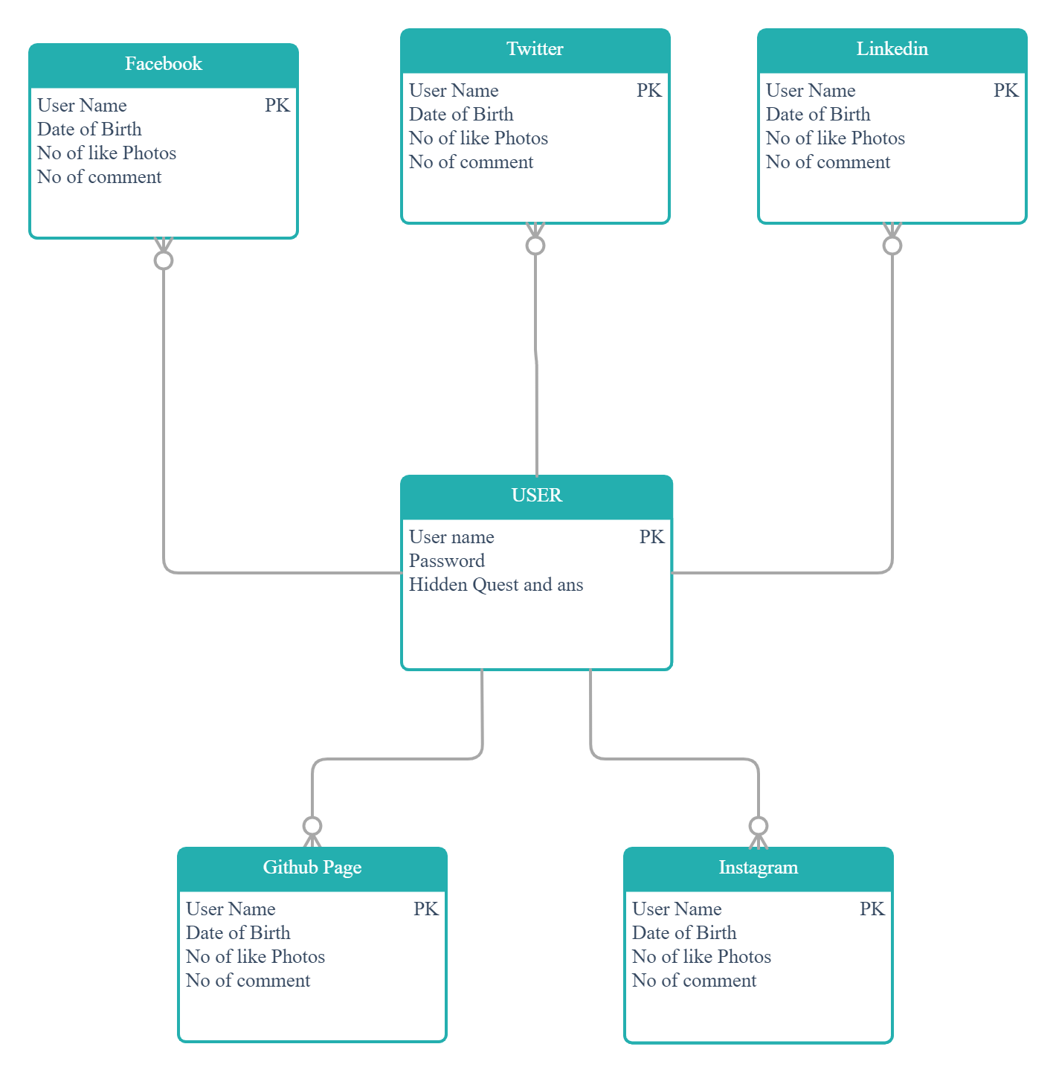

1. **STATE DIAGRAM**

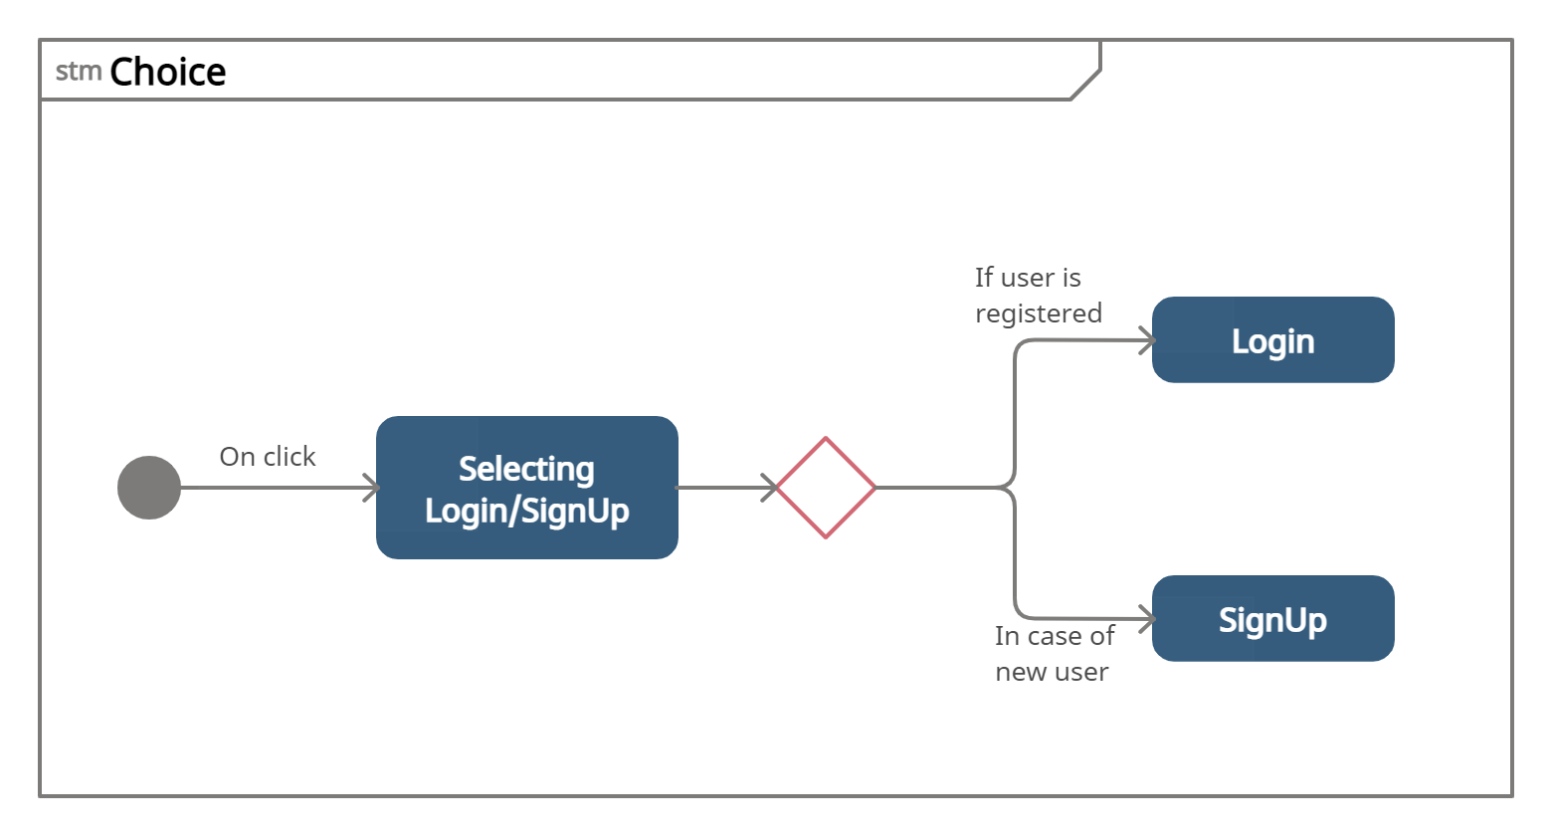

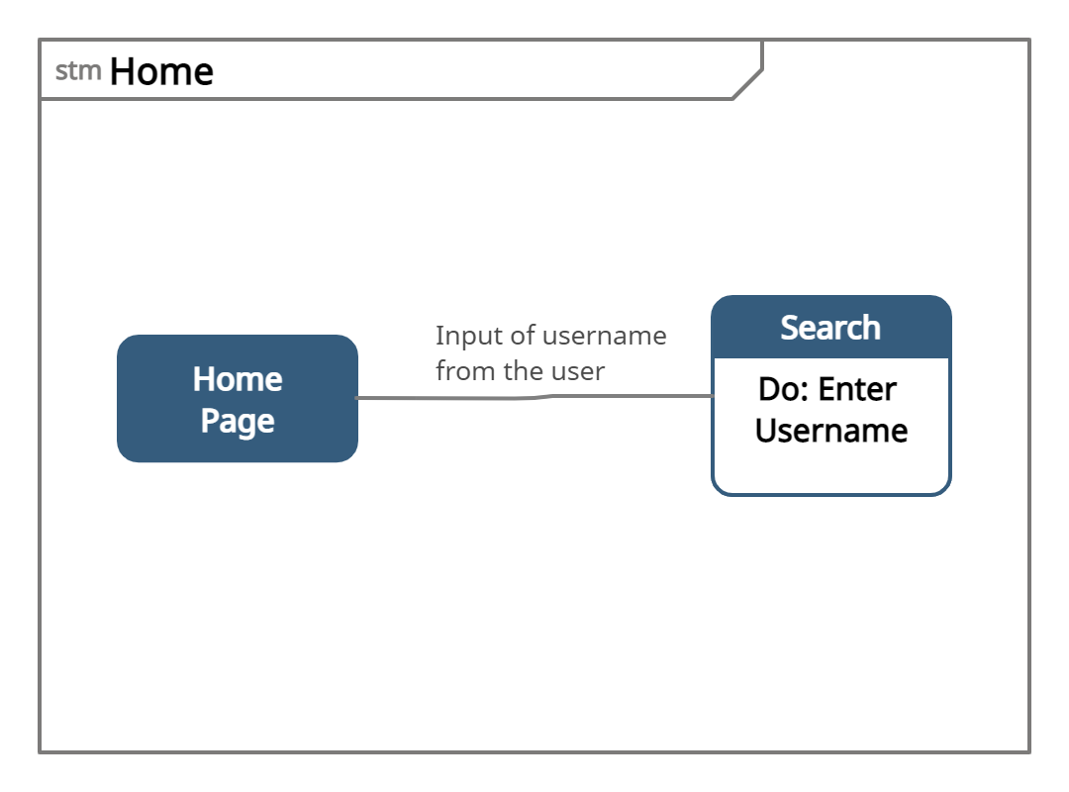

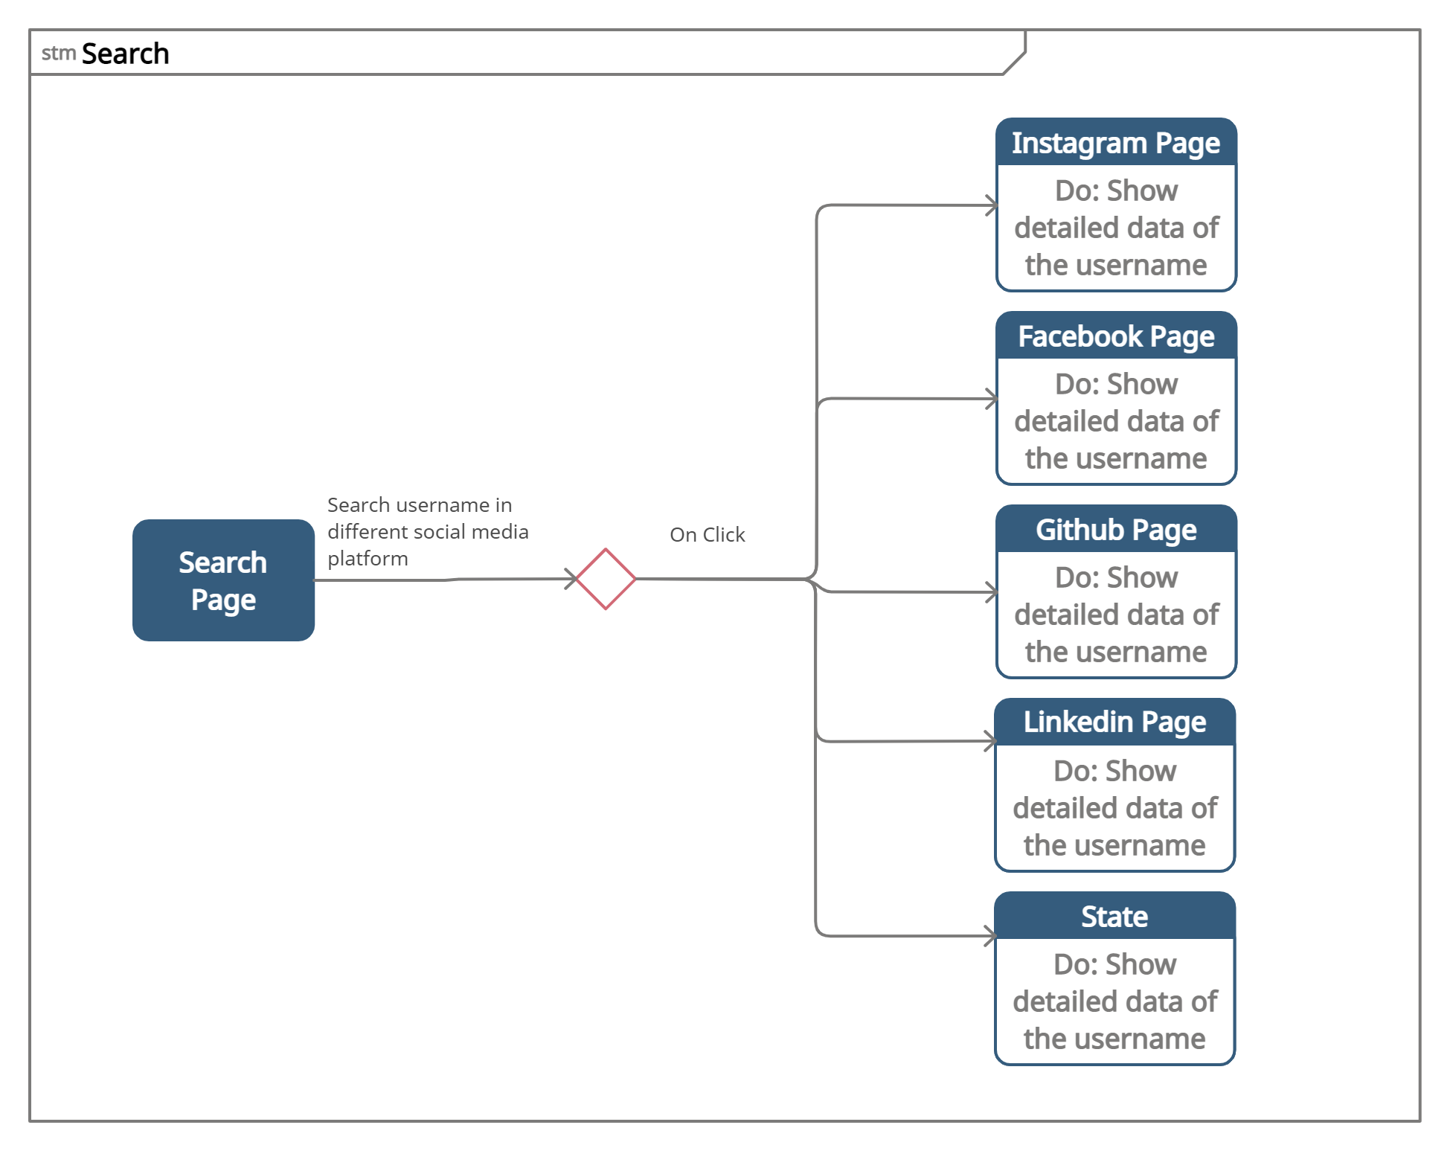

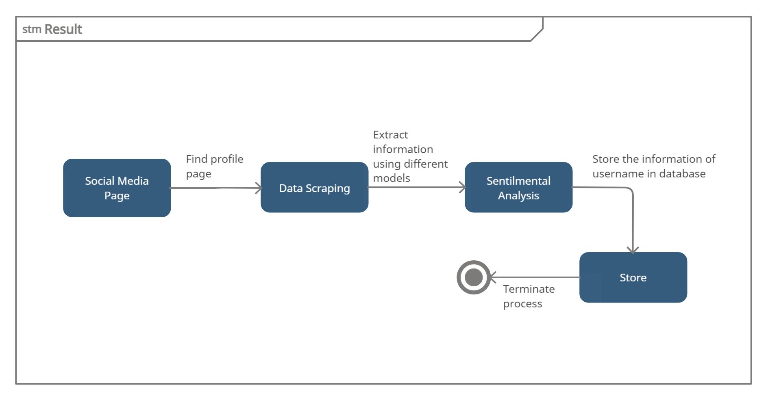

1. **ACTIVITY DIAGRAM**

