**INDIAN INSTITUTE OF INFORMATION TECHNOLOGY, ALLAHABAD**

**Software Engineering**

Instructor: Abhishek Sir

SOFTWARE DESIGN SPECIFICATION

For

**SPOTR**



A PROFILE GENERATION

WEB APPLICATION

Group Members:

IIT2019127 MRIDUL MITTAL [iit2019127@iiita.ac.in](mailto:iit2019127@iiita.ac.in)

IIT2019145 PARAS AGRAWAL [iit2019145@iiita.ac.in](mailto:iit2019145@iiita.ac.in)

IIT2019146 KSHITIJ KUMAR [iit2019146@iiita.ac.in](mailto:iit2019146@iiita.ac.in)

IIT2019148 PIYUSH GURJAR [iit2019148@iiita.ac.in](mailto:iit2019148@iiita.ac.in)

**Index**

* **Introduction** 
  + Purpose
  + Scope
  + Definitions, Acronyms, and Abbreviations
  + References
  + Overview
* **Conceptual Architecture/Architecture Diagram**
* **Logical Architecture**
  + Data Flow diagram
  + Sequence diagram
  + State diagram
    - Home
    - Choice
    - Search
    - Result
  + ER diagram
* **Execution Architecture**
* **Design decisions and tradeoffs**
* **Pseudocode for components**

**Section 1: Introduction:**

The Software Design Document is a document to provide documentation which will be used to aid in software development by providing the details for how the software should be built. Within the Software Design Document are narrative and graphical documentation of the software design for the project including use case models, sequence diagrams, collaboration models, object behaviour models, and other supporting requirement information.

**1.1 Purpose:**

This document will define the design of the one runway simulator. It contains specific information about the expected input, output, classes, and functions. The interaction between the classes to meet the desired requirements are outlined in detailed figures at the end of the document.

**1.2 Scope:**

We have described what features are in the scope of the software and what features are not in the scope of the software.

*In scope:*

1. Search user across various social media platforms
2. Can see the number of post made and like pages
3. Can extract profile information and other details which are visible publicly
4. Can store data in databases

*Out of Scope:*

1. No communication via this application
2. Cannot see the hidden post or like pages

**1.3 Definitions, Acronyms, and Abbreviations:**

*Acronyms, and Abbreviations:*

* “Spotr©”: Copyrighted app name.
* SDS: Software Design Specification
* IEEE: Institute of Electrical and Electronics Engineers

*Definitions:*

“Spotr©”: A web application for tracing the user across various social media platforms by taking username as input and storing the information in the database.

**1.4 References:**

* IEEE SRS format
* R. S. Pressman, Software Engineering: A Practitioner's Approach, 5th Ed, McGraw-Hill, 2001.

**1.5 Overview:**

The rest of this SDS is organized into different sections and subsections. The sections of the Software Design Specification document is:

1. **Introduction:** describes about the document, purpose, scope of development, project definitions and abbreviations used.
2. **Conceptual Architecture/Architecture Diagram:** describes the overview of the components, modules, structure and relationships along with user interface issues.
3. **Logical Architecture:** describes Logical Architecture Description and Components.
4. **Execution Architecture:** defines the runtime environment, processes, deployment view.
5. **Design Decisions and Trade-offs:** describes the decisions taken along with the reason as to why they were chosen over other alternatives.
6. **Pseudocode for components:** describes pseudocode, as the name indicates.
7. **Appendices**: describes subsidiary matter if any.

**Section 2:Conceptual Architecture/Architecture Diagram**

**2.1. Activity Diagram**

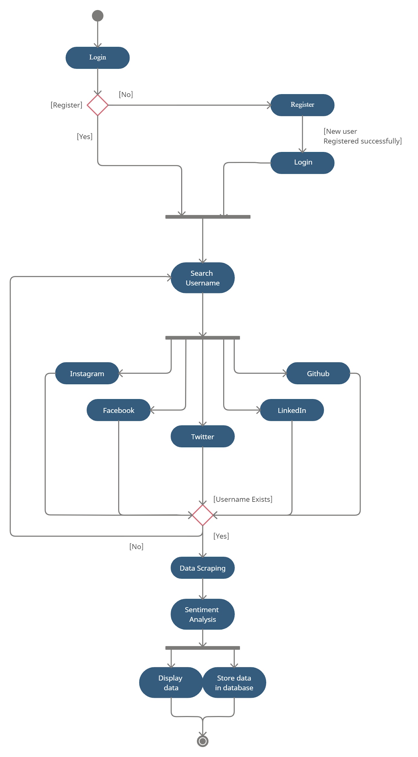

**Section 3: Logical Architecture ( Data Flow , Sequence , State diagram , ER diagram)**

**3.1. Data Flow Diagram**

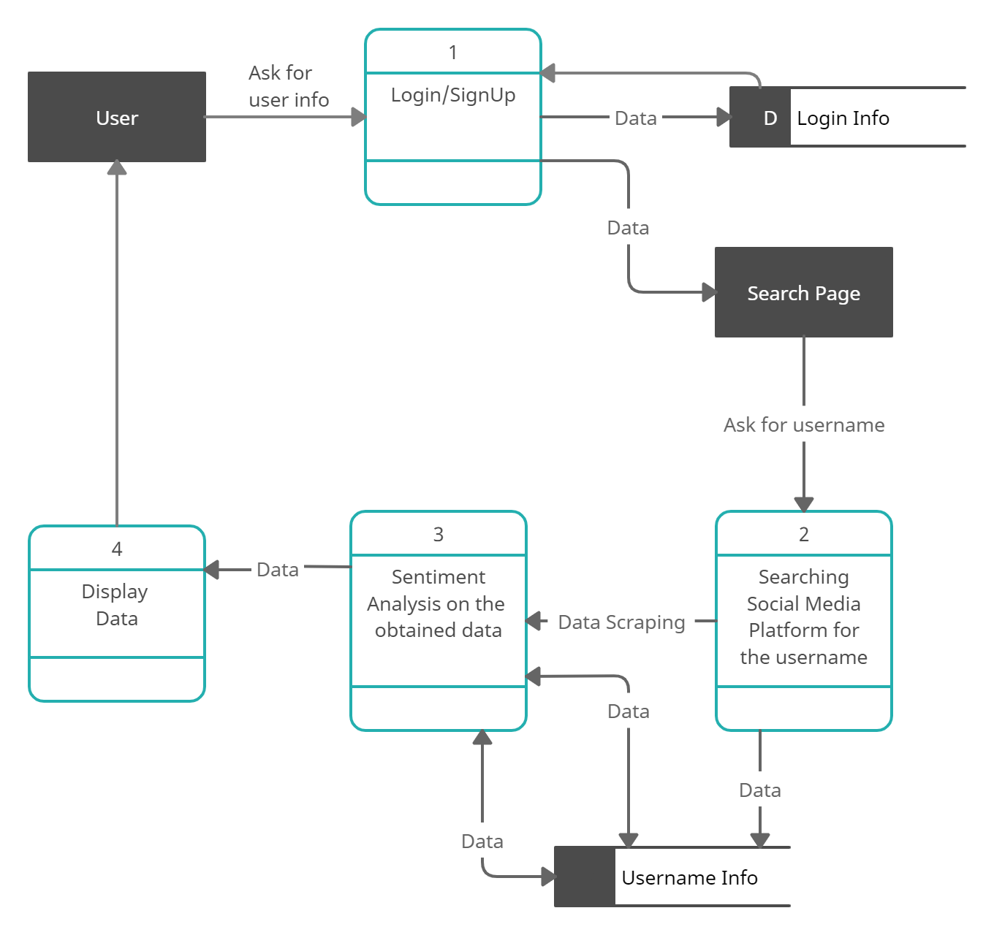

**3.2. Sequence Diagram**

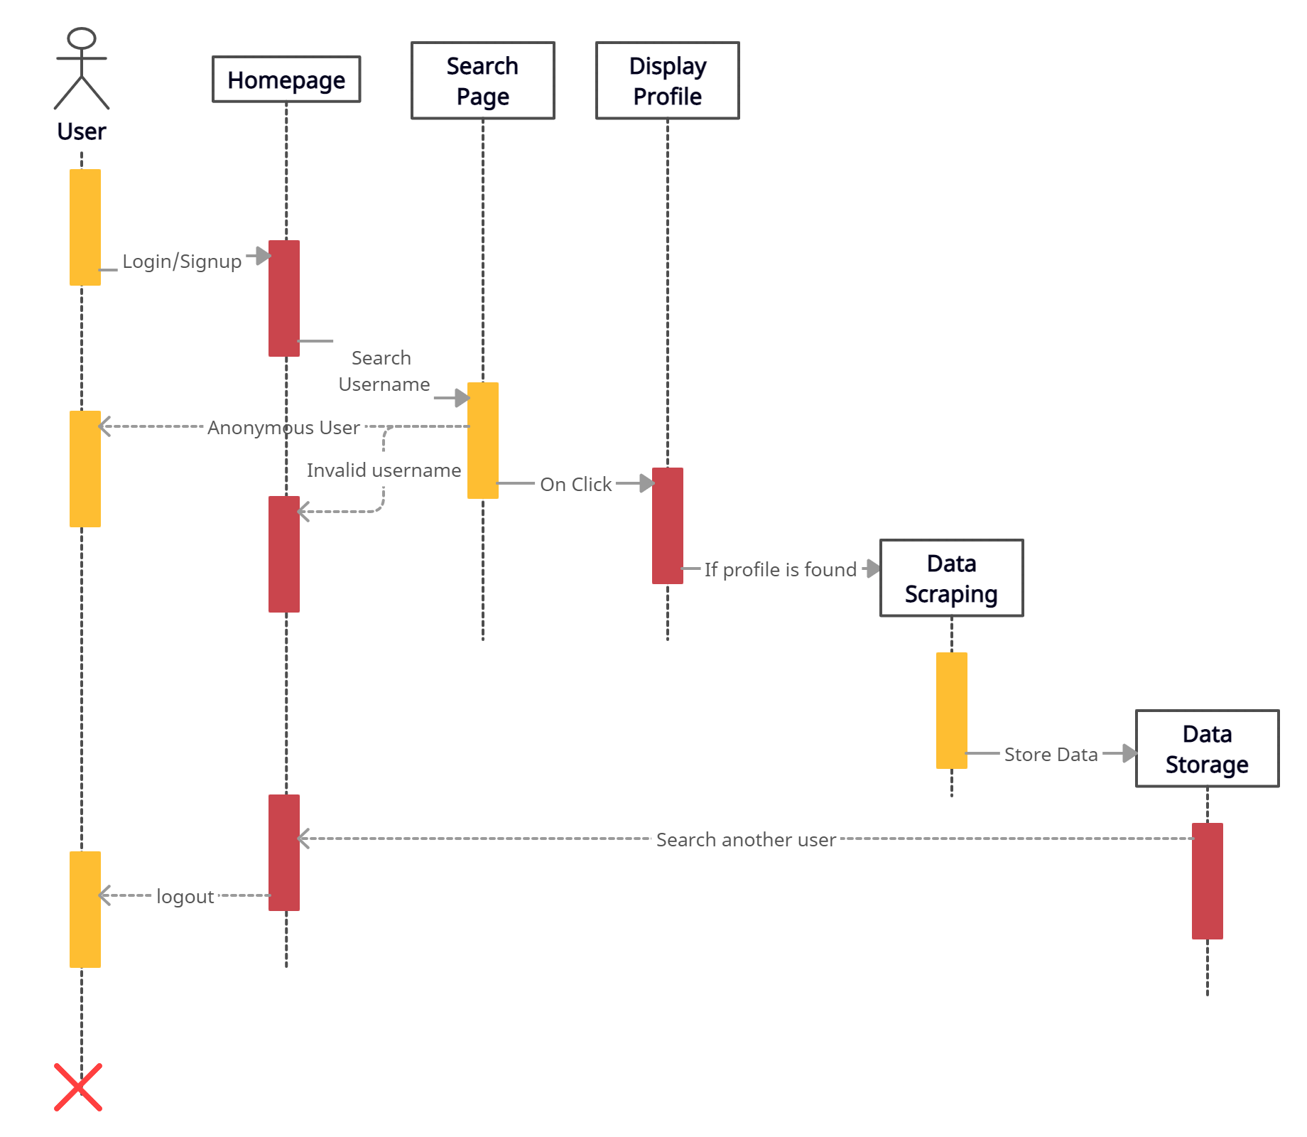

**3.3. State Diagram**

*Home :*

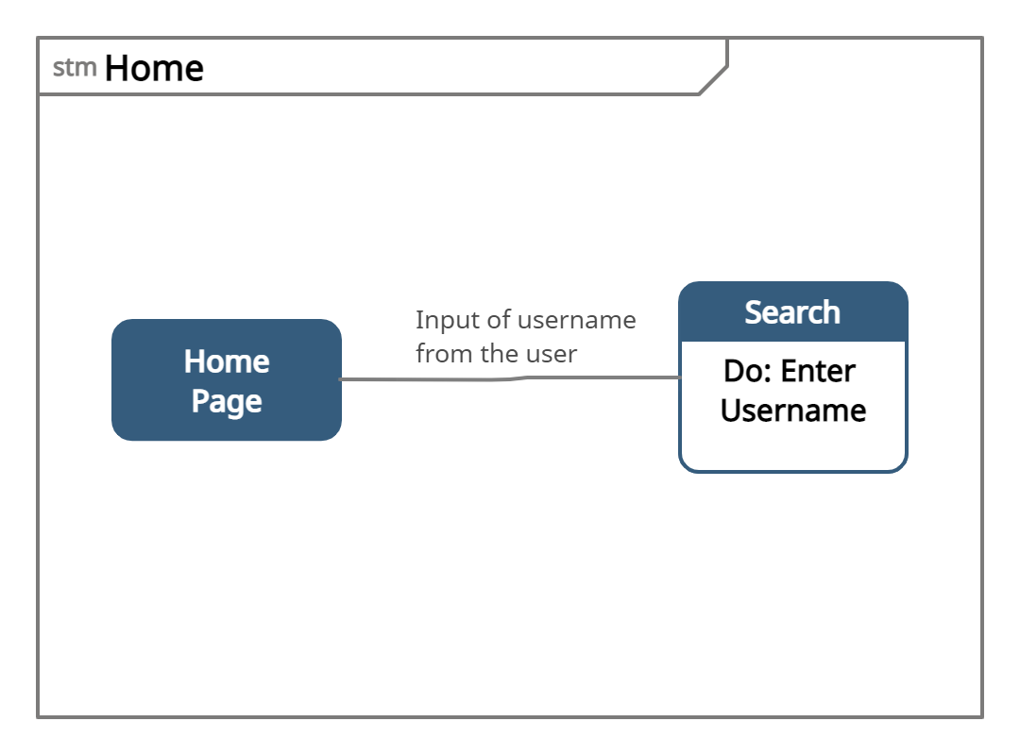

*Choice :*

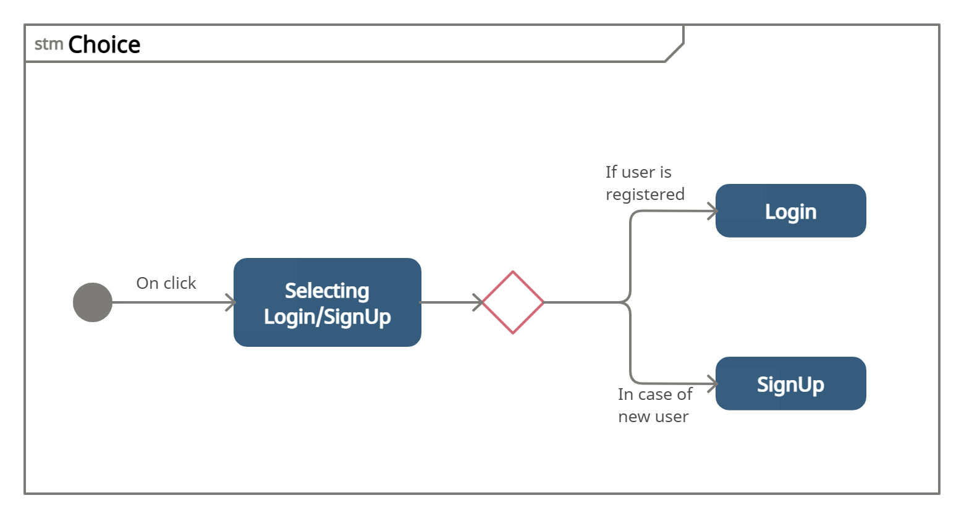

*Search :*

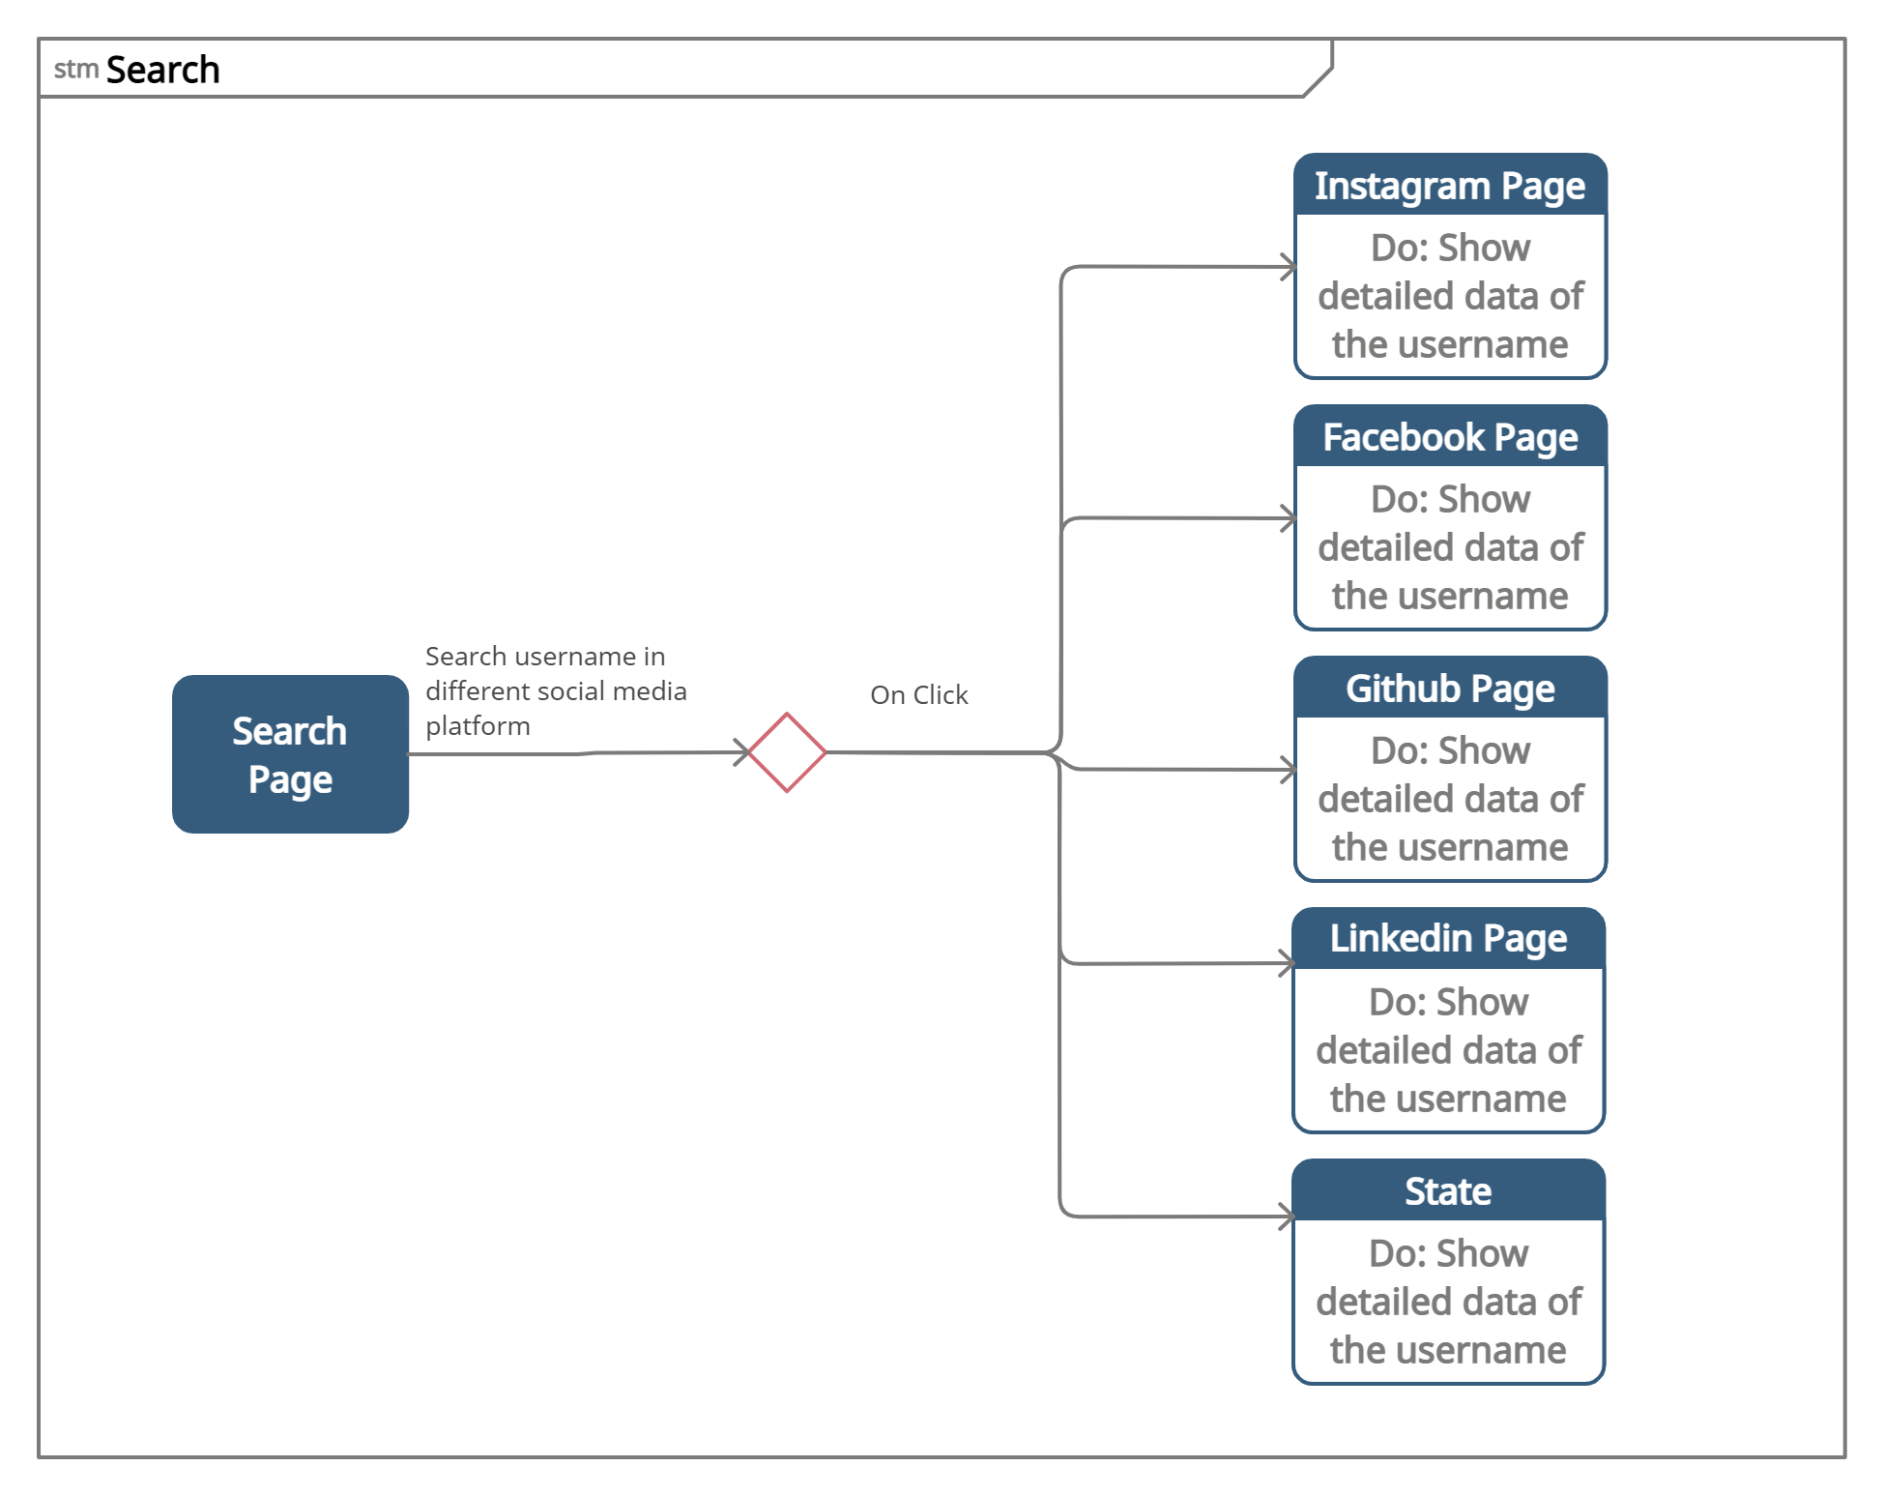

*Result :*

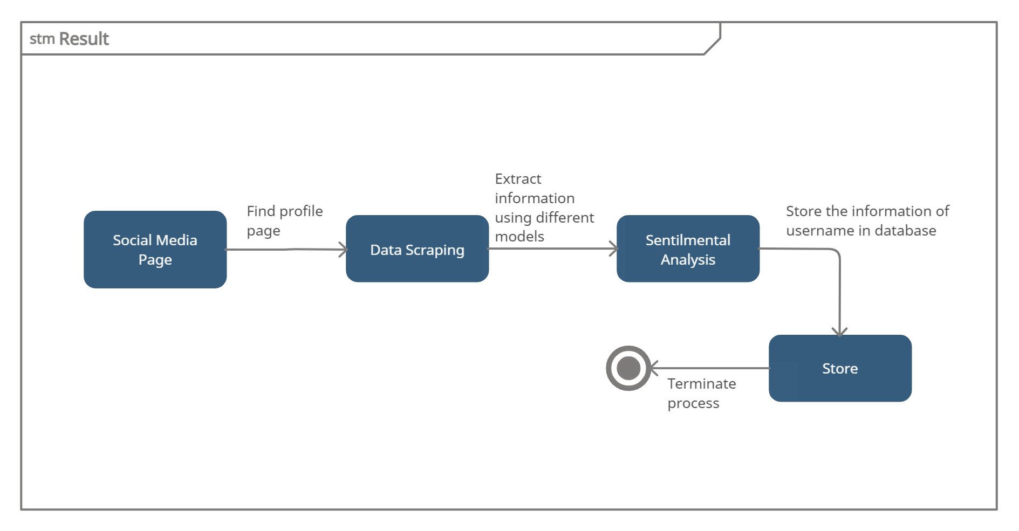

**3.4. ER Diagram**

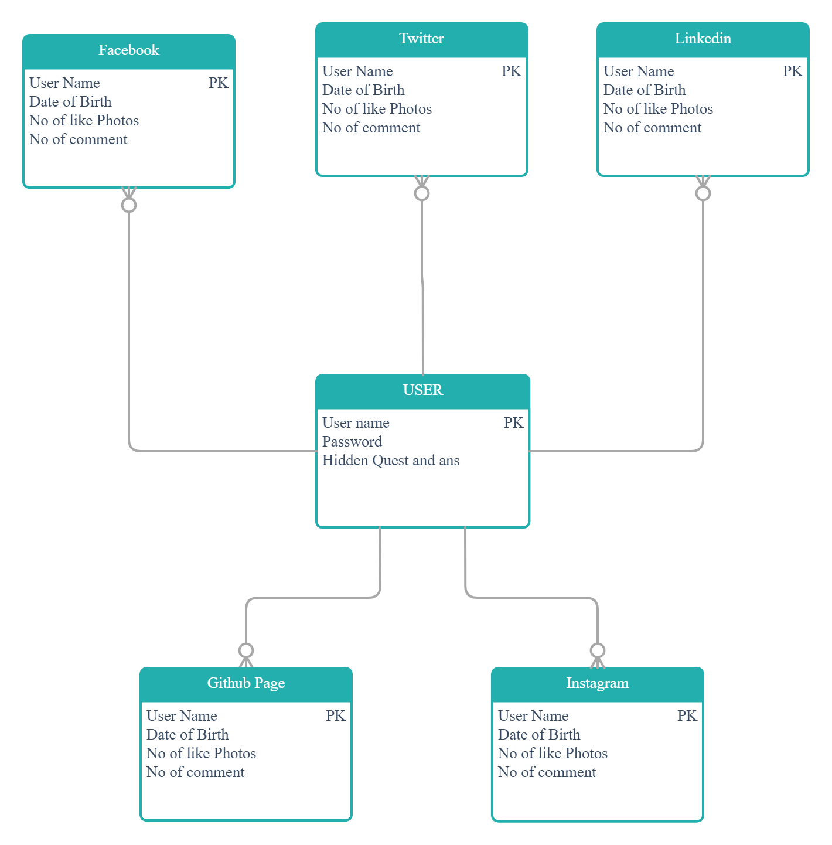

**3.1. Data Flow Diagram**

Data flow diagrams are used to graphically represent the flow of data in a business information system. DFD describes the processes that are involved in a system to transfer data from the input to the file storage and reports generation.

The user is an entity which is asked for login information. In case of registration details are taken as input and stored in the database using a data store.

In case of login the input credentials are checked in the database using login info data store . The user is then redirected to the search page of the website.

The input username is searched across various social media platforms and the data of that particular user is extracted and analysed. This data is then stored in the database using a separate data store for future uses.

This data is then displayed to the user

**3.2. Sequence Diagram**

Sequence Diagrams are interaction diagrams that detail how operations are carried out.They capture the interaction between objects in the context of a collaboration.

Sequence Diagrams are time focused and they show the order of the interaction visually by using the vertical axis of the diagram to represent time, what messages are sent and when.

*3.2.1 Homepage*

Search for particular username ,contact information of admins ,services provided by the website,login signup page and feedback forum.

*3.2.2 Search Page*

If a user is logged in the user can search a particular username and check for all available platforms with that username. If user is not redirected to login sign up page

*3.2.1Display Profile*

Display the information for every social media platform in which the username exists. After clicking on the display profile button on the search page user is redirected to the main profile page of that particular username.

*3.2.4 Data Processing*

Data is collected from all social media platforms and sentiment analysis is performed for extracted data. This is then stored in the database

**3.3. State Diagram**

A state diagram consists of states, transitions, events, and activities. You use state diagrams to illustrate the dynamic view of a system. They are especially important in modeling the behavior of an interface, class, or collaboration.

State diagrams emphasize the event-ordered behavior of an object, which is especially useful in modeling reactive systems.

*3.2.1 Home*

Search for particular username ,contact information of admins ,services provided by the website,login signup page and feedback forum.

*3.2.2 Choice*

Allows users to enter credentials, which are being checked for authentication in the back-end. After being authenticated successfully, it lands up on Search Page

*3.2.3 Search*

If a user is logged in the user can search a particular username and check for all available platforms with that username. If user is not redirected to login sign up page

*3.2.4 Result*

Display the information for every social media platform in which the username exists. After clicking on the display profile button on the search page user is redirected to the main profile page of that particular username.

Data is collected from all social media platforms and sentiment analysis is performed for extracted data. This is then stored in the database

**3.4. ER Diagram**

Entity Relationship Diagram (ERD), a database design tool that provides graphical representation of database tables, their columns and inter-relationships. ERD is the most popular database design tool. A well-developed ERD can provide sufficient information for database administrators to follow when developing and maintaining a database.

We have a separate database for each social media platform which stores its basic information such as name, number of posts with primary key as name. We also have a common database table which stores user login credentials used for login signup page.

**Section 4: Execution Architecture:**

The framework which ties up this relation and interaction together is Web Application Architecture. In a nutshell, the flow of processes typically include the user browsing for an URL, following which the browser triggers a search.

**4.1 Reuse and relationships to other products**

This project uses API of various social media products to deliver information of any public user.

For example we use twitter API tweepy to extract user’s information thus in relationship with all social media platforms.

This project reuses the data as once an username is searched the respective data along with the analysis is stored in the database for any further use. In future if the same username is search we can simply fetch the information from our database instead of relying on external sources.

**Section 5: Design Decisions and Tradeoff:**

The design decision to use two screens separately for old users and new users is to provide encapsulation. It may have been possible to get all the information on one screen.

However, using two screens will keep the data of signed-in users separate from the data being accessed by anonymous users .

A possible tradeoff when considering links is to use buttons instead of items in the menu. This design decision - to use buttons for navigating between screens - is to enhance visibility.

Text links in the menu bar located at the bottom of the PDA’s screen can be hard to see. The tradeoff for buttons with descriptive labels rather than text links in the menu bar will be that navigation from screen to screen will be easier.

Descriptive labels will let the user know where he is navigating. Buttons are larger than the text links located in the menu bar.

Therefore, it is easier for the user to locate the mechanisms needed to navigate from screen to screen.

**Section 6: Pseudocode for components:**

login user()

{

get username

get Password

if username exists ()

{

if password matches()

Login successful

else

Invalid password

}

else

Invalid username

}

register user()

{

get FullName

get email address

get Phone Number

get Password

get Password Again

if data is valid ()

Store in database

else

Invalid data

}

search username() {

get username

search for username in social media sites

if username found

{

display data

analyse data()

}

else

No user found

}

analyse data()

{

get information from profile page

if information extracted successfully

sentimental analysis of the user based on the

information provided by the social media site

display data to the user

store the extracted data in database

}