**Design and development of a weather-based automatic irrigation system for conventional farming**

**Microprocessor and Embedded System**

1. **Introduction**
   1. **Background of Study**

Agriculture is the country's backbone and is intertwined with its food security. Bangladesh's government's 'Vision 2021' calls for the country to achieve food self-sufficiency by 2013 and to feed everyone. The most important concern is increased agriculture output, which is caused by increasing population expansion. Aside from food security, the industry contributes around 12% of GDP and employs 44% of the workforce in the country. For these reasons, the government has provided the agriculture sector lot of emphasis. The agriculture sector is intimately tied to rural poverty since this helps the livelihood opportunities of the rural poor, who make up a significant portion of the population. [26] - [28]

Bangladesh's agriculture industry is a major source of revenue and employment. Subsistence farming is practiced by the majority of the farmers. Crop production increases rural income and provides employment for the impoverished [41]. The country, which is trapped between both the Himalayas and the Bay of Bengal, is prone to natural calamities. Climate change has increased the severity and frequency of salinity, storms, droughts, erratic rainfall, high temperatures, flash floods, and other global warming-related events. Tropical countries' crops are being harmed by global warming. As a result, one of the biggest issues in Bangladesh is weather forecasting, which has an impact on people's quality of life and activities. Collecting previous and current information regarding the weather condition as it is understood today [4] - [6] is quite challenging. Bangladeshi farmers may find it beneficial to water their already-grown crops before they get damaged.

The bulk of irrigation equipment are now operated manually. In a sensor-based irrigation system, the humidity sensor includes the calculation of water vapor in the atmosphere, which effects current flow through the soil, while the temperature sensor records the temperature in the land area. The Grove 128*64 OLED display shows the value of these two sensors. [16] - [18] [19].

Agriculture has grown steadily throughout the years, owing primarily to climate change. However, if steps are implemented, higher growth may be feasible. As a result, to make agriculture viable in Bangladesh, efficient irrigation water utilization and effective irrigation facilities are essential. A dc motor appears to be more environmentally friendly. If irrigation systems are automated, farmers may be able to water crops more effectively and safely during seasons with fewer outages. By saving resources like water and power, our strategy will help small farmers improve their livelihoods [28] - [30]. Farmers in climate-vulnerable locations can use efficient irrigation systems to adapt and strengthen their resilience to climate change.

* 1. **Motivation**

Agriculture is a tool that can help to ensure food security. With the growing need for food, it's vital that we keep the correct balance in order to grow the right quantity of crops. Despite the fact that agriculture is critical to our country's survival, we are unable to effectively use its resources. The principal culprits include climate change, water waste, and a shortage of land reservoir water. Farmers use 35 percent of 100 liters of water for vital irrigation and misuse the remaining 65 percent, according to Lutfor Rahman, Chief Engineer of Bangladesh Agricultural Development Corporation, resulting in billions of tones of water squandered each year. Furthermore, repeated water extraction from the soil lowers the water level in the soil, resulting in an increase in unirrigated land zones. Agriculture is the most susceptible industry since its output is impacted by environmental conditions including temperature, air pressure, humidity, and rainfall, which are all expected to be unpredictable. To overcome these challenges, we devised a system that employs DHT11 sensors to accurately anticipate weather while also decreasing water waste by shutting down the engine when necessary. Farmers may utilize our method to carry out irrigation tasks in a cost-effective and resource-saving manner. Food is one of our most fundamental requirements, hence the pivotal role in our economy has been mentioned at first. As a result, the prior data supplied by Bangladesh agricultural statistics are presented for adequate irrigation. The intricacies of each component are then briefly addressed. Following that, a circuit schematic of the project's implementation was provided. The project's functioning concept and outcome were then addressed. Following that, we addressed the project's influence on our society and environment.

* 1. **Project Objectives**

The demand for food is growing every day, but the proportionate increase remains the same. All agricultural commodities are getting extremely expensive in this epidemic condition. Because of the reducing cost and increase of agricultural crops, an automated system is highly vital and necessary in the agriculture area. In this system, we employed two types of sensors. The DHT11 Humidity and Temperature sensor is the first, while the BMP180 Digital Pressure Sensor Breakout Board is the second. The primary goal of this article was to enable farmers to grow the same amount of crops with less water, hence saving energy. This paper's strategy also encourages environmental stewardship.

* 1. **A brief outline of the report**

1. **Literature Review**

Closed loop control and sensor feedback in an automated irrigation system might help match water supply to crop demand and prevent waste [1]. The system's aim is thwarted when an excessive quantity of water is regularly applied to the crop, or when an inadequate amount of water is constantly applied to the crop. The output of the Humidity and Temperature sensor-based systems is sent through an A/D converter, which converts it to digital domain before feeding it to the controller for further processing. [2]. Aside from that, today's Automated Irrigation Systems collect data from the field and weather using a sensor network. On his cell phone, the farmer receives the relevant information of a [3].

On the other side, the technology improved water saving by employing a meteorological forecast that takes data from a webpage about rain predictions and distributes adequate water for certain crop and soil combinations" [4]. However, it ran into problems obtaining real-time data. Irrigation systems based on humidity detectors and soil moisture [5] and solar-powered irrigation systems [6] have also had a significant influence on the irrigation process.

First and foremost, the world's water resources are vanishing. Robotized Drip Irrigation is the unequaled solution to this problem. The developed water system technology eliminates the need for craftsmanship in both floods and trickle water systems. Direct programming allows us to disperse available water to harvests if and only if there is a great demand for water to the harvest in order to achieve the most benefit for the least money [13]. Water scarcity causes plants to wilt before visible wilting, consumes more water, and causes the water delivery to the land to be delayed, causing the crops to dry up.  This problem might be fully remedied if we used Automation Irrigation, which only watered when there was a strong need for water, as indicated by soil moisture [17]. The gadget regulates monitoring depth of the water on a regular basis to ensure that the plant or crop gets the exact amount of water it requires. The device maintains a record of the soil's temperature and humidity in order to preserve the soil's nutritional content under control for optimal root growth. The sensor conveys a signal from the field to the person if the quantity of water available increases or decreases, and the operator controls the pump to regulate or turning off the phone [18]. On the other hand, a computerized Sunlight-based water system control framework was employed to save water in smart cities, and the framework is also using the Internet of Things to keep up with connection between the water systems land and rancher. The GSM framework displays SMS and maintains a relationship between the homestead unit and the rancher's cell phone. To provide the precise benefit of wetness, temperature sensors and soil sensors are used, after which the valve in the framework is switched on/off. [21].

There is a revolutionary technique in the world of solar energy. There has been a demonstration of the concept. The irrigation system's energy is generated by photovoltaic panels. Farmers will see energy from the sun smart irrigation as the way of the future, as well as a solution to the energy crisis. As reported in this paper, the solar-powered system uses the Sine PWM technique for inverter operation with minimal harmonics, which enhances the system's efficiency [11]. Despite the fact that this method uses renewable energy, it has some drawbacks, including a high initial cost and a big footprint. A unique system for monitoring soil moisture levels has been devised using a wireless sensor network. That is how the project's architecture was presented, as well as the decisions that were made using real-time data. It has several disadvantages as well, such as maintenance issues and complicated installation [23]. There is an enhanced automated irrigation system that is based on a GSM-based prototype. The key advantage of this method is that it provided a summary of data and a schedule for the irrigation operation. The authors created a low-cost programmable automation controller (PLC) irrigation system in order to raise the market's economic level. This also resulted in the development of an irrigation water based on the Internet of Things and Artificial Intelligence [20].

Remote Measurement and Analysis System for Greenhouses GSM-SMS was used to develop a remote measuring and analysis system for greenhouses. Information is sent by SMS across the GSM network between the remote end and the targeted system. [10]. This research [16] describes the usage of a remote sensor network for a low-cost remote controlled and verified water system design. Remote Measurement and Analysis Solution for Greenhouses The proposed system included a GSM-SMS remotely measurement and analysis system for greenhouses, which again was based on just a Computer database system coupled to a GSM-SMS station. Whenever the user is within a few meters of the chosen system, a Bluetooth is also connected to the main micro controller, which reduces SMS costs. The alert Message may be delivered to the User-specified Mobile phone automatically in an IOT alarm system based on SIM900A through the system settings, regardless of the user's location [22].

When compared to normal water system practices, Torsi meters and granular lattice sensors (GMS) to inundate tomatoes conserved water. More research is needed to redo this type of study, and future studies should be conducted on a larger scale to determine the effectiveness of programmed water systems against manual water systems [15]. These systems transform the way field resources are managed. For mobile devices, a software stack called Android was built, which combines an operating system, networking, and critical apps. As an irrigation control system, this program makes advantage of the GPRS function of a mobile phone. Water management decisions are supported by the system [19]. First and foremost, the world's water resources are vanishing. Robotized Drip Irrigation is the unequaled solution to this problem. The developed water system technology eliminates the need for craftsmanship in both floods and trickle water systems. Furthermore, direct Programming aids us in the proper management of readily available water [13]. We will utilize a microcontroller in our Automated Irrigation to solve this problem.

1. **Methodology and Modeling**
   1. **Introduction**

We propose a system that will monitor temperature, air pressure, and humidity, as well as provide weather updates, allowing farmers to apply the appropriate amount of water at the appropriate time by turning on/off the motor. Proteus Software is being used to simulate our project. In Proteus, we put the components into schematic capture and use Visual Designer to create the flowchart. We used an Arduino Board R3 (Atmega328p) board, a DC motor shield, a DHT11 humidity and temperature sensor, a 0.96 OLED 128*624, a BMP 180, a breadboard with jumper wires, and an LED light to construct our system.

* 1. **Working principle of the proposed project**
     1. **Process of Work** → [**Part under OBE assessment]**

This project's major goal is to:

Manage the water supply to ensure healthy plant growth. As a result, a substantial volume of water will be avoided from being wasted. The irrigation is controlled by the microcontroller, which determines when the pump should be switched on or off, saving the farmers a lot of time. Farmers will be able for some much rest since they will never longer have to manually turn the pump on and off. Increase the pace of agriculture output by ensuring that agricultural resources are used properly. This gadget is designed to detect humidity, temperature, and pressure, all of which can tell a farmer when to water and when not to irrigate a field. This gadget has a display that shows the indication. According to the Bangladesh Annual Agricultural Report over the past three years, temperature varies by place and month, but is typically 9 degrees Celsius to 30 degrees Celsius, with humidity ranging from 65 percent to 98 percent. With these parameters in mind, the gadget was created to rapidly inform farmers of their current measurement.

* 1. **Description of the important component**

|  |  |
| --- | --- |
| DHT11 temperature sensor: | Used for sensing temperature and humidity. |
| BMP(Barometric Pressure)180 | Used for measure atmospheric pressure |
| PWM | Used for controlling speed in DC motor shield and pulse width Modulation. |
| H-Bridge | used for controlling rotation direction of DC motor shield. |
| Grove - OLED Display | use for how output of temperature and weather pressure |
| LED light | Is a semiconductor that emits light when an electric current is passed through it |

* 1. **Implementation**

For Schematic Capture Arduino Motor Shield with DC Motors, Arduino DHT11 Humidity Temperature Breakout Board, Arduino BMP180 Digital Pressure Sensor Breakout Board, Grove OLED display module, Arduino LED's Breakout Board is used. For Arduino Motor Shield with DC Motors I03, I08, I09, I011, I012, IO13 pins are used. For Arduino DHT11 Humidity Temperature Breakout Board IO7 pin is used. For Arduino LED Red I05 Yellow 105 Green Breakout Board IO6 pin is used.

For the Visual Designer Setup Function, at first Assignment Block is assigned. In the Assignment Block “Cur_Allt”, “Temp ', “M_Pressure”, “Humi”, “Simp_Wea_diff” ”St_Pressure” and “message” variables are created and 23 is assigned in the “Cur_Allt” variable. After that by expanding the LED1,2,3 “off” method is assigned which will initially turn the LED off. Then by expanding the M1, M2 “stop” function is assigned. For Loop, at first by expanding the HTS1, “readTemperature” method is assigned Then which will read the temperature value and will keep the value in the “Temp” variable. Then in the Assignment Block,” Temp:” +toString(Temp)+”*C” is assigned to the “message” variable. After that “Display" method is called. Then by expanding the PS1, “readPressure” method is attributed which will read the value for the pressure and keep it to the “M_Pressure” variable. Then in the Assignment Block” M_Pressure:” +toString(M_Pressure)+”Kpa” is assigned to the “message” variable. After that again “Display” method is called. Then by expanding the HTS1, “readHumidity” method is attributed which will take the value of the humidity and keep the value to the “Humi” variable. Then in the Assignment Block Humidity: + toString(Humi)+% is assigned in the message variable. Then again the “Display” method is called.

After that an Assignment Block is assigned where 100.3*exp (Cur_Allt / (-7990))) is assigned in the St_Pressure variable and (M_Pressure/10)- St_Pressure is assigned to the Simp_Wea_diff variable. Then again the “Condition” method is called and after that “Display” method is called. Next a delay for 2 second is generated. For the condition vent block at first decision block is assigned. Then a decision block is assigned where (Simp_Wea_diff >0.25) is assigned as the condition for the decision block. If the condition of the decision block is matched, then LED1 will turn on and LED2 , LED3 will be turn off. After that in the Assignment Block” Weather= Sunny” is assigned in the “message” variable. Then “run” method is assigned by expanding the M1 where “FORWARDS” is set to the “dir” and 255 is set to the “speed”. That means the motor will run in the forward direction with the speed of 255. In the same way we have set the M2 motor. If the condition (Simp_Wea_diff >0.25) is not matched, then again a block with the condition (Simp_Wea_diff >=-0.25) && (Simp_Wea_diff <=0.25) is assigned. If the condition of the decision block is matched, then LED2 will turn on and LED1, LED3 will be turn off. After that in the Assignment Block” Weather= Sunny/Cloudy” is assigned in the “message” variable. Then “run” method is assigned by expanding the M1 where “FORWARDS” is set to the “dir” and 128 is set to the “speed”. That means the motor will run in the forward direction with the speed of 128. In the same way we have set the M2 motor. If the condition (Simp_Wea_diff >=-0.25) && (Simp_Wea_diff <=0.25) is not matched, then again a decision block with condition (Simp_Wea_diff <=-0.25) is assigned. If the condition of the decision block is matched, then LED3 will turn on and LED1, LED2 will be turn off. After that in the Assignment Block” Weather= Rainy” is assigned in the “message” variable. Then “stop” method is assigned by expanding the M1. That means the motor will turn off. In the same way we have set the M2 motor. For the Display Vent Block at first by expanding the LCD1 “clearDisplay” method is assigned. Then again by expanding the LCD1 “setTextColor” method is assigned where the value is white. Then by expanding the LCD1 “setTextSize” method is assigned where the value is 1. “setCursor” method is assigned by expanding the LCD1 where the value for both the x & y is set to 2. Next by expanding the LCD1 “print” method is assigned where “message” is set to the “variable” and “display” method is assigned in the same way. Finally, a delay for 1second is generated.

* 1. **Test/Experimental setup** → [**Part under OBE assessment]**

Firstly, by adding assignment block, new variables were created then all parameters were initialized. After all the LED lights and motors were kept off. From the peripheral LCD1, PS1, HTS1, LED1, LED2, LED3, M1, M2 were implemented and expanded. From HTS1 for reading temperature we used the variable Temp. Before showing all the results full screen was cleared and text color, size was declared and by the set cursor block whether the results will be shown was determined. For showing on the display the temperature was brought through message block. By the same process humidity and pressure were shown on the display. For applying all the conditions another assignment block was implemented. For maintaining the conditions, it will go 2ndpage automatically. After printing all the results were holding repeatedly with 2s on display.

* 1. **Cost analysis**

**[Guideline for section 3.2.1:** The ascertained project is a complex engineering problem and certainly it follows a specific method or working procedure to ensure intended functionality. Hence, one should discuss how the process is developed and the proposed “Process” is irrespective of users’ cultural (religion, language, morals etc.) and societal factors (education level, income, gender etc.).**]**

**[Guideline for section 3.5:** The design process of the experiment and the investigation behind the finalized setup should be reported here. The conception of the “Experiment” includes both the setup and study to justify the desired functionality of the developed prototype. Hence, before presenting the experimental setup and procedure, one should present which kind of engineering knowledge is required to develop such setup along with the analysis that is conducted to reach the final stage of the setup. It should be highlighted that the developed setup is a technically complicated one that requires many components to build; else, it is a big challenge to design such setup and the ultimate setup is accomplished tackling several sub-challenges.**]**

1. **Results and Discussion**
   1. **Simulation/Numerical analysis**

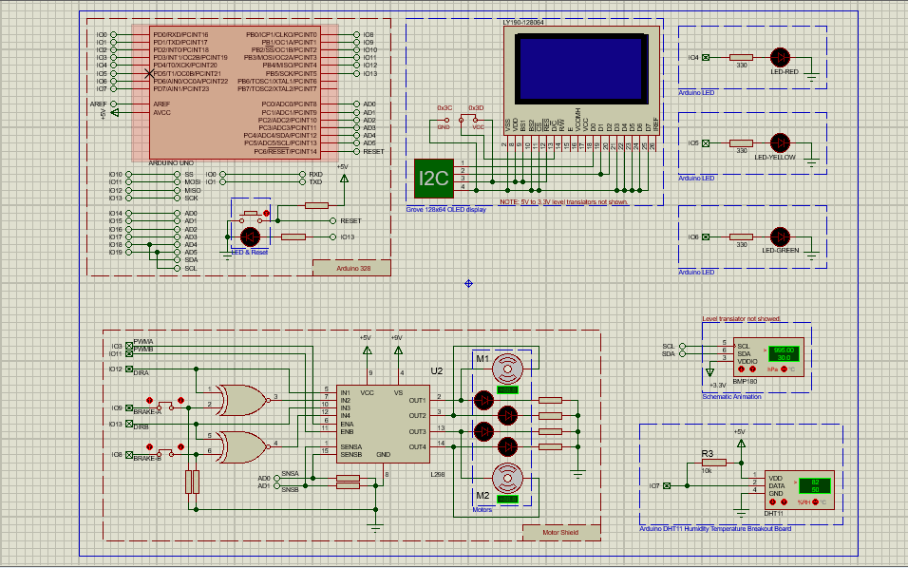

**Figure1: Main Schematic Diagram**

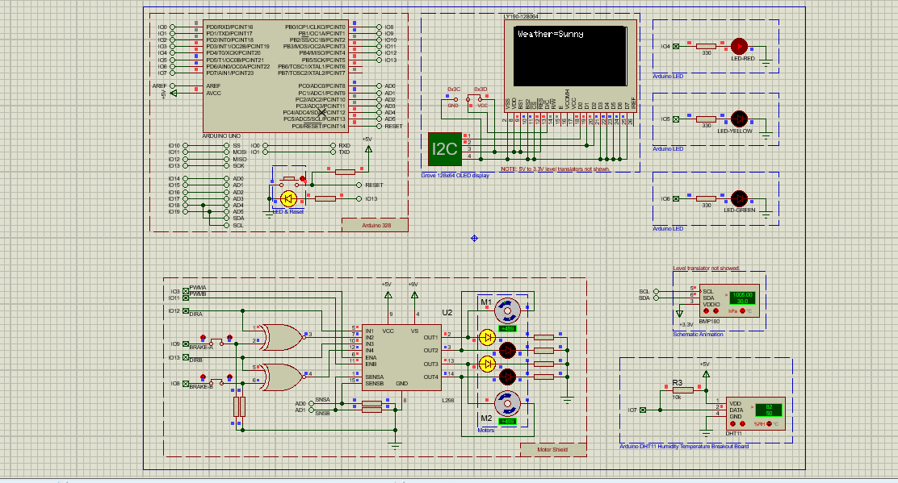**Figure2: When sunny condition occurs, Motor runs at high speed, Red LED turns on**

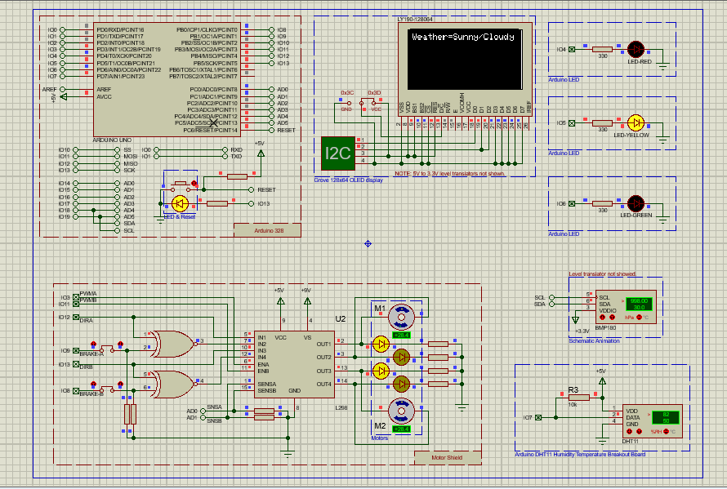

**Figure3: When sunny/ rainy condition occurs, Motor runs at medium speed and Yellow LED turns on**

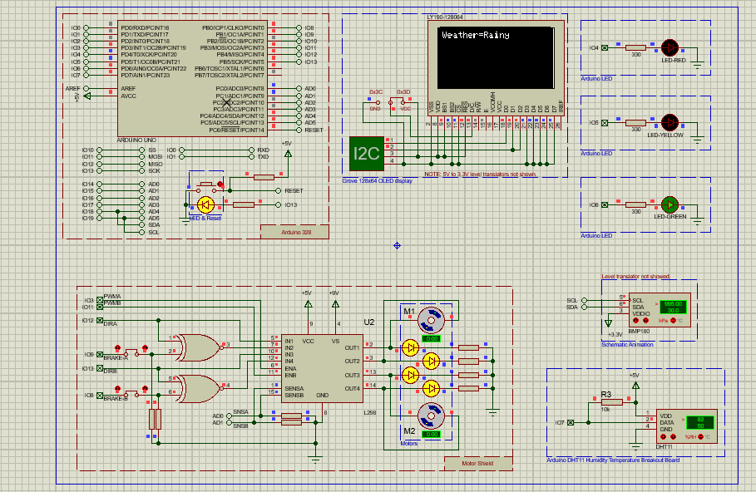

**Figure4: When rainy condition occur, Motor turns off and green LED turns on.**

* 1. Measured response/Experimental results
  2. Comparison between numerical and experimental results

[NB: Due to the pandemic, the current mode of education is completely online based; therefore, the project functionality will be demonstrated based on simulation results only. **Hence, section 4.2 can be ignored and in section 4.3, a brief discussion on the simulation results should be presented instead of comparative analysis. Since the experimental results will not be presented, so a substantial amount of simulation results and analysis should be reported in this chapter.**]

1. **Conclusion and Limitation**
2. **Reference**

[1] Balbis, L., & Jassim, A. (2018, November). Dynamic Model of Soil Moisture for Smart Irrigation Systems. In 2018 International Conference on Innovation and Intelligence for Informatics, Computing, and Technologies (3ICT) (pp. 1-4). IEEE.

[2] Ingale, H. T., & Kasat, N. N. (2012). Automated irrigation system. International Journal of Engineering Research and Development, 4(11), 51-54.

[3] Chang, H., Zhou, N., Zhao, X., Cao, Q., Tan, M., & Zhang, Y. (2014, October). A new agriculture monitoring system based on WSNs. In 2014 12th International Conference on Signal Processing (ICSP) (pp. 1755-1760). IEEE.

[4] Sirohi, K., Tanwar, A., & Jindal, P. (2016, November). Automated irrigation and fire alert system based on hargreaves equation using weather forecast and ZigBee protocol. In 2016 2nd International Conference on Communication Control and Intelligent Systems (CCIS) (pp. 13-17). IEEE.

[5] Uddin, J., Reza, S. T., Newaz, Q., Uddin, J., Islam, T., & Kim, J. M. (2012, December). Automated irrigation system using solar power. In 2012 7th International Conference on Electrical and Computer Engineering (pp. 228-231). IEEE.

[6] Malhotra, A., Saini, S., & Kale, V. V. (2017). Automated irrigation system with weather forecast integration. International Journal of Engineering Technology, Management and Applied Sciences, 5(6), 179-184.

[7] Rajavarman, R., Rengan, S. A., Daniel, P. A., ArunKumar, R., & Karuppaiya, K. SMART AGRICULTURAL WATER IRRIGATION MONITORING AND CONTROL SYSTEM USING IOT BLYNK SERVER. Stud. Rosenthal, (1781), 9.

[8] Pradeep, K. V., & Balasundaram, A. (2021). IoT based Smart Irrigation for Agricultural Fields. Annals of the Romanian Society for Cell Biology, 2000-2009.

[9] Yashaswini, L. S., Vani, H. U., Sinchana, H. N., & Kumar, N. (2017, September). Smart automated irrigation system with disease prediction. In 2017 IEEE International Conference on Power, Control, Signals and Instrumentation Engineering (ICPCSI) (pp. 422-427). IEEE.

[10] Rawal, S. (2017). IOT based smart irrigation system. International Journal of Computer Applications, 159(8), 7-11.

[11] S. Harishankar, R. Sathish Kumar, K.P. Sudharsan, U. Vignesh and T. Viveknath (2014). “Solar powered smart irrigation system. Advance in electronic and electric engineering,” Volume 4, Number 4 (2014), pp. 341-346.

[12] Darshna, S., Sangavi, T., Mohan, S., Soundharya, A., & Desikan, S. (2015). Smart irrigation system. IOSR Journal of Electronics and Communication Engineering (IOSR-JECE), 10(3), 32-36.

[13] Giri, M., & Wavhal, D. N. (2013). Automated intelligent wireless drip irrigation using linear programming. Proceedings of the Special Interest Group on Management of Data Record, International Journal of Advanced Research in Computer Engineering Technology, 2(1).

[14] Munoth, P., Goyal, R., & Tiwari, K. (2016). Sensor based irrigation system: A review. NCACE. USA.

[15] Boutraa, T., Akhkha, A., Alshuaibi, A., & Atta, R. (2011). Evaluation of the effectiveness of an automated irrigation system using wheat crops. Agriculture and Biology Journal of North America, 2(1), 80-88.

[16] Awati, J. S., & Patil, V. S. (2012). Automatic Irrigation Control by using wireless sensor networks. Journal of Exclusive Management Science, 1(6), 1-7

[17] G unturi, V. N. R. (2013). Micro controller based automatic plant irrigation system. International h, of Advancements in Research & Technology, 2(4), 194-198.

[18] Gutiérrez, J., Villa-Medina, J. F., Nieto-Garibay, A., & Porta-Gándara, M. Á. (2013). Automated irrigation system using a wireless sensor network and GPRS module. IEEE transactions on instrumentation and measurement, 63(1), 166-176.

[19] Kansara, K., Zaveri, V., Shah, S., Delwadkar, S., & Jani, K. (2015). Sensor based automated irrigation system with IOT: A technical review. International Journal of Computer Science and Information Technologies, 6(6), 5331-5333.

[20] Harishankar, S., Kumar, R. S., Sudharsan, K. P., Vignesh, U., & Viveknath, T. (2014). Solar powered smart irrigation system. Advance in electronic and electric engineering, 4(4), 341-346.

[21] García, Laura, Lorena Parra, Jose M. Jimenez, Jaime Lloret, and Pascal Lorenz. "IoT-based smart irrigation systems: An overview on the recent trends on sensors and IoT systems for irrigation in precision agriculture." Sensors 20, no. 4 (2020): 1042.

[22] Darshna, S., Sangavi, T., Mohan, S., Soundharya, A., & Desikan, S. (2015). Smart irrigation system. IOSR Journal of Electronics and Communication Engineering (IOSR-JECE), 10(3), 32-36.

[23] Rawal, S., 2017. IOT based smart irrigation system. International Journal of Computer Applications, 159(8), pp.7-11.

[24] Harishankar, S., Kumar, R. S., Sudharsan, K. P., Vignesh, U., & Viveknath, T. (2014). Solar powered smart irrigation system. Advance in electronic and electric engineering, 4(4), 341-346.

[25] Swetha, M. R. N., Nikitha, J., & Pavitra, M. B. (2017). SMART DRIP IRRIGATION SYSTEM FOR CORPARATE FARMING-USING INTERNET OF THINGS. International Journal of Creative Research Thoughts, 5(4), 1846-1851.

[26] Sahu, C. K., & Behera, P. (2015, February). A low cost smart irrigation control system. In 2015 2nd International conference on electronics and communication systems (ICECS) (pp. 1146-1152). IEEE.

[27] Kodali, R. K., & Sarjerao, B. S. (2017, July). A low cost smart irrigation system using MQTT protocol. In 2017 IEEE Region 10 Symposium (TENSYMP) (pp. 1-5). IEEE.

[28] Gunturi, V. N. R. (2013). Micro controller based automatic plant irrigation system. International Journal of Advancements in Research & Technology, 2(4), 194-198.

[29] Tehzeeb, A. H., Kaiser, R., Sharfuzzaman, A. M., & Sarkar, M. R. A Low Cost Smart Gardening and Irrigation System.

[30] Sharma, N., & SINGH, A. K. (2021). Development and field evaluation of a low-cost automated drip irrigation system. Journal of Soil and Water Conservation, 20(2), 188-194.

[31] Garg, A., Munoth, P., & Goyal, R. (2016, December). Application of soil moisture sensor in agriculture. In Proceedings of Internation Conference on Hydraulic (pp. 8-10).

[32] Debo-Saiye, Y., Okeke, H. S., & Mbamaluikem, P. O. (2020). Implementation of an Arduino-Based Smart Drip Irrigation System.

[33] Arshad, I. (2020). Importance of Drip Irrigation System Installation and Management-A Review. Psm biological research, 5(1), 22-29.

[34] Arora, D., & Saini, H. S. (2017, November). Design and implementation of an automatic irrigation feedback control system based on monitoring of soil moisture. In 2017 International Conference on Inventive Computing and Informatics (ICICI) (pp. 540-544). IEEE.

[35] Patil, G. L., Gawande, P. S., & Bag, R. V. (2017). Smart agriculture system based on IoT and its social impact. International Journal of Computer Applications, 176(1), 0975-8887.

[36] Agrawal, N., & Singhal, S. (2015, May). Smart drip irrigation system using raspberry pi and arduino. In International Conference on Computing, Communication & Automation (pp. 928-932). IEEE.

[37] Ojha, M., Mohite, S., Kathole, S., & Tarware, D. (2016). Microcontroller based automatic plant watering system. International Journal of Computer Science and Engineering, 5(3), 25-36.

[38] Nayyar, A., & Puri, V. (2016, September). Smart farming: IoT based smart sensors agriculture stick for live temperature and moisture monitoring using Arduino, cloud computing & solar technology. In Proc. of the International Conference on Communication and Computing Systems (ICCCS-2016) (pp. 9781315364094-121).

[39] Hassan, A., Shah, W. M., Harum, N., Bahaman, N., & Mansourkiaie, F. (2019). The development of an automated irrigation system using an open source microcontroller. International Journal of Human and Technology Interaction (IJHaTI), 3(1), 101-108.

[40] Adenugba, F., Misra, S., Maskeliūnas, R., Damaševičius, R., & Kazanavičius, E. (2019). Smart irrigation system for environmental sustainability in Africa: An Internet of Everything (IoE) approach. Mathematical biosciences and engineering, 16(5), 5490-5503.

[41] Mustafa, M., Abbas, A., Bsoul, Q., & Shabbir, A. (2021). Smart Irrigation System Based on the Internet of Things and the Cloud.

[42] Akter, S., & Mahata, P. (2018). Developing a smart irrigation system using Arduino. International Journal of Research Studies in Science, Engineering and Technology, 6(1), 31-39.

[43] Izzuddin, T. A., Johari, M. A., Rashid, M. Z. A., & Jali, M. H. (2018). Smart irrigation using fuzzy logic method. ARPN Journal of Engineering and Applied Sciences, 13(2), 1819-6608.

[44] Kumar, B. D., Srivastava, P., Agrawal, R., & Tiwari, V. (2017). Microcontroller based automatic plant irrigation system. International Research Journal of Engineering and Technology, 4(5), 1436-1439.

[45] Dharrao, D., Kolape, L., Pawar, S., & Patange, A. (2015). Automated Irrigation System using WSN. Asian Journal of Engineering and Technology Innovation, 3(6), 18-21.

[46] Shiraz Pasha, B. R., & Yogesha, D. B. (2014). Microcontroller based automated irrigation system. The International Journal of Engineering and Science (IJES), Volume3, (7), 06-09.

[47] Guerbaoui, M., El Afou, Y., Ed-Dahhak, A., Lachhab, A., & Bouchikhi, B. (2013). Pc-based automated drip irrigation system. International Journal of Engineering Science and Technology, 5(1), 221-225.

[48] Bathan, J. P. M., Carla, M., & Jianelli, P. (2013, March). Automated Irrigation System Using Thermoelectric Generator as Soil Moisture Detector. In Research Congress De La Salle University Manila March (7-9).

[49] Susmitha, A., Alakananda, T., Apoorva, M. L., & Ramesh, T. K. (2017, August). Automated Irrigation System using Weather Prediction for Efficient Usage of Water Resources. In IOP Conference Series: Materials Science and Engineering (Vol. 225, No. 1, p. 012232). IOP Publishing.

[50] Sahu, C. K., & Behera, P. (2015, February). A low cost smart irrigation control system. In 2015 2nd International conference on electronics and communication systems (ICECS) (pp. 1146-1152). IEEE.

[51] Salvi, S., Jain, S. F., Sanjay, H. A., Harshita, T. K., Farhana, M., Jain, N., & Suhas, M. V. (2017, February). Cloud based data analysis and monitoring of smart multi-level irrigation system using IoT. In 2017 International Conference on I-SMAC (IoT in Social, Mobile, Analytics and Cloud)(I-SMAC) (pp. 752-757). IEEE.

[52] Monica, M., Yeshika, B., Abhishek, G. S., Sanjay, H. A., & Dasiga, S. (2017, October). IoT based control and automation of smart irrigation system: An automated irrigation system using sensors, GSM, Bluetooth and cloud technology. In 2017 International Conference on recent innovations in signal processing and embedded systems (RISE) (pp. 601-607). IEEE.

[53] Saraf, S. B., & Gawali, D. H. (2017, May). IoT based smart irrigation monitoring and controlling system. In 2017 2nd IEEE International Conference on Recent Trends in Electronics, Information & Communication Technology (RTEICT) (pp. 815-819). IEEE.

[54] Vaishali, S., Suraj, S., Vignesh, G., Dhivya, S., & Udhayakumar, S. (2017, April). Mobile integrated smart irrigation management and monitoring system using IOT. In 2017 international conference on communication and signal processing (ICCSP) (pp. 2164-2167). IEEE.

[55] Koduru, S., Padala, V. P. R., & Padala, P. (2019). Smart irrigation system using cloud and internet of things. In Proceedings of 2nd international conference on communication, computing and networking (pp. 195-203). Springer, Singapore.

[56] Krishnan, R. S., Julie, E. G., Robinson, Y. H., Raja, S., Kumar, R., & Thong, P. H. (2020). Fuzzy logic based smart irrigation system using internet of things. Journal of Cleaner Production, 252, 119902.

[57] Harishankar, S., Kumar, R. S., Sudharsan, K. P., Vignesh, U., & Viveknath, T. (2014). Solar powered smart irrigation system. Advance in electronic and electric engineering, 4(4), 341-346.

[58] Lakshmiprabha, K. E., & Govindaraju, C. (2019). Hydroponic‐based smart irrigation system using Internet of Things. International Journal of Communication Systems, e4071.

[59] Khelifa, B., Amel, D., Amel, B., Mohamed, C., & Tarek, B. (2015, July). Smart irrigation using internet of things. In 2015 Fourth International Conference on future generation communication technology (FGCT) (pp. 1-6). IEEE.

[60] Kumbar, B., Galagi, B., & Honnalli, N. (2016). Smart irrigation system using internet of things. Bonfring International Journal of Research in Communication Engineering, 6(Special Issue Special Issue on Recent Advancements in Electronics and Communication Engineering| Editors: Dr. GA Bidkar, Dr. C. Vijaya and Dr. SB Kulkarni), 04-09.

[61] Gupta, L., Intwala, K., Khetwani, K., Hanamshet, T., & Somkunwar, R. (2017). Smart irrigation system and plant disease detection. International Research Journal of Engineering and Technology, 4(3), 2395-56.

[62] Mousavi, S. K., & Ghaffari, A. (2021). Data cryptography in the Internet of Things using the artificial bee colony algorithm in a smart irrigation system. Journal of Information Security and Applications, 61, 102945.

[63] Guchhait, P., Sehgal, P., & Aski, V. J. (2020). Sensoponics: IoT-enabled automated smart irrigation and soil composition monitoring system. In Information and communication technology for sustainable development (pp. 93-101). Springer, Singapore.

[64] Dobbs, N. A., Migliaccio, K. W., Dukes, M. D., Morgan, K. T., & Li, Y. C. (2013). Interactive irrigation tool for simulating smart irrigation technologies in lawn turf. Journal of irrigation and drainage engineering, 139(9), 747-754.

**Salman (8) Sadia (8) Rahat (8) Afrida (8) Mridul (8) Lukaiya (8) Mahin(8) Siam(8)**

**Appendix (if any)**