**Problem statement:**

The existing manual Mobile Company customer care system cannot cope with the high volume of telephone calls. An online-based computerized system for client appointments and quarries needs to be developed.

Find out current common problems of the mentioned topic.

The existing manual Mobile Company customer care system is unable to cope with the high volume of telephone calls. So, our "Online based computerized system for client appointment and quarries" project is helping the existing manual Mobile Company customer to connect the customer care without the high volume of telephone calls. The online-based computerized system is more accessible and hassle-free for the customer. Some problems that may arise are that the issues and requirements that the customers have asked for could not be met because they were never clearly discussed or mentioned by the customer, who in this case is the customer care's authority. There may be a lack of communication and supervision from the customer care authority during the development because the existing manual Mobile Company customer care system cannot cope with the high volume of telephone calls. The requirements from the customer care were an appointment functionality and reduced high volume of telephone calls functionality, but it may never be mentioned which one had to be given the higher priority. Constantly changes were being made, and the customer care was changing requirements.

Employees take input from the customer, and this causes a lot of delay and chopping and changing.

And the other common problems are

* Not everyone is familiar with an online-based system.
* The response times can be Long.
* Lack of communication
* Customers claimed that all requirements were critical, so they didn't prioritize them.
* The Requirements may never mention which one had to give the higher priority.
* The specification was satisfied, but the customer or the business objectives were not.
* Some problems that may arise are that the problems and requirements that the customers have asked for could not be met because they were never clearly discussed or mentioned by the customer, who in this case is the existing manual Mobile Company.

**State the Requirements:**

Business Requirement, User Requirement, Functional Requirement, System Requirement.

The business requirements are:

• Cuts down on cost: Manual labor is cut down and a lot of employees are not needed hence saving a lot of salary cost.

• Cuts down on utility cost: Brings down the use of electricity and the use of telephones.

• Increases profit: The number of customer increase as no customer is being lost and everyone is getting appointments. Which at times results in customer taking more solution and thus increases the number of payments received from manual Mobile Company customer.

**The user requirements are:**

* Mobile Company customer care appointments are taken more efficiently from customers, and no customers are lost.
* Data are being appropriately recorded automatically without the need for manual labor.

**The functional requirements are:**

* The system will not take appointments after a certain number of appointments have been reached.
* The system will not take appointments if the online-based computerized system is unavailable.
* If an online-based computerized system is unavailable, the system will recommend a fixed time.
* The system will ask for customer problems.

**The system requirements are:**

The system will require interaction from the customer’s side and there will be an employee from the online-based computerized system’s end who will take out the records and the appointments for the day and plan things accordingly.

**Requirements Developments:**

Requirements Development (RD) aims to produce and analyze customer, product, and product component requirements. All development projects have requirements. In a project focused on maintenance activities, the changes to the product or product components are based on changes to the existing requirements, design, or implementation.

Requirements are the basis for design. The development of requirements includes the following activities:

1. Elicitation

2. Analysis

3. Specification

4. Validation

In an online-based computerized system, we must work with all those criteria. Every single step is essential for this. In Elicitation, understanding user tasks and goals and the business objectives with which those tasks align. Learning about the environment in which the new system will be used. Working with individuals representing each user class to understand their functionality needs and quality expectations. After this Analysis, we have to analyze the information received from users to distinguish their task goals into functional requirements, quality expectations, business rules, suggested solutions, etc. Allocating requirements to software components defined in the system architecture. Negotiating requirements priority and their implementation priorities. Then in Specification, we will transcribe the collected user needs into written requirements and diagrams suitable for comprehension, review, and use by their intended audiences. In Validation, Review the documented requirements (SRS) to correct any problems before the development group accepts them. The SRS describes the expected behavior of the software system as thoroughly as necessary. The SRS is used in the development, testing, quality assurance, project management, and related project functions. Adopt requirement document templates (well-defined standard of writing requirements) and identify requirement origins. Developing acceptance tests and criteria to confirm that a product based on the requirements would

meet customer needs and achieve the business objectives. At last, Simulate the criteria to find errors.

**Two core elements of the business requirements**

**Product Vision and Project Scope**

* The product vision briefly describes the ultimate product that will achieve the business objectives.
* The vision describes what the product is about and what it ultimately could become.
* The project scope identifies what portion of the ultimate product vision the current project or development iteration will address.
* The statement of scope draws the boundary between what’s in and what’s out for this project.
* The vision and scope document collects the business requirements into a single deliverable that sets the stage for the subsequent development work.

**Product Vision for the company:**

We can create a project charter (agreement) or a business case document that serves a similar purpose. Create a market (or marketing) requirements document (MRD) for building the project.

**Project Scope for the company:**

The project’s executive sponsor, funding authority for this project

Someone in a similar role will do all the work from his observation.

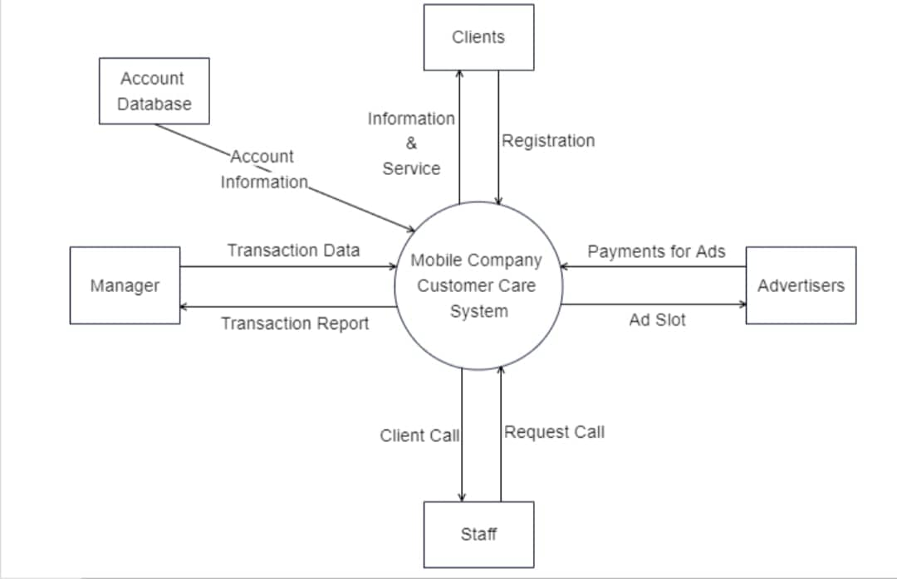

In general, a context diagram is a relationship between entities and systems.

The big circle in the middle identifies the name of the system.

In the mobile company customer care system, 1st external entity is the clients. Client registration by giving their details such as name, address, phone number, email, etc. And this registration led to another entity called Account database. Here we store our clients' account information. Then clients approach staff for their needed information by calling. Staff request calls to the client to value and suggest those products to clients. In return, they got a large amount of money from 6m advertisers. The last entity is the manager, who calls the transaction report from the system. His job is to take out transaction data from the report and input them into the system.

**Explain Software Requirement Specification:**

This Software Requirements Specification (SRS) is the requirements work product that formally specifies an online customer care system for an efficient banking service. It includes the results of both business analysis and systems analysis efforts. Various techniques were used to elicit the requirements and we have identified user needs, analyzed and refined them. The objective of this document therefore is to formally describe the system’s high-level requirements including functional requirements, non-functional requirements and constraints.

**Key components of an SRS**

The main sections of a software requirements specification are:

Business model – this section describes the business model of the customer that the system has to support, including organizational, business context, main business functions and process flow diagrams.

Business and system use cases – this section consists of a Unified Modeling Language ([UML](https://searchsoftwarequality.techtarget.com/definition/Unified-Modeling-Language)) use case diagram depicting the key external entities that will be interacting with the system and the different use cases that they’ll have to perform.

[Technical requirements](https://whatis.techtarget.com/definition/technical-requirements) – this section lists the non-functional requirements that make up the technical environment where software needs to operate and the technical restrictions under which it needs to operate.

System qualities – this section is used to describe the non-functional requirements that define the quality attributes of the system, such as reliability, serviceability, security, scalability, availability and maintainability.

Constraints and assumptions – this section includes any constraints that the customer has imposed on the system design. It also includes the requirements engineering team’s assumptions about what is expected to happen during the project.

**Purpose of an SRS**

An SRS forms the basis of an organization’s entire project. It sets out the framework that all the development teams will follow. It provides critical information to all the teams, including development, operations, quality assurance and maintenance, ensuring the teams are in agreement.

Using the SRS helps an enterprise confirm that the requirements are fulfilled and helps business leaders make decisions about the lifecycle of their product, such as when to retire a feature.

**Mention Constraints:**

A constraint is a statement that restricts the actions that the system or its users  
are allowed to perform.

Following are some constraints with various origins for the following customer care service:

* + **General Constraints**

The system must be delivered by the proposed deadline.

The system must be user-friendly

* + **Government regulations**

All software applications must comply with government regulations for usage by visually impaired persons.

**Validation and verification**

Validation and verification are not the concept. They might seem similar but they are very different from each other.

**Verification**

[**Verification**](https://www.professionalqa.com/software-verification)and validation both are software testing activity. Verification is followed by the validation. Verification in Software Testing is a process of checking documents, design, code and program in order to check if the software has been built according to the requirements or not. The main goal of verification process is to ensure quality of software application, design, architecture etc. Verification is the most crucial part for developing a software. Our goal will be to ensure that our product doesn’t have any issues what so ever. For that the team that will do the verification of our product will give their a-game.

**Validation**

Validation is the process of checking that a software system meets specifications and requirements so that it fulfills its intended purpose. The concept of validation has been in vogue for centuries. Irrespective of the industry or products, validation ensures various critical aspects of a product and guarantees its success in the market as well as among users. **software validation** plays an immensely significant role and helps the testing and development teams to create a quality product. It ensures that the software meets the pre-defined and specified business requirements as well as the end users/customers' demands and expectations. Validation is usually carried out at the end of the software development.

**Steps**

Here are some things that we must follow while doing our verification and validation.

1. User requirements document: We must always keep in mind the requirements of the users.
2. Project plan: Project planning gives us a clear path and a straight idea of what the product will be.
3. GAP analysis: GAP analysis is used to determine risk, or the difference between the desired performance and the existing performance.
4. Testing protocol and Testing report: Keeping eye on the protocol and report will be our number one priority.
5. Validation complete: If all are applied and monitored properly the produce will be properly verified and be validated. And it will do ready for the market.

Reference

<https://www.processproerp.com/10-steps-to-software-validation>