Practical 1

Create a simple sequence-based project

Theory:

A sequence is a basic automation process in RPA. It is used when the process is divided into steps and sequential. It is simpler and easier to use.

Steps:

1. Open UI path studio.
2. In uipath studio start page, under new project click on process
3. A dialog box appears, give a name to the process and select the language as C# and click on create.
4. Once a process is created, go to activity panel and add new sequence
5. Add name to the sequence and click on create. A sequence is created.
6. Once the sequence is created, add a message box.
7. Add the text you want to display and click on debug at the top ribbon.
8. This is how we create a simple sequence.

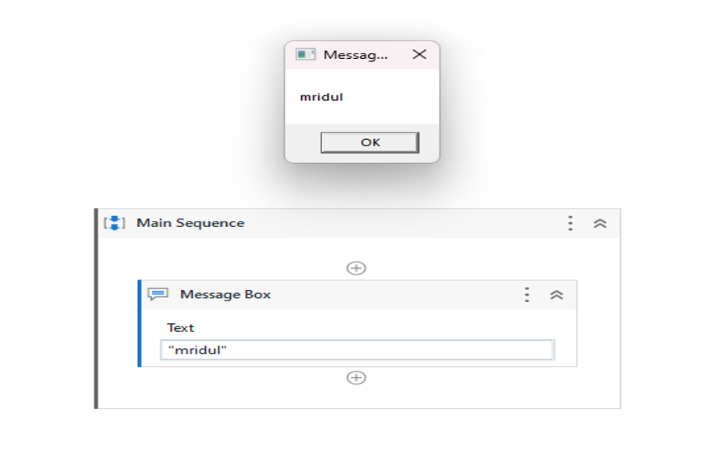Output:

Practical 2a

Automate UiPath Number Calculation (Subtraction, Multiplication, Division of numbers).

Steps:

1. Create a new sequence.
2. In the sequence, drag and drop an assign box to assign a variable. Assign a variable “a” with value 10.
3. On the variables tab, create the variable and assign the variable type as Int32.
4. Repeat steps 2 and 3 to create another variable “b” of integer type and give it the value 15.
5. Add a third assign box and create a variable “result” that will store the value of the operation between a and b. (a+b). This variable will also be integer.
6. Once done, drag and drop a write line box and add: “Addition is” + result since the output will be in string format.
7. Repeat steps from 5 and 6 thrice and change the operation as result=a-b, result=a*b, result=a/b.
8. Run the automation.

Output:

This will give the output of addition, subtraction, multiplication, division between variables a and b

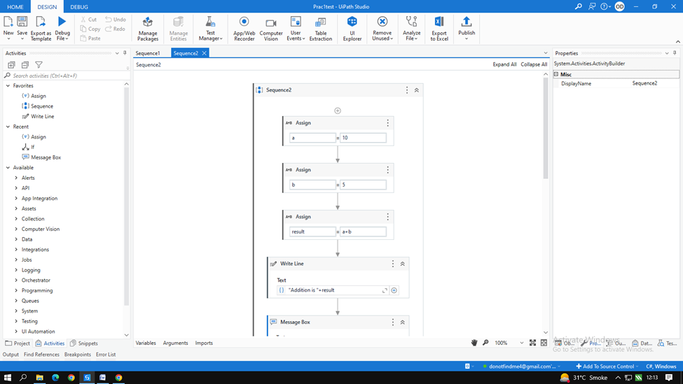

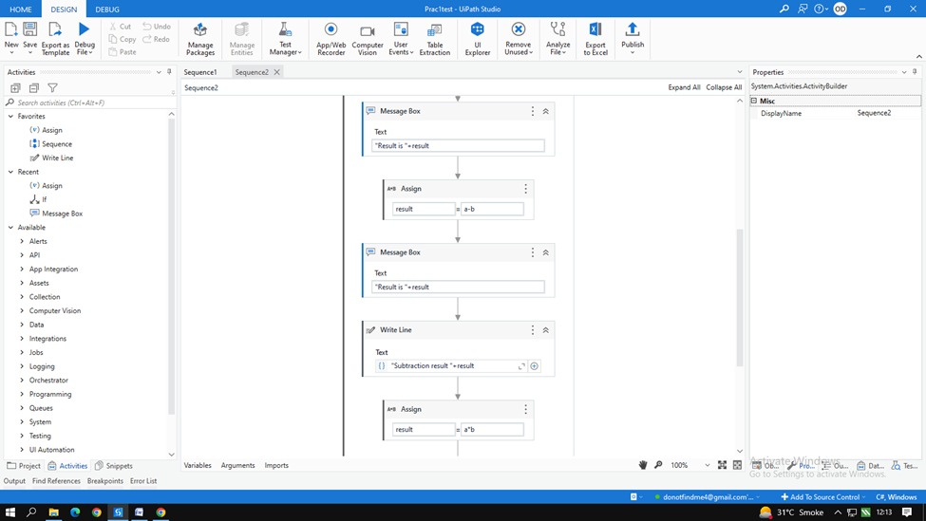

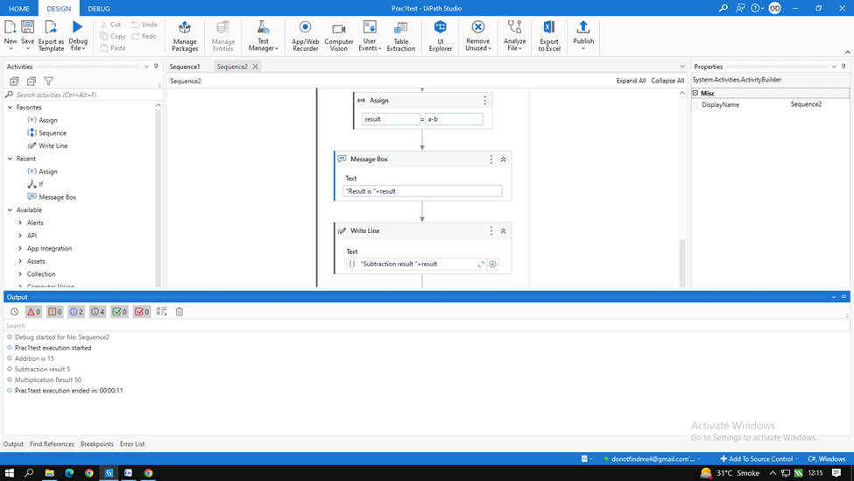

Practical 2b

Create an automation UiPath project using different types of variables (array, data table)

Steps: To create array

1. Create a new sequence.
2. Drag and drop multiple assign activity.
3. Create an array variable a where,

* marks = new int[5]{99,100,50,22,98}

1. Once done, go to variable option and change the data type of the array to array of [T]. Click on the option and select the array type as int 32.
2. Create another variable i=0 where i will be the iteration.
3. Drag and drop while activity. In the condition part add i<5
4. In the body drag and drop writeline and add marks[i].ToString() to display the array
5. Finally drag and drop a new assign and add i=i+1 to increase the iteration by 1. This will display all the members of the array.
6. Run the automation and check the output.

Output:

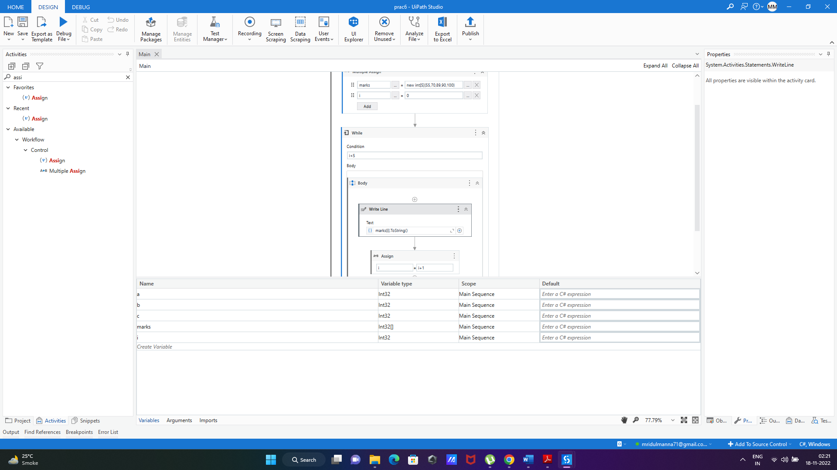

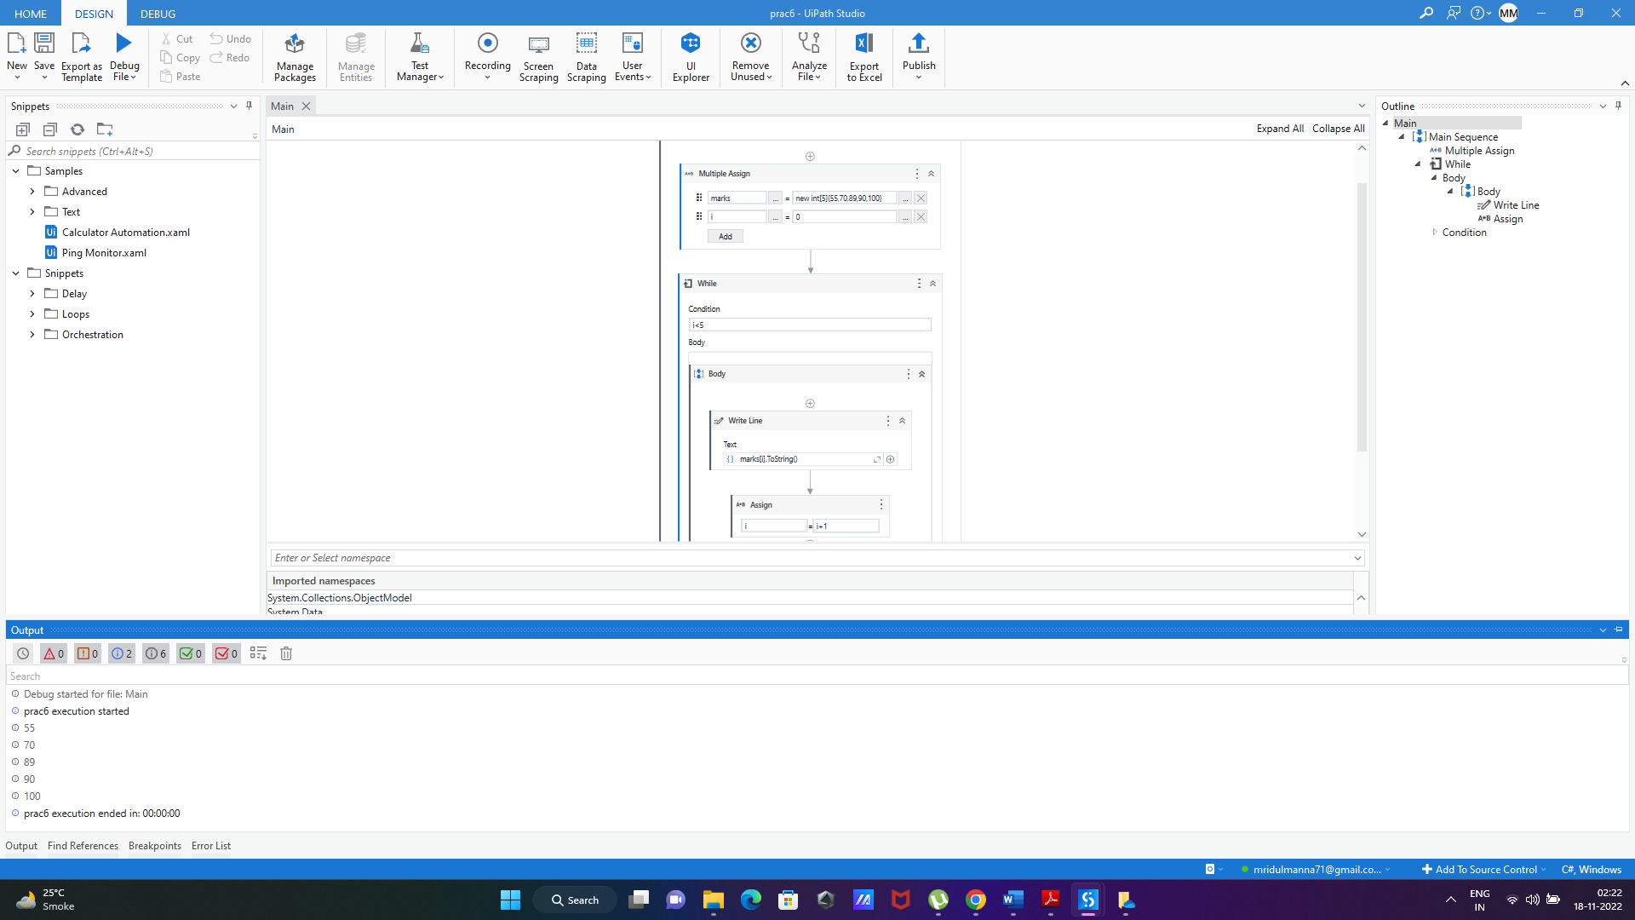

Practical 2b

Create an automation UiPath project using different types of variables (array, data table)

Steps: To create datatable.

1. Create a new sequence.
2. Drag and drop build data table activity from activity panel.
3. In the build data table acclivity, click on data table button and add the data you want to add in the data table.
4. Once done, on the right side in the properties tab, right click on the output option and click on create variable and add the variable name as mytable.
5. Drag and drop the for each row in data table activity in the sequence.
6. ForEach= CurrentRow and In=mytable. This will take the value in each row in the data table.
7. Once done, in the body of the for each activity, drag and drop the “get row item activity” and add the following:

* Row= CurrentRow
* Choose column as Name
* Add column name as “name”
* Add value = name

1. On the right-hand side in the properties panel, right click on output and select create variable
2. Create the variable as name.
3. Once done, drag and drop a writeline activity and add “name” as the column name.
4. Run the automation and check the output.

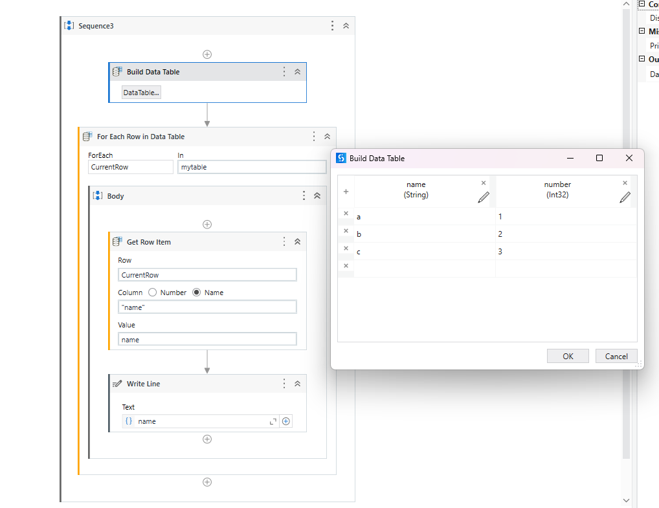

Output: This will display the data in the name column of the datatable.

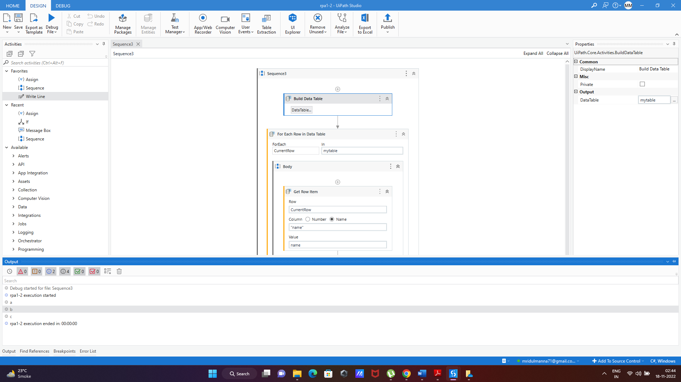

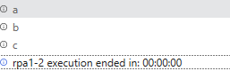

**Practical 3A:**

**Create an automation UiPath Project using decision statements.**

Theory:

The If activity contains a statement and two conditions. The first condition (the activity in the Then section) is executed if the statement is true, while the second one (the activity in the optional Else section) is executed if the statement is false.

If activities can be useful to make decisions based on the value of variables.

Steps:

1. Create a new sequence.
2. Drag and drop multiple assign activity.
3. Create an array variable a where,

marks = new int[5]{99,100,50,22,98}

1. Once done, go to variable option and change the data type of the array to array of [T]. Click on the option and select the array type as int 32.
2. Create another variable i=0 where I will be the iteration.
3. Drag and drop while activity. In the condition part add i<5
4. In the body of the while activity, drag and drop the if activity and add the condition:

Marks[i]>50

1. In the “then” panel drag and drop writeline activity and add marks[i].ToString() to display the array
2. Finally drag and drop a new assign outside the if activity and add i=i+1 to increase the iteration by 1. This will display all the members of the array.
3. Run the automation and check the output.

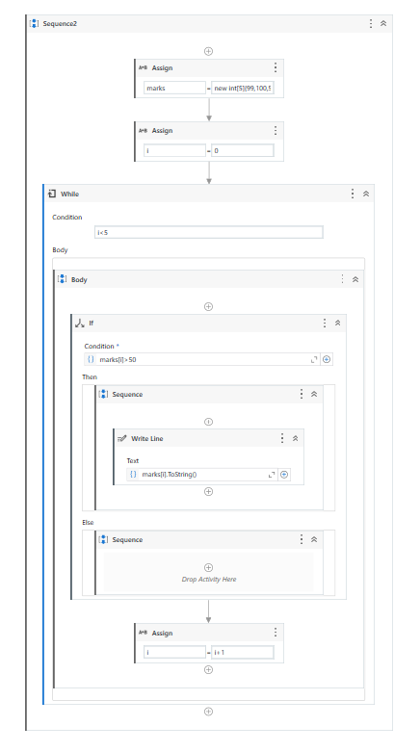

Output: This automation will print the numbers in the array greater than 50.

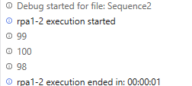

**Practical 3A:**

**Create an automation UiPath Project using looping statements**

Theory:

Loops are structures used to automate repetitive tasks.

In flowcharts, the simplest types of loops can be created by connecting a certain point in our workflow to an earlier execution one.

In sequences, there are special activities (or containers) that repeat the action that is inside the body section.

While loop:

If the condition is met, the set of actions in the body are executed. If the conditions are false, then the loop breaks and the next step is executed. Unless the condition is true, the loop will not start to execute in while loop.

For- each activity:

The For Each loop works by iterating through a list of items, one item at a time, and executing whatever actions are in the body of the action.

Steps: While activity

1. Create a new sequence.
2. Drag and drop multiple assign activity.
3. Create an array variable a where,
   1. marks = new int[5]{99,100,50,22,98}
4. Once done, go to variable option and change the data type of the array to array of [T]. Click on the option and select the array type as int 32.
5. Create another variable i=0 where I will be the iteration.
6. Drag and drop while activity. In the condition part add i<5
7. In the body drag and drop writeline and add marks[i].ToString() to display the array
8. Finally drag and drop a new assign and add i=i+1 to increase the iteration by 1. This will display all the members of the array.
9. Run the automation and check the output.

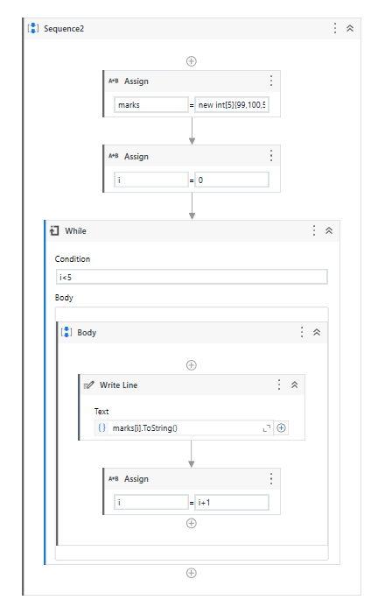

Output:

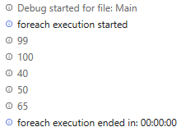

Steps: For-each activity

1. Create a new sequence.
2. Drag and drop assign activity.
3. Create an array variable marks where,
   1. marks = new int[5]{99,100,50,22,98}
4. Once done, go to variable option and change the data type of the array to array of [T]. Click on the option and select the array type as int 32.
5. Drag and drop for each activity.
6. In the ForEach activity add the following statements:

* In “for each” field add item
* Add marks in “In” field

1. In the body drag and drop writeline and add item.ToString() to display the array
2. Run the automation and check the output.

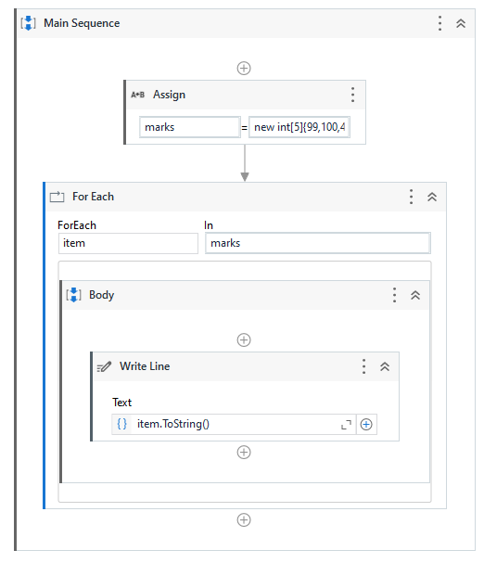

Output: This automation will print an array using for each activity.

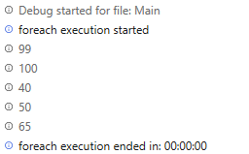

**Practical 4:**

**Automate any process using web/basic recording.**

Theory:

Recording is an important part of UiPath Studio, that can help you save a lot of time when automating your business processes. This functionality enables you to easily capture a user’s actions on the screen and translates them into sequences.

These projects can be modified and parameterized so that you can easily replay and reuse them in as many other processes as you need.

All user interface elements are highlighted while you record, as you can see in the following screenshot, so that you can be sure the correct buttons, fields or menus are selected.

Steps: Recording steps to send an email

1. Create a new sequence.
2. On the top in the ribbon, click on the recording option. A drop down will appear.
3. Select web recording option from the dropdown.
4. Open the Google chrome window.
5. Start recording
6. On the chrome window, click on gmail link
7. After clicking on gmail link, the gmail webpage opens. Click on compose.
8. After compose, a box appears to enter the mail.
9. Click on the To: option and enter the email address you want the mail to send to
10. After adding the receiver’s email address, press enter
11. Click on the body of the email and add any text and click on send
12. Press esc and click on save and exit
13. Run the automation and check the output

Output: This system will send an email automatically using automation.

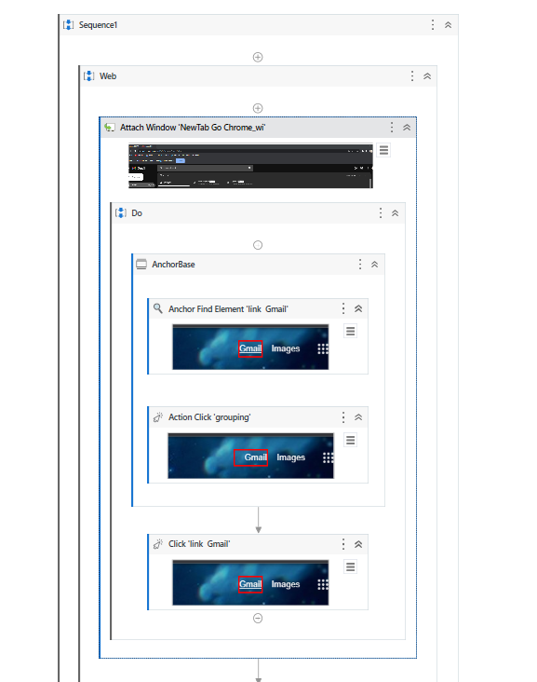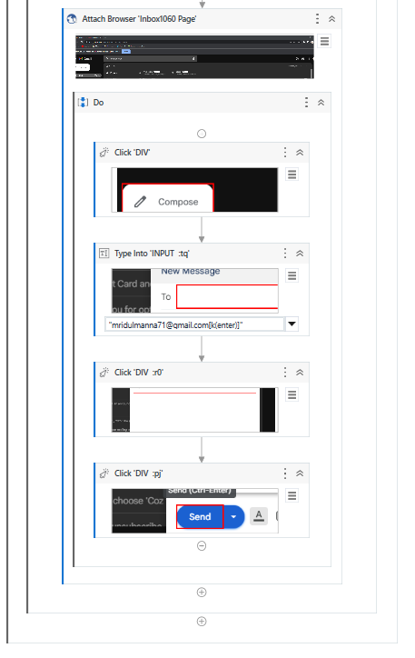

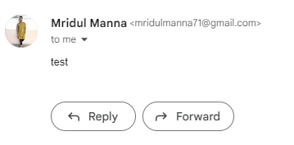

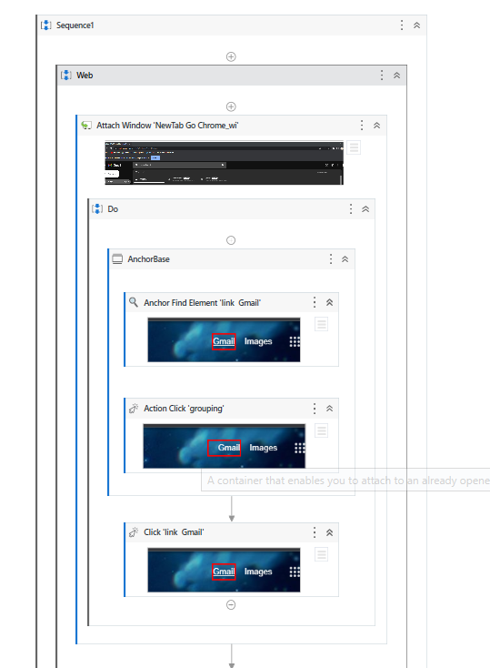

**Practical 5:**

**Consider an array of names. We have to find out how many of them start with the letter "a". Create an automation where the number of names starting with "a" is counted and the result is displayed.**

Steps:

1. Create a new sequence.
2. Drag and drop multiple assign activity
3. Create a string array and add the names you wish to add

Names=New String[5]{“Aman”,”Ajay”,”Omkar”,”Ashish”,”Tejas”}

1. Once the array is created, go to the variable tab and change the data type of the array to Array of [T] and select the datatype as string.
2. Once array is created, create a new variable i=0 for iteration and count=0 and select the datatype as Int32 for both the variables.
3. Once done, Drag and drop a while activity from activities panel.
4. Add condition as i<5
5. In the body panel of the while activity, drag and drop an if activity
6. Add the following condition in the if activity:

Names[i].StartsWith(“A”)

1. Drag and drop an assign activity in the “then” panel of the if activity and add

Count=count+1(This will increase the counter by 1 if the condition is true)

1. After the else panel in the if activity, drag and drop an assign activity and add

i=i+1

1. Outside the while loop in the main sequence, drag and drop writeline activity and add:

Count.ToString().

1. Run the automation and check the output.

Output:

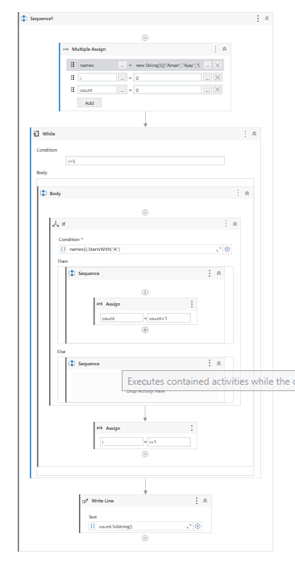

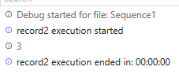

**Practical 6A:**

**Create an application automating the read, write and append operation on excel file.**

Steps: Read operation

1. Create a new sequence.
2. 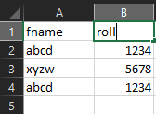Create a excel file and add 2 columns of data
3. Drag and drop Excel application scope from the activities panel
4. In the application scope, browse the excel file in the system and add the path of the file.
5. In the DO panel of the excel application scope, Drag and drop read cell activity.
6. It will automatically take the sheet as “Sheet1” and cell as “A1” as the initial point .
7. Right click on the “Sheet1” and select create variable and add a variable as name and add any cell number you want to print.
8. Drag and drop a Writeline activity and add : “Name:”+name
9. Run the automation and check the output.

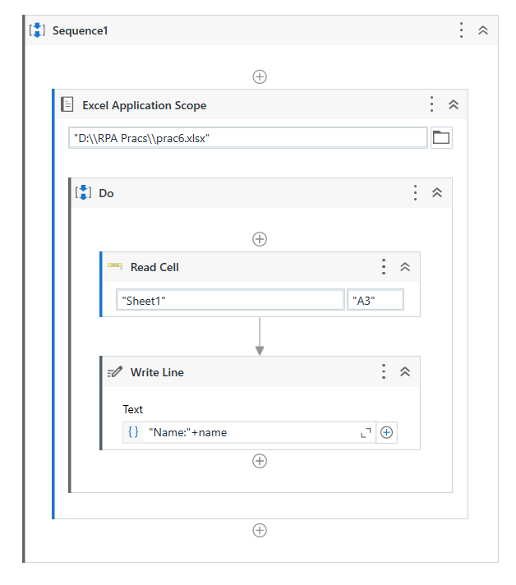

Output: The system will print the data available in cell A3

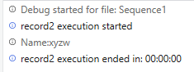

Steps: Write operation using user input

1. Create a new sequence.
2. Create a excel file and add 2 columns of data
3. Drag and drop Excel application scope from the activities panel
4. In the application scope, browse the excel file in the system and add the path of the file.
5. Drag and drop an input dialog in the DO activity of the excel application scope.
6. Add the following:

Dialog Title = "name"

InputLabel = "name:"

Select the Input type as TextBox

Right click on the Value Entered panel and click on create variable and add a variable “inputvalue”

1. In the DO panel of the excel application scope, Drag and drop write cell activity.
2. It will automatically take the sheet as “Sheet1” and cell as “A1” as the initial point.
3. It will also give a text box to enter the data you wish to write in the excel file. Add the variable name as inputvalue
4. Run the automation and check the output.

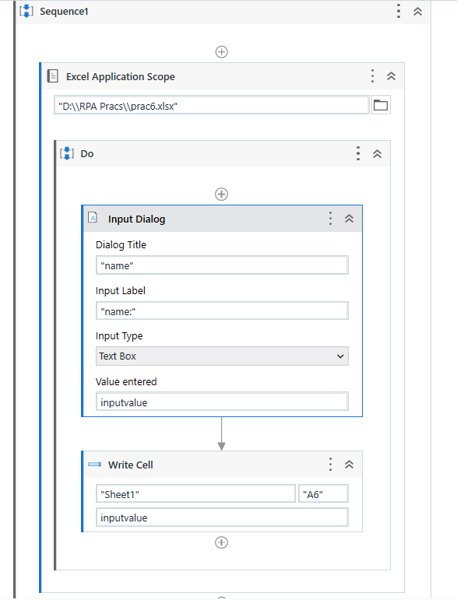

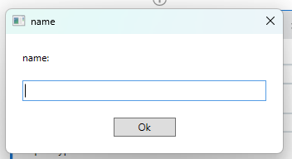

Output: This automation will add “Mridul” in cell A7 of excel file by taking user input

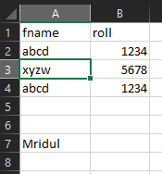

**Practical 6B:**

**Automate the process to extract data from an data table into an excel file**

Steps: Write operation using user input

1. Create a new sequence.
2. Create a excel file and keep the file empty
3. Drag and drop Excel application scope from the activities panel
4. In the application scope, browse the excel file in the system and add the path of the file.
5. Drag and drop Build data table activity and add a datatable and click on create option
6. On the right side of the page, right click on the output option and create a variable “mytable”
7. In the DO panel of the excel application scope, Drag and drop append range / write range activity.
8. It will automatically take the sheet as “Sheet1” and cell as “A1” as the initial point if you use write range.
9. It will also give a text box to enter the data you wish to write in the excel file. Add the variable name as mytable.
10. Run the automation and check the output.

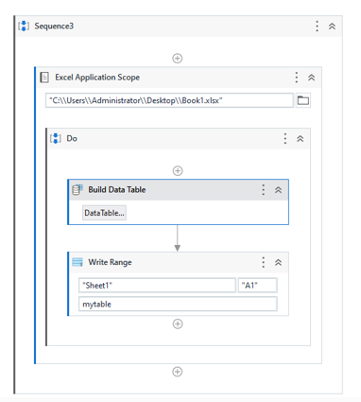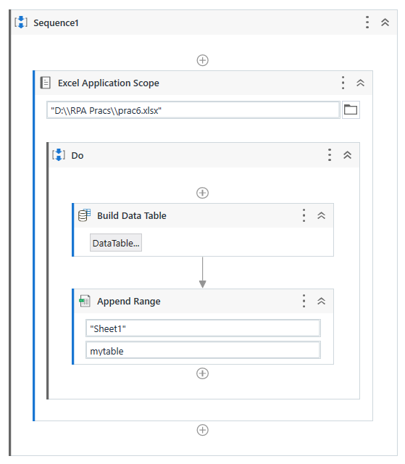

Output: This automation will write the data of the data table in the excel file and append the data the number of times you run the automation.

