**INTRODUCTION TO DATA MANAGEMENT**

**PROJECT REPORT**

(Project Semester August-December 2021)

***ETHEREUM ANALYSIS(2020-2021)***

Submitted by: -

Mridul Jain

Registration No: - 11911255

Section: - KM001

Course Code: - INT217

Under the Guidance of :-

**Mrs. Sandeep Kaur : 23614**

**Discipline of CSE/IT**

**Lovely School of Computer Science and Engineering**

**Lovely Professional University, Phagwara**





**CERTIFICATE**

This is to certify that **Mridul Jain** bearing Registration no. **11911255** has completed **INT217** project titled, **“ETHEREUM ANALYSIS (2020-2021)”** under my guidance and supervision. To the best of my knowledge, the present work is the result of his/her original development, effort and study.

**Mrs. Sandeep Kaur (23614)**

**School of Computer Science and Engineering**

Lovely Professional University

Phagwara, Punjab.

Date: 14 Dec 2021



**DECLARATION**

I, **Mridul Jain**, student of **Introduction To Data Management** under CSE/IT Discipline at, Lovely Professional University, Punjab, hereby declare that all the information furnished in this project report is based on my own intensive work and is genuine.

Date: 14 Dec 2021

Name of the Student:- Mridul Jain

Registration No:- 11911255



**ACKNOWLEDGEMENT**

In conjunction with my University, I would like to thank my Professors for providing me

with the fantastic opportunity to study for Data management during this semester, which helped me finish my homework and learn quite a bit. As a result, I learned a lot of new things. So, I really

thank them.

Furthermore, I would like to thank all the friends who helped me out whenever I ran into a

problem with my course. As their support always has my back whenever I need it, I am

thankful to have such excellent assistance from them.

Additionally, I would like to thank my parents who, throughout my life, have always

supported me and made me decide to do the right thing. Without them, I could never have

learned and become the person I am now.

I have taken efforts in this project. In spite of that, it would not have been possible without

the generous support and assistance of several individuals and organizations. I would like to

extend my sincere thanks to all of them



**TABLE OF CONTENT**

|  |  |
| --- | --- |
| Serial No | CONTENTS |
| 1 | **INTRODUCTION** |
| 2 | **SOURCE OF DATASET** |
| 3 | **DASHBOARD** |
| 4 | **OBJECTIVES/SCOPES OF ANALYSIS** |
| 5 | **ANALYSIS ON THE DATASET** |
| 6 | **OTHER INFORMATION** |
| 7 | **BIBLIOGRAPHY** |



**INTRODUCTION**

**Ethereum** is a [decentralized](https://en.wikipedia.org/wiki/Decentralization), [open-source](https://en.wikipedia.org/wiki/Open-source_software) [blockchain](https://en.wikipedia.org/wiki/Blockchain) with [smart contract](https://en.wikipedia.org/wiki/Smart_contract) functionality. **Ether** (**ETH** or **Ξ**) is the native [cryptocurrency](https://en.wikipedia.org/wiki/Cryptocurrency) of the platform. Amongst cryptocurrencies, Ether is second only to [Bitcoin](https://en.wikipedia.org/wiki/Bitcoin) in [market capitalization](https://en.wikipedia.org/wiki/Market_capitalization).[[2]](https://en.wikipedia.org/wiki/Ethereum#cite_note-ft20210528-2)[[3]](https://en.wikipedia.org/wiki/Ethereum#cite_note-wsj20210603-3)

Ethereum was conceived in 2013 by programmer [Vitalik Buterin](https://en.wikipedia.org/wiki/Vitalik_Buterin" \o "Vitalik Buterin).[[4]](https://en.wikipedia.org/wiki/Ethereum#cite_note-FOOTNOTETapscottTapscott201687-4) Additional founders of Ethereum included [Gavin Wood](https://en.wikipedia.org/wiki/Gavin_Wood), [Charles Hoskinson](https://en.wikipedia.org/wiki/Charles_Hoskinson), [Anthony Di Iorio](https://en.wikipedia.org/wiki/Anthony_Di_Iorio) and [Joseph Lubin](https://en.wikipedia.org/wiki/Joseph_Lubin_(entrepreneur)).[[5]](https://en.wikipedia.org/wiki/Ethereum#cite_note-paumgarten-5) In 2014, development work commenced and was [crowdfunded](https://en.wikipedia.org/wiki/Crowdfunding), and the network went live on 30 July 2015.[[6]](https://en.wikipedia.org/wiki/Ethereum#cite_note-6) The platform allows anyone to deploy permanent and immutable [decentralized applications](https://en.wikipedia.org/wiki/Decentralized_application) onto it, with which users can interact.[[7]](https://en.wikipedia.org/wiki/Ethereum#cite_note-7)[[8]](https://en.wikipedia.org/wiki/Ethereum#cite_note-8) [Decentralized finance](https://en.wikipedia.org/wiki/Decentralized_finance) (DeFi) applications provide a broad array of financial services without the need for typical [financial intermediaries](https://en.wikipedia.org/wiki/Financial_intermediary) like [brokerages](https://en.wikipedia.org/wiki/Brokerage), [exchanges](https://en.wikipedia.org/wiki/Exchange_(organized_market)), or [banks](https://en.wikipedia.org/wiki/Bank), such as allowing cryptocurrency users to borrow against their holdings or lend them out for [interest](https://en.wikipedia.org/wiki/Interest).[[9]](https://en.wikipedia.org/wiki/Ethereum#cite_note-9)[[10]](https://en.wikipedia.org/wiki/Ethereum#cite_note-fortune20210506-10) Ethereum also allows for the creation and exchange of [NFTs](https://en.wikipedia.org/wiki/Non-fungible_token), which are non-interchangeable tokens connected to digital works of art or other real-world items and sold as unique digital property. Additionally, many other cryptocurrencies operate as ERC-20 tokens on top of the Ethereum blockchain and have utilized the platform for [initial coin offerings](https://en.wikipedia.org/wiki/Initial_coin_offering).

Ether (ETH) is the cryptocurrency generated by the Ethereum protocol as a reward to miners in a [proof-of-work](https://en.wikipedia.org/wiki/Proof_of_work) system for adding blocks to the blockchain. It is the only currency accepted in the payment of transaction fees, which also go to miners. The block reward together with the transaction fees provide the incentive to miners to keep the blockchain growing (i.e. to keep processing new transactions). Therefore, ETH is fundamental to the operation of the network. Each Ethereum account has an ETH balance and may send ETH to any other account. The smallest subunit of ETH is known as a Wei and is equal to 10−18 ETH. Ether is often erroneously referred to as "Ethereum".[[61]](https://en.wikipedia.org/wiki/Ethereum#cite_note-61)

Ether is listed on exchanges under the currency code ETH. The Greek uppercase [Xi](https://en.wikipedia.org/wiki/Xi_(letter)) character (Ξ) is sometimes used for its currency symbol.

The shift to Ethereum 2.0 may reduce the issuance rate of Ether.[[55]](https://en.wikipedia.org/wiki/Ethereum#cite_note-bloomberg20201125-55) There is currently no implemented hard cap on the total supply of Ether.

**(1)**



**SOURCE OF DATASET**

**Source of the dataset:- Kaggle**

This dataset is about the value of and volume transacted of each currency between Jan-1-2020 and Apr-19-2021. Data is collected for every minute between these two dates from the open of stock exchange to close.

**Unix Timestamp** - Date represented as Epoc value  
**Date** - date and time when the data point was collected  
**Symbol** - Symbol of the currency  
**Open** - Open value of the currency  
**High** - Highest value of currency in the given minute  
**Low** - Lowest value of currency in the given minute  
**Close** - Close value of the currency in the given minute  
**Volume** - Volume of the currency transacted in the given minute.

Below is the photo of data set 658060 rows and 9 columns :-

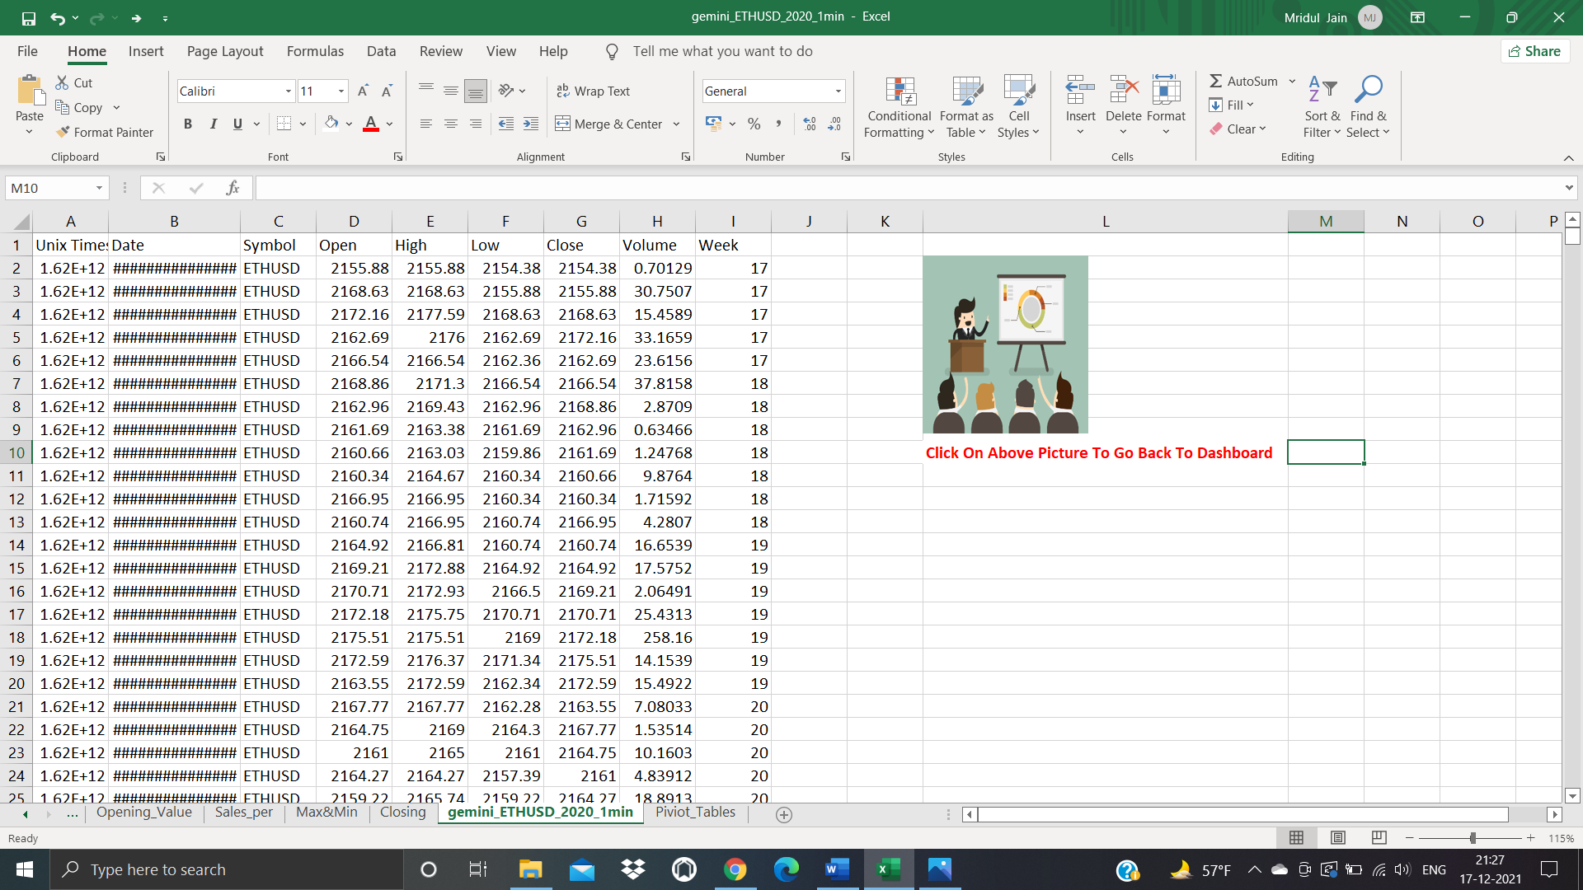



**DASHBOARD**

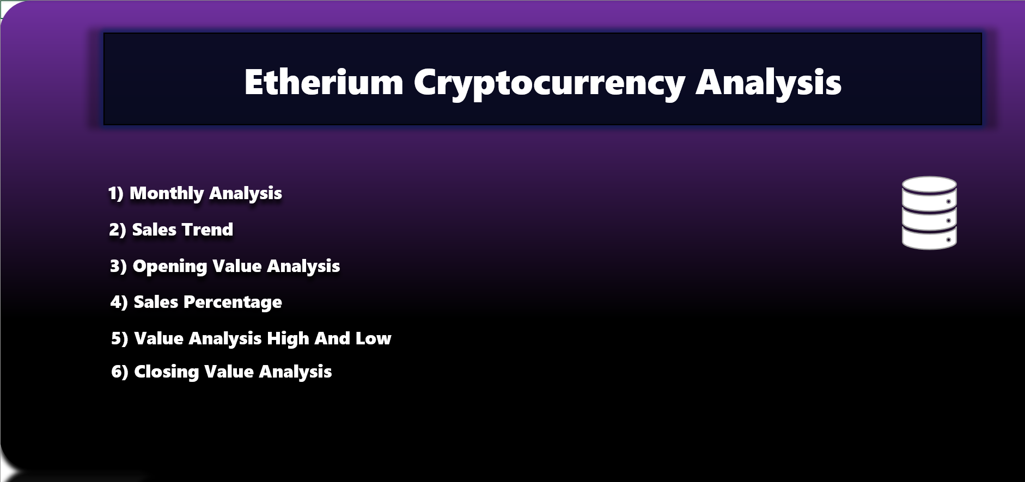

**Desc:-** All Objective are connected with hyperlinks to it corresponding tabs

The objective is work as a hyperlinks . It is made for quick access to the Dashboard

**OBJECTIVES/SCOPES OF ANALYSIS**

1. **MONTHY DIFFERENCES IN VALUE**
2. **SALES TRENDS IN VOLUMES**
3. **OPENING VALUE ANALYSIS**
4. **SALES PERCENTAGES**
5. **VALUE ANALYSIS (MINIMUM AND MAXIMUM TRENDS)**
6. **CLOSING VALUE ANALYSIS**



**ANALYSIS OF DATASET**

1. **MONTHY DIFFERENCES IN VALUE**

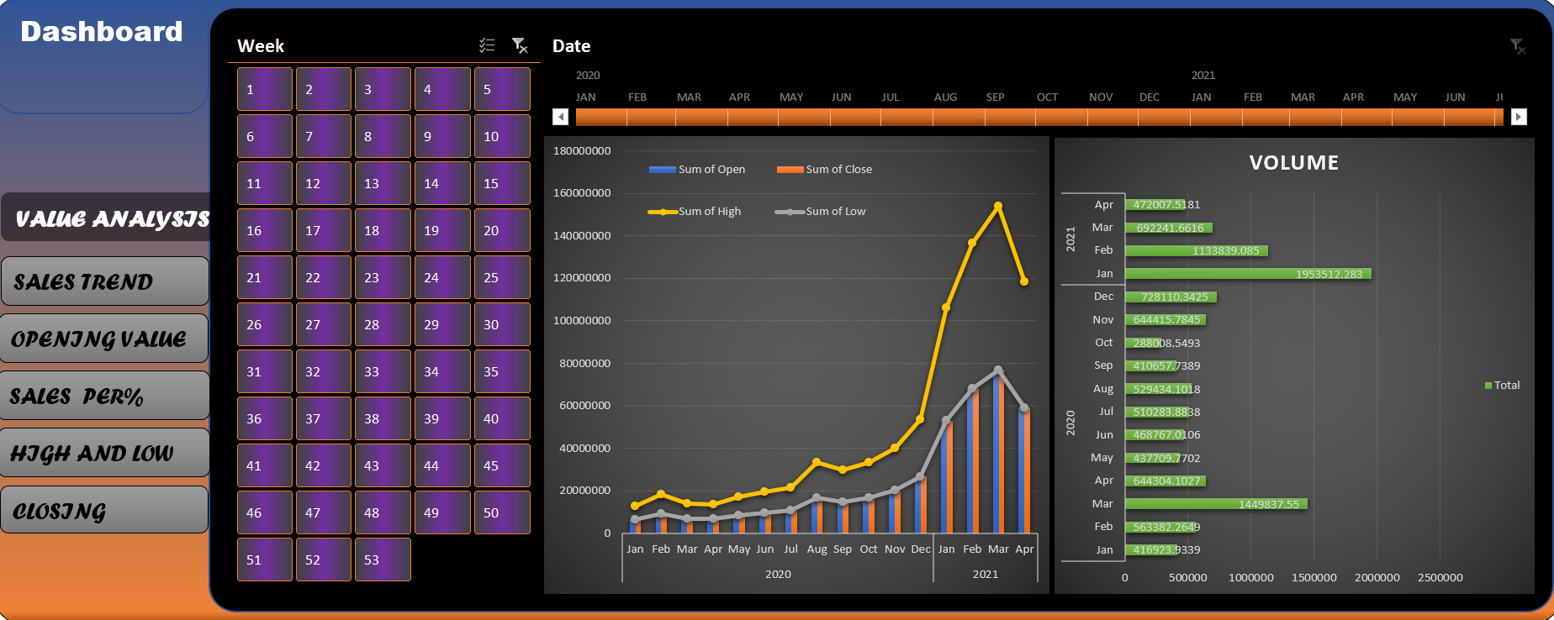

**Analysis:-** The above figure represents Average monthly values , which helps in identifying the variation in values and could be used in prediction for future values .

**Data table:**-

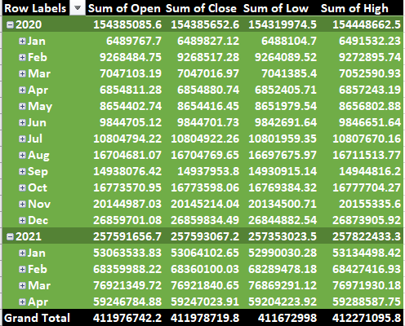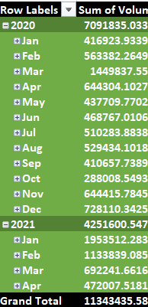

1. **SALES TRENDS**

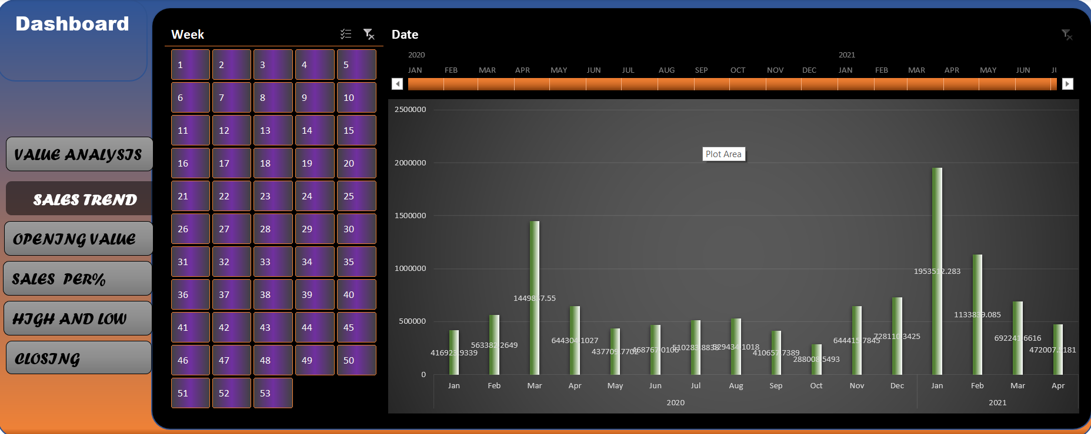

**Analysis:-**  The above figure displays the quantity of the Ethereums sold from 1-january-2020 till 19-april-2021 on monthly basis. This figure could help us to observe the selling trends of Ethereums that further helps in determining the months in which the most amount of Ethereums are sold.

**Data table:-**



1. **OPENING VALUE ANALYSIS**

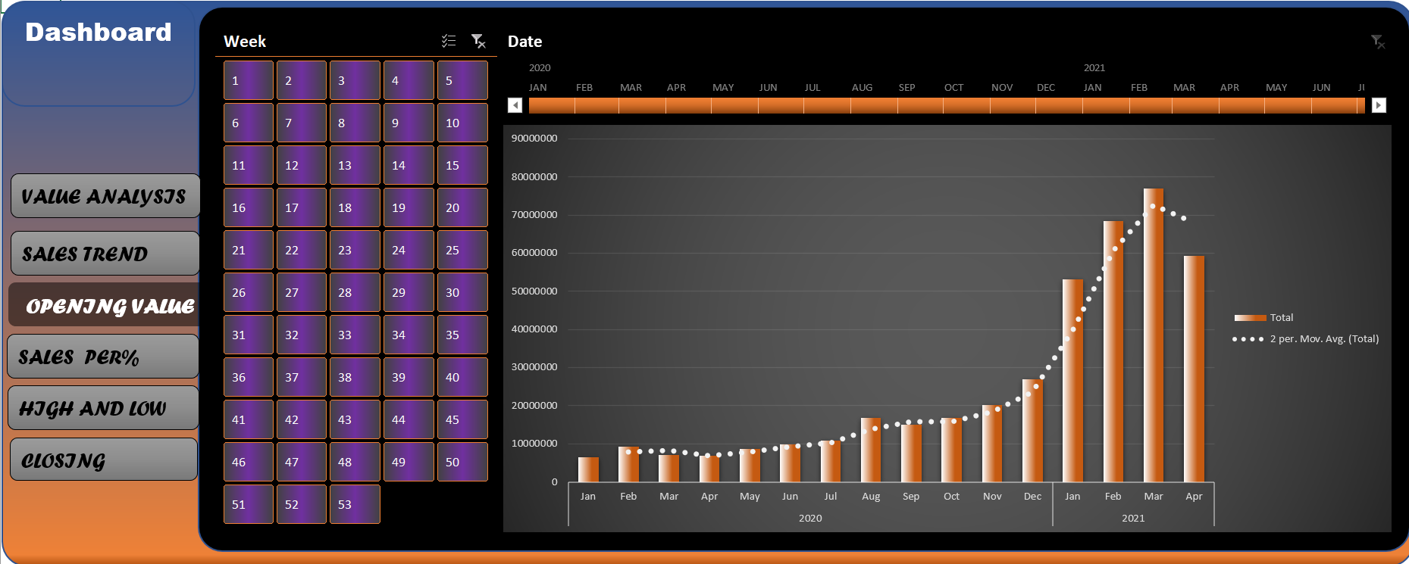

**Analysis:-**  The above figure displays the quantity of the Ethereums opening value from 1-january-2020 till 19-april-2021 on monthly basis. This figure could help us to observe the opening trends of Ethereums that further helps in determining the months in which the lowest value of Ethereums reach.

**Data table:-**

|  |  |
| --- | --- |
| **Row Labels** | **Sum of Open** |
| **2020** | **154385085.6** |
| **Jan** | **6489767.7** |
| **Feb** | **9268484.75** |
| **Mar** | **7047103.19** |
| **Apr** | **6854811.28** |
| **May** | **8654402.74** |
| **Jun** | **9844705.12** |
| **Jul** | **10804794.22** |
| **Aug** | **16704681.07** |
| **Sep** | **14938076.42** |
| **Oct** | **16773570.95** |
| **Nov** | **20144987.03** |
| **Dec** | **26859701.08** |
| **2021** | **257591656.7** |
| **Jan** | **53063533.83** |
| **Feb** | **68359988.22** |
| **Mar** | **76921349.72** |
| **Apr** | **59246784.88** |
| **Grand Total** | **411976742.2** |

1. **SALES PERCENTAGE:-**

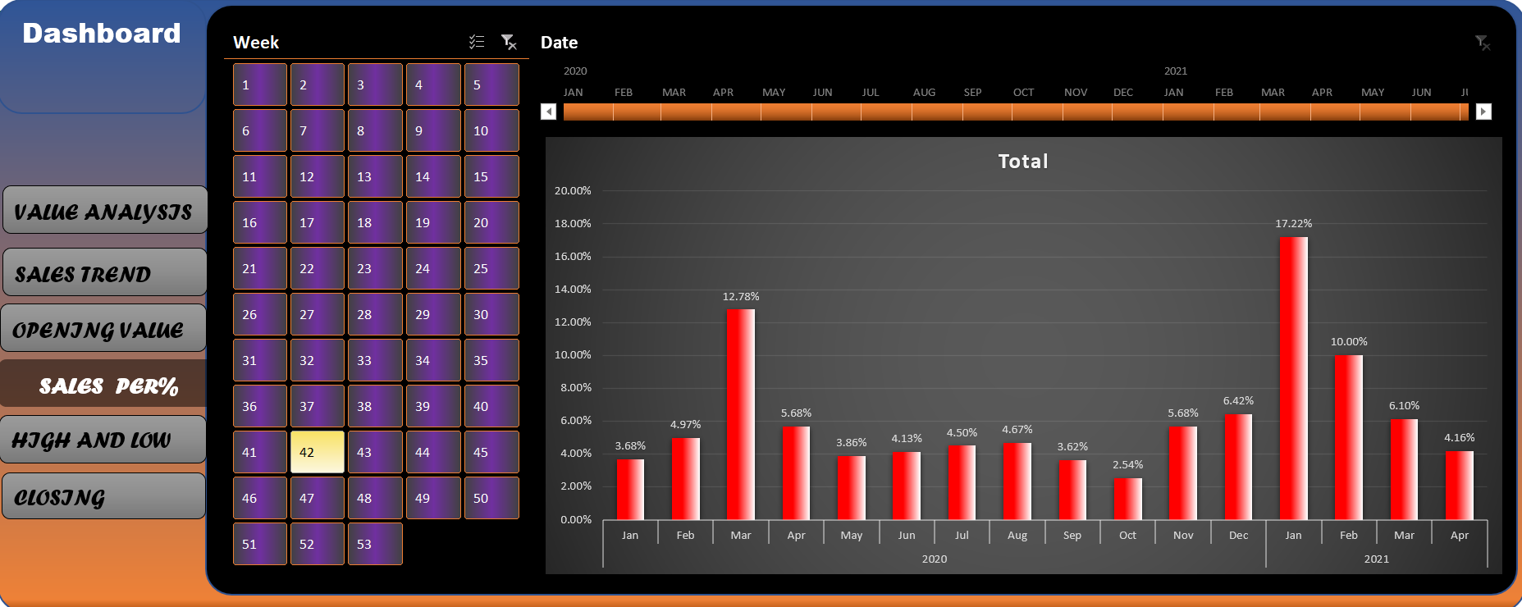

**Analysis:-**  The above pie chart shows the quarterly sales. The above includes 4 quarters of 2020 and two quarters of 2021. This visualization is useful for determining the exact quarterly sales of Ethereums.

**Data table:**-

|  |  |
| --- | --- |
| **Row Labels** | **Sum of Volume** |
| **2020** | **62.52%** |
| **Jan** | **3.68%** |
| **Feb** | **4.97%** |
| **Mar** | **12.78%** |
| **Apr** | **5.68%** |
| **May** | **3.86%** |
| **Jun** | **4.13%** |
| **Jul** | **4.50%** |
| **Aug** | **4.67%** |
| **Sep** | **3.62%** |
| **Oct** | **2.54%** |
| **Nov** | **5.68%** |
| **Dec** | **6.42%** |
| **2021** | **37.48%** |
| **Jan** | **17.22%** |
| **Feb** | **10.00%** |
| **Mar** | **6.10%** |
| **Apr** | **4.16%** |
| **Grand Total** | **100.00%** |
|  |  |

**5. VALUE ANALYSIS (MINIMUM AND MAXIMUM TRENDS)**

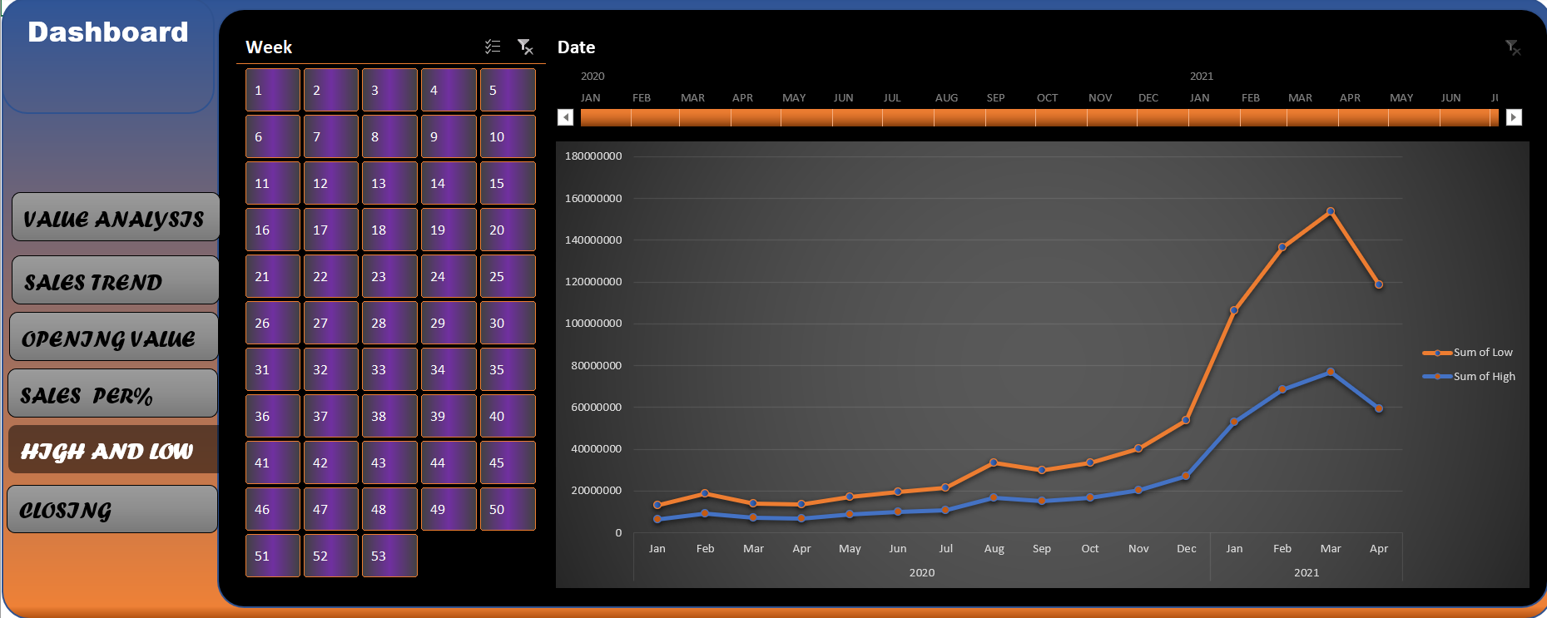

**Analysis:-** The above bar graph shows the maximum opening , maximum closing , highest value reached by Ethereums and the maximum of the lower value. This figure helps us to determine the increase in the value of Ethereum periodically.

**Data table:**-

|  |  |  |
| --- | --- | --- |
| **Row Labels** | **Sum of High** | **Sum of Low** |
| **2020** | **154448662.5** | **154319974.5** |
| **Jan** | **6491532.23** | **6488104.7** |
| **Feb** | **9272895.74** | **9264089.52** |
| **Mar** | **7052590.93** | **7041385.4** |
| **Apr** | **6857243.19** | **6852405.71** |
| **May** | **8656802.88** | **8651979.54** |
| **Jun** | **9846651.64** | **9842691.64** |
| **Jul** | **10807670.16** | **10801959.35** |
| **Aug** | **16711513.77** | **16697675.97** |
| **Sep** | **14944816.2** | **14930915.14** |
| **Oct** | **16777704.27** | **16769384.32** |
| **Nov** | **20155335.6** | **20134500.71** |
| **Dec** | **26873905.92** | **26844882.54** |
| **2021** | **257822433.3** | **257353023.5** |
| **Jan** | **53134498.42** | **52990030.28** |
| **Feb** | **68427416.93** | **68289478.18** |
| **Mar** | **76971930.18** | **76869291.12** |
| **Apr** | **59288587.75** | **59204223.92** |
| **Grand Total** | **412271095.8** | **411672998** |

**6. CLOSING VALUE ANALYSIS**

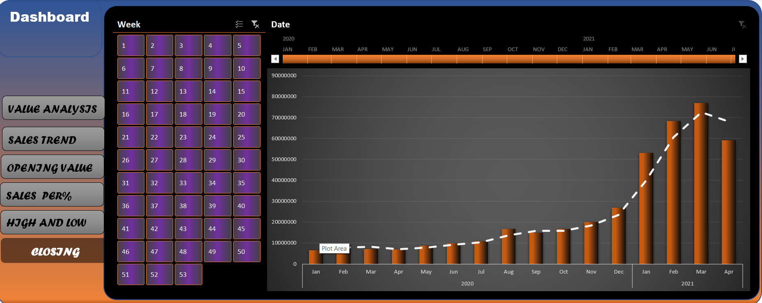

**Analysis:-** The above bar graph shows the maximum closing , minimum value reached by Ethereum and the maximum of the lower value. This figure helps us to determine the increase in the value of Ethereum periodically.

**Data table:**-

|  |  |
| --- | --- |
| **Row Labels** | **Sum of Close** |
| **2020** | **154385652.6** |
| **Jan** | **6489827.12** |
| **Feb** | **9268517.28** |
| **Mar** | **7047016.97** |
| **Apr** | **6854880.74** |
| **May** | **8654416.45** |
| **Jun** | **9844701.73** |
| **Jul** | **10804922.26** |
| **Aug** | **16704769.65** |
| **Sep** | **14937953.8** |
| **Oct** | **16773598.06** |
| **Nov** | **20145214.04** |
| **Dec** | **26859834.49** |
| **2021** | **257593067.2** |
| **Jan** | **53064102.65** |
| **Feb** | **68360100.03** |
| **Mar** | **76921840.65** |
| **Apr** | **59247023.91** |
| **Grand Total** | **411978719.8** |



1. **Formula used for extract weeks from date = WEEKNUM(Date cell)**

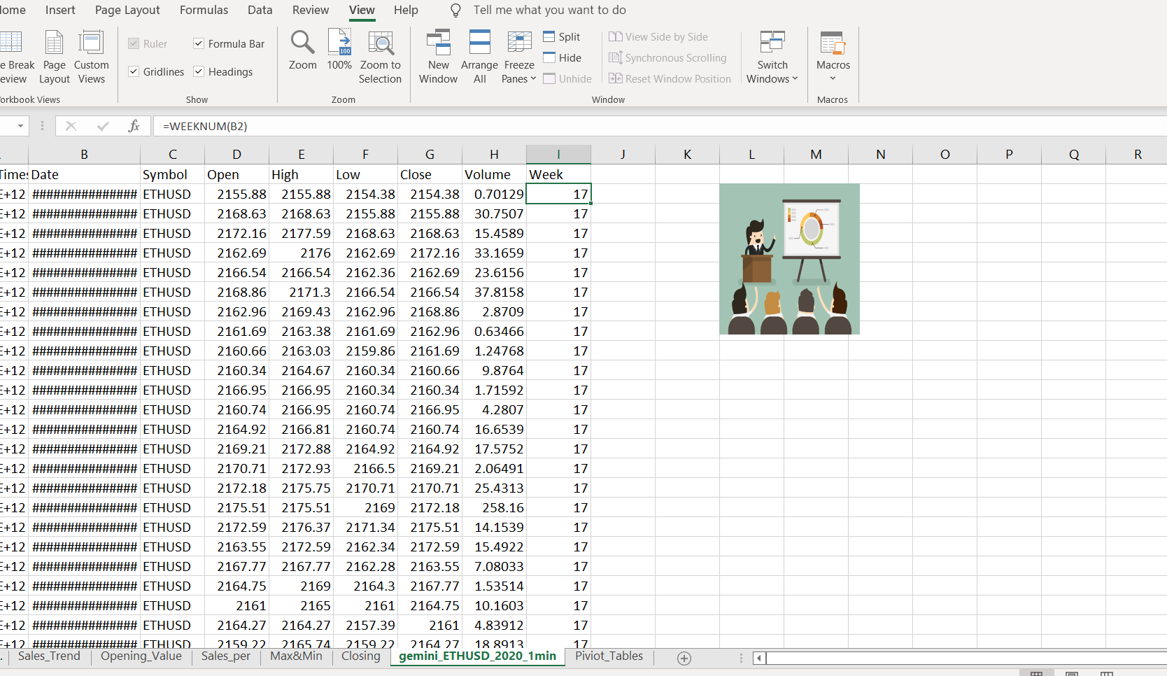

**2) Linking files = Right click on object > link > Place in this document > select sheet which you have to connect**

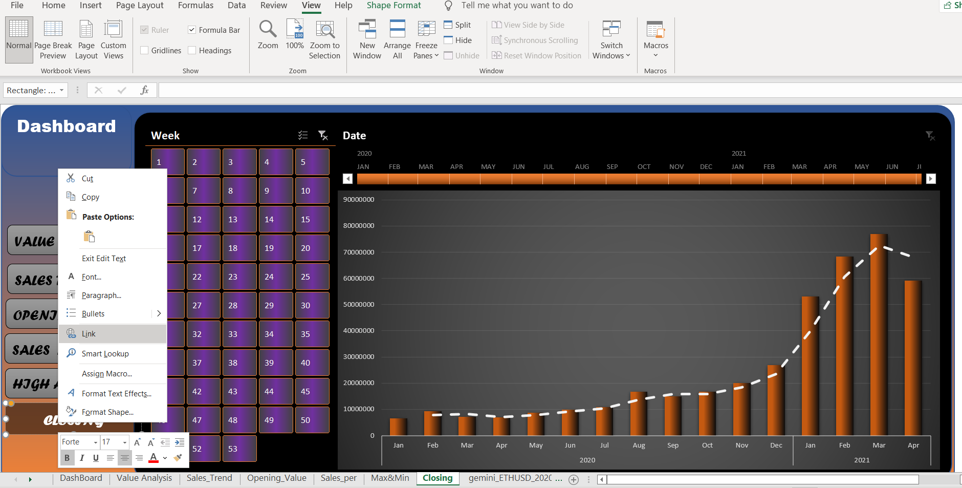

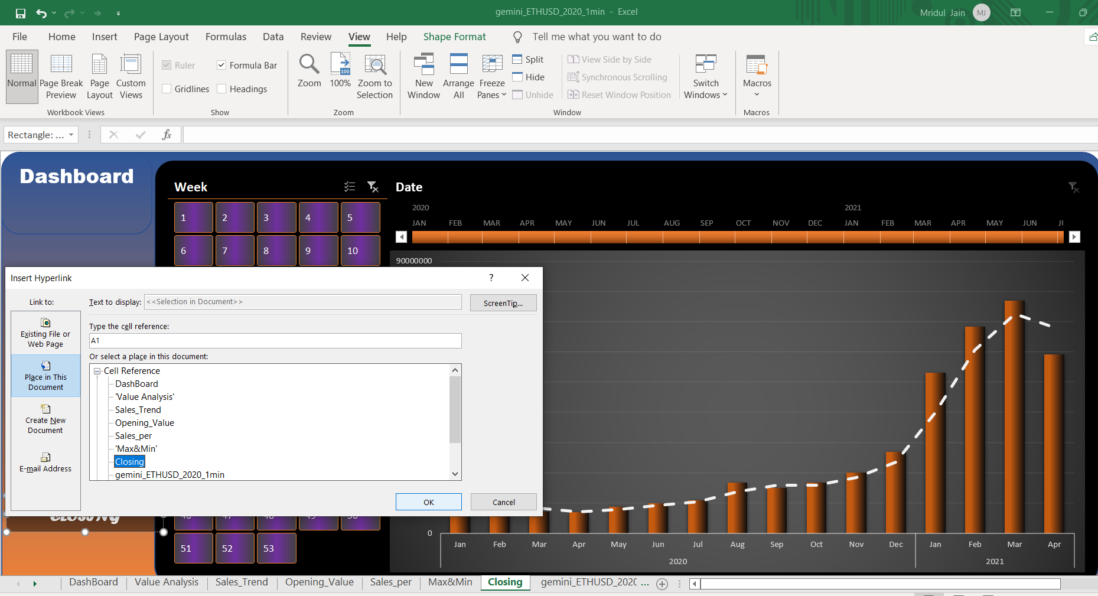

1. **Making piviot table -> Insert > PivotTable > new sheet > Now select pivot field you want**

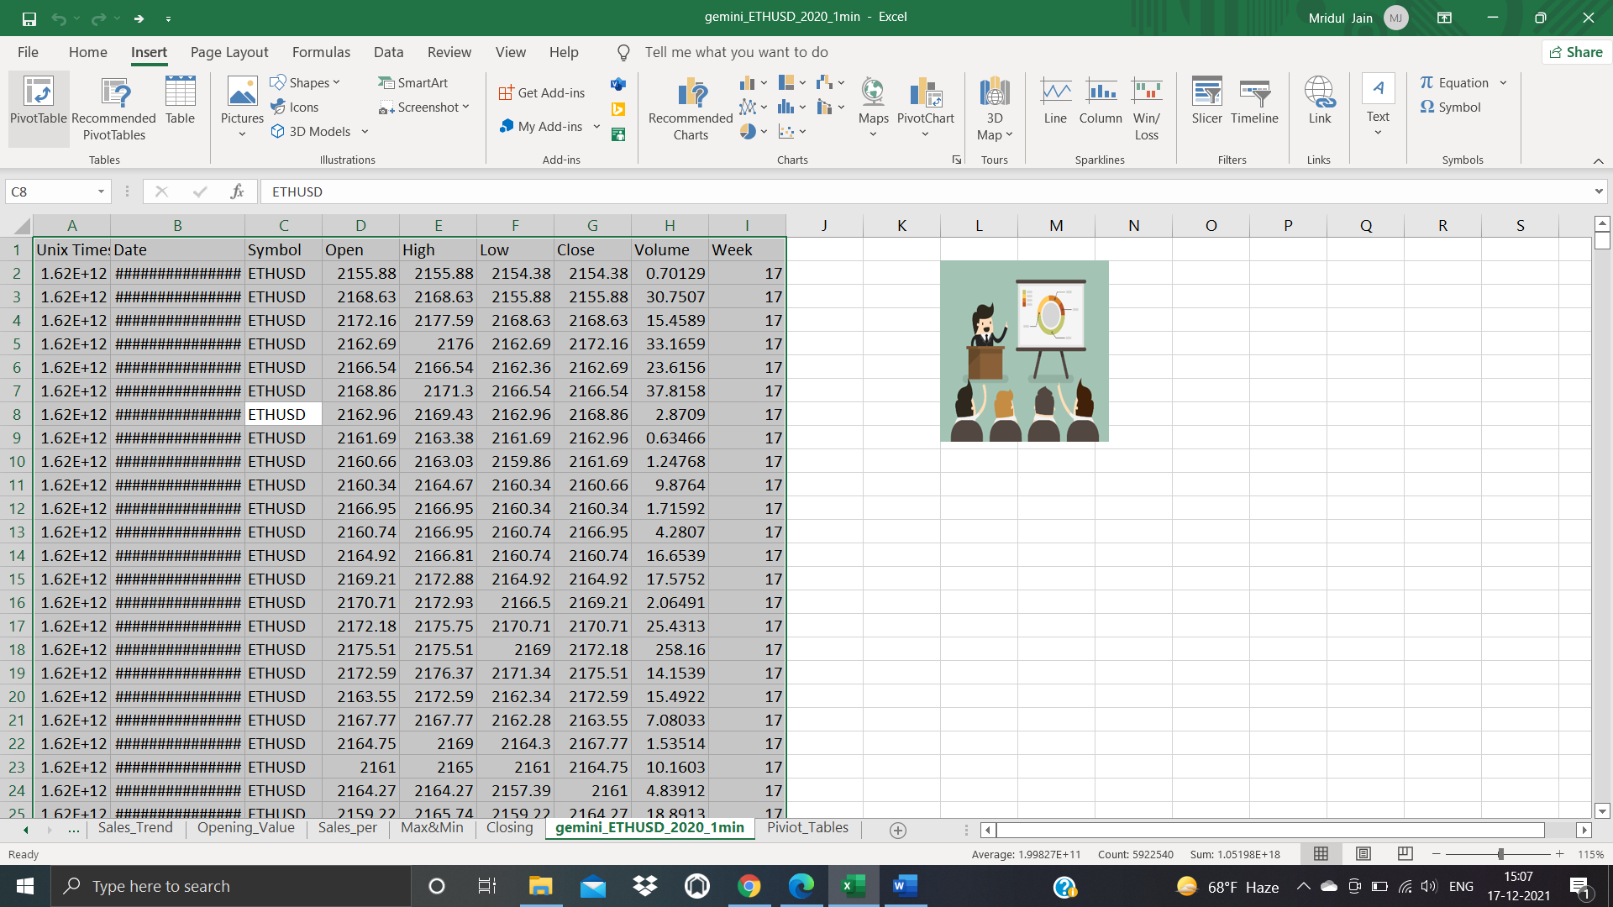

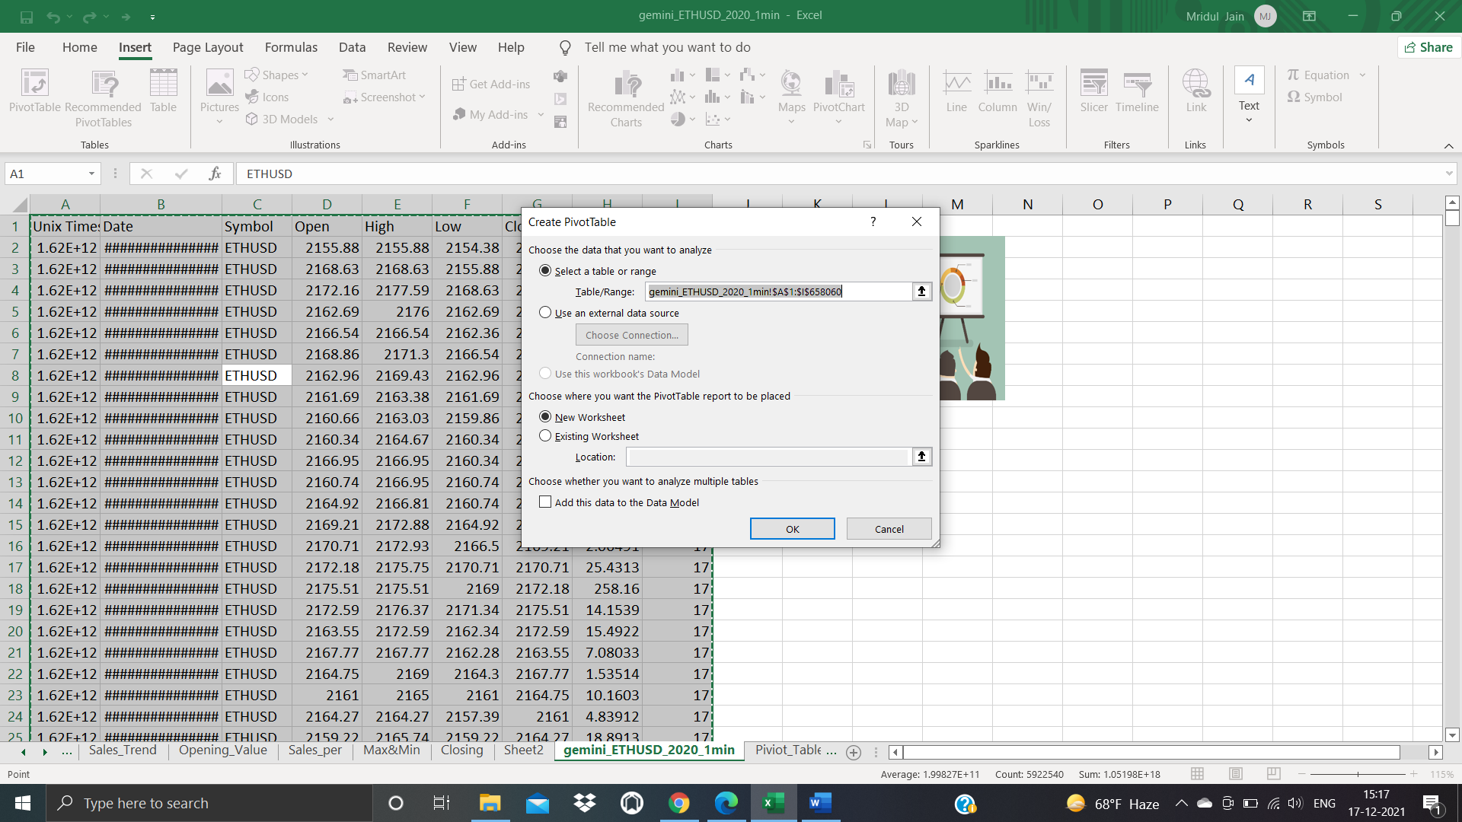

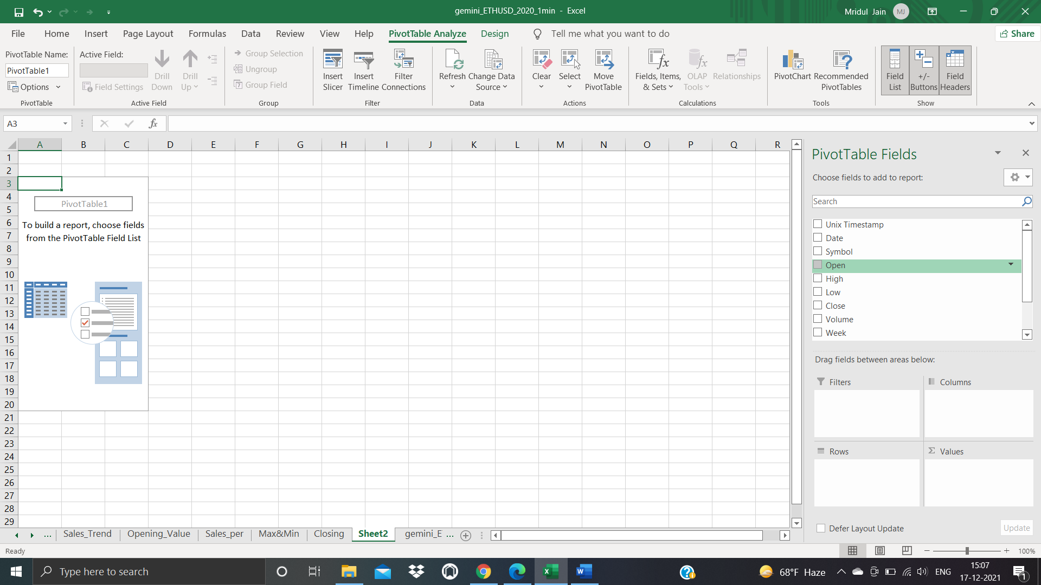

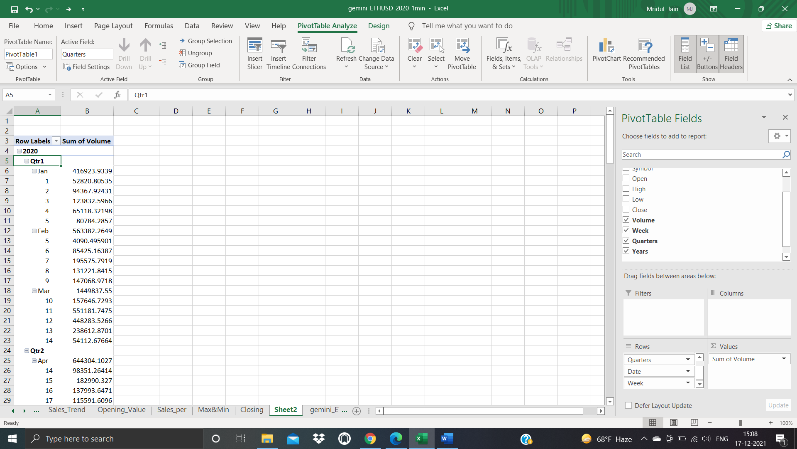

1. **Making charts -> Select a cell of pivot table > PivotTable Analyze > pivot chart > Select a chart type > ok**

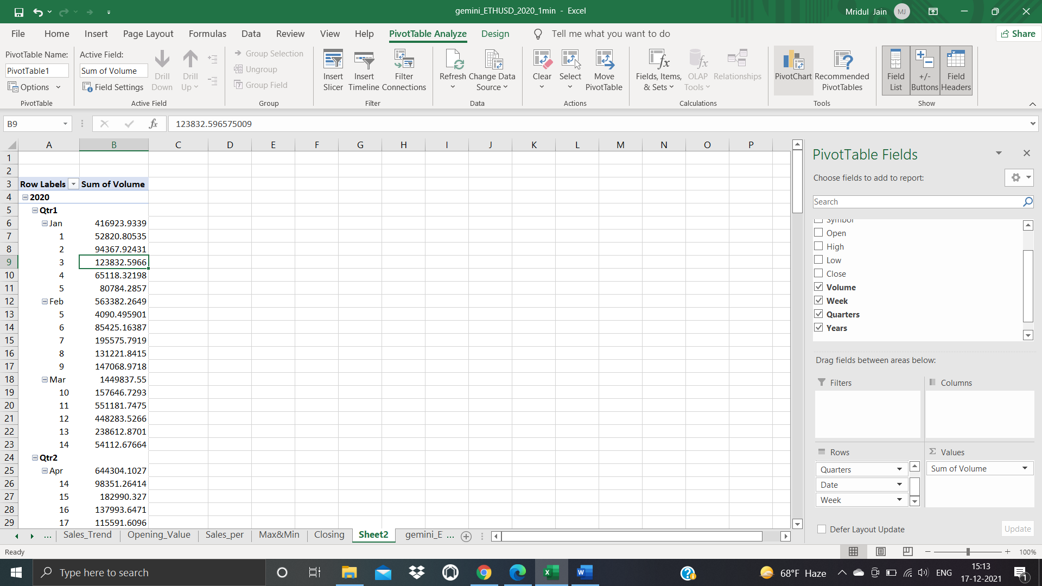

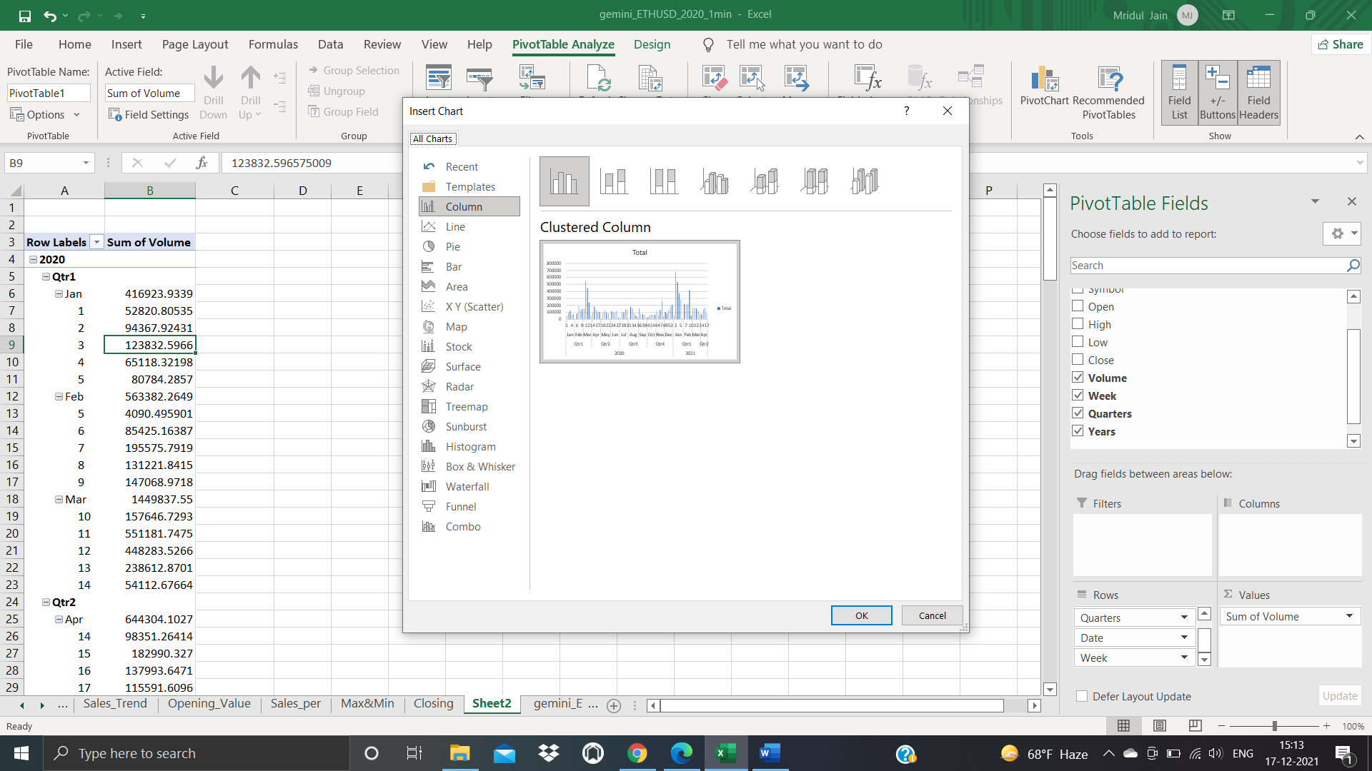

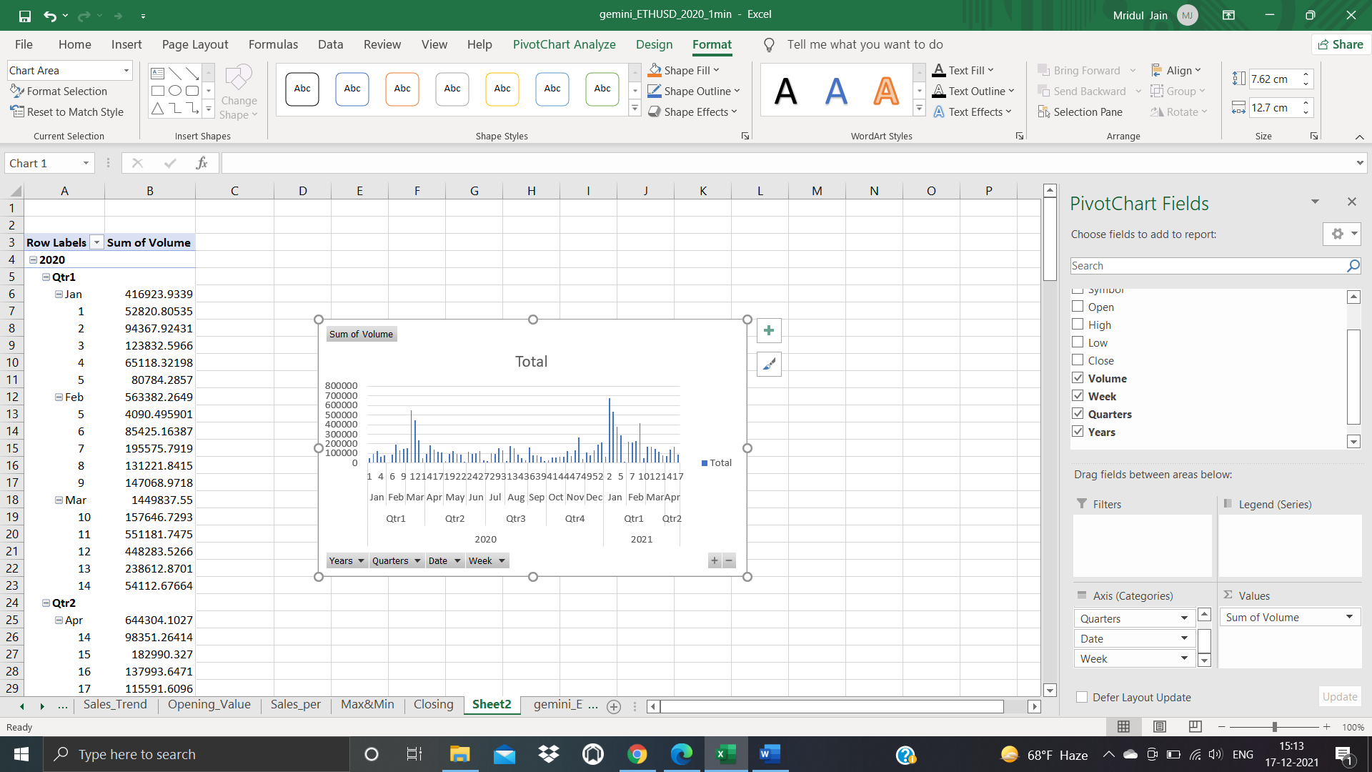



**BIBLIOGRAPHY**

1. Youtube
2. Microsoft Excel
3. Kaggle