MECHANICAL FINDINGS REPORT
Braillix Cam, Linkage and Print-Risk Review
Why the current full assembly will jam, what remains uncertain, and how to validate the redesign without wasting the resin print
Prepared for: AJ / Braillix capstone team
Repository: github.com/MridulNegi2005/Capstone
Reviewed revision: 4788e44 (main, 31 July 2026)
Evidence basis: Current SCAD sources, checked-in dimensions, motion simulation and derived geometry
Scope: Cam disk, six resin linkages, springs, dot insert, top plate, motor shaft and vertical stack

DECISION: Do not print the complete mechanism at the current revision. The enclosure cannot seat around the checked-in cam/linkage stack, and the first requested follower lift has no compliant travel available. A small motion coupon is reasonable; the complete resin batch is not.

Executive verdict
The cam logic is not the immediate problem. In an unconstrained preview, the six physical L-shaped linkages follow the cam profile as designed. The failure happens when the real enclosure stack is added: a 4.0 mm hub is placed in a 2.0 mm space, forcing the cam and every linkage approximately 2.0 mm upward. That one mismatch propagates into the springs, top plate, dot height and motor load.
The full assembly therefore fails before questions such as long-term resin fatigue or wear become relevant. Those material risks still matter, but they are second-order until the vertical geometry is repaired.

ID | Status | Finding | Evidence
F-01 | CRITICAL FAIL | Cam hub vs. available depth | 4.0 mm hub; 2.0 mm space; 2.0 mm hard interference
F-02 | CRITICAL FAIL | Spring stack at plate seat | 1.0 mm available vs. 1.5 mm stated solid height
F-03 | CRITICAL FAIL | Dot rest height | Linkage stack is forced about 2.0 mm above the reading surface
F-04 | UNRESOLVED | Shaft vs. central risers | Safe only in the already-wrong raised position; no axial stop
R-05 | HIGH RISK | Running clearances | 0.10 mm/side at both foot/track and dome/hole
R-06 | HIGH RISK | Follower stability | No positive anti-yaw feature; tangential cam drag is uncontrolled
R-07 | HIGH RISK | Ramp force / motor margin | 72-79° local ramp slope; real spring and motor data missing
R-08 | HIGH RISK | Thin printed features | 1.0 mm arms and 0.4 mm walls are process-sensitive

1. Scope, evidence and confidence
This report answers a narrow practical question: if the current parts are printed and assembled, can the disk rotate while the physical followers transition without binding, collapsing or wasting the print?

1.1 Evidence reviewed
- cad/scad/mech_layout.scad - shared track, dot, spring and vertical-stack dimensions.
- cad/scad/braille_cam.scad - 64-position cam geometry, cosine ramps, hub and double-D bore.
- cad/scad/linkage.scad - the six 1.0 mm-thick L-shaped resin cranks and follower feet.
- cad/scad/top_plate.scad and dot_insert.scad - guide holes, spring counterbores and reading surface.
- cad/scad/base_plate.scad and outer_box.scad - motor face, cam pocket and enclosure seating.
- docs/CAD_FIT_CHECK.md, docs/MEASUREMENTS_NEEDED.md and .ai-sync/handoff.md - prior fit findings, measurement status and the interactive rigid-body/contact preview generated at commit 4788e44.

1.2 Confidence labels used
Label | Meaning | How to use it
Confirmed failure | The checked-in dimensions overlap or violate a hard physical limit. | Must be redesigned before a full print.
High risk | The geometry is nominally possible but the margin is too small or the control feature is missing. | Prototype with a coupon and measure.
Measurement-blocked | The answer depends on a real component dimension that is not yet fully confirmed. | Do not patch CAD from catalogue guesses.
Unknown | Material, friction, force or process data are absent. | Requires physical testing or material input; simulation cannot certify it.

IMPORTANT LIMIT: This is not a nonlinear contact FEA. It can decisively identify hard interference and small nominal clearances, but it cannot predict resin fracture, creep, shrinkage, surface friction or spring force without real material and process inputs.

2. What the mechanism actually contains
The moving members are not six straight rods. The repository models six separate resin-printed L-shaped cranks. Each crank has a rolled cam foot, a vertical foot riser, a horizontal 1.0 mm arm, an upper dot riser, a 2.2 mm spring flange and a printed 1.5 mm braille dome.
The six feet sit around the disk at 60° intervals. This fan layout prevents the horizontal arms from crossing and allows all six arms to occupy the same vertical level. That plan-view improvement is valid: the closest nominal arm-to-arm approach is 2.60 mm against 1.00 mm arm thickness, leaving 1.60 mm clearance.
Parameter | Current value | Mechanical meaning
Cam positions | 64 | 5.625° per indexed position
Track centre radii | 12.8 to 21.3 mm | Six concentric tracks
Track / foot radial width | 1.6 / 1.4 mm | 0.10 mm nominal margin per side
Cam lift | 0.8 mm | Required dot travel
Linkage height | 12.2 mm | Cam flat to recessed reading surface
Arm spans | 10.40 to 17.87 mm | Six unique fan-out linkages
Arm thickness | 1.0 mm | Resin printed
Dot / guide hole | 1.5 / 1.7 mm | 0.10 mm nominal radial clearance
Spring | 2.0 mm OD, 4.0 mm free | 1.5 mm stated solid height
Row pitch / spring bore | 2.6 / 2.2 mm | Only 0.4 mm material between adjacent bores

3. Confirmed failure chain
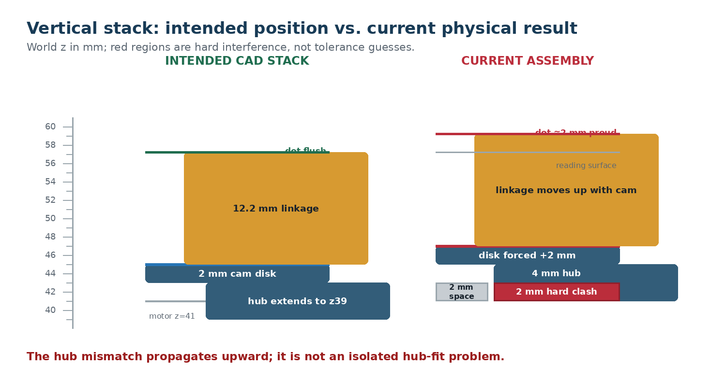
Figure 1. The current hub mismatch moves the complete cam/linkage stack upward.

3.1 The hub cannot occupy its designed space
The motor bracket face and base-plate underside are modeled at world z = 41 mm. The bottom of the cam pocket is at z = 43 mm. Therefore the only space below the cam disk is 2.0 mm. The hub is modeled as 4.0 mm tall.
Available hub space = 43.0 - 41.0 = 2.0 mm
Hard interference = hub_h - available space = 4.0 - 2.0 = 2.0 mm
The hub cannot pass through the motor face. In a rigid assembly it bottoms out and holds the disk approximately 2.0 mm above the pocket floor. This is a direct geometric collision, not a printer-tolerance concern.

3.2 The cam, linkage and dots all move upward
The source calculates linkage height from the intended cam flat at z = 45.0 mm to the recessed reading surface at z = 57.2 mm. That produces link_total_h = 12.2 mm. If the hub forces the cam flat to approximately z = 47.0 mm, the down-state dome reaches z = 59.2 mm.
Actual down-state dot top ≈ 47.0 + 12.2 = 59.2 mm
Dot error relative to reading surface ≈ 59.2 - 57.2 = +2.0 mm
A braille dot intended to be flush when down would instead be roughly 2.0 mm proud. The cell would feel active even in the down state. More importantly, the top plate and spring system must somehow absorb this 2.0 mm error, and they cannot.

3.3 The return spring reaches solid height before the plate seats
The spring counterbore ceiling is 2.0 mm above the top-plate underside. With the plate correctly seated, that ceiling is at z = 56.0 mm. The linkage flange top is designed to sit 8.0 mm above the cam. With the cam forced to z = 47.0 mm, the flange top is at z = 55.0 mm.
Available spring length at full plate seat = 56.0 - 55.0 = 1.0 mm
Spring solid-height shortfall = 1.5 - 1.0 = 0.5 mm
A steel spring cannot compress below its solid stack without yielding, embedding into printed surfaces, or preventing assembly. The plate therefore stops roughly 0.5 mm above its intended seat even with the follower fully down. At that stopped position the spring is already at its hard limit; there is no travel left for the 0.8 mm cam lift.
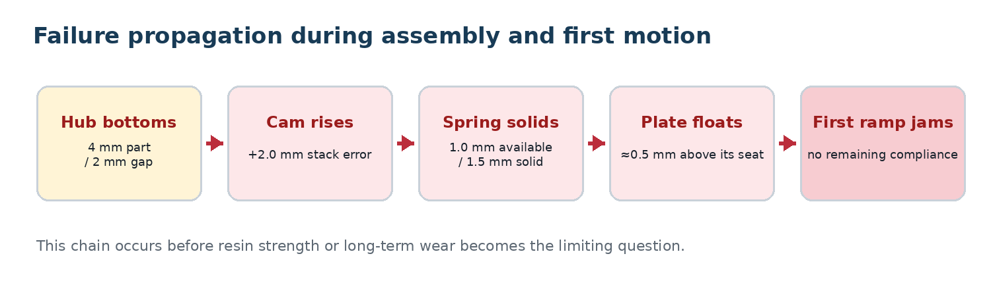
Figure 2. The first failure causes every later failure in the assembled mechanism.

3.4 Why the disk can begin turning and then bind
A follower sitting on a flat dwell does not immediately change height. The motor may therefore rotate through part of a dwell and appear healthy. When the first foot enters a ramp, however, the cam demands vertical motion. The spring is already solid and the plate cannot rise freely inside the enclosure. Contact force rises sharply, so the likely outcomes are stepper stall, skipped steps, foot slip, linkage deflection or local resin damage.
PRACTICAL SYMPTOM: A bench test could misleadingly show a few degrees of rotation before failure. That is not smooth operation; it is merely movement across the flat portion before the first lift demand.

4. Shaft location and axial control

4.1 The double-D bore has no axial stop
The bore passes through the 4.0 mm hub and the 2.0 mm disk floor. Physical engagement is therefore at most 6.0 mm, not the older 8.0 mm comment. Because the bore is open at the top, it does not establish how far the cam is pushed onto the shaft. Cam height is assembly-dependent unless another positive stop is added.
Maximum material engagement = 4.0 mm hub + 2.0 mm disk floor = 6.0 mm
This is especially serious because the functional dot travel is only 0.8 mm. An uncontrolled axial placement error of even a few tenths of a millimetre consumes a large fraction of the intended motion.

4.2 Fixing the hub alone can expose a shaft/riser collision
The reported shaft height M6 is 9.5 mm above the bracket face. With the face at z = 41.0 mm, the shaft tip is approximately z = 50.5 mm. The central braille risers are at x = ±2.4 mm, directly beside a nominal Ø5 mm shaft.
Measured shaft tip ≈ 41.0 + 9.5 = 50.5 mm
In the already-wrong raised cam position, the upper risers begin about 4.5 mm above the cam, at z ≈ 51.5 mm, leaving only about 1.0 mm axial margin. In the intended cam position, the upper risers begin at z ≈ 49.5 mm, creating about 1.0 mm of axial overlap with the shaft envelope. Exact contact depends on the printed riser shape, shaft boss, assembly depth and lateral tolerances.
DESIGN TRAP: Shortening the hub or lowering the cam without redesigning the shaft stop can move the mechanism from a hub collision directly into a shaft/riser collision. The vertical stack and shaft termination must be solved together.

4.3 Current confidence
Question | Current answer | Reason
Does the double-D profile transmit torque? | Nominally yes | 5.2 mm diameter and 3.2 mm flats give about 0.10 mm/side nominal clearance against a 5.0/3.0 mm shaft.
Does the cam have enough engagement? | Probably, but unverified | 6.0 mm engagement is plausible for torque, but the real shaft and resin fit are untested.
Is cam height repeatable? | No | The through-bore has no positive axial shoulder.
Is shaft-to-linkage clearance safe? | No confirmed answer | The intended stack creates an overlap envelope; the current raised stack leaves only about 1.0 mm.

5. Running clearances: nominally possible, operationally fragile
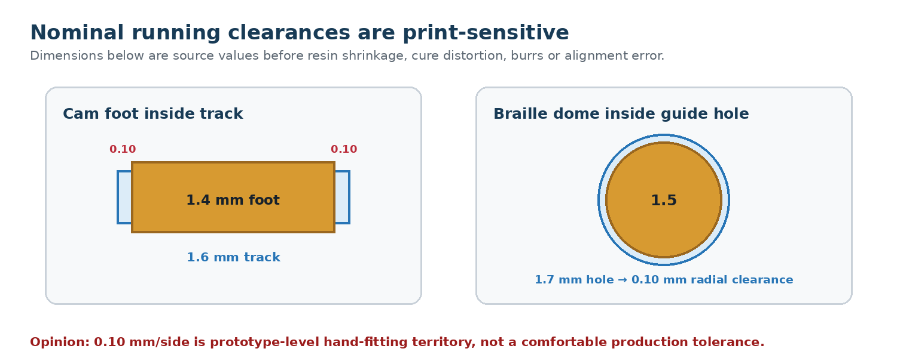
Figure 3. Both key sliding interfaces have only 0.10 mm nominal clearance per side.

5.1 Foot-to-track radial margin
Radial margin per side = (1.6 - 1.4) / 2 = 0.10 mm
That margin must absorb track shrinkage, foot oversize, cam eccentricity, shaft runout, linkage yaw, assembly offset, cure distortion and debris. A single speck of cured resin or a lightly swollen feature can consume it. This is not impossible, but it is hand-fit territory.

5.2 Dome-to-hole guide margin
Guide margin per side = (1.7 - 1.5) / 2 = 0.10 mm
The dome must repeatedly slide through the resin insert without side loading. If the hole prints undersize, is not perfectly vertical, or the linkage yaws, the dome can rub and prevent full return. Reaming may rescue a prototype, but that should be an intentional process step rather than a surprise.

5.3 Fastest-track dwell margin
The fastest-changing bit is deliberately assigned to the outermost track, where one 5.625° slice is widest. At r = 21.3 mm the slice arc is about 2.09 mm. With 20% allocated to the transition ramp, the nominal flat dwell is about 1.67 mm.
Outer slice arc = 2π(21.3) / 64 = 2.09 mm
Flat dwell = 0.80 × 2.09 = 1.67 mm
Centered tangential margin = (1.67 - 1.00) / 2 ≈ 0.34 mm/side
This logic correction is sensible and the nominal tangential dwell is larger than the foot. However, yaw and indexing error consume this margin. It should be verified on a real cam at the intended motor microstep/full-step position.

5.4 Other small features
Feature | Nominal margin | Risk
Adjacent spring bores | 0.40 mm total wall | One-nozzle / thin-resin wall; chipping, bleed-through or cure distortion can merge bores.
Adjacent flanges | 0.40 mm gap | Misalignment or burrs can create flange-to-flange contact.
Closest horizontal arms | 1.60 mm free gap | Comfortable geometrically, but flex or yaw can reduce it.
Arm top to plate underside | 3.70 mm nominal | Good in the intended stack; invalid once the whole linkage is shifted upward.
Spring ID vs. nub | 0.20 mm/side | Reasonable nominally, but the 1.5 mm dome is intentionally larger than the 1.4 mm spring ID and must be threaded through.

6. Cam ramp, force and motor-load risk

6.1 The geometric ramp is very steep
Each 5.625° slice uses only 20% of its angle for the complete transition, so the transition spans 1.125°. The physical run available under a foot depends on track radius.
Ramp angle = 5.625° × 0.20 = 1.125°
Inner-track run = 12.8 × radians(1.125°) ≈ 0.251 mm
Outer-track run = 21.3 × radians(1.125°) ≈ 0.418 mm
For a cosine lift of 0.8 mm, the maximum local surface slope is roughly 79° on the inner track and 72° on the outer track. The rolled 0.5 mm foot radius helps, but the follower is still climbing a short, steep transition. Surface roughness or a sharp printed ridge will strongly affect force.

6.2 Peak torque estimate
For the cosine transition, the maximum lift derivative is approximately 64 mm of follower motion per radian of cam rotation. Generalized cam torque is follower force multiplied by this derivative.
max(dh/dθ) = 0.8π / [2 × radians(1.125°)] ≈ 64 mm/rad
If a spring near the top of its stated range produces about 0.18 N when compressed to the up position, one follower can require roughly 11.5 N·mm before friction. A worst-case boundary can ask several or all followers to transition together; six equal followers would approach 69 N·mm before friction, shaft loss, gearbox loss or misalignment.
Illustrative peak per follower ≈ 0.18 N × 64 mm/rad = 11.5 N·mm
Illustrative six-follower peak ≈ 6 × 11.5 = 69 N·mm (before friction)
NOT A MOTOR CERTIFICATION: The actual spring rate, preload, motor running torque at the chosen voltage/speed, gearbox backlash and friction are not measured. The estimate exposes the missing safety-factor calculation; it does not prove the motor will or will not stall after the geometry is fixed.

6.3 Why the current jam is worse than the nominal estimate
The estimate above assumes the spring operates within its elastic travel. In the current assembly the spring is already at solid height before lift. Once solid, effective stiffness increases dramatically and the cam sees a near-rigid stop. Motor torque is then spent deforming printed parts, lifting the plate, slipping contact or skipping gearbox steps rather than producing controlled braille travel.

7. Linkage stability and structural risks

7.1 No positive anti-yaw guide
The old comb-style guide was removed when the feet were spread around the disk. The current layout avoids arm crossing, but there is no explicit key, slot or guide that positively fixes each linkage's rotation about the dot axis. The circular guide hole and coaxial spring constrain translation, yet they do not define angular orientation.
Tangential friction at the cam foot can therefore apply a yaw moment to the linkage. If the linkage rotates, the foot can approach a track edge, the dome can rub the guide hole, and neighbouring flanges or arms can lose their nominal clearance. The exact yaw angle that causes trouble depends on each arm's geometry and contact friction, so it is not proven by the rigid preview.

7.2 Thin resin arms
The arms are 1.0 mm thick and 10.40-17.87 mm long. The source includes internal and external fillets, which is good practice, but no measured resin modulus, yield strain, cure schedule or print orientation performance is available. The longest arms will be more compliant and more sensitive to torsion than the shortest.
Flexibility is not automatically bad: small compliance can reduce shock. The problem is uncontrolled compliance. Too much bending changes dot height and track alignment; too little makes the steep cam ramp shock-load the foot. This balance requires a physical coupon or a material/contact model.

7.3 Contact wear and edge damage
- A cured resin foot sliding on a cured resin cam can polish, powder or chip depending on resin toughness and surface finish.
- The 0.5 mm rolled contact radius reduces edge digging but is small enough that layer/facet ridges remain important.
- A track-edge strike is dangerous because only 0.10 mm radial margin exists on either side.
- Lubrication may reduce friction but can attract dust, attack some resins or alter tactile cleanliness; it must be material-compatible.

8. Printing and assembly risks

8.1 Mixed-process tolerance stack
The top plate is PETG while the dot insert, cam and linkages are resin. Their shrinkage, hole accuracy, surface finish and post-processing differ. The assembled mechanism depends on all of them sharing a common centreline within tenths of a millimetre. Glue thickness under the insert and seating error in the PETG rebate add another uncontrolled offset.

8.2 Features likely to need process compensation
Feature | Why it is sensitive | Recommended proof
1.7 mm dot holes | Small resin holes often cure undersize or taper. | Print a six-hole insert coupon; gauge and ream deliberately.
1.6 mm cam tracks | Track width and edge sharpness control a 1.4 mm foot. | Measure multiple radii after full wash/cure.
1.0 mm linkage arms | Warp and brittleness vary with orientation and resin. | Print sacrificial arms in intended orientation; bend/load test.
0.4 mm bore walls | May chip, merge or remain uncured between counterbores. | Microscope/bright-light inspection after cleaning.
Double-D bore | 0.10 mm/side nominal fit may print too tight. | Separate bore coupon using the real shaft.
Insert glue shelf | Adhesive thickness can lift or tilt the guide holes. | Dry-fit and measure flushness before bonding.

8.3 Spring installation is intentionally interfering
The spring ID is 1.4 mm while the dome is 1.5 mm, so assembly requires twisting the spring over the dome. That can be workable, but it should be tested on a spare linkage. Forcing or prying the coil can nick the dome, distort the spring end or snap the 1.0 mm riser.

8.4 Backlash and indexing
The cam uses 64 indexed positions, each 5.625° apart. Gearbox backlash, shaft/bore play and step loss can move a foot toward a ramp instead of the centre of its dwell. The outer fast track has about 0.34 mm tangential margin per side only when perfectly centred. Homing detects a reference; it does not remove gearbox backlash during direction changes.

9. Documentation and source-consistency hazards
The live formulas are generally more reliable than older comments, but several comments have drifted. This is not a direct collision, yet it creates a real build risk because someone can source or assemble from stale prose.
Location | Stale or conflicting statement | Live design
linkage.scad header/reference comments | Still mentions total_h = 13.0 mm in places. | link_total_h is computed as 12.2 mm from reading surface 57.2 minus cam flat 45.0.
top_plate.scad spring-spec comments | Some lines describe the deleted mid-arm pad and old spring relationship. | Current mechanism uses a 2.0 mm OD spring coaxial with the dot, acting on the upper flange.
CAD_FIT_CHECK.md | Preserves superseded v7.2/v7.3 failures alongside fixed items. | The header status table must be read before treating older sections as current.
braille_cam.scad historical comments | Older text claimed 8 mm bore engagement. | Material exists for only 6 mm of maximum engagement.

TIP: Treat mech_layout.scad and live geometry as the source of truth, then delete or correct stale assembly comments in the same change that fixes the vertical stack. This project has already suffered from silent comment drift.

10. What the motion simulation proves - and what it does not

10.1 Proven by the current preview
- The actual six-link fan layout can be represented without arm crossing.
- The cam height function and 64-slice cosine transitions move the isolated linkages through 0.8 mm travel.
- The assembled hub/pocket geometry has 2.0 mm hard interference.
- The propagated stack leaves only 1.0 mm at the intended spring location, below the stated 1.5 mm solid height.
- The plate cannot reach its intended seat while preserving spring travel.
- The first requested lift encounters a rigid stack and is expected to stall, deflect or damage something.

10.2 Not proven
- Actual resin strain, fracture, fatigue, creep or wear.
- Real coefficient of friction and whether a foot self-centres or walks toward a track edge.
- Actual spring rate, solid height and end condition for the purchased spring.
- Motor running torque and thermal margin at the intended speed and supply.
- As-printed shrinkage, warp, hole taper, glue thickness or post-cure movement.
- Long-cycle reliability after hundreds or thousands of transitions.

11. Recommended redesign and validation sequence
STRONG RECOMMENDATION: Do not repair one number at a time. Re-derive the motor face, cam pocket, hub, cam flat, linkage height, spring window, plate seat and shaft termination as one vertical dependency chain.

- Finish the fit-critical measurements. Confirm M5 (shaft flat-to-flat), M7a (shaft-boss height), M8 centre-to-centre interpretation, M10a/M10b bracket dimensions, and the actual spring solid height/rate. Recheck M2 = 19 mm and M6 = 9.5 mm using the measurement sheet definitions.
- Choose the fixed axial datum. Decide exactly which physical surface locates the cam: a shaft shoulder, blind bore ceiling, spacer, retained collar or another positive stop. A friction push-fit is not accurate enough for 0.8 mm functional travel.
- Rebuild the vertical stack algebraically. Start from the measured motor/bracket datum, reserve real hub/boss clearance (target at least 0.3 mm), place the cam, then derive linkage height, flange height, spring working range and plate seat. Do not reuse cam_flat_z = 45 unless the equations produce it.
- Resolve shaft/riser clearance in the same CAD pass. Ensure the intended cam position leaves a measurable margin around the central dot-2 and dot-5 risers throughout 0.8 mm travel.
- Add positive yaw control. Evaluate a keyed dot guide, a very light guide comb, a non-circular lower guide or another feature that constrains linkage orientation without over-constraining vertical motion.
- Increase tolerance where the envelope allows. The first targets are foot/track and dome/hole interfaces. A comfortable prototype goal is at least 0.20-0.25 mm/side after the real print process, not merely in nominal CAD.
- Print isolated coupons before the mechanism. Use the actual resin, orientation, wash and cure settings for: double-D bore, one cam track plus foot, dot insert holes, spring bore wall, and one complete linkage.
- Build a one-follower transparent/open rig. Use the real spring and motor, rotate through multiple ramps, film in slow motion and mark the foot so yaw or edge-walking is visible.
- Build the six-link mechanism without the enclosure top constraint. Confirm a full revolution, spring return and dwell repeatability before adding the final plate and box.
- Only then print the complete assembly. Run acceptance tests below before committing additional resin cells.

12. Acceptance criteria before a full resin print
Test | Pass condition | Gate
Plate seating | Plate reaches its datum without force; ≤0.20 mm visible/measurement gap. | Required
Spring reserve | At maximum lift, compressed length remains ≥0.30 mm above measured solid height. | Required
Down-dot height | Each down dome is flush to +0.10 mm maximum at the reading surface. | Required
Up-dot height | Measured rise is 0.70-0.90 mm and repeatable across all six dots. | Required
Shaft clearance | ≥0.50 mm verified clearance from every linkage throughout travel. | Required
Foot tracking | No foot touches a track edge during a full clockwise revolution. | Required
Yaw | No visible permanent rotation or dome rubbing after 100 cycles. | Required
Motor motion | Full 360° cycle at required speed with no skipped index, stall or driver fault. | Required
Return | Every dot returns under spring force from every tested state. | Required
Wear screen | No chips, powder, cracks or polished edge-catching after 500 cycles. | Recommended

13. Cheapest safe prototype strategy
The best way to avoid wasting the current print is not a more beautiful full assembly; it is a deliberately ugly proof rig that isolates one uncertainty at a time.
Prototype | Parts | Question answered | Full-print risk avoided
Coupon A | Double-D bore + real shaft | Does the bore fit after cure and hold torque? | Cam rejected for an unusable bore
Coupon B | One track segment + one foot | Does the foot climb without edge strike or roughness jam? | Six-link cam failure
Coupon C | Dot insert + one linkage + spring | Does the dome slide and spring return without solid stacking? | Top-plate/guide failure
Open rig | Motor + cam + one then six links | Does motion remain centred under real force? | Enclosure hides the root cause
Final cell | Complete corrected stack | Does the integrated product meet acceptance gates? | Only attempted after cheap risks are retired

BOTTOM LINE: The concept is worth continuing, but the current full geometry is not a brave prototype - it is a guaranteed fit failure followed by several unquantified motion risks. Fix the vertical datum chain first, then spend resin on coupons that measure the remaining unknowns.

Appendix A - Source values used
Parameter | Value | Trace
inner_radius | 12.0 mm | mech_layout.scad
track_width / track_gap | 1.6 / 0.1 mm | mech_layout.scad
track centres | 12.8, 14.5, 16.2, 17.9, 19.6, 21.3 mm | mech_layout.scad
dot_track | [2, 3, 4, 1, 0, 5] | mech_layout.scad
dot_phase | [120, 180, 240, 60, 0, 300]° | mech_layout.scad
cam_flat_z / pin_lift | 45.0 / 0.8 mm | mech_layout.scad
plate_under_z / reading_surface_z | 54.0 / 57.2 mm | mech_layout.scad
link_total_h | 12.2 mm | mech_layout.scad
spring OD / free / stated solid | 2.0 / 4.0 / 1.5 mm | mech_layout.scad comments
dot / plate hole | 1.5 / 1.7 mm | mech_layout.scad
flange / row pitch | 2.2 / 2.6 mm | mech_layout.scad
link thickness / foot width | 1.0 / 1.4 mm | linkage.scad
arm_y / arm_h | 3.5 / 1.0 mm | linkage.scad
foot roll radius | 0.5 mm | linkage.scad
states / ramp fraction | 64 / 0.20 | braille_cam.scad
disk floor / hub height | 2.0 / 4.0 mm | braille_cam.scad
base plate underside / pocket floor | 41.0 / 43.0 mm world z | outer_box.scad + base_plate.scad
reported shaft height M6 | 9.5 mm | .ai-sync/handoff.md

Appendix B - Derived checks
Check | Calculation | Result
Hub interference | 4.0 - (43.0 - 41.0) | 2.0 mm
Actual cam flat if hub bottoms | 45.0 + 2.0 | ≈47.0 mm
Actual down-dot top | 47.0 + 12.2 | ≈59.2 mm
Dot proud error | 59.2 - 57.2 | ≈2.0 mm
Spring room at seated plate | (54.0 + 2.0) - (47.0 + 8.0) | 1.0 mm
Spring solid shortfall | 1.5 - 1.0 | 0.5 mm
Foot radial clearance | (1.6 - 1.4) / 2 | 0.10 mm/side
Dome radial clearance | (1.7 - 1.5) / 2 | 0.10 mm/side
Outer fast-track dwell | 0.8 × 2π × 21.3 / 64 | 1.67 mm
Ramp angle | 5.625° × 0.20 | 1.125°
Inner / outer ramp run | r × radians(1.125°) | 0.251 / 0.418 mm
Max lift derivative | 0.8π / [2 × radians(1.125°)] | ≈64 mm/rad
Illustrative six-follower torque | 6 × 0.18 × 64 | ≈69 N·mm before friction

Appendix C - Recommended CAD change order
- Measurement sheet and hardware dimensions.
- outer_box.scad motor/ledge datum and base_plate_z.
- base_plate.scad cam pocket floor and motor boss clearance.
- braille_cam.scad hub height, bore depth and positive axial stop.
- mech_layout.scad cam_flat_z, link_total_h, flange and spring working range.
- linkage.scad anti-yaw strategy and any tolerance changes.
- top_plate.scad / dot_insert.scad guide and spring-counterbore changes.
- Full assembly render, automated clearance assertions, coupon prints, then regenerated STLs/G-code.
Report conclusion: no production CAD was modified during this findings pass. The report records the current revision and the evidence required for the next correction.

